VECC web application - Instrucciones
Raw data processing
Script: time_series.R
- Read input data (one file for each model)
- Process data and prepare time series files (one file for each subcatchment)
- Generate file for showing 30-year average values for all subcatchments on map
GIS data processing
In QGIS: Prepare vector layer with precipitation data
- Layer/Add layer/Add vector layer/Select shp file (scs_mantaro_utm.shp)
- Load csv file: Layer/Add layer/Add delimited text file/Select csv file
- Check column names and number of elements (subcatchments)
- Vector layer/Properties/Joins/”+”/Join layer/Join field/Target field/Ok
- Rename field: Attributes table/Field calculator/Create new field/…/Ok/Save edits
- Export/Save features as/Save shp layer
- In saved layer: Attributes table/Toggle/Delete old fields

Styling of vector layer
Examples: absolute annual P and variation in mm
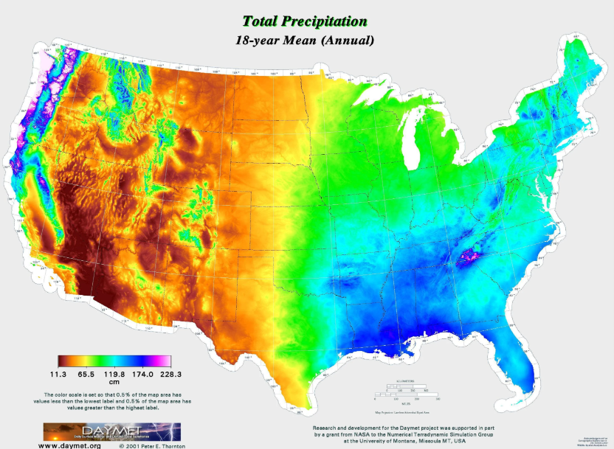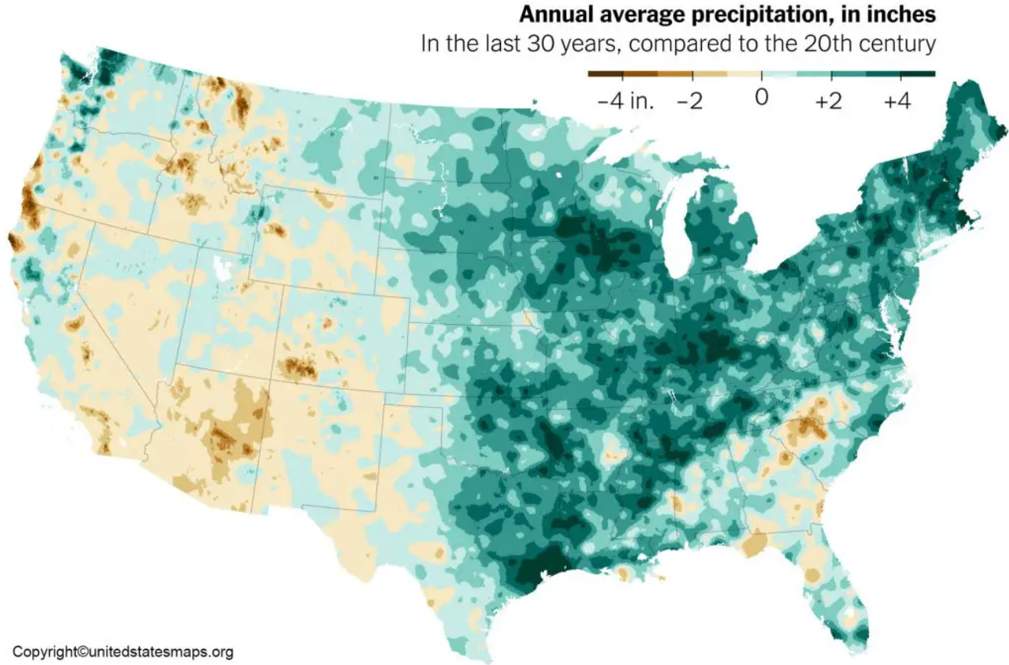
=> Style for annual precipitation 0-2000 mm/a
0% #5f2f05
10% #ed8e35
20% #f8f012
30% #1aec8a
40% #26e4ec
60% #1070ed
80% #0d15af
100% #da92f6
Export/Save QGIS Layer style file
Conversion to raster layer: Vector layer/Raster/Conversion/Rasterize:
- Input layer
- Field to use
- Output raster size unit: georeferenced
- Width: 1000 / Height: 1000
- Run
- Define and save style for raster layer (uniband)
Styling of other raster layers
- Properties/Symbology/Style/Load style (raster style)
Save as rendered image (geotiff)
- Export/Save as/Geotiff (tick “Rendered image”, define filename)
Convert tif into png file (image)
- In QGIS: Plugins/Python console
- Show editor
- Run the script: convert_tif_to_png.py (update file paths and file names):
from osgeo import gdal

# Input and output file paths
input_tif = “C:/Users/wkrin/DocsNonSync/webapp/geotiff/pr_1995_300_rendered_new.tif”
output_png = “C:/Users/wkrin/DocsNonSync/webapp/png/pr_1995.png”

# Open the dataset
dataset = gdal.Open(input_tif)

# Convert to PNG
gdal.Translate(output_png, dataset, format=”PNG”, scaleParams=[[0, 255]], options=[“-co”, “WORLDFILE=YES”])

# Close dataset
dataset = None

print(“Conversion complete:”, output_png)

Displaying map in vector format
Convert shape file to GeoJSON
- In QGIS: Export/Save features as/GeoJSON
- CRS: EPSG 4326/WGS 84
Flask API to serve GeoJSON file
See backend script: app.py

Backend
Script: app.py
Data files:
- Subcatchment map (vector): geojson/subcatchments.geojson
- Subcatchment data: mapdata/pr_1995_all_subcatchments.csv, …
- Time series data files: timeseries/pr_1.csv, …

Frontend
index.html
styles.css
scripts.js
Folder structure
vecc/
│── data/
│ ├── geojson/
│ ├── mapdata/
│ ├── timeseries/
│── static/
│ ├── css/ styles.css
│ ├── js/ scripts.js
│── templates/
│ ├── index.html
app.py
CHANGELOG.md
config.py
README.md
requirements.txt

Start development server (through Flask, included in app.py):
- Open Windows command prompt
- Navigate to directory
- Run: python app.py
- Stop with: Ctrl + C
Check:
- Type in browser: http://127.0.0.1:10000/
- F12 => Browser console

