Biol 365 – Scientific computing Name

Translating decimal numbers to binary

1. Decimal integers: count to 10 in binary - use the binary converter to find the binary equivalents to the numbers from 0 to 10. You don't need to record leading 0's.

Decimal number | 0 | 1 | 2 | 3 | 4 | 5 | 6 | 7 | 8 | 9 | 10
Binary number

How many bits were needed to represent 10?

2. Decimal floating point numbers: express the following as floating point numbers. In each case 4321 are the significant digits. A floating point number expresses the significant digits as a whole number, multiplied by an exponent. The first is done for you.

4321 = 4321 x 10⁰ 0.004321 = 432100 =

4.321 = 43.21 =

Representing text using ASCII codes

3. a. Translate the following ASCII codes to binary numbers, and then into letters. Use the binary to decimal converter in the instructions web page to get the binary numbers. Use the ASCII table linked on the web page to get the letters.

ASCII code | 66 | 105 | 111 | 108 | 111 | 103 | 121 | 33
Binary number
Letter

b. Look at the ASCII table again – is the ASCII code for the number 0 the same as the binary number that is equivalent to 0? What does this tell you about the importance of letting the computer know what kind of data you are using?

4. Spell your first name in ASCII - each letter should be an 8-bit binary number. Don't forget to capitalize!

The RGB color model

5. Use the RGB color picker for this part of the assignment. RGB values are expressed as three numbers between 0 and 255, separated with commas, in the order R,G,B. For example, white has maximum value for all three channels, and is 255,255,255. Black has no light of any color, and is thus 0,0,0.

a. Find the color that has code 255,0,0 – what color is it?

b. Find the color with code 150,0,0 – what color is it?

c. What is the RGB code for a shade of pink? Why isn't it 150,0,0 (moderate on red, no green or blue)?

d. What is the RGB code for bright yellow? Is yellow a primary color in the RGB model?

e. Grayscale images use a single 8-bit channel to represent 256 shades of gray. It is possible to represent gray in a 24 bit RGB image. For example:

What is the code for white?

What is the code for a shade of gray?

What about black?

Given these codes for white, gray, and black, how many different shades of gray can be represented by the RGB color model?

Digitizing sound

6. On the axes below, sketch how many different levels of sound intensity could be represented with 2 bit, 4 bit, or 8 bit sound.
2 bit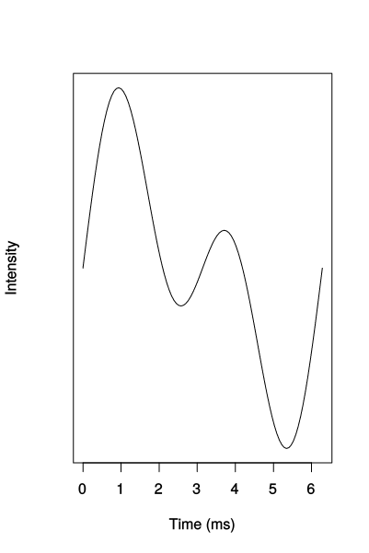
4 bit
8 bit
Why does 8 bit sound better reproduce a sound wave than 2 or 4 bit sound? Can digital sound perfectly reproduce an analog sound wave? Why or why not?

Lossy and lossless compression - sound

7. Explain what happened to the humpback whale sound when you saved it using a lossy file format. Could you tell that the sound changed by listening to the compressed file? If it didn't sound different to you, why would it matter if you used lossy compression?

Lossy and lossless compression - images

8. What happened to the image when you saved it using the jpeg file format? Was the difference visible on the screen before you zoomed in to pixel level? If the images don't look much different, why would it matter if you used lossy compression?

