Biol 365 – Scientific computing Name KEY

Random numbers
1. Computers are not capable of generating truly random numbers, because they can only failthfully execute commands exactly as they are given. They can be programmed to generate pseudo-random numbers.

a. What do we mean by “pseudo-random”? In what way do pseudo-random numbers mimic actual random numbers, and in what way are they different?

Pseudo-random numbers are unpatterned like real random numbers, but given the same seed you get identical values. Real random numbers are always different.

b. When you use the same seed for your random number generator, what do you get (are the numbers the same, or do they change at random)?

Using the same seed gives identical numbers.

c. How can we make the random number generator produce different pseudo-random numbers every time?

Random number generators can use system time as the seed, which is never the same twice.

The RGB color model

2. Use the RGB color picker for this part of the assignment. RGB values are expressed as three numbers between 0 and 255, separated with commas, in the order R,G,B. For example, white has maximum value for all three channels, and is 255,255,255. Black has no light of any color, and is thus 0,0,0.

a. Find the color that has code 255,0,0 – what color is it? Red (bright red)

b. Find the color with code 150,0,0 – what color is it? Darker red

c. What is the RGB code for a shade of pink? Why isn't it 150,0,0 (moderate on red, no green or blue)?

To get a shade of pink you need a lot of red, with lesser amounts of green and blue that are the same as one another. 150,0,0 is darker red – since white is 255, 255, 255 you need to add some green and blue to lighten the color.

d. What is the RGB code for bright yellow? Is yellow a primary color in the RGB model?

Bright yellow is a mix of red and green, 255, 255, 0. Yellow is not a primary color in the RGB model.

e. Grayscale images use a single 8-bit channel to represent 256 shades of gray. It is possible to represent gray in a 24 bit RGB image. For example:
What is the code for white? What is the code for black?

White is 255, 255, 255 and black is 0,0,0

If you set the three color channels to the same numbers (any number between 1 and 254) what do you get?
Any set of identical RGB values gives a shade of gray.

f. In what sense is 24 bit RGB color considered “true color”? Does that mean that we can use RGB color for any kind of imaging we encounter in biology?

It is true color in that it can produce more distinct colors than the human eye can see, but it’s only suitable for visible light.

Digitizing sound

3. On the axes below, sketch bars on the graph that show many different levels of sound intensity could be represented with 2 bit, 4 bit, or 8 bit sound, with samples taken once per millisecond.
2 bit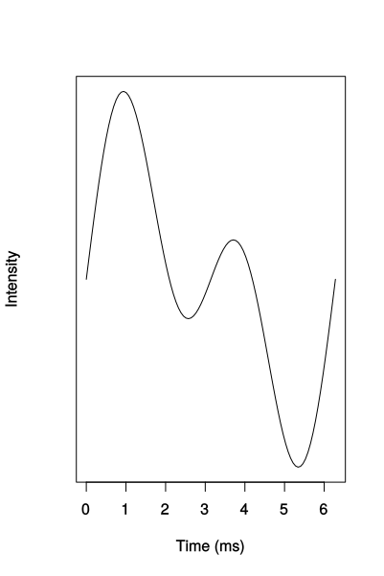
4 bit
8 bit
Why does 8 bit sound reproduce a sound wave better than 2 or 4 bit sound? Can digital sound perfectly reproduce an analog sound wave? Why or why not?

Eight bit does better because there are more levels of intensity it can take, so it can come closer to the wave form. It isn’t possible to perfectly reproduce the wave because the wave form is continuous and the digital representation is discrete.
Lossy and lossless compression - sound

4. Explain what happened to the blackbird sound when you saved it using a lossy file format. How could you tell that saving in a lossy format changed the sound file data?

The lossy format discards some of the sound data from frequencies that we don’t hear. We could tell that the data changed because the inverted lossy track combined with the original didn’t end up with a flat line, which it would have if the lossy track was identical to the original.

Lossy and lossless compression - images

5. What happened to the image when you saved the image using the jpeg file format? Was the difference visible on the screen before you zoomed in to pixel level? If the images don't look much different, why would it matter if you used lossy compression for scientific work?

The jpeg file changed most of the image at least a little bit. The differences weren’t obvious, and weren’t visible until you zoomed in to pixel level.

Lossy compression is risky for scientific work, because it changes the data. Since lossy sound and image compression are designed to produce smaller files by discarding parts of the recordings we can’t hear or see it can become a problem if we’re working with recordings from species that can hear or see different wavelengths than we can.

