Biol 365 – Scientific computing Name

Random numbers
1. Computers are not capable of generating truly random numbers, because they can only failthfully execute commands exactly as they are given. They can be programmed to generate pseudo-random numbers.

a. What do we mean by “pseudo-random”? In what way do pseudo-random numbers mimic actual random numbers, and in what way are they different?

b. When you use the same seed for your random number generator, what do you get (are the numbers the same, or do they change at random)?

c. How can we make the random number generator produce different pseudo-random numbers every time?

The RGB color model

2. Use the RGB color picker for this part of the assignment. RGB values are expressed as three numbers between 0 and 255, separated with commas, in the order R,G,B. For example, white has maximum value for all three channels, and is 255,255,255. Black has no light of any color, and is thus 0,0,0.

a. Find the color that has code 255,0,0 – what color is it?

b. Find the color with code 150,0,0 – what color is it?

c. What is the RGB code for a shade of pink? Why isn't it 150,0,0 (moderate on red, no green or blue)?

d. What is the RGB code for bright yellow? Is yellow a primary color in the RGB model?

e. Grayscale images use a single 8-bit channel to represent 256 shades of gray. It is possible to represent gray in a 24 bit RGB image. For example:

What is the code for white? What is the code for black?

If you set the three color channels to the same numbers (any number between 1 and 254) what do you get?

f. In what sense is 24 bit RGB color considered “true color”? Does that mean that we can use RGB color for any kind of imaging we encounter in biology?

Digitizing sound

3. On the axes below, sketch bars on the graph that show many different levels of sound intensity could be represented with 2 bit, 4 bit, or 8 bit sound, with samples taken once per millisecond.
2 bit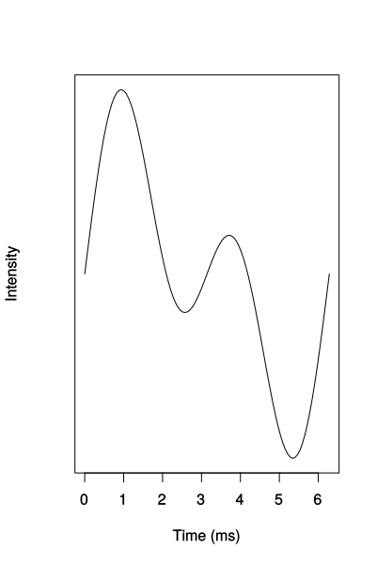
4 bit
8 bit
Why does 8 bit sound reproduce a sound wave better than 2 or 4 bit sound? Can digital sound perfectly reproduce an analog sound wave? Why or why not?

Lossy and lossless compression - sound

4. Explain what happened to the blackbird sound when you saved it using a lossy file format. How could you tell that saving in a lossy format changed the sound file data?

Lossy and lossless compression - images

5. What happened to the image when you saved the image using the jpeg file format? Was the difference visible on the screen before you zoomed in to pixel level? If the images don't look much different, why would it matter if you used lossy compression for scientific work?

