Biol 215 - Biostatistics Midterm 1 Name KEY

Read all of the questions carefully, and answer fully. Show work whenever possible.

Question 1 deleted – probability question that will be covered on midterm 2 this semester.

2. Identify the variable type (numeric or non-numeric). For numeric variables, also indicate whether they are continuous or discrete. Give the measurement scale (interval, ratio, nominal, or ordinal) for each.
Variable | Type | Measurement scale
Number of eggs in a nest | Discrete numeric | Ratio
Calendar years | Discrete numeric | Interval
Heights of shrubs | Continuous numeric | Ratio
Seasons | Categorical | Ordinal

3. A small team of researchers is designing a study of diabetes. They want to enroll a large number of diabetes patients in their study, but the cost of doing large numbers of blood tests in the hospital is prohibitive. They would like to use cheaper home test kits, but they are concerned that the kits might not be suitable for scientific research. They decide that to be useful for their study there can be no interobserver variation in using the kits, and none of the readings can be more than 0.5 mmol/L different from the true value. If either of these problems occurs, they will need to find a different instrument.

To test whether the test kits work well enough to use, one of the researchers (Bob) volunteers to be the blood source. They draw a single sample of blood from Bob, and the other three researchers (Laine, Andrea, and Kaitlin) test his blood sugar levels four times each with a home test kit. They send the remainder of the blood sample to the lab. The lab results show that Bob's blood sugar level is 5.0 mmol/L, which they use as the true blood sugar level.

The data from these tests are in the file "Question3.xlsx" on the class web site.

A. Is there any biological variation in the data? Explain why or why not. What else besides biological variation could cause variability in the data?

No there is not. Biological variation is the real variation among individuals, but only a single blood sample from a single person is being used, so there is no variation due to differences in blood sugar between people. Any variation in the data is due to differences in how the observers are using the instrument, or variation in the instrument itself.

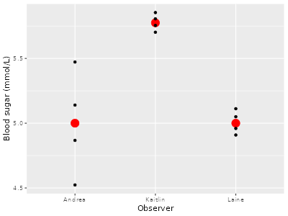
B. Make an individual value plot with groups, using "Blood sugar" as the "Dependent variable", and "Observer" as the "Grouping variable". Add a mean symbol. Based on this graph, is there interobserver variation? Why or why not?

The means are different, and the points don't overlap between Kaitlin and the other two, so there is interobserver variation.

C. Which observer has the most biased measurements? Who has the least precise measurements?

Kaitlin's are the most biased, Andrea's are the least precise.

D. Are there any observations that are more than 0.5 mmol/L from the true blood sugar level? Whose measurements are they?

Kaitlin's are all above 5.5. She is the most consistent, though, so this is just due to her consistently high measurements (her bias).

E. Based on the data, is it possible to use this instrument well enough for the study? What could they do to improve their use of the home test kit so that it's acceptable for their study?

Yes, it's possible. Both Andrea and Laine were able to use the kit well enough. If they worked with Kaitlin to get her numbers in line with theirs, it could be okay. Additionally, Laine and Kaitlin were both very consistent, so they could work on Andrea's consistency.

F. If you wanted to make a summary graph of their blood sugar data, would it be better to use an interval plot or a pie chart? Why?

These data are measurements of continuous variables, so the best summary would be a mean, and interval plots are good at plotting means and standard errors. Pie charts are for frequencies, relative frequencies, or percentages.

4. Rachel wanted to determine whether two different generic brands of aspirin, Brand A and Brand B, were accurately representing the sizes of their pills. Both bottles were supposed to be 100 mg, so she weighed 100 pills of each brand on a balance. Her data are in the file "Question4.xlsx" on the course web site.
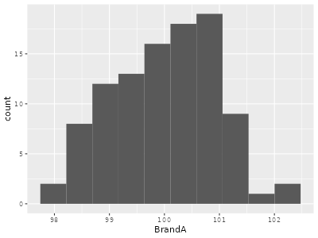
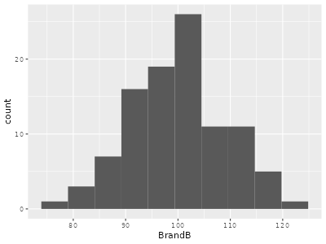
A. Make histograms for BrandA and BrandB. What is the shape of each distribution (note: if there appear to be too many or too few bars to tell, you may change the number of bins. If you do change the number of bins, note how many bins you used in your answer)?

The histograms look pretty bell-shaped, using the default number of bins. There isn't anything wrong with the default, so there is no need to change the number of bins.

B. Calculate the mean, standard deviation, and standard error for each brand, and report them in the summary statistics table to the right.
Summary statistics
Statistic | BrandA | BrandB
Mean | 100.0 | 100.00
s | 0.941 | 9.330
s_{x} | 0.0941 | 0.933

Confidence intervals
Brand | Lower | Upper
BrandA | 99.8 | 100
BrandB | 98.2 | 102

C. Calculate the 95% confidence interval and report the lower and upper limits in the confidence intervals table on the previous page. You can use Jamovi for this. What degrees of freedom was used in these confidence intervals?

There are 100 pills for each brand, so d.f. = n -1 = 99.

D. Are either of the manufacturers producing pills that are not 100 mg in size on average? How do you know?

No, both are producing pills with an average of 100, and with confidence intervals that contain 100

E. Why do the confidence intervals differ in size for these two brands?

The only thing that's different is the amount of variability in the size of the pills. The sample sizes are the same, which means the degrees of freedom and t-values are the same. The intervals are different because the standard deviation is about 90 times bigger for Brand B.

F. If you increased the sample size for the brand with the wider confidence interval to make it narrower, would you be more likely to contain the true mean within the interval? Why or why not?

No, the probability of including the true value is set by the confidence level, which we specified at 95%. Increasing the sample size will make the intervals smaller, but as long as they are 95% intervals the probability of including the true value will be the same.

G. Are you sure that using symmetrical confidence intervals is appropriate for these data? Why or why not?

Yes, it's fine, both because the data distribution is bell-shaped, and because the sample size is large enough that the central limit theorem would make the sampling distribution bell-shaped even if the data distribution was not.

H. When you take a medication, it's important that each dose is correct. Under-dosing can lead to ineffective treatment, and over-dosing can lead to toxicity. If you had to pick one of the brands to take, based on the data presented here which brand would be better?

Both brands have the same average dose, but A is much more consistent – the standard deviation for A is only 0.941, but it’s ten times that for B, 9.33. With B you could easily get a dose that is as low as 80 mg or as high as 120 mg, but with A every dose should be between about 98 and 102 mg.

5. In file "Question5.xlsx" are examples of three variables we might encounter in the biological sciences: ages of trees in a forest (in years), lengths of axons from nerve cells in the brain (in mm), and gene expression levels (i.e. the amount of protein being produced by a gene) for 1000 genes on a chip.

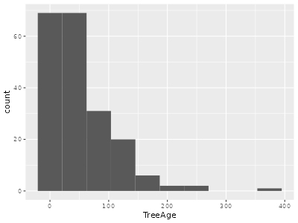
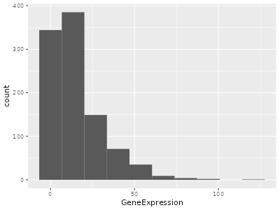
A. Make a histogram of each, and describe their shapes.
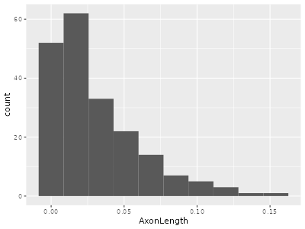

Each are right-skewed (or positively skewed).

B. Why would it be more common to have right-skewed variables than left-skewed variables in the biological sciences?

Most of the variables we measure are counts or dimensions of physical objects, which have a "basement" at 0. This means there is a lower limit to the possible measurements, but not an upper limit, which tends to make distributions pile up at small numbers and spread out towards large ones.

C. Would a box plot or interval plot be more appropriate as a summary graph for these variables? Why?

Box plots are better for skewed distributions, because the presence of a skew is visible in the plot.

