

**STRENGTH**

**DEXTERITY**

**CONSTITUTION**

**INTELLIGENCE**

**WISDOM**

**CHARISMA**

**ARMOR CLASS**

**INITIATIVE**

**SPEED**

Hit Point Maximum

**CURRENT HIT POINTS**

**TEMPORARY HIT POINTS**

Total

SUCCESSES

FAILURES

HIT DICE

DEATH SAVES

PERSONALITY TRAITS

IDEALS

BONDS

FLAWS

NAME

ATK BONUS DAMAGE/TYPE

**ATTACKS & SPELLCASTING**



CLASS & LEVEL

BACKGROUND

PLAYER NAME

CHARACTER NAME

RACE

ALIGNMENT

EXPERIENCE POINTS



Strength Dexterity Constitution Intelligence Wisdom Charisma

**SAVING THROWS**

**PROFICIENCY BONUS**

PASSIVE WISDOM (PERCEPTION)

**FEATURES & TRAITS**

**OTHER PROFICIENCIES & LANGUAGES**

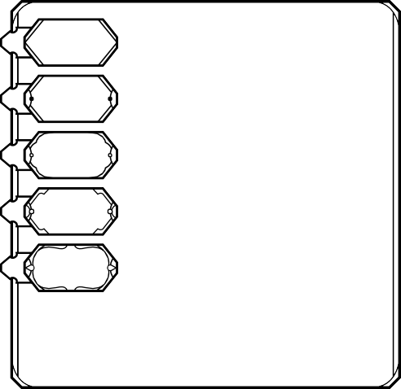

CP

SP

EP

GP

PP

**EQUIPMENT**

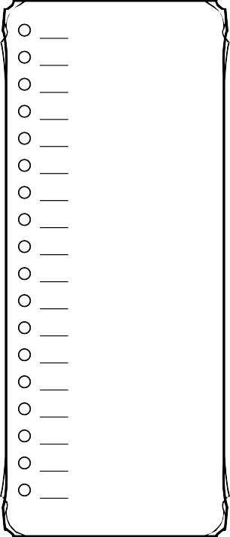

Acrobatics (Dex) Animal Handling (Wis) Arcana (Int)

Athletics (Str) Deception (Cha) History (Int) Insight (Wis) Intimidation (Cha) Investigation (Int) Medicine (Wis) Nature (Int) Perception (Wis) Performance (Cha) Persuasion (Cha) Religion (Int)

Sleight of Hand (Dex) Stealth (Dex)

Survival (Wis)

**SKILLS**

**INSPIRATION**

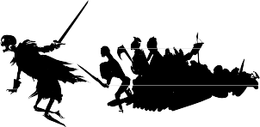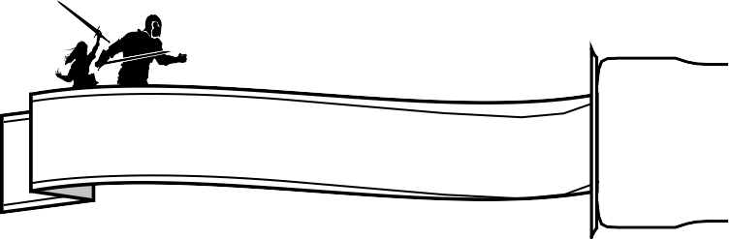

AGE

HEIGHT

WEIGHT

CHARACTER NAME

EYES

SKIN

HAIR

NAME

**SYMBOL**

**CHARACTER APPEARANCE**

**ALLIES & ORGANIZATIONS**

**ADDITIONAL FEATURES & TRAITS**

**TREASURE**

**CHARACTER BACKSTORY**

**0 CANTRIPS 3 6**

SPELL LEVEL

**1**

SLOTS TOTAL

SLOTS EXPENDED

**7**



SPELLCASTING

CLASS

SPELL ATTACK BONUS

SPELL SAVE DC

SPELLCASTING ABILITY



**SPELL NAME**

**A**

**R**

**E**

**D**

**P**

**R**

**E**

**P**

**4**

SPELLS KNOWN

**8**

**2**

**5**

**9**