WarBots
Revised June 21, 2002
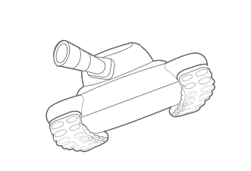

Introduction
The WarBots package is a programming game based on Tom Poindexter's TclRobots, copyright 1994,1996 Tom Poindexter (http://www.nyx.net/~tpoindex) which is in turn based on an ancient programming game called 'Core Wars'.

In WarBots, you write a Visual Basic program to control a robot. Up to four robots compete in a battle to the death. All robots are identical with the exception of the control programs. Each robot has a drive mechanism, a cannon, and a scanner to look for other robots.

The WarBots package provides a simple programming interface to your robot, as well as some sample robots that you can use as programming examples and as competitors.

When you start the first robot, a server process is automatically started. This server process provides a control and status window and a display of the arena where the robots will compete. Each robot also gets it's own status window.

Arena and Coordinates
Robot battles take place in a walled arena. The arena is 1000 meters square. The x axis runs horizontally, with left edge being 0 and the right edge being 999. The y axis runs vertically, with 0 at the bottom. Directions start with 0 pointing to the right and increase counterclockwise;
999

90

Y axis
0
180

270
0
0 X axis 999

Legal directions are 0 to 359 inclusive. You can obtain your robot's coordinates at any time.

The arena is surrounded by walls. Running into a wall stops the robot and causes five units of damage.

Robots
Robots are tracked vehicles that can travel at 7 meters per second, and can reach 20 meters per second for short periods of time. Each robot has a cannon that fires explosive shells and a radar that can be used to detect other robots. In addition to these features, robots have a built-in GPS system so they can determine their exact location and heading in the arena. There are also sensors to measure motor temperature, current speed, and health, as well as a radar detector so that you can tell when another robot has scanned you.

Robots start in a random quadrant of the arena, and will always start at least 100 units away from the nearest edge. Robots start with 100% health, and are declared 'dead' when health drops to 0%. Health does not affect robot function - a nearly dead robot still functions exactly like a perfectly healthy one.

All robots are the same. The only difference is the program that you write.

Drive System
Robot speeds are expressed in percentages. 100% speed is 20 meters per second. At speeds above 35%, the motors begin to overheat. When the motor temperature reaches 200 degrees, the robot is restricted to 35% speed until it cools down. There is a temperature sensor in the robot, so you can check your motor temperature.

The drive system has an automatic protection mechanism to prevent tipping over. Large course changes are not allowed at high speeds.

Course Change | Max Speed
<= 25 | 100%
25-50 | 50%
50-75 | 30%
> 75 | 20%

Any attempt to exceed these limits results in the drive mechanism disengaging. The robot will coast to a stop in the current direction.

The slower the robot is moving, the higher the rate of course change:

Speed | Rate of turn (degrees per second)
<= 25% | 90
25 - 50% | 60
50 - 75% | 40
> 75% | 30

Scanner
Each robot has a scanner which can be used to detect other robots. The scanner can be pointed in any direction, independent of the robot's orientation. The scanner detects enemy robots in a wedge-shaped area up to +/- 10 degrees from the scanner direction. The scanner will return the distance to the nearest robot in the scan beam area, subject to two error sources:

- The wider the scanner beam, the more error. At the widest setting, a random distance error up to 10 meters is introduced.
- Each shell fired from the cannon causes the cannon barrel to heat up. Barrel heat causes a random plus-or-minus error equal to the barrel heat. At barrel heats above 35, the scanner always returns a range of 0.

The robot also has a digital signal processor which can determine the identity of the last scanned robot.

Scan Detector
Each robot has a detector than can tell when it is scanned by another robot. The ping detector will automatically execute your 'Ping()' process, passing you the ID of the robot that scanned you. There is no way to determine the distance or heading to the robot that scanned you.

Cannon
Each robot has a cannon with a maximum range of 700 meters. The cannon fires an explosive shell which causes damage to any robot within 40 meters of the explosion. Shells travel at 200 meters per second, so it may take as much as 3.5 seconds for the shell to reach the target coordinates.

Damage to nearby robots is based on distance from the explosion:

Meters from
Explosion Damage
<= 6 25%
6-10 12%
10-20 7%
20-40 3%

Each robot has an unlimited number of shells. Shells come in clips of four. Reloading takes four seconds, and installing a new clip takes twelve seconds.

Firing a shell heats the cannon barrel by 20 units. The cannon barrel cools by 2 units per second. Barrel heat affects scanner performance as described in the scanner section. There is no temperature sensor for the cannon barrel.

Running a competition
To run a competition, simply start two or more robot programs. The first robot program will also cause the robot server to start. The server provides a display of the combat arena and a server control panel:

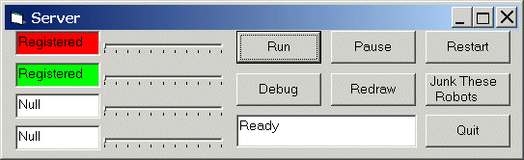

This control panel shows information about each robot. The robot’s server-assigned color appears on the left next to a sliding bar indicator that shows current health. This panel provides the ability to run, pause, and restart the competition. ‘Junk These Robots’ clears the arena and allows new robot programs to be started. ‘Debug’ allows special debug command to become functional.

Each robot program will display a status window:

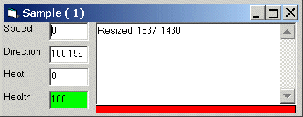

This window shows information about a particular robot. The robot’s name and server-assigned number are in the title bar. The robot’s server-assigned color is highlighted below the text window. Speed, direction, motor temperature, and health are displayed along the left. Any messages declared via the user’s ‘post’ commands appear in the text window.

The arena display shows an aerial view of the competition arena:

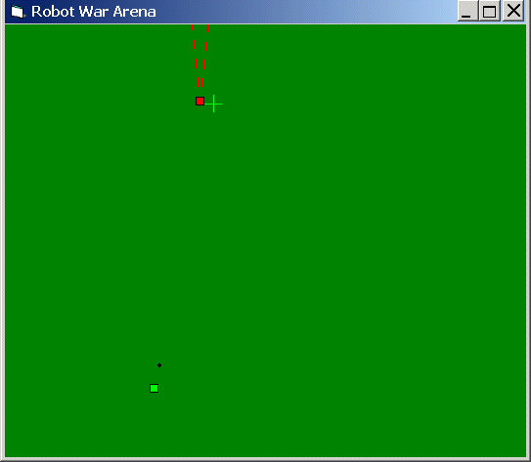

Each robot appears as a colored square. Scans appear as a colored ‘V’, showing the angle covered by the scan. In this snapshot the red robot is scanning upwards. When a robot fires a shell, a colored mark is drawn where the shell will hit. In this case, the green robot has fired a shell (which is visible in flight) which will explode just to the right of the red robot’s current position.

You may start up to four robot programs. Each robot is assigned a number and a color, and is placed in the arena. As soon as you have started the robot programs, click Run on the server control panel.

Programming Your Own Robot

Since your robot is a virtual creation, you won’t have the opportunity to work on the physical components. Instead, you create the program which controls his actions. Since the robot has many limitations, you’ll need to be clever to get the best performance out of him. In fact, you may find it a challenge to keep him from running into the walls!

To make your own robot program, you’ll need Visual Basic. Create a subdirectory to contain your robot. Copy the files in the Sample directory to your directory. Start Visual Basic by double-clicking on the file MyBot.vbp.

Visual basic should start and display the code for MyRobot. The sample robot that you have copied contains everything you need. In fact, you can run it just as it is.

Running your robot interactively
From Visual Basic, click the Run button. The first time you do this, it will start the robot server process. Minimize the Visual Basic window. You should see the arena window, the server control panel, and a status window for your robot. Start additional robots if you wish, and click the Run button on the server control panel. When you are done, pause the server and click the Junk These Robots button. Maximize Visual Basic and continue with your programming.

Compiling your robot the first time
In Visual Basic, choose File | Make Sample.exe. In the window that pops up, change the name of the executable to whatever you choose to name your robot.

Robot Programming Commands
These are the methods that you can use with 'MyRobot'. The first group are commands that tell the robot to do something. They return a value that you can use to check what happened.

MyRobot.drive (dir as integer, speed as integer) as integer
Command the robot to go in dir direction at a speed of speed. Returns the maximum speed that the robot is capable of based on motor temperature and commanded turn rate. The direction must be in the range 0 to 359, and speed must be between 0 and 100. This command requires 100 milliseconds to execute.

Examples:

Call MyRobot.Drive (90, 35)
-----------------------------------------------------------------------
Const west = 180
Const mediumspeed = 35
Dim result as integer

result = MyRobot.Drive (west, mediumspeed)
Myrobot.Post ( "Tried to go " + str(mediumspeed))
Myrobot.Post ( "Went " + str(result))
-----------------------------------------------------------------------
Dim dir as integer
Dim speed as integer
dir = 37
speed = 100
Call Myrobot.Drive (dir, speed)

MyRobot.scan(dir as single, resolution as integer) as integer
Use the scanner to look for other robots. Scan at dir +/- resolution degrees. Returns the distance to the detected robot, or 0 if no robot detected. Dir must be in the range 0 to 359, and resolution must be 1 to 10 .

This command requires 200 milliseconds to execute.

Example: Perform a scan 20 degrees wide centered at 90 degrees. If a robot is detected, fire a shell at a bearing of 90 degrees to the distance measured by the scan.

Dim range as integer

range = MyRobot.scan(90, 10)
If range > 0 then
Call MyRobot.cannon(90, range)
End If

Note that in this case, the range contains an error between +10 and –10 meters because of the scan width, and the actual bearing to the enemy robot could be anywhere between 80 and 100 degrees. Under these conditions, a direct hit may not occur.

MyRobot.cannon (dir as integer, range as integer) as integer
Attempt to fire a shell. If your robot is not busy reloading and the direction and range are legal values, a shell is fired. Dir must be in the range 0 to 359, and range must be between 40 and 700. The cannon function returns:

0 if a shell was fired
-1 if no shell was fired

This command requires 100 milliseconds to execute IF a shell is fired, and 200 milliseconds if no shell is fired.

The next group of commands allow you to get information about the robot or battle environment.

MyRobot.x() as integer
Returns the horizontal position of the robot. The position will be between 0 (the left edge) and 999 (the right edge) of the arena.

MyRobot.y() as integer
Returns the vertical position of the robot. The position will be between 0 (the bottom) and 999 (the top) of the arena.

MyRobot.health() as integer
Returns the current value for health of your robot. 100 is unharmed, and 0 is dead.

MyRobot.heat() as integer
Returns the current motor temp for your robot.

MyRobot.speed() as integer
Returns the current speed of your robot.

MyRobot.direction() as integer
Returns the current direction of your robot.

MyRobot.dsp() as integer
Returns the identity of the robot who last scanned you.

MyRobot.index() as integer
Returns the number of your robot (1-4) assigned by the server.

MyRobot.time() as single
Returns the current time in seconds/fractional seconds. Maximum useful resolution is 50 milliseconds.

There are a couple of commands that allow you to display information about your robot.

MyRobot.post(message as string)
Display message on the status display for your robot.

MyRobot.SetName(name as string)
Set the robot's name to name.

General Programming Considerations

Time
The server recalculates everything about 20 times per second, or about once every 50 milliseconds. Your program runs as fast as the computer will support, except that motor drive commands, scanning, and firing the cannon each take time. During these delays, the computer will process other tasks.

If your program contains loops (for/next or while/wend) which may run for any significant time, there must be one of these ‘time consuming’ commands inside the loop. If not, include the ‘DoEvents’ command inside the loop.

Debugging
There are several commands to support debugging. These commands are typically used when running your robot interactively. These commands do nothing unless the ‘Debug’ button is clicked on the server control panel.

MyRobot.Pause()
Pause the server. Same effect as clicking the ‘Pause’ button on the server control panel.

MyRobot.Run()
Same effect as clicking the ‘Run’ button on the server control panel.

MyRobot.Mark(x as integer, y as integer, c as long)
Make a mark on the arena at x,y in color c.

MyRobot.whereis(e) as Long
Returns the location of enemy robot e as a long integer in the form 1000x + y. For instance, if the enemy robot is at x=437, y=854 the function will return 437854.

MyRobot.bheat() as integer
Returns the barrel heat for your robot.

