Jukebox Documentation
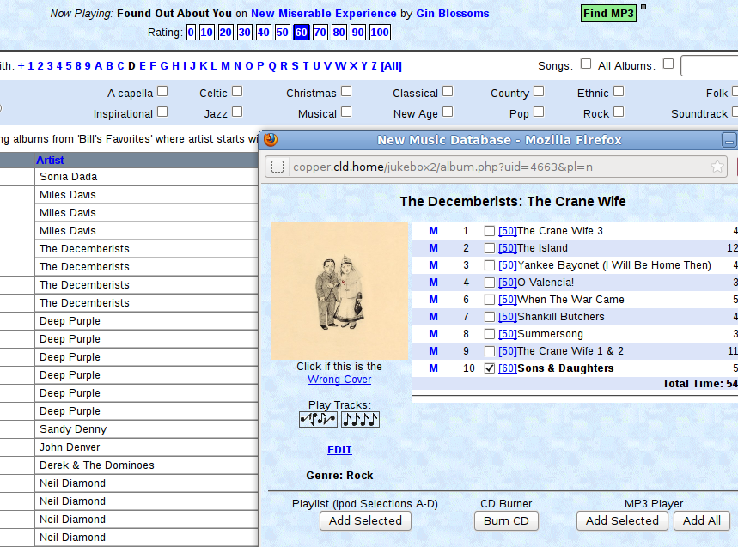



Table of Contents
Really Short Version 3
Terminology and Basic Navigation 4
Terminology 4
Navigation 4
Top Panel 4
Left Panel 5
Main Panel 6
Home Tab 7
First Things First: The 'Play' Button 7
Artists Starting With 7
Searching 7
Genre Selection 8
Results Display 8
Albums 9
Album Window 9
Track Details 9
Users and Collections 11
First Task For New User: Create 'Favorites' Collection 11
Choosing a Collection 11
System-wide Collections 11
Collection Management 12
Adding albums to a collection using 'All Albums' 12
Adding albums from another collection 13
Playlists 14
Adding Tracks To A Playlist 15
Artists 16
Alphabetizing 16
MP3 Players and iPods 17
Maintenance 18
Importing Music 18

Really Short Version

If you just want to play music, this is all you need.

2
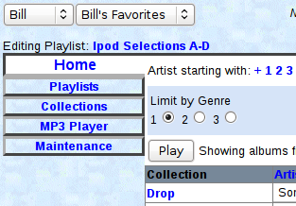
3
- Open the jukebox in your browser of choice.
- Select a name (preferably your own) in the top left selection box.
- Select a collection (or accept the default) in the next box.
4
- Click the 'Play' button.

Now that you've got music playing, peruse the rest of the manual.

Note: Once you've done steps 2 and 3 on any browser, it will remember the settings and steps 2 and 3 will not be necessary.

Terminology and Basic Navigation
The Jukebox web page is intended to provide quick access to the most-needed information and controls in as direct a way as possible. This section will describe the page layout and basic operation as well as definitions for terminology used in this document,

Terminology
- Album: A set of songs with a title. Usually corresponds to a vinyl record or a CD.
- Track: Synonym for song. An individual sound file. Track is a more general term, since some jukebox items may be podcasts, book chapters, comedy sketches, or other non-musical content.
- User: A person, identified by name, who is using the jukebox. The jukebox allows personalization for each individual user.
- Collection: A list of albums, usually related in some way. For example, “Bill's Favorites” might be a collection of albums that Bill likes.
- Current Collection: There is always a single collection that is selected as the basis for jukebox operation. This collection is selected and displayed at the top left corner of the screen.
- Playlist: A set of tracks, usually based on a theme. Playlists have titles and are usually organized by and belong to a specific user.
- Album Tag: All albums are identified by a three letter code called an album tag. This code facilitates some maintenance tasks. For the most part it's not relevant to normal operations.

There are some user interface conventions used in the jukebox.

- In general, any bold blue text is clickable.
- Playlists are usually presented in italics to distinguish them from albums

Navigation
For purposes of navigation, the Jukebox web page is divided into three sections: the top panel, the left panel, and the main panel.

Top Panel

Starting at the left edge, the top panel displays and allows selection of the current user. While any user may be selected, this is a situation where you should always be yourself. There are a number of settings and defaults that are based on the selected user.

The next selection is the current collection. There is a more detailed description of collections later in this document, but in general you will want to choose one of your collections here. The choice of user and collection is saved between sessions.

Below the user and collection choices, the system will display the currently selected playlist, if any. Playlists will be covered in a later section. If there is a playlist displayed here, clicking on it will open the playlist in a popup window.

The next section displays information about whatever song is currently being played. Clicking on the album name will open the album in a popup window, while clicking on the artist's name will display a list of all albums by that artist in the main panel.

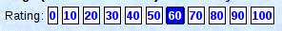
Below the song / album / artist display, there are a series of numbered boxes. These are for managing the rating of the current song. Ratings are used to determine the probability that a song will be chosen when playing songs at random. A value of 20 or less will prevent a song from being chosen for random play. The current rating is highlighted. Clicking on any other value will change the rating for the current song. The value will update in a second or two after clicking.

The next section is for status and control of connected audio players (iPods or other mp3 players). Audio player management will be covered in another section.

Finally, the next two buttons will skip to the next song or end the current song list.

Left Panel
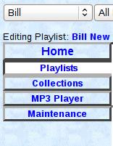
The left panel contains a list of tabs to allow access to pages that deal with playlists, collections, MP3 players, and other specialized functions. For general use, only the top tab (Home) is needed.

Main Panel
The contents of the main panel will vary depending of which tab is selected in the left panel. In general, the main panel will display information about songs, albums, playlists, or collections.
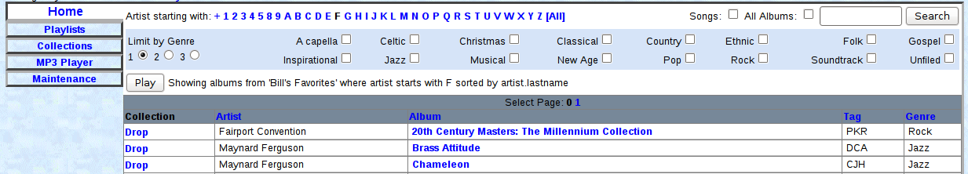
In this example, the 'Home' tab contents are displayed. The top of the main panel provides more navigation and control options, while the balance of the panel shows a list of albums for the selected user. Use of each different tab and associated main panel contents will be described in the rest of this document.

Home Tab
The 'Home' tab is the default and most commonly used tab. It provides the ability to search, filter, and play songs. This page always displays search results. By default it displays all albums from the current collection, any genre, sorted by artist. This selection can be expanded to include all albums and may be narrowed by specifying search criteria or genre(s).

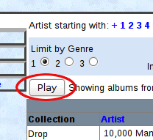
First Things First: The 'Play' Button
Most often, the one thing that you'll use on the Home tab is the 'Play' button. It will play randomly selected songs from whatever is displayed in the lower portion of the main panel – by default, all albums in the current collection. If genre filtering is in effect or if other search results are displayed, the 'Play' button will play random songs from those results.

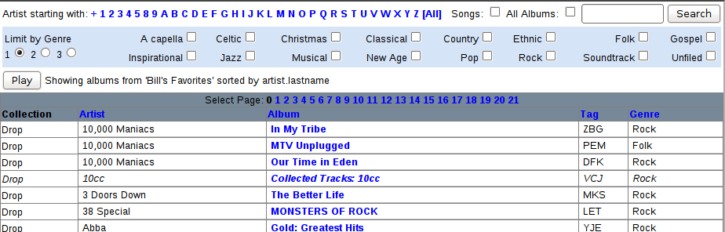
Artists Starting With
Starting in the top left corner of the 'Home' tab page, there is a list of letters, numbers, and possibly other characters. Clicking on any one of these will display only artists starting with that character. The [All] link at the right end of this list will display albums by all artists.

Searching
In the upper right corner, there are controls for searching. By default, searches look for albums in the current collection where search phrase matches all or part of the album title or the artist name. There are two checkboxes that can modify this behavior.
The first is a checkbox to indicate that you want to search for song titles rather that albums and artists.
The second is a checkbox that indicates that you want to search through all albums rather than just the current collection.
Checking or unchecking the checkboxes takes effect immediately and search results are updated accordingly.
If the search text is blank, all albums (or songs) are displayed.
Search text must be four or more letters. If three letters are entered, it will search for and display the album with that three letter album tag.

Genre Selection
The next section deals with limiting search results by specifying which genre(s) are desired. To limit results to albums with a specific genre, simply check the box for that genre. Multiple boxes can be checked – in that case, any album matching any of the selected genres will be displayed. If no genre is selected, albums from all genres will be displayed.
There are over 100 genres available, many of which are used only rarely or not at all. There are three radio buttons that determine how many genre checkboxes are displayed:
- Only the most commonly used genres (default)
- All but the really obscure genres
- All genres

Results Display
The bottom portion of the panel shows the results of the search criteria specified above.
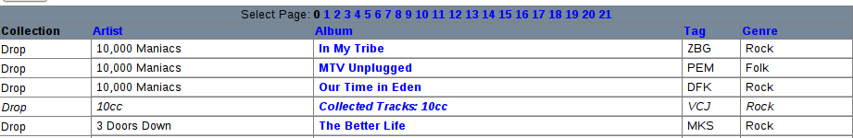
If the search results in more than 50 albums or songs, the first 50 will be displayed and the header area will display clickable links for each page of results. In the example above, there are 22 pages of results (pages 0 through 21).
Albums are displayed in normal font, while playlists are displayed in italics.
Some column heads are also clickable. Clicking on a column head causes the results to be sorted by the values in that column. Default is to sort by artist name.
Album titles are clickable. Clicking on an album title opens the album in a popup window (next section).

Albums
Albums are the principal organizing method in the Jukebox. All content is organized into albums. Every song, podcast, chapter – every audio file – is contained in an album.

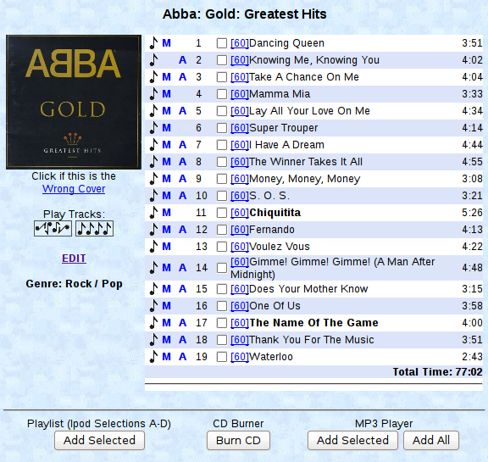
Album Window
Clicking on an album title will open a popup window displaying various information about that album:
- Artist – all albums have an artist. If an album contains tracks by different artists, then the album artist is 'Various'. If the artist isn't known, then the artist is 'Unknown'.
- Title – all albums have titles. If the tracks come from an unknown album or source, the title is 'Unknown Album'.
- Cover image – optional.
- Genre – albums have either one or two genres. If the genre doesn't match any available option, it's listed as 'Other'. If no one has assigned a genre, it's 'Unfiled'.
- Tracks – a list of all tracks contained in the album. Track details are listed below.

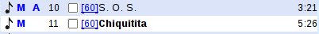
Track Details
Each track is shown with details and clickable links. Starting from the left:
- A clickable musical note IF there's a .wav file (full fidelity uncompressed music) for this track.
- A clickable blue M if there's an MP3 file for this track.
- A clickable blue A if there's an M4A file for this track.
- A track number
- A checkbox to select this track for playlist or MP3 player use.
- A rating number (discussed later). Clicking this causes the track to be played in your browser, NOT on the jukebox.
- The track title. If the track title is bold, it's in the currently active playlist.
- The playing time. If this is 0:00, then there's a maintenance task that needs to be run.

This window also provides various actions that can be performed:
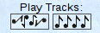
- Play Album – The two graphics below the album art provide the option to play the tracks randomly or in original sequence.
- Remove incorrect album cover – click on the link below the album cover if the image is incorrect.
- Edit album details – click on the 'Edit' link to edit the album title or track names, or to delete tracks.
- Play individual tracks using the clickable links described above
- Add selected tracks to currently active playlist
- Burn tracks to a cd
- Add selected tracks to an MP3 player or iPod.
- Add all tracks to an MP3 player or iPod.
Playlist management and MP3 / iPod management are covered in later chapters.

Users and Collections
The jukebox contains thousands of albums and is designed to be used by multiple people, possibly from multiple locations. As a result, any individual user is likely to be interested in only a subset of the music contained on it. It can be tedious to sort through lots of irrelevant albums to find the ones you want.

In order to address this issue, the jukebox can have individual users, each of whom can have one or more collections of albums that they like. A collection is simply a list of albums. Each user should have at least one collection containing all the albums that they are interested in. Users may also create special purpose collections as well, such as 'Christmas Music'. The purpose of collections is to make it easier to find and play your music.

First Task For New User: Create 'Favorites' Collection
Because the jukebox depends so heavily on collections, each user should plan on taking time to create a personal 'favorites' collection as a starting point. This is not something that should require excessive analysis – simply add any album that you might like to listen to. It's trivially easy to remove albums if you decide that you don't want to listen to anything on them ever again. Create a new collection as described on the next page, and spend some time to build that collection to a useful level.

Choosing a Collection
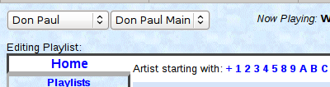
This is a very important step, since it sets the stage for ALL jukebox actions.

The current user can be selected via a selection box at the top left corner.

Once the current user is selected, the user's collections (or any of the system-wide collections) can be chosen in the adjacent selection box.

On any individual browser, user and collection choices are remembered between sessions via browser cookies. In this example, the current user is Don Paul, and the current collection is 'Don Paul Main'.

Important Concept: There is always a current user and a current collection.

Important Concept: All jukebox operations – searching, playing, rating, listing – deal by default ONLY with albums in the current collection.

System-wide Collections

The system maintains some collections that are available to all users:
- 'All Albums' – as the name suggests, this is a collection containing all albums on the jukebox.
- 'All Playlists' – also as the name suggests, a collection of all playlists
- Date Stamp Collections – the system will create a collection with a date stamp whenever content is added to the jukebox. These collections contain everything added on that date.

Users can't add or delete albums from system-wide collections.

Collection Management

In normal operation, all that a user needs to do is select a collection as described above. However, there are tools to create and manage collections.

To create a new collection, click on the 'Collections' tab.
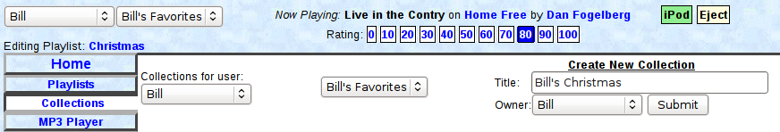
In the 'Create New Collection' form, enter a collection title. Make sure that the desired owner is selected and click 'Submit'. Refresh the main page and your new collection is ready to be selected.

Adding albums to a collection using 'All Albums'
Once a collection is selected, there are many ways to add albums to it. The most common is to click on the 'Home' tab and check the 'All Albums' checkbox.

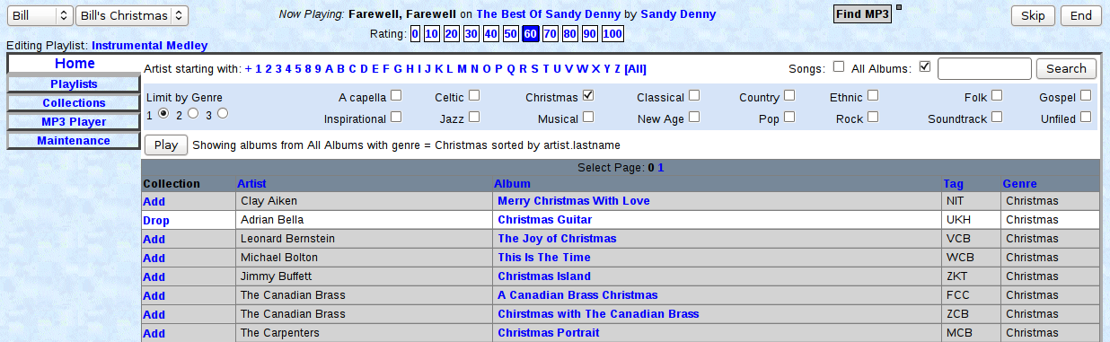
In the example above, the current collection is the 'Bill's Christmas' collection. The 'All Albums' checkbox is checked, and we're filtering by genre to show only albums classified as 'Christmas'.

Since 'All Albums' is checked, the main panel shows all albums classified as belonging to the Christmas genre, whether or not they're in the current collection. If we weren't filtering by genre, then all albums of all genres would be shown – currently well over 100 pages worth.

The second album, Adrian Bella's 'Christmas Guitar', is in the current collection and is shown in white with the option to drop it from our current collection. The other albums are not in the current collection and are shown in grey with the option to add them.

To manage the current collection, simply add or drop albums.

Adding albums from another collection
Sorting through all the albums can be tedious. If there's another user with similar taste who has already done the hard work, you can look at their collection(s) and add albums to your collection.

First, choose your collection as the current collection in the top left corner of the page. Then click on the 'Collections' tab and choose the user and collection that you'd like to review.

Note: There is a special user named 'System' who owns the system collections. Select this user to view system collections. This can be particularly useful for viewing the special dated collections that the system creates when new content is added.

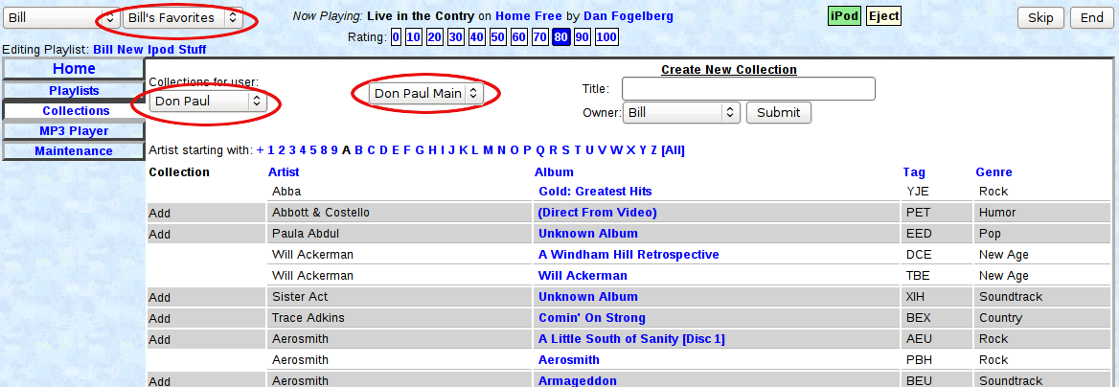
In this example, we're adding selections to the 'Bill's Favorites' collection. We're looking at Don Paul's 'Don Paul Main' collection for ideas. In the selected view, we're only seeing artists from the Don Paul Main collection with names starting with 'A'.

Some of the albums in the Don Paul Main collection are already in the Bill's Favorites collection – these are shown in white. Others are not in Bill's Favorites, and these are shown in grey with an 'Add' link.

Simply click the 'Add' link to add any desired albums to the current collection.

Playlists
Playlists are sets of tracks that are grouped together, usually by a user and usually with a theme. Playlists can be played just like albums, and they can be loaded onto iPods or MP3 players, or burned to CD.
Playlists can be created, edited, and deleted at any time without affecting the albums or tracks themselves.
To work with playlists, select the 'Playlists' tab from the left navigation panel:
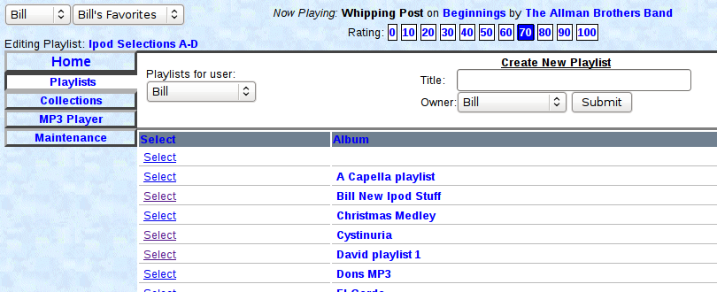
By default, you'll see your own playlists. You can see other user's playlists by selecting a different user in the selection box in the playlist panel.
At this point, there are three different actions that you can take.
- To select a playlist to add tracks to it, click the 'Select' link next to the playlist title. The selected playlist title will be displayed below the user and collection selection boxes at the top of the page. In the above example, the playlist 'Ipod Selections A-D' has been selected.
- To open a playlist to see the songs in it and/or delete songs from it, simply click on the playlist title. The playlist will open in a popup window.
- To create a new playlist, type in a name (no punctuation marks in playlist names, please). Verify the correct owner, and click 'Submit'.

Adding Tracks To A Playlist
Once you have selected a playlist (option 1 above) that playlist will remain selected until a different playlist is selected. The selected playlist can have tracks added to it from albums or other playlists.
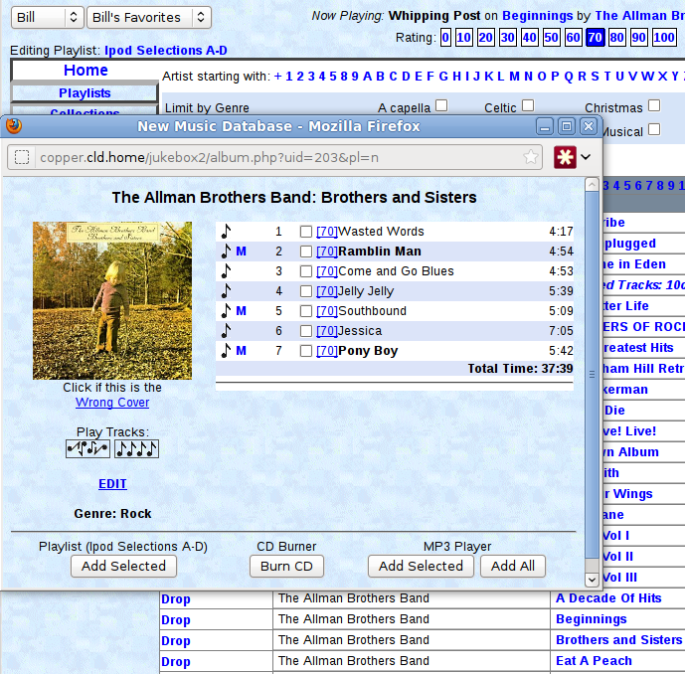
In almost all cases, you'll want to return to the 'Home' tab once you've selected a playlist.
In this example, we've selected the 'Ipod Selections A-D' playlist and opened the 'Home' tab to view albums from our current collection (Bill's Favorites).
We've clicked on the Allman Brothers' 'Brothers and Sisters' album, which is open in a popup window.
In the bottom left there is a button to add selected tracks to our playlist. The name of the current playlist is shown directly above the button.
To add tracks, simply check the tracks that you want, then click the Playlist 'Add Selected' button.
Tracks that are already in the current playlist will be shown in bold (Ramblin Man and Pony Boy in this example).

Artists
Every album is linked to an artist. Every track is also linked to an artist. In the majority of cases, this is simple and straightforward. One exception is when the album is a collection of tracks by different artists – 'Sounds of the 70s', for instance. In this case, the album is linked to the artist 'Various', while each track is (hopefully) linked to the artist who performs it.
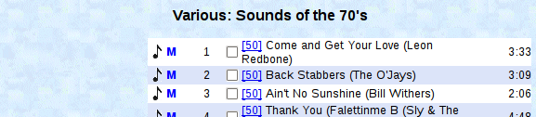
In that case, the album window will display each track's artist in parentheses next to the track title.

Alphabetizing
There's some ambiguity when alphabetizing musical artists and groups. The Jukebox generally alphabetizes by last name, but there's often a manual process to manage the artist database. For instance, it's pretty clear that Bill Withers should be alphabetized under 'W', but what about 'Young Jeezy' or 'Uncle John'?
Be prepared that artists might not be alphabetized the way you would expect.
Another alphabetizing issue is groups whose name starts with 'The'. In some cases, it's an integral part of the name as in 'The Who', while in other cases it's incidental as in 'The University Of Vermont Top Cats'.
The convention in the jukebox is that group names are NOT alphabetized using 'The'.

MP3 Players and iPods
The Jukebox has extensive facilities for dealing with MP3 players as well as iPods. Unfortunately, these capabilities have not yet been documented. Good luck.

Maintenance
There are a variety of tasks and functions that can be performed from the 'Maintenance' tab. Don't do any of them. In fact, don't even click on this tab. There's nothing to see here. Move on.

Importing Music
In order to import music from iPods, iTunes databases, or MP3 file collections, copy the files or entire directory structures into the /music/import directory. Then forget about it. Didn't you read the paragraph above? Don't forget to make sure that www-data owns all the imported files.

