Nitrogen’s form determines its fate in the North Pacific Subtropical Gyre
William Kumler, Laura T. Carlson, Rhea K. Foreman, Eric Grabowski, Fernanda Henderikx Freitas, Fuyan Li, Matthew J. Church, Edward F. DeLong, Angelicque E. White, David M. Karl, Anitra E. Ingalls

Abstract
Nitrogen availability controls productivity in much of the surface ocean and the form of this nitrogen controls which organisms it is available to and how it is used. Here, we explored how four different forms of nitrogen (ammonia, nitrate, arginine, and guanosine monophosphate) were taken up and transformed in the North Pacific Subtropical Gyre using stable isotope labeling metabolomics. We repeated these experiments both at the surface and at the base of the euphotic zone as well as in the morning and evening. We found that ammonia is converted into glutamate in less than 20 minutes and results in labeling throughout the metabolome after 24 hours, though osmolytes like betaines had slow turnover rates. Nitrate amendments resulted in the labeling of only a small selection of molecules such as mycosporine-like amino acids (MAAs), whose incorporation patterns suggest that this form of nitrogen was available to a subset of the community, likely eukaryotes. The two organic nitrogen amendments labeled the metabolome more slowly than the inorganic forms of nitrogen and showed similar usage at 25 meters and 175 meters, hinting at the major role that heterotrophic bacteria play in cycling organic matter. The organic nitrogen added was mostly converted into glutamate after 24 hours rather than used as intact substrates, though labeled arginine was incorporated into protein directly and we were able to trace the carbon backbone from both arginine and GMP into several additional metabolites. We also show that nitrogen assimilation and use was largely the same between morning and evening with the exception of UV-sensitive compounds such as MAAs. These measurements reveal the forms and fluxes of nitrogen in the natural environment and provide constraints on biogeochemical models that require characterizing the transformations between organic and inorganic nitrogen.

Introduction
In most of the surface ocean the flux of carbon is controlled by the availability of nitrogen, an element with a complex and incompletely characterized biogeochemical cycle (Deborah A. Bronk and Steinberg 2008; Moore et al. 2013; Hutchins and Capone 2022). Organic nitrogen in particular is often treated as a black box despite substantial variability in its bioavailability and chemical nature. Turnover times for labile organic compounds like urea and amino acids can be orders of magnitude shorter than high molecular weight DON (Aluwihare et al. 2005; Deborah A. Bronk et al. 2024). Additionally, the availability of the precious nitrogen atom is determined not only by the form of the organic material it composes but also the environment in which it’s found.
While extensive work has been done to characterize the forms and fluxes of nitrogen within the inorganic pool, the equivalent for the organic pool is woefully underdeveloped (Zehr and Kudela 2011; Deborah A. Bronk and Steinberg 2008). This is largely due to the difficulty of comprehensively measuring the many organic molecules that contain nitrogen in the marine environment (Boysen et al. 2018; Moran et al. 2022). Recently, however, we have improved our understanding of community composition via genomics and transcriptomics and made progress in our ability to characterize organic matter via proteomics and metabolomics. These advancements, paired with the increased availability of pure and isotope-labeled substrates, mean that we can now apply metabolically resolved isotope tracing to resolve how organic nitrogen is transformed in the marketplace of metabolites that powers the surface ocean (Heal et al. 2021; McParland, Alexander, and Johnson 2021; Moran et al. 2022).
Nitrogen assimilation is a well-documented process in the ocean after decades of research and demonstrates how biochemistry derived from non-marine organisms can be applied to the ocean (Mulholland and Lomas 2008). Central to the process is ammonia, which can be directly taken up from the environment by all organisms and combined with glutamate. This forms glutamine, which is then combined with alpha-ketoglutarate to form two glutamate molecules that can then be used as a nitrogen source throughout the cell (Walker and Van Der Donk 2016). Nitrate, on the other hand, must first be reduced to ammonia in an energetically expensive process that some organisms have stripped from their genomes (Partensky and Garczarek 2010; Zehr and Kudela 2011).
Unlike the relatively well-resolved pathways for inorganic nitrogen, the use of organic nitrogen remains underexplored in the marine environment. Organic nitrogen is generally thought to be accessible to most organisms but the high levels of DON make it clear that this is highly substrate-specific (Antia, Harrison, and Oliveira 1991; D. A. Bronk et al. 2007; Aluwihare and Meador 2008; Zehr and Kudela 2011; Deborah A. Bronk et al. 2024). Additionally, many of the transformations possible are only active in specific communities or times of day (Bender, Parker, and Armbrust 2012). Linking the transformations that nitrogen undergoes to known molecular pathways from other environments or axenic cultures is a particularly promising way to understand what we observe on the global scale.
The lack of a comprehensive understanding of nitrogen’s fate after it is assimilated makes molecular modeling difficult and undermines our ability to connect the community to the organic nitrogen it produces (Jones et al. 2024). Here, we trace the uptake and use of labeled ammonia, nitrate, arginine, and guanosine monophosphate in a natural community from the North Pacific Subtropical Gyre at multiple depths and diel conditions. Our application of metabolomics to these samples allows us to map the pathways and restructuring that organic nitrogen experiences in the largest biomes on the planet, quantifying the pool sizes and turnover rates for various low molecular weight compounds that serve as building blocks and intermediates of cell biology.

Results
Samples were collected from 25 meters and 175 meters during the 2021 SCOPE PARAGON cruise (KM2112, July 23rd - August 5th) near Station ALOHA that targeted a bloom within an anticyclonic eddy. The bloom was initially dominated by the diatom genus Hemiaulus with a large surface chlorophyll signal that decayed into a more typical North Pacific Subtropical Gyre community composed mostly of Prochlorococcus and SAR11. Community composition at our sampling depth below the deep chlorophyll maximum (DCM) was fairly typical of ALOHA, with a prokaryotic community dominated by SAR11, SAR282, and SAR 406, low levels of picoeukaryotes, and a microeukaryotic community equally distributed between diatoms, haptophytes, and dinoflagellates (Supplemental figure 1).
Samples collected from 25 meters were within the mixed layer and had PAR levels of 20-35% of the surface light while the 175 meter samples had a PAR level between 0.05 and 0.1%. Nitrate, nitrite, and ammonia data indicated that inorganic N was low in the surface (<0.01 µM), while the deeper samples at 175 meters were collected in the middle of the nutricline, with a clear DCM at 125 meters, an ammonia maximum at 150 meters, and a nitrite max at 160-165 meters. Environmental nitrate concentrations were about 0.5 µM at 175 meters (Supplemental figure 1).
We performed the incubations in succession, with the nitrate incubations first, followed by arginine, then guanosine monophosphate and finally ammonia. 6AM and 6PM data was always collected the same day and we alternated days between the surface and deep sampling depths to allow for reasonable sample processing times (Supplemental figure 1).

Differences in nitrogen labeling at the surface between amendments
We observed significant differences in ¹⁵N labeling patterns between the different treatment incubations (Figure 1). Ammonia incubations resulted in very rapid labeling, with glutamine more than 75% labeled even at the T0 timepoint, corresponding to the amount of time required to spike and immediately filter the 2 liters of seawater (~15 minutes). The dominant labeling pattern at T0 was a single ¹⁵N, though all later timepoints showed more doubly-¹⁵N labeled glutamine than singly-labeled. After 24 hours, glutamine was more than 95% labeled and had approximately doubled in pool size (initially ~0.3 nM becoming 0.8 nM).
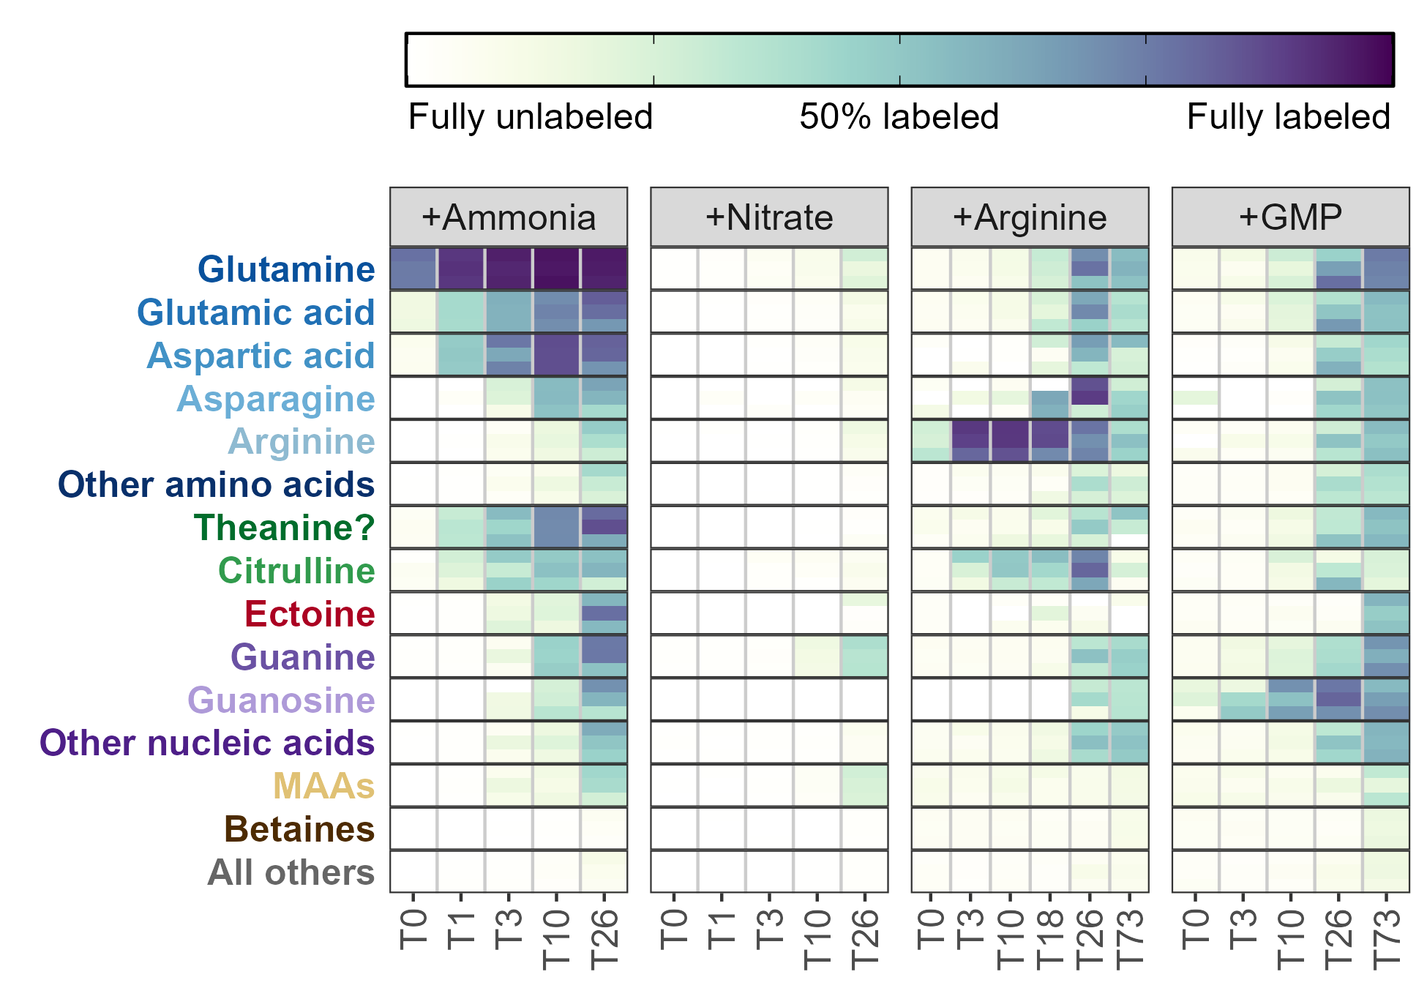
Figure 1: Fraction of each metabolite or metabolite group containing at least one ¹⁵N label during the surface seawater amendments with various substrates after the number of hours shown on the x-axis. Darker colors indicate a larger percentage of the compound signal was isotopically labeled. Three biological replicates are stacked vertically at each timepoint and the categories with multiple entries have been averaged. MAA = mycosporine-like amino acids, GMP = guanosine monophosphate.
The ¹⁵N was then quickly propagated to glutamate and aspartate, creating a metabolite pool 40-50% labeled for each of these after a single hour. Aspartate was labeled slightly faster than glutamate, likely as a result of its smaller pool size (0.2 nM Asp versus 0.5 nM Glu). Also rapidly labeled was citrulline, reaching 20% labeled after a single hour, though arginine was not labeled until much later despite its location immediately downstream of this metabolite. Untargeted detection of other molecular features revealed an additional metabolite that was 30% labeled at the one hour timepoint with an m/z value of 175.1077 and a retention time of 8.2 minutes which we have putatively identified as theanine (N5-ethyl glutamine) based on m/z match and labeling pattern (Figure 1).
Other amino acids and nucleobases/nucleosides had trace amounts of labeling after 3 hours and were extensively labeled (>25%) after 24 hours (Figure 1). Cytidine (42.2% labeled) and adenosine (59.9%) were more heavily ¹⁵N labeled than their nucleobase derivatives at T26 (22.9% and 42.1%, respectively), corresponding to the expected synthesis pathway. Guanine, however, had the inverse trend with guanosine being 44.9% labeled while guanine was only 30% (Supplemental figure XX). The deoxyribose forms were in all cases less completely labeled than their ribose counterparts (deoxycytidine = 18.9%, deoxyadenosine = 20.3%, and deoxyguanosine = 17.2%). In each case, the fully ¹⁵N labeled nucleobase was the dominant constituent of the isotope envelope (¹⁵N₃ for cytosine and ¹⁵N₅ for adenine and guanine). Other compounds, including betaines (here restricted to quaternary amines with a carboxylic acid group) and choline derivatives showed very little labeling at all.
Amendments with ¹⁵NO₃ showed a significantly different labeling pattern with very few metabolites incorporating the ¹⁵N label at the surface even after 24 hours. Glutamine and glutamate, which were labeled within 20 minutes from ammonia and are the main way in which inorganic nitrogen becomes organic, here saw only trace amounts of production from the added nitrate even after 24 hours. The most heavily labeled compound was guanine, which saw trace amounts of labeling at the T10 timepoint and reached ~40% labeling at T26. This labeling was not seen in the other nucleobases. The only group of compounds that did see compelling degrees of label incorporation were the mycosporine-like amino acids (MAAs), a group of compounds whose primary function is thought to be protection from UV light (see below). These compounds, like guanine, were labeled in excess of the bulk glutamate/amino acid pool from which their nitrogen is sourced. This is only possible if the nitrate is assimilated by a subset of the community whose glutamate is a small, isolated fraction of the total glutamate pool. Metabolites specific to those organisms can then be made from the small pool of heavily-labeled organic material with only a small influence on the fraction of glutamate or glutamine labeled in bulk.
The organic nitrogen amendments also showed labeling patterns distinct from the ammonia incubations, though a large fraction of the nitrogen was clearly remineralized into ammonia/glutamate and used to label a similar suite of compounds (Figure 1). Fully C and N labeled (¹³C₆, ¹⁵N₄) arginine was visibly taken up at the T0 timepoint (within 20 minutes) and 80-90% of the pool was fully labeled after 12 hours. Surprisingly, the fraction of arginine labeled decreased from this point, with the T26 and T73 timepoints dropping to 73% and 46% labeled, respectively. This labeling rapidly propagated into citrulline via the urea cycle, indicating that labeled urea (¹³C₁, ¹⁵N₂) was created and available in the system as well though we were unable to measure this directly. Glutamate and glutamine were labeled much more slowly, reaching 10% labeled after 10 hours and a maximum of 66% labeled after 24 hours. Much of this nitrogen was then cycled very quickly among other compounds which also saw a jump in labeling at 24 hours. This was particularly true for other amino acids and the nucleobases/nucleosides and here, guanine was not labeled more than other nucleobases. Mycosporine-like amino acids and betaines were unlabeled above background even after 3 days of incubation.
The guanosine monophosphate (GMP) incubations showed a pattern very similar to the arginine incubations in the identity, timing, and magnitude in which metabolites were labeled (Figure 1). While we were unable to measure GMP directly we saw clear labeling of fully C and N labeled guanosine (¹³C₁₀, ¹⁵N₅) after 3 hours that increased to a maximum of 75% after 24 hours before decreasing slightly to 64% labeled at the end of the three-day incubation. A small part of this signal was reflected in guanine, with ¹³C₅, ¹⁵N₅ guanine representing about 10% of the signal at T3 and reaching a maximum of 40% at T26. At T26 we also saw extensive labeling in adenine, adenosine, and hypoxanthine though their dominant labeling patterns (¹³C₀ ¹⁵N₅, ¹³C₅ ¹⁵N₅, and ¹³C₀ ¹⁵N₄ respectively, Supplemental figure XX) suggested that the adenine and hypoxanthine were synthesized from glutamate and that the ribose pool had been swamped by guanosine cleavage. Here, unlike the arginine incubations, we also saw some MAA labeling at the end of the 3 day incubation.
We also explored the degree of labeling incorporation into proteins by measuring the total hydrolyzable amino acids (THAAs) at both the start of each incubation and the end (Figure 2).
Proteins were a 33-65% of total particulate carbon pool (2.84 µM at 25 meters and 1.36 µM at 175 meters) and a large part of the total particulate nitrogen (PN, 0.36 µM at 25 meters and 0.15 µM at 175 meters), with total estimated nitrogen in the THAAs sometimes exceeding the total PN measurements. Free amino acids composed between 0.15% and 17% of the total THAA pool with the highest contributions from glutamate. There were also differences in THAA labeling patterns between the amendments (Figure 2). Despite their shorter incubation time (26 hours vs 73 hours), the inorganic nitrogen amendments generally had higher fractions of labeled protein. The nitrate amendments in particular were surprisingly heavily labeled given the minimal signal seen in the free metabolites, with a degree of labeling exceeding the ammonia incubation. This indicates that most of the assimilation was done by the small subset of organisms able to reduce nitrate and use it for growth and that these organisms did not share the reduced nitrogen with the rest of the community.
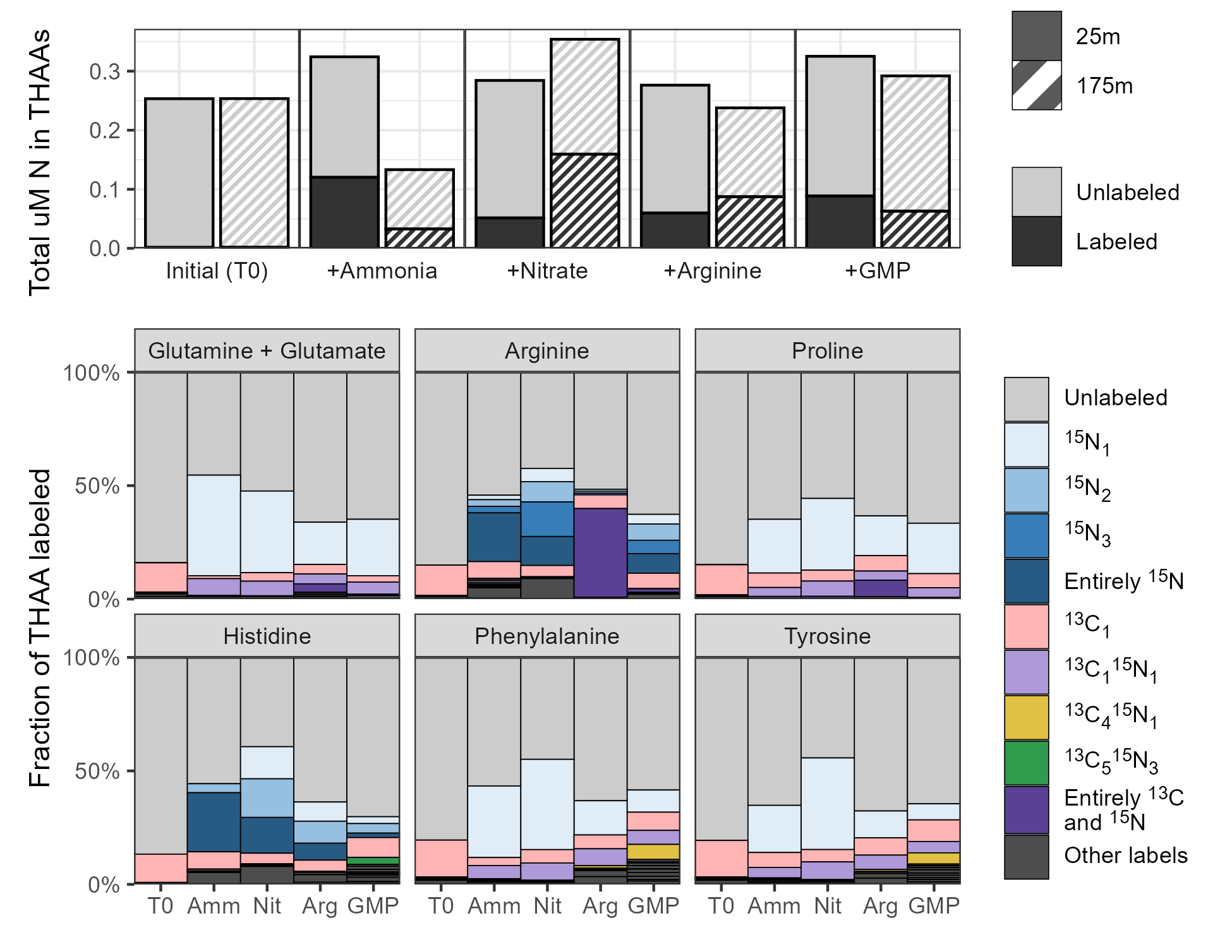
Figure 2: Stacked bar plots showing the fraction of various total hydrolyzable amino acids (THAAs) labeled at the end of the incubations across the four amendments. Total µM nitrogen (N) in the protein pool is shown in the top plot while the fraction of individual amino acids labeled is shown in the rows below. Colors denote specific labeling patterns detected in the THAAs.
We believe the organic nitrogen amendments largely resulted in metabolite labeling via remineralization to ammonia or glutamate based on the absence of a labeled carbon backbone in most of the labeled metabolites, but in the THAAs we were able to see some transformations that used the carbon backbone as-is. Proline and glutamate both had detectable ¹³C₅ ¹⁵N₁ labels in the arginine treatments. We also saw histidine ¹³C₅ ¹⁵N₃ synthesized during the guanosine monophosphate treatment, confirming again that the ribose pool must have been swamped with fully ¹³C labeled ribose cleaved from guanosine in order to enter the PRPP pathway. The ¹⁵N₃ pattern also indicates that for these organisms, glutamate, glutamine, and adenine were also heavily labeled. Finally, both phenylalanine and tyrosine had significant ¹³C₄ ¹⁵N₁ labeling, likely from erythrose 4-phosphate via the pentose phosphate pathway indicating new synthesis through shikimate with nitrogen addition from a heavily labeled glutamate pool again.

Minimal diel signal observed except in the UV-absorbing mycosporine-like amino acids
We performed experiments with each of the 4 forms of nitrogen at both 6AM and at 6PM to test for any diel effects in labeling patterns. Very few compounds showed a significant difference between the 6AM start time and the 6PM start time with the exception being the mycosporine-like amino acids (MAAs, Figure 3). Shinorine and palythine were confirmed via MS² fragments while the other annotations remain putative, though their presence exclusively in the surface is compelling. During the ammonia incubations, six MAAs showed clear ¹⁵N incorporation while exposed to sunlight, with the labeled fraction increasing sharply over the first 10 hours in the incubations started at 6AM. Incubations started at 6PM showed very little labeling from ammonia until a full 24 hours had passed. Shinorine, mycosporine-glycine, palythine, porphyra-334 were all clearly labeled (>20% ¹⁵N) as well as two of three molecular features detected at an m/z of 285.1445 likely corresponding to palythene and usujirene.
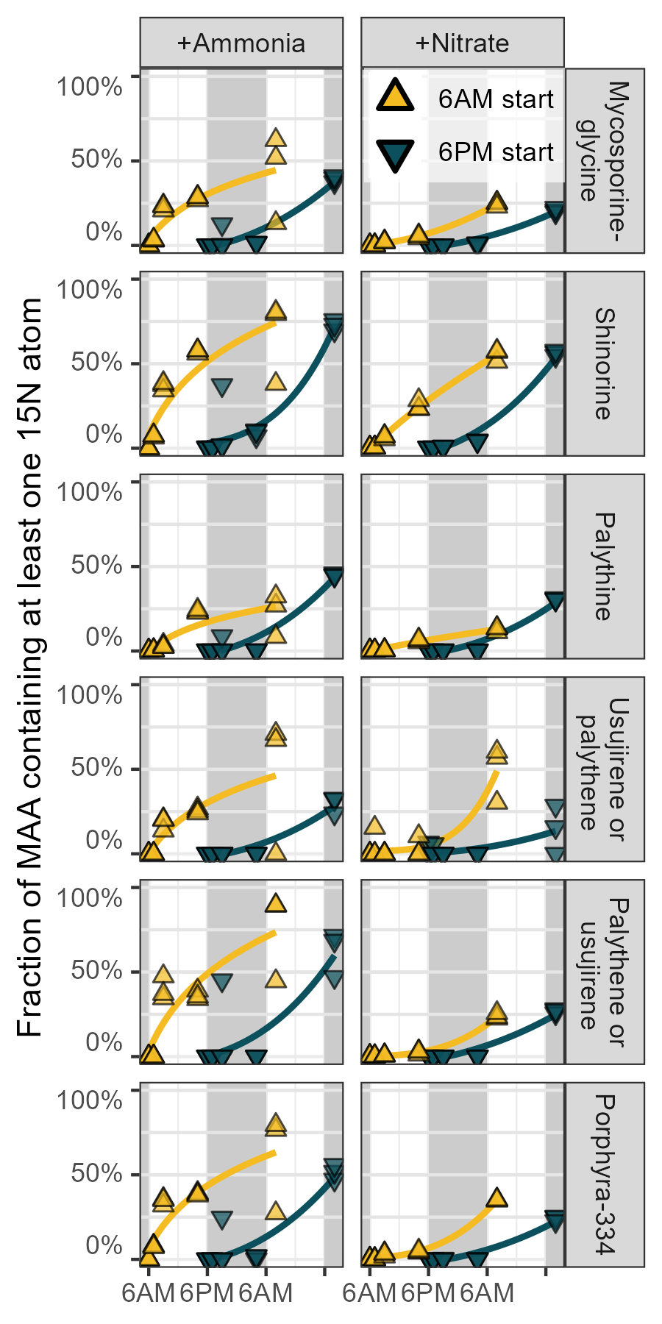
Figure 3: Fraction of UV-absorbing mycosporine-like amino acids (MAAs) containing at least one ¹⁵N label over one day during the treatments amended with ¹⁵N labeled ammonia or nitrate. Incubations started at 6AM are shown in yellow while incubations started at 6PM are shown in blue, with grey background regions highlighting nighttime. Three replicates are included at each of the 5 timepoints and best-fit power law curves have been fit behind the data.
Nitrate data showed similar degrees of labeling which was again surprising given the reduced amount of bulk metabolite labeling in those amendments, though the synthesis of MAAs from nitrate appeared less clearly diel. Shinorine and porphyra-334 were particularly well-labeled under nitrate, approaching the values achieved in the ammonia incubations. Very little MAA labeling was observed during the arginine and GMP amendments until the 73 hour timepoint, though at that point the fraction labeled was approximately equivalent to the inorganic amendments and slightly higher for GMP than arginine.

Ammonia more bioavailable at surface, organics equally bioavailable at 25m and 175m
We also performed the four nitrogen amendments at both the surface (25 meters) and below the euphotic zone (175 meters, <0.1% PAR) to investigate the effect of depth on organic and inorganic nitrogen use. We found that ammonia was used much more readily at the surface as measured by the fraction of metabolite labeled, with ¹⁵N incorporation for amino acids 5-25% greater in the surface than at depth (Figure 4). Glutamate, theanine, aspartate, and asparagine were among the most different with glutamate and theanine surface values about 10 times those at depth while ¹⁵N aspartate was undetectable until hour 3 of the incubation and ¹⁵N asparagine was never detected. In contrast, glutamine labeling was similar between the two depths, with the fraction labeled 10-20 percentage points higher at the surface across all timepoints; a trend which was clearly not propagated to glutamate or other amino acids and instead must have represented accumulation or protein incorporation.
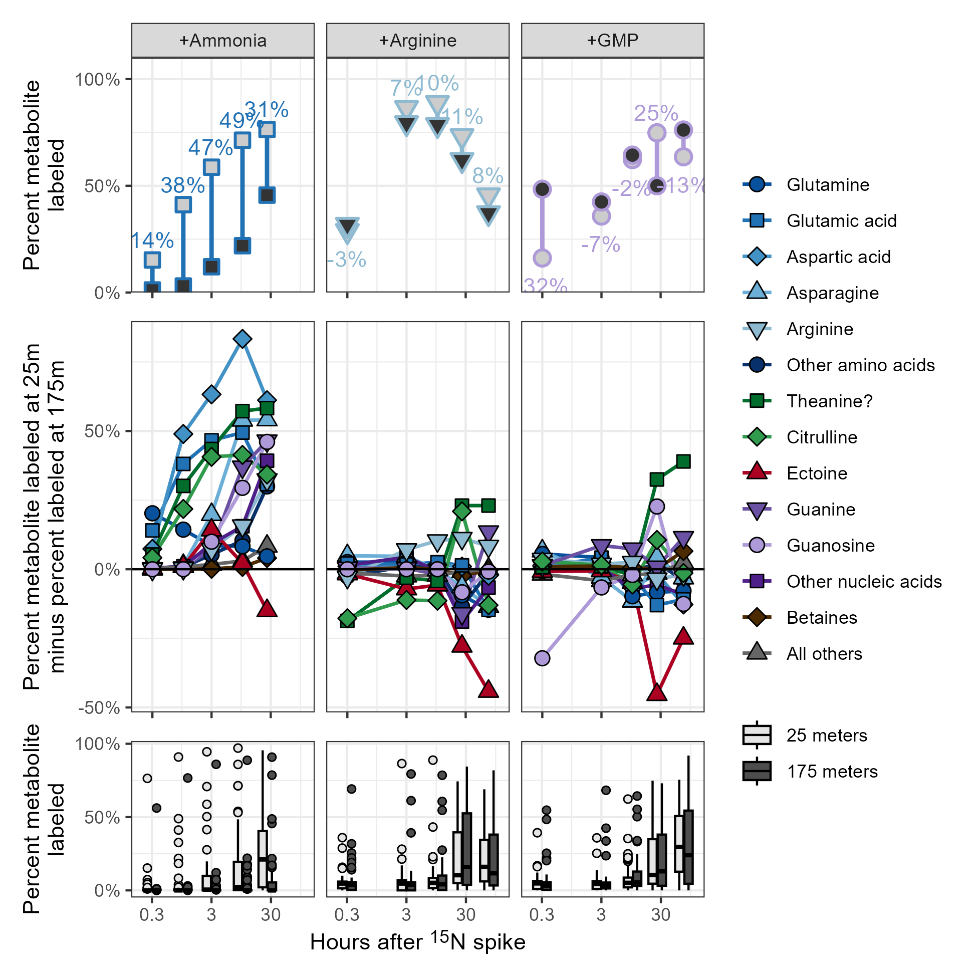
Figure 4: Plots of the metabolite fraction labeled at the surface (25 meters) and the fraction labeled at 175 meters. Incubations with added ammonia, arginine, and guanosine monophosphate (GMP) are shown. Top row of plots show the calculation of % labeled at 25 meters minus % labeled at 175 meters for three example compounds. All compounds are shown in the middle row of plots, grouped by chemical similarity and labeling pattern where positive values indicate increased synthesis in the surface samples relative to those at depth. Finally, the bottom row of plots shows the relative difference between the surface and deep as boxplots for all compounds without aggregating. Points in the first two rows are the average of six biological replicates (incubations started in the morning and the evening are combined here for additional power) while points in the bottom row denote metabolites with labeled fractions falling outside 1.5 times the interquartile range.
Other metabolites varied in their degree of labeling (Figure 4). Nucleobases and nucleosides were much more heavily labeled from ammonia at the surface, with maximum labeling 3-10 times more extensive around T3 and T10 if the isotope was measurable at both depths and infinitely more so if not. Betaines and other nitrogen-containing metabolites, however, were almost entirely unlabeled at 175 meters until the 24 hour mark, at which time the fraction labeled in both was 5-20 times higher at the surface. An important exception to this rule is the osmolyte ectoine, an aspartate derivative that nonetheless was synthesized with nitrogen from ammonia at depth with the fraction labeled equal to or exceeding that of the surface in an equal amount of time.
We were unfortunately unable to present the data collected from the 175 meter labeled nitrate incubations here due to missed timepoints and our inability to confidently connect data to the correct timepoint for those samples but the raw numbers are provided in the supplement (Supplemental Figure XX).
¹⁵N use from the organic nitrogen substrates was again strikingly similar between the 25 meter and 175 meter samples aside from the direct products of the amended compounds. In both cases, uptake and use of the labeled substrate was equal or slightly higher at depth for a majority of the metabolites measured. Exceptions to this were theanine, which was 20-30 percentage points more heavily labeled at the surface by the end of the incubations, and ectoine, which was synthesized more at depth even to a larger degree than it was during the ammonia treatments, reaching nearly 50 percentage points more labeled at 175 meters than it was at 25m.

Untargeted methods reveal widespread labeling throughout the metabolome
After a heuristic compound discovery approach revealed the putatively identified theanine, deoxyguanosine, deoxycytidine, and MAAs had interesting labeling patterns, we decided to perform a fully untargeted analysis to detect additional compounds that were labeled over the course of the incubations. Fairly lax peakpicking settings for xcms returned nearly 10,000 chromatographic peaks in each of the ~280 samples across the four LC runs used, one for each amendment sample set. At this point we noted that the nitrate amendment samples had an unusually large number of peaks detected due to the inclusion of a contaminant suite, likely plastic, which fortunately eluted before many of our compounds of interest. Correspondence requiring the presence of a peak in all three biological triplicates for a given treatment/timepoint combination reduced that number to approximately 5,000 unique features. Random inspection revealed that the majority of these features were noise so we calculated additional peak quality metrics as well as reintegrated each peak and its predicted isotope (see Methods). Of the initial 5,602 features, over half (2,956) failed quality control and an additional 1,690 were determined to be likely solvent artifacts due to their elution in less than two minutes or and were removed from downstream analysis.
Of the 219 features that remained, the majority (150) had a ¹⁵N isotope with the correct m/z value and a chromatographic similarity score above 0.8 (see Methods). 80 of these 150 also showed linear increases in peak area across the timepoints, denoting likely ¹⁵N-labeled metabolites. We manually inspected each of these 80 metabolites and were able to identify the majority as either compounds in our list of authentic standards (19/80), an isotope of a known compound (39/80), or an in-source fragment of a known compound (12/80, with fragments from proline (70.0658), glutamic acid/glutamate (84.0449, 102.0550, and 130.0499), and the loss of ribose from nucleosides). Five compounds were putatively identified using isotope labeling patterns and literature searches: FT1362 with an m/z of 121.07798 and a retention time (RT) of 4.5 minutes we flagged as indoline, FT1564 with an m/z of 124.0524 and a 2.7 minute RT we flagged as the ¹⁵N isotope of nicotinamide, FT4529 with an m/z of 228.0979 and a 6.7 minute RT we flagged as deoxycytidine, FT5860 with an m/z of 282.1182 and an 11.1 minute RT we flagged as pangamic acid, and FT6622 with an m/z of 333.1292 and an 11.2 minute RT we flagged as shinorine. Four additional compounds could not be putatively identified but had plausible molecular formulae: FT3699 with an m/z of 192.0866 and 10.3 RT we assigned C₇H₁₄NO₅, FT4598 with an m/z of 231.1703 and 1.9 RT we assigned C₁₁H₂₃N₂O₃, FT4733 with an m/z of 236.1492 and 10.0 RT we assigned C₁₀H₂₂NO₅, and FT5185 with an m/z of 252.1441 and 10.7 RT we assigned C₁₀H₂₂NO₆. One feature we were unable to annotate at all (FT5076, m/z 248.1258 and RT 12.0).
To derive biological meaning from the untargeted analysis, we performed a k-means clustering of the features across all the treatments and timepoints and included our targeted data in the clustering. Clear patterns of isotope incorporation emerged in 6 of the 10 clusters we used (Figure 5). Cluster 1, the largest with 64 molecular features, contained many of the unlabeled compounds including those without any nitrogen and all of the betaines. Cluster 2 contained most of the amino acids, the nucleobases cytosine and guanine, and the deoxynucleosides as well as ectoine and citrulline. Cluster 3 contained homarine, beta-alanine, and O-acetylcarnitine as well as the remaining amino acids aside from aspartate, glutamate, and glutamine which fell into cluster 4. Known compounds in cluster 5 consisted of adenine, adenosine, cytidine, and hypoxanthine while guanosine fell alone into cluster 6. The MAAs were distributed across clusters 8 and 9, while clusters 7 and 10 had no known compounds.
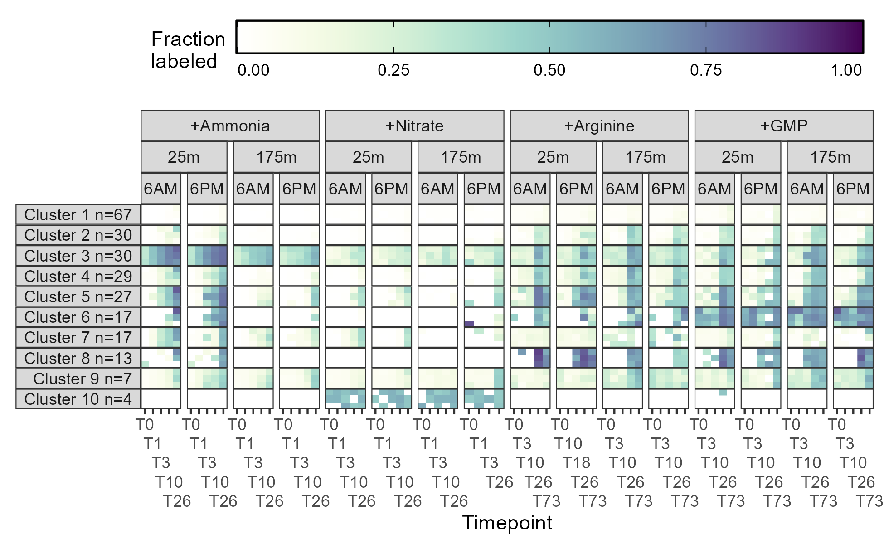
Figure 5: Fraction of each cluster containing at least one ¹⁵N label during the surface seawater amendments with various substrates after the number of hours shown on the x-axis. Darker colors indicate a larger percentage of the feature signal was isotopically labeled. Three biological replicates are stacked vertically at each timepoint and the labeling within each clusters has been averaged across all the composing features. The number of features in each cluster is specified by the n in the facet name. GMP = guanosine monophosphate.

Discussion
The chronic nitrogen limitation of the North Pacific Subtropical Gyre (NPSG) creates fierce competition for this element, yet clearly not all nitrogen is equally available. Instead, a grand marketplace of metabolites exists in which organisms attempt to match high-affinity uptake transporters and catabolic enzymes to the available dissolved nitrogen while minimizing energy costs (Moran et al. 2016). Here, we directly measured the uptake and use of four forms of nitrogen using stable isotope metabolomics.
- We sampled from a decaying DDA bloom
  - Biogeochemically looked super similar to ALOHA
  - Enriched in Hemiaulus at the surface at the beginning and pretty typical ALOHA conditions at the end
    - Elevated pro and het. bact at the end
    - Does Hemiaulus respond to nitrate amendments? or is it another diatom that usually grows in?
      - Hemiaulus has diazotrophs, do they get all their nitrogen from fixation or any from environment?
  - Typical ALOHA at 175 meters throughout
    - Big question mark on this one since we’re extrapolating from a single depth profile in both cases
- All N added in excess of normal ALOHA
  - 1mL 6mM nitrate/ammonia into 2L bottles = 3uM (on par with other experiments Rii, Bidigare, and Church (2018) Zimmerman et al. (2023) Shilova et al. (2017))
    - Nitrate background @ surface < 0.01 uM? (Typical ALOHA is 0-5nM Rii, Bidigare, and Church (2018))
    - Nitrate background @ 175m = 0.46-0.57 uM
    - Ammonia background @ surface ~ 0.01 (58nM in Shilova et al. (2017))
    - Ammonia background @ 175m ~ 0.01
      - Excessive ammonia add means that there was probably less competition, everyone got what they wanted
  - 1mL 0.1mM arginine/GMP into 2L bottles = 50nM
    - DON @ surface ~ 4.7 uM, @ depth = 4.2 uM
    - Arginine concentration @ ALOHA ~ at most nanomolar, lower @ depth
    - GMP concentration @ ALOHA ~ unknown, lower @ depth
      - GMP potentially used for phosphate and created guanosine (SRP = 0.16uM @ 175m, <0.05uM @ surface?)
      - E. hux can clearly grow well on purines though this requires nickel (?) and urease (Palenik and Henson (1997))
  - Unclear how much of this was USED, Rii2018 measured 100-500nM NO3/NH4 uptake per day
    - Implies mine was probably not drawn all the way down
  - Likelihood of inducing a community shift in 24 hours? 72 hours from organics?
    - Shilova et al. (2017) got a BIG growth in of random Alteromonadaceae after 1 day, growth in of picoeuks from ammonia, Bradley et al. (2010) showed that het. bact. can grow on inorganics
    - Rii, Bidigare, and Church (2018) found diatoms and pelagophytes growing in after 48 hours
    - Alexander et al. (2015) found diatoms and haptophytes
- Contrasting the inorganics
  - Ammonia transporters clearly “active” and the entire community ready to take it up
    - Glutamine 2x labeling maybe faster than glutamate
    - Citrulline labeling from ammonia is a surprise and indicates a “broken” urea cycle
    - Surprising how quickly the nucleobases were labeled given the length of that pathway
      - indicates high demand / storage / replication triggered?
      - All of them being mostly fully-labeled means new synthesis rather than recycling
      - Implications of DNA vs RNA labeling differences?
  - Nitrate use by only a subset of the community while ammonia appears to be universal
    - Aligns with Zimmermann data
    - MAAs and guanine labeling hints at euks, nitrate likely resulted in diatoms -> biomarkers?
      - The nitrogen in MAAs comes from amino acids (glycine = M-gly, gly+ser=shinorine, gly+thr = porphyra334/palythine/palythene/usujirene)
    - Important differences in labeling between THAAs and metabolites
      - Super rapidly turning over subset of the pool segregated from rest of the community
      - Note that nitrate resulted in more labeling at depth than surface while opposite true for ammonia
    - Surface community likely not “expecting” nitrate
      - How much time would it take to “turn on” NR and NiR genes?
      - Clear upward propagation of nitrate -> nitrite -> ammonia in water column data
- Contrasting the organics
  - Surface = phototrophs + heterotrophs, deep = just heterotrophs
    - Not a lot of surf/deep differences implies mostly het. using these at surface?
      - Kinda surprising since most phytos can eat organics
    - Are things generally slower at 175m? Or is this only in the absolute sense because there’s less biomass?
      - Fraction labeled nicely cancels out the biomass problem
  - How widespread are arginine/GMP transporters? Generic AA/NB transporters?
  - Not expecting to see 13C labeling from Arg/GMP because C pool is much larger
  - What does the decrease in arginine labeling in +Arg at T26 and T73 indicate?
    - Pulse-chase behavior?
    - How is the labeled pool specifically decreasing?
  - Clear backbone use for protein that’s not really seen in the metabolites - dedicated pathways again?
- Ectoine - mention that it’s mostly bacterial (McParland, Alexander, and Johnson 2021)
Need more discussion of betaines and cholines? Ask Anitra - Large pool sizes - What does a very slow osmolyte turnover mean for the cell? - Ref Angie’s paper about GBT use and how it’s mostly just held onto - Relative or absolute is really hard to tell because they’re below detection limits
No diel differences agrees well with Waldbauer (Zimmermann) 15N paper except they saw a bunch in Pro - How well does overall protein inclusion agree with Zimmermann? - Nitrate much slower in their data implying that the extra 12 hours (they incubated for 11) was necessary?
How representative is Station ALOHA and the bloom of the open ocean more generally?
What would have happened at the DCM? Or deeper?

Conclusion

Methods
[explain chromatographic similarity scoring as pearson’s correlation coefficient]

Acknowledgements

Data availability

References
Alexander, Harriet, Mónica Rouco, Sheean T. Haley, Samuel T. Wilson, David M. Karl, and Sonya T. Dyhrman. 2015. “Functional Group-Specific Traits Drive Phytoplankton Dynamics in the Oligotrophic Ocean.” Proceedings of the National Academy of Sciences 112 (44). https://doi.org/10.1073/pnas.1518165112.
Aluwihare, Lihini I., and Travis Meador. 2008. “Chemical Composition of Marine Dissolved Organic Nitrogen.” In Nitrogen in the Marine Environment, 2nd ed., 95–140. Academic Press Burlington, MA.
Aluwihare, Lihini I., Daniel J. Repeta, Silvio Pantoja, and Carl G. Johnson. 2005. “Two Chemically Distinct Pools of Organic Nitrogen Accumulate in the Ocean.” Science 308 (5724): 1007–10. https://doi.org/10.1126/science.1108925.
Antia, N. J., P. J. Harrison, and L. Oliveira. 1991. “The Role of Dissolved Organic Nitrogen in Phytoplankton Nutrition, Cell Biology and Ecology.” Phycologia 30 (1): 1–89. https://doi.org/10.2216/i0031-8884-30-1-1.1.
Bender, Sara J., Micaela S. Parker, and E. Virginia Armbrust. 2012. “Coupled Effects of Light and Nitrogen Source on the Urea Cycle and Nitrogen Metabolism over a Diel Cycle in the Marine Diatom Thalassiosira Pseudonana.” Protist 163 (2): 232–51. https://doi.org/10.1016/j.protis.2011.07.008.
Boysen, Angela K., Katherine R. Heal, Laura T. Carlson, and Anitra E. Ingalls. 2018. “Best-Matched Internal Standard Normalization in Liquid Chromatography–Mass Spectrometry Metabolomics Applied to Environmental Samples.” Analytical Chemistry 90 (2): 1363–69. https://doi.org/10.1021/acs.analchem.7b04400.
Bradley, Paul B., Marta P. Sanderson, Marc E. Frischer, Jennifer Brofft, Melissa G. Booth, Lee J. Kerkhof, and Deborah A. Bronk. 2010. “Inorganic and Organic Nitrogen Uptake by Phytoplankton and Heterotrophic Bacteria in the Stratified Mid-Atlantic Bight.” Estuarine, Coastal and Shelf Science 88 (4): 429–41. https://doi.org/10.1016/j.ecss.2010.02.001.
Bronk, D. A., J. H. See, P. Bradley, and L. Killberg. 2007. “DON as a Source of Bioavailable Nitrogen for Phytoplankton.” Biogeosciences 4 (3): 283–96. https://doi.org/10.5194/bg-4-283-2007.
Bronk, Deborah A., Rachel E. Sipler, Robert T. Letscher, and Matthew D. McCarthy. 2024. “Dissolved Organic Nitrogen.” In Biogeochemistry of Marine Dissolved Organic Matter, 343–404. Elsevier. https://doi.org/10.1016/B978-0-443-13858-4.00016-2.
Bronk, Deborah A., and Deborah K. Steinberg. 2008. “Nitrogen Regeneration.” In Nitrogen in the Marine Environment, 2nd ed., 385–450. Academic Press Burlington, MA.
Heal, Katherine R., Bryndan P. Durham, Angela K. Boysen, Laura T. Carlson, Wei Qin, François Ribalet, Angelicque E. White, Randelle M. Bundy, E. Virginia Armbrust, and Anitra E. Ingalls. 2021. “Marine Community Metabolomes Carry Fingerprints of Phytoplankton Community Composition.” Edited by Manuel Liebeke. mSystems 6 (3): e01334–20. https://doi.org/10.1128/mSystems.01334-20.
Hutchins, David A., and Douglas G. Capone. 2022. “The Marine Nitrogen Cycle: New Developments and Global Change.” Nature Reviews Microbiology 20 (7): 401–14. https://doi.org/10.1038/s41579-022-00687-z.
Jones, Catriona L. C., Judith Camps-Castella, Mike Smykala, Morgan S. Sobol, and Keisuke Inomura. 2024. “Seeing Through the Gray Box: An Integrated Approach to Physiological Modeling of Phytoplankton Stoichiometry.” Frontiers in Ecology and Evolution 12 (December): 1505025. https://doi.org/10.3389/fevo.2024.1505025.
McParland, Erin L., Harriet Alexander, and Winifred M. Johnson. 2021. “The Osmolyte Ties That Bind: Genomic Insights Into Synthesis and Breakdown of Organic Osmolytes in Marine Microbes.” Frontiers in Marine Science 8 (July): 689306. https://doi.org/10.3389/fmars.2021.689306.
Moore, C. M., M. M. Mills, K. R. Arrigo, I. Berman-Frank, L. Bopp, P. W. Boyd, E. D. Galbraith, et al. 2013. “Processes and Patterns of Oceanic Nutrient Limitation.” Nature Geoscience 6 (9): 701–10. https://doi.org/10.1038/ngeo1765.
Moran, Mary Ann, Elizabeth B. Kujawinski, William F. Schroer, Shady A. Amin, Nicholas R. Bates, Erin M. Bertrand, Rogier Braakman, et al. 2022. “Microbial Metabolites in the Marine Carbon Cycle.” Nature Microbiology 7 (4): 508–23. https://doi.org/10.1038/s41564-022-01090-3.
Moran, Mary Ann, Elizabeth B. Kujawinski, Aron Stubbins, Rob Fatland, Lihini I. Aluwihare, Alison Buchan, Byron C. Crump, et al. 2016. “Deciphering Ocean Carbon in a Changing World.” Proceedings of the National Academy of Sciences 113 (12): 3143–51. https://doi.org/10.1073/pnas.1514645113.
Mulholland, Margaret R., and Michael W. Lomas. 2008. “Nitrogen Uptake and Assimilation.” In Nitrogen in the Marine Environment, 303–84. Elsevier. https://doi.org/10.1016/B978-0-12-372522-6.00007-4.
Palenik, Brian, and Sarah E. Henson. 1997. “The Use of Amides and Other Organic Nitrogen Sources by the Phytoplankton Emiliania Huxleyi.” Limnology and Oceanography 42 (7): 1544–51. https://doi.org/10.4319/lo.1997.42.7.1544.
Partensky, Frédéric, and Laurence Garczarek. 2010. “Prochlorococcus: Advantages and Limits of Minimalism.” Annual Review of Marine Science 2 (1): 305–31. https://doi.org/10.1146/annurev-marine-120308-081034.
Rii, Yoshimi M., Robert R. Bidigare, and Matthew J. Church. 2018. “Differential Responses of Eukaryotic Phytoplankton to Nitrogenous Nutrients in the North Pacific Subtropical Gyre.” Frontiers in Marine Science 5 (March): 92. https://doi.org/10.3389/fmars.2018.00092.
Shilova, I. N., M. M. Mills, J. C. Robidart, K. A. Turk-Kubo, K. M. Björkman, Z. Kolber, I. Rapp, et al. 2017. “Differential Effects of Nitrate, Ammonium, and Urea as N Sources for Microbial Communities in the North Pacific Ocean.” Limnology and Oceanography 62 (6): 2550–74. https://doi.org/10.1002/lno.10590.
Walker, Mark C, and Wilfred A Van Der Donk. 2016. “The Many Roles of Glutamate in Metabolism.” Journal of Industrial Microbiology and Biotechnology 43 (2-3): 419–30. https://doi.org/10.1007/s10295-015-1665-y.
Zehr, Jonathan P., and Raphael M. Kudela. 2011. “Nitrogen Cycle of the Open Ocean: From Genes to Ecosystems.” Annual Review of Marine Science 3 (1): 197–225. https://doi.org/10.1146/annurev-marine-120709-142819.
Zimmerman, Amy E., Justin C. Podowski, Gwendolyn E. Gallagher, Maureen L. Coleman, and Jacob R. Waldbauer. 2023. “Tracking Nitrogen Allocation to Proteome Biosynthesis in a Marine Microbial Community.” Nature Microbiology 8 (3): 498–509. https://doi.org/10.1038/s41564-022-01303-9.

Supplement

Supp fig: full heatmap of all compounds and timepoints

Supp fig: THAA labeling broken down by triplicate

Supp fig: All MAA labeling

