Nitrogen’s form determines its fate in the North Pacific Subtropical Gyre
William Kumler, Laura T. Carlson, Rhea K. Foreman, Eric Grabowski, Fernanda Henderikx Freitas, Fuyan Li, Matthew J. Church, Edward F. DeLong, Angelicque E. White, David M. Karl, Anitra E. Ingalls

Abstract
Nitrogen (N) availability limits the growth of many surface ocean microbial communities, particularly in the ocean gyres. Yet, even before growth is limited, some metabolic pathways or specific taxa ma experience lower than optimal N flux due to cellular allocation and competition for various forms of N. Here, we present a stable isotope probing metabolomics study that illustrates the metabolic pathways taken by four different forms of nitrogen: ammonia, nitrate, arginine, and guanosine monophosphate. In the moning and evening, we followed isotope labeled substrates through metabolic pathways for 26 (inorganic N additions) and 73 (organic N additions) hours in both surface (25m) and deep (175m) microbial communities in the North Pacific Subtropical Gyre. We found that nearly the entire surface glutamine pool (1-2 nM) is labeled by ammonia in less than an hour and goes on to label the metabolome more broadly after 24 hours, though abundant osmolytes like betaines (e.g. glycine betaine, 0.4-0.5 nM) had slow turnover rates (<5% in 24 hours). Nitrate amendments resulted in the labeling of only a small selection of molecules such as ultraviolet light absorbing compounds (mycosporine-like amino acids, or MAAs), whose incorporation patterns suggest that this form of nitrogen was available to a subset of the community, likely eukaryotes. The two organic nitrogen amendments labeled the metabolome more slowly than the inorganic forms of nitrogen and showed similar usage at 25 meters and 175 meters, hinting at the major role that heterotrophic bacteria play in cycling organic matter. The organic nitrogen added was mostly converted into glutamate after 24 hours rather than used as intact substrates, though labeled arginine was incorporated into protein directly and we were able to trace the carbon backbone from both arginine and GMP into several additional metabolites. We also show that nitrogen assimilation and use was largely the same between morning and evening with the exception of MAAs. These measurements reveal the forms and fluxes of nitrogen in the natural environment and provide constraints on biogeochemical models that require characterizing the transformations between organic and inorganic nitrogen.

Introduction
In most of the surface ocean the flux of carbon is controlled by the availability of nitrogen, an element with a complex and incompletely characterized biogeochemical cycle (Deborah A. Bronk and Steinberg 2008; Moore et al. 2013; Hutchins and Capone 2022). Organic nitrogen in particular is often treated as a black box despite substantial variability in its bioavailability and chemical nature. Turnover times for labile organic compounds like urea and amino acids can be orders of magnitude shorter than semi-labile or refractory DOM (Benner and Amon 2015; Deborah A. Bronk et al. 2024). Additionally, the availability of the precious nitrogen atom is determined not only by the form of the organic material it composes but also the environment in which it’s found.
While extensive work has been done to characterize the forms and fluxes of nitrogen within the inorganic pool, the equivalent for the organic pool is woefully underdeveloped (Zehr and Kudela 2011; Deborah A. Bronk and Steinberg 2008). This is largely due to the difficulty of comprehensively measuring the many organic molecules that contain nitrogen in the marine environment (Boysen et al. 2018; Moran et al. 2022). Recently, however, we have improved our understanding of community composition via genomics and transcriptomics and made progress in our ability to characterize organic matter via proteomics and metabolomics. These advancements, paired with the increased availability of pure and isotope-labeled substrates, mean that we can now apply metabolically resolved isotope tracing to resolve how organic nitrogen is transformed in the marketplace of metabolites that powers the surface ocean (Heal et al. 2021; McParland, Alexander, and Johnson 2021; Moran et al. 2022).
Nitrogen assimilation is a well-documented process in the ocean after decades of research and demonstrates how our understanding of non-marine organisms can be applied to the ocean (Mulholland and Lomas 2008). Central to the process is ammonia, which can be directly taken up from the environment by all organisms and combined with glutamate. This forms glutamine, which is then combined with alpha-ketoglutarate to form two glutamate molecules that can then be used as a nitrogen source throughout the cell (Walker and Van Der Donk 2016). Nitrate, on the other hand, must first be reduced to ammonia in an energetically expensive process that some organisms have stripped from their genomes (Partensky and Garczarek 2010; Zehr and Kudela 2011).
Unlike the relatively well-resolved pathways for inorganic nitrogen, the use of organic nitrogen remains underexplored in the marine environment. Organic nitrogen is generally thought to be accessible to most organisms but the high levels of DON make it clear that this is highly substrate-specific (Antia, Harrison, and Oliveira 1991; D. A. Bronk et al. 2007; Aluwihare and Meador 2008; Zehr and Kudela 2011; Deborah A. Bronk et al. 2024). Additionally, many of the transformations possible are only active in specific communities or times of day (Bender, Parker, and Armbrust 2012). Linking the transformations that nitrogen undergoes to known molecular pathways from other environments or axenic cultures is a particularly promising way to understand what we observe on the global scale.
The lack of a comprehensive understanding of nitrogen’s fate after it is assimilated makes molecular modeling difficult and undermines our ability to connect the community to the organic nitrogen it produces (Jones et al. 2024; Gonsior et al. 2022). Here, we trace the uptake and use of labeled ammonia, nitrate, arginine, and guanosine monophosphate in a natural community from the North Pacific Subtropical Gyre at multiple depths and diel conditions. Our application of metabolomics to these samples allows us to map the pathways and restructuring that organic nitrogen experiences in the largest biomes on the planet, quantifying the pool sizes and turnover rates for various low molecular weight compounds that serve as building blocks and intermediates of cell biology.

Results
Samples were collected from 25 meters and 175 meters during the 2021 SCOPE PARAGON cruise (KM2112, July 23rd - August 5th) near Station ALOHA that targeted a bloom within an anticyclonic eddy. The bloom was initially dominated by the diatom genus Hemiaulus with a large surface chlorophyll signal that decayed into a more typical North Pacific Subtropical Gyre community composed mostly of Prochlorococcus and SAR11. Community composition at our sampling depth below the deep chlorophyll maximum (DCM) was fairly typical of ALOHA, with a prokaryotic community dominated by SAR11, SAR282, and SAR 406, low levels of picoeukaryotes, and a microeukaryotic community equally distributed between diatoms, haptophytes, and dinoflagellates (Figure 1).
Samples collected from 25 meters were within the mixed layer and had PAR levels of 20-35% of the surface light while the 175 meter samples had a PAR level between 0.05 and 0.1%. Nitrate, nitrite, and ammonia data indicated that inorganic N was low in the surface (<0.01 µM), while the deeper samples at 175 meters were collected in the middle of the nutricline, with a clear DCM at 125 meters, an ammonia maximum at 150 meters, and a nitrite max at 160-165 meters. Environmental nitrate concentrations were about 0.5 µM at 175 meters (Figure 1).
We performed the incubations in succession, with the nitrate incubations first, followed by arginine, then guanosine monophosphate and finally ammonia. 6AM and 6PM data was always collected the same day and we alternated days between the surface and deep sampling depths to allow for reasonable sample processing times (Figure 1).
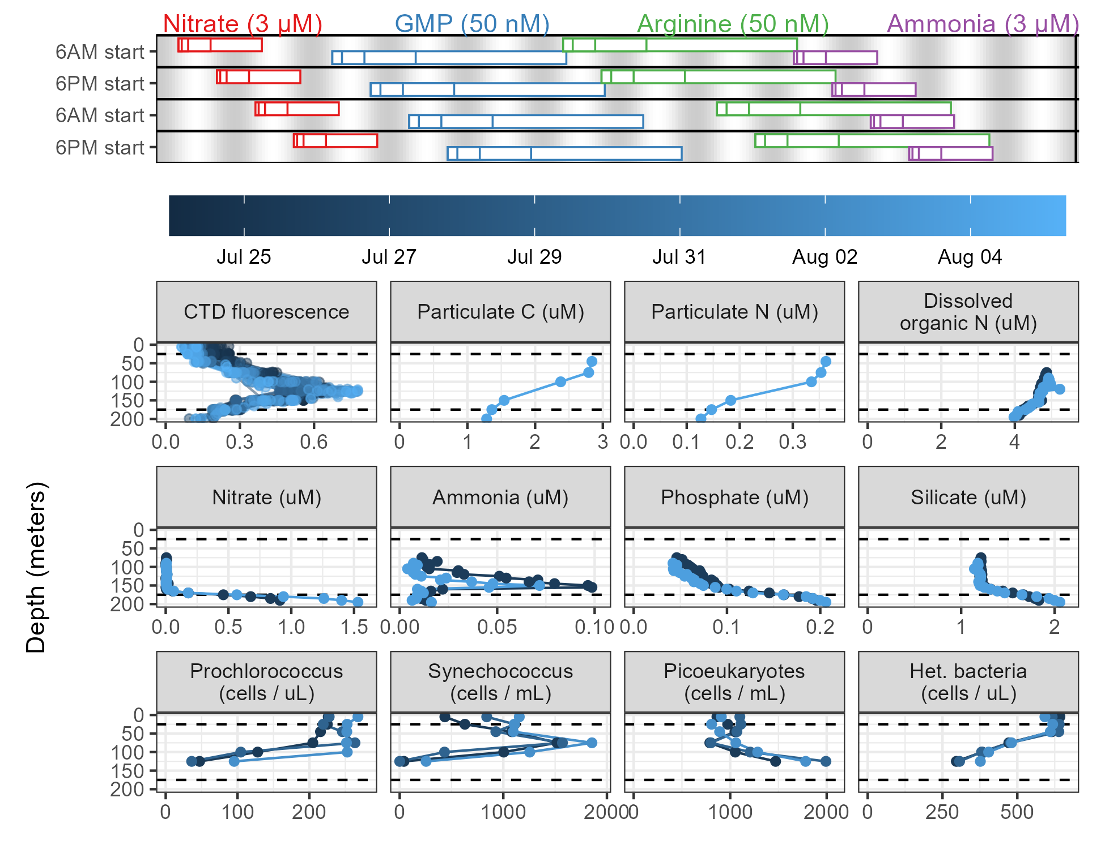
Figure 1: Biogeochemical and community composition data collected during the PARAGON cruise alongside the incubation sampling plan. The top plot shows the start and end times of each incubation as rectangles aligned with the dates of the cruise in the middle color bar, with each rectangle representing a biological triplicate sacrificed at the given time. Grey shading in the background denotes light levels with grey corresponding to nighttime. The four amendments are shown as different colors. The lower panels show various biogeochemical and flow cytometry measurements colored by the date they were collected during the cruise. Note that Prochlorococcus and heterotrophic bacteria (Het. bacteria) are reported in cells per microliter while Synechococcus and picoeukaryotes are reported per milliliter. The 25 meter and 175 meter sampling depths have been added as dashed lines. C = carbon, N = nitrogen, GMP = guanosine monophosphate.

Differences in nitrogen labeling at the surface between amendments
We observed significant differences in ¹⁵N labeling patterns between the different treatment incubations (Figure 2). Ammonia incubations resulted in very rapid labeling, with glutamine more than 75% labeled even at the T0 timepoint, corresponding to the amount of time required to spike and immediately filter the 2 liters of seawater (~15 minutes). The dominant labeling pattern at T0 was a single ¹⁵N, though all later timepoints showed more doubly-¹⁵N labeled glutamine than singly-labeled. After 24 hours, glutamine was more than 95% labeled and had approximately doubled in pool size (initially ~0.3 nM becoming 0.8 nM).
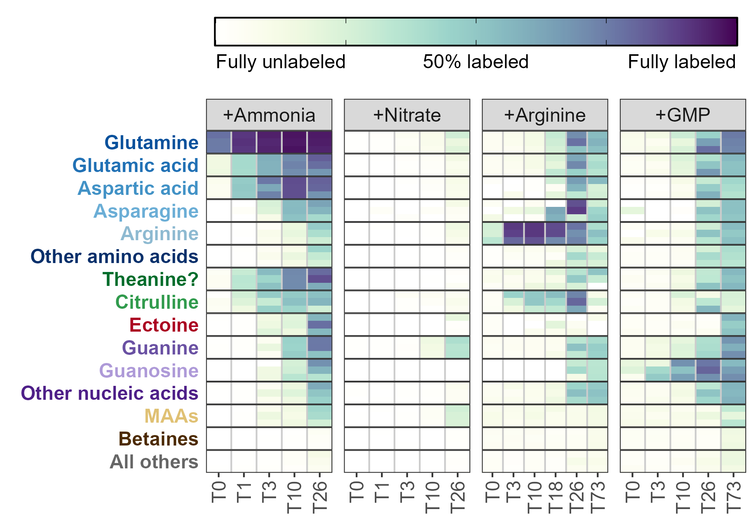
Figure 2: Fraction of each metabolite or metabolite group containing at least one ¹⁵N label during the surface seawater amendments with various substrates after the number of hours shown on the x-axis. Darker colors indicate a larger percentage of the compound signal was isotopically labeled. Three biological replicates are stacked vertically at each timepoint and the categories with multiple entries have been averaged. MAA = mycosporine-like amino acids, GMP = guanosine monophosphate.
The ¹⁵N was then quickly propagated to glutamate and aspartate, creating a metabolite pool 40-50% labeled for each of these after a single hour. Aspartate was labeled slightly faster than glutamate, likely as a result of its smaller pool size (0.2 nM Asp versus 0.5 nM Glu). Also rapidly labeled was citrulline, reaching 20% labeled after a single hour, though arginine was not labeled until much later despite its location immediately downstream of this metabolite. Untargeted detection of other molecular features revealed an additional metabolite that was 30% labeled at the one hour timepoint with an m/z value of 175.1077 and a retention time of 8.2 minutes which we have putatively identified as theanine (N5-ethyl glutamine) based on m/z match and labeling pattern (Figure 2).
Other amino acids and nucleobases/nucleosides had trace amounts of labeling after 3 hours and were extensively labeled (>25%) after 24 hours (Figure 2). Cytidine (42.2% labeled) and adenosine (59.9% labeled) were more heavily ¹⁵N labeled than their nucleobase derivatives at T26 (22.9% for cytidine and 42.1% for adenosine), corresponding to the expected synthesis pathway. Guanine, however, had the inverse trend with guanosine being 44.9% labeled while guanine was only 30% labeled. The deoxyribose forms were in all cases less completely labeled than their ribose counterparts (deoxycytidine = 18.9%, deoxyadenosine = 20.3%, and deoxyguanosine = 17.2%). In each case, the fully ¹⁵N labeled nucleobase was the dominant constituent of the isotope envelope (¹⁵N₃ for cytosine and ¹⁵N₅ for adenine and guanine). Other compounds, including betaines (here restricted to quaternary amines with a carboxylic acid group) and choline derivatives showed very little labeling at all (<10%).
Amendments with ¹⁵NO₃ showed a significantly different labeling pattern with very few metabolites incorporating the ¹⁵N label at the surface even after 24 hours. Only trace amounts of glutamine were labeled by the added nitrate even after 24 hours. The most heavily labeled compound was guanine, which saw trace amounts of label at the T10 timepoint and was ~40% labeled at T26. Adenine and adenosine were both ~15% labeled, while deoxyadenosine, deoxyguanosine, deoxycytidine, and guanosine were all 5% labeled or less. The only other group of compounds that did see compelling degrees of label incorporation from nitrate were the mycosporine-like amino acids (MAAs), a group of compounds whose primary function is thought to be protection from UV light (see below). These compounds, like guanine, were labeled in excess of the bulk glutamate/amino acid pool from which their nitrogen is sourced.
The organic nitrogen amendments also showed labeling patterns distinct from the ammonia incubations, though a large fraction of the nitrogen was clearly remineralized into ammonia/glutamate and used to label a similar suite of compounds (Figure 2). At least 50 picomoles of fully C and N labeled (¹³C₆, ¹⁵N₄) arginine was taken up at the T0 timepoint (within 20 minutes, creating an arginine pool 30% labeled), and 80-90% of the pool was fully labeled after 12 hours with a maximum arginine concentration of 0.73 nM. Surprisingly, the fraction of arginine labeled decreased from this point, with the T26 and T73 timepoints dropping to 74% and 48% labeled, respectively, as the total amount of both labeled and unlabeled arginine dropped back to initial concentrations (~0.08 nM). This labeling rapidly propagated into citrulline, likely via the urea cycle, indicating that labeled urea (¹³C₁, ¹⁵N₂) was probably created and available in the system, though we were unable to measure this directly. Glutamate and glutamine were labeled much more slowly, reaching 10% labeled after 10 hours and a maximum of 66% labeled after 24 hours. Much of this nitrogen was then cycled very quickly among other compounds which also saw an abrupt increase in fraction labeled at 24 hours. This was particularly true for other amino acids and the nucleobases/nucleosides and unlike the inorganic N incubations guanine was not labeled more in excess of the other nucleobases. Mycosporine-like amino acids and betaines were unlabeled above background even after 3 days of incubation.
The guanosine monophosphate (GMP) incubations showed a pattern very similar to the arginine incubations in the identity, timing, and magnitude in which metabolites were labeled (Figure 2). While we were unable to measure GMP directly we saw clear labeling of fully C and N labeled guanosine (¹³C₁₀, ¹⁵N₅) after 3 hours that increased to a maximum of 75% after 24 hours before decreasing slightly to 64% labeled at the end of the three-day incubation. A small part of this signal was reflected in guanine, with ¹³C₅, ¹⁵N₅ guanine representing about 10% of the signal at T3 and reaching a maximum of 40% at T26. At T26 we also saw extensive labeling in adenine, adenosine, and hypoxanthine though their dominant labeling patterns (¹³C₀ ¹⁵N₅, ¹³C₅ ¹⁵N₅, and ¹³C₀ ¹⁵N₄ respectively, Supplemental figure XX) suggested that the adenine and hypoxanthine were synthesized from glutamate and that the ribose pool had been swamped by guanosine cleavage. Here, unlike the arginine incubations, we also saw some MAA labeling at the end of the 3 day incubation.
We also explored the degree of labeling incorporation into proteins by measuring the total hydrolyzable amino acids (THAAs) at both the start of each incubation and the end (Figure 3). THAAs come from protein (which can be in living biomass or detritus) and include minor contributions from metabolites and peptides with hydrolyzable amino acid moieties (e.g. MAAs and glutathione). THAAs were 26% (±6.5%, SD, n=24) of the total surface particulate carbon pool (PC = 2.84 µM in mixed layer) at T0 and 55% (±14.3%, SD, n=24) of the particulate nitrogen (PN = 0.36 µM in mixed layer) at the start of the incubations. Free amino acids composed between 0.2% and 14% of the total hydrolyzable fractions with the highest contributions from free glutamate (Table 1).
Amino acid | THAA (T0) | Free (T0) | % free (T0) |  | THAA (final) | Free (final) | % free (final)
Glutamate + glutamine | 19.57 | 1.66 | 8.47% |  | 29.41 | 4.04 | 13.72%
Histidine | 2.53 | 0.04 | 1.59% |  | 2.76 | 0.07 | 2.58%
Arginine | 6.87 | 0.08 | 1.13% |  | 8.15 | 0.20 | 2.51%
Aspartate + asparagine | 14.54 | 0.33 | 2.28% |  | 20.93 | 0.48 | 2.28%
Alanine | 15.24 | 0.17 | 1.09% |  | 20.79 | 0.46 | 2.22%
Proline | 7.22 | 0.04 | 0.56% |  | 8.47 | 0.16 | 1.86%
Serine | 20.26 | 0.21 | 1.04% |  | 21.25 | 0.27 | 1.27%
Glycine | 29.57 | 0.17 | 0.59% |  | 29.28 | 0.34 | 1.15%
Leucine + isoleucine | 22.49 | 0.18 | 0.78% |  | 26.95 | 0.30 | 1.12%
Threonine | 12.06 | 0.03 | 0.22% |  | 14.71 | 0.06 | 0.38%
Table 1: Concentrations of all 10 amino acids detected in both the total hydrolyzable (THAA) and dissolved free (DFAA) pools for unlabeled data in the surface averaged across all treatments. Values are reported in nanomoles per liter (nM).
There were also differences in THAA labeling patterns between the amendments (Figure 3). Despite their shorter incubation time (26 hours vs 73 hours), the inorganic nitrogen amendments had approximately equal fractions of labeled protein. The nitrate amendments in particular were surprisingly heavily labeled given the minimal signal seen in free metabolites.
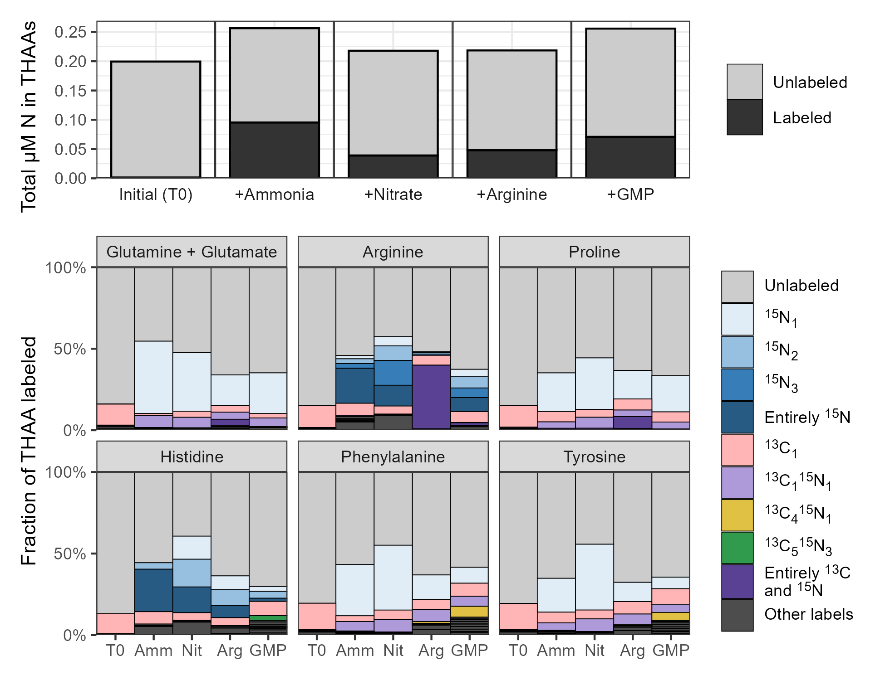
Figure 3: Stacked bar plots showing the fraction of various total hydrolyzable amino acids (THAAs) labeled at the end of the incubations across the four amendments. Total µM nitrogen (N) in the protein pool is shown in the top plot while the fraction of individual amino acids labeled is shown in the rows below. Colors denote specific labeling patterns detected in the THAAs.
In the THAAs we were able to see the carbon backbone from the organics propagate into other compounds, resulting in ¹³C labeling in excess of natural abundance. Proline and glutamate both had detectable ¹³C₅ ¹⁵N₁ labels in the arginine treatments. We also saw histidine ¹³C₅ ¹⁵N₃ synthesized during the guanosine monophosphate treatment, with the ¹⁵N₃ pattern indicating that glutamate, glutamine, and adenine were also heavily ¹⁵N labeled. Finally, both phenylalanine and tyrosine had significant ¹³C₄ ¹⁵N₁ labeling in the GMP amendments.

Minimal diel signal observed except in the UV-absorbing mycosporine-like amino acids
We performed experiments with each of the 4 forms of nitrogen at both 6AM and at 6PM to test for any diel effects in labeling patterns. Very few compounds showed a detectable difference between the 6AM start time and the 6PM start time with the exception being the mycosporine-like amino acids (MAAs, Figure 4). Shinorine and palythine were confirmed via MS² fragments while the other annotations remain putative, though their presence exclusively in the surface is compelling. During the ammonia incubations, six MAAs showed clear ¹⁵N incorporation while exposed to sunlight, with the labeled fraction increasing sharply over the first 10 hours in the incubations started at 6AM. Incubations started at 6PM showed very little labeling from ammonia until a full 24 hours had passed. Shinorine, mycosporine-glycine, palythine, porphyra-334 were all clearly labeled (>20% ¹⁵N) as well as two of three molecular features detected at an m/z of 285.1445 likely corresponding to palythene and usujirene.
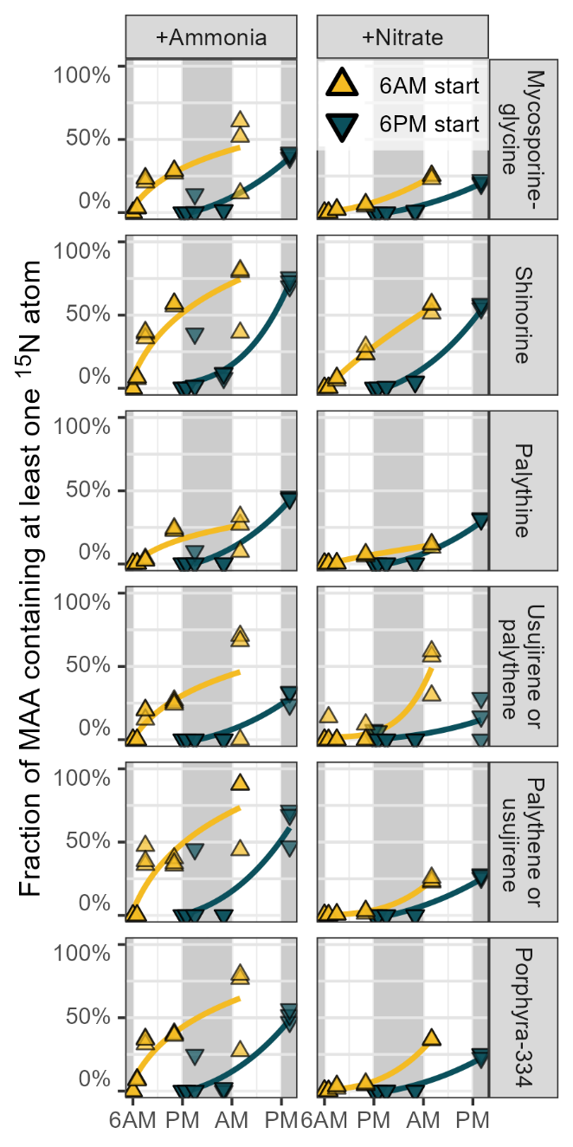
Figure 4: Fraction of UV-absorbing mycosporine-like amino acids (MAAs) containing at least one ¹⁵N label over one day during the treatments amended with ¹⁵N labeled ammonia or nitrate. Incubations started at 6AM are shown in yellow while incubations started at 6PM are shown in blue, with grey background regions highlighting nighttime. Three replicates are included at each of the 5 timepoints and best-fit power law curves have been fit behind the data.
Nitrate data showed similar degrees of labeling which was again surprising given the reduced amount of bulk metabolite labeling in those amendments, though the synthesis of MAAs from nitrate appeared less clearly diel. Shinorine and porphyra-334 were particularly well-labeled under nitrate, approaching the values achieved in the ammonia incubations. Very little MAA labeling was observed during the arginine and GMP amendments until the 73 hour timepoint, though at that point the fraction labeled was approximately equivalent to the inorganic amendments and slightly higher for GMP than arginine.

Ammonia more bioavailable at surface, organics equally bioavailable at 25m and 175m
We also performed the four nitrogen amendments at both the surface (25 meters) and below the euphotic zone (175 meters, <0.1% PAR) to investigate the effect of depth on organic and inorganic nitrogen use. We found that ammonia was used much more readily at the surface as measured by the fraction of metabolite labeled, with ¹⁵N incorporation for amino acids 5-25% greater in the surface than at depth (Figure 5). Glutamate, theanine, aspartate, and asparagine were among the most different with glutamate and theanine surface values about 10 times those at depth while ¹⁵N aspartate was undetectable until hour 3 of the incubation and ¹⁵N asparagine was never detected. In contrast, glutamine labeling was similar between the two depths, with the fraction labeled 10-20 percentage points higher at the surface across all timepoints; a trend which was clearly not propagated to glutamate or other amino acids and instead must have represented accumulation or protein incorporation.
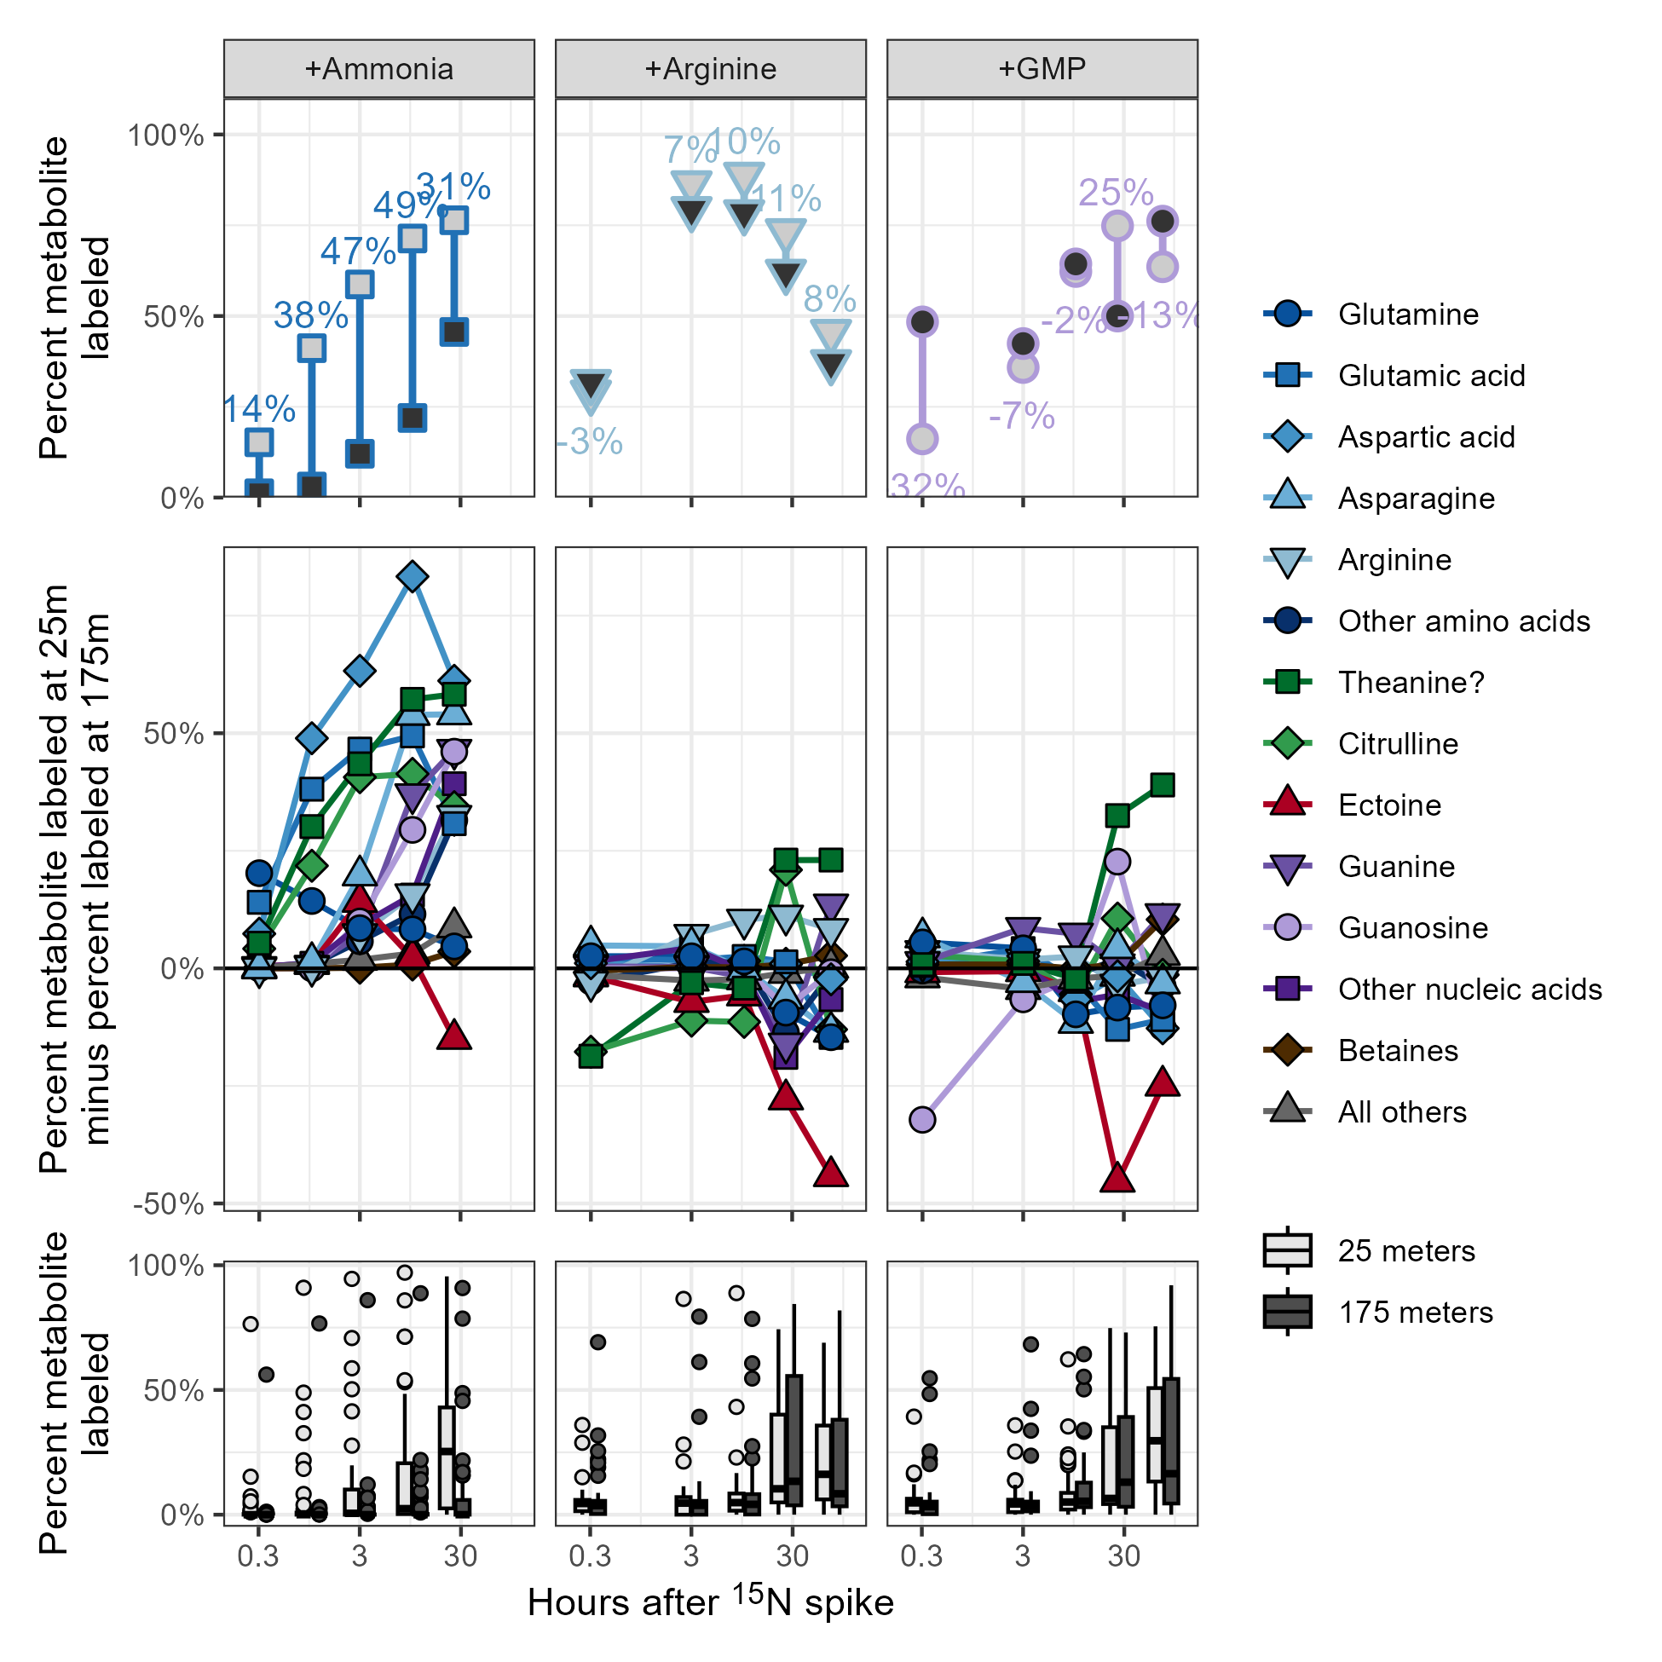
Figure 5: Plots of the metabolite fraction labeled at the surface (25 meters) and the fraction labeled at 175 meters. Incubations with added ammonia, arginine, and guanosine monophosphate (GMP) are shown. Top row of plots show the calculation of % labeled at 25 meters minus % labeled at 175 meters for three example compounds. All compounds are shown in the middle row of plots, grouped by chemical similarity and labeling pattern where positive values indicate increased synthesis in the surface samples relative to those at depth. Finally, the bottom row of plots shows the relative difference between the surface and deep as boxplots for all compounds without aggregating. Points in the first two rows are the average of six biological replicates (incubations started in the morning and the evening are combined here for additional power) while points in the bottom row denote metabolites with labeled fractions falling outside 1.5 times the interquartile range.
Other metabolites varied in their degree of labeling (Figure 5). Nucleobases and nucleosides were much more heavily labeled from ammonia at the surface, with maximum labeling 3-10 times more extensive around T3 and T10 if the isotope was measurable at both depths and infinitely more so if not. Betaines and other nitrogen-containing metabolites, however, were almost entirely unlabeled at 175 meters until the 24 hour mark, at which time the fraction labeled in both was 5-20 times higher at the surface. An important exception to this rule is the osmolyte ectoine, an aspartate derivative that nonetheless was synthesized with nitrogen from ammonia at depth with the fraction labeled equal to or exceeding that of the surface in an equal amount of time.
We were unfortunately unable to present the data collected from the 175 meter labeled nitrate incubations here due to our inability to confidently connect data to the correct timepoint for those samples but the raw numbers are provided in the supplement (Supplemental Figure XX).
¹⁵N use from the organic nitrogen substrates was similar between the 25 meter and 175 meter samples aside from the direct products of the amended compounds. In both cases, uptake and use of the labeled substrate was equal or slightly higher at depth for a majority of the metabolites measured. Exceptions to this were theanine, which was 20-30 percentage points more heavily labeled at the surface by the end of the incubations, and ectoine, which was synthesized more at depth even to a larger degree than it was during the ammonia treatments, reaching nearly 50 percentage points more labeled at 175 meters than it was at 25 meters.
At 175 meters, the difference between organic and inorganic amendments also becomes apparent (Figure 6). Organic compounds result in increases in absolute metabolite concentration and fraction labeled while the inorganic substrates are essentially unused. This is in direct contrast to the surface data, where ammonia also resulted in an increased metabolite load likely corresponding to overall growth. Much of the labeling at 175 meters appears to be in the less-abundant compounds. Glutamine (~1 nM) was almost entirely labeled after 24 hours and half the glutamate pool (3-5 nM) had been synthesized from the ¹⁵N in arginine and GMP, while the other 7 most abundant compounds were not nearly as heavily labeled. The less-abundant compounds, however, were also on average 50% labeled, representing an additional 1-2 nanomoles of ¹⁵N label incorporation per liter.
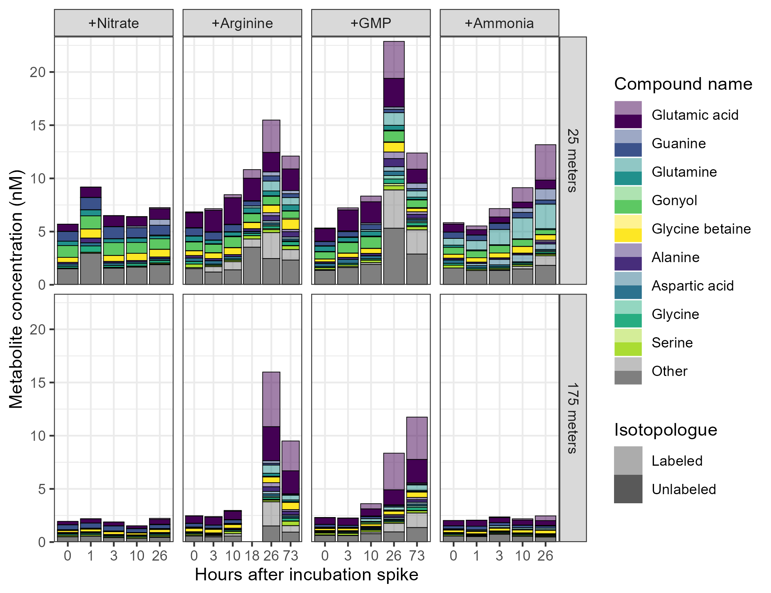
Figure 6: Quantified metabolite concentrations in nanomolar throughout the incubations for the 9 most abundant metabolites as distinguished by color. Concentrations have been broken down by whether they are fully unlabeled or contain any amount of ¹⁵N (or ¹³C in the case of the arginine and GMP amendments). Compounds other than the top 9 have been averaged and are shown in grey. Totals for all four amendments are shown here in the order they were done during the cruise, with separate panels for the 25 meter samples and the 175 meter samples.
We explored this further by investigating the total amount of nitrogen contained within the metabolites and THAAs in the experiments. We saw that the absolute amount of ¹⁴N remained relatively constant around 10 nM at the surface and 5 nM at 175 meters, while the absolute amount of ¹⁵N increased smoothly. The same pattern was observed in the THAAs, where ¹⁴N concentrations overed around 150-200 nM at the surface and ~100 nM at 175 meters while the ¹⁵N concentrations jumped up between the initial and final timepoints for arginine and GMP after the three day incubation while the increase was only observed for ammonia at the surface.
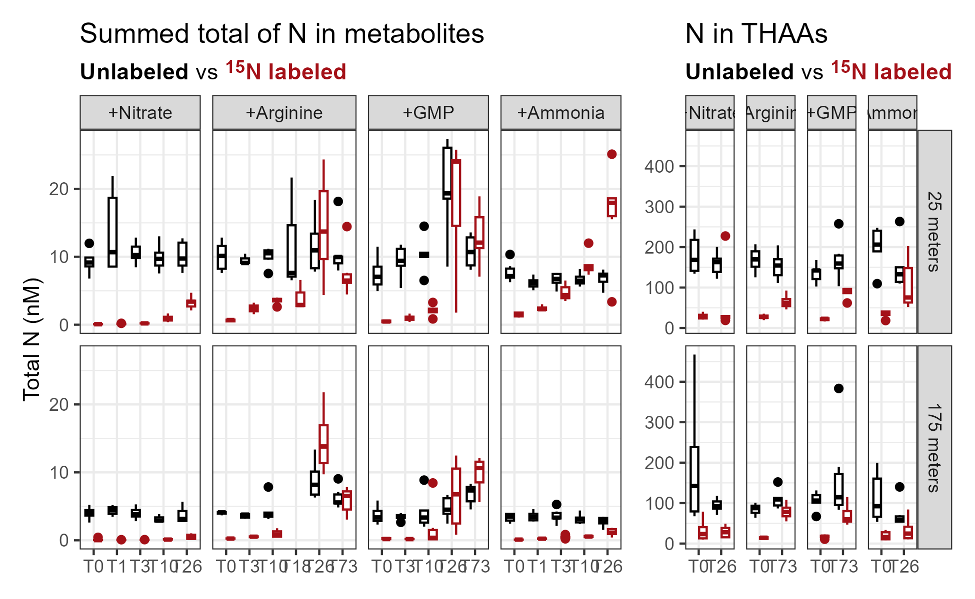
Figure 7: Quantified metabolite concentrations in nanomolar throughout the incubations for both metabolites and THAAs. Colors denote whether they are fully unlabeled or contain any amount of ¹⁵N (or ¹³C in the case of the arginine and GMP amendments). Totals for all four amendments are shown here in the order they were done during the cruise.
Finally, to investigate what fraction of this labeling was due to net synthesis or metabolite turnover for the metabolome as a whole, we plotted the relative concentration change between the initial timepoint and T26 against the fraction of the metabolite labeled (Figure 8). While most metabolites increased their labeling in sync with their total increase in abundance, two metabolites stood out in particular. The amino acid methionine experienced large amounts of synthesis and jumped from below the limit of detection at T0 (a few pM) to hundreds of picomolar. This did not occur in the 175 meter ammonia or nitrate incubations, and the 25 meter nitrate incubation’s methionine concentration actually decreased between T0 and T26. Unlike methionine and most other compounds, adenosine also stood out for its high levels of turnover without much increase in abundance (Figure 8). Adenosine concentrations consistently decreased after 24 hours despite accumulating large amounts of label (40-80%), indicating high turnover and use of this metabolite even in the GMP incubation where a similar nucleoside was abundant in the environment. This pattern was especially unique because the nucleobase adenine did not follow this pattern and instead mapped onto most other metabolites with simultaneous synthesis and labeling, as did the other nucleosides guanosine and cytidine.
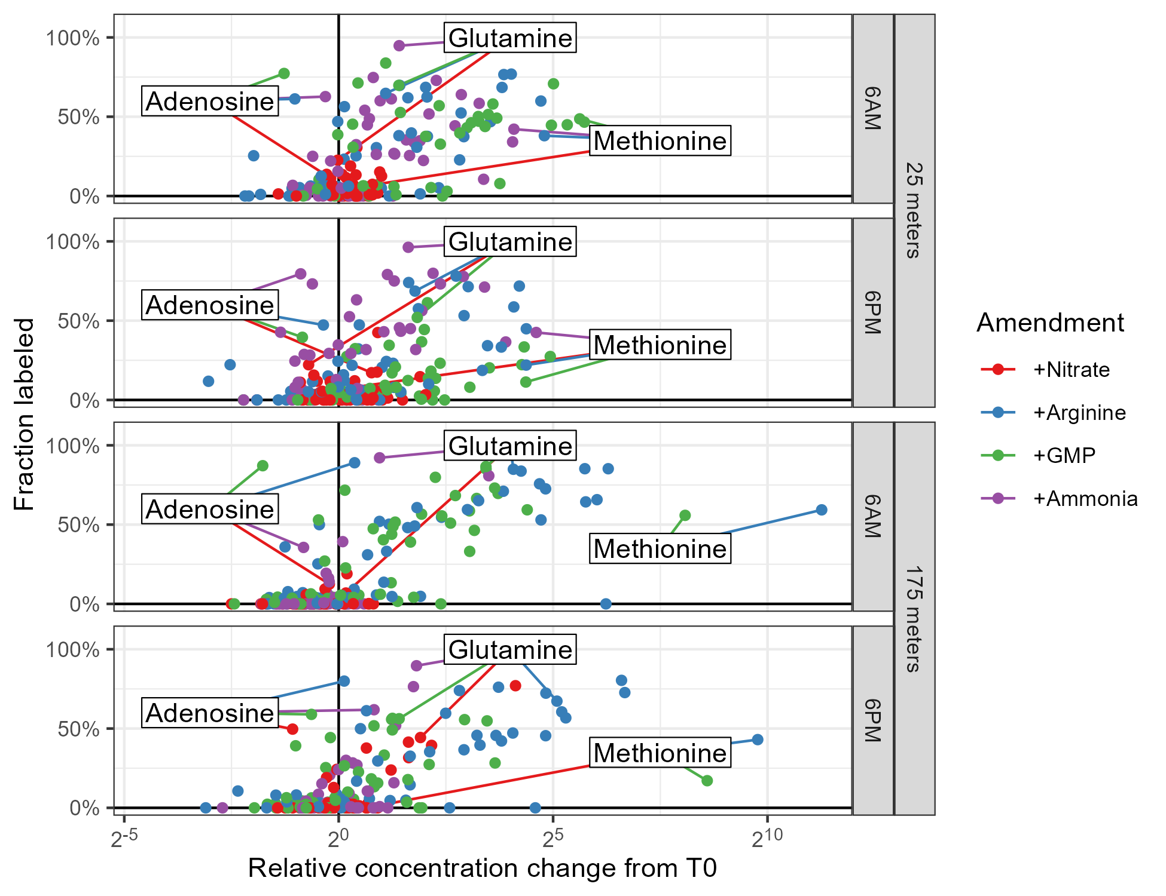
Figure 8: Turnover vs new synthesis of metabolites after ~24 hours. Points correspond to individual metabolites with the x-coordinate indicating the log2-fold change difference between the compound’s initial concentration and its final amount and the y-coordinate indicating the fraction of the metabolite labeled at T26. Points near zero on the x-axis but with large y-axis values underwent significant turnover without much synthesis, while values sloping up to the right are the result of net growth. Colors denote each of the four amendments and the 6AM/6PM and 25m/175m incubations are in separate panels. The three outermost metabolites have been manually labeled, though zero methionine signal was detected at T0 for the 175 meter samples in the 6AM nitrate and ammonia incubations as well as the 6PM ammonia incubation, so no points can be annotated.

Untargeted methods reveal widespread labeling throughout the metabolome
After a heuristic compound discovery approach revealed that the putatively identified compounds theanine, deoxyguanosine, deoxycytidine, and MAAs had interesting labeling patterns, we decided to perform a fully untargeted analysis to detect additional compounds that were labeled over the course of the incubations. Fairly lax peakpicking settings for xcms returned nearly 10,000 chromatographic peaks in each of the ~280 samples across the four LC runs used, one for each amendment sample set. At this point we noted that the nitrate amendment samples had an unusually large number of peaks detected due to the inclusion of a contaminant suite, likely plastic, which fortunately eluted before many of our compounds of interest. Correspondence requiring the presence of a peak in all three biological triplicates for a given treatment/timepoint combination reduced that number to approximately 5,000 unique features. Random inspection revealed that the majority of these features were noise so we calculated additional peak quality metrics as well as reintegrated each peak and its predicted isotope (see Methods). Of the initial 5,602 features, over half (2,956) failed quality control and an additional 1,690 either eluted within the first two minutes or were likely adducts of bisulfate (eluting between 14 and 14.5 minutes) and were removed from downstream analysis as well.
Of the 219 features that remained, the majority (150) had a ¹⁵N isotope with the correct m/z value and a chromatographic similarity score between the unlabeled and labeled data above 0.8 (see Methods). 80 of these 150 also showed linear increases in peak area across the timepoints, denoting likely ¹⁵N-labeled metabolites. We manually inspected each of these 80 metabolites and were able to identify the majority as either compounds in our list of authentic standards (19/80), an isotope of a known compound (39/80), or an in-source fragment of a known compound (12/80, consisting of fragments from proline (70.0658), glutamic acid/glutamate (84.0449, 102.0550, and 130.0499), and the loss of ribose from nucleosides). Five compounds were putatively identified using isotope labeling patterns and literature searches: FT1362 with an m/z of 121.07798 and a retention time (RT) of 4.5 minutes we flagged as indoline, FT1564 with an m/z of 124.0524 and a 2.7 minute RT we flagged as the ¹⁵N isotope of nicotinamide, FT4529 with an m/z of 228.0979 and a 6.7 minute RT we flagged as deoxycytidine, FT5860 with an m/z of 282.1182 and an 11.1 minute RT we flagged as pangamic acid, and FT6622 with an m/z of 333.1292 and an 11.2 minute RT we flagged as shinorine. Four additional compounds could not be putatively identified but had plausible molecular formulae: FT3699 with an m/z of 192.0866 and 10.3 RT we assigned C₇H₁₄NO₅, FT4598 with an m/z of 231.1703 and 1.9 RT we assigned C₁₁H₂₃N₂O₃, FT4733 with an m/z of 236.1492 and 10.0 RT we assigned C₁₀H₂₂NO₅, and FT5185 with an m/z of 252.1441 and 10.7 RT we assigned C₁₀H₂₂NO₆. One feature we were unable to annotate at all (FT5076, m/z 248.1258 and RT 12.0).
To derive biological meaning from the untargeted analysis, we performed a k-means clustering of the features across all the treatments and timepoints and included our targeted data in the clustering. Clear patterns of isotope incorporation emerged in 6 of the 10 clusters we used (Figure 9). Cluster 1, the largest with 64 molecular features, contained many of the unlabeled compounds including those without any nitrogen and all of the betaines. Cluster 2 contained most of the amino acids and beta-alanine. Cluster 3 contained the nucleobases other than cytosine and the ribose nucleosides as well as asparagine and proline, while cluster 5 contained the deoxyribose nucleosides and cytosine which did not get labeled as rapidly in the ammonia treatment. Cluster 4 contained 27 rapidly-labeled compounds including glutamine, glutamic acid, and aspartic acid. The sole known compound in cluster 6 was guanosine, with heavy labeling in the GMP incubations and mild labeling elsewhere. Cluster 7 consisted exclusively of the MAAs for the known compounds and 9 other unknowns. Finally, cluster 8 contained arginine, citrulline, ectoine, theanine, and N-acetyllysine, all of which had significant labeling in the arginine amendment. None of the 7 compounds in clusters 9 or 10 had known metabolites and these appear to be largely noise signals with 50% or more labeled at T0 (Figure 9).
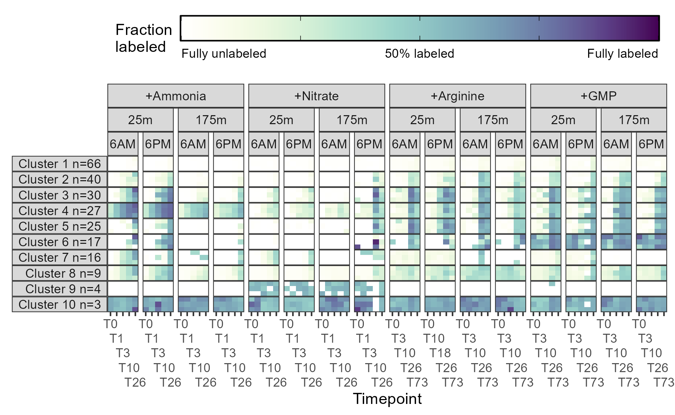
Figure 9: Fraction of each cluster containing at least one ¹⁵N label during the surface seawater amendments with various substrates after the number of hours shown on the x-axis. Darker colors indicate a larger percentage of the feature signal was isotopically labeled. Three biological replicates are stacked vertically at each timepoint and the labeling within each clusters has been averaged across all the composing features. The number of features in each cluster is specified by the n in the facet name. GMP = guanosine monophosphate.

Discussion

Environmental context of the incubations
The chronic nitrogen limitation of the North Pacific Subtropical Gyre (NPSG) creates fierce competition for this element, yet clearly not all nitrogen is equally available. Instead, a grand marketplace of nitrogenous molecules exists in which organisms attempt to match high-affinity uptake transporters and intracellular enzymes to the available dissolved nitrogen while minimizing energy costs (Moran et al. 2016). Here, we directly measured the uptake and use of four forms of nitrogen using stable isotope metabolomics.
We collected water for the incubations from an anticyclonic eddy near Station ALOHA that was experiencing the decay of a surface diatom bloom, specifically Hemiaulus. Hemiaulus is known to be associated with the diazotroph Richelia and has been observed in blooms worldwide (Carpenter et al. 1999; Villareal 1994; White, Watkins-Brandt, and Church 2018; Castillo Cieza et al. 2024) where its production from N₂ fixation can exceed that of nitrate upwelling. By the end of the bloom, we saw a return to more typical Station ALOHA conditions with a well-defined deep chlorophyll maximum (DCM) and an ingrowth of Synechococcus and Prochlorococcus while the amount of heterotrophic bacteria decreased. Data from 175 meters was significantly more sparse, with only a few CTD casts that indicated relatively stable conditions below the DCM.
The incubations were amended with large amounts of nitrate and ammonia to ensure a detectable signal. The final 3 µM concentration is comparable to other recent incubations with nitrate and ammonia (Rii, Bidigare, and Church 2018; Zimmerman et al. 2023; Shilova et al. 2017) and for a comparable length of time. Fewer incubations have been done with organic nitrogen, particularly with a whole seawater community, but we estimate that the arginine and guanosine monophosphate (GMP) that we added (50 nM) was at least a hundred times the normal environmental concentration of these compounds. However, the 4-5 µM concentration of dissolved organic nitrogen (DON) was another hundred times the concentrations we used, so while we almost certainly swamped the arginine and GMP pools (and likely the labile organic pool as a whole) we did not exceed the total organic nitrogen available in the system. Additionally, our use of GMP instead of guanosine means that organisms may have taken up GMP for the phosphate, especially at the surface where environmental concentrations were <0.05 uM, though this part of the molecule was unlabeled and we were unable to trace it.
We also did not measure the final concentrations of the amended molecules remaining in the dissolved phase at the end of the experiments. However, Rii, Bidigare, and Church (2018) reports nitrate and ammonia uptake rates in the hundreds of nanomolar per day indicating the excess DIN was likely available after the 26 hour incubations. We did see a sizable fraction of the organics used, however, with up to 25 nM ¹⁵N labeling in the metabolites and nearly 100 nM concentrations of labeled THAAs at both depths. The fact that the summed quantity of label in the THAAs exceeds the initial concentration is a result of the amended molecule providing more than 1 mole of ¹⁵N per mole of substrate, with arginine containing 4 nitrogens and GMP containing 5 nitrogens for a final ¹⁵N concentration of 200 nM and 250 nM, respectively.
An important question when assessing the applicability of this study to the broader environment is the likelihood of a community shift during the incubation. While these were relatively short (1 day for the inorganics and 3 days for the organics), prior studies have shown that a significant amount of diatoms, haptophytes, and pelagophytes are capable of growing in within a few days (Rii, Bidigare, and Church 2018; Alexander et al. 2015; McAndrew et al. 2007). The heterotrophic bacteria appear to respond even more quickly, with Shilova et al. (2017) observing a growth of Alteromonadaceae and picoeukaryotes and Goldberg et al. (2017) detecting an extensive cascade of heterotrophic organisms during a one-week incubation. In contrast, Zimmerman et al. (2023) found very few changes in community structure during their 11-hour incubations. Thus, the first few timepoints of our study likely reflected Station ALOHA conditions quite well, while the 1 day and 3 day incubations probably resulted in a community shift towards larger eukaryotes.

Contrasting the metabolic pathways taken by four forms of nitrogen
Ammonia was taken up immediately and resulted in extensive labeling of glutamine even within the first 20 minutes of the incubation at both 25 and 175 meters. This indicates that the ammonia transporters and glutamine synthetase were expressed throughout the community and the substrate was eagerly consumed at both the surface and below the DCM, demonstrating the bioavailability of ammonia and the intense competition as well as hinting at a very high flux of the existing ammonia pool even at environmental concentrations. This ¹⁵N signal rapidly propagated to the expected amino acids via well-established pathways, though much slowly at depth. One surprise was the extensive labeling of citrulline, a central urea cycle metabolite, without the associated propagation to arginine and ornithine. This indicates that the ammonia was likely being processed into carbamoyl phosphate via the CPS enzyme instead of ornithine via the Arg* synthesis pathway, potentially as a detoxification mechanism (Armbrust et al. 2004; Armbrust 2009). Also surprising to us was the rate at which nucleobases were labeled, most commonly with all nitrogens as ¹⁵N. This indicates that either nucleobase synthesis was already highly active or was triggered by the addition of ammonia. Notably, the deoxyribose forms of the nucleosides were then labeled more slowly than the ribose forms, hinting at a slower turnover of DNA components than RNA.
In contrast, nitrate was available to only a subset of the community and did not result in widespread labeling either at the surface or at depth. Not all organisms are able to use nitrate, most notably absent in a majority of clades in the abundant cyanobacteria Prochlorococcus (Berube et al. 2015; Partensky and Garczarek 2010; Martiny, Kathuria, and Berube 2009). Typically, nitrate amendments result in the growth of diatoms, with smaller contributions from haptophytes or pelagophytes (Alexander et al. 2015; Rii, Bidigare, and Church 2018). Diatoms are capable of nitrate reduction and we suspect that they are the primary source of the ¹⁵N labeling seen in the nitrate incubations. We see clear patterns of a community subset in the labeling patterns of guanine, MAAs, and the THAAs, all of which had a fraction labeled greater than the bulk glutamine/glutamate pool and is thus not possible with a homogeneously mixed pool. The extensive labeling of the THAAs in particular relative to the metabolite pool indicates that a majority of the protein synthesis was done by a subset of the community able to assimilate nitrate which requires a high-flux amino acid pool. Additionally, the MAAs are synthesized by adding amino acids to the 4-deoxygadusol core (Wada, Sakamoto, and Matsugo 2015), requiring that the glycine, serine, and threonine pools also be at least as heavily labeled as the MAAs they compose.
Importantly, the amount of nitrate added is massively in excess of the quantity normally available at the surface which likely resulted in a lag as nitrate-sensitive genes were turned on and processing proteins translated, so it is possible that a longer incubation time would have resulted in additional labeling if this was a major limiting factor. However, we see similar results in the amount of protein labeled between ammonia and nitrate by Zimmerman et al. (2023), who also observed significantly more labeling from ammonia than nitrate. The clear upward vertical propagation of increasingly reduced forms of nitrogen (ammonia max < nitrite max < nitrate max) also hints at the role the more oxidized forms may play as electron sinks in the surface ocean where light is abundant.
The two forms of organic nitrogen were used almost identically at both the surface and below the DCM as well as at 6AM and 6PM. In all eight circumstances, the first 10 hours showed essentially no labeling aside from the amended molecule and its direct products (e.g. citrulline & guanosine), then the fraction labeled spiked up at T26. This similarity leads us to believe that the heterotrophic community was responsible for most of the labeling that occurred in these incubations, in agreement with the general philosophy that heterotrophic bacteria are the primary sinks of DON on long timescales (Berthelot et al. 2021; Bradley et al. 2010) despite clear evidence that autotrophs are capable of taking up and using organic substrates (Muñoz-Marín et al. 2020; Antia, Harrison, and Oliveira 1991; Deborah A. Bronk et al. 2024). The especially heavy labeling (>75% across the board) of the nucleobases and nucleosides from organic substrates indicate that their synthesis was a priority for the community. This, combined with the large amount of THAA synthesis indicates net synthesis of biomass, as seen in the majority of the metabolite concentrations also increasing over the experiment duration.
Organic nitrogen additions may have relieved N limitation at the surface and C limitation at depth, allowing similar degrees of growth in both locations. This is supported by the reuse of the carbon backbone in the THAAs, with proline and glutamate both showing ¹³C₅ ¹⁵N₁ labels in the arginine treatments and histidine showing ¹³C₅ ¹⁵N₃ synthesized during the guanosine monophosphate treatment, confirming that the ribose pool must have been swamped with fully ¹³C labeled ribose cleaved from guanosine in order to enter the phosphoribosyl pyrophosphate pathway. The ¹⁵N₃ pattern also indicates that for these communities, glutamate, glutamine, and adenine were also >50% labeled. Finally, both phenylalanine and tyrosine had significant ¹³C₄ ¹⁵N₁ labeling, likely from erythrose 4-phosphate via the pentose phosphate pathway indicating new synthesis through shikimate with nitrogen addition from a heavily labeled glutamate pool again. In contrast, the lack of corresponding osmolyte synthesis would indicate that total biomass did not increase enough to demand the synthesis of additional salinity-balancing metabolites.

Conclusion
Together, these results highlight the diverse strategies employed by marine microbial communities to obtain nitrogen under oligotrophic conditions. Ammonia was rapidly and broadly utilized, underscoring its high bioavailability and central role in nitrogen metabolism across depths. In contrast, nitrate uptake was limited to a smaller subset of the community, likely eukaryotic phytoplankton, and occurred more slowly. Organic nitrogen substrates, though used more slowly initially, were ultimately incorporated into a wide range of metabolites with striking similarity across depths and diel cycles, pointing to the central role of heterotrophic bacteria in dissolved organic nitrogen assimilation. These findings reinforce the view of the ocean’s nitrogen pool as a dynamic and structured marketplace, shaped not only by elemental availability but by the biochemical capabilities and ecological roles of distinct microbial players.

Methods

Cruise information
The PARAGON cruise (KM2112) departed Honolulu, HI on July 22nd, 2021 and returned on August 5th. Satellite chlorophyll and sea level anomaly estimates were used to target an anticyclonic eddy with a large bloom signal. Samples were collected during the CTD upcast between 21.4 °N, 155.1 °W and 25.5 °N, 156.6 °W.

Biogeochemical data
Biogeochemical measurements were collected following protocols used by the HOT program (http://hahana.soest.hawaii.edu/hot/methods/results.html). Particulate carbon and particulate nitrogen were measured using an elemental analyzer. Nitrate + nitrite (N+N) was measured on an autoanalyzer while ammonia and nitrite were measured via. Soluble reactive phosphorus (phosphate, PO$​_{4}^{3-}$) was measured on an autoanalyzer or following the magnesium induced coprecipitation method.

Community composition data
Water column community composition was estimated for the initial community via flow cytometry (FCM), imaging flowcytobot (IFCB), and amplicon sequence variants (ASVs). FCM was done via XXX three times during the cruise on July 25th, July 29th, and August 2nd at six depths from 5 to 125 meters. Depth profiles from the IFCB were collected twice via XXX. The first IFCB profile took place on July 27th at nine depths from 5 to 300 meters and the second on August 5th at four depths from 5 to 125 meters. Annotation of the selected particles was done via a convolutional neural net. One ASV depth profile was collected during the PARAGON cruise on July 30th, also at nine depths from 5 meters down to 500 meters and processed according to the methods detailed in Li et al. (2023).

¹⁵N incubations
Morning CTD casts were returned to the surface between 6:40 and 7:15AM, with amendments happening ~20 minutes after the CTD surfaced. Evening casts were sometimes delayed, with most incubations beginning between 7:15 and 7:45PM but the nitrate 175m cast amended at 9:30PM, the arginine 175m cast amended at 8:30PM, and the guanosine monophosphate 25m cast amended at 8:25PM. ~30 liters of water from multiple CTD bottles were distributed into 15 prewashed (3x DI, 3x with sampled seawater) polycarbonate 2L bottles (3x biological triplicates at each of 5 timepoints) for metabolites and 6 250 mL bottles for THAAs (3x triplicates of initial and final conditions). Clean 53 µm mesh was used when transferring from CTD to incubations bottles to exclude zooplankton and large aggregates from the incubations.
2L samples were given a 1 mL spike with 6 mM Na¹⁵NO₃, 6 mM ¹⁵NH₄Cl, 0.1 mM ¹³C₅ ¹⁵N₄ arginine, or ¹³C₁₀ ¹⁵N₅ guanosine monophosphate to obtain a 3 µM final concentration of the inorganics and a 50 nM final concentration of the organics. 250 mL samples were given a 125 µL spike to the same final concentrations. T0 samples were then immediately filtered using a peristaltic pump and Masterflex tubing onto 47 mm 0.2 µm Omnipore (PTFE) filters held by polycarbonate holders. We tried to filter the entire sample in less than 20 minutes (flow rate ~6 L/hour) but some samples took up to an hour. All 250 mL THAA samples finished within 5 minutes and were filtered onto Durapore (PVDF) instead. Filters were then removed using ethanol-washed tweezers and placed into pre-combusted foil packets before flash-freezing in liquid nitrogen and then stored at -80 °C until processing.
Later timepoints followed the same process but were stored in flow-through incubators with blue shading to match mixed layer light and temperature conditions. Inorganic amendments were sampled after 1, 3, 10, and 26 hours to avoid sampling overlap with the next set. The organic amendments were sampled at 3, 10, 26, and 73 hours except for the arginine 25 meter 6AM samples, where the T3 timepoint was missed and sampled after 18 hours instead. 175 meter samples were stored in black trash bags to minimize light exposure during the incubations as well.

Incubation sample processing

Metabolite extractions
A modified Bligh & Dyer dichloromethane:water/methanol extraction was used as detailed in Boysen et al. (2018). Sample filters were removed from the freezer and randomly assigned to PTFE centrifuge tubes with a 1:1 mix of 100 µm and 400 µm silica beads, approximately 2 mL -20 °C Optima-grade dichloromethane, and approximately 3 mL -20 °C 1:1 methanol/water solution (both also Optima-grade). Samples were then run through a bead-beater and had the aqueous layer removed and replaced three times. The aqueous fraction was then warmed and dried under clean nitrogen gas before reconstitution into 300 µL of Optima-grade water.
At this point the samples were split into two 30 µL aliquot for analysis both with and without a full suite of isotope-labeled internal standards. Samples that received the internal standards were used for quantification of the unlabeled metabolite while those that did not were used to estimate the isotope distributions though they still received an internal standard mix of ²H₈ phenylalanine and ²H₄ taurine to ensure all samples were successfully injected. The full list of internal standards can be found in the Supplemental Information (Table XX).
A pooled sample was created from 5-10 µL of each sample for a total volume of 300-600 µL that was used to assess matrix suppression and obscuring variation. We also ran samples of pure, unlabeled compounds split into two mixes in the pooled sample used to estimate the response factor of the instrument for quantification (Boysen et al. 2018). Samples were then placed directly into the autosampler for injection.

Total hydrolyzable amino acid extractions
Amino acids were hydrolyzed as in Fountoulakis and Lahm (1998) with minor modifications. Samples were heated at 120 °C for 20 hours instead of 110 °C for 20-24 hours. Initial recovery tests with bovine serum albumin (BSA) resulted in better recovery of the amino acids at 120 °C as compared to 110 °C. A shorter hydrolysis with BSA at 150 °C was also tried but recovery of amino acids was highest at 120 °C.
Filters were transferred into combusted 4 mL glass vials with enough 6N hydrochloric acid to cover the filter. Each sample was purged under nitrogen gas for 30 seconds before immediately sealing with a solvent rinsed cap. The samples were then heated at 120 °C for 20 hours. The acid was then transferred to a clean, combusted glass vial. The original glass vial and filter were rinsed with approximately 500 µL of Optima grade water and transferred to the new glass vial. A rinsing step was repeated with an equal volume of Optima grade methanol. The acid mixture was concentrated to dryness under nitrogen gas and medium heat. Once dried, approximately 500 µL of water was used to rinse each vial and samples were returned to the nitrogen gas. Dried samples were re-dissolved in 400 µL of Optima grade water and syringe filtered into LCMS vials.
Amino acids were derivatized as in Gray et al. (2017) using the AccQ Tag Ultra derivatization kit from Waters. 10 µL of each sample was transferred into a new glass LCMS vial and 70 µL of borate buffer was added to each vial. After vortexing, 20 µL of AccQ Tag Ultra derivatizing agent was added to each sample and the vials were heated at 55 °C for 10 minutes before being cooled and transferred to the autosampler for injection.

HPLC-MS methods
Separate LC-MS runs were used for each amendment experiment. Nitrate samples were run in August 2021, ammonia samples were run in September, and the organics were run in July 2022. Each run was treated as a single batch and injected in sequence while maintaining the randomization that had occurred during extraction to minimize chromatographic shifts from solvent or column switching.
For each run, a Waters Acquity I-Class UPLC with a SeQuant ZIC-pHILIC column (5 µm particle size, 2.1 mm x 150 mm, from Millipore) was used with 10 mM ammonium carbonate in 85:15 acetonitrile to water (Solvent A) and 10 mM ammonium carbonate in 85:15 water to acetonitrile (Solvent B) at a flow rate of 0.15 mL/min. The column was held at 100% A for 2 minutes, ramped to 64% B over 18 minutes, ramped to 100% B over 1 minute, held at 100% B for 5 minutes, and equilibrated at 100% A for 25 minutes (50 minutes total). The column was maintained at 30 °C. The injection volume was 2 µL for samples and standard mixes. When starting a batch, the column was equilibrated at the starting conditions for at least 30 minutes. To improve the performance of the HILIC column, we maintained the same injection volume, kept the instrument running water blanks between samples as necessary, and injected standards in a representative matrix (the pooled sample) in addition to standards in water. After each batch, the column was flushed with 10 mM ammonium carbonate in 85:15 water to acetonitrile for 20 to 30 minutes.
The Waters Acquity UPLC was coupled to a Thermo Q Exactive HF hybrid Orbitrap high resolution mass spectrometer equipped with a heated electrospray ionization source (H-ESI). Each metabolite sample was run on a full scan method three times: once from the vial with internal standards with polarity switching at a resolution of 60,000, once from the vial without internal standards at a resolution of 240,000 in positive mode, and once again from the vial without internal standards at a resolution of 240,000 in negative mode. During all injections we set a scan range of 60 to 900 m/z and with an AGC target of 1 million and a max injection time of 200 ms. The capillary temperature was set to 320 °C, the H-ESI spray voltage to 3.5 kV, and the auxiliary gas heater temperature to 90 °C. The S-lens RF level was 65. Sheath gas, auxiliary gas, and sweep gas flow rates were maintained at 16, 3, and 1, respectively. For the quality control pooled samples, both high-resolution MS scans and data dependent MS/MS scans were collected and separate injections were done for positive and negative ion modes (30,000 resolution and a dynamic exclusion time of 20 seconds for MS/MS data, top five most abundant ions in each cycle were fragmented, collision energies of 20, 35, and 50 eV). The MS/MS AGC target was set to 50,000 and the maximum injection time was 100 ms. The mass spectrometer was calibrated weekly in positive and negative mode using solutions provided by the manufacturer.
For analysis of derivatized amino acids, a Waters Acquity UPLC HSS T3 column (1.8 µm particle size, 2.1 mm x 150 mm) was used with 0.1% formic acid in water (Solvent A) and 0.1% formic acid in acetonitrile (Solvent B) at a flow rate of 0.6 mL/min. The column was held at 4% B for 0.5 minutes, ramped to 10% B over 2 minutes, ramped 28% B over 2.5 minutes, ramped to 95% B over 0.5 minutes, held at 95% B for 1 minute, and equilibrated back to 4% B for 2.5 minutes (total run time is 9 minutes). The column temperature was maintained at 45°C. A full scan method in positive ion mode was used with a scan range of 100 to 600 m/z and a resolution of 60,000 on a Thermo Scientific Q Exactive HF Orbitrap. The capillary temperature was 320 °C, the H-ESI spray voltage was 3.8 kV, and the auxiliary gas heater temperature was 90 °C. The S-lens RF level was 65. Sheath gas, auxiliary gas, and sweep gas flow rates were maintained at 50, 15, and 1, respectively.

Data analysis
Raw files were converted to mzML format via Proteowizard’s MSConvert command line tool (version 3.0.25009, Chambers et al. (2012)) with vendor centroiding and separated into positive and negative mode files.

Targeted analysis
We used the RaMS R package (version 1.4.3, Kumler and E. Ingalls (2022)) to extract ion chromatograms from the samples without internal standards for each of the ~200 compounds for which we had a pure standard available. Each chromatogram was then visualized and the start and end retention times manually entered for each compound and MS run that had a high-quality mass feature that matched the pure standard in retention time. We then calculated all the possible isotopes for each known compound and extracted those EICs as well, using the same retention time bounds as for the unlabeled feature. We integrated each of those peak areas using a trapezoidal Riemann sum (trapz function in the RaMS package) if the unlabeled and labeled chromatograms shared more than 5 scans and had a correlation between the ¹⁴N and ¹⁵N peak intensities with a p-value below 0.01 to remove interfering ions. Samples which accidentally received isotope-labeled internal standards had the peak areas for that specific isotopologue set to zero. After the untargeted analysis we repeated this process for any compounds for which we were confident of an annotation (e.g. theanine and the MAAs).
The same process was used for the samples with internal standards except that the isotopes were not considered. These peak areas were then normalized to their best-matched internal standard (Boysen et al. 2018) and quantified using the response factors estimated from the standards in the pooled sample. Samples that accidentally did not receive isotope-labeled internal standards had their peak areas interpolated as the average value of the samples immediately preceding and following.

Untargeted analysis
We used the R package xcms (version 4.6.0, Smith et al. (2006)) to perform an untargeted analysis on the positive-mode pooled and environmental samples without internal standards across all four MS runs simultaneously (282 files). We used the CentWave algorithm (Tautenhahn, Böttcher, and Neumann 2008) with default settings except for ppm which was set to 5, peakwidth which was set to between 20 and 80, prefilter which was set to 5 scans above 10,000, snthresh which we set to 5, and integrate which we set to 2. We also enabled verboseColumns and extendLengthMSW. We did not perform retention time correction since manual inspection of the TIC and a few selected compounds did not reveal significant retention time drift. We then performed correspondence via peak density with each set of replicates counting as a sample group, the bandwidth set to 12, minFraction set to 1, binSize set to 0.001, and all other settings kept at their defaults. Finally, we filled peaks using the original xcms algorithm and default settings.
Once features were identified, we then re-integrated the individual peaks and used the same retention time bounds to integrate any data at a mass difference of -0.997035, in essence assuming that the peak detected by xcms was a ¹⁵N peak for which a ¹⁴N peak should exist to get high-quality isotope ratios. High quality features were those with a retention time above 2 minutes and a median beta_snr value larger than the median beta_snr value times -50 plus 50, thus drawing a diagonal line through the med_snr:med_cor space above which high quality features are more likely to be found (Kumler, Hazelton, and Ingalls 2023). Additionally, high-quality features were only considered to be isotopes if the correlation between the intensity values of the ¹⁴N and ¹⁵N peaks was above 0.8. We also removed peaks that eluted between 14 and 14.5 minutes because many of them appeared to be adducts or in-source transformations of bisulfate.

Statistics
Statistics were run in R version 4.5.0 (R Core Team 2025). We fit logistic regression curves to the fraction of the metabolite peak area labeled using R’s glm function to model labeling fractions and error distributions except where only the final timepoint had signal, in which case we used a one-sample t-test to determine whether the labeling was significantly different from zero using only the final timepoint’s data. When testing whether untargeted compounds were increased over time we used Type-I linear models (lm in R) with a false-discovery rate correction (p.adjust, Benjamini and Hochberg (1995)) and log-scaled time and peak area. Analyses were performed on triplicate data points across the 5 timepoints for a sample size of 15 with the exception of the 175 meter 6PM nitrate incubations for which T10 was removed due to anomalous labeling patterns and unclear sampling timing (resulting in n=12) and replicate B in the 25 meter 6AM guanosine monophosphate amendments at T26 which was lost during sample processing (n=14). k-means clustering was performed via kmeans from the stats package with 10 clusters after no clear jump in variance explained was observed with other cluster numbers, indicating the labeling patterns likely exist as a gradient instead of discrete groups.

Acknowledgements
We would like to acknowledge the captain and crew of the R/V Kilo Moana for making this science possible. We would also like to thank the other members of the Ingalls, White, and BEACH labs who provided assistance in sample processing, integration, and analysis. This work was supported by grants from the Simons Foundation (SCOPE Award ID 329108 to AI, SF Award ID 385428 to AI, and SCOPE Award ID 721264 to David Karl which supported BB).
The authors have no conflicts of interest to declare.

Data availability

References
Alexander, Harriet, Mónica Rouco, Sheean T. Haley, Samuel T. Wilson, David M. Karl, and Sonya T. Dyhrman. 2015. “Functional Group-Specific Traits Drive Phytoplankton Dynamics in the Oligotrophic Ocean.” Proceedings of the National Academy of Sciences 112 (44). https://doi.org/10.1073/pnas.1518165112.
Aluwihare, Lihini I., and Travis Meador. 2008. “Chemical Composition of Marine Dissolved Organic Nitrogen.” In Nitrogen in the Marine Environment, 2nd ed., 95–140. Academic Press Burlington, MA.
Antia, N. J., P. J. Harrison, and L. Oliveira. 1991. “The Role of Dissolved Organic Nitrogen in Phytoplankton Nutrition, Cell Biology and Ecology.” Phycologia 30 (1): 1–89. https://doi.org/10.2216/i0031-8884-30-1-1.1.
Armbrust, E. Virginia. 2009. “The Life of Diatoms in the World’s Oceans.” Nature 459 (7244): 185–92. https://doi.org/10.1038/nature08057.
Armbrust, E. Virginia, John A. Berges, Chris Bowler, Beverley R. Green, Diego Martinez, Nicholas H. Putnam, Shiguo Zhou, et al. 2004. “The Genome of the Diatom Thalassiosira Pseudonana : Ecology, Evolution, and Metabolism.” Science 306 (5693): 79–86. https://doi.org/10.1126/science.1101156.
Bender, Sara J., Micaela S. Parker, and E. Virginia Armbrust. 2012. “Coupled Effects of Light and Nitrogen Source on the Urea Cycle and Nitrogen Metabolism over a Diel Cycle in the Marine Diatom Thalassiosira Pseudonana.” Protist 163 (2): 232–51. https://doi.org/10.1016/j.protis.2011.07.008.
Benjamini, Yoav, and Yosef Hochberg. 1995. “Controlling the False Discovery Rate: A Practical and Powerful Approach to Multiple Testing.” Journal of the Royal Statistical Society: Series B (Methodological) 57 (1): 289–300. https://doi.org/10.1111/j.2517-6161.1995.tb02031.x.
Benner, Ronald, and Rainer M. W. Amon. 2015. “The Size-Reactivity Continuum of Major Bioelements in the Ocean.” Annual Review of Marine Science 7 (1): 185–205. https://doi.org/10.1146/annurev-marine-010213-135126.
Berthelot, Hugo, Solange Duhamel, Stéphane L’Helguen, Jean-François Maguer, and Nicolas Cassar. 2021. “Inorganic and Organic Carbon and Nitrogen Uptake Strategies of Picoplankton Groups in the Northwestern Atlantic Ocean.” Limnology and Oceanography 66 (10): 3682–96. https://doi.org/10.1002/lno.11909.
Berube, Paul M, Steven J Biller, Alyssa G Kent, Jessie W Berta-Thompson, Sara E Roggensack, Kathryn H Roache-Johnson, Marcia Ackerman, et al. 2015. “Physiology and Evolution of Nitrate Acquisition in Prochlorococcus.” The ISME Journal 9 (5): 1195–1207. https://doi.org/10.1038/ismej.2014.211.
Boysen, Angela K., Katherine R. Heal, Laura T. Carlson, and Anitra E. Ingalls. 2018. “Best-Matched Internal Standard Normalization in Liquid Chromatography–Mass Spectrometry Metabolomics Applied to Environmental Samples.” Analytical Chemistry 90 (2): 1363–69. https://doi.org/10.1021/acs.analchem.7b04400.
Bradley, Paul B., Marta P. Sanderson, Marc E. Frischer, Jennifer Brofft, Melissa G. Booth, Lee J. Kerkhof, and Deborah A. Bronk. 2010. “Inorganic and Organic Nitrogen Uptake by Phytoplankton and Heterotrophic Bacteria in the Stratified Mid-Atlantic Bight.” Estuarine, Coastal and Shelf Science 88 (4): 429–41. https://doi.org/10.1016/j.ecss.2010.02.001.
Bronk, D. A., J. H. See, P. Bradley, and L. Killberg. 2007. “DON as a Source of Bioavailable Nitrogen for Phytoplankton.” Biogeosciences 4 (3): 283–96. https://doi.org/10.5194/bg-4-283-2007.
Bronk, Deborah A., Rachel E. Sipler, Robert T. Letscher, and Matthew D. McCarthy. 2024. “Dissolved Organic Nitrogen.” In Biogeochemistry of Marine Dissolved Organic Matter, 343–404. Elsevier. https://doi.org/10.1016/B978-0-443-13858-4.00016-2.
Bronk, Deborah A., and Deborah K. Steinberg. 2008. “Nitrogen Regeneration.” In Nitrogen in the Marine Environment, 2nd ed., 385–450. Academic Press Burlington, MA.
Carpenter, Ej, Jp Montoya, J Burns, Mr Mulholland, A Subramaniam, and Dg Capone. 1999. “Extensive Bloom of a N2-fixing Diatom/Cyanobacterial Association in the Tropical Atlantic Ocean.” Marine Ecology Progress Series 185: 273–83. https://doi.org/10.3354/meps185273.
Castillo Cieza, S. Alejandra, Rachel H. R. Stanley, Pierre Marrec, Diana N. Fontaine, E. Taylor Crockford, Dennis J. McGillicuddy Jr., Arshia Mehta, et al. 2024. “Unusual Hemiaulus Bloom Influences Ocean Productivity in Northeastern US Shelf Waters.” Biogeosciences 21 (5): 1235–57. https://doi.org/10.5194/bg-21-1235-2024.
Chambers, Matthew C, Brendan Maclean, Robert Burke, Dario Amodei, Daniel L Ruderman, Steffen Neumann, Laurent Gatto, et al. 2012. “A Cross-Platform Toolkit for Mass Spectrometry and Proteomics.” Nature Biotechnology 30 (10): 918–20. https://doi.org/10.1038/nbt.2377.
Fountoulakis, Michael, and Hans-Werner Lahm. 1998. “Hydrolysis and Amino Acid Composition Analysis of Proteins.” Journal of Chromatography A 826 (2): 109–34. https://doi.org/10.1016/S0021-9673(98)00721-3.
Goldberg, S. J., C. E. Nelson, D. A. Viviani, C. N. Shulse, and M. J. Church. 2017. “Cascading Influence of Inorganic Nitrogen Sources on DOM Production, Composition, Lability and Microbial Community Structure in the Open Ocean.” Environmental Microbiology 19 (9): 3450–64. https://doi.org/10.1111/1462-2920.13825.
Gonsior, Michael, Leanne Powers, Madeline Lahm, and Shannon Leigh McCallister. 2022. “New Perspectives on the Marine Carbon Cycle–The Marine Dissolved Organic Matter Reactivity Continuum.” Environmental Science & Technology 56 (9): 5371–80. https://doi.org/10.1021/acs.est.1c08871.
Gray, Nicola, Rabiya Zia, Adam King, Vishal C. Patel, Julia Wendon, Mark J. W. McPhail, Muireann Coen, Robert S. Plumb, Ian D. Wilson, and Jeremy K. Nicholson. 2017. “High-Speed Quantitative UPLC-MS Analysis of Multiple Amines in Human Plasma and Serum via Precolumn Derivatization with 6-Aminoquinolyl- N -Hydroxysuccinimidyl Carbamate: Application to Acetaminophen-Induced Liver Failure.” Analytical Chemistry 89 (4): 2478–87. https://doi.org/10.1021/acs.analchem.6b04623.
Heal, Katherine R., Bryndan P. Durham, Angela K. Boysen, Laura T. Carlson, Wei Qin, François Ribalet, Angelicque E. White, Randelle M. Bundy, E. Virginia Armbrust, and Anitra E. Ingalls. 2021. “Marine Community Metabolomes Carry Fingerprints of Phytoplankton Community Composition.” Edited by Manuel Liebeke. mSystems 6 (3): e01334–20. https://doi.org/10.1128/mSystems.01334-20.
Hutchins, David A., and Douglas G. Capone. 2022. “The Marine Nitrogen Cycle: New Developments and Global Change.” Nature Reviews Microbiology 20 (7): 401–14. https://doi.org/10.1038/s41579-022-00687-z.
Jones, Catriona L. C., Judith Camps-Castella, Mike Smykala, Morgan S. Sobol, and Keisuke Inomura. 2024. “Seeing Through the Gray Box: An Integrated Approach to Physiological Modeling of Phytoplankton Stoichiometry.” Frontiers in Ecology and Evolution 12 (December): 1505025. https://doi.org/10.3389/fevo.2024.1505025.
Kumler, William, and Anitra E. Ingalls. 2022. “Tidy Data Neatly Resolves Mass-Spectrometry’s Ragged Arrays.” The R Journal 14 (3): 193–202. https://doi.org/10.32614/RJ-2022-050.
Kumler, William, Bryna J. Hazelton, and Anitra E. Ingalls. 2023. “Picky with Peakpicking: Assessing Chromatographic Peak Quality with Simple Metrics in Metabolomics.” BMC Bioinformatics 24 (1): 404. https://doi.org/10.1186/s12859-023-05533-4.
Li, Fuyan, Andrew Burger, John M. Eppley, Kirsten E. Poff, David M. Karl, and Edward F. DeLong. 2023. “Planktonic Microbial Signatures of Sinking Particle Export in the Open Ocean’s Interior.” Nature Communications 14 (1): 7177. https://doi.org/10.1038/s41467-023-42909-9.
Martiny, Adam C., Satish Kathuria, and Paul M. Berube. 2009. “Widespread Metabolic Potential for Nitrite and Nitrate Assimilation Among Prochlorococcus Ecotypes.” Proceedings of the National Academy of Sciences 106 (26): 10787–92. https://doi.org/10.1073/pnas.0902532106.
McAndrew, Pm, Km Björkman, Mj Church, Pj Morris, N Jachowski, leB Williams Pj, and Dm Karl. 2007. “Metabolic Response of Oligotrophic Plankton Communities to Deep Water Nutrient Enrichment.” Marine Ecology Progress Series 332 (March): 63–75. https://doi.org/10.3354/meps332063.
McParland, Erin L., Harriet Alexander, and Winifred M. Johnson. 2021. “The Osmolyte Ties That Bind: Genomic Insights Into Synthesis and Breakdown of Organic Osmolytes in Marine Microbes.” Frontiers in Marine Science 8 (July): 689306. https://doi.org/10.3389/fmars.2021.689306.
Moore, C. M., M. M. Mills, K. R. Arrigo, I. Berman-Frank, L. Bopp, P. W. Boyd, E. D. Galbraith, et al. 2013. “Processes and Patterns of Oceanic Nutrient Limitation.” Nature Geoscience 6 (9): 701–10. https://doi.org/10.1038/ngeo1765.
Moran, Mary Ann, Elizabeth B. Kujawinski, William F. Schroer, Shady A. Amin, Nicholas R. Bates, Erin M. Bertrand, Rogier Braakman, et al. 2022. “Microbial Metabolites in the Marine Carbon Cycle.” Nature Microbiology 7 (4): 508–23. https://doi.org/10.1038/s41564-022-01090-3.
Moran, Mary Ann, Elizabeth B. Kujawinski, Aron Stubbins, Rob Fatland, Lihini I. Aluwihare, Alison Buchan, Byron C. Crump, et al. 2016. “Deciphering Ocean Carbon in a Changing World.” Proceedings of the National Academy of Sciences 113 (12): 3143–51. https://doi.org/10.1073/pnas.1514645113.
Mulholland, Margaret R., and Michael W. Lomas. 2008. “Nitrogen Uptake and Assimilation.” In Nitrogen in the Marine Environment, 303–84. Elsevier. https://doi.org/10.1016/B978-0-12-372522-6.00007-4.
Muñoz-Marín, M C, G Gómez-Baena, A López-Lozano, J A Moreno-Cabezuelo, J Díez, and J M García-Fernández. 2020. “Mixotrophy in Marine Picocyanobacteria: Use of Organic Compounds by Prochlorococcus and Synechococcus.” The ISME Journal 14 (5): 1065–73. https://doi.org/10.1038/s41396-020-0603-9.
Partensky, Frédéric, and Laurence Garczarek. 2010. “Prochlorococcus: Advantages and Limits of Minimalism.” Annual Review of Marine Science 2 (1): 305–31. https://doi.org/10.1146/annurev-marine-120308-081034.
R Core Team. 2025. “R: A Language and Environment for Statistical Computing.” Vienna, Austria: R Foundation for Statistical Computing.
Rii, Yoshimi M., Robert R. Bidigare, and Matthew J. Church. 2018. “Differential Responses of Eukaryotic Phytoplankton to Nitrogenous Nutrients in the North Pacific Subtropical Gyre.” Frontiers in Marine Science 5 (March): 92. https://doi.org/10.3389/fmars.2018.00092.
Shilova, I. N., M. M. Mills, J. C. Robidart, K. A. Turk-Kubo, K. M. Björkman, Z. Kolber, I. Rapp, et al. 2017. “Differential Effects of Nitrate, Ammonium, and Urea as N Sources for Microbial Communities in the North Pacific Ocean.” Limnology and Oceanography 62 (6): 2550–74. https://doi.org/10.1002/lno.10590.
Smith, Colin A., Elizabeth J. Want, Grace O’Maille, Ruben Abagyan, and Gary Siuzdak. 2006. “XCMS: Processing Mass Spectrometry Data for Metabolite Profiling Using Nonlinear Peak Alignment, Matching, and Identification.” Analytical Chemistry 78 (3): 779–87. https://doi.org/10.1021/ac051437y.
Tautenhahn, Ralf, Christoph Böttcher, and Steffen Neumann. 2008. “Highly Sensitive Feature Detection for High Resolution LC/MS.” BMC Bioinformatics 9 (1): 504. https://doi.org/10.1186/1471-2105-9-504.
Villareal, TA. 1994. “Widespread Occurrence Of The Hemiaulus-Cyanobacterial Symbiosis In The Southwest North-Atlantic Ocean Widespread Occurrence Of The Hemiaulus-Cyanobacterial Symbiosis In The Southwest North-Atlantic Ocean Check Uw Holdings Widespread Occurrence Of The Hemiaulus-Cyanobacterial Symbiosis In The Southwest North-Atlantic Ocean.” Bulletin of Marine Science 54 (1): 1–7.
Wada, Naoki, Toshio Sakamoto, and Seiichi Matsugo. 2015. “Mycosporine-Like Amino Acids and Their Derivatives as Natural Antioxidants.” Antioxidants 4 (3): 603–46. https://doi.org/10.3390/antiox4030603.
Walker, Mark C, and Wilfred A Van Der Donk. 2016. “The Many Roles of Glutamate in Metabolism.” Journal of Industrial Microbiology and Biotechnology 43 (2-3): 419–30. https://doi.org/10.1007/s10295-015-1665-y.
White, Angelicque E., Katie S. Watkins-Brandt, and Matthew J. Church. 2018. “Temporal Variability of Trichodesmium Spp. And Diatom-Diazotroph Assemblages in the North Pacific Subtropical Gyre.” Frontiers in Marine Science 5 (February): 27. https://doi.org/10.3389/fmars.2018.00027.
Zehr, Jonathan P., and Raphael M. Kudela. 2011. “Nitrogen Cycle of the Open Ocean: From Genes to Ecosystems.” Annual Review of Marine Science 3 (1): 197–225. https://doi.org/10.1146/annurev-marine-120709-142819.
Zimmerman, Amy E., Justin C. Podowski, Gwendolyn E. Gallagher, Maureen L. Coleman, and Jacob R. Waldbauer. 2023. “Tracking Nitrogen Allocation to Proteome Biosynthesis in a Marine Microbial Community.” Nature Microbiology 8 (3): 498–509. https://doi.org/10.1038/s41564-022-01303-9.

Supplement

Supp fig: full heatmap of all compounds and timepoints

Supp fig: THAA labeling broken down by triplicate

Supp fig: All MAA labeling

Supp fig: All quant concentrations for top 15 across all treatments and timepoints

Supp fig: untargeted heatmap

Supp fig? Untargeted zimmerman

