Introduction

* Marine carbon is important and controlled by N availability in the NPSG
* Organic nitrogen is super diverse but this is not recognized
* Source of cell’s N has major influence on who uses it and presumably how it’s used
  + Lit review for nitrate and ammonia
    - GS/GOGAT/GDH
    - Nitrate mostly means diatoms
  + Expected pathways for arginine and GMP
* Metabolomics allows us to look at the actual metabolites and their labeling patterns
* Expected differences by time of day and sampling depth
  + Morning = preparation for photosynthesis, evening = prep to divide? ask Kathy
  + Surface = largely photosynthetic, 175m = largely heterotrophic
  + From Fuyan – surface = mostly pro and syn plus a little alpha gamma and SAR11, 175m = MG1, SAR324. “As expected, SASVs from surface waters were well represented by abundant photoautotrophic cyanobacteria like Prochlorococcus and Synechococcus, reflecting their passive entrainment with sinking particles that reach greater depths. Prokaryotic SASVs from 175 to 200 m included oligotrophic heterotrophs like SAR324, SAR11, and chemolithoautotrophic archaeal nitrifiers like Nitrosopelagicus.”

Methods

Results

* Rapid labeling of amino acids and nucleobases from ammonia at surface in morning, slow labeling of osmolytes
  + FIGURE: Heatmap with grouped categories
  + 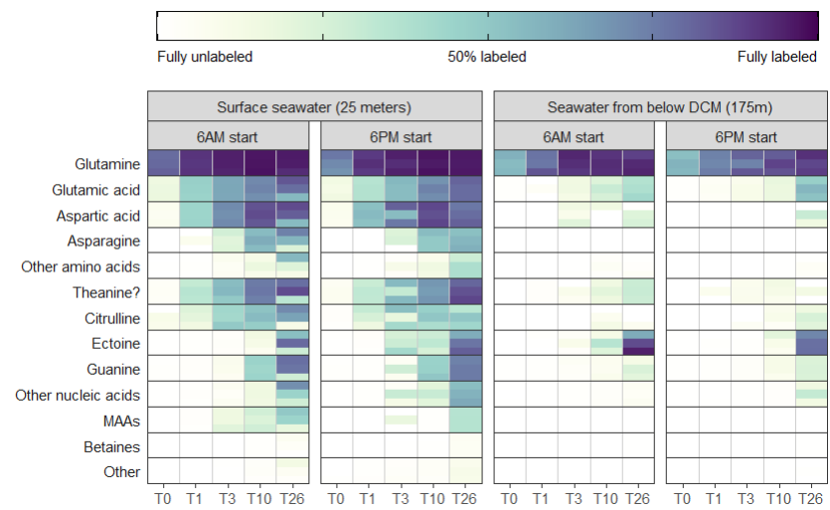
* Same basic pattern in the evening except MAAs, guanosine, proline?
* Deep labeling is slower and much more limited
  + FIGURE: Regression coefficients  
    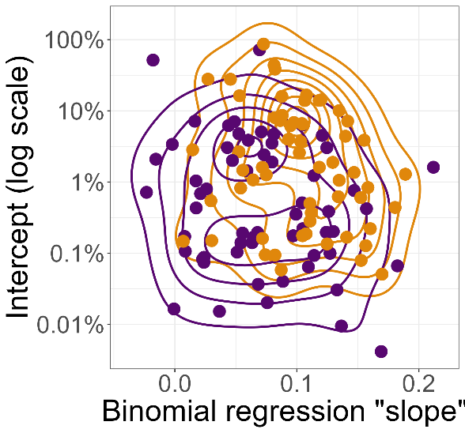  
    Plot alongside a couple actual regressions? Glut/Guan/Ecto/GBT/Asp/Asn  
    Plot with error bars?  
    Maybe just do histogram of differences?  
    Maybe just do boxplot of differences?
  + Asp/Asn especially
  + Ectoine major exception (ref mcparland for bacterial signal)
  + No real morn/eve differences, as expected
* Nitrate surface labeling surprisingly minimal
  + “out of order” labeling in guanine and MAAs, maybe also arginine, taurine, NAc-lysine, maybe maybe theanine being unlabeled because it would mean diatoms don’t make it?
  + FIGURE: MAA labeling?  
    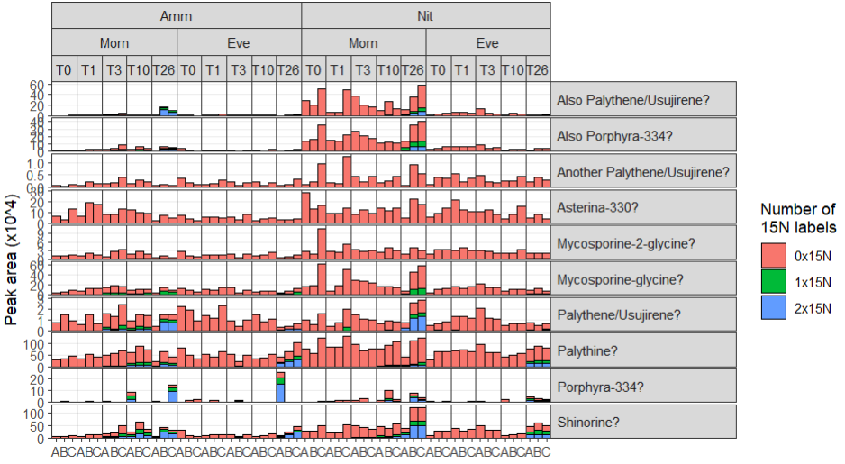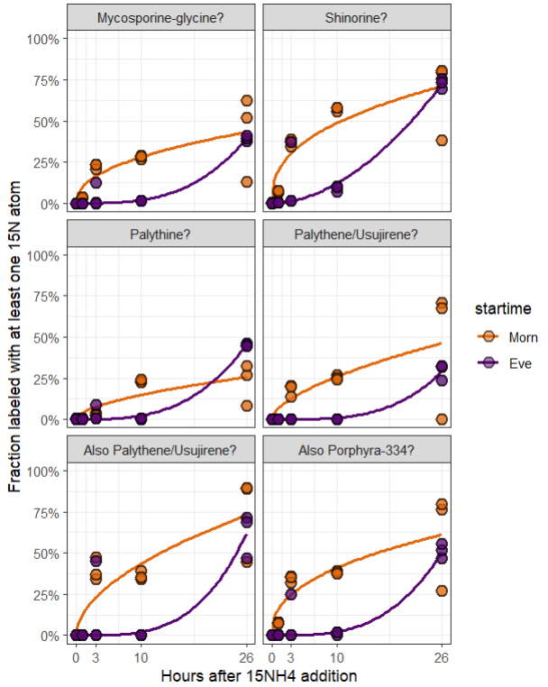
* Deep nitrate labeling borked by bad sampling :(
  + Based on data available certainly seems like more labeling happens at depth than at surface
  + Very heavy labeling of nucleobases, homarine – looks like late organic sample
  + No MAAs present – probably deep sample
  + Very LITTLE labeling in the morning samples at T10/T26 when they should be the same
  + Should I just throw out these data points? Ugh.
* Both organics look very similar to each other
  + Exceptions for guanosine (not guanine!) in GMP
  + Exceptions for arginine/citrulline in Arg, maybe some ornithine
    - Arginine (and citrulline) label seems to go away after 24/72 hours unclear how
  + Equal labeling at surface vs deep, maybe a little more at depth
  + Basically zero diel differences
  + Surprised at BIG labeling pulse at 24hr no matter what condition, no real increase in labeling to T73
  + Organics appear to be mostly remineralized into ammonia instead of passed around as-is
    - Carbon backbone traced into glutamate from arginine
    - Carbon backbone traced into other nucleobases from GMP
    - Possibly due to way too much of a given compound, useless to have that much Arg/GMP
    - Not very much fully-labeled guanine despite guanosine being easily cleavable, instead it’s mostly made from scratch (CHECK THIS)
  + Fun callouts
    - Creatine for being mostly 2x15N 1x13C labeled from arginine
  + Discussion: 73 hours is probably enough for some early community restructuring
  + FIGURE: tbd, maybe another heatmap?
* Total number of compounds labeled at a given level over time
  + 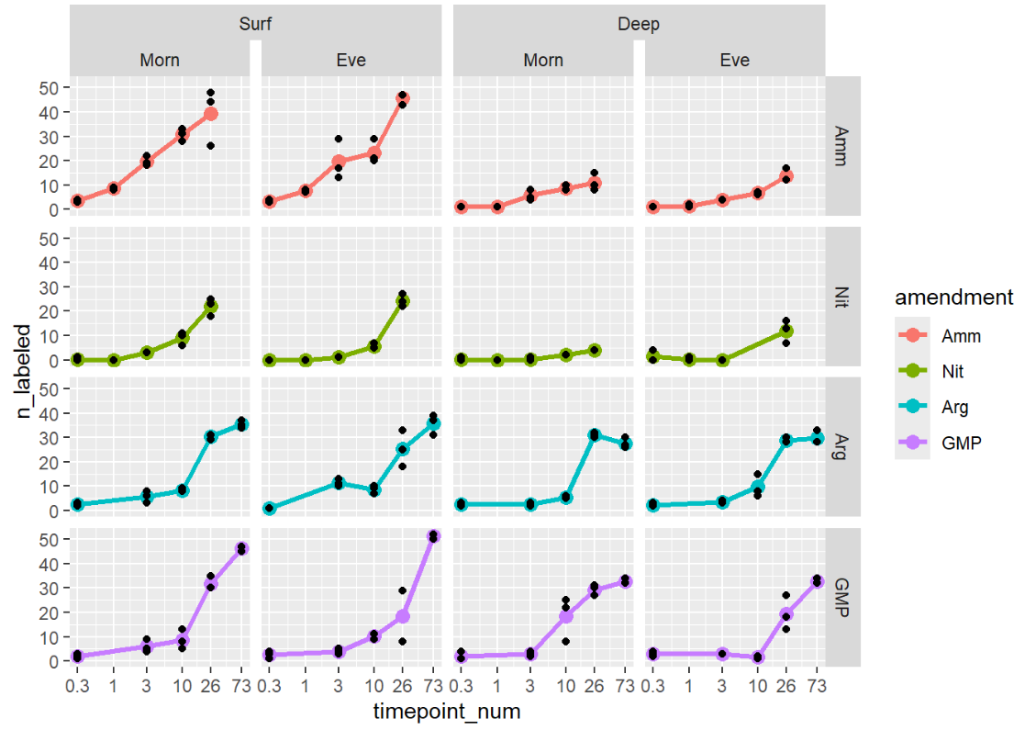
* Other possible figures that don’t yet have a home:
  + Guanine data:  
    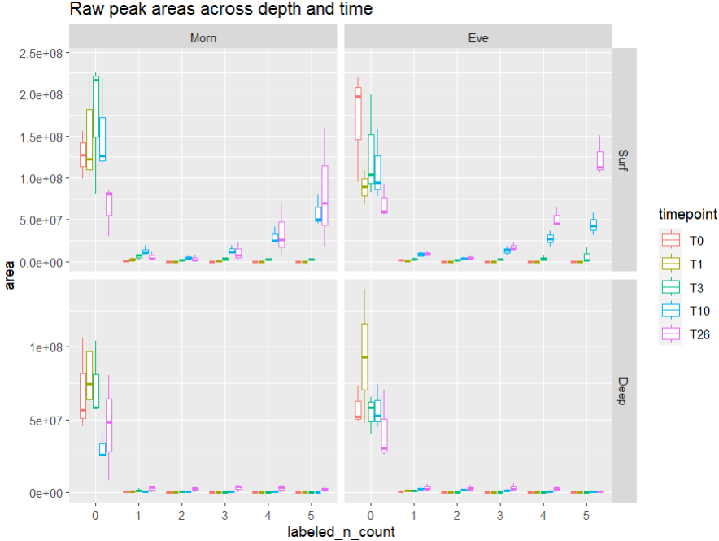
  + NMDS plot of metabolites with just unlabeled known metabs (no isotopologues)  
    Shows change in unlabeled metabolite abundance over the course of the incubation (decreases in most compounds since new things are being made from isotope versions?  
    