First interview:
- The interviewer(He) asked me if there is anything I did not on the resume but I want to share.
I said what I did is just on my resume. The better answer would be: I did have other projects, but I think they are not very related to the role. For example, in the network processor design course, we built a multi-threaded network processor with a hardware accelerator based on bloom filter to find the malicious packet in wired-speed.( I can also share ML hardware accelerator project below, but my brain just went blank during the interview)
- He asked me if I have any projects on my ML hardware accelerator courses.
My answer was too vague and not confident. Since I write it on my resume, I should prepare to talk about at least the overview of my project. So the better answer would be:
We first trained and quantized a CNN model called SqueezeNet on Pytorch. Then we modeled the hardware accelerator using HLS and implemented the accelerator on Xilinx ZYNQ FPGA platform to accelerate inference. (If asking for results, then answer accuracy and kernel latency(performance).)
- How RoB and CFC work together to allow out-of-order execution while guarantee in-order commitment
My explanation lacked organization. I started with RoB, but I didn’t explain that well. A clearer explanation: The ROB guarantees in-order retirement even though instructions execute out of order. Instructions may finish execution in any order, but they commit from the head of the ROB in program order. This ensures precise exceptions and allows safe recovery from branch mispredictions or faults. The ROB also tracks speculative instructions and identifies which younger instructions must be flushed after a misprediction.
The CFC handles speculative register renaming recovery. It maintains the committed RRAT state together with checkpointed speculative rename information that collectively represent the FRAT state. During dispatch, instructions are renamed using speculative mappings to eliminate WAR and WAW hazards. When a branch is dispatched, a checkpoint is created. If the branch later mispredicts, the processor restores the checkpoint associated with that branch and frees all younger speculative checkpoints.
- Why do we need two kinds of RAT, what they are solving
The FRAT (Front-end RAT) tracks the latest speculative register mappings and is used during dispatch for register renaming. It allows the processor to eliminate WAR and WAW hazards by assigning new physical registers to destination operands.
The RRAT (Retirement RAT) stores only committed mappings, so it represents the precise architectural state of the machine.
We need both because speculative instructions may later be flushed due to exceptions or branch mispredictions. In that case, the processor must recover the last correct architectural state quickly. The RRAT provides this committed mapping, while the FRAT may contain speculative mappings from wrong-path instructions.

- Then he asked what is the purpose of CFC and what is it solving in the tomasulo machine
I think it’s because I didn’t explain well in my previous question.
- Describe the key difference between MOESI vs simpler MESI protocol. What problem does that O state solve and how to improve performance
MOESI protocol adds an additional “dirty” state called O state.
The O state allows a cache line to be both dirty and shared at the same time.
In MESI, when another core reads a line in Modified state, the dirty data usually has to be written back to memory (or memory updated) before the line can become shared.
In MOESI, the cache holding the dirty line transitions from M to O and directly supplies the data to the requesting cache through cache-to-cache transfer. The requester enters S state while memory may still contain stale data.
This reduces memory writebacks and memory bandwidth usage, improving performance and latency.

- What is the difference between a particular processor owing the line in exclusive state versus modified state
I didn’t say the point. Exclusive state is the “clean” state that has the only copy of a cache line, while Modified state is the “dirty” state that has the only copy of a cache line.

- Fill the state transition table for each step using MOESI and MESI respectively
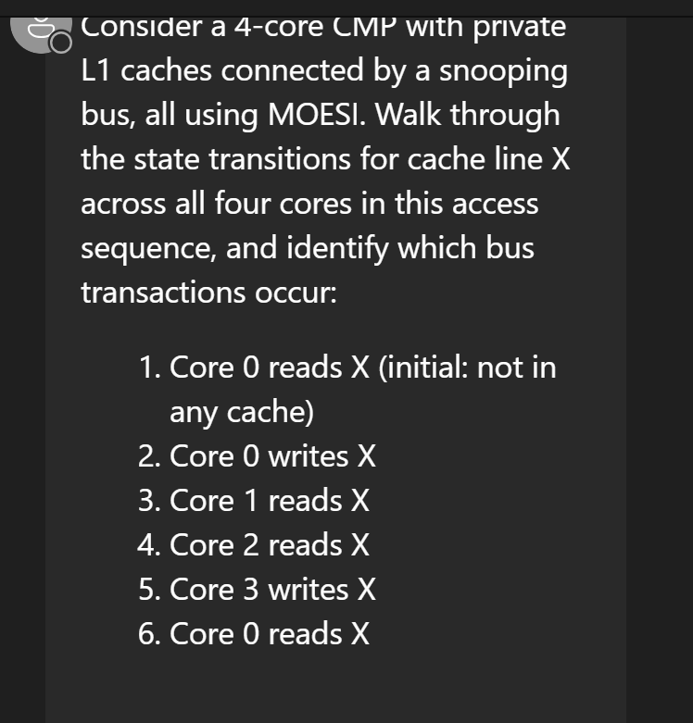
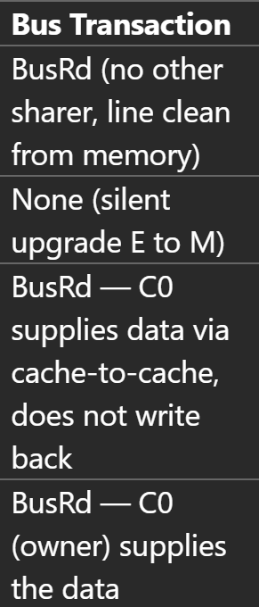
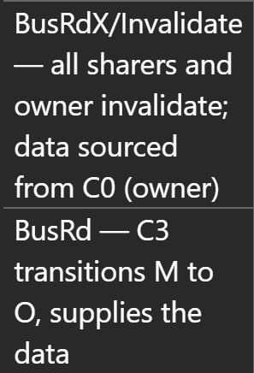

It’s ok for me to fill the table. But I didn’t answer the follow up question correctly: which step should write back to main memory using MESI protocol.
In MESI, the writeback occurs in step 3 and step 6.
In step 3, Core0 holds the cache line in Modified state. When Core1 reads the line, the line transitions from M to S. Since Shared state represents a clean shared copy, memory must become up-to-date before both caches can hold the line in S state.
Similarly, in step 6, Core3 holds the line in Modified state. When Core0 reads the line, Core3 transitions from M to S, so the modified data must again be written back (or memory updated) before the line becomes shared.

