**Setup for Running the Sequencing Tool with VS Code**

First lets install and set up Visual Studio Code (VS Code) for using Python.

Download and install VS Code from here (its free):

<https://code.visualstudio.com/>

Open VS Code and navigate to the Extensions tab on the sidebar (Ctrl Shift X).

From here, install the Python and Pylance extensions. You can search for them or they should appear in the “Recommended” section if you open any python file (.py or .ipynb) with VS code.

Note in the following screenshot, these extensions are already installed; you will see a blue “install” box which you can click on.

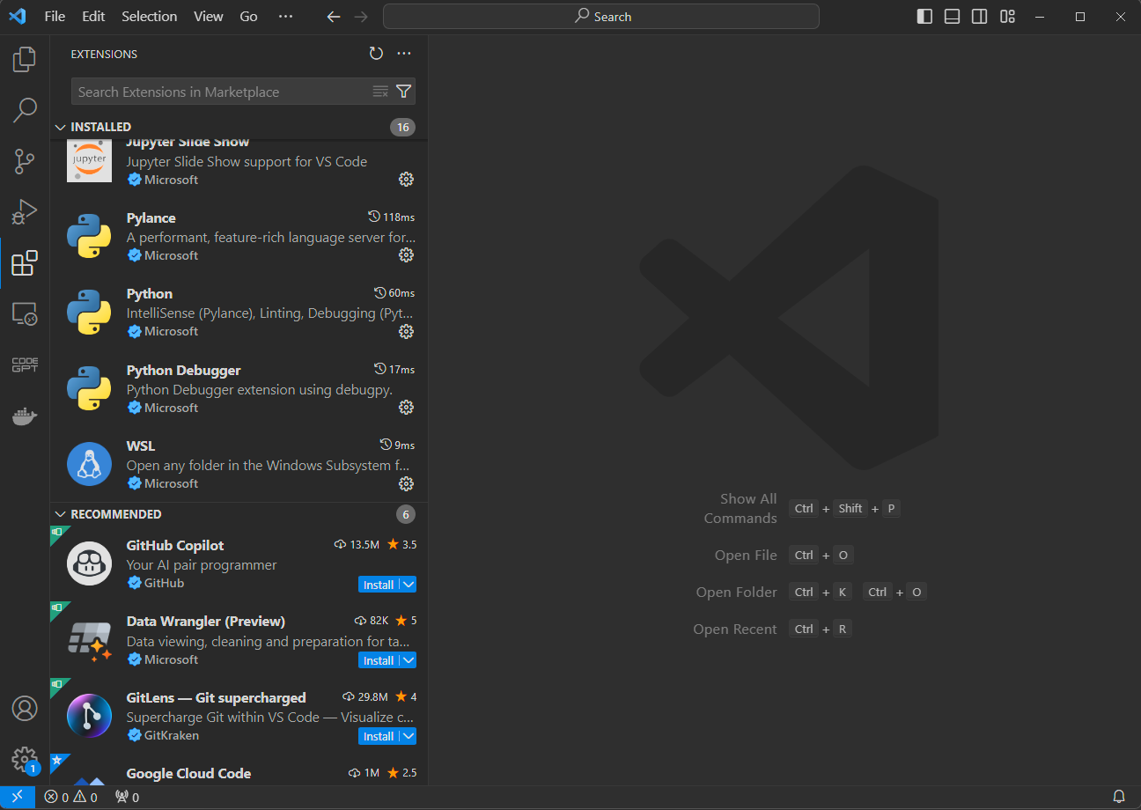

That’s it for now with VScode, go ahead and close it for the moment.

Now lets go through the process of downloading anaconda (a popular python distribution), create a virtual environment (venv) for our program to operate within, and install the required python libraries.

This is all actually quite simple to do.

First let’s download and install Anaconda from here (its free):

<https://www.anaconda.com/download>

Once Anaconda is installed, open an Anaconda prompt window. (you can do this easily by starting to type “anaconda” in the windows search bar)

From the Anaconda prompt, enter the following two lines one at a time (you can copy/paste):

**conda create -n biopython python=3.10.8**

**conda activate biopython**

The first command creates our virtual environment called “biopython” with Python version 3.10.8

The second command activates the environment so we can install packages into it.

*Note how the initial (base) version of anaconda has now been changed to (biopython)*

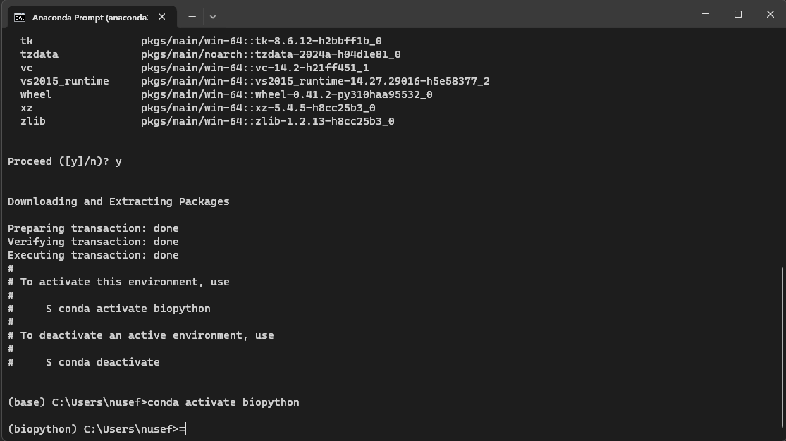

Now, lets install the library packages that our sequencing program will need.

To do this, run the following line to install everything at once:

**pip install biopython==1.81 pandas numpy tqdm ipywidgets seaborn**

We are now ready open VS Code again and start running our program.

Use VS Code to open **DelScreenProcessing.ipynb**

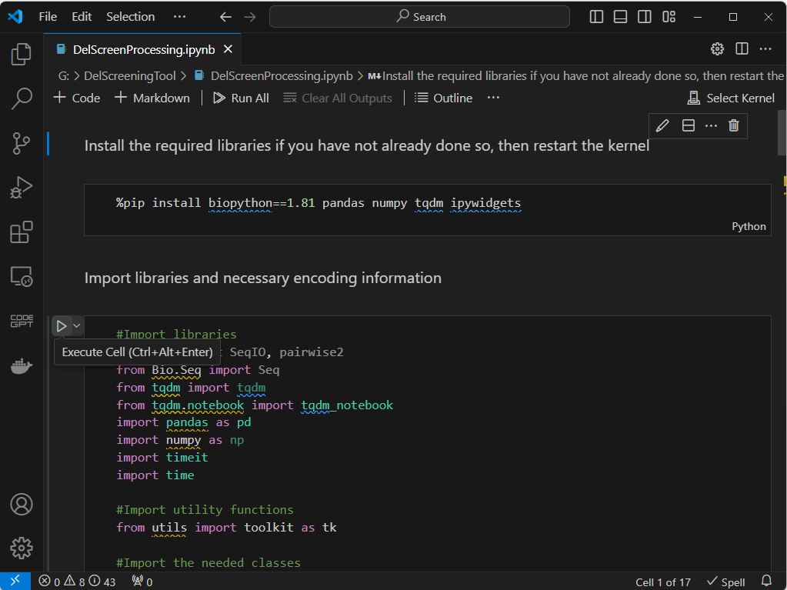

Now tell VS Code to use the biopython venv we created earlier to run this notebook.

In the upper right, Click:

Select Kernel > Python Environments… > biopython (Python 3.10.8)

Some popups will probably also appear at some point when using this biopython environment for the first time. Go ahead and use the popups to install anything VS Code says it needs for full functionality.

Finally, if a bar has appeared near the top of your VS Code notifying you of a Restricted Mode, go ahead and click “Manage” to enable Trust for the current workspace (i.e. folder)

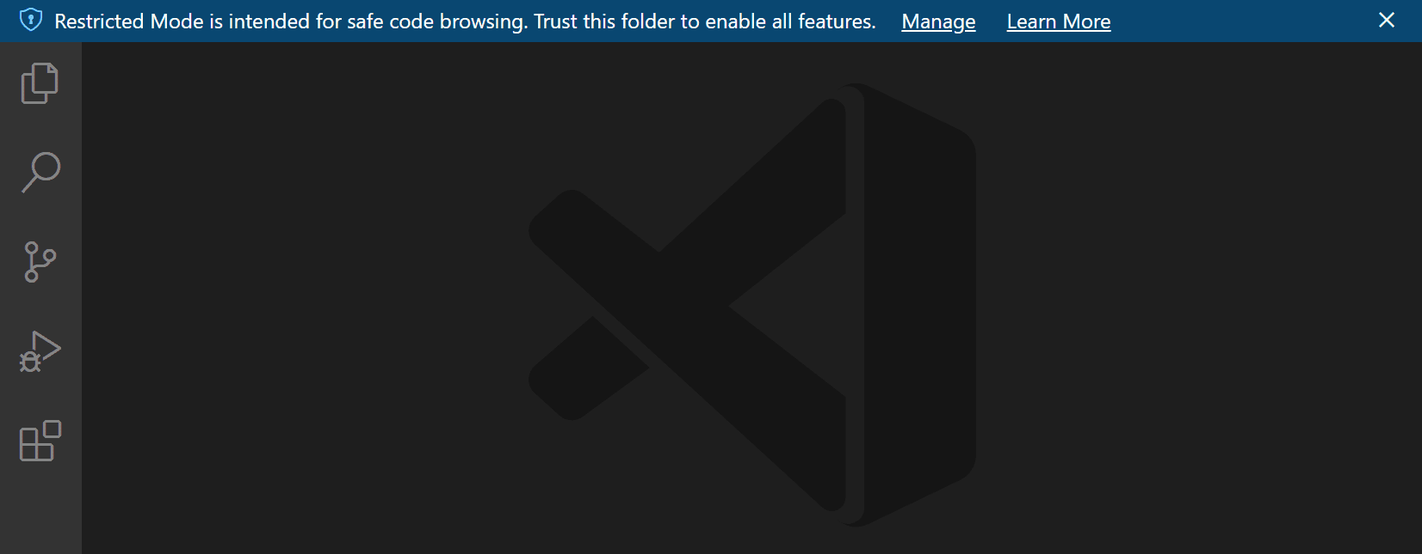

That should be it for the VS Code set up and the notebook should be ready to run.

For details on how to operate and run the notebook, see **Operation.pdf**