**Step by step building a dashboard using HTML and CSS**

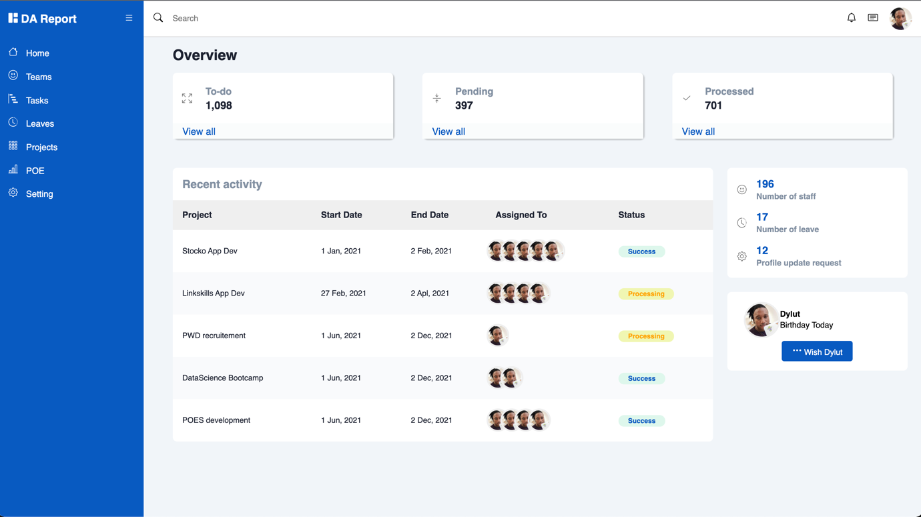

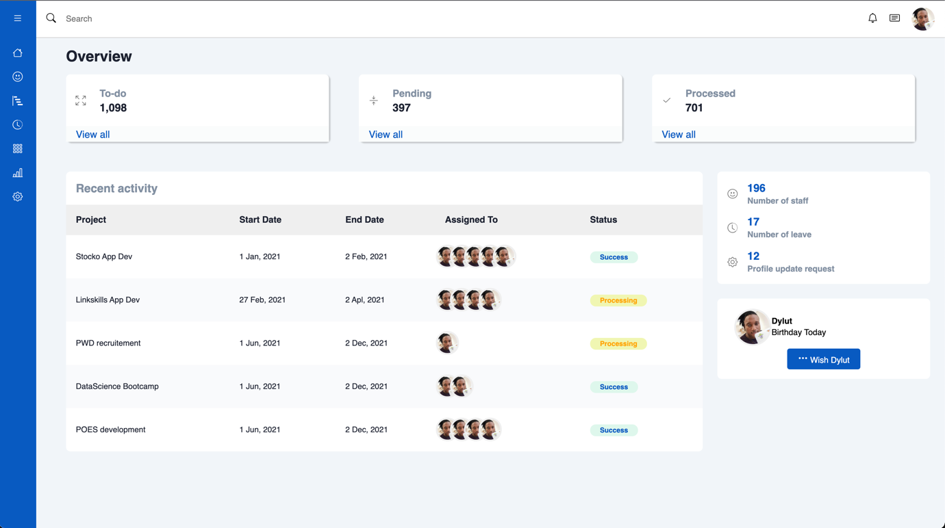

We are going to use few external resources such as:

* Bootstap icons <https://icons.getbootstrap.com/icons/list/>
* Google Fonts <https://fonts.google.com/specimen/Roboto>

We are going to analyze the Dashboard image and come up with a plan on how to achieve it

.main-content

.sidebar

.header



.main

Keep this structure in mind

We are going to use all the best practices for HTML and CSS.

Here our different main blogs: .sidebar, .main-content, .main, header

* Create a folder and give it a name of your choice
* Open the folder in a IDE of your choice, use vscode <https://code.visualstudio.com/download>
* Create 2 files inside the folder: **index.html** and **style.css**
* In the **index.html** file, add the following html codes to start

<!DOCTYPE html>

<html lang="en">

<head>

<meta charset="UTF-8">

<meta http-equiv="X-UA-Compatible" content="IE=edge">

<meta name="viewport" content="width=device-width, initial-scale=1.0">

<title>Dylut2000</title>

</head>

<body>

</body>

</html>

* And then add a link to a CSS file in the document ***<head></head>***

<link rel="stylesheet" href="style.css">

* Add this code in the ***<body></body>*** tag

<!--side bar-->

<div class="sidebar"></div>

<!--main-content-->

<div class="main-content">

<!--header-->

<header></header>

<!--main-->

<main></main>

</div>

After separating the different Main section, we are going to start with the ***sidebar***

* Go to ***<div class=”sidebar”></div>*** and add the following code

<!--sidebar-header-->

<div class="sidebar-header">

<h3 class="brand">

<span>

<svg

xmlns="http://www.w3.org/2000/svg"

width="16"

height="16"

fill="currentColor"

class="bi bi-grid-1x2-fill"

viewBox="0 0 16 16"

>

<path

d="M0 1a1 1 0 0 1 1-1h5a1 1 0 0 1 1 1v14a1 1 0 0 1-1 1H1a1 1 0 0 1-1-1V1zm9 0a1 1 0 0 1 1-1h5a1 1 0 0 1 1 1v5a1 1 0 0 1-1 1h-5a1 1 0 0 1-1-1V1zm0 9a1 1 0 0 1 1-1h5a1 1 0 0 1 1 1v5a1 1 0 0 1-1 1h-5a1 1 0 0 1-1-1v-5z"

/>

</svg>

</span>

<span>DA Report</span>

</h3>

<label for="sidebar-toggle" style="cursor: pointer">

<svg

xmlns="http://www.w3.org/2000/svg"

width="16"

height="16"

fill="currentColor"

class="bi bi-list"

viewBox="0 0 16 16"

>

<path

fill-rule="evenodd"

d="M2.5 12a.5.5 0 0 1 .5-.5h10a.5.5 0 0 1 0 1H3a.5.5 0 0 1-.5-.5zm0-4a.5.5 0 0 1 .5-.5h10a.5.5 0 0 1 0 1H3a.5.5 0 0 1-.5-.5zm0-4a.5.5 0 0 1 .5-.5h10a.5.5 0 0 1 0 1H3a.5.5 0 0 1-.5-.5z"

/>

</svg>

</label>

</div>

<!--sidebar-menu-->

<div class="sidebar-menu">

<ul>

<li>

<a href="#">

<span>

<svg

xmlns="http://www.w3.org/2000/svg"

width="16"

height="16"

fill="currentColor"

class="bi bi-house"

viewBox="0 0 16 16"

>

<path

fill-rule="evenodd"

d="M2 13.5V7h1v6.5a.5.5 0 0 0 .5.5h9a.5.5 0 0 0 .5-.5V7h1v6.5a1.5 1.5 0 0 1-1.5 1.5h-9A1.5 1.5 0 0 1 2 13.5zm11-11V6l-2-2V2.5a.5.5 0 0 1 .5-.5h1a.5.5 0 0 1 .5.5z"

/>

<path

fill-rule="evenodd"

d="M7.293 1.5a1 1 0 0 1 1.414 0l6.647 6.646a.5.5 0 0 1-.708.708L8 2.207 1.354 8.854a.5.5 0 1 1-.708-.708L7.293 1.5z"

/>

</svg>

</span>

<span>Home</span>

</a>

</li>

<li>

<a href="#">

<span>

<svg

xmlns="http://www.w3.org/2000/svg"

width="16"

height="16"

fill="currentColor"

class="bi bi-emoji-smile"

viewBox="0 0 16 16"

>

<path

d="M8 15A7 7 0 1 1 8 1a7 7 0 0 1 0 14zm0 1A8 8 0 1 0 8 0a8 8 0 0 0 0 16z"

/>

<path

d="M4.285 9.567a.5.5 0 0 1 .683.183A3.498 3.498 0 0 0 8 11.5a3.498 3.498 0 0 0 3.032-1.75.5.5 0 1 1 .866.5A4.498 4.498 0 0 1 8 12.5a4.498 4.498 0 0 1-3.898-2.25.5.5 0 0 1 .183-.683zM7 6.5C7 7.328 6.552 8 6 8s-1-.672-1-1.5S5.448 5 6 5s1 .672 1 1.5zm4 0c0 .828-.448 1.5-1 1.5s-1-.672-1-1.5S9.448 5 10 5s1 .672 1 1.5z"

/>

</svg>

</span>

<span>Teams</span>

</a>

</li>

<li>

<a href="#">

<span>

<svg

xmlns="http://www.w3.org/2000/svg"

width="16"

height="16"

fill="currentColor"

class="bi bi-bar-chart-steps"

viewBox="0 0 16 16"

>

<path

d="M.5 0a.5.5 0 0 1 .5.5v15a.5.5 0 0 1-1 0V.5A.5.5 0 0 1 .5 0zM2 1.5a.5.5 0 0 1 .5-.5h4a.5.5 0 0 1 .5.5v1a.5.5 0 0 1-.5.5h-4a.5.5 0 0 1-.5-.5v-1zm2 4a.5.5 0 0 1 .5-.5h7a.5.5 0 0 1 .5.5v1a.5.5 0 0 1-.5.5h-7a.5.5 0 0 1-.5-.5v-1zm2 4a.5.5 0 0 1 .5-.5h6a.5.5 0 0 1 .5.5v1a.5.5 0 0 1-.5.5h-6a.5.5 0 0 1-.5-.5v-1zm2 4a.5.5 0 0 1 .5-.5h7a.5.5 0 0 1 .5.5v1a.5.5 0 0 1-.5.5h-7a.5.5 0 0 1-.5-.5v-1z"

/>

</svg>

</span>

<span>Tasks</span>

</a>

</li>

<li>

<a href="#">

<span>

<svg

xmlns="http://www.w3.org/2000/svg"

width="16"

height="16"

fill="currentColor"

class="bi bi-clock-history"

viewBox="0 0 16 16"

>

<path

d="M8.515 1.019A7 7 0 0 0 8 1V0a8 8 0 0 1 .589.022l-.074.997zm2.004.45a7.003 7.003 0 0 0-.985-.299l.219-.976c.383.086.76.2 1.126.342l-.36.933zm1.37.71a7.01 7.01 0 0 0-.439-.27l.493-.87a8.025 8.025 0 0 1 .979.654l-.615.789a6.996 6.996 0 0 0-.418-.302zm1.834 1.79a6.99 6.99 0 0 0-.653-.796l.724-.69c.27.285.52.59.747.91l-.818.576zm.744 1.352a7.08 7.08 0 0 0-.214-.468l.893-.45a7.976 7.976 0 0 1 .45 1.088l-.95.313a7.023 7.023 0 0 0-.179-.483zm.53 2.507a6.991 6.991 0 0 0-.1-1.025l.985-.17c.067.386.106.778.116 1.17l-1 .025zm-.131 1.538c.033-.17.06-.339.081-.51l.993.123a7.957 7.957 0 0 1-.23 1.155l-.964-.267c.046-.165.086-.332.12-.501zm-.952 2.379c.184-.29.346-.594.486-.908l.914.405c-.16.36-.345.706-.555 1.038l-.845-.535zm-.964 1.205c.122-.122.239-.248.35-.378l.758.653a8.073 8.073 0 0 1-.401.432l-.707-.707z"

/>

<path

d="M8 1a7 7 0 1 0 4.95 11.95l.707.707A8.001 8.001 0 1 1 8 0v1z"

/>

<path

d="M7.5 3a.5.5 0 0 1 .5.5v5.21l3.248 1.856a.5.5 0 0 1-.496.868l-3.5-2A.5.5 0 0 1 7 9V3.5a.5.5 0 0 1 .5-.5z"

/>

</svg>

</span>

<span>Leaves</span>

</a>

</li>

<li>

<a href="#">

<span>

<svg

xmlns="http://www.w3.org/2000/svg"

width="16"

height="16"

fill="currentColor"

class="bi bi-grid-3x3-gap"

viewBox="0 0 16 16"

>

<path

d="M4 2v2H2V2h2zm1 12v-2a1 1 0 0 0-1-1H2a1 1 0 0 0-1 1v2a1 1 0 0 0 1 1h2a1 1 0 0 0 1-1zm0-5V7a1 1 0 0 0-1-1H2a1 1 0 0 0-1 1v2a1 1 0 0 0 1 1h2a1 1 0 0 0 1-1zm0-5V2a1 1 0 0 0-1-1H2a1 1 0 0 0-1 1v2a1 1 0 0 0 1 1h2a1 1 0 0 0 1-1zm5 10v-2a1 1 0 0 0-1-1H7a1 1 0 0 0-1 1v2a1 1 0 0 0 1 1h2a1 1 0 0 0 1-1zm0-5V7a1 1 0 0 0-1-1H7a1 1 0 0 0-1 1v2a1 1 0 0 0 1 1h2a1 1 0 0 0 1-1zm0-5V2a1 1 0 0 0-1-1H7a1 1 0 0 0-1 1v2a1 1 0 0 0 1 1h2a1 1 0 0 0 1-1zM9 2v2H7V2h2zm5 0v2h-2V2h2zM4 7v2H2V7h2zm5 0v2H7V7h2zm5 0h-2v2h2V7zM4 12v2H2v-2h2zm5 0v2H7v-2h2zm5 0v2h-2v-2h2zM12 1a1 1 0 0 0-1 1v2a1 1 0 0 0 1 1h2a1 1 0 0 0 1-1V2a1 1 0 0 0-1-1h-2zm-1 6a1 1 0 0 1 1-1h2a1 1 0 0 1 1 1v2a1 1 0 0 1-1 1h-2a1 1 0 0 1-1-1V7zm1 4a1 1 0 0 0-1 1v2a1 1 0 0 0 1 1h2a1 1 0 0 0 1-1v-2a1 1 0 0 0-1-1h-2z"

/>

</svg>

</span>

<span>Projects</span>

</a>

</li>

<li>

<a href="#">

<span>

<svg

xmlns="http://www.w3.org/2000/svg"

width="16"

height="16"

fill="currentColor"

class="bi bi-bar-chart-line"

viewBox="0 0 16 16"

>

<path

d="M11 2a1 1 0 0 1 1-1h2a1 1 0 0 1 1 1v12h.5a.5.5 0 0 1 0 1H.5a.5.5 0 0 1 0-1H1v-3a1 1 0 0 1 1-1h2a1 1 0 0 1 1 1v3h1V7a1 1 0 0 1 1-1h2a1 1 0 0 1 1 1v7h1V2zm1 12h2V2h-2v12zm-3 0V7H7v7h2zm-5 0v-3H2v3h2z"

/>

</svg>

</span>

<span>POE</span>

</a>

</li>

<li>

<a href="#">

<span>

<svg

xmlns="http://www.w3.org/2000/svg"

width="16"

height="16"

fill="currentColor"

class="bi bi-gear"

viewBox="0 0 16 16"

>

<path

d="M8 4.754a3.246 3.246 0 1 0 0 6.492 3.246 3.246 0 0 0 0-6.492zM5.754 8a2.246 2.246 0 1 1 4.492 0 2.246 2.246 0 0 1-4.492 0z"

/>

<path

d="M9.796 1.343c-.527-1.79-3.065-1.79-3.592 0l-.094.319a.873.873 0 0 1-1.255.52l-.292-.16c-1.64-.892-3.433.902-2.54 2.541l.159.292a.873.873 0 0 1-.52 1.255l-.319.094c-1.79.527-1.79 3.065 0 3.592l.319.094a.873.873 0 0 1 .52 1.255l-.16.292c-.892 1.64.901 3.434 2.541 2.54l.292-.159a.873.873 0 0 1 1.255.52l.094.319c.527 1.79 3.065 1.79 3.592 0l.094-.319a.873.873 0 0 1 1.255-.52l.292.16c1.64.893 3.434-.902 2.54-2.541l-.159-.292a.873.873 0 0 1 .52-1.255l.319-.094c1.79-.527 1.79-3.065 0-3.592l-.319-.094a.873.873 0 0 1-.52-1.255l.16-.292c.893-1.64-.902-3.433-2.541-2.54l-.292.159a.873.873 0 0 1-1.255-.52l-.094-.319zm-2.633.283c.246-.835 1.428-.835 1.674 0l.094.319a1.873 1.873 0 0 0 2.693 1.115l.291-.16c.764-.415 1.6.42 1.184 1.185l-.159.292a1.873 1.873 0 0 0 1.116 2.692l.318.094c.835.246.835 1.428 0 1.674l-.319.094a1.873 1.873 0 0 0-1.115 2.693l.16.291c.415.764-.42 1.6-1.185 1.184l-.291-.159a1.873 1.873 0 0 0-2.693 1.116l-.094.318c-.246.835-1.428.835-1.674 0l-.094-.319a1.873 1.873 0 0 0-2.692-1.115l-.292.16c-.764.415-1.6-.42-1.184-1.185l.159-.291A1.873 1.873 0 0 0 1.945 8.93l-.319-.094c-.835-.246-.835-1.428 0-1.674l.319-.094A1.873 1.873 0 0 0 3.06 4.377l-.16-.292c-.415-.764.42-1.6 1.185-1.184l.292.159a1.873 1.873 0 0 0 2.692-1.115l.094-.319z"

/>

</svg>

</span>

<span>Setting</span>

</a>

</li>

</ul>

</div>

After adding the code, your page should look like this

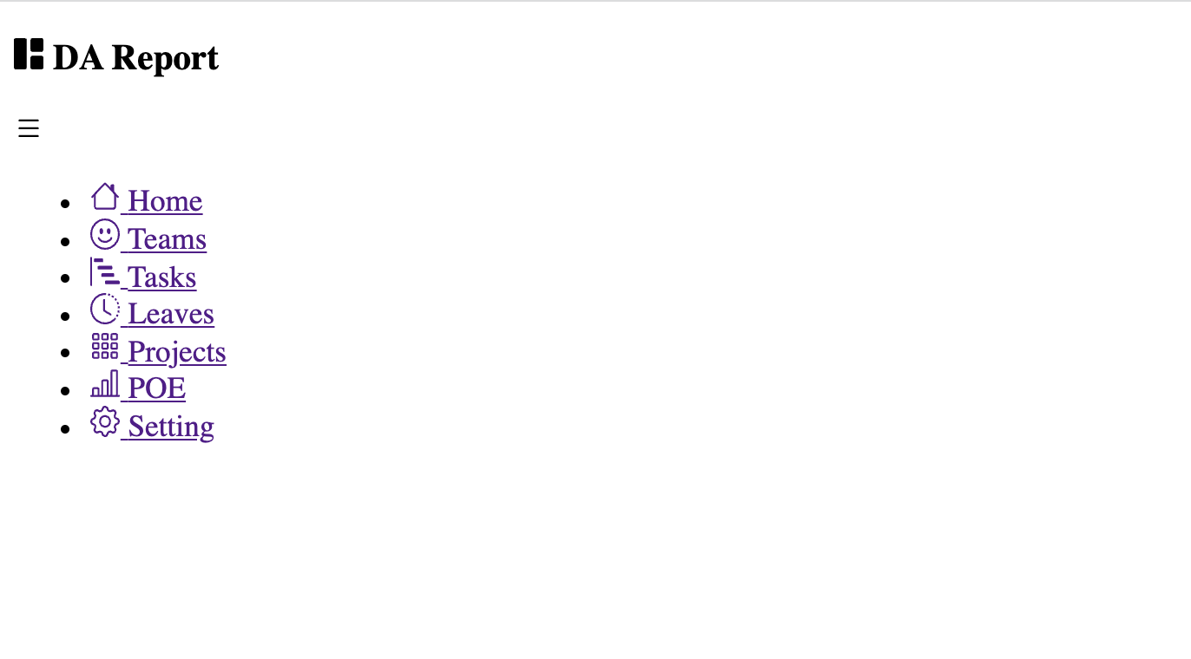

We are going to add general CSS for our project.

In your ***style.css*** file, add the following styles

@import url('https://fonts.googleapis.com/css2?family=Roboto:wght@100;300;400;500;700;900&display=swap');

:root {

--main-color: #075ac1;

--color-dark: #1d2231;

--text-gray: #8390a2;

--body-bg: #f1f5f9;

}

* {

font-family: "Poppins", sans-serif;

margin: 0;

padding: 0;

text-decoration: none;

list-style-type: none;

box-sizing: border-box;

}

body {

background-color: var(--body-bg);

font-family: 'Roboto', sans-serif;

}

And now add the sidebar css in the ***style.css*** file

#sidebar-toggle {

display: none;

}

.sidebar {

height: 100%;

width: 240px;

position: fixed;

top: 0;

left: 0;

z-index: 100;

background-color: var(--main-color);

color: #ffffff;

overflow-y: auto;

transition: width 500ms;

}

.sidebar-header {

display: flex;

justify-content: space-between;

align-items: center;

height: 60px;

padding: 0rem 1rem;

}

.sidebar-menu {

padding: 1rem;

}

.sidebar li {

margin-bottom: 1.2rem;

}

.sidebar a {

color: #ffffff;

font-size: 0.9rem;

}

.sidebar a span:last-child {

padding-left: 0.6rem;

}

#sidebar-toggle:checked ~ .sidebar {

width: 60px;

}

#sidebar-toggle:checked ~ .sidebar .sidebar-header h3 span,

#sidebar-toggle:checked ~ .sidebar li span:last-child {

display: none;

}

#sidebar-toggle:checked ~ .sidebar .sidebar-header,

#sidebar-toggle:checked ~ .sidebar li {

display: flex;

justify-content: center;

}

#sidebar-toggle:checked ~ .main-content {

margin-left: 60px;

}

#sidebar-toggle:checked ~ .main-content header {

left: 60px;

width: calc(100% - 60px);

}

Your application should look like this

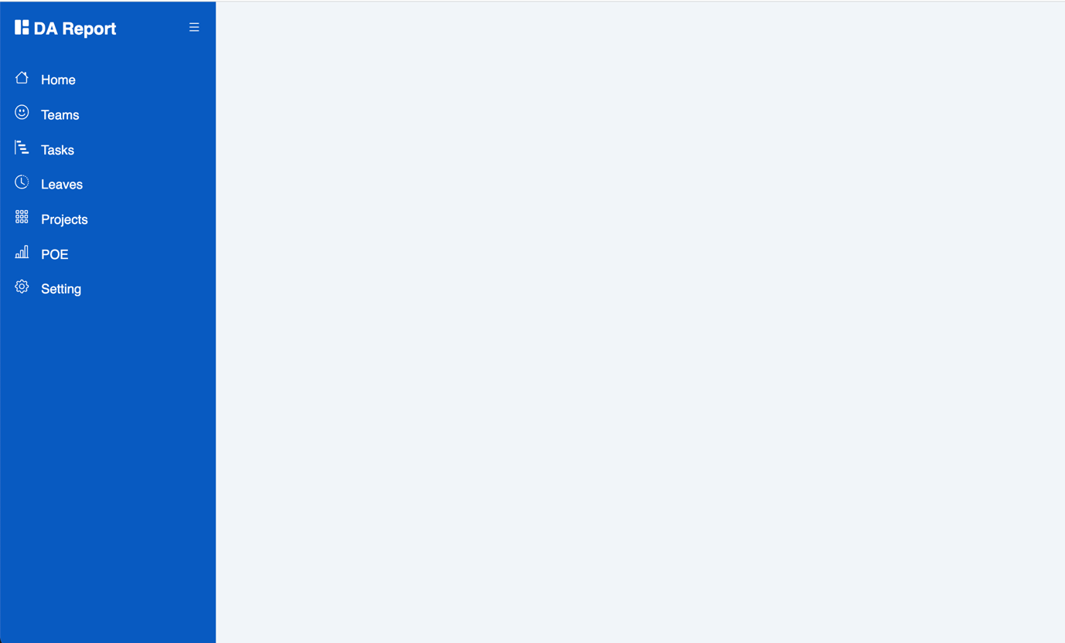

Now we must make the menu button functional

Add the following line of code in your index.html just after the opening ***<body>*** tag

<input type="checkbox" id="sidebar-toggle">

Here is the picture of where you should put the code

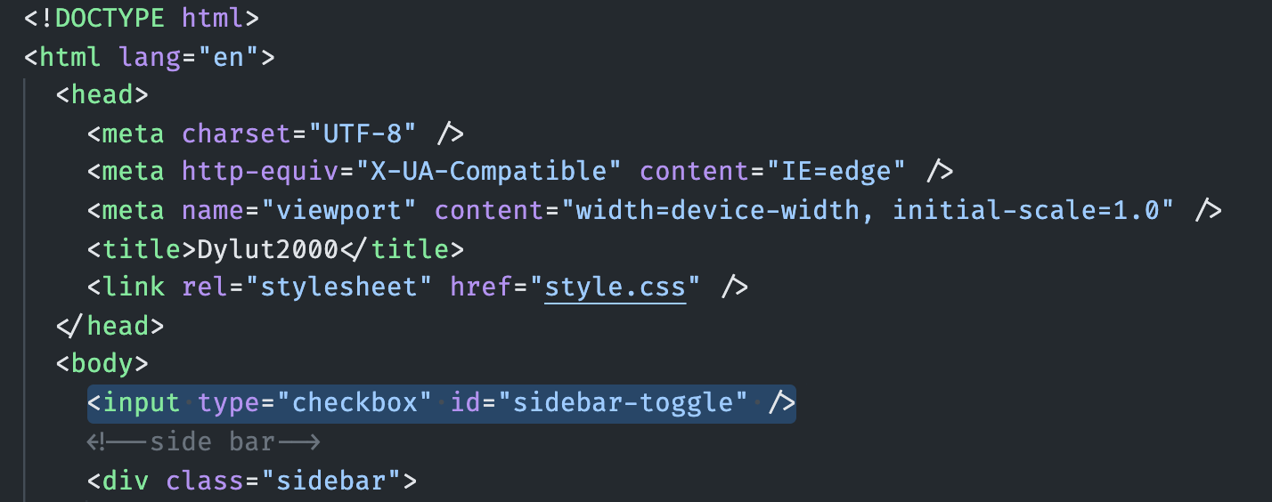

After placing that code, your app should be able to toggle menu after you click in the menu button



Now we are going to work with the main-content.

Go to ***<header></header>*** and add the following code

<div class="search-wrapper">

<span>

<svg xmlns="http://www.w3.org/2000/svg" width="16" height="16" fill="currentColor" class="bi bi-search" viewBox="0 0 16 16">

<path d="M11.742 10.344a6.5 6.5 0 1 0-1.397 1.398h-.001c.03.04.062.078.098.115l3.85 3.85a1 1 0 0 0 1.415-1.414l-3.85-3.85a1.007 1.007 0 0 0-.115-.1zM12 6.5a5.5 5.5 0 1 1-11 0 5.5 5.5 0 0 1 11 0z"/>

</svg>

</span>

<input type="text" name="search" placeholder="Search" />

</div>

<div class="social-icons">

<span>

<svg xmlns="http://www.w3.org/2000/svg" width="16" height="16" fill="currentColor" class="bi bi-bell" viewBox="0 0 16 16">

<path d="M8 16a2 2 0 0 0 2-2H6a2 2 0 0 0 2 2zM8 1.918l-.797.161A4.002 4.002 0 0 0 4 6c0 .628-.134 2.197-.459 3.742-.16.767-.376 1.566-.663 2.258h10.244c-.287-.692-.502-1.49-.663-2.258C12.134 8.197 12 6.628 12 6a4.002 4.002 0 0 0-3.203-3.92L8 1.917zM14.22 12c.223.447.481.801.78 1H1c.299-.199.557-.553.78-1C2.68 10.2 3 6.88 3 6c0-2.42 1.72-4.44 4.005-4.901a1 1 0 1 1 1.99 0A5.002 5.002 0 0 1 13 6c0 .88.32 4.2 1.22 6z"/>

</svg>

</span>

<span>

<svg xmlns="http://www.w3.org/2000/svg" width="16" height="16" fill="currentColor" class="bi bi-card-text" viewBox="0 0 16 16">

<path d="M14.5 3a.5.5 0 0 1 .5.5v9a.5.5 0 0 1-.5.5h-13a.5.5 0 0 1-.5-.5v-9a.5.5 0 0 1 .5-.5h13zm-13-1A1.5 1.5 0 0 0 0 3.5v9A1.5 1.5 0 0 0 1.5 14h13a1.5 1.5 0 0 0 1.5-1.5v-9A1.5 1.5 0 0 0 14.5 2h-13z"/>

<path d="M3 5.5a.5.5 0 0 1 .5-.5h9a.5.5 0 0 1 0 1h-9a.5.5 0 0 1-.5-.5zM3 8a.5.5 0 0 1 .5-.5h9a.5.5 0 0 1 0 1h-9A.5.5 0 0 1 3 8zm0 2.5a.5.5 0 0 1 .5-.5h6a.5.5 0 0 1 0 1h-6a.5.5 0 0 1-.5-.5z"/>

</svg>

</span>

<div></div>

</div>

Now we are going to add the style for our header.

Go to ***style.css*** and add the following styles

.main-content {

position: relative;

margin-left: 240px;

transition: margin-left 500ms;

}

header {

position: fixed;

top: 0;

left: 240px;

z-index: 100;

width: calc(100% - 240px);

background-color: #ffffff;

height: 60px;

padding: 0rem 1rem;

display: flex;

align-items: center;

justify-content: space-between;

border-bottom: solid 1px #ccc;

transition: 500ms;

}

.search-wrapper {

display: flex;

align-items: center;

}

.search-wrapper input {

border: 0;

outline: 0;

padding: 1rem;

height: 38px;

}

.social-icons {

display: flex;

align-items: center;

}

.social-icons span,

.social-icons div {

margin-left: 1.2rem;

}

.social-icons div {

height: 38px;

width: 38px;

background-size: cover;

background-repeat: no-repeat;

background-image: url(img/hardylutula.jpeg);

border-radius: 50%;

}

After adding the css, your project should look like this

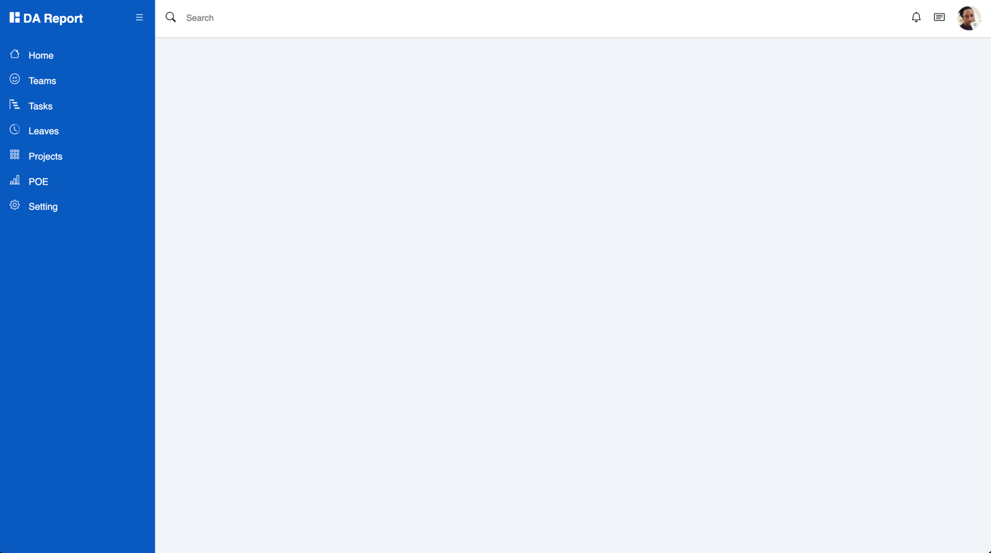

Go to the ***<main></main>*** tag

Add the following code

<h2 class="dash-title">Overview</h2>

<!--cards-->

<div class="dash-cards">

<div class="card-single">

<div class="card-body">

<span>

<svg xmlns="http://www.w3.org/2000/svg" width="16" height="16" fill="currentColor" class="bi bi-arrows-fullscreen" viewBox="0 0 16 16">

<path fill-rule="evenodd" d="M5.828 10.172a.5.5 0 0 0-.707 0l-4.096 4.096V11.5a.5.5 0 0 0-1 0v3.975a.5.5 0 0 0 .5.5H4.5a.5.5 0 0 0 0-1H1.732l4.096-4.096a.5.5 0 0 0 0-.707zm4.344 0a.5.5 0 0 1 .707 0l4.096 4.096V11.5a.5.5 0 1 1 1 0v3.975a.5.5 0 0 1-.5.5H11.5a.5.5 0 0 1 0-1h2.768l-4.096-4.096a.5.5 0 0 1 0-.707zm0-4.344a.5.5 0 0 0 .707 0l4.096-4.096V4.5a.5.5 0 1 0 1 0V.525a.5.5 0 0 0-.5-.5H11.5a.5.5 0 0 0 0 1h2.768l-4.096 4.096a.5.5 0 0 0 0 .707zm-4.344 0a.5.5 0 0 1-.707 0L1.025 1.732V4.5a.5.5 0 0 1-1 0V.525a.5.5 0 0 1 .5-.5H4.5a.5.5 0 0 1 0 1H1.732l4.096 4.096a.5.5 0 0 1 0 .707z"/>

</svg>

</span>

<div>

<h5>To-do</h5>

<h4>1,098</h4>

</div>

</div>

<div class="card-footer">

<a href="#">View all</a>

</div>

</div>

<div class="card-single">

<div class="card-body">

<span>

<svg xmlns="http://www.w3.org/2000/svg" width="16" height="16" fill="currentColor" class="bi bi-arrows-collapse" viewBox="0 0 16 16">

<path fill-rule="evenodd" d="M1 8a.5.5 0 0 1 .5-.5h13a.5.5 0 0 1 0 1h-13A.5.5 0 0 1 1 8zm7-8a.5.5 0 0 1 .5.5v3.793l1.146-1.147a.5.5 0 0 1 .708.708l-2 2a.5.5 0 0 1-.708 0l-2-2a.5.5 0 1 1 .708-.708L7.5 4.293V.5A.5.5 0 0 1 8 0zm-.5 11.707-1.146 1.147a.5.5 0 0 1-.708-.708l2-2a.5.5 0 0 1 .708 0l2 2a.5.5 0 0 1-.708.708L8.5 11.707V15.5a.5.5 0 0 1-1 0v-3.793z"/>

</svg>

</span>

<div>

<h5>Pending</h5>

<h4>397</h4>

</div>

</div>

<div class="card-footer">

<a href="#">View all</a>

</div>

</div>

<div class="card-single">

<div class="card-body">

<span>

<svg xmlns="http://www.w3.org/2000/svg" width="16" height="16" fill="currentColor" class="bi bi-check2" viewBox="0 0 16 16">

<path d="M13.854 3.646a.5.5 0 0 1 0 .708l-7 7a.5.5 0 0 1-.708 0l-3.5-3.5a.5.5 0 1 1 .708-.708L6.5 10.293l6.646-6.647a.5.5 0 0 1 .708 0z"/>

</svg>

</span>

<div>

<h5>Processed</h5>

<h4>701</h4>

</div>

</div>

<div class="card-footer">

<a href="#">View all</a>

</div>

</div>

</div>

<section class="recent">

<div class="activity-grid">

<div class="activity-card">

<h3>Recent activity</h3>

<table>

<thead>

<tr>

<th>Project</th>

<th>Start Date</th>

<th>End Date</th>

<th>Assigned To</th>

<th>Status</th>

</tr>

</thead>

<tbody>

<tr>

<td>Stocko App Dev</td>

<td>1 Jan, 2021</td>

<td>2 Feb, 2021</td>

<td class="td-team">

<div class="img-1"></div>

<div class="img-1"></div>

<div class="img-1"></div>

<div class="img-1"></div>

<div class="img-1"></div>

</td>

<td>

<span class="badge success">Success</span>

</td>

</tr>

<tr>

<td>Linkskills App Dev</td>

<td>27 Feb, 2021</td>

<td>2 Apl, 2021</td>

<td class="td-team">

<div class="img-1"></div>

<div class="img-1"></div>

<div class="img-1"></div>

<div class="img-1"></div>

</td>

<td>

<span class="badge warning">Processing</span>

</td>

</tr>

<tr>

<td>PWD recruitement</td>

<td>1 Jun, 2021</td>

<td>2 Dec, 2021</td>

<td class="td-team">

<div class="img-1"></div>

</td>

<td>

<span class="badge warning">Processing</span>

</td>

</tr>

<tr>

<td>DataScience Bootcamp</td>

<td>1 Jun, 2021</td>

<td>2 Dec, 2021</td>

<td class="td-team">

<div class="img-1"></div>

<div class="img-1"></div>

</td>

<td>

<span class="badge success">Success</span>

</td>

</tr>

<tr>

<td>POES development</td>

<td>1 Jun, 2021</td>

<td>2 Dec, 2021</td>

<td class="td-team">

<div class="img-1"></div>

<div class="img-1"></div>

<div class="img-1"></div>

<div class="img-1"></div>

</td>

<td>

<span class="badge success">Success</span>

</td>

</tr>

</tbody>

</table>

</div>

<div class="summary">

<div class="summery-card">

<div class="summery-single">

<span>

<svg xmlns="http://www.w3.org/2000/svg" width="16" height="16" fill="currentColor" class="bi bi-emoji-smile" viewBox="0 0 16 16">

<path d="M8 15A7 7 0 1 1 8 1a7 7 0 0 1 0 14zm0 1A8 8 0 1 0 8 0a8 8 0 0 0 0 16z"/>

<path d="M4.285 9.567a.5.5 0 0 1 .683.183A3.498 3.498 0 0 0 8 11.5a3.498 3.498 0 0 0 3.032-1.75.5.5 0 1 1 .866.5A4.498 4.498 0 0 1 8 12.5a4.498 4.498 0 0 1-3.898-2.25.5.5 0 0 1 .183-.683zM7 6.5C7 7.328 6.552 8 6 8s-1-.672-1-1.5S5.448 5 6 5s1 .672 1 1.5zm4 0c0 .828-.448 1.5-1 1.5s-1-.672-1-1.5S9.448 5 10 5s1 .672 1 1.5z"/>

</svg>

</span>

<div>

<h5>196</h5>

<small>Number of staff</small>

</div>

</div>

<div class="summery-single">

<span>

<svg xmlns="http://www.w3.org/2000/svg" width="16" height="16" fill="currentColor" class="bi bi-clock-history" viewBox="0 0 16 16">

<path d="M8.515 1.019A7 7 0 0 0 8 1V0a8 8 0 0 1 .589.022l-.074.997zm2.004.45a7.003 7.003 0 0 0-.985-.299l.219-.976c.383.086.76.2 1.126.342l-.36.933zm1.37.71a7.01 7.01 0 0 0-.439-.27l.493-.87a8.025 8.025 0 0 1 .979.654l-.615.789a6.996 6.996 0 0 0-.418-.302zm1.834 1.79a6.99 6.99 0 0 0-.653-.796l.724-.69c.27.285.52.59.747.91l-.818.576zm.744 1.352a7.08 7.08 0 0 0-.214-.468l.893-.45a7.976 7.976 0 0 1 .45 1.088l-.95.313a7.023 7.023 0 0 0-.179-.483zm.53 2.507a6.991 6.991 0 0 0-.1-1.025l.985-.17c.067.386.106.778.116 1.17l-1 .025zm-.131 1.538c.033-.17.06-.339.081-.51l.993.123a7.957 7.957 0 0 1-.23 1.155l-.964-.267c.046-.165.086-.332.12-.501zm-.952 2.379c.184-.29.346-.594.486-.908l.914.405c-.16.36-.345.706-.555 1.038l-.845-.535zm-.964 1.205c.122-.122.239-.248.35-.378l.758.653a8.073 8.073 0 0 1-.401.432l-.707-.707z"/>

<path d="M8 1a7 7 0 1 0 4.95 11.95l.707.707A8.001 8.001 0 1 1 8 0v1z"/>

<path d="M7.5 3a.5.5 0 0 1 .5.5v5.21l3.248 1.856a.5.5 0 0 1-.496.868l-3.5-2A.5.5 0 0 1 7 9V3.5a.5.5 0 0 1 .5-.5z"/>

</svg>

</span>

<div>

<h5>17</h5>

<small>Number of leave</small>

</div>

</div>

<div class="summery-single">

<span>

<svg xmlns="http://www.w3.org/2000/svg" width="16" height="16" fill="currentColor" class="bi bi-gear" viewBox="0 0 16 16">

<path d="M8 4.754a3.246 3.246 0 1 0 0 6.492 3.246 3.246 0 0 0 0-6.492zM5.754 8a2.246 2.246 0 1 1 4.492 0 2.246 2.246 0 0 1-4.492 0z"/>

<path d="M9.796 1.343c-.527-1.79-3.065-1.79-3.592 0l-.094.319a.873.873 0 0 1-1.255.52l-.292-.16c-1.64-.892-3.433.902-2.54 2.541l.159.292a.873.873 0 0 1-.52 1.255l-.319.094c-1.79.527-1.79 3.065 0 3.592l.319.094a.873.873 0 0 1 .52 1.255l-.16.292c-.892 1.64.901 3.434 2.541 2.54l.292-.159a.873.873 0 0 1 1.255.52l.094.319c.527 1.79 3.065 1.79 3.592 0l.094-.319a.873.873 0 0 1 1.255-.52l.292.16c1.64.893 3.434-.902 2.54-2.541l-.159-.292a.873.873 0 0 1 .52-1.255l.319-.094c1.79-.527 1.79-3.065 0-3.592l-.319-.094a.873.873 0 0 1-.52-1.255l.16-.292c.893-1.64-.902-3.433-2.541-2.54l-.292.159a.873.873 0 0 1-1.255-.52l-.094-.319zm-2.633.283c.246-.835 1.428-.835 1.674 0l.094.319a1.873 1.873 0 0 0 2.693 1.115l.291-.16c.764-.415 1.6.42 1.184 1.185l-.159.292a1.873 1.873 0 0 0 1.116 2.692l.318.094c.835.246.835 1.428 0 1.674l-.319.094a1.873 1.873 0 0 0-1.115 2.693l.16.291c.415.764-.42 1.6-1.185 1.184l-.291-.159a1.873 1.873 0 0 0-2.693 1.116l-.094.318c-.246.835-1.428.835-1.674 0l-.094-.319a1.873 1.873 0 0 0-2.692-1.115l-.292.16c-.764.415-1.6-.42-1.184-1.185l.159-.291A1.873 1.873 0 0 0 1.945 8.93l-.319-.094c-.835-.246-.835-1.428 0-1.674l.319-.094A1.873 1.873 0 0 0 3.06 4.377l-.16-.292c-.415-.764.42-1.6 1.185-1.184l.292.159a1.873 1.873 0 0 0 2.692-1.115l.094-.319z"/>

</svg>

</span>

<div>

<h5>12</h5>

<small>Profile update request</small>

</div>

</div>

</div>

<div class="bday-card">

<div class="bday-flex">

<div class="bday-img"></div>

<div class="bday-info">

<h5>Dylut</h5>

<small>Birthday Today</small>

</div>

</div>

<div class="text-center">

<button>

<span>

<svg xmlns="http://www.w3.org/2000/svg" width="16" height="16" fill="currentColor" class="bi bi-three-dots" viewBox="0 0 16 16">

<path d="M3 9.5a1.5 1.5 0 1 1 0-3 1.5 1.5 0 0 1 0 3zm5 0a1.5 1.5 0 1 1 0-3 1.5 1.5 0 0 1 0 3zm5 0a1.5 1.5 0 1 1 0-3 1.5 1.5 0 0 1 0 3z"/>

</svg>

</span>

Wish Dylut

</button>

</div>

</div>

</div>

</div>

</section>

After adding the html code in your <main></main> tag, your app should look like this

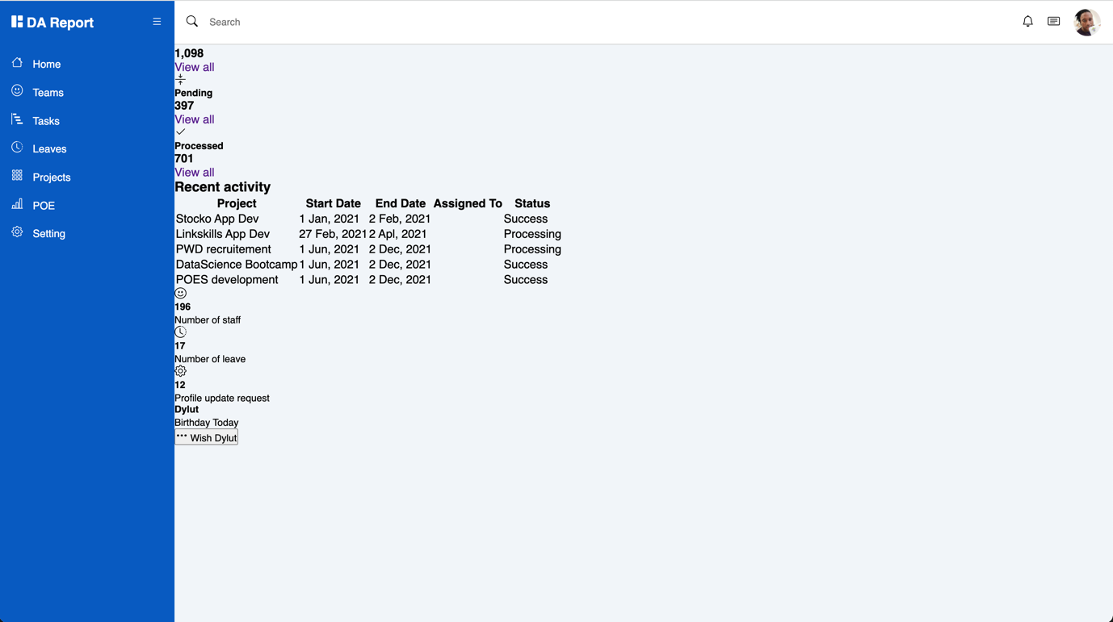

Now we are going to add the styles in the ***style.css*** file

main {

margin-top: 60px;

background-color: #f1f5f9;

min-height: 90vh;

padding: 1rem 3rem;

}

.dash-title {

color: var(--color-dark);

margin-bottom: 1rem;

}

.dash-cards {

display: grid;

grid-template-columns: repeat(3, 1fr);

grid-column-gap: 3rem;

}

.card-single {

background-color: #ffffff;

border-radius: 7px;

box-shadow: 2px 2px 2px rgba(0, 0, 0, 0.2);

}

.card-body {

padding: 1.3rem 1rem;

display: flex;

align-items: center;

}

.card-body span {

font-size: 1.5rem;

color: #777;

padding-right: 1.4rem;

}

.card-body h5 {

color: var(--text-gray);

font-size: 1rem;

}

.card-body h4 {

color: var(--color-dark);

font-size: 1.1rem;

margin-top: 0.2rem;

}

.card-footer {

padding: 0.2rem 1rem;

background: #f9fcfc;

}

.card-footer a {

color: var(--main-color);

}

.recent {

margin-top: 3rem;

margin-bottom: 3rem;

}

.activity-grid {

display: grid;

grid-template-columns: 75% 25%;

grid-column-gap: 1.5rem;

}

.activity-card,

.summery-card,

.bday-card {

background-color: #ffffff;

border-radius: 7px;

}

.activity-card h3 {

color: var(--text-gray);

margin: 1rem;

}

.activity-card table {

width: 100%;

border-collapse: collapse;

}

.activity-card thead {

background: #efefef;

text-align: left;

}

th,

td {

font-size: 0.9rem;

padding: 1rem 1rem;

color: var(--color-dark);

}

td {

font-size: 0.8rem;

}

tbody tr:nth-child(even) {

background: #f9fafc;

}

.badge {

padding: 0.2rem 1rem;

border-radius: 20px;

font-weight: 700;

font-size: 0.7rem;

}

.badge.success {

background: #def7ec;

color: var(--main-color);

}

.badge.warning {

background: #f0f6b2;

color: orange;

}

.td-team {

display: flex;

align-items: center;

}

.img-1,

.img-2,

.img-3 {

height: 38px;

width: 38px;

border-radius: 38px;

margin-left: -15px;

border: solid 3px #efefef;

background-size: cover;

background-repeat: no-repeat;

}

.img-1 {

background-image: url(img/hardylutula.jpeg);

}

.img-2 {

background-image: url(img/hardy2.jpeg);

}

.summery-card {

margin-bottom: 1.5rem;

padding-top: 0.5rem;

padding-bottom: 0.5rem;

}

.summery-single {

padding: 0.5rem 1rem;

display: flex;

align-items: center;

}

.summery-single span {

font-size: 1.5rem;

color: #777;

padding-right: 1rem;

}

.summery-single h5 {

color: var(--main-color);

font-size: 1.1rem;

margin-bottom: 0rem !important;

}

.summery-single small {

font-weight: 700;

color: var(--text-gray);

}

.bday-flex {

display: flex;

align-items: center;

margin-bottom: 0.3rem;

}

.bday-card {

padding: 1rem;

}

.bday-img {

height: 60px;

width: 60px;

border-radius: 50%;

border: solid 3px #efefef;

background-size: cover;

background-repeat: no-repeat;

background-image: url(img/hardylutula.jpeg);

margin-left: 0.7rem;

}

.text-center {

text-align: center;

}

.text-center button {

background-color: var(--main-color);

color: #ffffff;

border: solid 1px var(--main-color);

border-radius: 4px;

padding: 0.4rem 1rem;

}

@media only screen and (max-width: 1200px) {

.sidebar {

width: 60px;

}

.sidebar .sidebar-header h3 span,

.sidebar li span:last-child {

display: none;

}

.sidebar .sidebar-header,

.sidebar li {

display: flex;

justify-content: center;

}

.main-content {

margin-left: 60px;

}

.main-content header {

left: 60px;

}

}

After adding the style, your app should look like this

