**《移动互联网项目实战》实验报告**

|  |  |  |  |  |  |  |
| --- | --- | --- | --- | --- | --- | --- |
| **实验名称** | **实验六 显示天气信息** | | | | **成 绩** |  |
| **实验类型** | **（验证型 √设计型 创新型 综合型）** | | | | **学 时** | **1** |
| **专业班级** | **2019级计科04班** | **学 号** | **41905332** | **姓 名** | **王康雄** | |

**一、【实验目的与要求】**

（1）掌握布局嵌套和布局引入的基本方法；

（2）掌握ScrollView的基本使用方法；

（3）掌握使用GSON实现JSON数据解析的基本方法；

（4）掌握图片加载库Glide的使用方法；

（5）巩固数据持久化技术SharedPreferences的使用方法；

（6）巩固利用Intent实现Activity间通信和跳转的基本方法；

（7）为实训项目下一阶段开发做准备。

**二、【实验内容】**

（1）在实训项目中添加最新版本的GSON库和Glide库；

（2）参考教材第14.5节完成天气信息显示界面；

（3）提交本地代码至远程仓库。

1. **【实验过程】（请针对上述每个小题完成下述内容）**

**1.程序源代码（格式调整好，程序5号字体）**

|  |
| --- |
| **Basic类**  package com.example.weatherappdemo.gson;  import com.google.gson.annotations.SerializedName;  public class Basic {   @SerializedName("city")  public String cityName;   @SerializedName("id")  public String weatherId;   public Update update;   public class Update {   @SerializedName("loc")  public String updateTime;   }  }  **AQI类**  package com.example.weatherappdemo.gson;  public class AQI {   public AQICity city;   public class AQICity {   public String aqi;   public String pm25;   }  }  **NOW类**  package com.example.weatherappdemo.gson;  import com.google.gson.annotations.SerializedName;  public class Now {   @SerializedName("tmp")  public String temperature;   @SerializedName("cond")  public More more;   public class More {   @SerializedName("txt")  public String info;   }  }  **Sugesstion类**  package com.example.weatherappdemo.gson;  import com.google.gson.annotations.SerializedName;  public class Suggestion {   @SerializedName("comf")  public Comfort comfort;   @SerializedName("cw")  public CarWash carWash;   public Sport sport;   public class Comfort {   @SerializedName("txt")  public String info;   }   public class CarWash {   @SerializedName("txt")  public String info;   }   public class Sport {   @SerializedName("txt")  public String info;   }  }  **Forecast类**  package com.example.weatherappdemo.gson;  import com.google.gson.annotations.SerializedName;  public class Forecast {   public String date;   @SerializedName("tmp")  public Temperature temperature;   @SerializedName("cond")  public More more;   public class Temperature {   public String max;   public String min;   }   public class More {   @SerializedName("txt_d")  public String info;   }  }  **Weather类**  package com.example.weatherappdemo.gson;  import com.google.gson.annotations.SerializedName;  import java.util.List;  public class Weather {   public String status;   public Basic basic;   public AQI aqi;   public Now now;   public Suggestion suggestion;   @SerializedName("daily_forecast")  public List<Forecast> forecastList;  }  **title.xml**  <?xml version="1.0" encoding="utf-8"?> <RelativeLayout  xmlns:android="http://schemas.android.com/apk/res/android"  android:layout_width="match_parent"  android:layout_height="?attr/actionBarSize">   <Button  android:id="@+id/nav_button"  android:layout_width="30dp"  android:layout_height="30dp"  android:layout_marginLeft="10dp"  android:layout_alignParentLeft="true"  android:layout_centerVertical="true"  android:background="@drawable/ic_home" />   <TextView  android:id="@+id/title_city"  android:layout_width="wrap_content"  android:layout_height="wrap_content"  android:layout_centerInParent="true"  android:textColor="#fff"  android:textSize="20sp" />   <TextView  android:id="@+id/title_update_time"  android:layout_width="wrap_content"  android:layout_height="wrap_content"  android:layout_marginRight="10dp"  android:layout_alignParentRight="true"  android:layout_centerVertical="true"  android:textColor="#fff"  android:textSize="16sp"/>  </RelativeLayout>  **now.xml**  <?xml version="1.0" encoding="utf-8"?> <LinearLayout  xmlns:android="http://schemas.android.com/apk/res/android"  android:orientation="vertical"  android:layout_width="match_parent"  android:layout_height="wrap_content"  android:layout_margin="15dp">   <TextView  android:id="@+id/degree_text"  android:layout_width="wrap_content"  android:layout_height="wrap_content"  android:layout_gravity="end"  android:textColor="#fff"  android:textSize="60sp" />   <TextView  android:id="@+id/weather_info_text"  android:layout_width="wrap_content"  android:layout_height="wrap_content"  android:layout_gravity="end"  android:textColor="#fff"  android:textSize="20sp" />  </LinearLayout>  **forecast_item.xml**  <?xml version="1.0" encoding="utf-8"?> <LinearLayout xmlns:android="http://schemas.android.com/apk/res/android"  android:layout_width="match_parent"  android:layout_height="wrap_content"  android:layout_margin="15dp">   <TextView  android:id="@+id/date_text"  android:layout_width="0dp"  android:layout_height="wrap_content"  android:layout_gravity="center_vertical"  android:layout_weight="2"  android:textColor="#fff"/>   <TextView  android:id="@+id/info_text"  android:layout_width="0dp"  android:layout_height="wrap_content"  android:layout_gravity="center_vertical"  android:layout_weight="1"  android:gravity="center"  android:textColor="#fff"/>   <TextView  android:id="@+id/max_text"  android:layout_width="0dp"  android:layout_height="wrap_content"  android:layout_gravity="center"  android:layout_weight="1"  android:gravity="right"  android:textColor="#fff"/>   <TextView  android:id="@+id/min_text"  android:layout_width="0dp"  android:layout_height="wrap_content"  android:layout_gravity="center"  android:layout_weight="1"  android:gravity="right"  android:textColor="#fff"/>  </LinearLayout>  **aqi.xml**  <?xml version="1.0" encoding="utf-8"?> <LinearLayout  xmlns:android="http://schemas.android.com/apk/res/android"  android:orientation="vertical"  android:layout_width="match_parent"  android:layout_height="wrap_content"  android:layout_margin="15dp"  android:background="#8000">   <TextView  android:layout_width="wrap_content"  android:layout_height="wrap_content"  android:layout_marginLeft="15dp"  android:layout_marginTop="15dp"  android:text="空气质量"  android:textColor="#fff"  android:textSize="20sp"/>   <LinearLayout  android:layout_width="match_parent"  android:layout_height="wrap_content"  android:layout_margin="15dp">   <RelativeLayout  android:layout_width="0dp"  android:layout_height="match_parent"  android:layout_weight="1">   <LinearLayout  android:orientation="vertical"  android:layout_width="match_parent"  android:layout_height="wrap_content"  android:layout_centerInParent="true">   <TextView  android:id="@+id/aqi_text"  android:layout_width="wrap_content"  android:layout_height="wrap_content"  android:layout_gravity="center"  android:textColor="#fff"  android:textSize="40sp"  />   <TextView  android:layout_width="wrap_content"  android:layout_height="wrap_content"  android:layout_gravity="center"  android:text="AQI指数"  android:textColor="#fff"/>   </LinearLayout>   </RelativeLayout>   <RelativeLayout  android:layout_width="0dp"  android:layout_height="match_parent"  android:layout_weight="1">   <LinearLayout  android:orientation="vertical"  android:layout_width="match_parent"  android:layout_height="wrap_content"  android:layout_centerInParent="true">   <TextView  android:id="@+id/pm25_text"  android:layout_width="wrap_content"  android:layout_height="wrap_content"  android:layout_gravity="center"  android:textColor="#fff"  android:textSize="40sp"  />   <TextView  android:layout_width="wrap_content"  android:layout_height="wrap_content"  android:layout_gravity="center"  android:text="PM2.5指数"  android:textColor="#fff"  />   </LinearLayout>   </RelativeLayout>   </LinearLayout>  </LinearLayout>  **sugesstion.xml**  <?xml version="1.0" encoding="utf-8"?> <LinearLayout  xmlns:android="http://schemas.android.com/apk/res/android"  android:orientation="vertical"  android:layout_width="match_parent"  android:layout_height="wrap_content"  android:layout_margin="15dp"  android:background="#8000">   <TextView  android:layout_width="wrap_content"  android:layout_height="wrap_content"  android:layout_marginLeft="15dp"  android:layout_marginTop="15dp"  android:text="生活建议"  android:textColor="#fff"  android:textSize="20sp"/>   <TextView  android:id="@+id/comfort_text"  android:layout_width="wrap_content"  android:layout_height="wrap_content"  android:layout_margin="15dp"  android:textColor="#fff" />   <TextView  android:id="@+id/car_wash_text"  android:layout_width="wrap_content"  android:layout_height="wrap_content"  android:layout_margin="15dp"  android:textColor="#fff" />   <TextView  android:id="@+id/sport_text"  android:layout_width="wrap_content"  android:layout_height="wrap_content"  android:layout_margin="15dp"  android:textColor="#fff" />  </LinearLayout>  **activity_item.xml**  <?xml version="1.0" encoding="utf-8"?> <FrameLayout  xmlns:android="http://schemas.android.com/apk/res/android"  android:layout_width="match_parent"  android:layout_height="match_parent"  android:background="@color/colorPrimary">   <ImageView  android:id="@+id/bing_pic_img"  android:layout_width="match_parent"  android:layout_height="match_parent"  android:scaleType="centerCrop" />   <androidx.drawerlayout.widget.DrawerLayout  android:id="@+id/drawer_layout"  android:layout_width="match_parent"  android:layout_height="match_parent">   <androidx.swiperefreshlayout.widget.SwipeRefreshLayout  android:id="@+id/swipe_refresh"  android:layout_width="match_parent"  android:layout_height="match_parent">   <ScrollView  android:id="@+id/weather_layout"  android:layout_width="match_parent"  android:layout_height="match_parent"  android:scrollbars="none"  android:overScrollMode="never">   <LinearLayout  android:orientation="vertical"  android:layout_width="match_parent"  android:layout_height="wrap_content"  android:fitsSystemWindows="true">   <include layout="@layout/title" />  <include layout="@layout/now" />  <include layout="@layout/forecast" />  <include layout="@layout/aqi" />  <include layout="@layout/suggestion" />   </LinearLayout>   </ScrollView>   </androidx.swiperefreshlayout.widget.SwipeRefreshLayout>   <fragment  android:id="@+id/choose_area_fragment"  android:name="com.example.weatherappdemo.ChooseAreaFragment"  android:layout_width="match_parent"  android:layout_height="match_parent"  android:layout_gravity="start"/>   </androidx.drawerlayout.widget.DrawerLayout>  </FrameLayout> |

**2.运行结果（电脑截图居中，只要结果图，不要全屏复制，不要用手机拍）**

**【截图】**

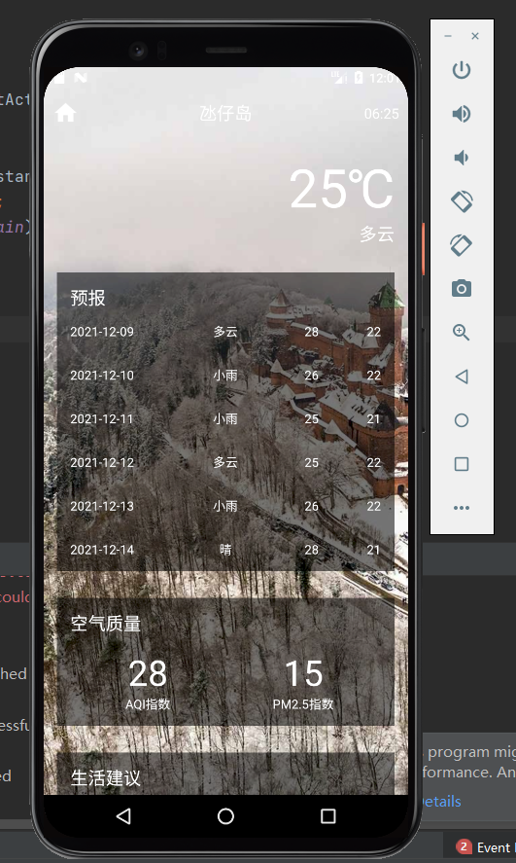

**四、【实验总结】（1. 所碰到的问题；2. 解决方法；3. 总结）**

|  |
| --- |
| **1.代码敲完之后无法正确显示天气信息；**  **2.可能是网络原因，更换网络之后重新卸载安装了APP；**  **3.通过本次实验学到了APP界面的布置以及相关逻辑。** |