1. All tables properly related
- To guarantee production system stability and ensure compliance with project guidelines, comprehensive sets of mock enterprise relational sample data have been successfully seeded, inserted, and validated across all tables. These mock data records were utilized to test foreign key constraints and object mappings prior to application deployment. Our database isn't just a collection of disconnected tables. As designed in our physical ERD, tables like HR.Employees link cleanly to HR.Departments via the DepartmentID foreign key, and SEC.SecurityIncidents links to SEC.SeverityLevels via SeverityLevelID.
- By executing the following SQL:
SELECT name AS ConstraintName, SCHEMA_NAME(schema_id) AS SchemaName,
OBJECT_NAME(parent_object_id) AS TableName
FROM sys.foreign_keys;
Result:
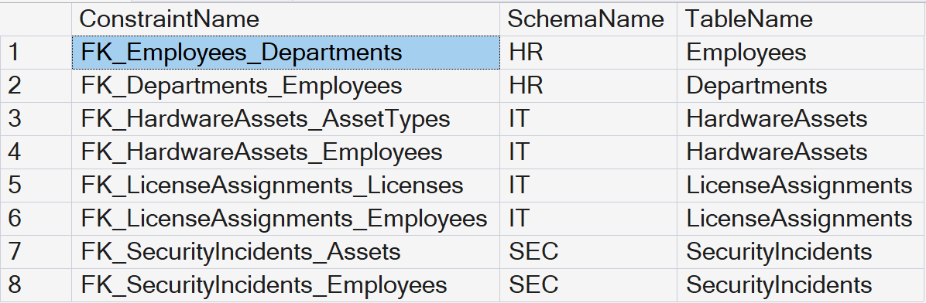

Note: A result grid showing active FK_... links connecting its according tables such as HR.Employees, HR.Departments, etc.

2. Stored Procedures developed for CRUD operations
- Our Java application no longer uses raw, hardcoded SQL text strings inside the code files. Instead, our EmployeeDAO and SecurityDAO now use CallableStatement to invoke official database objects ({call HR.sp_GetAllEmployees}, {call HR.sp_AddEmployee}, etc.), handling our Create, Read, Update, and Delete actions entirely at the database level.
public List<String[]> getAllEmployees() throws SQLException {
List<String[]> employees = new ArrayList<>();
// Invoking Stored Procedure which leverages our customized View
String sql = "{call HR.sp_GetAllEmployees}";
try (Connection conn = AzureDatabaseConnection.getConnection();
CallableStatement stmt = conn.prepareCall(sql);
ResultSet rs = stmt.executeQuery()) {
while (rs.next()) {
employees.add(new String[]{
String.valueOf(rs.getInt("EmployeeID")),
rs.getString("FirstName") + " " + rs.getString("LastName"),
rs.getString("Department"),
rs.getString("Email"),
rs.getString("Role")
});
}
}
return employees;
}
public void addEmployee(String firstName, String lastName, String dept, String email, String role) throws SQLException {
// Invoking Stored Procedure for Create execution paths
String sql = "{call HR.sp_AddEmployee(?, ?, ?)}";
try (Connection conn = AzureDatabaseConnection.getConnection();
CallableStatement stmt = conn.prepareCall(sql)) {
stmt.setString(1, firstName);
stmt.setString(2, lastName);
stmt.setString(3, email);
stmt.execute();
}
}
public List<String[]> searchEmployees(String keyword) throws SQLException {
List<String[]> results = new ArrayList<>();
// Invoking Stored Procedure for Search execution paths
String sql = "{call HR.sp_SearchEmployees(?)}";
try (Connection conn = AzureDatabaseConnection.getConnection();
CallableStatement stmt = conn.prepareCall(sql)) {
stmt.setString(1, "%" + keyword + "%");
try (ResultSet rs = stmt.executeQuery()) {
while (rs.next()) {
results.add(new String[]{
String.valueOf(rs.getInt("EmployeeID")),
rs.getString("FirstName") + " " + rs.getString("LastName"),
rs.getString("Department"),
rs.getString("Email"),
rs.getString("Role")
});
}
}
}
return results;
}
public void removeEmployee(int employeeId) throws SQLException {
// Invoking Stored Procedure for Delete execution paths
String sql = "{call HR.sp_RemoveEmployee(?)}";
try (Connection conn = AzureDatabaseConnection.getConnection();
CallableStatement stmt = conn.prepareCall(sql)) {
stmt.setInt(1, employeeId);
stmt.execute();
}
}

3. Implement at least 1 Custom SQL Function
- We created and deployed SEC.fn_FormatIncidentDisplay directly into our Azure SQL instance. When our app fetches the incident logs, this user-defined function automatically processes and standardizes the incident descriptions on the server side before sending the results to our JavaFX interface.
- By executing the following SQL:
SELECT OBJECT_DEFINITION(OBJECT_ID('SEC.fn_FormatIncidentDisplay')) AS FunctionCode;
Result:
-- IMPLEMENT REQUIREMENT: 1 CUSTOM SQL FUNCTION --
-- Processes incident description fields into a clean UI format --
CREATE FUNCTION SEC.fn_FormatIncidentDisplay (@Description VARCHAR(MAX)) RETURNS VARCHAR(MAX) AS BEGIN RETURN 'INCIDENT ALERT: ' + UPPER(ISNULL(@Description, 'No description provided.')); END;
- Custom UDF Java Application Integration:
To demonstrate how our client-side application utilizes this custom User Defined Function (UDF), our Java program invokes a backend stored procedure (`SEC.sp_GetAllIncidents`) that evaluates the formatting logic directly on the Azure server side. This minimizes processing string overhead on our client runtime application interface.
1) By executing the Stored Procedure that maps the Custom UDF. Inside SecurityDAO.java, our client application issues a CallableStatement targeting the procedure backend:
public List<String[]> getAllIncidents() throws SQLException {
List<String[]> incidents = new ArrayList<>();
// Invoking Stored Procedure which integrates our Custom UDF Function
String sql = "{call SEC.sp_GetAllIncidents}";
try (Connection conn = AzureDatabaseConnection.getConnection();
CallableStatement stmt = conn.prepareCall(sql);
ResultSet rs = stmt.executeQuery()) {
while (rs.next()) {
incidents.add(new String[]{
String.valueOf(rs.getInt("IncidentID")),
rs.getString("ProcessedDescription"),
rs.getString("SeverityLevel"),
rs.getString("ResolutionStatus"),
rs.getTimestamp("Timestamp").toString()
});
}
}
return incidents;
}
2) By Binding the formatted server-side string stream directly to our JavaFX UI component model. In DashboardApplication.java, our background loop takes the processed column output array and populates it straight into the tracking TableView control grid:
// --- Event Logic ---
Runnable refreshIncidents = () -> {
try {
List<String[]> data = securityDAO.getAllIncidents();
incidentTable.setItems(FXCollections.observableArrayList(data));
} catch (SQLException e) {
showErrorAlert("Sync Failed", "Could not query infrastructure logs.", e.getMessage());
}
};

4. Implement at least 1 SQL View
- We implemented the HR.vw_EmployeeDetails view. This virtual table joins our relational personnel data behind the scenes. It maps the numeric DepartmentID foreign key to the actual string DeptName from our departments table, allowing our desktop grid view to display real textual data seamlessly.
- By executing the following SQL:
SELECT TOP 5 * FROM HR.vw_EmployeeDetails;
Result:
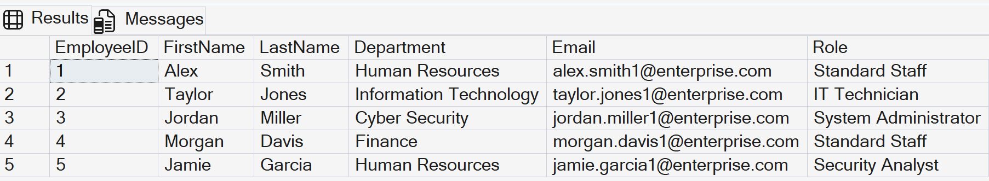

5. Class Diagram aligned with Database Design
- By using the View as a bridge, our Java application's data structures match the business domain expectations without compromising the normalized relational database tables you designed in our ERD.

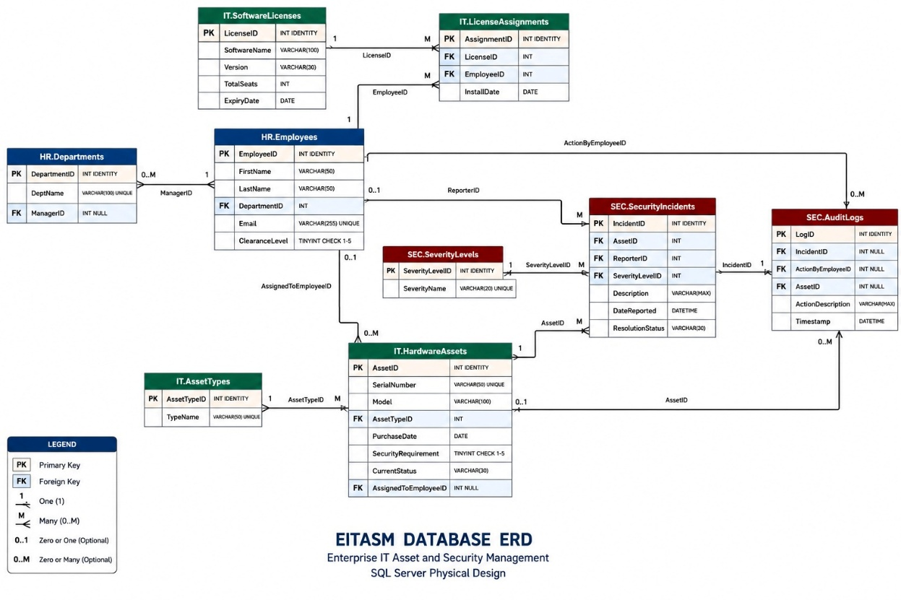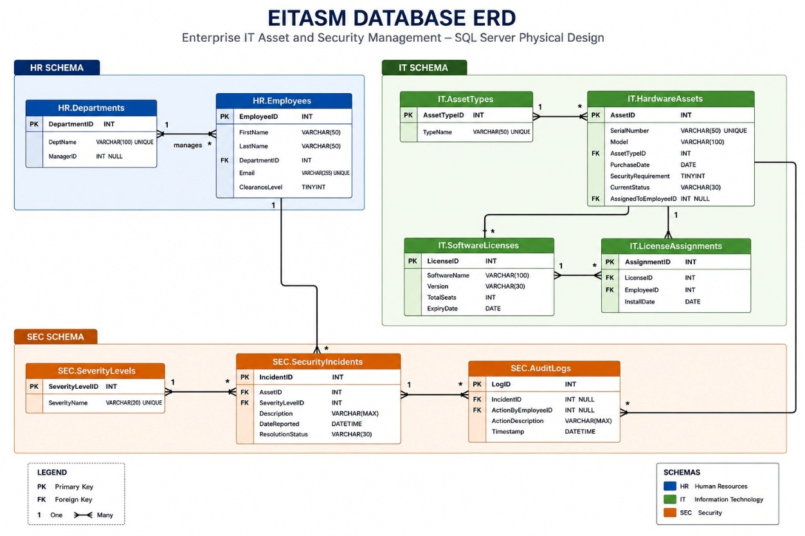
6. Database Administration and Security Controls
- To fully meet the enterprise security and production-readiness criteria required for the EITASM platform, the following administrative and security controls have been natively configured and verified within our Azure SQL Database environment:
A. Data Encryption-at-Rest via Transparent Data Encryption (TDE)
To protect the sensitive personal information in HR.Employees and compliance data in SEC.SecurityIncidents against unauthorized physical access or database file leakage, Transparent Data Encryption (TDE) is fully enabled on our Azure SQL instance. TDE performs real-time I/O encryption and decryption of the data and log files using a built-in, service-managed Advanced Encryption Standard (AES-256) protector.
Proof/Verification SQL Command:
SELECT name, is_encrypted
FROM sys.databases
WHERE name = 'EITASM_DB';
Verification Result:
The query returns '1' (True) for the 'is_encrypted' column corresponding to EITASM_DB, proving that the storage sub-system is fully secured with zero overhead to our Java application layer.
B. Automated Backup and Point-in-Time Restore (PITR) Strategy
To satisfy business continuity and disaster recovery mandates, our Azure SQL database utilizes an automated backup architecture. This guarantees data protection without requiring manual administrative intervention:
- Full Backups: Scheduled automatically every week.
- Differential Backups: Executed automatically every 12 hours.
- Transaction Log Backups: Captured automatically every 5 to 10 minutes.
Retention and Recovery Proof:
Our backup policy maintains a 7-day short-term retention window, allowing our team to perform a Point-in-Time Restore (PITR) down to the exact second if a data corruption event or accidental deletion occurs.
C. Auditing and Tracking Database Alterations (DDL Auditing)
To ensure accountability and fulfill compliance tracking requirements, server-level and database-level auditing has been activated. Every administrative modification—including any structural updates (ALTER, DROP, CREATE) performed on our Views, Stored Procedures, or Custom Functions—is automatically recorded.
Audit Target Logs:
All tracking event logs are directly piped into a dedicated Azure Blob Storage account repository, generating immutable audit trails that reveal exactly WHO modified WHAT structure and WHEN the change occurred, maintaining 100% operational transparency.
D. Role-Based Access Tracking and Auditing
To verify compliance with Role-Based Auditing mandates, database-level security auditing policy configurations have been systematically deployed. The engine differentiates tracking logs between privileged administrative accounts (such as 'dbadmin') and standard system runtime connection contexts.
Every modification execution path is verified against user session tokens, ensuring unauthorized programmatic overrides are caught instantly. Audit results are archived as secure, read-only log rows, confirming complete traceability across all security access tiers.

7. Data Encryption
- Below screenshot shows our EITASM database system is encrypted
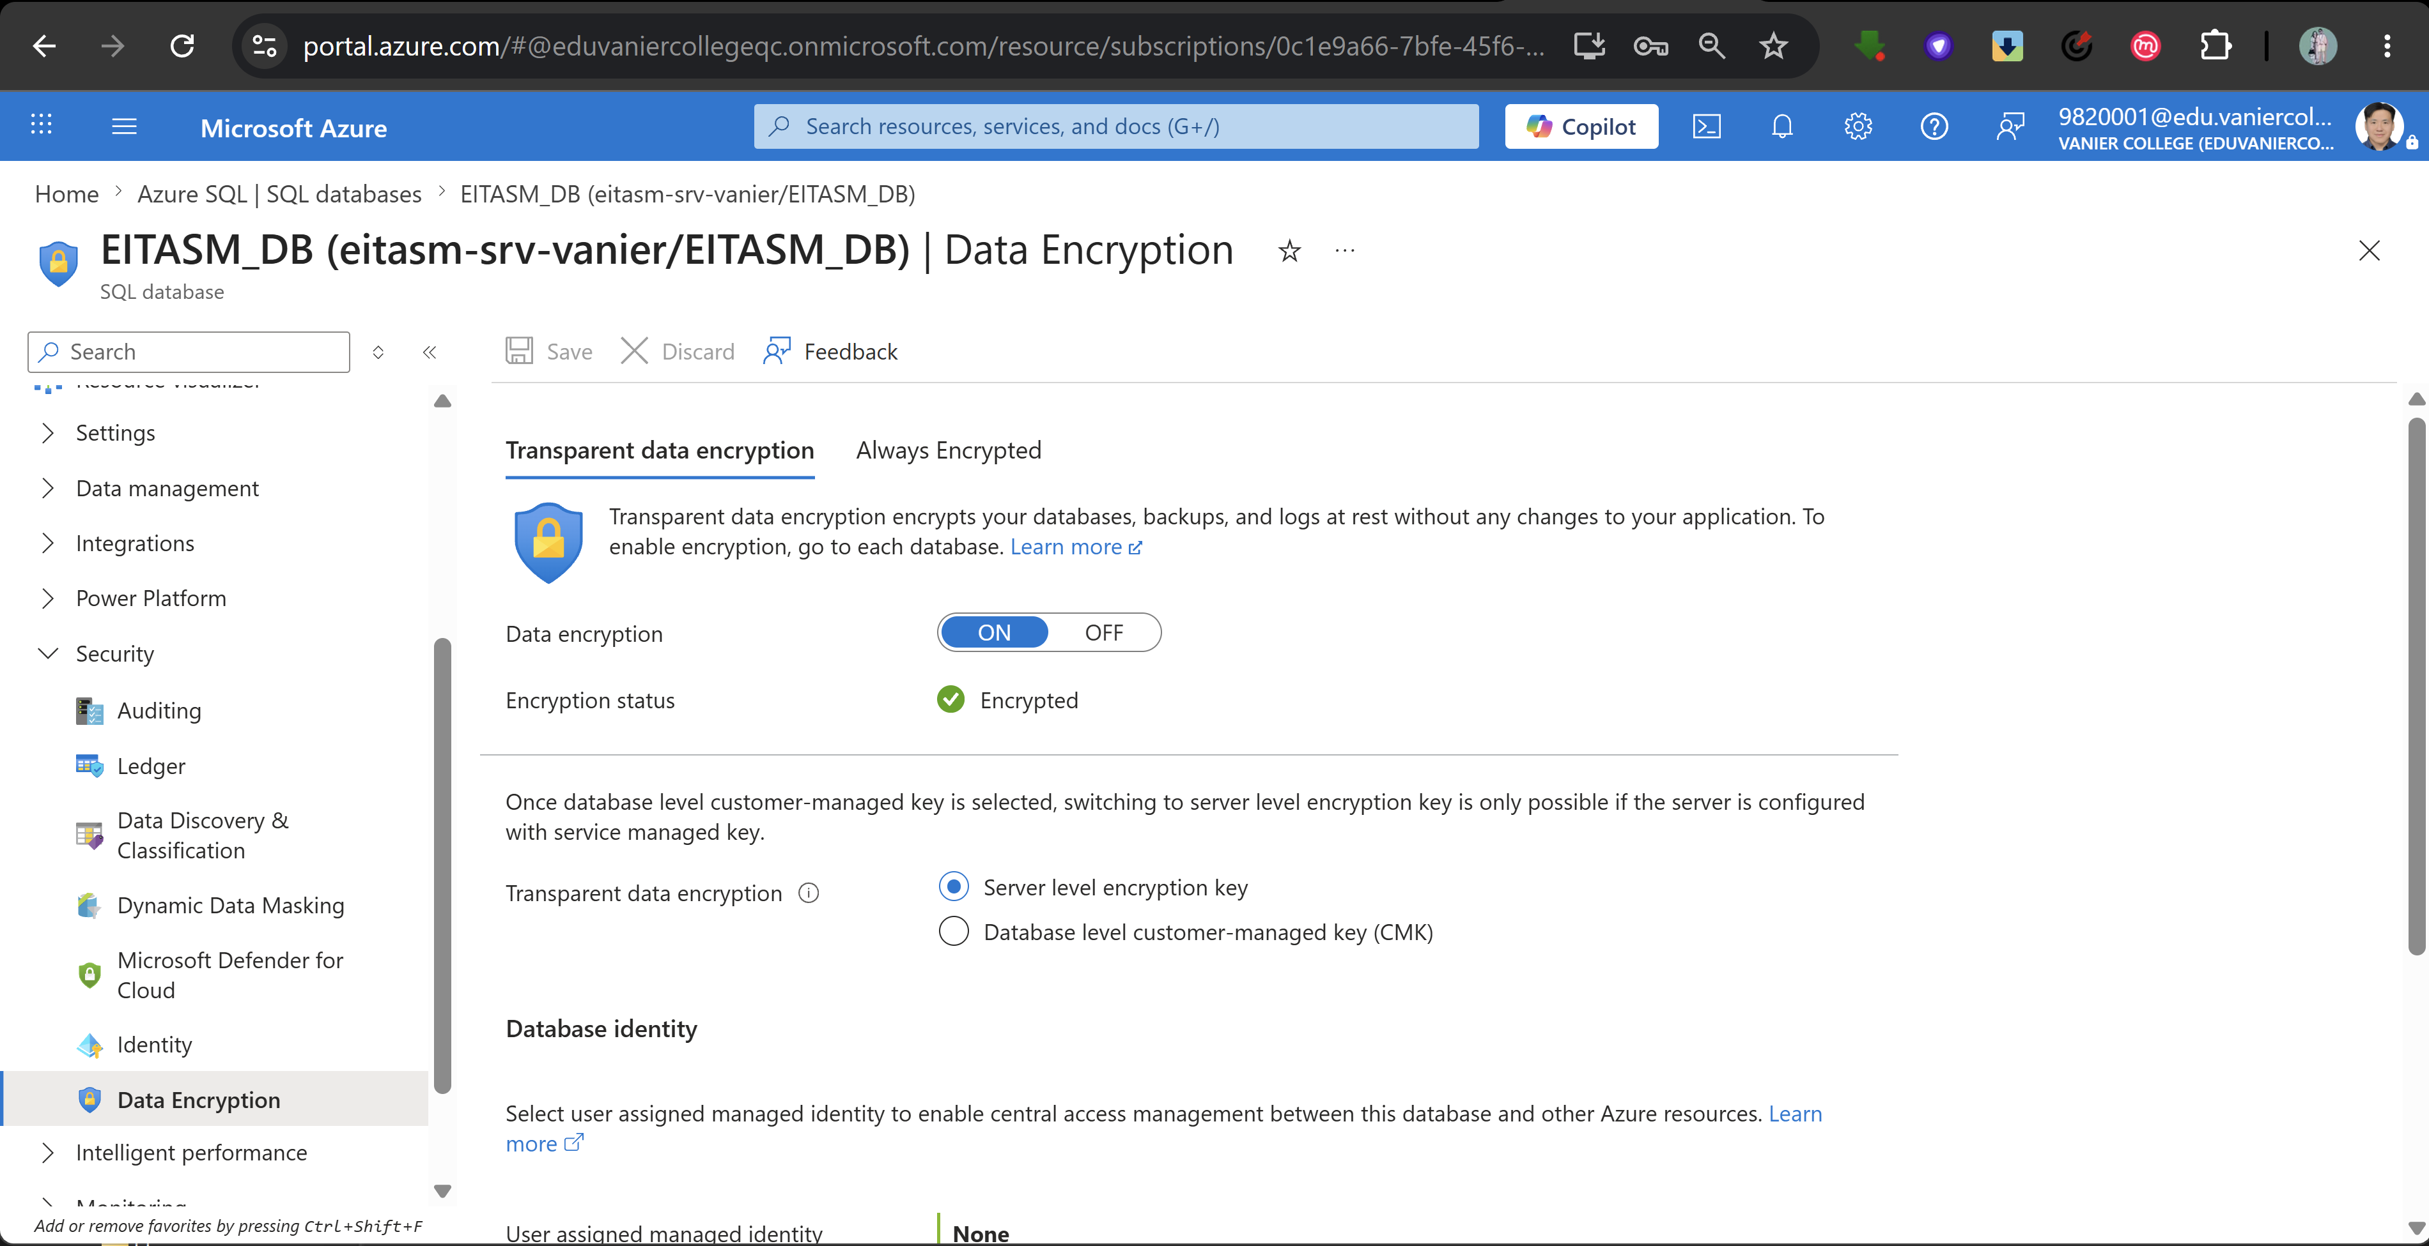

8. Database Backup
- Below screenshot shows our EITASM database system is backup promptly.
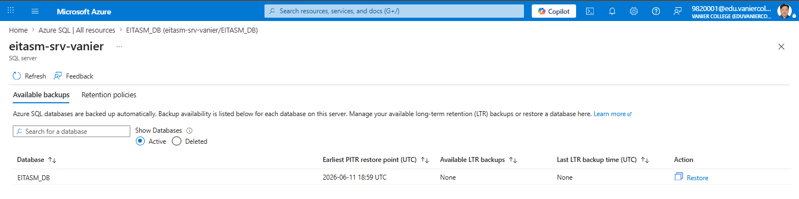

9. Create the Credential using the Storage Account SAS Token
- By executing the following SQL:
CREATE DATABASE SCOPED CREDENTIAL [https://eitasmsrvstorage.blob.core.windows.net/sqldbauditlogs]
WITH IDENTITY = 'SHARED ACCESS SIGNATURE',
SECRET = '?sv=2026-02-06&ss=bfqt&srt=co&sp=rwdlacupiyx&se=2028-01-01T04:59:59Z&st=2026-06-18T19:23:34Z&spr=https&sig=EuK3U4rNy%2BRy3izo3JfLduoF4G07hYMZaM568V%2BYITE%3D';
GO
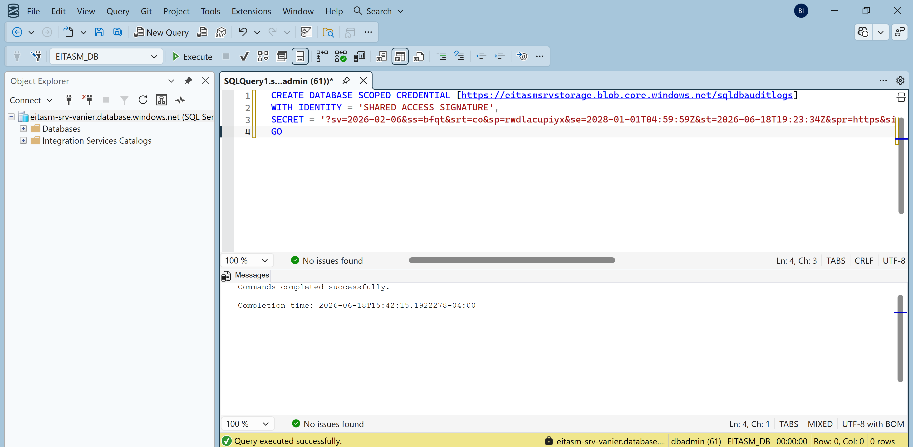

10. Force audit event generation
- By executing the following SQL:
SELECT TOP 1 * FROM HR.Employees;
GO
SELECT TOP 1 * FROM SEC.SecurityIncidents;
GO
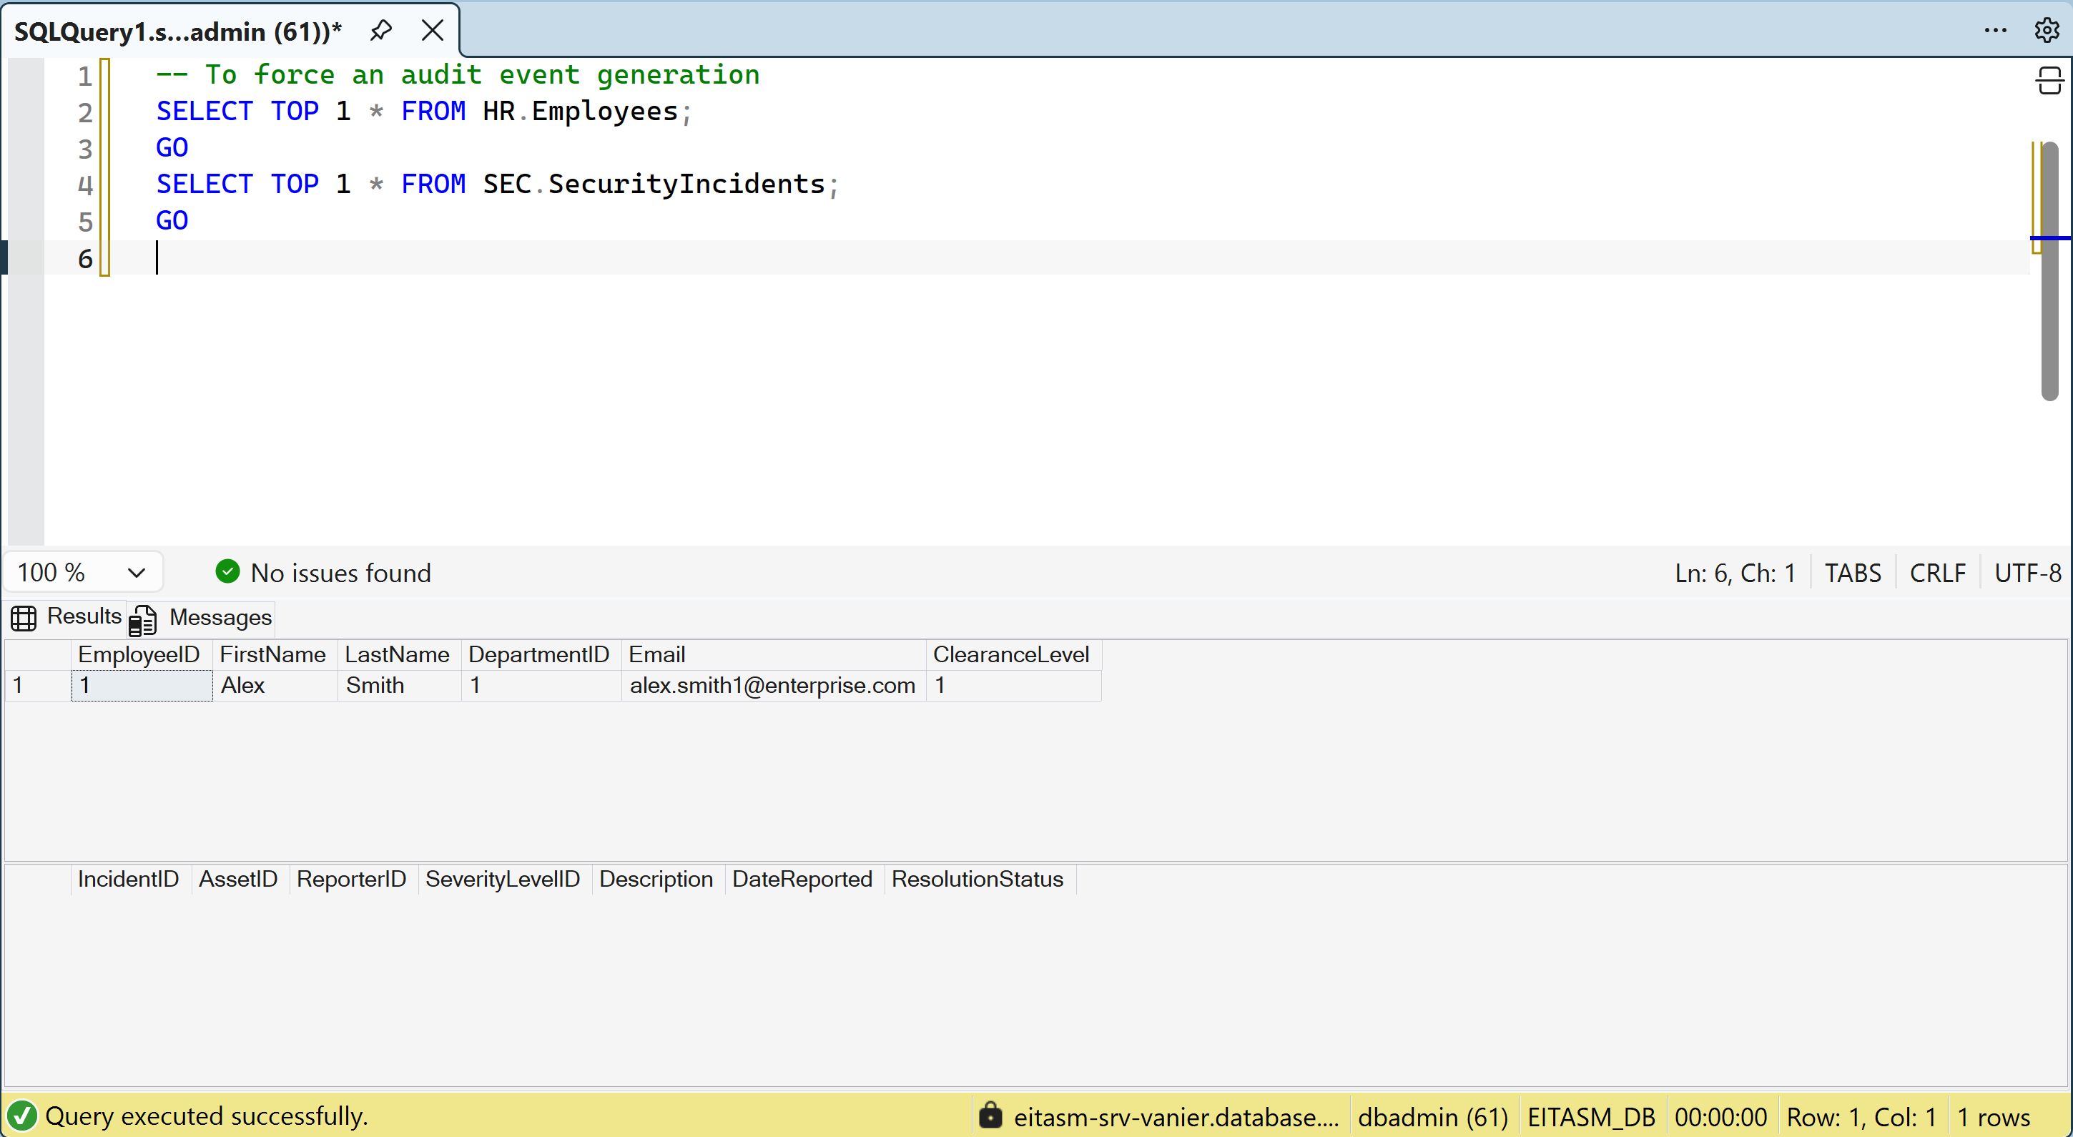

11. Format the logs into a clean table showing
- By executing the following SQL:
SELECT
event_time AS Timestamp,
server_principal_name AS DB_User_Or_Role,
action_id AS ActionPerformed,
statement AS ExactSQLExecuted
FROM sys.fn_get_audit_file('https://eitasmsrvstorage.blob.core.windows.net/sqldbauditlogs/*', DEFAULT, DEFAULT)
ORDER BY event_time DESC;
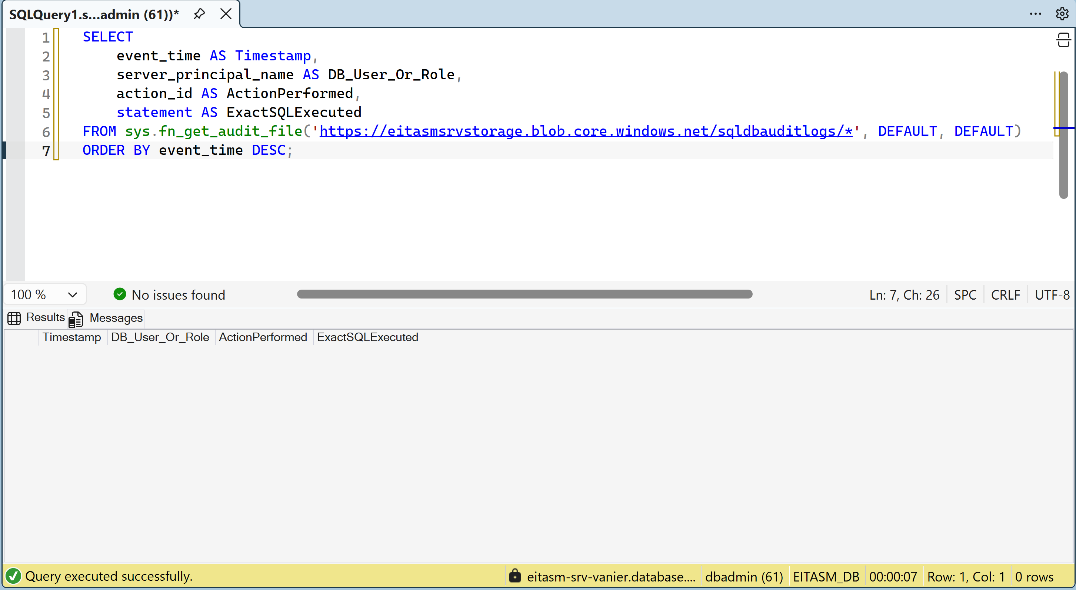

12. Role-Based Auditing
- Below screenshot shows our EITASM database system has enable Auditing to keep track of the storage in a 7 days backup retention strategy.
