在MasterDB 建立一般user

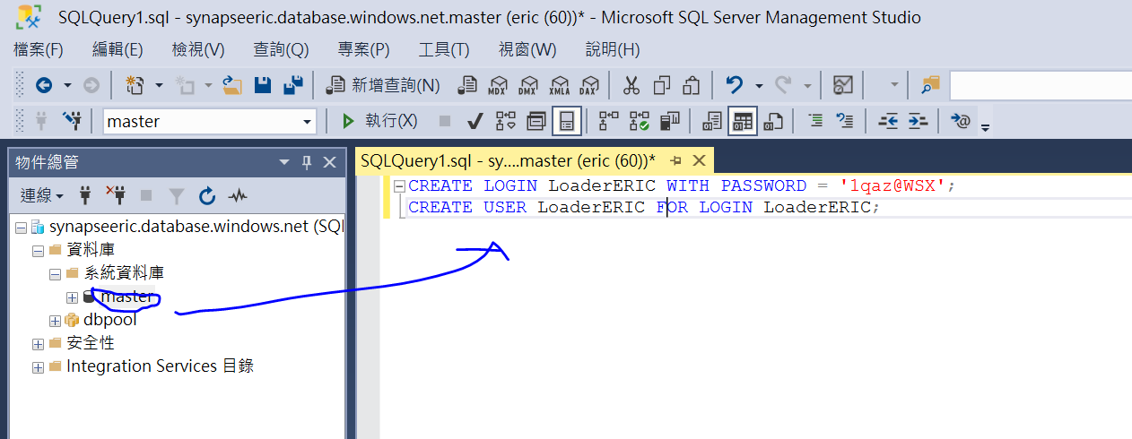

在dbpool DB建立登入權限

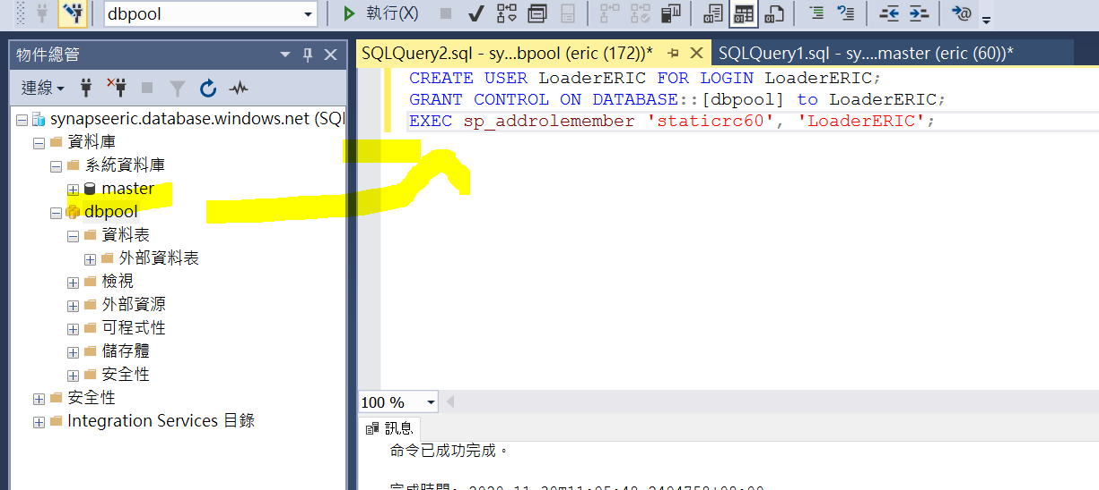

使用LoaderEric登入

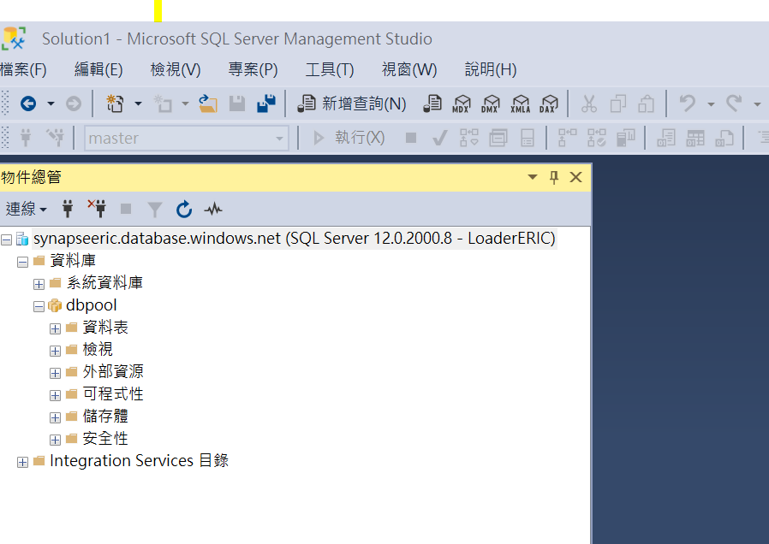

針對dbpool建立master key

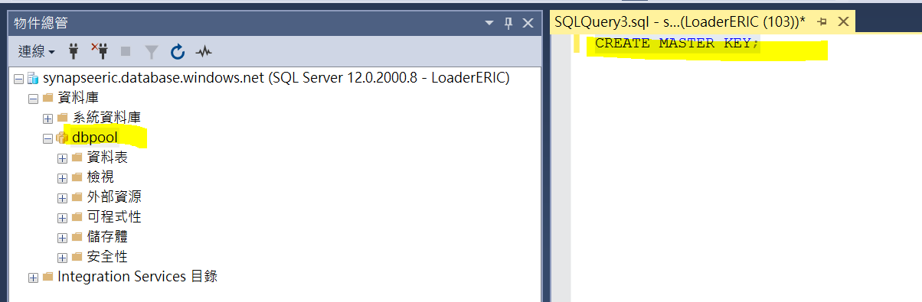

[CREATE EXTERNAL DATA SOURCE](https://docs.microsoft.com/en-us/sql/t-sql/statements/create-external-data-source-transact-sql?toc=/azure/synapse-analytics/sql-data-warehouse/toc.json&bc=/azure/synapse-analytics/sql-data-warehouse/breadcrumb/toc.json&view=azure-sqldw-latest) statement

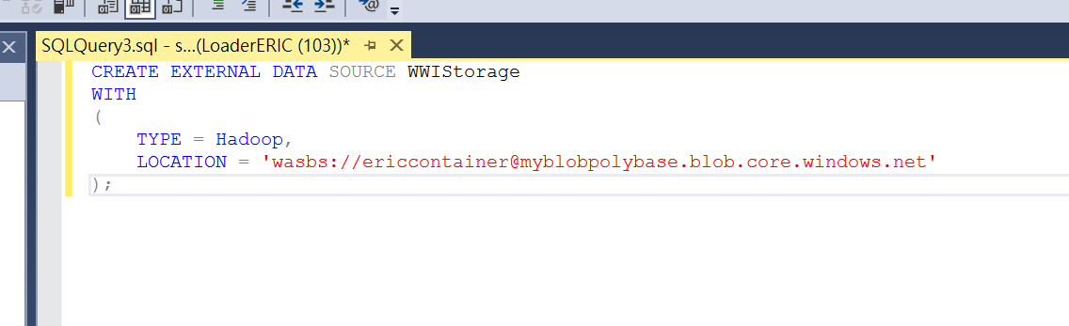

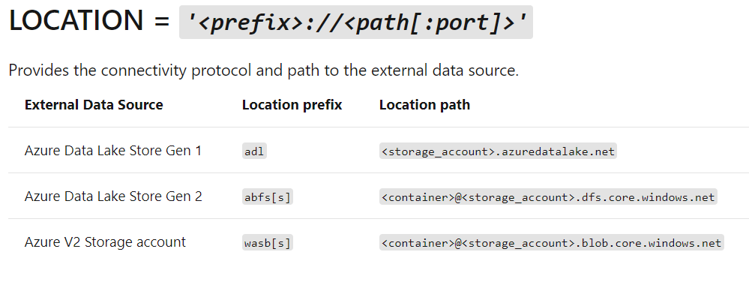

[CREATE EXTERNAL FILE FORMAT](https://docs.microsoft.com/en-us/sql/t-sql/statements/create-external-file-format-transact-sql?toc=/azure/synapse-analytics/sql-data-warehouse/toc.json&bc=/azure/synapse-analytics/sql-data-warehouse/breadcrumb/toc.json&view=azure-sqldw-latest) T-SQL statement to specify the formatting

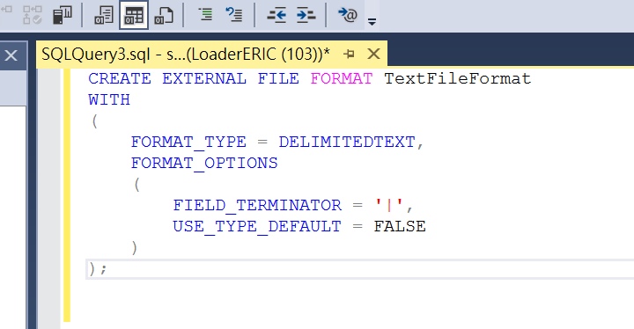

[CREATE SCHEMA](https://docs.microsoft.com/en-us/sql/t-sql/statements/create-schema-transact-sql?toc=/azure/synapse-analytics/sql-data-warehouse/toc.json&bc=/azure/synapse-analytics/sql-data-warehouse/breadcrumb/toc.json&view=azure-sqldw-latest) statements to create a schema for your external file format. The ext schema provides a way to organize the external tables you are about to create. The wwi schema organizes the standard tables that will contain the data.

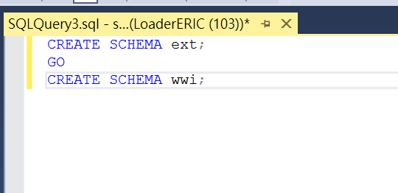

Create the external tables. The table definitions are stored in the database, but the tables reference data that is stored in Azure blob storage

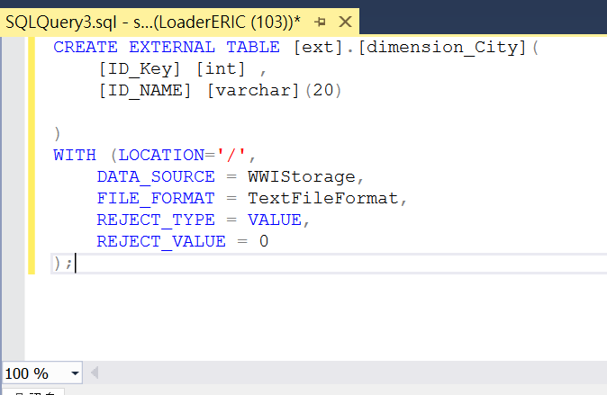

uses the [CREATE TABLE AS SELECT (CTAS)](https://docs.microsoft.com/en-us/sql/t-sql/statements/create-table-as-select-azure-sql-data-warehouse?toc=/azure/synapse-analytics/sql-data-warehouse/toc.json&bc=/azure/synapse-analytics/sql-data-warehouse/breadcrumb/toc.json&view=azure-sqldw-latest) T-SQL statement to load the data from Azure Storage Blob into new tables in your data warehouse

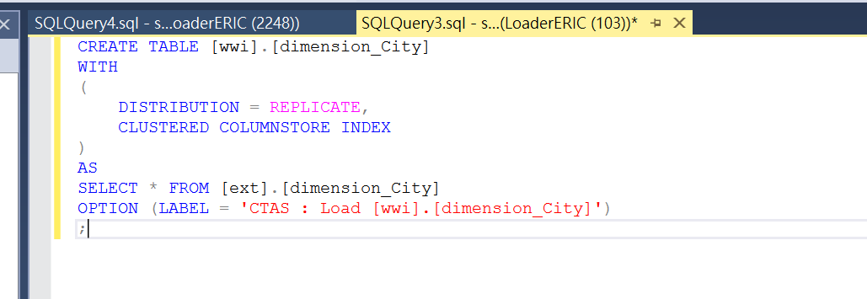

確認資料有載入

