【MUI后台管理系统】
主要内容
- 登录功能
- 班级管理
- 学生管理
- ECharts实现统计
- POI实现导出
- AJAX的分页查询
学习目标
知识点 | 要求
单表增删改查 | 掌握
AJAX分页查询 | 掌握
ECharts统计 | 掌握
POI导出 | 掌握
Servlet动态生成验证码 | 掌握
单表增删改查 | 掌握
AJAX分页查询 | 掌握
ECharts统计 | 掌握
POI导出 | 掌握
Servlet动态生成验证码 | 掌握
单表增删改查 | 掌握
AJAX分页查询 | 掌握

实现班级修改的回显功能

需求
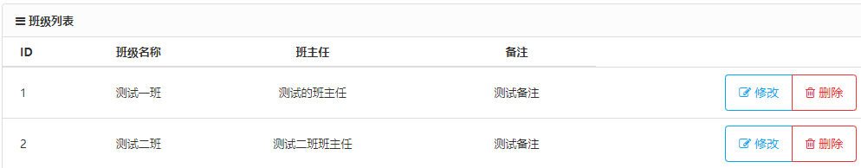
用户在班级列表页面中点击某条数据后面的修改按钮时，跳转到一个修改页面，然后在修改页面中要回显出要修改的数据。

思路分析
- 编写一个修改页面，其实和添加页面差不多
- 点击列表展示中的修改按钮时，使用超链接的方式跳转到修改页面，而且要带上本条数据
- 在修改页面中使用${param.参数名}的方式去接收请求中的参数！即可回显。

具体实现

编写班级修改页面
复制班级添加页面直接修改一下即可。
<%@ page contentType="text/html;charset=UTF-8" language="java" %>
<!DOCTYPE html>
<html lang="zh-cn">
<head>
<meta http-equiv="Content-Type" content="text/html; charset=utf-8" />
<meta http-equiv="X-UA-Compatible" content="IE=edge">
<meta name="viewport" content="width=device-width, initial-scale=1.0, maximum-scale=1.0, user-scalable=no" />
<meta name="renderer" content="webkit">
<title>修改班级</title>
<base href="${pageContext.request.contextPath}/">
<link rel="stylesheet" href="css/pintuer.css">
<link rel="stylesheet" href="css/admin.css">
<script src="js/jquery.js"></script>
<script src="js/pintuer.js"></script>
<script>
$(function(){
})
</script>
</head>
<body>
<div class="panel admin-panel">
<div class="panel-head">
<strong>
<span class="icon-pencil-square-o"></span>修改班级
</strong>
</div>
<div class="body-content">
<form method="post" class="form-x" action="xxxxxx">
<input type="hidden" name="cid" id="cid" value="${param.cid}">
<div class="form-group">
<div class="label">
<label>班级名称：</label>
</div>
<div class="field">
<input type="text" class="input" name="cname" id="cname" value="${param.cname}" style="width:30%"/>
<div class="tips"></div>
</div>
</div>
<div class="form-group">
<div class="label">
<label>班主任：</label>
</div>
<div class="field">
<input type="text" class="input" name="cteacher" id="cteacher" value="${param.cteacher}" style="width:30%"/>
</div>
</div>
<div class="form-group">
<div class="label">
<label>备注：</label>
</div>
<div class="field">
<textarea type="text" class="input" name="remark" id="remark" style="height:80px;">${param.remark}</textarea>
</div>
</div>
<div class="form-group">
<div class="label">
<label></label>
</div>
<div class="field">
<input class="button bg-main icon-check-square-o" id="btn" type="submit" value="提交"/>
</div>
</div>
</form>
</div>
</div>
</body>
</html>

编写班级列表展示页面
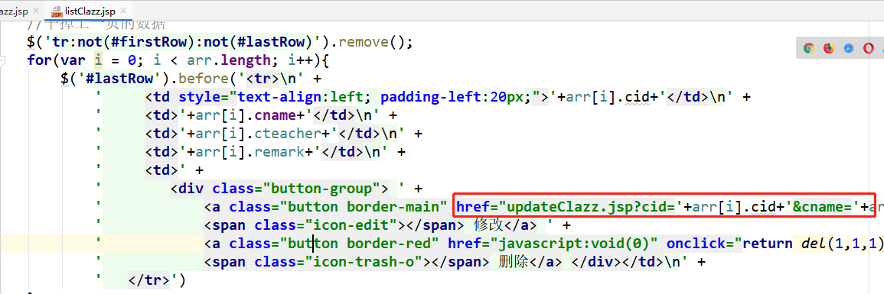

启动测试
启动项目，查看修改的回显功能。

实现班级修改的功能

需求
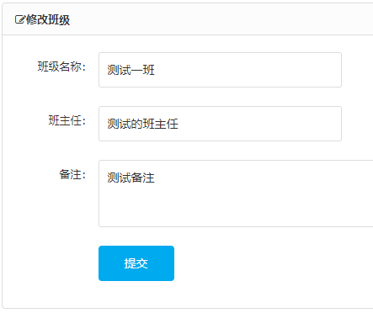
用户输入修改后最新的信息，然后点击提交按钮后，对数据进行修改。修改成功或者失败都给一个提示！

思路分析
对于修改功能，我们也使用ajax的方式进行请求的发送！
- 给提交按钮绑定点击事件
- 点击后，发送ajax请求到后端，携带表单中的各个参数和方法名！
- 后端修改完数据后给前端一个响应
- ajax收到响应结果后进行判断，提示修改成功或失败！成功的话，将表单内容清空即可！

具体实现

编写修改页面的ajax
$(function(){
$('#btn').click(function(){
var cid = $('#cid').val();
var cname = $('#cname').val();
var cteacher = $('#cteacher').val();
var remark = $('#remark').val();
$.post('ClazzServlet',{cid:cid,cname:cname,cteacher:cteacher,remark:remark,methodName:'updateClazz'},function(data){
if(data == 1){
alert('修改成功！');
$('#cid').val('');
$('#cname').val('');
$('#cteacher').val('');
$('#remark').val('');
}else{
alert('修改失败！')
}
});
return false; //阻止表单的提交
});
})

编写dao层
public interface ClazzDao {
int updateClazz(Clazz clazz);

public class ClazzDaoImpl implements ClazzDao {
@Override
public int updateClazz(Clazz clazz) {
Connection connection = null;
PreparedStatement ps = null;
int i = 0;
try {
connection = JDBCUtils.getConnection();
String sql = "update clazz set cname=?, cteacher=?, remark=? where cid=?";
ps = connection.prepareStatement(sql);
ps.setString(1, clazz.getCname());
ps.setString(2, clazz.getCteacher());
ps.setString(3, clazz.getRemark());
ps.setInt(4, clazz.getCid());
i = ps.executeUpdate();
} catch (Exception e) {
e.printStackTrace();
} finally {
JDBCUtils.closeConnection(ps, connection);
}
return i;
}

编写service层
public interface ClazzService {
int updateClazz(Clazz clazz);

public class ClazzServiceImpl implements ClazzService {
private ClazzDao clazzDao = new ClazzDaoImpl();
@Override
public int updateClazz(Clazz clazz) {
return clazzDao.updateClazz(clazz);
}

编写controller层
@WebServlet("/ClazzServlet")
public class ClazzServlet extends BaseServlet {
private ClazzService clazzService = new ClazzServiceImpl();
protected void updateClazz(HttpServletRequest req, HttpServletResponse resp) throws ServletException, IOException {
req.setCharacterEncoding("utf-8");
String cidStr = req.getParameter("cid");
int cid = Integer.parseInt(cidStr);
String cname = req.getParameter("cname");
String cteacher = req.getParameter("cteacher");
String remark = req.getParameter("remark");
Clazz clazz = new Clazz(cid, cname, cteacher, remark);
int i = clazzService.updateClazz(clazz);
resp.getWriter().write(i > 0 ? "1" : "0");
}

启动测试
启动项目，测试修改的效果！

实现班级删除的功能

需求
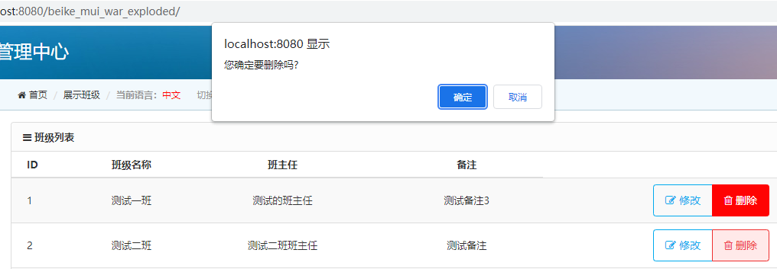
用户点击删除按钮后，提示是否确定删除，确定后即可删除数据。
删除成功后，班级列表应该展示最新的数据。

思路分析
删除使用的也是ajax请求的方式。
给删除按钮绑定鼠标单击事件去发送ajax请求，并且带上本条数据的id。
删除成功后，提示删除成功；否则提示删除失败！
注意，给超链接绑定单击事件去发请求，那么超链接本身就不要跳转了！！！

具体实现

编写dao层
public interface ClazzDao {
int deleteClazz(Integer cid);

public class ClazzDaoImpl implements ClazzDao {
@Override
public int deleteClazz(Integer cid) {
Connection connection = null;
PreparedStatement ps = null;
int i = 0;
try {
connection = JDBCUtils.getConnection();
String sql = "delete from clazz where cid=?";
ps = connection.prepareStatement(sql);
ps.setInt(1, cid);
i = ps.executeUpdate();
} catch (Exception e) {
e.printStackTrace();
} finally {
JDBCUtils.closeConnection(ps, connection);
}
return i;
}

编写service层
public interface ClazzService {
int deleteClazz(Integer cid);

public class ClazzServiceImpl implements ClazzService {
private ClazzDao clazzDao = new ClazzDaoImpl();
@Override
public int deleteClazz(Integer cid) {
return clazzDao.deleteClazz(cid);
}

编写controller层
@WebServlet("/ClazzServlet")
public class ClazzServlet extends BaseServlet {
private ClazzService clazzService = new ClazzServiceImpl();
protected void deleteClazz(HttpServletRequest req, HttpServletResponse resp) throws ServletException, IOException {
String cid = req.getParameter("cid");
int i = clazzService.deleteClazz(Integer.parseInt(cid));
resp.getWriter().write(i > 0 ? "1" : "0");
}

编写列表展示页面删除功能
我们要给删除按钮绑定事件，而删除按钮是后面通过ajax出来的，不能直接绑定，需要使用 $(document).on() 的方式才行！
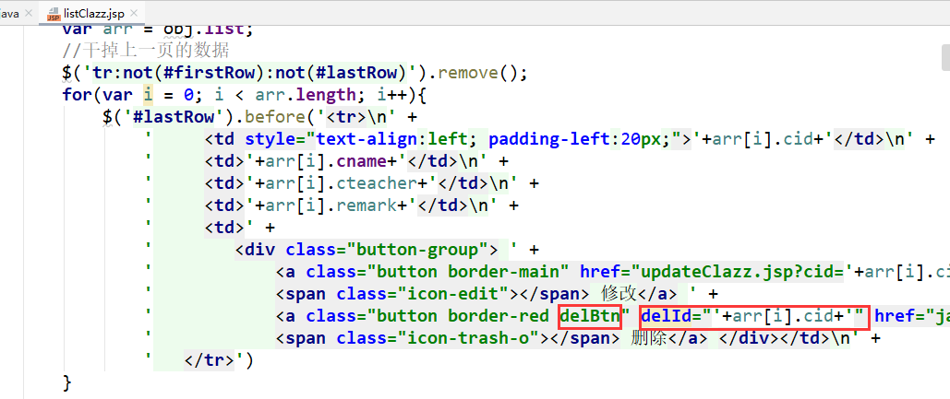
注意，原来的超链接上面有个onclick的点击事件，把那个要去掉！！！
//删除按钮的事件
$(document).on('click','.delBtn',function(){
var b = confirm('确定删除吗？');
if(!b){
return;
}
var cid = $(this).attr('delId');
$.get('ClazzServlet',{cid:cid,methodName:'deleteClazz'},function(data){
if(data == 1){
alert('删除成功！');
index = 1;
//重新获取数据
getData();
}else{
alert('删除失败！');
}
});
})

启动测试
启动项目，查看删除效果！

实现统计班级人数的功能

需求
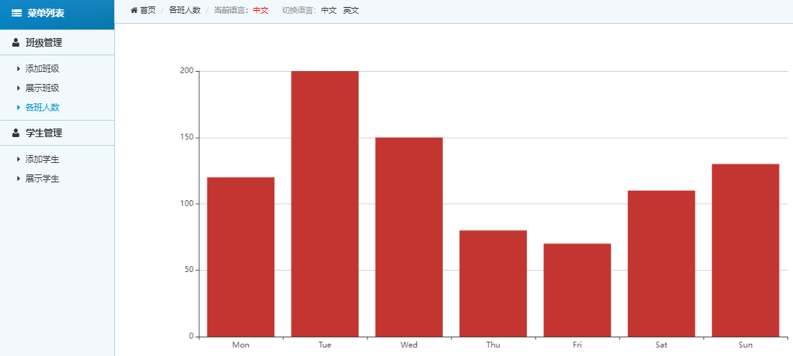
用户点击各班人数的菜单后，在右侧展示班级人数统计信息。

思路分析
上图中，统计信息的条形图是使用的echarts这个前端小插件。专门是用来做统计图表的。
我们需要在后端对学生表分组查询每个班级的学生人数。
将查询到的结果封装为List集合，集合的泛型是自定义的一个类TongJi类，里面有两个前端需要的属性：grade、count。
之后前端发送ajax请求，我们将数据打给前端。

具体实现

编写实体类
package com.bjsxt.pojo;
public class TongJi {
private String grade; //班级名称
private Integer count; //班级人数
public TongJi() {
}
public TongJi(String grade, Integer count) {
this.grade = grade;
this.count = count;
}
public String getGrade() {
return grade;
}
public void setGrade(String grade) {
this.grade = grade;
}
public Integer getCount() {
return count;
}
public void setCount(Integer count) {
this.count = count;
}
@Override
public String toString() {
return "TongJi{" +
"grade='" + grade + '\'' +
", count=" + count +
'}';
}
}

编写dao层
public interface ClazzDao {
List<TongJi> getTongJi();

public class ClazzDaoImpl implements ClazzDao {
@Override
public List<TongJi> getTongJi() {
Connection connection = null;
PreparedStatement ps = null;
List<TongJi> list = null;
try {
connection = JDBCUtils.getConnection();
String sql = "select count(*) count, c.cname grade from student s,clazz c where s.cid=c.cid group by c.cname;";
ps = connection.prepareStatement(sql);
ResultSet rs = ps.executeQuery();
list = new ArrayList<>();
while(rs.next()){
int count = rs.getInt("count");
String grade = rs.getString("grade");
TongJi tongJi = new TongJi(grade, count);
list.add(tongJi);
}
} catch (Exception e) {
e.printStackTrace();
} finally {
JDBCUtils.closeConnection(ps, connection);
}
return list;
}

编写service层
public interface ClazzService {
List<TongJi> getTongJi();

public class ClazzServiceImpl implements ClazzService {
private ClazzDao clazzDao = new ClazzDaoImpl();
@Override
public List<TongJi> getTongJi() {
return clazzDao.getTongJi();
}

编写controller层
@WebServlet("/ClazzServlet")
public class ClazzServlet extends BaseServlet {
private ClazzService clazzService = new ClazzServiceImpl();
protected void getTongJi(HttpServletRequest req, HttpServletResponse resp) throws ServletException, IOException {
resp.setContentType("text/html;charset=utf-8");
List<TongJi> list = clazzService.getTongJi();
Gson gson = new Gson();
String s = gson.toJson(list);
resp.getWriter().write(s);
}

编写统计页面
<%@ page contentType="text/html;charset=UTF-8" language="java" %>
<!DOCTYPE html>
<html style="height: 100%">
<head>
<meta charset="utf-8">
<base href="${pageContext.request.contextPath}/">
<script type="text/javascript" src="js/jquery.js"></script>
<script type="text/javascript" src="js/echarts.min.js"></script>
<script type="text/javascript">
$(function(){
$.get('ClazzServlet',{methodName:'getTongJi'},function(data){
eval('var arr = ' + data);
var arr1 = [];//存放所有班级的数组
var arr2 = [];//存放所有人数的数组
for(var i = 0; i < arr.length; i++){
arr1.push(arr[i].grade);
arr2.push(arr[i].count);
}
var dom = document.getElementById("container");
var myChart = echarts.init(dom);
var app = {};
var option;
option = {
xAxis: {
type: 'category',
data: arr1
},
yAxis: {
type: 'value'
},
series: [{
data: arr2,
type: 'bar'
}]
};
if (option && typeof option === 'object') {
myChart.setOption(option);
}
});
})
</script>
</head>
<body style="height: 100%; margin: 0">
<div id="container" style="height: 100%">
</div>
</body>
</html>

启动测试
启动项目，查看统计效果！

实现添加学生时班级下拉列表功能

需求
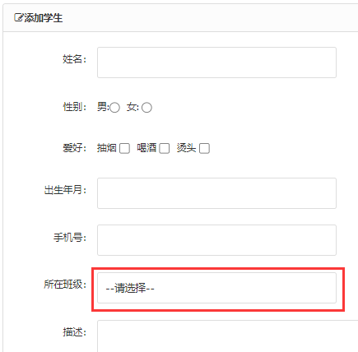
用户点击添加学生进入到添加页面后，在所在班级选项中要可以看到所有的班级信息！

思路分析
- 用户点击添加菜单进入到添加页面后，页面加载完毕后，发送ajax请求到后端
- 后端查询所有的班级信息，响应给前端
- 前端收到班级列表信息后，使用jQuery动态拼接到select下拉列表中

具体实现

编写dao层
前面已经实现了查询所有班级信息的功能！

编写service层
前面已经实现了查询所有班级信息的功能！

编写controller层
前面已经实现了查询所有班级信息的功能！

编写添加页面
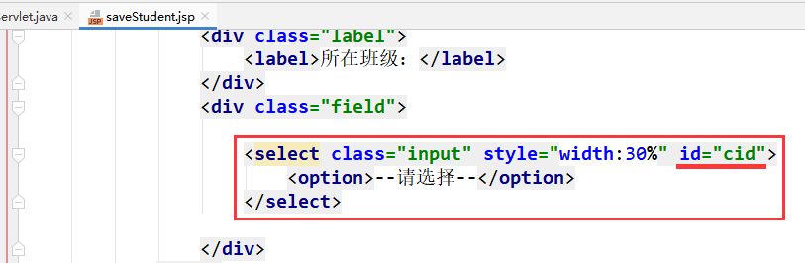
<script>
$(function(){
//查询所有班级信息
$.get('ClazzServlet',{methodName:'getAll'},function(data){
eval('var arr = ' + data);
for(var i = 0; i < arr.length; i++){
$('#cid').append('<option value="'+arr[i].cid+'">'+arr[i].cname+'</option>');
}
});
})
</script>

启动测试
启动服务器查看添加页面班级下拉列表的效果！

实现添加学生的功能

需求
用户在添加学生页面输入学生信息，点击添加按钮后添加学生信息。成功或失败要有提示！
成功后要清空表单的信息。
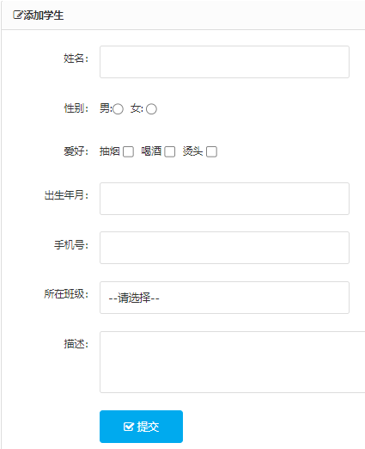

思路分析
- 给提交按钮绑定鼠标单击事件，点击后发送ajax请求到后端
- 后端收到所有的请求参数后添加数据到数据库
- 给前端一个响应，成功则清除表单信息

具体实现

编写dao层
public interface StudentDao {
int addStudent(Student student);
}

public class StudentDaoImpl implements StudentDao {
@Override
public int addStudent(Student s) {
Connection connection = null;
PreparedStatement ps = null;
int i = 0;
try {
connection = JDBCUtils.getConnection();
String sql = "insert into student values(null,?,?,?,?,?,?,?)";
ps = connection.prepareStatement(sql);
ps.setString(1, s.getSname());
ps.setString(2, s.getSex());
ps.setString(3, s.getHobby());
long time = s.getBirthdate().getTime();
Date date = new Date(time);
ps.setDate(4, date);
ps.setString(5, s.getPhone());
ps.setString(6, s.getReamrk());
ps.setInt(7, s.getClazz().getCid());
i = ps.executeUpdate();
} catch (Exception e) {
e.printStackTrace();
} finally {
JDBCUtils.closeConnection(ps, connection);
}
return i;
}
}

编写service层
public interface StudentService {
int addStudent(Student student);
}

public class StudentServiceImpl implements StudentService {
private StudentDao studentDao = new StudentDaoImpl();
@Override
public int addStudent(Student student) {
return studentDao.addStudent(student);
}
}

编写controller层
@WebServlet("/StudentServlet")
public class StudentServlet extends BaseServlet {
private StudentService studentService = new StudentServiceImpl();
protected void addStudent(HttpServletRequest req, HttpServletResponse resp) throws ServletException, IOException {
req.setCharacterEncoding("utf-8");
String sname = req.getParameter("sname");
String sex = req.getParameter("sex");
String[] hobbies = req.getParameterValues("hobby");
String hobby = "";
for (String s : hobbies) {
hobby += s + ",";
}
hobby = hobby.substring(0, hobby.length() - 1);
String birthdateStr = req.getParameter("birthdate");
Date birthdate = null;
try {
SimpleDateFormat sdf = new SimpleDateFormat("yyyy-MM-dd");
birthdate = sdf.parse(birthdateStr);
} catch (ParseException e) {
e.printStackTrace();
}
String phone = req.getParameter("phone");
String reamrk = req.getParameter("reamrk");
String cid = req.getParameter("cid");
Clazz clazz = new Clazz();
clazz.setCid(Integer.parseInt(cid));
Student student = new Student(null, sname, sex, hobby, birthdate, phone, reamrk, clazz);
int i = studentService.addStudent(student);
resp.getWriter().write(i > 0 ? "1" : "0");
}
}

编写添加页面
//添加学生
$('#btn').click(function(){
var param = $('#stuForm').serialize() + '&methodName=addStudent';
$.post('StudentServlet',param,function(data){
if(data == 1){
alert('添加成功！');
$('#stuForm')[0].reset();
}else{
alert('添加失败！');
}
});
return false;
});

<form method="post" id="stuForm" class="form-x" action="">
<div class="form-group">
<div class="label">
<label>姓名：</label>
</div>
<div class="field">
<input type="text" class="input" name="sname" value="" style="width:30%"/>
<div class="tips"></div>
</div>
</div>
<div class="form-group">
<div class="label">
<label>性别：</label>
</div>
<div class="field" style="padding-top:8px;">
男:<input type="radio" name="sex" value="男" />
女: <input type="radio" name="sex" value="女" />
</div>
</div>
<div class="form-group">
<div class="label">
<label>爱好：</label>
</div>
<div class="field" style="padding-top:8px;">
抽烟 <input type="checkbox" name="hobby" value="抽烟"/>
喝酒 <input type="checkbox" name="hobby" value="喝酒"/>
烫头 <input type="checkbox" name="hobby" value="烫头"/>
</div>
</div>
<div class="form-group">
<div class="label">
<label>出生年月：</label>
</div>
<div class="field">
<input type="text" class="input" name="birthdate" value="" style="width:30%"/>
<div class="tips"></div>
</div>
</div>
<div class="form-group">
<div class="label">
<label>手机号：</label>
</div>
<div class="field">
<input type="text" class="input" name="phone" value="" style="width:30%"/>
</div>
</div>
<div class="form-group">
<div class="label">
<label>所在班级：</label>
</div>
<div class="field">
<select class="input" style="width:30%" id="cid" name="cid">
<option>--请选择--</option>
</select>
</div>
</div>
<div class="form-group">
<div class="label">
<label>描述：</label>
</div>
<div class="field">
<textarea type="text" class="input" name="reamrk" style="height:80px;"></textarea>
</div>
</div>
<div class="form-group">
<div class="label">
<label></label>
</div>
<div class="field">
<button class="button bg-main icon-check-square-o" id="btn" type="submit"> 提交</button>
</div>
</div>
</form>

实现分页展示学生功能

实现展示第一页功能

编写dao层
public interface StudentDao {
int getTotalCount();
List<Student> getStudentByPage(int start, int size);

public class StudentDaoImpl implements StudentDao {
@Override
public int getTotalCount() {
Connection connection = null;
PreparedStatement ps = null;
int totalCount = 0;
try {
connection = JDBCUtils.getConnection();
String sql = "select count(*) from student";
ps = connection.prepareStatement(sql);
ResultSet resultSet = ps.executeQuery();
totalCount = 0;
if(resultSet.next()){
totalCount = resultSet.getInt(1);
}
} catch (Exception e) {
e.printStackTrace();
} finally {
JDBCUtils.closeConnection(ps, connection);
}
return totalCount;
}
@Override
public List<Student> getStudentByPage(int start, int size) {
Connection connection = null;
PreparedStatement ps = null;
List<Student> list = null;
try {
connection = JDBCUtils.getConnection();
String sql = "select s.sid,s.sname,s.sex,s.hobby,s.birthdate,s.phone,s.reamrk,s.cid,c.cname\n" +
"from student s,clazz c where s.cid=c.cid limit ?,?";
ps = connection.prepareStatement(sql);
ps.setInt(1, start);
ps.setInt(2, size);
ResultSet resultSet = ps.executeQuery();
list = new ArrayList<>();
while(resultSet.next()){
int sid = resultSet.getInt("sid");
String sname = resultSet.getString("sname");
String sex = resultSet.getString("sex");
String hobby = resultSet.getString("hobby");
Date birthdate = resultSet.getDate("birthdate");
String phone = resultSet.getString("phone");
String reamrk = resultSet.getString("reamrk");
int cid = resultSet.getInt("cid");
String cname = resultSet.getString("cname");
Clazz clazz = new Clazz();
clazz.setCid(cid);
clazz.setCname(cname);
Student student = new Student(sid, sname, sex, hobby, birthdate, phone, reamrk, clazz);
list.add(student);
}
} catch (Exception e) {
e.printStackTrace();
} finally {
JDBCUtils.closeConnection(ps, connection);
}
return list;
}

编写service层
public interface StudentService {
PageBean<Student> getStudentByPage(int index);

public class StudentServiceImpl implements StudentService {
private StudentDao studentDao = new StudentDaoImpl();
@Override
public PageBean<Student> getStudentByPage(int index) {
PageBean<Student> pageBean = new PageBean<>();
pageBean.setIndex(index);
pageBean.setSize(5);
List<Student> list = studentDao.getStudentByPage((index - 1) * 5, 5);
pageBean.setList(list);
int totalCount = studentDao.getTotalCount();
pageBean.setTotalCount(totalCount);
return pageBean;
}

编写controller层
@WebServlet("/StudentServlet")
public class StudentServlet extends BaseServlet {
private StudentService studentService = new StudentServiceImpl();
protected void getStudentByPage(HttpServletRequest req, HttpServletResponse resp) throws ServletException, IOException {
resp.setContentType("text/html;charset=utf-8");
String index = req.getParameter("index");
PageBean<Student> pageBean = studentService.getStudentByPage(Integer.parseInt(index));
Gson gson = new Gson();
String s = gson.toJson(pageBean);
resp.getWriter().write(s);
}

编写列表展示页面
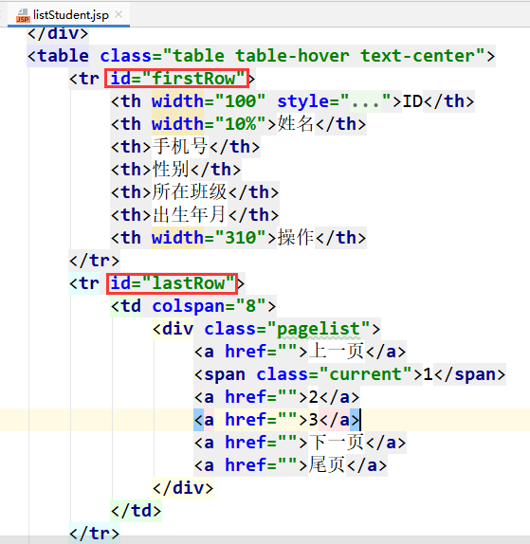
<script>
$(function(){
$.get('StudentServlet',{methodName:'getStudentByPage',index:1},function(data){
eval('var obj = ' + data);
var arr = obj.list;
//去掉之前的分页数据
$('tr:not(#lastRow):not(#firstRow)').remove();
for(var i = 0; i < arr.length; i++){
$('#lastRow').before('<tr>\n' +
' <td style="text-align:left; padding-left:20px;">'+arr[i].sid+'</td>\n' +
' <td>'+arr[i].sname+'</td>\n' +
' <td>'+arr[i].phone+'</td>\n' +
' <td>'+arr[i].sex+'</td>\n' +
' <td>'+arr[i].clazz.cname+'</td>\n' +
' <td>'+arr[i].birthdate+'</td>\n' +
' <td>' +
' <div class="button-group"> ' +
' <a class="button border-main" href="add.html">' +
' <span class="icon-edit"></span> 修改</a> ' +
' <a class="button border-red" href="javascript:void(0)">' +
' <span class="icon-trash-o"></span> 删除</a> ' +
' </div>' +
' </td>\n' +
' </tr>');
}
});
})
</script>

启动测试
启动项目，查看第一页的分页效果！

优化第一页功能的页面代码
<script>
$(function(){
var index = 1;//当前页
var size = 5; //每页条数
var totalPageCount;//总页数
var totalCount;//总记录数
function getData(){
$.get('StudentServlet',{methodName:'getStudentByPage',index:index},function(data){
eval('var obj = ' + data);
var arr = obj.list;
index = obj.index;
totalPageCount = obj.totalPageCount;
totalCount = obj.totalCount;
//去掉之前的分页数据
$('tr:not(#lastRow):not(#firstRow)').remove();
for(var i = 0; i < arr.length; i++){
$('#lastRow').before('<tr>\n' +
' <td style="text-align:left; padding-left:20px;">'+arr[i].sid+'</td>\n' +
' <td>'+arr[i].sname+'</td>\n' +
' <td>'+arr[i].phone+'</td>\n' +
' <td>'+arr[i].sex+'</td>\n' +
' <td>'+arr[i].clazz.cname+'</td>\n' +
' <td>'+arr[i].birthdate+'</td>\n' +
' <td>' +
' <div class="button-group"> ' +
' <a class="button border-main" href="add.html">' +
' <span class="icon-edit"></span> 修改</a> ' +
' <a class="button border-red" href="javascript:void(0)">' +
' <span class="icon-trash-o"></span> 删除</a> ' +
' </div>' +
' </td>\n' +
' </tr>');
}
});
}
//初始化调用
getData();
})
</script>

实现下一页功能
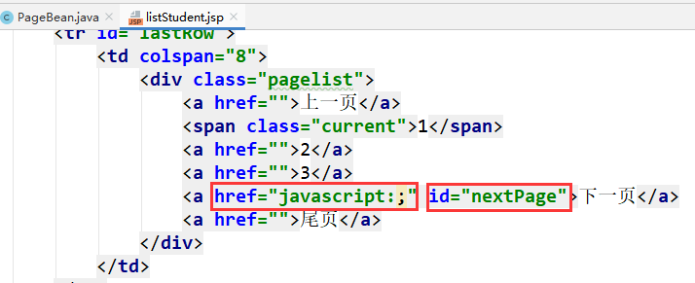
//下一页
$('#nextPage').click(function(){
if(index == totalPageCount){
alert('已经是最后一页了！');
return false;
}else{
index = index + 1;
getData();
}
});

实现上一页功能
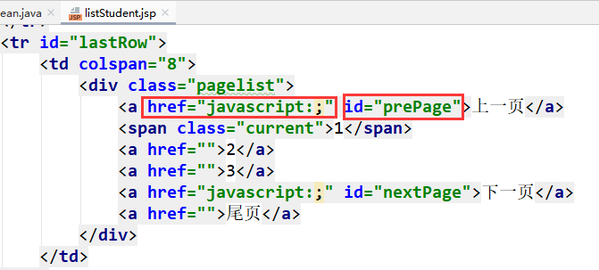
//上一页
$('#prePage').click(function(){
if(index == 1){
alert('已经是第一页了！');
return false;
}else{
index = index - 1;
getData();
}
});

实现展示页码的功能
function getData(){
$.get('StudentServlet',{methodName:'getStudentByPage',index:index},function(data){
eval('var obj = ' + data);
var arr = obj.list;
index = obj.index;
totalPageCount = obj.totalPageCount;
totalCount = obj.totalCount;
//去掉之前的分页数据
$('tr:not(#lastRow):not(#firstRow)').remove();
for(var i = 0; i < arr.length; i++){
$('#lastRow').before('<tr>\n' +
' <td style="text-align:left; padding-left:20px;">'+arr[i].sid+'</td>\n' +
' <td>'+arr[i].sname+'</td>\n' +
' <td>'+arr[i].phone+'</td>\n' +
' <td>'+arr[i].sex+'</td>\n' +
' <td>'+arr[i].clazz.cname+'</td>\n' +
' <td>'+arr[i].birthdate+'</td>\n' +
' <td>' +
' <div class="button-group"> ' +
' <a class="button border-main" href="add.html">' +
' <span class="icon-edit"></span> 修改</a> ' +
' <a class="button border-red" href="javascript:void(0)">' +
' <span class="icon-trash-o"></span> 删除</a> ' +
' </div>' +
' </td>\n' +
' </tr>');
}
//展示页码
var numbers = obj.numbers;
//清空之前的页码
$('.pagelist>a:not(#prePage):not(#nextPage),.pagelist>span').remove();
for(var i = 0; i < numbers.length; i++){
if(numbers[i] == index){
$('#nextPage').before('<span class="current">'+index+'</span>');
}else{
$('#nextPage').before('<a href="">'+numbers[i]+'</a>');
}
}
});
}

实现点击页码跳转的功能
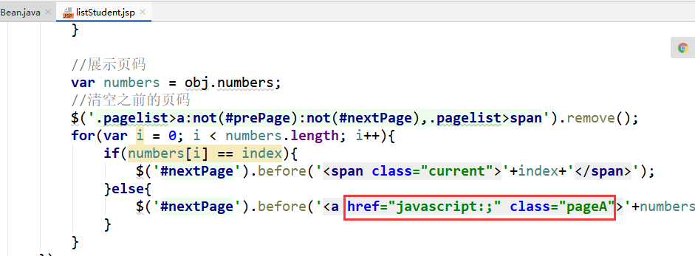
//点击页码进行跳转
$(document).on('click','.pageA',function(){
index = $(this).text();
getData();
});

实现搜索功能

需求
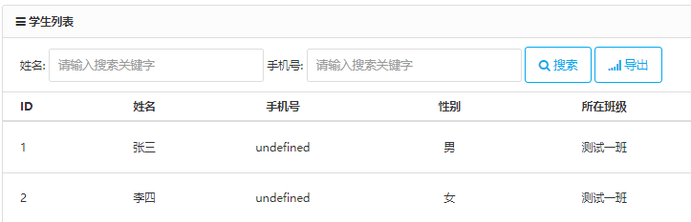
用户可以输入姓名和手机号进行搜索。姓名可以模糊搜索！
搜索到的内容进行分页展示！

思路分析
在之前分页的基础上直接加条件查询即可。
给搜索按钮绑定点击事件，点击后，执行getData那个方法，但是需要带上姓名和手机号这两个参数！

具体实现

编写dao层
public interface StudentDao {
int getTotalCount(String sname, String phone);
List<Student> getStudentByPage(int start, int size, String name, String phone);

public class StudentDaoImpl implements StudentDao {
@Override
public int getTotalCount(String sname, String phone) {
Connection connection = null;
PreparedStatement ps = null;
int totalCount = 0;
try {
connection = JDBCUtils.getConnection();
String sql = "select count(*) from student where 1=1 ";
if(sname != null && !sname.equals("")){
sql += " and sname like '%"+sname+"%'";
}
if(phone != null && !phone.equals("")){
sql += " and phone='"+phone+"'";
}
ps = connection.prepareStatement(sql);
ResultSet resultSet = ps.executeQuery();
totalCount = 0;
if(resultSet.next()){
totalCount = resultSet.getInt(1);
}
} catch (Exception e) {
e.printStackTrace();
} finally {
JDBCUtils.closeConnection(ps, connection);
}
return totalCount;
}
@Override
public List<Student> getStudentByPage(int start, int size, String sname, String phone) {
Connection connection = null;
PreparedStatement ps = null;
List<Student> list = null;
try {
connection = JDBCUtils.getConnection();
String sql = "select s.sid,s.sname,s.sex,s.hobby,s.birthdate,s.phone,s.reamrk,s.cid,c.cname\n" +
"from student s,clazz c where s.cid=c.cid ";
if(sname != null && !sname.equals("")){
sql += " and sname like '%"+sname+"%'";
}
if(phone != null && !phone.equals("")){
sql += " and phone='"+phone+"'";
}
sql += " limit ?,?";
ps = connection.prepareStatement(sql);
ps.setInt(1, start);
ps.setInt(2, size);
ResultSet resultSet = ps.executeQuery();
list = new ArrayList<>();
while(resultSet.next()){
int sid = resultSet.getInt("sid");
String sname2 = resultSet.getString("sname");
String sex = resultSet.getString("sex");
String hobby = resultSet.getString("hobby");
Date birthdate = resultSet.getDate("birthdate");
String phone2 = resultSet.getString("phone");
String reamrk = resultSet.getString("reamrk");
int cid = resultSet.getInt("cid");
String cname = resultSet.getString("cname");
Clazz clazz = new Clazz();
clazz.setCid(cid);
clazz.setCname(cname);
Student student = new Student(sid, sname2, sex, hobby, birthdate, phone2, reamrk, clazz);
list.add(student);
}
} catch (Exception e) {
e.printStackTrace();
} finally {
JDBCUtils.closeConnection(ps, connection);
}
return list;
}

编写service层
public interface StudentService {
PageBean<Student> getStudentByPage(int index, String sname, String phone);

public class StudentServiceImpl implements StudentService {
private StudentDao studentDao = new StudentDaoImpl();
@Override
public PageBean<Student> getStudentByPage(int index, String sname, String phone) {
PageBean<Student> pageBean = new PageBean<>();
pageBean.setIndex(index);
pageBean.setSize(5);
List<Student> list = studentDao.getStudentByPage((index - 1) * 5, 5, sname, phone);
pageBean.setList(list);
int totalCount = studentDao.getTotalCount(sname, phone);
pageBean.setTotalCount(totalCount);
return pageBean;
}

编写controller层
@WebServlet("/StudentServlet")
public class StudentServlet extends BaseServlet {
private StudentService studentService = new StudentServiceImpl();
protected void getStudentByPage(HttpServletRequest req, HttpServletResponse resp) throws ServletException, IOException {
resp.setContentType("text/html;charset=utf-8");
String index = req.getParameter("index");
String sname = req.getParameter("sname");
String phone = req.getParameter("phone");
PageBean<Student> pageBean = studentService.getStudentByPage(Integer.parseInt(index), sname, phone);
Gson gson = new Gson();
String s = gson.toJson(pageBean);
resp.getWriter().write(s);
}

编写页面
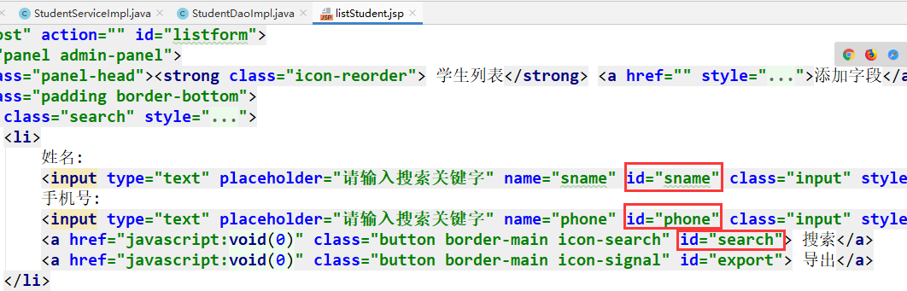
//搜索按钮
$('#search').click(function(){
index = 1;
getData();
});

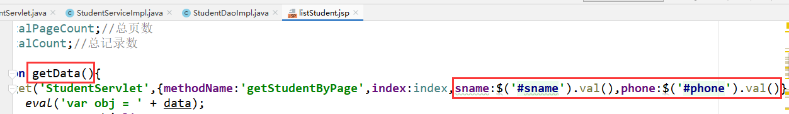

实现导出功能

需求
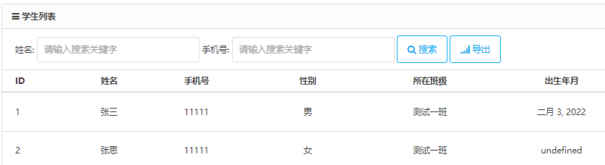
用户点击导出按钮后，要导出目前查询到的所有信息。
如果没有搜索条件，那就导出所有；如果有搜索条件，就导出搜索到的所有数据。

思路分析
给导出按钮绑定一个点击事件
点击按钮后，发送普通的请求到后端，并携带目前的搜索条件
在后端通过条件查询到所有符合的数据，写出到Excel文件中！

具体实现

编写dao层
dao层不需要编写了，用之前写好的分页查询的即可！

编写service层
public interface StudentService {
List<Student> getStudentForExport(String sname, String phone);

public class StudentServiceImpl implements StudentService {
private StudentDao studentDao = new StudentDaoImpl();
@Override
public List<Student> getStudentForExport(String sname, String phone) {
//这里我们没有在dao层写查询所有符合条件的方法，调用的是目前分页查询的方法
//所以将起始位置设置为0，每页条数设置为int最大值
return studentDao.getStudentByPage(0, Integer.MAX_VALUE, sname, phone);
}

导入相关jar包
导出Excel文件的操作，我们使用第三方的jar包，POI！
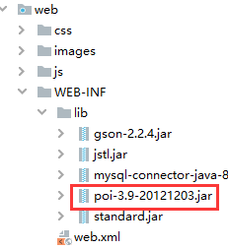
具体导出相关代码，使用工具类。
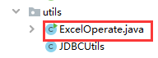

编写controller层
@WebServlet("/StudentServlet")
public class StudentServlet extends BaseServlet {
private StudentService studentService = new StudentServiceImpl();
protected void export(HttpServletRequest req, HttpServletResponse resp) throws ServletException, IOException {
req.setCharacterEncoding("utf-8");
//设置响应的数据类型
resp.setContentType("application/vnd.ms-excel");
//设置不要打开内容，以下载的方式去展示
resp.setHeader("Content-disposition", "attachment; fileName=" + new String(("学生表.xls").getBytes(), "iso8859-1"));
String sname = req.getParameter("sname");
String phone = req.getParameter("phone");
List<Student> list = studentService.getStudentForExport(sname, phone);
try {
ExcelOperate.createExcel(list, resp.getOutputStream());
} catch (Exception e) {
e.printStackTrace();
}
}

改造编写工具类代码
package com.bjsxt.utils;
import java.io.OutputStream;
import java.text.SimpleDateFormat;
import java.util.List;
import com.bjsxt.pojo.Student;
import org.apache.poi.hssf.usermodel.HSSFCell;
import org.apache.poi.hssf.usermodel.HSSFCellStyle;
import org.apache.poi.hssf.usermodel.HSSFRow;
import org.apache.poi.hssf.usermodel.HSSFSheet;
import org.apache.poi.hssf.usermodel.HSSFWorkbook;
import org.apache.poi.ss.util.CellRangeAddress;
public class ExcelOperate {
public static void createExcel(List<Student> list, OutputStream os) {
// 创建一个Excel文件
HSSFWorkbook workbook = new HSSFWorkbook();
// 创建一个工作表
HSSFSheet sheet = workbook.createSheet("学生表一");
CellRangeAddress region = new CellRangeAddress(0, // first row
0, // last row
0, // first column
5 // last column
);
sheet.addMergedRegion(region);
HSSFRow hssfRow = sheet.createRow(0);
HSSFCell headCell = hssfRow.createCell(0);
headCell.setCellValue("学生列表");
// 设置单元格格式居中
HSSFCellStyle cellStyle = workbook.createCellStyle();
cellStyle.setAlignment(HSSFCellStyle.ALIGN_CENTER);
headCell.setCellStyle(cellStyle);
// 添加表头行
hssfRow = sheet.createRow(1);
// 添加表头内容
headCell = hssfRow.createCell(0);
headCell.setCellValue("编号");
headCell.setCellStyle(cellStyle);
headCell = hssfRow.createCell(1);
headCell.setCellValue("姓名");
headCell.setCellStyle(cellStyle);
headCell = hssfRow.createCell(2);
headCell.setCellValue("手机号");
headCell.setCellStyle(cellStyle);
headCell = hssfRow.createCell(3);
headCell.setCellValue("性别");
headCell.setCellStyle(cellStyle);
headCell = hssfRow.createCell(4);
headCell.setCellValue("所在班级");
headCell.setCellStyle(cellStyle);
headCell = hssfRow.createCell(5);
headCell.setCellValue("出生年月");
headCell.setCellStyle(cellStyle);
// 添加数据内容
for (int i = 0; i < list.size(); i++) {
hssfRow = sheet.createRow((int) i + 2);
Student student = list.get(i);
// 创建单元格，并设置值
HSSFCell cell = hssfRow.createCell(0);
cell.setCellValue(student.getSid());
cell.setCellStyle(cellStyle);
cell = hssfRow.createCell(1);
cell.setCellValue(student.getSname());
cell.setCellStyle(cellStyle);
cell = hssfRow.createCell(2);
cell.setCellValue(student.getPhone());
cell.setCellStyle(cellStyle);
cell = hssfRow.createCell(3);
cell.setCellValue(student.getSex());
cell.setCellStyle(cellStyle);
cell = hssfRow.createCell(4);
cell.setCellValue(student.getClazz().getCname());
cell.setCellStyle(cellStyle);
cell = hssfRow.createCell(5);
SimpleDateFormat sdf = new SimpleDateFormat("yyyy-MM-dd");
cell.setCellValue(sdf.format(student.getBirthdate()));
cell.setCellStyle(cellStyle);
}
// 保存Excel文件
try {
workbook.write(os);
os.close();
} catch (Exception e) {
e.printStackTrace();
}
}
}

编写页面导出
