Out of the Box check of ZedBoard

- ZedBoard Box:

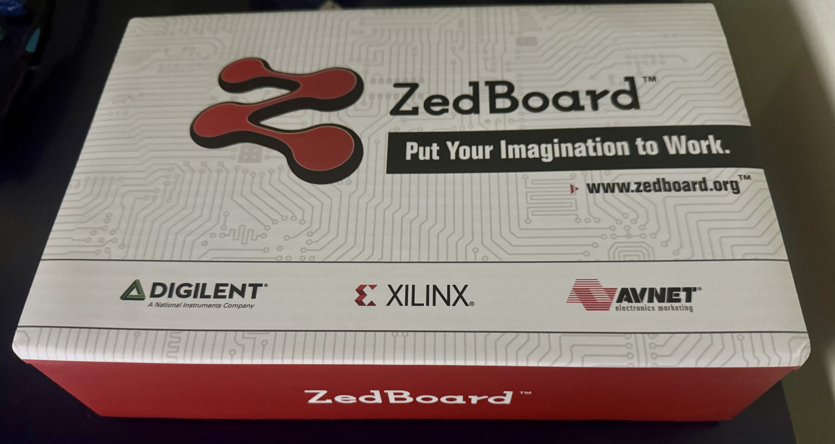

- Followed “Getting Started Instructions” card included with ZedBoard to bring up board from SDRAM (linux image) and check if working....
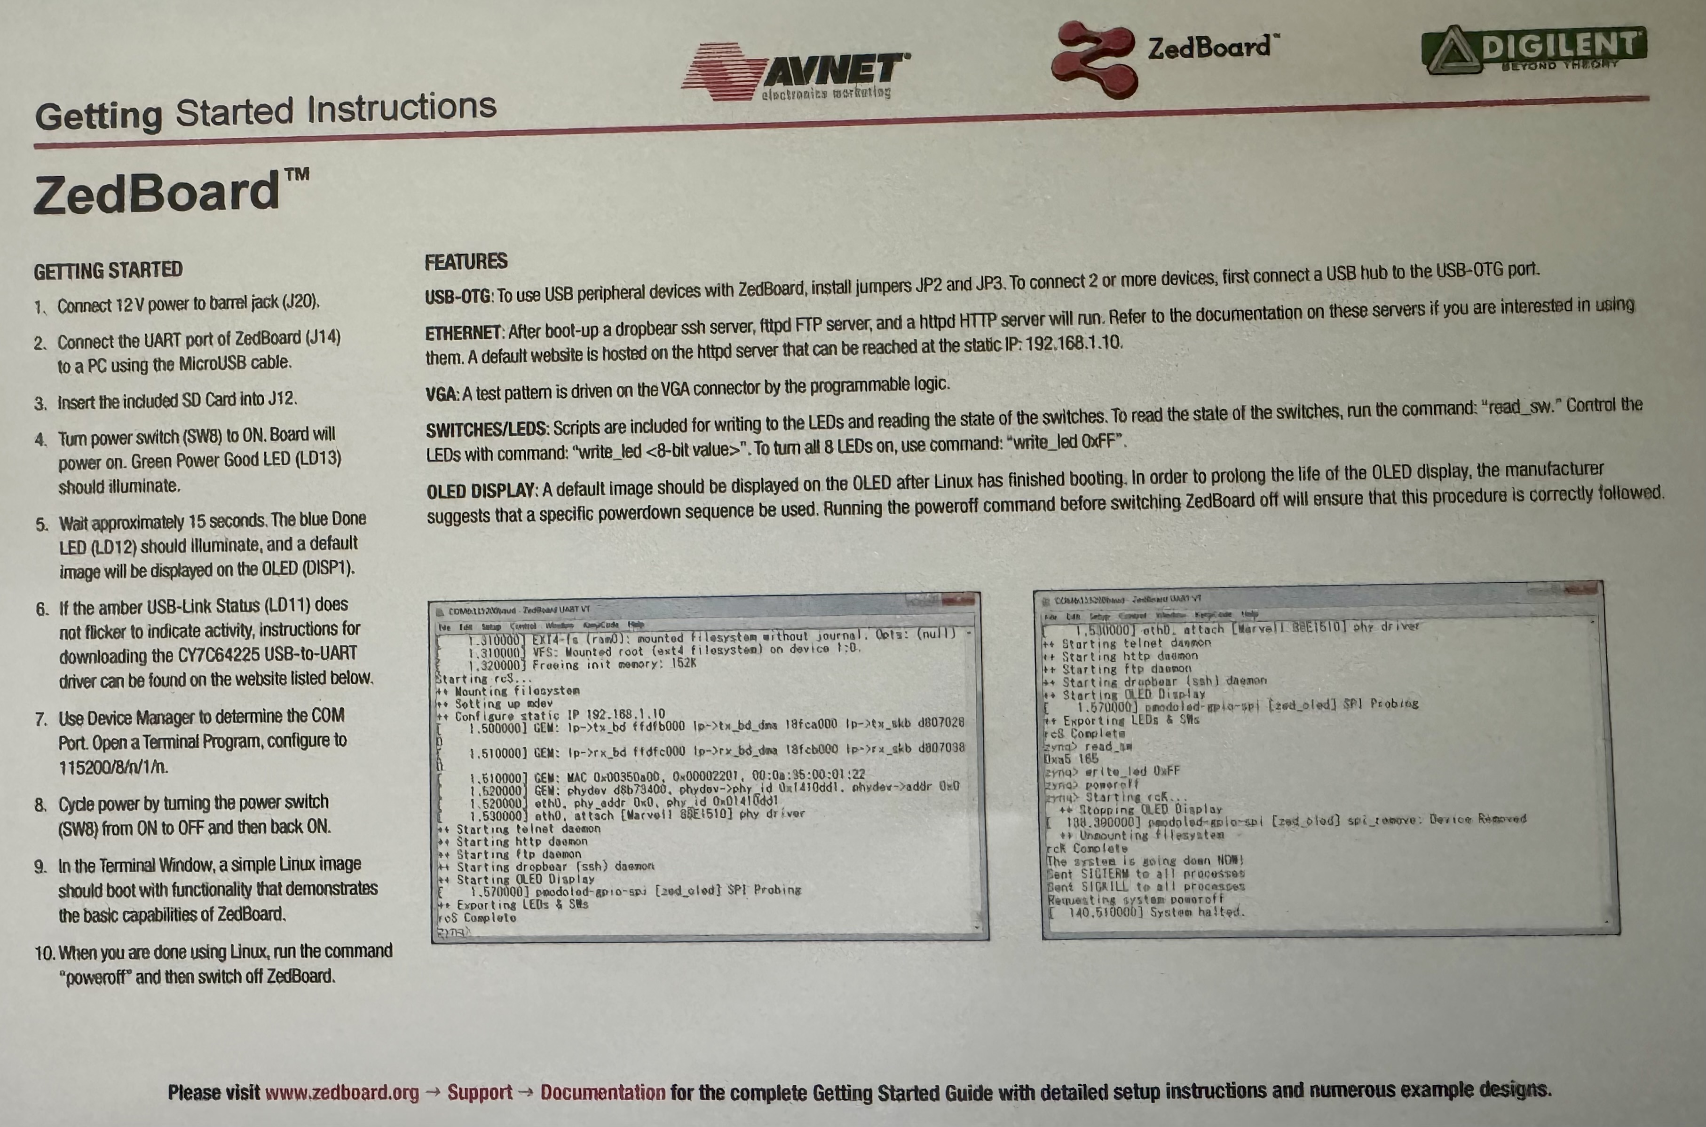
- Output from ZedBoard connected to PC via Putty serial connection using USB cable provided in box to "J14" on board (terminal settings: 115200/8/N/1):

U-Boot 2011.03-dirty (Jul 11 2012 - 16:07:00)

DRAM: 512 MiB
MMC: SDHCI: 0
Using default environment

In: serial
Out: serial
Err: serial
Net: zynq_gem
Hit any key to stop autoboot: 0
Copying Linux from SD to RAM...
Device: SDHCI
Manufacturer ID: 12
OEM: 3456
Name: SDTran Speed: 25000000
Rd Block Len: 512
SD version 1.10
High Capacity: Yes
Capacity: 7929331712
Bus Width: 1-bit
reading zImage

2479640 bytes read
reading devicetree_ramdisk.dtb

5817 bytes read
reading ramdisk8M.image.gz

3694108 bytes read
## Starting application at 0x00008000 ...
Uncompressing Linux... done, booting the kernel.
[ 0.000000] Booting Linux on physical CPU 0
[ 0.000000] Linux version 3.3.0-digilent-12.07-zed-beta (tinghui.wang@DIGILENT_LINUX) (gcc version 4.6.1 (Sourcery CodeBench Lite 2011.09-50) ) #2 SMP PREEMPT Thu Jul 12 21:01:42 PDT 2012
[ 0.000000] CPU: ARMv7 Processor [413fc090] revision 0 (ARMv7), cr=18c5387d
[ 0.000000] CPU: PIPT / VIPT nonaliasing data cache, VIPT aliasing instruction cache
[ 0.000000] Machine: Xilinx Zynq Platform, model: Xilinx Zynq ZED
[ 0.000000] bootconsole [earlycon0] enabled
[ 0.000000] Memory policy: ECC disabled, Data cache writealloc
[ 0.000000] BUG: mapping for 0xf8f00000 at 0xfe00c000 out of vmalloc space
[ 0.000000] BUG: mapping for 0xe0000000 at 0xfe000000 out of vmalloc space
[ 0.000000] BUG: mapping for 0xffff1000 at 0xfe200000 out of vmalloc space
[ 0.000000] PERCPU: Embedded 7 pages/cpu @c1489000 s5696 r8192 d14784 u32768
[ 0.000000] Built 1 zonelists in Zone order, mobility grouping on. Total pages: 125824
[ 0.000000] Kernel command line: console=ttyPS0,115200 root=/dev/ram rw initrd=0x800000,8M earlyprintk rootfstype=ext4 rootwait devtmpfs.mount=0
[ 0.000000] PID hash table entries: 2048 (order: 1, 8192 bytes)
[ 0.000000] Dentry cache hash table entries: 65536 (order: 6, 262144 bytes)
[ 0.000000] Inode-cache hash table entries: 32768 (order: 5, 131072 bytes)
[ 0.000000] Memory: 240MB 256MB = 496MB total
[ 0.000000] Memory: 489856k/489856k available, 34432k reserved, 0K highmem
[ 0.000000] Virtual kernel memory layout:
[ 0.000000] vector : 0xffff0000 - 0xffff1000 ( 4 kB)
[ 0.000000] fixmap : 0xfff00000 - 0xfffe0000 ( 896 kB)
[ 0.000000] vmalloc : 0xe0800000 - 0xfd000000 ( 456 MB)
[ 0.000000] lowmem : 0xc0000000 - 0xe0000000 ( 512 MB)
[ 0.000000] pkmap : 0xbfe00000 - 0xc0000000 ( 2 MB)
[ 0.000000] modules : 0xbf000000 - 0xbfe00000 ( 14 MB)
[ 0.000000] .text : 0xc0008000 - 0xc042f040 (4253 kB)
[ 0.000000] .init : 0xc0430000 - 0xc0456640 ( 154 kB)
[ 0.000000] .data : 0xc0458000 - 0xc0485dc0 ( 184 kB)
[ 0.000000] .bss : 0xc0485de4 - 0xc049d734 ( 95 kB)
[ 0.000000] Preemptible hierarchical RCU implementation.
[ 0.000000] Verbose stalled-CPUs detection is disabled.
[ 0.000000] NR_IRQS:128
[ 0.000000] xlnx,ps7-ttc-1.00.a #0 at 0xe0800000, irq=43
[ 0.000000] Console: colour dummy device 80x30
[ 0.000000] Calibrating delay loop... 1594.16 BogoMIPS (lpj=7970816)
[ 0.090000] pid_max: default: 32768 minimum: 301
[ 0.090000] Mount-cache hash table entries: 512
[ 0.090000] CPU: Testing write buffer coherency: ok
[ 0.090000] CPU0: thread -1, cpu 0, socket 0, mpidr 80000000
[ 0.100000] smp_twd: clock not found: -2
[ 0.100000] Calibrating local timer... 399.37MHz.
[ 0.170000] hw perfevents: enabled with ARMv7 Cortex-A9 PMU driver, 7 counters available
[ 0.170000] Setting up static identity map for 0x2f8d48 - 0x2f8d7c
[ 0.270000] CPU1: Booted secondary processor
[ 0.310000] CPU1: thread -1, cpu 1, socket 0, mpidr 80000001
[ 0.310000] Brought up 2 CPUs
[ 0.310000] SMP: Total of 2 processors activated (3188.32 BogoMIPS).
[ 0.320000] devtmpfs: initialized
[ 0.320000] ------------[ cut here ]------------
[ 0.320000] WARNING: at arch/arm/mm/dma-mapping.c:198 consistent_init+0x70/0x104()
[ 0.330000] Modules linked in:
[ 0.330000] [<c0012920>] (unwind_backtrace+0x0/0xe0) from [<c001e924>] (warn_slowpath_common+0x4c/0x64)
[ 0.340000] [<c001e924>] (warn_slowpath_common+0x4c/0x64) from [<c001e954>] (warn_slowpath_null+0x18/0x1c)
[ 0.350000] [<c001e954>] (warn_slowpath_null+0x18/0x1c) from [<c04345a8>] (consistent_init+0x70/0x104)
[ 0.360000] [<c04345a8>] (consistent_init+0x70/0x104) from [<c000858c>] (do_one_initcall+0x90/0x160)
[ 0.360000] [<c000858c>] (do_one_initcall+0x90/0x160) from [<c043085c>] (kernel_init+0x84/0x128)
[ 0.370000] [<c043085c>] (kernel_init+0x84/0x128) from [<c000dfcc>] (kernel_thread_exit+0x0/0x8)
[ 0.380000] ---[ end trace 1b75b31a2719ed1c ]---
[ 0.380000] ------------[ cut here ]------------
[ 0.390000] WARNING: at arch/arm/mm/dma-mapping.c:198 consistent_init+0x70/0x104()
[ 0.390000] Modules linked in:
[ 0.390000] [<c0012920>] (unwind_backtrace+0x0/0xe0) from [<c001e924>] (warn_slowpath_common+0x4c/0x64)
[ 0.400000] [<c001e924>] (warn_slowpath_common+0x4c/0x64) from [<c001e954>] (warn_slowpath_null+0x18/0x1c)
[ 0.410000] [<c001e954>] (warn_slowpath_null+0x18/0x1c) from [<c04345a8>] (consistent_init+0x70/0x104)
[ 0.420000] [<c04345a8>] (consistent_init+0x70/0x104) from [<c000858c>] (do_one_initcall+0x90/0x160)
[ 0.430000] [<c000858c>] (do_one_initcall+0x90/0x160) from [<c043085c>] (kernel_init+0x84/0x128)
[ 0.430000] [<c043085c>] (kernel_init+0x84/0x128) from [<c000dfcc>] (kernel_thread_exit+0x0/0x8)
[ 0.440000] ---[ end trace 1b75b31a2719ed1d ]---
[ 0.440000] NET: Registered protocol family 16
[ 0.460000] L310 cache controller enabled
[ 0.460000] l2x0: 8 ways, CACHE_ID 0x410000c8, AUX_CTRL 0x72060000, Cache size: 524288 B
[ 0.460000] registering platform device 'pl330' id 0
[ 0.470000] registering platform device 'arm-pmu' id 0
[ 0.470000]
[ 0.470000] ###############################################
[ 0.480000] # #
[ 0.480000] # Board ZED Init #
[ 0.480000] # #
[ 0.490000] ###############################################
[ 0.490000]
[ 0.500000] hw-breakpoint: found 5 (+1 reserved) breakpoint and 1 watchpoint registers.
[ 0.500000] hw-breakpoint: maximum watchpoint size is 4 bytes.
[ 0.530000] xslcr xslcr.0: at 0xF8000000 mapped to 0xE0808000
[ 0.540000] bio: create slab <bio-0> at 0
[ 0.540000] gpiochip_add: registered GPIOs 0 to 245 on device: xgpiops
[ 0.540000] xgpiops e000a000.gpio: gpio at 0xe000a000 mapped to 0xe080a000
[ 0.550000] SCSI subsystem initialized
[ 0.550000] usbcore: registered new interface driver usbfs
[ 0.560000] usbcore: registered new interface driver hub
[ 0.560000] usbcore: registered new device driver usb
[ 0.570000] Advanced Linux Sound Architecture Driver Version 1.0.24.
[ 0.570000] Switching to clocksource xttcpss_timer1
[ 0.580000] NET: Registered protocol family 2
[ 0.580000] IP route cache hash table entries: 4096 (order: 2, 16384 bytes)
[ 0.580000] TCP established hash table entries: 16384 (order: 5, 131072 bytes)
[ 0.590000] TCP bind hash table entries: 16384 (order: 5, 196608 bytes)
[ 0.590000] TCP: Hash tables configured (established 16384 bind 16384)
[ 0.600000] TCP reno registered
[ 0.600000] UDP hash table entries: 256 (order: 1, 8192 bytes)
[ 0.610000] UDP-Lite hash table entries: 256 (order: 1, 8192 bytes)
[ 0.610000] NET: Registered protocol family 1
[ 0.620000] Trying to unpack rootfs image as initramfs...
[ 0.620000] rootfs image is not initramfs (no cpio magic); looks like an initrd
[ 0.650000] Freeing initrd memory: 8192K
[ 0.660000] xscugtimer xscugtimer.0: ioremap fe00c200 to e0810200 with size 400
[ 0.660000] pl330 dev 0 probe success
[ 0.670000] msgmni has been set to 972
[ 0.670000] io scheduler noop registered
[ 0.670000] io scheduler deadline registered
[ 0.670000] io scheduler cfq registered (default)
[ 0.680000] e00▒ ▒▒▒▒▒▒ͽ▒▒j▒▒▒AMu▒▒▒▒▒▒▒▒▒э▒▒ͽ▒▒▒▒ͅ▒▒▒▒▒r▒�▒▒▒▒▒ͽ▒▒m▒▒▒AMr▒▒▒▒▒▒▒▒▒э▒▒ͽ▒▒▒▒ͅ▒▒▒▒▒r▒ʂ▒▒▒�▒ٍ▒▒▒▒▒▒▒▒r"▒ٍ▒▒J▒ɕ▒▒▒▒▒▒▒▒▒▒▒▒▒▒▒▒▒▒ѡΥ镂▒▒▒[ 0.700000] [drm] Initialized drm 1.1.0 20060810
[ 0.710000] brd: module loaded
[ 0.720000] loop: module loaded
[ 0.720000] xqspips e000d000.qspi: at 0xE000D000 mapped to 0xE0816000, irq=51
[ 0.730000] GEM: BASEADDRESS hw: e000b000 virt: e0818000
[ 0.730000] XEMACPS mii bus: probed
[ 0.740000] eth0, pdev->id -1, baseaddr 0xe000b000, irq 54
[ 0.740000] ehci_hcd: USB 2.0 'Enhanced' Host Controller (EHCI) Driver
[ 0.750000] usb_hcd_xusbps_probe: No OTG assigned!
[ 0.750000] usb_hcd_xusbps_probe: OTG now assigned!
[ 0.750000] xusbps-ehci xusbps-ehci.0: Xilinx PS USB EHCI Host Controller
[ 0.760000] xusbps-ehci xusbps-ehci.0: new USB bus registered, assigned bus number 1
[ 0.800000] xusbps-ehci xusbps-ehci.0: irq 53, io mem 0x00000000
[ 0.820000] xusbps-ehci xusbps-ehci.0: USB 2.0 started, EHCI 1.00
[ 0.820000] hub 1-0:1.0: USB hub found
[ 0.820000] hub 1-0:1.0: 1 port detected
[ 0.830000] Initializing USB Mass Storage driver...
[ 0.830000] usbcore: registered new interface driver usb-storage
[ 0.840000] USB Mass Storage support registered.
[ 0.840000] Xilinx PS USB Device Controller driver (Apr 01, 2011)
[ 0.850000] mousedev: PS/2 mouse device common for all mice
[ 0.850000] Linux video capture interface: v2.00
[ 0.860000] gspca_main: v2.14.0 registered
[ 0.860000] usbcore: registered new interface driver uvcvideo
[ 0.860000] USB Video Class driver (1.1.1)
[ 0.870000] WDT OF probe
[ 0.870000] xwdtps f8005000.swdt: Xilinx Watchdog Timer at 0xe081c000 with timeout 10 seconds
[ 0.880000] sdhci: Secure Digital Host Controller Interface driver
[ 0.880000] sdhci: Copyright(c) Pierre Ossman
[ 0.890000] sdhci-pltfm: SDHCI platform and OF driver helper
[ 0.890000] mmc0: SDHCI controller on e0100000.sdhci [e0100000.sdhci] using ADMA
[ 0.900000] No connectors reported connected with modes
[ 0.900000] [drm] Cannot find any crtc or sizes - going 1024x768
[ 0.910000] usbcore: registered new interface driver usbhid
[ 0.920000] drivers/gpu/drm/analog/analog_drm_fbdev.c:analog_drm_fbdev_probe[241]
[ 0.930000] usbhid: USB HID core driver
[ 0.930000] adv7511 0-0039: Failed to add route DAI IN->TMDS
[ 0.960000] Console: switching to colour frame buffer device 128x48
[ 0.970000] asoc: adv7511 <-> 75c00000.axi-spdif-tx mapping ok
[ 0.970000] axi-spdif 75c00000.axi-spdif-tx: Failed to set DAI format: -22
[ 0.970000] ALSA device list:
[ 0.970000] #0: HDMI monitor
[ 0.970000] TCP cubic registered
[ 0.970000] NET: Registered protocol family 17
[ 0.970000] VFP support v0.3: implementor 41 architecture 3 part 30 variant 9 rev 4
[ 0.970000] Registering SWP/SWPB emulation handler
[ 0.970000] registered taskstats version 1
[ 0.970000] drivers/rtc/hctosys.c: unable to open rtc device (rtc0)
[ 1.030000] RAMDISK: gzip image found at block 0
[ 1.040000] fb0: frame buffer device
[ 1.040000] drm: registered panic notifier
[ 1.040000] [drm] Initialized analog_drm 1.0.0 20110530 on minor 0
[ 1.060000] mmc0: new high speed SDHC card at address 0001
[ 1.060000] mmcblk0: mmc0:0001 SD 7.38 GiB
[ 1.070000] mmcblk0: p1
[ 1.300000] EXT4-fs (ram0): warning: mounting unchecked fs, running e2fsck is recommended
[ 1.310000] EXT4-fs (ram0): mounted filesystem without journal. Opts: (null)
[ 1.310000] VFS: Mounted root (ext4 filesystem) on device 1:0.
[ 1.320000] Freeing init memory: 152K
Starting rcS...
++ Mounting filesystem
++ Setting up mdev
++ Configure static IP 192.168.1.10
[ 1.500000] GEM: lp->tx_bd ffdfb000 lp->tx_bd_dma 18ae6000 lp->tx_skb d8ab56c0
[ 1.510000] GEM: lp->rx_bd ffdfc000 lp->rx_bd_dma 1829f000 lp->rx_skb d8ab57c0
[ 1.510000] GEM: MAC 0x00350a00, 0x00002201, 00:0a:35:00:01:22
[ 1.520000] GEM: phydev d8b71400, phydev->phy_id 0x1410dd1, phydev->addr 0x0
[ 1.520000] eth0, phy_addr 0x0, phy_id 0x01410dd1
[ 1.530000] eth0, attach [Marvell 88E1510] phy driver
++ Starting telnet daemon
++ Starting http daemon
++ Starting ftp daemon
++ Starting dropbear (ssh) daemon
++ Starting OLED Display
[ 1.570000] pmodoled-gpio-spi [zed_oled] SPI Probing
++ Exporting LEDs & SWs
rcS Complete
zynq> [ 4.530000] eth0: link up (100/FULL)

- Responses to command line commands on ZedBoard:

zynq> ls -al

total 55
drwxr-xr-x 17 12319 300 1024 Jan 1 00:04 .
drwxr-xr-x 17 12319 300 1024 Jan 1 00:04 ..
-rw------- 1 root 0 25262 Jan 1 00:05 .ash_history
-rw-r--r-- 1 root 0 0 Jan 1 00:04 TMDS
-rw-r--r-- 1 root 0 0 Jan 1 00:04 addr
drwxr-xr-x 2 12319 300 2048 Jan 9 2012 bin
drwxr-xr-x 4 12319 300 3072 Jan 1 00:00 dev
drwxr-xr-x 4 12319 300 1024 Jan 1 00:00 etc
-rw-r--r-- 1 root 0 0 Jan 1 00:04 id
drwxr-xr-x 3 12319 300 2048 Jul 12 2012 lib
drwxr-xr-x 11 12319 300 1024 Jan 9 2012 licenses
lrwxrwxrwx 1 12319 300 11 Jan 9 2012 linuxrc -> bin/busybox
drwx------ 2 root 0 12288 Jan 9 2012 lost+found
drwxr-xr-x 2 12319 300 1024 Aug 21 2010 mnt
drwxr-xr-x 2 12319 300 1024 Aug 21 2010 opt
-rw-r--r-- 1 root 0 0 Jan 1 00:04 phy_id
dr-xr-xr-x 46 root 0 0 Jan 1 00:00 proc
drwxr-xr-x 2 12319 300 1024 Jul 12 2012 root
-rw-r--r-- 1 root 0 0 Jan 1 00:04 rx_bd
-rw-r--r-- 1 root 0 0 Jan 1 00:04 rx_bd_dma
-rw-r--r-- 1 root 0 0 Jan 1 00:04 rx_skb
drwxr-xr-x 2 12319 300 1024 Jan 9 2012 sbin
drwxr-xr-x 12 root 0 0 Jan 1 00:00 sys
drwxrwxrwt 2 root 0 40 Jan 1 00:00 tmp
-rw-r--r-- 1 root 0 0 Jan 1 00:04 tx_bd
-rw-r--r-- 1 root 0 0 Jan 1 00:04 tx_bd_dma
-rw-r--r-- 1 root 0 0 Jan 1 00:04 tx_skb
drwxr-xr-x 5 12319 300 1024 Mar 30 2012 usr
drwxr-xr-x 4 12319 300 1024 Oct 25 2010 var

zynq> uname -a

Linux (none) 3.3.0-digilent-12.07-zed-beta #2 SMP PREEMPT Thu Jul 12 21:01:42 PDT 2012 armv7l GNU/Linux

zynq> cat proc/version

Linux version 3.3.0-digilent-12.07-zed-beta (tinghui.wang@DIGILENT_LINUX) (gcc version 4.6.1 (Sourcery CodeBench Lite 2011.09-50) ) #2 SMP PREEMPT Thu Jul 12 21:01:42 PDT 2012

zynq> free -h

BusyBox v1.18.4 (2012-01-09 15:03:52 PST) multi-call binary.

Usage: free [-b/k/m/g]

Display the amount of free and used system memory

zynq> free -k

total used free shared buffers
Mem: 498200 30168 468032 0 260
-/+ buffers: 29908 468292
Swap: 0 0 0

zynq> ifconfig

eth0 Link encap:Ethernet HWaddr 00:0A:35:00:01:22
inet addr:192.168.1.10 Bcast:192.168.1.255 Mask:255.255.255.0
UP BROADCAST RUNNING MULTICAST MTU:1500 Metric:1
RX packets:1043 errors:0 dropped:0 overruns:0 frame:0
TX packets:0 errors:0 dropped:0 overruns:0 carrier:0
collisions:0 txqueuelen:1000
RX bytes:218976 (213.8 KiB) TX bytes:0 (0.0 B)
Interrupt:54 Base address:0xb000

- Connect PC via wired Ethernet port on ZedBoard

PC IP address = 192.168.1.173/24
ZedBoard (as defaulted from linux boot) = 192.168.1.10/24

- Launched web browser on PC and entered ZedBoard IP in URL:

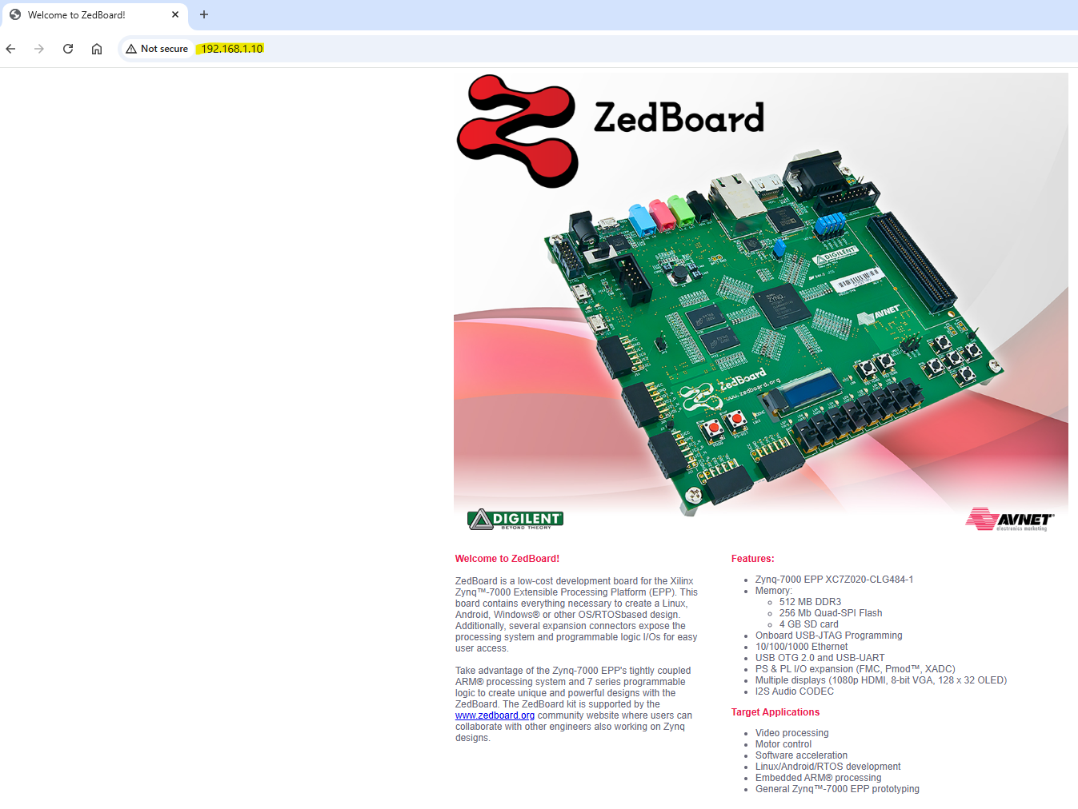

- Launched SSH session form PC via PUTTY application to ZedBoard IP address:

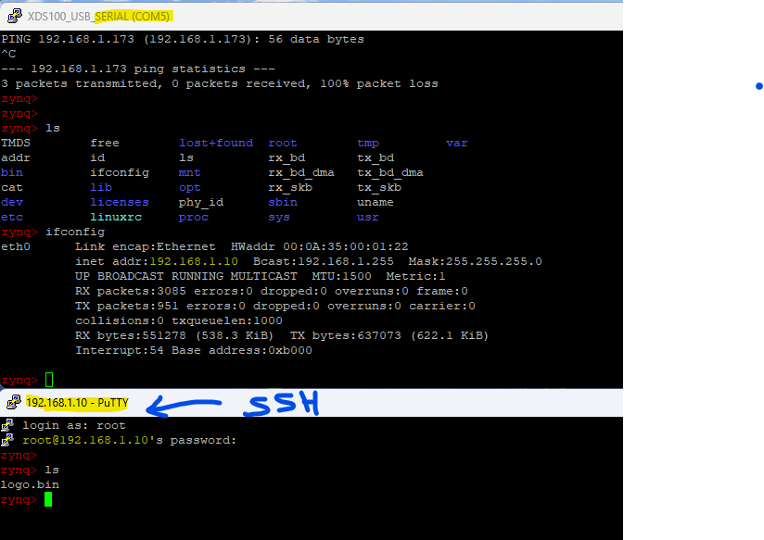
  - Putty serial connection confirmed ZedBoard IP address as shown.
  - Validated SSH login as shown.

- ZedBoard operating during out of the box checks:



