Build and debug simple hello world program for ZedBoard using Vitis Unified IDE

ref: https://www.youtube.com/watch?v=a-jD66901-I&t=1s

Tools:

- Vitis Unified 2024.2 to build and debug program on the ZedBoard
- Putty to connect to serial terminal port of ZedBoard

Steps:

- Connect JTAG adapter included with ZedBoard to "JTAG" header on board
- Connect USB adapter included with ZedBoard to “J14” on board and setup corresponding virtual COM port to 115200,8N1
- Launch Vitis Unified and perform steps below:

  - 'Set Workspace' to a work folder on your PC
  - 'Create Platform Component' – Enter/Select info and click 'Next'

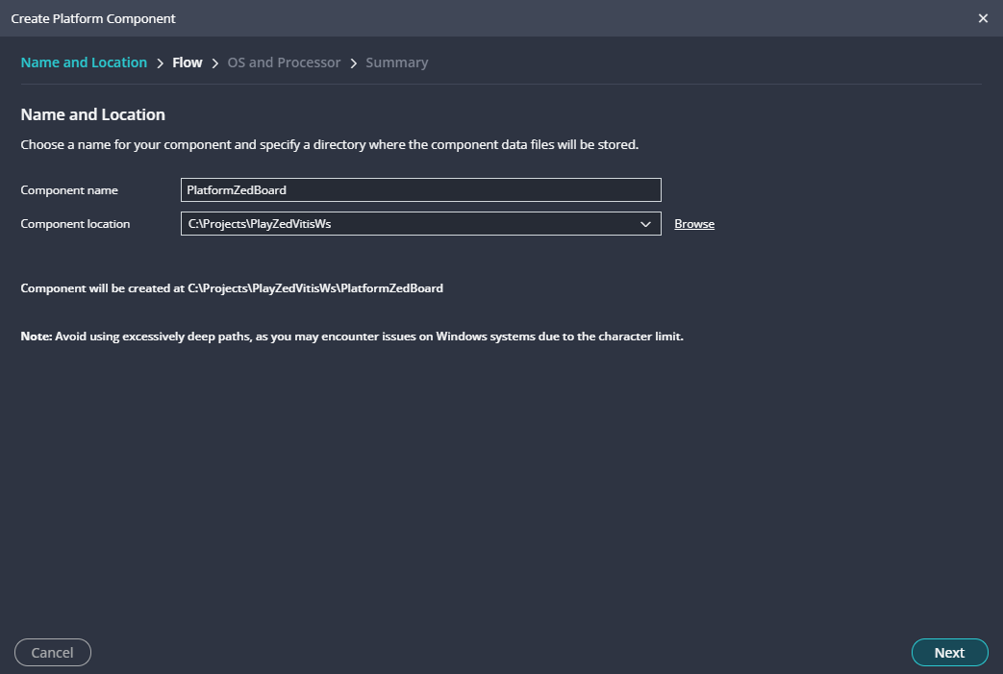
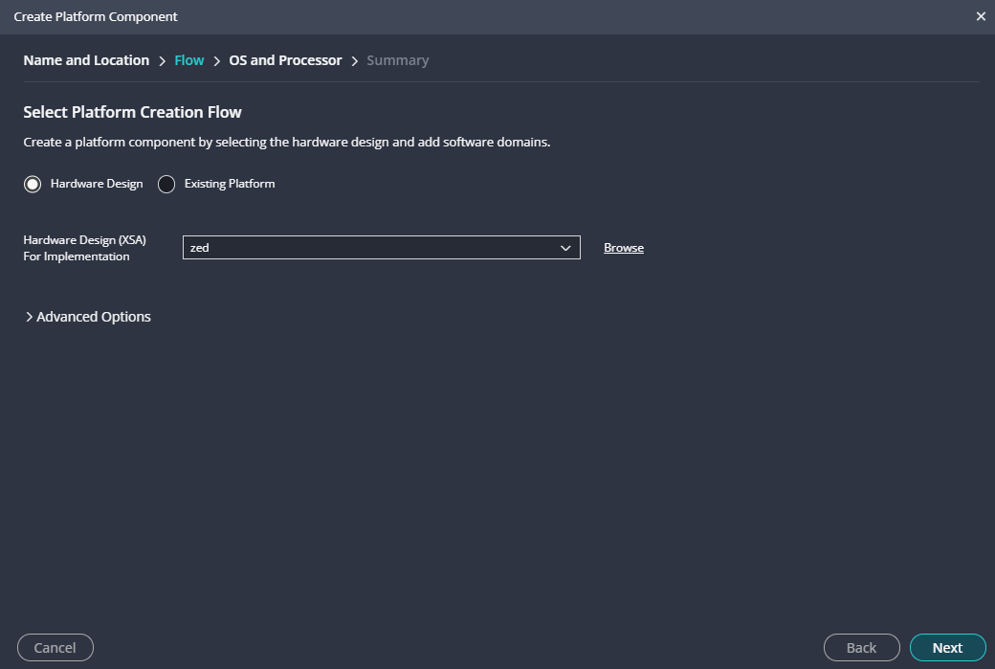

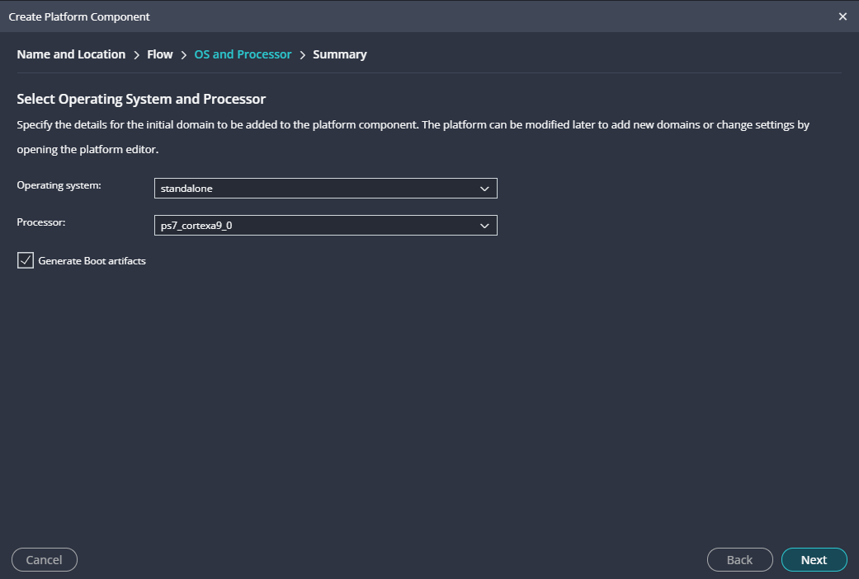

  - 'Create Plaform Component' – Review summary and click 'Finish'
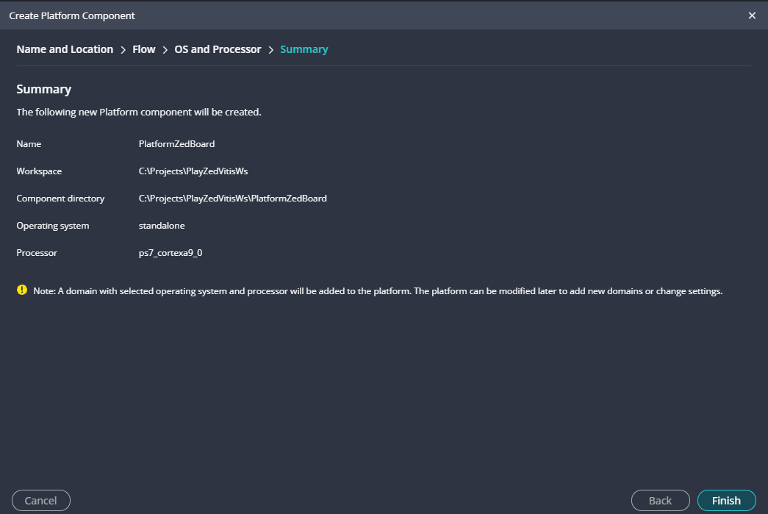

  - Clicking 'Finish' will cause an automatic platform build in 'OUTPUT' window:

20:01:54 INFO : Found no platform with name 'zed' in install repositories
20:01:54 INFO : Install SDT for given XSA copied Successfully
20:01:54 INFO : cmd.exe, /C, C:\Xilinx\Vitis\2024.2\tps\win64\lopper-1.1.0\env\Scripts\activate.bat && lopper --enhanced --werror -f -O C:\Projects\PlayZedVitisWs\.rigel_lopper -i C:\Xilinx\Vitis\2024.2\tps\win64\lopper-1.1.0\env\Lib\site-packages\lopper\lops\lop-cpu-oslist.dts C:\Projects\PlayZedVitisWs\.rigel_lopper_temp_platform\zed\hw\sdt\system-top.dts && C:\Xilinx\Vitis\2024.2\tps\win64\lopper-1.1.0\env\Scripts\deactivate.bat
20:01:55 INFO : CPU List generated successfully
20:08:41 INFO : Platform PlatformZedBoard creation started.
20:08:41 INFO : Lopper command for cpu List generation: lopper --enhanced --werror -f -O C:\Projects\PlayZedVitisWs\.rigel_lopper -i C:\Xilinx\Vitis\2024.2\tps\win64\lopper-1.1.0\env\Lib\site-packages\lopper\lops\lop-cpu-oslist.dts C:\Projects\PlayZedVitisWs\PlatformZedBoard\hw\sdt\system-top.dts
20:08:41 INFO : cmd.exe, /C, C:\Xilinx\Vitis\2024.2\tps\win64\lopper-1.1.0\env\Scripts\activate.bat && lopper --enhanced --werror -f -O C:\Projects\PlayZedVitisWs\.rigel_lopper -i C:\Xilinx\Vitis\2024.2\tps\win64\lopper-1.1.0\env\Lib\site-packages\lopper\lops\lop-cpu-oslist.dts C:\Projects\PlayZedVitisWs\PlatformZedBoard\hw\sdt\system-top.dts && C:\Xilinx\Vitis\2024.2\tps\win64\lopper-1.1.0\env\Scripts\deactivate.bat
20:08:42 INFO : CPU List generated successfully
20:08:42 INFO : created .gitignore file for the project C:\Projects\PlayZedVitisWs\PlatformZedBoard
20:08:42 INFO : ZYNQ: Using the QEMU args from install at : C:\Xilinx\Vitis\2024.2\data\emulation\platforms\zynq\sw\a9_linux\qemu\qemu_args.txt
20:08:42 INFO : ZYNQ: Using the QEMU args from install at : C:\Xilinx\Vitis\2024.2\data\emulation\platforms\zynq\sw\a9_standalone\qemu\qemu_args.txt
20:08:42 INFO : ZYNQ: Using the QEMU args from install at : C:\Xilinx\Vitis\2024.2\data\emulation\platforms\zynq\sw\a9_standalone\qemu\qemu_args.txt

20:08:42 INFO : lopper command to generate BSP :python C:\Xilinx\Vitis\2024.2\data\embeddedsw/scripts/pyesw//create_bsp.py -w C:\Projects\PlayZedVitisWs\PlatformZedBoard\ps7_cortexa9_0\standalone_ps7_cortexa9_0\bsp -p ps7_cortexa9_0 -o standalone -s C:\Projects\PlayZedVitisWs\PlatformZedBoard\hw\sdt\system-top.dts -t empty_application -r C:\Projects\PlayZedVitisWs\_ide\.wsdata\.repo.yaml
20:08:42 INFO : lopper command to generate BSP :python C:\Xilinx\Vitis\2024.2\data\embeddedsw/scripts/pyesw//create_bsp.py -w C:\Projects\PlayZedVitisWs\PlatformZedBoard\zynq_fsbl\zynq_fsbl_bsp -p ps7_cortexa9_0 -o standalone -s C:\Projects\PlayZedVitisWs\PlatformZedBoard\hw\sdt\system-top.dts -t zynq_fsbl -r C:\Projects\PlayZedVitisWs\_ide\.wsdata\.repo.yaml
20:08:42 INFO : cmd.exe, /C, C:\Xilinx\Vitis\2024.2\tps\win64\lopper-1.1.0\env\Scripts\activate.bat && python C:\Xilinx\Vitis\2024.2\data\embeddedsw\scripts\pyesw\\create_bsp.py -w C:\Projects\PlayZedVitisWs\PlatformZedBoard\zynq_fsbl\zynq_fsbl_bsp -p ps7_cortexa9_0 -o standalone -s C:\Projects\PlayZedVitisWs\PlatformZedBoard\hw\sdt\system-top.dts -t zynq_fsbl -r C:\Projects\PlayZedVitisWs\_ide\.wsdata\.repo.yaml && C:\Xilinx\Vitis\2024.2\tps\win64\lopper-1.1.0\env\Scripts\deactivate.bat
20:08:42 INFO : cmd.exe, /C, C:\Xilinx\Vitis\2024.2\tps\win64\lopper-1.1.0\env\Scripts\activate.bat && python C:\Xilinx\Vitis\2024.2\data\embeddedsw\scripts\pyesw\\create_bsp.py -w C:\Projects\PlayZedVitisWs\PlatformZedBoard\ps7_cortexa9_0\standalone_ps7_cortexa9_0\bsp -p ps7_cortexa9_0 -o standalone -s C:\Projects\PlayZedVitisWs\PlatformZedBoard\hw\sdt\system-top.dts -t empty_application -r C:\Projects\PlayZedVitisWs\_ide\.wsdata\.repo.yaml && C:\Xilinx\Vitis\2024.2\tps\win64\lopper-1.1.0\env\Scripts\deactivate.bat
20:08:53 INFO : Successfully created Domain at C:\Projects\PlayZedVitisWs\PlatformZedBoard\ps7_cortexa9_0\standalone_ps7_cortexa9_0\bsp
20:08:53 INFO : Domain standalone_ps7_cortexa9_0 added successfully.
20:08:53 INFO : Successfully created Domain at C:\Projects\PlayZedVitisWs\PlatformZedBoard\zynq_fsbl\zynq_fsbl_bsp
20:08:53 INFO : Successfully Generated Domain C:\Projects\PlayZedVitisWs\PlatformZedBoard\zynq_fsbl\zynq_fsbl_bsp
20:08:53 INFO : lopper command to create baremetal application :python C:\Xilinx\Vitis\2024.2\data\embeddedsw/scripts/pyesw//create_app.py -s C:\Projects\PlayZedVitisWs\PlatformZedBoard\zynq_fsbl -t zynq_fsbl -d C:\Projects\PlayZedVitisWs\PlatformZedBoard\zynq_fsbl\zynq_fsbl_bsp -n fsbl -r C:\Projects\PlayZedVitisWs\_ide\.wsdata\.repo.yaml
20:08:53 INFO : cmd.exe, /C, C:\Xilinx\Vitis\2024.2\tps\win64\lopper-1.1.0\env\Scripts\activate.bat && python C:\Xilinx\Vitis\2024.2\data\embeddedsw\scripts\pyesw\\validate_bsp.py -t zynq_fsbl -d C:\Projects\PlayZedVitisWs\PlatformZedBoard\zynq_fsbl\zynq_fsbl_bsp -r C:\Projects\PlayZedVitisWs\_ide\.wsdata\.repo.yaml && C:\Xilinx\Vitis\2024.2\tps\win64\lopper-1.1.0\env\Scripts\deactivate.bat
20:08:55 INFO : Successfully validated template zynq_fsbl
20:08:58 INFO : Successfully Created Application sources at C:/Projects/PlayZedVitisWs/PlatformZedBoard/zynq_fsbl
20:08:58 INFO : Platform FSBL Boot domain added successfully.
20:08:58 INFO : Platform creation finished successfully.
20:08:58 INFO : Platform Quick Build initiated.
20:08:58 INFO : Generating Export directory
20:08:58 INFO : Generated platform metadata for creating application(s) based on platform PlatformZedBoard

  - Updated GUI view after the platform build:
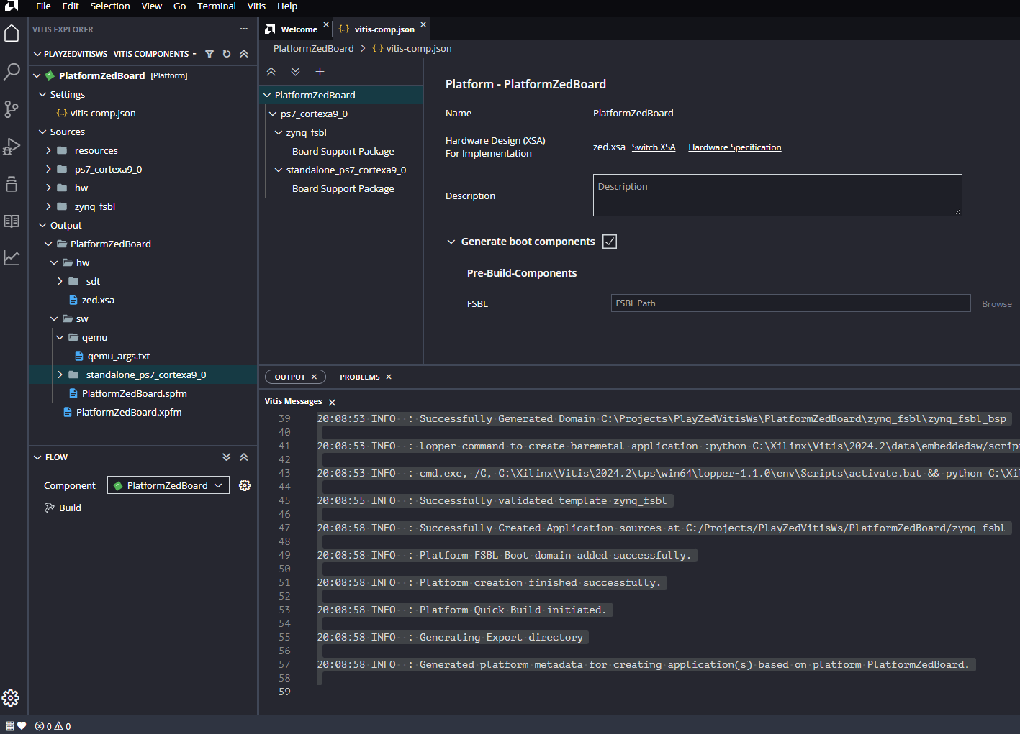
  - Create a simple hello world project by clicking on this symbol

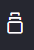
  - Click on “Hello World” in the “Embedded Software Examples” list:

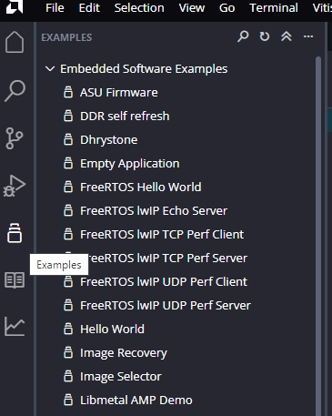
- A new “Hello World” tab should appear
- Click the “Create Application Component from Template” button at top of view
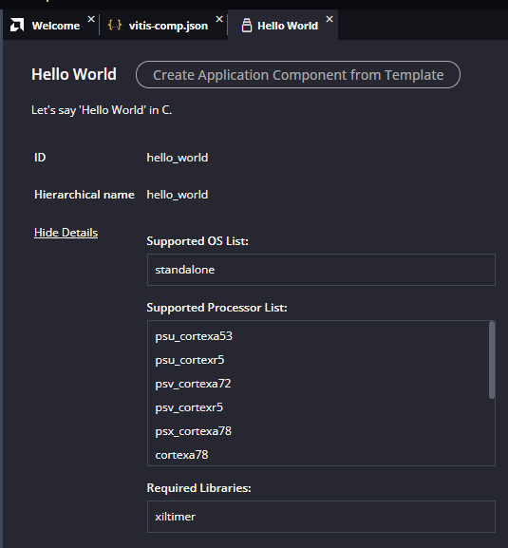
  - Click 'Next' button on this view
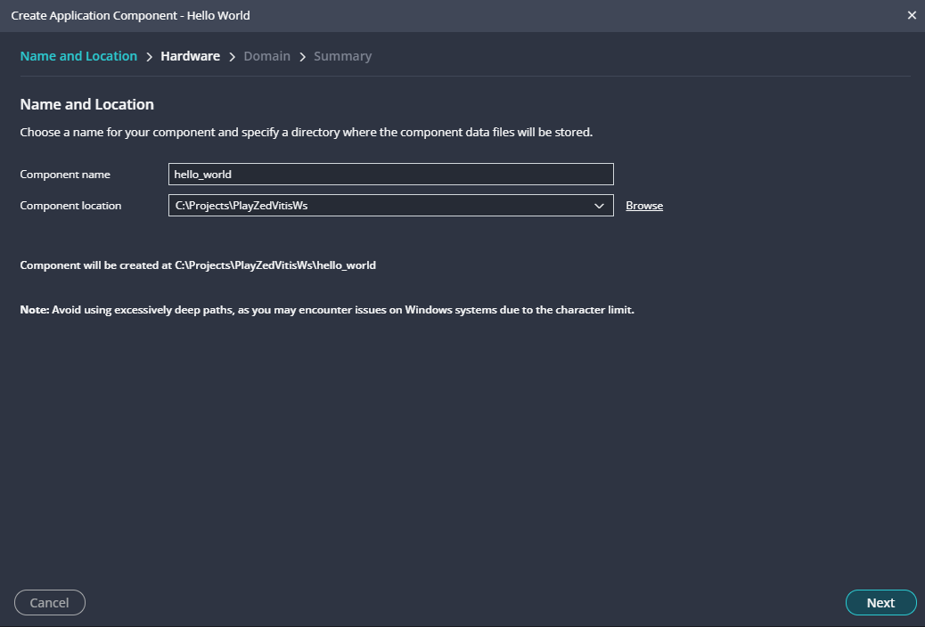
  - Select 'PlatformZedBoard' on this view and click 'Next'
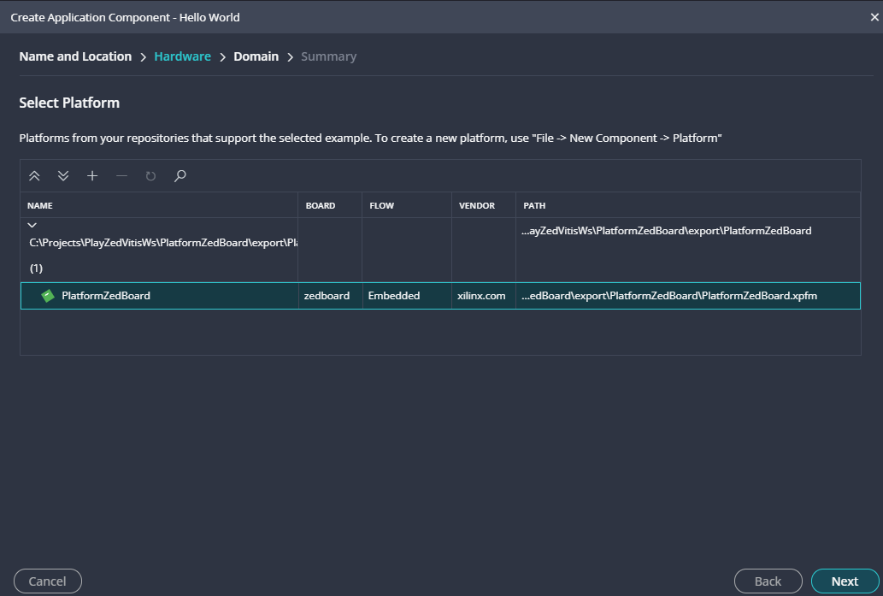

- Select 'standalone_ps7_cortexa9_0' domain on this view and click 'Next'

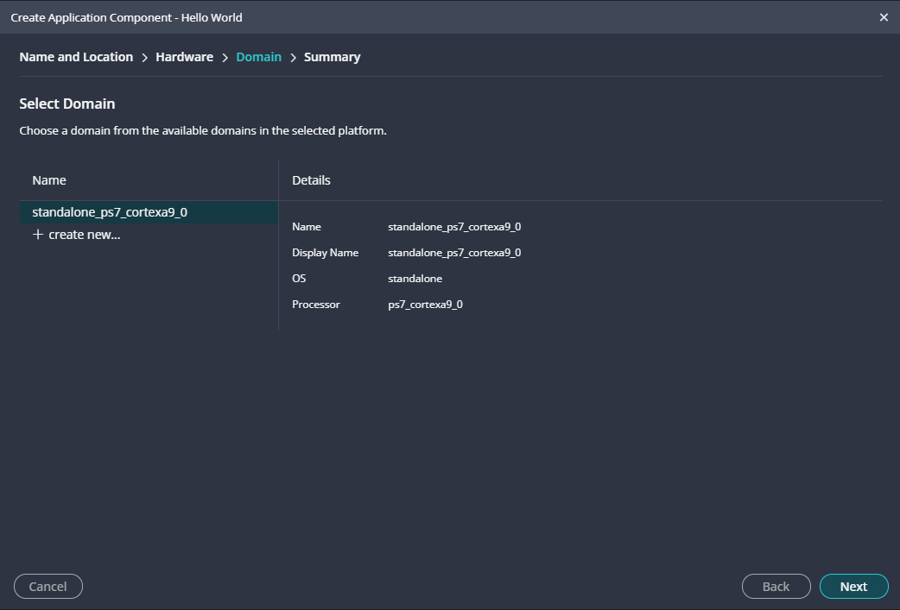
  - Review the summary info on this view and click 'Finish'

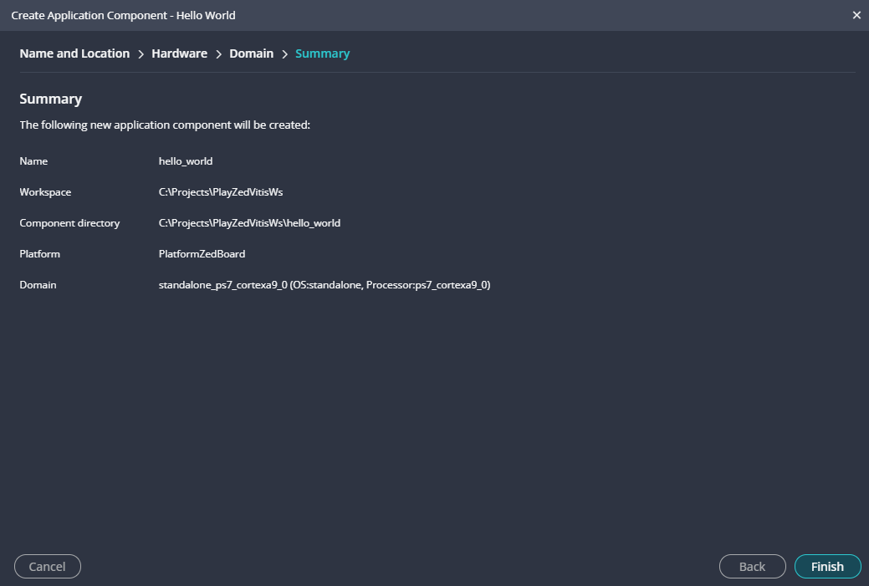
  - Clicking 'Finish' will cause an automatic component build in 'OUTPUT' window:
21:07:12 INFO : cmd.exe, /C, C:\Xilinx\Vitis\2024.2\tps\win64\lopper-1.1.0\env\Scripts\activate.bat && python C:\Xilinx\Vitis\2024.2\data\embeddedsw\scripts\pyesw\\validate_bsp.py -t hello_world -d C:\Projects\PlayZedVitisWs\PlatformZedBoard\export\PlatformZedBoard\sw\standalone_ps7_cortexa9_0 -r C:\Projects\PlayZedVitisWs\_ide\.wsdata\.repo.yaml && C:\Xilinx\Vitis\2024.2\tps\win64\lopper-1.1.0\env\Scripts\deactivate.bat
21:07:13 INFO : Successfully validated template hello_world
21:20:35 INFO : lopper command to create baremetal application :python C:\Xilinx\Vitis\2024.2\data\embeddedsw/scripts/pyesw//create_app.py -s C:\Projects\PlayZedVitisWs\hello_world\src -t hello_world -d C:\Projects\PlayZedVitisWs\PlatformZedBoard\export\PlatformZedBoard\sw\standalone_ps7_cortexa9_0 -n hello_world -r C:\Projects\PlayZedVitisWs\_ide\.wsdata\.repo.yaml
21:20:37 INFO : Successfully validated template hello_world
21:20:40 INFO : Successfully Created Application sources at C:/Projects/PlayZedVitisWs/hello_world/src
21:20:40 INFO : The hardware specification used by project 'C:\Projects\PlayZedVitisWs\hello_world' is out of sync with the platform. Resource files extracted from the hardware specification will be updated.
21:20:40 INFO : The updated ps init files are copied from platform to folder 'C:\Projects\PlayZedVitisWs\hello_world\_ide\psinit' in project 'C:\Projects\PlayZedVitisWs\hello_world'.
21:20:40 INFO : created .gitignore file for the project C:\Projects\PlayZedVitisWs\hello_world
  - Updated GUI view after the component build:
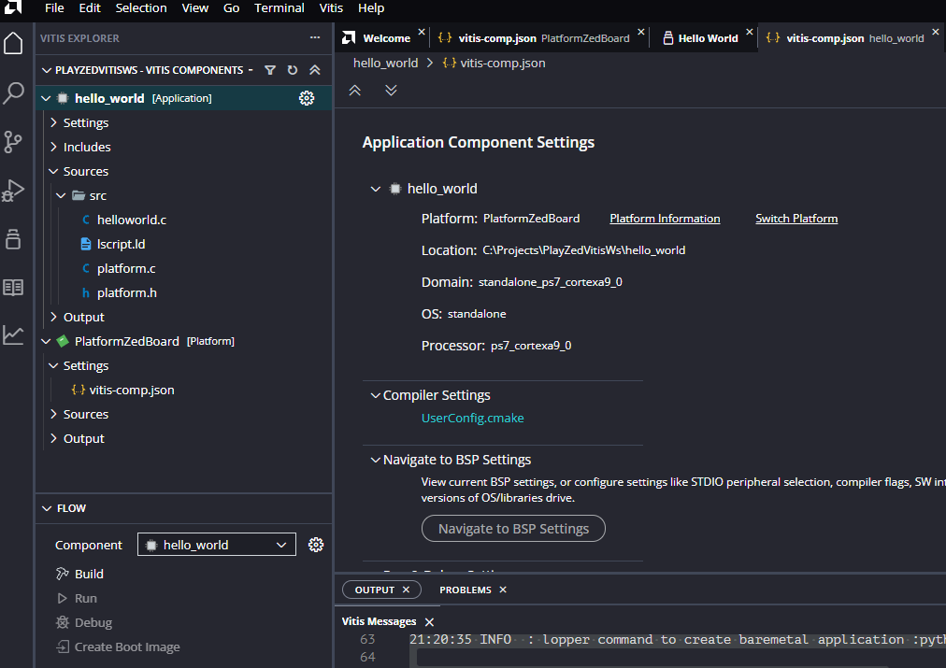

  - Selected 'Build' button which proceeded in 'OUTPUT' window:

--------------------------------------------------------------------------------
[7/7/2025, 9:30:15 PM]: Build for hello_world::build with id '0172c894-8b17-40da-8d4c-bd5823a25f08' started.
--------------------------------------------------------------------------------
-- The C compiler identification is GNU 13.3.0
-- The CXX compiler identification is GNU 13.3.0
-- Detecting C compiler ABI info
-- Detecting C compiler ABI info - done
-- Check for working C compiler: C:/Xilinx/Vitis/2024.2/gnu/aarch32/nt/gcc-arm-none-eabi/bin/arm-none-eabi-gcc.exe - skipped
-- Detecting C compile features
-- Detecting C compile features - done
-- Detecting CXX compiler ABI info
-- Detecting CXX compiler ABI info - done
-- Check for working CXX compiler: C:/Xilinx/Vitis/2024.2/gnu/aarch32/nt/gcc-arm-none-eabi/bin/arm-none-eabi-g++.exe - skipped
-- Detecting CXX compile features
-- Detecting CXX compile features - done
-- The ASM compiler identification is GNU
-- Found assembler: C:/Xilinx/Vitis/2024.2/gnu/aarch32/nt/gcc-arm-none-eabi/bin/arm-none-eabi-gcc.exe
-- Configuring done
-- Generating done
-- Build files have been written to: C:/Projects/PlayZedVitisWs/hello_world/build
[1/3] C:\Xilinx\Vitis\2024.2\gnu\aarch32\nt\gcc-arm-none-eabi\bin\arm-none-eabi-gcc.exe -isystem C:/Projects/PlayZedVitisWs/PlatformZedBoard/export/PlatformZedBoard/sw/standalone_ps7_cortexa9_0/include -isystem C:/Xilinx/Vitis/2024.2/gnu/aarch32/nt/gcc-arm-none-eabi/x86_64-oesdk-mingw32/usr/lib/arm-xilinx-eabi/gcc/arm-xilinx-eabi/13.3.0/include -isystem C:/Xilinx/Vitis/2024.2/gnu/aarch32/nt/gcc-arm-none-eabi/x86_64-oesdk-mingw32/usr/lib/arm-xilinx-eabi/gcc/arm-xilinx-eabi/13.3.0/include-fixed -isystem C:/Xilinx/Vitis/2024.2/gnu/aarch32/nt/gcc-arm-none-eabi/aarch32-xilinx-eabi/usr/include -O2 -DSDT -mcpu=cortex-a9 -mfpu=vfpv3 -mfloat-abi=hard -MMD -MP -specs=C:/Projects/PlayZedVitisWs/PlatformZedBoard/export/PlatformZedBoard/sw/standalone_ps7_cortexa9_0/Xilinx.spec -IC:/Projects/PlayZedVitisWs/PlatformZedBoard/export/PlatformZedBoard/sw/standalone_ps7_cortexa9_0/include -Wall -Wextra -O0 -g3 -U__clang__ "-D__FILENAME__='__FILE__'" -MD -MT CMakeFiles/hello_world.elf.dir/platform.c.obj -MF CMakeFiles\hello_world.elf.dir\platform.c.obj.d -o CMakeFiles/hello_world.elf.dir/platform.c.obj -c C:/Projects/PlayZedVitisWs/hello_world/src/platform.c
[3/3] cmd.exe /C "cd . && C:\Xilinx\Vitis\2024.2\gnu\aarch32\nt\gcc-arm-none-eabi\bin\arm-none-eabi-gcc.exe -O2 -DSDT -mcpu=cortex-a9 -mfpu=vfpv3 -mfloat-abi=hard -MMD -MP -specs=C:/Projects/PlayZedVitisWs/PlatformZedBoard/export/PlatformZedBoard/sw/standalone_ps7_cortexa9_0/Xilinx.spec -IC:/Projects/PlayZedVitisWs/PlatformZedBoard/export/PlatformZedBoard/sw/standalone_ps7_cortexa9_0/include -Wall -Wextra -O0 -g3 -U__clang__ CMakeFiles/hello_world.elf.dir/helloworld.c.obj CMakeFiles/hello_world.elf.dir/platform.c.obj -o hello_world.elf -Wl,-T -Wl,"C:/Projects/PlayZedVitisWs/hello_world/src/lscript.ld" -L"C:/Projects/PlayZedVitisWs/hello_world/src/" -L"C:/Projects/PlayZedVitisWs/PlatformZedBoard/export/PlatformZedBoard/sw/standalone_ps7_cortexa9_0/lib/" -L"/" -Wl,--start-group,-lxilstandalone -lxiltimer -lxil -lgcc -lc -Wl,--end-group && cmd.exe /C "cd /D C:\Projects\PlayZedVitisWs\hello_world\build && arm-none-eabi-size --format=berkeley hello_world.elf && arm-none-eabi-size --format=berkeley hello_world.elf > C:/Projects/PlayZedVitisWs/hello_world/build/hello_world.elf.size""
text data bss dec hex filename
24152 1416 22952 48520 bd88 hello_world.elf
Build Finished successfully
--------------------------------------------------------------------------------
[7/7/2025, 9:30:17 PM]: Build for hello_world::build with id '0172c894-8b17-40da-8d4c-bd5823a25f08' ended.

  - Powered on ZedBoard to prepare for debug connection from Vitis IDE
  - Clicked 'Debug'
  - Vitis connected to the target and updated the view to debug perspective
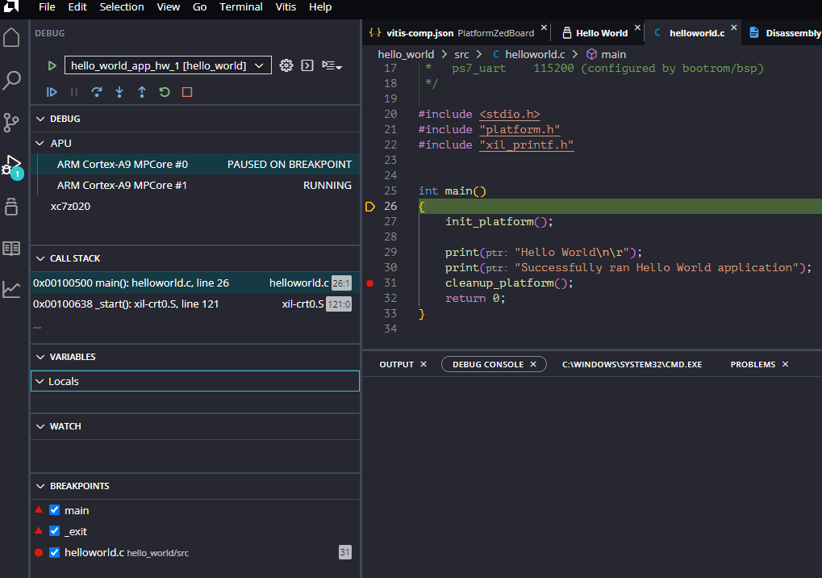
  - Could single step and set breakpoints
  - Ran to breakpoint and verified that print messages were displayed on serial terminal:
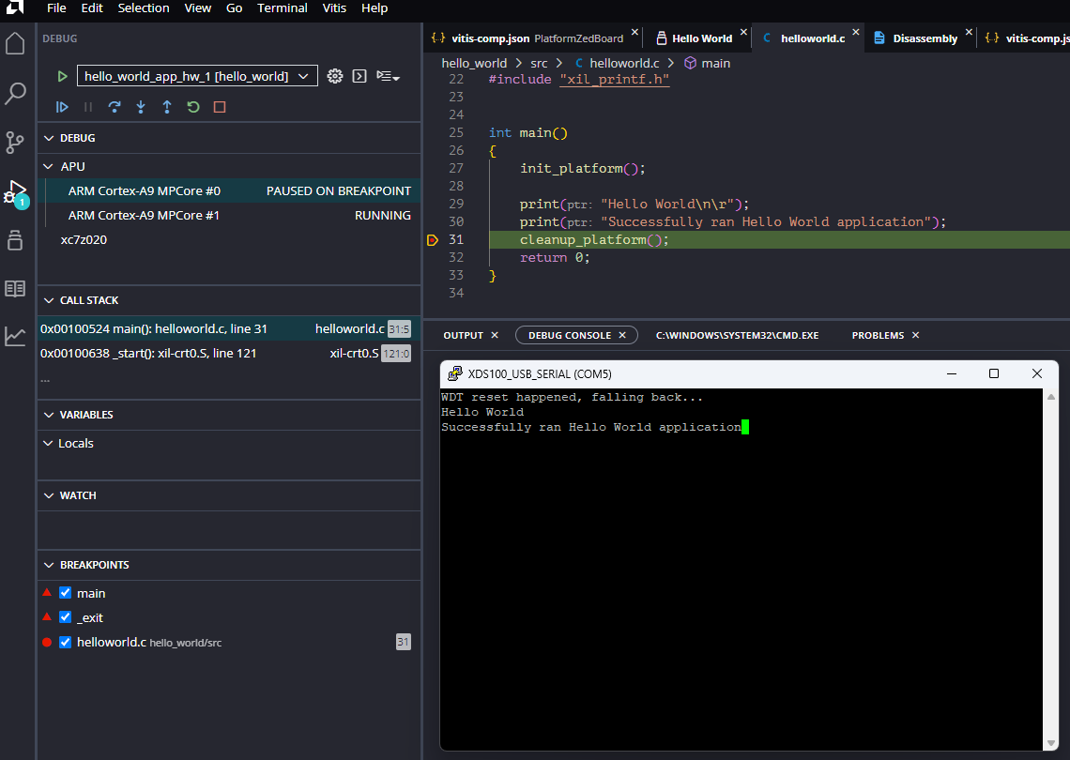
- Summary: Created a simple hello world program that can build and run on a ZedBoard using Vitis Unified IDE.

