Build and debug 'Linux Hello World' with Vitis Unified

- Want to run/debug a linux application on our ZedBoard
- Will use the 'linux hello world' example project that comes with Vitis

Using Vitis Unified 2024.2:

- Set workspace to 'Projects/VitisZedLinuxWs' (brand new folder)
- In 'Embedded Development' panel, click 'Create Platform Component'

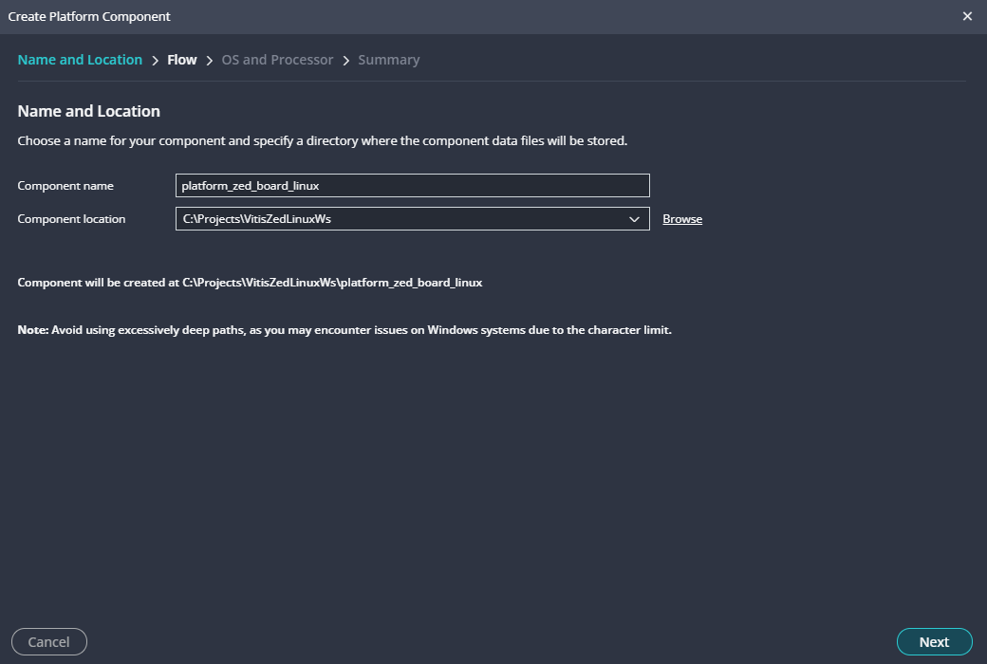

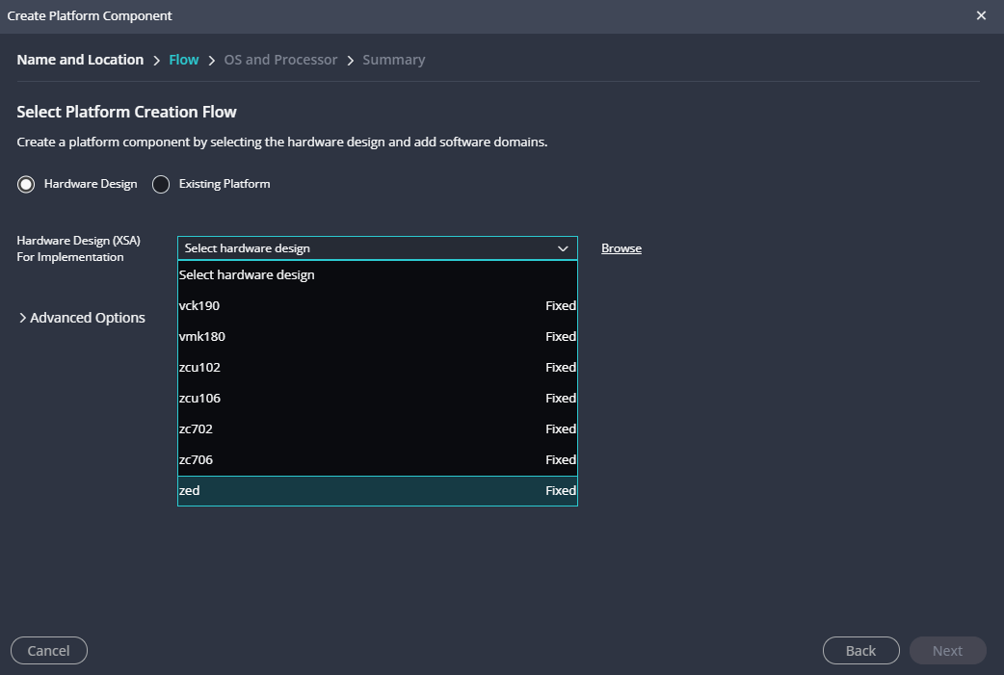

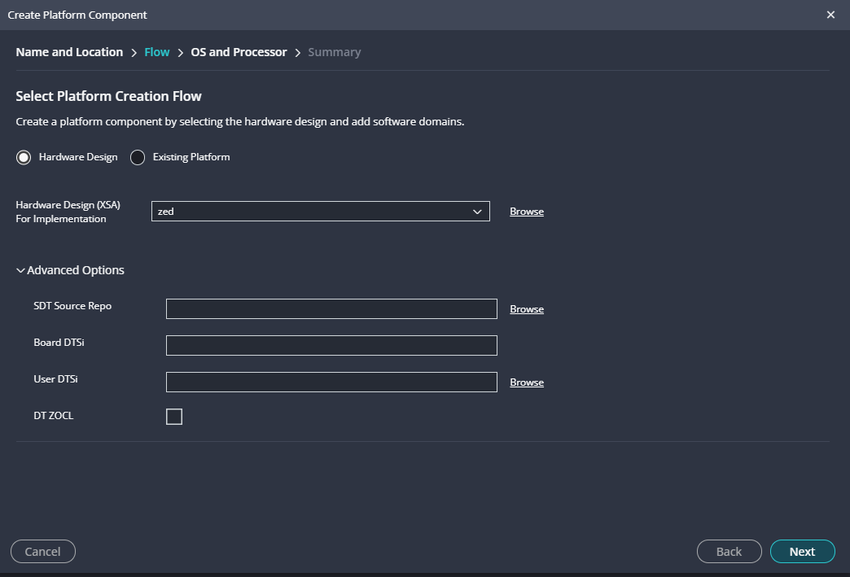

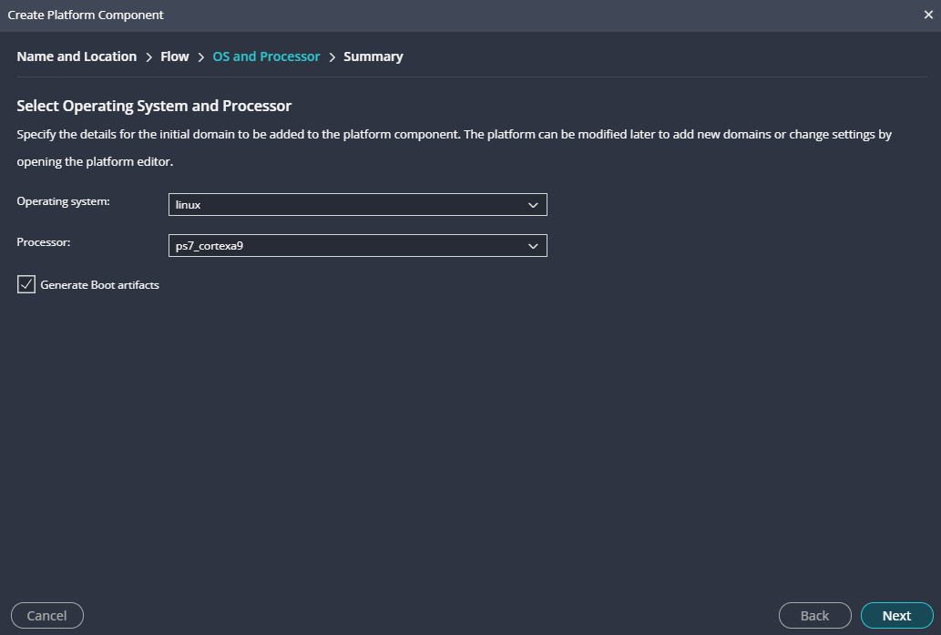
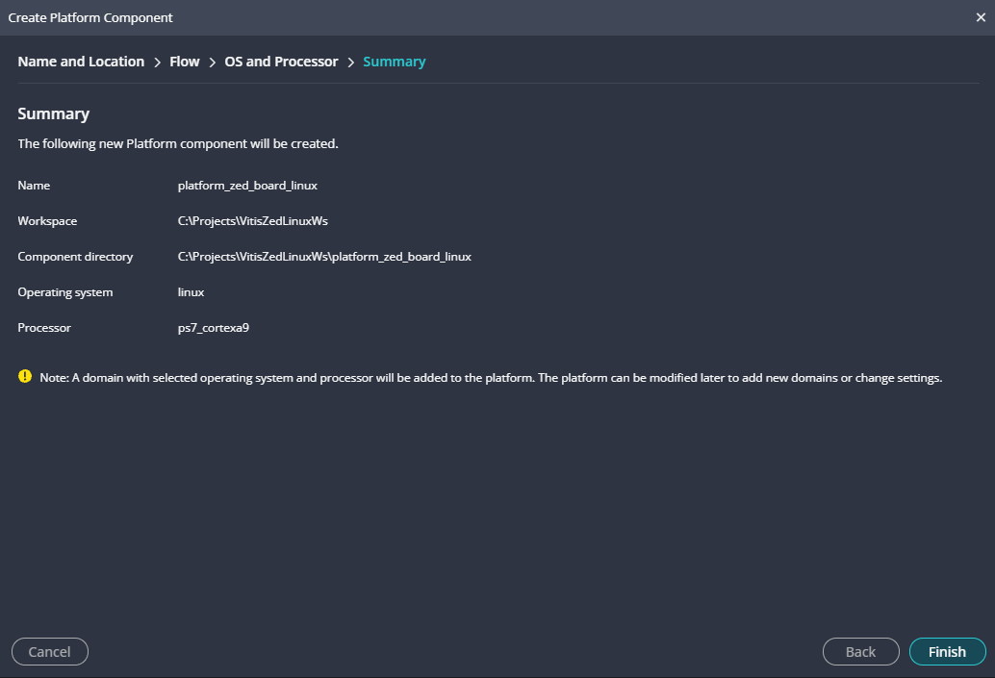

Output console:

18:01:33 INFO : updated workspace path: C:\Projects\VitisZedLinuxWs
18:01:35 INFO : Successfully created repository data at C:\Users\wlaba\AppData\Local\Temp\rigel_lopper_wlaba15563819171094951191
18:01:35 INFO : cmd.exe, /C, C:\Xilinx\Vitis\2024.2\tps\win64\lopper-1.1.0\env\Scripts\activate.bat && python C:\Xilinx\Vitis\2024.2\data\embeddedsw\scripts\pyesw\\get_template_data.py -d C:\Users\wlaba\AppData\Local\Temp\rigel_lopper_wlaba11976232445309139885 -r C:\Users\wlaba\AppData\Local\Temp\rigel_lopper_wlaba15563819171094951191\.repo.yaml && C:\Xilinx\Vitis\2024.2\tps\win64\lopper-1.1.0\env\Scripts\deactivate.bat
18:01:36 INFO : Embedded Template List generated successfully
18:01:36 INFO : cmd.exe, /C, C:\Xilinx\Vitis\2024.2\tps\win64\lopper-1.1.0\env\Scripts\activate.bat && python C:\Xilinx\Vitis\2024.2\data\embeddedsw\scripts\pyesw\\repo.py -st C:\Xilinx\Vitis\2024.2\data\embeddedsw && C:\Xilinx\Vitis\2024.2\tps\win64\lopper-1.1.0\env\Scripts\deactivate.bat
18:01:38 INFO : Successfully created repository data at C:\Projects\VitisZedLinuxWs/_ide\.wsdata
18:01:38 INFO : cmd.exe, /C, C:\Xilinx\Vitis\2024.2\tps\win64\lopper-1.1.0\env\Scripts\activate.bat && python C:\Xilinx\Vitis\2024.2\data\embeddedsw\scripts\pyesw\\get_template_data.py -d C:\Users\wlaba\AppData\Local\Temp\rigel_lopper_wlaba8550755919004480838 -r C:\Projects\VitisZedLinuxWs\_ide\.wsdata\.repo.yaml && C:\Xilinx\Vitis\2024.2\tps\win64\lopper-1.1.0\env\Scripts\deactivate.bat
18:01:39 INFO : Embedded Template List generated successfully
18:40:59 INFO : Found no platform with name 'zed' in install repositories

18:40:59 INFO : Install SDT for given XSA copied Successfully

18:40:59 INFO : cmd.exe, /C, C:\Xilinx\Vitis\2024.2\tps\win64\lopper-1.1.0\env\Scripts\activate.bat && lopper --enhanced --werror -f -O C:\Projects\VitisZedLinuxWs\.rigel_lopper -i C:\Xilinx\Vitis\2024.2\tps\win64\lopper-1.1.0\env\Lib\site-packages\lopper\lops\lop-cpu-oslist.dts C:\Projects\VitisZedLinuxWs\.rigel_lopper_temp_platform\zed\hw\sdt\system-top.dts && C:\Xilinx\Vitis\2024.2\tps\win64\lopper-1.1.0\env\Scripts\deactivate.bat

18:41:01 INFO : CPU List generated successfully

18:47:13 INFO : Platform platform_zed_board_linux creation started.

18:47:13 INFO : Lopper command for cpu List generation: lopper --enhanced --werror -f -O C:\Projects\VitisZedLinuxWs\.rigel_lopper -i C:\Xilinx\Vitis\2024.2\tps\win64\lopper-1.1.0\env\Lib\site-packages\lopper\lops\lop-cpu-oslist.dts C:\Projects\VitisZedLinuxWs\platform_zed_board_linux\hw\sdt\system-top.dts

18:47:13 INFO : cmd.exe, /C, C:\Xilinx\Vitis\2024.2\tps\win64\lopper-1.1.0\env\Scripts\activate.bat && lopper --enhanced --werror -f -O C:\Projects\VitisZedLinuxWs\.rigel_lopper -i C:\Xilinx\Vitis\2024.2\tps\win64\lopper-1.1.0\env\Lib\site-packages\lopper\lops\lop-cpu-oslist.dts C:\Projects\VitisZedLinuxWs\platform_zed_board_linux\hw\sdt\system-top.dts && C:\Xilinx\Vitis\2024.2\tps\win64\lopper-1.1.0\env\Scripts\deactivate.bat

18:47:14 INFO : CPU List generated successfully

18:47:14 INFO : created .gitignore file for the project C:\Projects\VitisZedLinuxWs\platform_zed_board_linux

18:47:14 INFO : ZYNQ: Using the QEMU args from install at : C:\Xilinx\Vitis\2024.2\data\emulation\platforms\zynq\sw\a9_linux\qemu\qemu_args.txt

18:47:14 INFO : ZYNQ: Using the QEMU args from install at : C:\Xilinx\Vitis\2024.2\data\emulation\platforms\zynq\sw\a9_standalone\qemu\qemu_args.txt

18:47:14 INFO : ZYNQ: Using the QEMU args from install at : C:\Xilinx\Vitis\2024.2\data\emulation\platforms\zynq\sw\a9_linux\qemu\qemu_args.txt

18:47:14 INFO : Domain linux_ps7_cortexa9 added successfully.

18:47:14 INFO : lopper command to generate BSP :python C:\Xilinx\Vitis\2024.2\data\embeddedsw/scripts/pyesw//create_bsp.py -w C:\Projects\VitisZedLinuxWs\platform_zed_board_linux\zynq_fsbl\zynq_fsbl_bsp -p ps7_cortexa9_0 -o standalone -s C:\Projects\VitisZedLinuxWs\platform_zed_board_linux\hw\sdt\system-top.dts -t zynq_fsbl -r C:\Projects\VitisZedLinuxWs\_ide\.wsdata\.repo.yaml

18:47:14 INFO : cmd.exe, /C, C:\Xilinx\Vitis\2024.2\tps\win64\lopper-1.1.0\env\Scripts\activate.bat && python C:\Xilinx\Vitis\2024.2\data\embeddedsw\scripts\pyesw\\create_bsp.py -w C:\Projects\VitisZedLinuxWs\platform_zed_board_linux\zynq_fsbl\zynq_fsbl_bsp -p ps7_cortexa9_0 -o standalone -s C:\Projects\VitisZedLinuxWs\platform_zed_board_linux\hw\sdt\system-top.dts -t zynq_fsbl -r C:\Projects\VitisZedLinuxWs\_ide\.wsdata\.repo.yaml && C:\Xilinx\Vitis\2024.2\tps\win64\lopper-1.1.0\env\Scripts\deactivate.bat

18:47:29 INFO : Successfully created Domain at C:\Projects\VitisZedLinuxWs\platform_zed_board_linux\zynq_fsbl\zynq_fsbl_bsp

18:47:29 INFO : lopper command to create baremetal application :python C:\Xilinx\Vitis\2024.2\data\embeddedsw/scripts/pyesw//create_app.py -s C:\Projects\VitisZedLinuxWs\platform_zed_board_linux\zynq_fsbl -t zynq_fsbl -d C:\Projects\VitisZedLinuxWs\platform_zed_board_linux\zynq_fsbl\zynq_fsbl_bsp -n fsbl -r C:\Projects\VitisZedLinuxWs\_ide\.wsdata\.repo.yaml

18:47:29 INFO : cmd.exe, /C, C:\Xilinx\Vitis\2024.2\tps\win64\lopper-1.1.0\env\Scripts\activate.bat && python C:\Xilinx\Vitis\2024.2\data\embeddedsw\scripts\pyesw\\validate_bsp.py -t zynq_fsbl -d C:\Projects\VitisZedLinuxWs\platform_zed_board_linux\zynq_fsbl\zynq_fsbl_bsp -r C:\Projects\VitisZedLinuxWs\_ide\.wsdata\.repo.yaml && C:\Xilinx\Vitis\2024.2\tps\win64\lopper-1.1.0\env\Scripts\deactivate.bat

18:47:32 INFO : Successfully validated template zynq_fsbl

18:47:37 INFO : Successfully Created Application sources at C:/Projects/VitisZedLinuxWs/platform_zed_board_linux/zynq_fsbl

18:47:37 INFO : Platform FSBL Boot domain added successfully.

18:47:38 INFO : Platform creation finished successfully.

18:47:38 INFO : Generating Export directory

18:47:38 INFO : Generated platform metadata for creating application(s) based on platform platform_zed_board_linux.

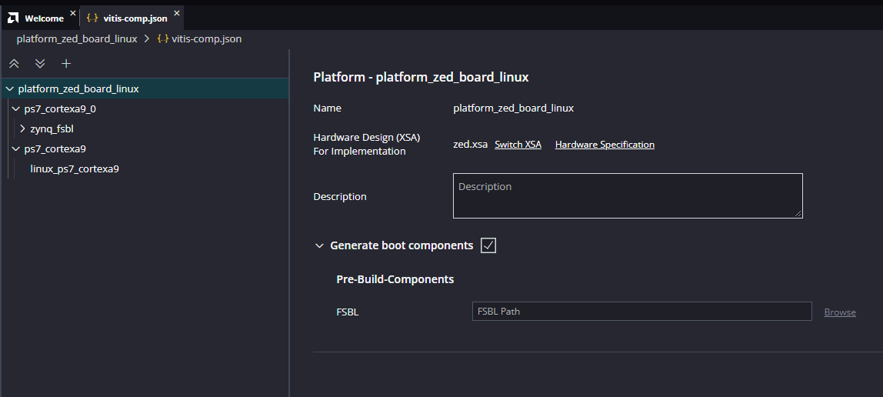

- Click on Examples Icon and select '+' sign to right of 'Linux Hello World' to create 'New Application Component'

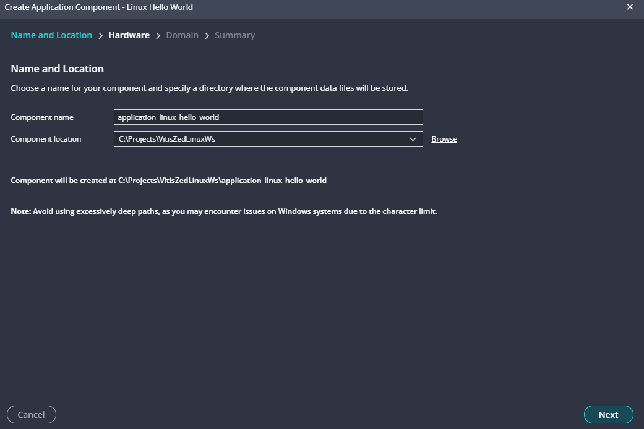

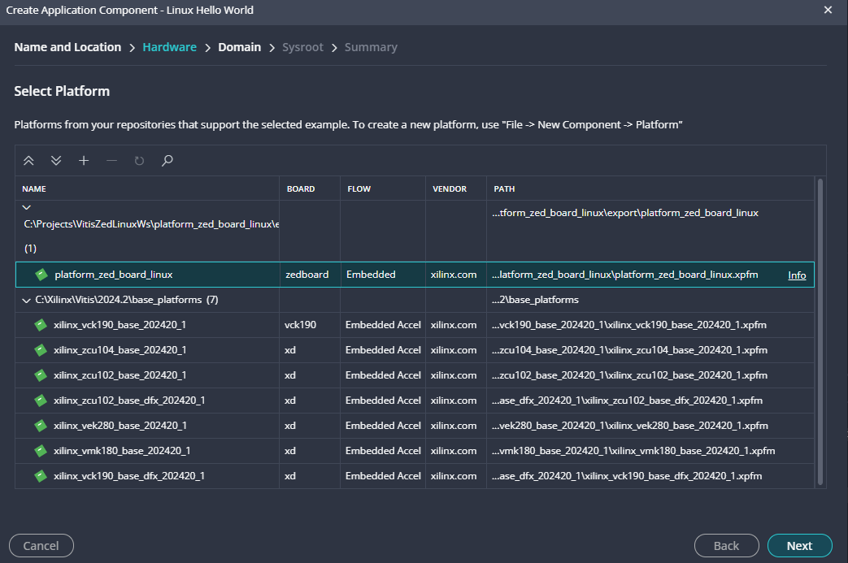

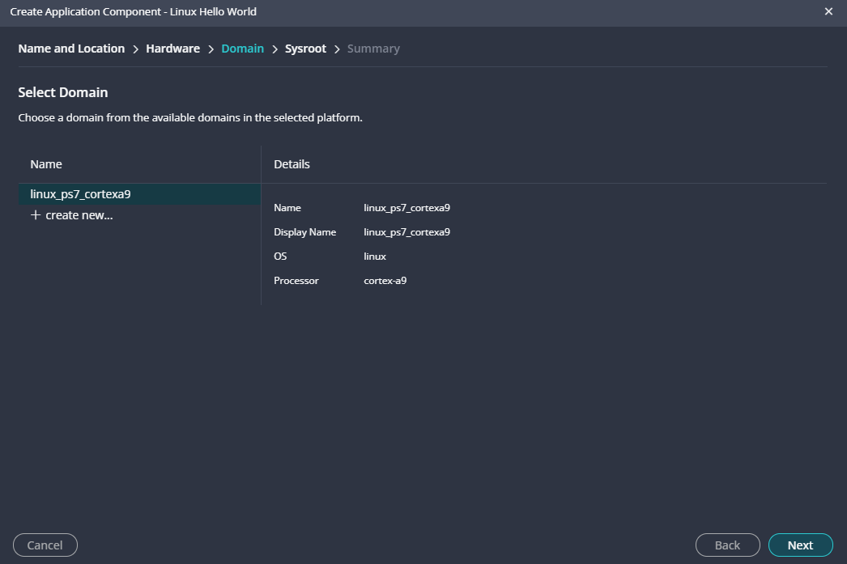

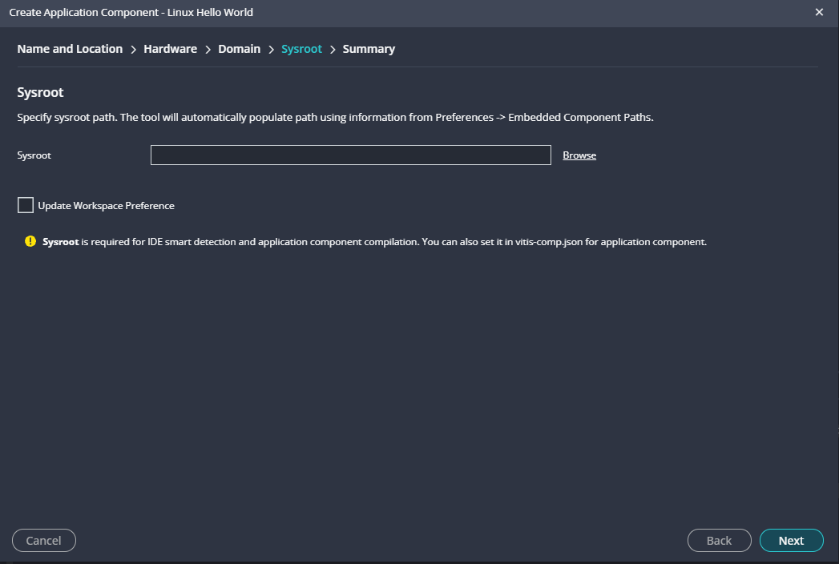

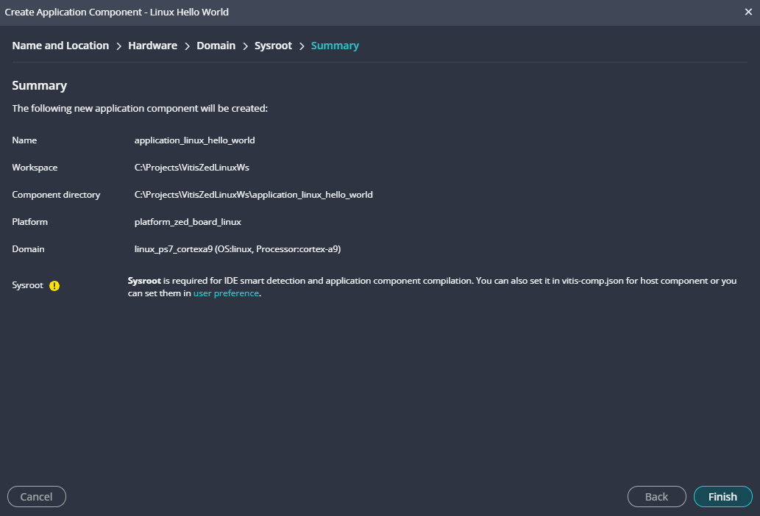

Output Console:

19:01:42 INFO : Found compiledb at C:\Xilinx\Vitis\2024.2\vitis-server\scripts\compiledb

19:01:45 INFO : Generated compile_commands.json at C:\Projects\VitisZedLinuxWs\application_linux_hello_world\_ide

- Building hello world project:

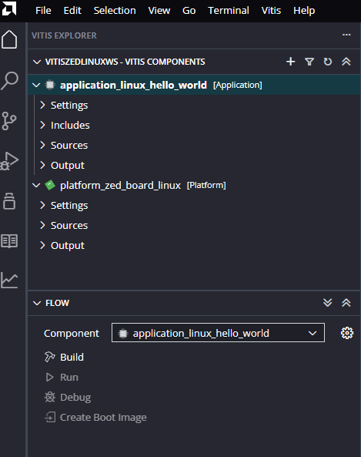
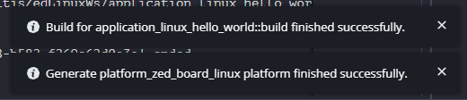
Console Output:

--------------------------------------------------------------------------------
[7/16/2025, 7:07:20 PM]: Build for application_linux_hello_world::build with id '5167207d-f0ec-4dc8-b582-f269e62d0a3a' started.
--------------------------------------------------------------------------------
-- The C compiler identification is GNU 13.3.0
-- The CXX compiler identification is GNU 13.3.0
-- Detecting C compiler ABI info
-- Detecting C compiler ABI info - done
-- Check for working C compiler: C:/Xilinx/Vitis/2024.2/gnu/aarch32/nt/gcc-arm-linux-gnueabi/bin/arm-linux-gnueabihf-gcc.exe - skipped
-- Detecting C compile features
-- Detecting C compile features - done
-- Detecting CXX compiler ABI info
-- Detecting CXX compiler ABI info - done
-- Check for working CXX compiler: C:/Xilinx/Vitis/2024.2/gnu/aarch32/nt/gcc-arm-linux-gnueabi/bin/arm-linux-gnueabihf-g++.exe - skipped
-- Detecting CXX compile features
-- Detecting CXX compile features - done
-- Configuring done
-- Generating done
-- Build files have been written to: C:/Projects/VitisZedLinuxWs/application_linux_hello_world/build
C:/Xilinx/Vitis/2024.2/tps/win64/cmake-3.24.2/bin/cmake.exe -SC:/Projects/VitisZedLinuxWs/application_linux_hello_world -BC:/Projects/VitisZedLinuxWs/application_linux_hello_world/build --check-build-system CMakeFiles/Makefile.cmake 0
C:/Xilinx/Vitis/2024.2/tps/win64/cmake-3.24.2/bin/cmake.exe -E cmake_progress_start C:/Projects/VitisZedLinuxWs/application_linux_hello_world/build/CMakeFiles C:/Projects/VitisZedLinuxWs/application_linux_hello_world/build//CMakeFiles/progress.marks
C:/ti/xdctools_3_23_04_60/gmake.exe -f CMakeFiles/Makefile2 all
gmake.exe[1]: Entering directory `C:/Projects/VitisZedLinuxWs/application_linux_hello_world/build'
C:/ti/xdctools_3_23_04_60/gmake.exe -f CMakeFiles/application_linux_hello_world.elf.dir/build.make CMakeFiles/application_linux_hello_world.elf.dir/depend
gmake.exe[2]: Entering directory `C:/Projects/VitisZedLinuxWs/application_linux_hello_world/build'
C:/Xilinx/Vitis/2024.2/tps/win64/cmake-3.24.2/bin/cmake.exe -E cmake_depends "Unix Makefiles" C:/Projects/VitisZedLinuxWs/application_linux_hello_world C:/Projects/VitisZedLinuxWs/application_linux_hello_world C:/Projects/VitisZedLinuxWs/application_linux_hello_world/build C:/Projects/VitisZedLinuxWs/application_linux_hello_world/build C:/Projects/VitisZedLinuxWs/application_linux_hello_world/build/CMakeFiles/application_linux_hello_world.elf.dir/DependInfo.cmake --color=
gmake.exe[2]: Leaving directory `C:/Projects/VitisZedLinuxWs/application_linux_hello_world/build'
C:/ti/xdctools_3_23_04_60/gmake.exe -f CMakeFiles/application_linux_hello_world.elf.dir/build.make CMakeFiles/application_linux_hello_world.elf.dir/build
gmake.exe[2]: Entering directory `C:/Projects/VitisZedLinuxWs/application_linux_hello_world/build'
[ 50%] [32mBuilding C object CMakeFiles/application_linux_hello_world.elf.dir/src/helloworld.c.obj[0m
C:/Xilinx/Vitis/2024.2/gnu/aarch32/nt/gcc-arm-linux-gnueabi/bin/arm-linux-gnueabihf-gcc.exe -DVITIS_MAJOR_VERSION="" -DVITIS_MINOR_VERSION="" -DVITIS_VERSION="" -g -Wall -Wextra -O0 -g3 -MD -MT CMakeFiles/application_linux_hello_world.elf.dir/src/helloworld.c.obj -MF CMakeFiles/application_linux_hello_world.elf.dir/src/helloworld.c.obj.d -o CMakeFiles/application_linux_hello_world.elf.dir/src/helloworld.c.obj -c C:/Projects/VitisZedLinuxWs/application_linux_hello_world/src/helloworld.c
[100%] [32m[1mLinking C executable application_linux_hello_world.elf[0m
C:/Xilinx/Vitis/2024.2/gnu/aarch32/nt/gcc-arm-linux-gnueabi/bin/arm-linux-gnueabihf-gcc.exe "CMakeFiles/application_linux_hello_world.elf.dir/src/helloworld.c.obj" -o application_linux_hello_world.elf
gmake.exe[2]: Leaving directory `C:/Projects/VitisZedLinuxWs/application_linux_hello_world/build'
[100%] Built target application_linux_hello_world.elf
gmake.exe[1]: Leaving directory `C:/Projects/VitisZedLinuxWs/application_linux_hello_world/build'
C:/Xilinx/Vitis/2024.2/tps/win64/cmake-3.24.2/bin/cmake.exe -E cmake_progress_start C:/Projects/VitisZedLinuxWs/application_linux_hello_world/build/CMakeFiles 0
Build Finished successfully
--------------------------------------------------------------------------------
[7/16/2025, 7:07:24 PM]: Build for application_linux_hello_world::build with id '5167207d-f0ec-4dc8-b582-f269e62d0a3a' ended.

- Looks like we successfully created/built a ZedBoard platform and Linux Hello World application using Vitis!

- Next, we are going to try to launch a debug session from Vitis ....

