Installing petalinux 2024.2 and configuring/building linux for our ZedBoard

- We used Vitis Unified 2024.2 to generate our platform component 'platform_zed_board_linux',
which contains the 'hw' output folder and zed.xsa file (reference 1_Steps.pdf)
- We have Ubuntu 22.04 LTS running via WSL2 on our Windows 11 PC
- This document is for:
  - Installing the petalinux tools in our Ubuntu VM,
  - Using the petalinux tools to configure and build the linux kernel for our ZedBoard.

Petalinux Download: https://www.xilinx.com/support/download/index.html/content/xilinx/en/downloadNav/embedded-design-tools/2024-2.html

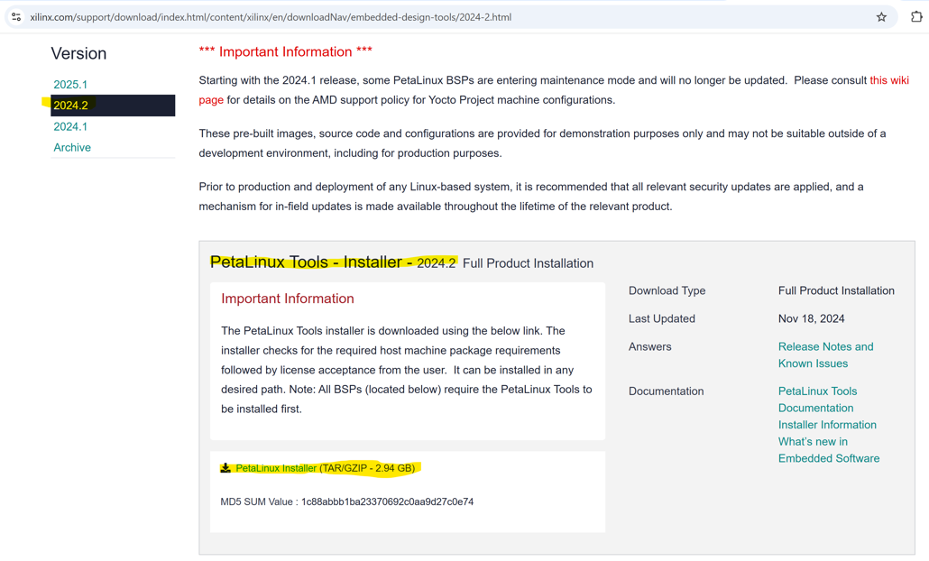

Downloaded file: petalinux-v2024.2-11062026-installer.run

Copied installer to Ubuntu

Launched a Ubuntu terminal and entered the command line

- Do these steps before installing petalinux:
  - 73296 - PetaLinux: How to install the required packages for the PetaLinux Build Host:
    - Download 'plnx-env-setup.sh' from 'https://adaptivesupport.amd.com/s/article/73296?language=en_US'
    - Copy script to Ubuntu
    - 'chmod +x plnx-env-setup.sh'
    - 'sudo ./plnx-env-setup.sh'
  - Disable 'dash':
    - Up to Ubuntu 22.04 included (and Debian 11 included):
        - 'sudo dpkg-reconfigure dash' (answer 'No' to transition to bash shell)
      - Or, for above version Ubuntu 22.04, try:
        - sudo ln -s bash /bin/sh.bash
        - sudo mv /bin/sh.bash /bin/sh
        - And if/when you want to restore back to dash:
          - sudo ln -s dash /bin/sh.dash
          - sudo mv /bin/sh.dash /bin/sh
  - Prevention of exception due to 'warning: setlocale: LC_ALL: cannot change locale (en_US.UTF-8):'
    - sudo apt install locales
    - sudo locale-gen en_US.UTF-8
    - sudo dpkg-reconfigure locales (make sure 'en_US.UTF-8' is starred)
  - Prevention of exception due to 'package require xsbd FAILED:'
    - sudo apt update
    - wget http://security.ubuntu.com/ubuntu/pool/universe/n/ncurses/libtinfo5_6.3-2ubuntu0.1_amd64.deb
    - sudo apt install ./libtinfo5_6.3-2ubuntu0.1_amd64.deb

Installing petalinux:

  - 'chmod +x petalinux-v2024.2-11062026-installer.run'
  - 'mkdir -p /home/wlaba/playZed/petalinux-tools'
  - './petalinux-v2024.2-11062026-installer.run -d /home/wlaba/playZed/petalinux-tools'

Installer ouput:

./petalinux-v2024.2-11062026-installer.run: line 3: warning: setlocale: LC_ALL: cannot change locale (en_US.UTF-8): No such file or directory
PetaLinux CMD tools installer version 2024.2
============================================
/bin/bash: warning: setlocale: LC_ALL: cannot change locale (en_US.UTF-8)
[WARNING] This is not a supported OS
[INFO] Checking free disk space
[INFO] Checking installed tools
[INFO] Checking installed development libraries
[INFO] Checking network and other services
[WARNING] No tftp server found - please refer to "UG1144 PetaLinux Tools Documentation Reference Guide" for its impact and solution

LICENSE AGREEMENTS

PetaLinux SDK contains software from a number of sources. Please review
the following licenses and indicate your acceptance of each to continue.

You do not have to accept the licenses, however if you do not then you may
not use PetaLinux SDK.

Use PgUp/PgDn to navigate the license viewer, and press 'q' to close

Press Enter to display the license agreements
/bin/bash: warning: setlocale: LC_ALL: cannot change locale (en_US.UTF-8)
Do you accept Xilinx End User License Agreement? [y/N] > y
/bin/bash: warning: setlocale: LC_ALL: cannot change locale (en_US.UTF-8)
Do you accept Third Party End User License Agreement? [y/N] > y
[INFO] Installing PetaLinux SDK...done
[INFO] Setting it up...
[INFO] Extracting xsct tarball...
:
:
[INFO] PetaLinux SDK has been successfully set up and is ready to be used.

cd to your installation folder (the folder given after the -d option)
source ./settings.sh

*************************************************************************************************************************************************
The PetaLinux source code and images provided/generated are for demonstration purposes only.
Please refer to https://xilinx-wiki.atlassian.net/wiki/spaces/A/pages/2741928025/Moving+from+PetaLinux+to+Production+Deployment
for more details
*************************************************************************************************************************************************
PetaLinux environment set to '/home/wlaba/playZed/petalinux-tools'
WARNING: /bin/sh is not bash!
bash is PetaLinux recommended shell. Please set your default shell to bash.
[WARNING] This is not a supported OS
[INFO] Checking free disk space
[INFO] Checking installed tools
[INFO] Checking installed development libraries
[INFO] Checking network and other services
[WARNING] No tftp server found - please refer to "UG1144 2024.2 PetaLinux Tools Documentation Reference Guide" for its impact and solution

Create our first project:

- cd /home/wlaba/playZed/petalinux-tools (change directory to our install folder)
- source ./settings.sh
- petalinux-create --type project --template zynq --name PetalinuxDemo1

Tool output:

[NOTE] Argument: "--type project" has been deprecated. It is recommended to start using new python command line Argument.
[NOTE] Use: petalinux-create project [OPTIONS]
[INFO] Create project: PetalinuxDemo1
[INFO] New project successfully created in /home/wlaba/playZed/petalinux-tools/PetalinuxDemo1

Create our first hardware description output:

- Using 'platform_zed_board_linux' folder generated by Vitis in '1_Steps.pdf'
- Copied Vitis output folder 'platform_zed_board_linux' from windows to Ubuntu folder:

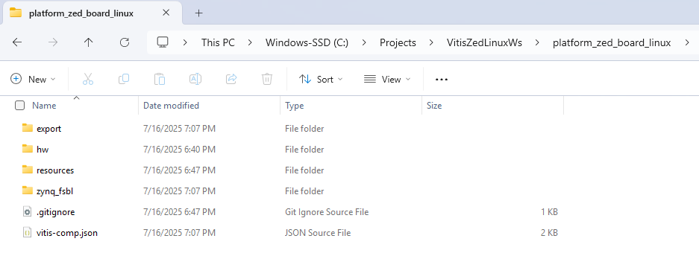
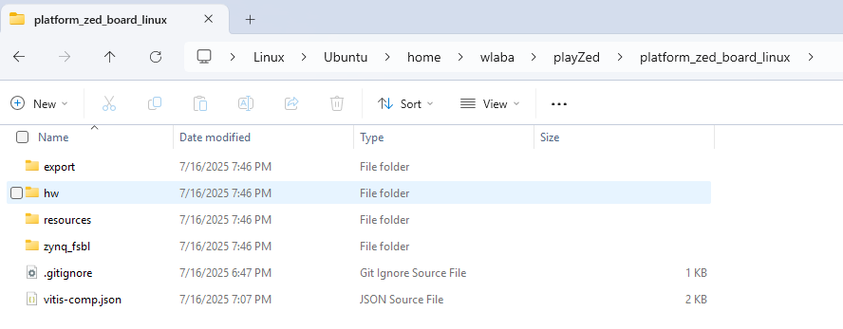
- The 'zed.xsa' file and 'sdt' folder were located under the 'hw' sub-folder:

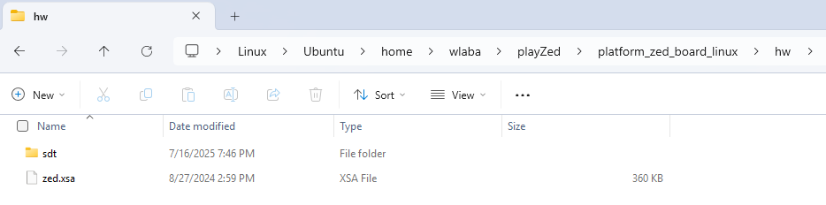
- cd /home/wlaba/playZed/petalinux-tools/PetalinuxDemo1 (change directory to our project folder)
- petalinux-config –get-hw-description=/home/wlaba/playZed/platform_zed_board_linux/hw/

Tool output:

[INFO] Getting hardware description
[INFO] Renaming zed.xsa to system.xsa
[INFO] Bitbake is not available, some functionality may be reduced.
[INFO] Using HW file: /home/wlaba/playZed/petalinux-tools/PetalinuxDemo1/project-spec/hw-description/system.xsa
[INFO] Getting Platform info from HW file
[INFO] Generating Kconfig for project
[INFO] Menuconfig project
[INFO] Generating kconfig for rootfs
[INFO] Silentconfig rootfs
[INFO] Generating configuration files
[INFO] Adding user layers
[INFO] Generating machine conf file
[INFO] Generating plnxtool conf file
[INFO] Generating workspace directory
NOTE: Starting bitbake server...
NOTE: Started PRServer with DBfile: /home/wlaba/playZed/petalinux-tools/PetalinuxDemo1/build/cache/prserv.sqlite3, Address: 127.0.0.1:37475, PID: 68582
INFO: Specified workspace already set up, leaving as-is
INFO: Enabling workspace layer in bblayers.conf
[INFO] Successfully configured project

Perform our first petalinux build:

- 'petalinux-build' (continuing from within our project folder)

Tool ouput:

[INFO] Building project
[INFO] Bitbake is not available, some functionality may be reduced.
[INFO] Using HW file: /home/wlaba/playZed/petalinux-tools/PetalinuxDemo1/project-spec/hw-description/system.xsa
[INFO] Getting Platform info from HW file
[INFO] Silentconfig project
[INFO] Silentconfig rootfs
[INFO] Generating configuration files
[INFO] Generating workspace directory
NOTE: Starting bitbake server...
NOTE: Started PRServer with DBfile: /home/wlaba/playZed/petalinux-tools/PetalinuxDemo1/build/cache/prserv.sqlite3, Address: 127.0.0.1:33071, PID: 68726
INFO: Specified workspace already set up, leaving as-is
[INFO] bitbake petalinux-image-minimal
NOTE: Started PRServer with DBfile: /home/wlaba/playZed/petalinux-tools/PetalinuxDemo1/build/cache/prserv.sqlite3, Address: 127.0.0.1:37863, PID: 68785
WARNING: XSCT has been deprecated. It will still be available for several releases. In the future, it's recommended to start new projects with SDT workflow.
WARNING: You are running bitbake under WSLv2, this works properly but you should optimize your VHDX file eventually to avoid running out of storage space
Loading cache: 100% | | ETA: --:--:--
Loaded 0 entries from dependency cache.
Parsing recipes: 100% |##########################################################################################################| Time: 0:14:29
Parsing of 5800 .bb files complete (0 cached, 5800 parsed). 8454 targets, 1106 skipped, 27 masked, 0 errors.
NOTE: Resolving any missing task queue dependencies
NOTE: Fetching uninative binary shim file:///home/wlaba/playZed/petalinux-tools/PetalinuxDemo1/components/yocto/downloads/uninative/6bf00154c5a7bc48adbf63fd17684bb87eb07f4814fbb482a3fbd817c1ccf4c5/x86_64-nativesdk-libc-4.6.tar.xz;sha256sum=6bf00154c5a7bc48adbf63fd17684bb87eb07f4814fbb482a3fbd817c1ccf4c5 (will check PREMIRRORS first)
Checking sstate mirror object availability: 100% |###############################################################################| Time: 0:01:28
Sstate summary: Wanted 2724 Local 0 Mirrors 2516 Missed 208 Current 0 (92% match, 0% complete)
NOTE: Executing Tasks
WARNING: xilinx-bootbin-1.0-r0 do_configure: Empty file /home/wlaba/playZed/petalinux-tools/PetalinuxDemo1/build/tmp/work/zynq_generic_7z020-xilinx-linux-gnueabi/xilinx-bootbin/1.0/recipe-sysroot/boot/bitstream/download-zynq-generic-7z020.bit, excluding from bif file
NOTE: Tasks Summary: Attempted 6008 tasks of which 5251 didn't need to be rerun and all succeeded.

Summary: There were 3 WARNING messages.
[INFO] Failed to copy built images to tftp dir: /tftpboot
[INFO] Successfully built project

Perform our first petalinux boot (qemu):

- 'petalinux-boot --qemu --kernel' (continuing from within our project folder)

Tool output:

[NOTE] Argument: "--qemu" has been deprecated. It is recommended to start using new python command line Argument.
[NOTE] Use: petalinux-boot qemu [OPTIONS]
[INFO] Set QEMU tftp to "/tftpboot"
[INFO] qemu-system-aarch64 -M arm-generic-fdt-7series -machine linux=on -serial /dev/null -serial mon:stdio -display none -dtb /home/wlaba/playZed/petalinux-tools/PetalinuxDemo1/images/linux/system.dtb -kernel /home/wlaba/playZed/petalinux-tools/PetalinuxDemo1/images/linux/zImage -initrd /home/wlaba/playZed/petalinux-tools/PetalinuxDemo1/images/linux/rootfs.cpio.gz.u-boot -gdb tcp:localhost:9000 -net nic,netdev=eth0 -netdev user,id=eth0,tftp=/tftpboot -device loader,addr=0xf8000008,data=0xDF0D,data-len=4 -device loader,addr=0xf8000140,data=0x00500801,data-len=4 -device loader,addr=0xf800012c,data=0x1ed044d,data-len=4 -device loader,addr=0xf8000108,data=0x0001e008,data-len=4 -device loader,addr=0xF8000910,data=0xF,data-len=0x4

:

********************************************************************************************
The PetaLinux source code and images provided/generated are for demonstration purposes only.
Please refer to https://xilinx-wiki.atlassian.net/wiki/spaces/A/pages/2741928025/Moving+from+PetaLinux+to+Production+Deployment
for more details.
********************************************************************************************
PetaLinux 2024.2+release-S11061705 PetalinuxDemo1 ttyPS0

PetalinuxDemo1 login: petalinux
You are required to change your password immediately (administrator enforced).
New password: <entered a new password>
Retype new password: <retyped the new password>

(once logged in, check a couple of standard linux commands...)

PetalinuxDemo1:~$ whoami
petalinux

PetalinuxDemo1:~$ ls -al
drwxr-xr-x 2 petalinu petalinu 0 Mar 9 12:34 .
drwxr-xr-x 4 root root 0 Mar 9 12:34 ..
-rwxr-xr-x 1 petalinu petalinu 410 Mar 9 12:34 .bashrc
-rwxr-xr-x 1 petalinu petalinu 241 Mar 9 12:34 .profile

PetalinuxDemo1:~$ ifconfig
enx000a35001e53 Link encap:Ethernet HWaddr 00:0A:35:00:1E:53
inet addr:10.0.2.15 Bcast:10.0.2.255 Mask:255.255.255.0
inet6 addr: fec0::20a:35ff:fe00:1e53/64 Scope:Site
inet6 addr: fe80::20a:35ff:fe00:1e53/64 Scope:Link
UP BROADCAST RUNNING MULTICAST MTU:1500 Metric:1
RX packets:4 errors:0 dropped:0 overruns:0 frame:0
TX packets:17 errors:0 dropped:0 overruns:0 carrier:0
collisions:0 txqueuelen:1000
RX bytes:1344 (1.3 KiB) TX bytes:2778 (2.7 KiB)
Interrupt:40 Base address:0xb000

lo Link encap:Local Loopback
inet addr:127.0.0.1 Mask:255.0.0.0
inet6 addr: ::1/128 Scope:Host
UP LOOPBACK RUNNING MTU:65536 Metric:1
RX packets:2 errors:0 dropped:0 overruns:0 frame:0
TX packets:2 errors:0 dropped:0 overruns:0 carrier:0
collisions:0 txqueuelen:1000
RX bytes:140 (140.0 B) TX bytes:140 (140.0 B)

PetalinuxDemo1:~$ QEMU: Terminated (exited qemu via Ctrl-A and X)

Summary:

- Petalinux 2024.2 was installed on Ubuntu successfully
- Petalinux project was created successfully
- Petalinux configure succeeded and we see the config screen!
- Petalinux build succeeded and we were able to boot our kernel in qemu!

