Vitis Unified 2024.2 debug connection to ZedBoard (or Qemu)

- Vitis Unified 2024.2
  - Platform component: ZedBoard
  - Application component: Example Linux Hello World
  - Understanding is that Vitis can connect to our target via Linux-TCF and provide debug capability:

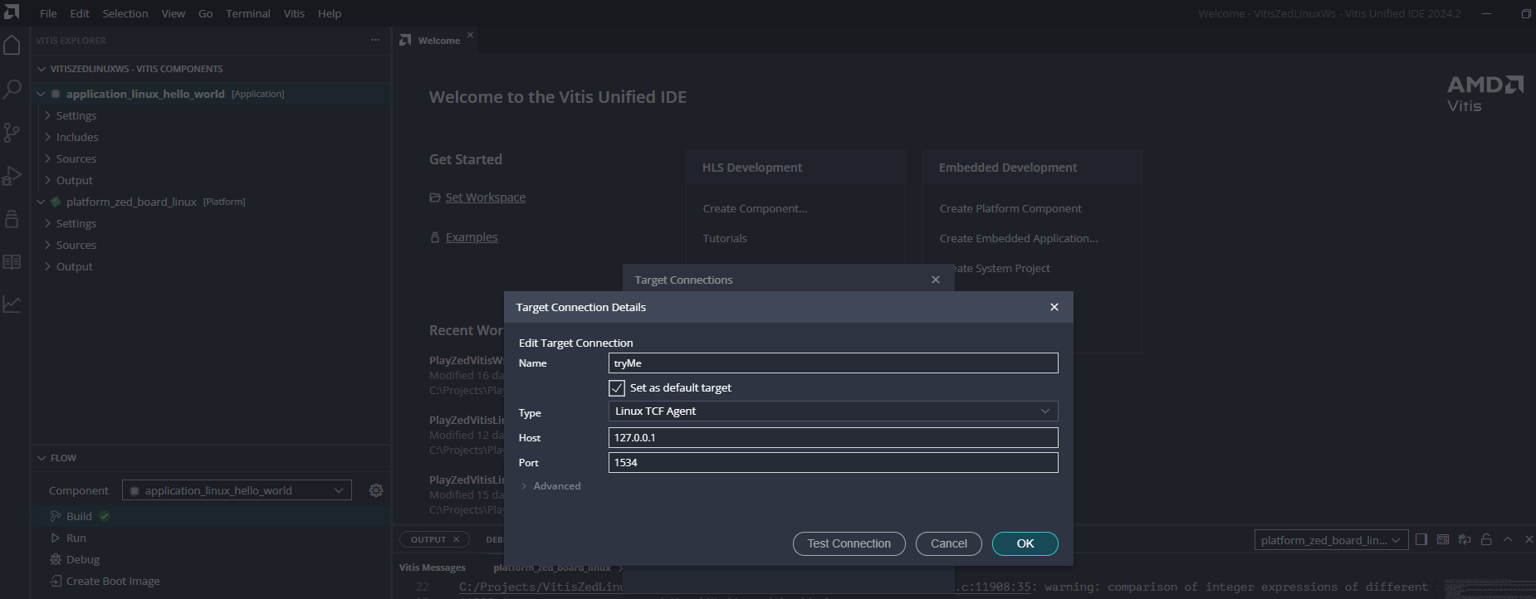
- However, after following all the appropriate steps, Vitis fails to connect to the QEMU session:

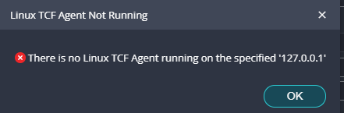
Our setup:
- Vitis 2024.2 installed on Win11 PC
- WSL2 running Ubuntu 22.04 to install and use the petalinux-tools
- Petalinux 2024.2 installed on our Ubuntu 22.04 distro
  - Using petalinux tools to configure, build linux support for our ZedBoard
  - 'petalinux-configure' use arg for path to the ZedBoard XSA file (zed.xsa)
  - 'petalinux-config -c rootfs' to enable tcf-agent for TCF-based debugging
  - 'petalinux-build' once configured as required
  - 'petalinux-boot --qemu –kernel' with –qemu-args setting port fowarding for SSH/TCF.
    - Examples (that work?):
      - petalinux-boot --qemu --kernel --qemu-args "-net nic -net user,hostfwd=tcp::10022-:22" (SSH support), or
      - petalinux-boot --qemu --kernel --qemu-args "-net nic -net user,hostfwd=tcp::1534-:1534" (Linux TCF support), or
  - Testing if port forwarding is working:
    - While QEMU is running... (hmmm... still see 'connection' for below checks, after killing TCF in QEMU?!)
    - Win PowerShell: "Test-NetConnection -ComputerName localhost -Port 1534"
      - If TcpTestSucceeded status is True, then that's good!
    - Xilinx XSCT tool:

      - At 'xsct%' prompt: "connect -url tcp:localhost:1534"
        - Check if 'connectioned failed' or not.
      - Or, from command line (?): xsct.bat -eval "connect -url tcp:localhost:1534; targets;"
      - " connect -url tcp:localhost:1534 -verbose "
      - " targets "
    - In WSL2:
  - In QEMU:
    - " ps | grep tcf " (check if running tcf agent)
    - " netstat -an | grep 1534 " (check if listening on port)
    - Can manually launch tcf agent:
      - " tcf-agent & " (basic launch, puts in background)
      - " tcf-agent -l 7 [&] " (verbose launch, if fails should show reason)
      - " tcf-agent -l 7 -L- -d " ( launch with compatibility options)
      - " killall tcf-agent " ,or " kill -9 <pid of tcf-agent> " ( kill tcf so can restart)
      - " /usr/sbin/tcf-agent -d -L- -l0 & "
      - " /usr/sbin/tcf-agent -d -L- -lprotocol,tcflog " (logs to syslog, should see stderr, detailed protocol, traffic logging)
      - " iptables -L -n " (firewall deny rules? Iptables or nftables?)
      - " netstat -tuln | grep 1534 "
      - " ps aux | grep tcf-agent "
      - " telnet 127.0.0.1 1534 " (tcf-agent accepts connections locally?
- Checks from Win11 PC:
  - PowerShell: " dism /online /Enable-Feature /FeatureName:TelnetClient " (if telnet not enabled)
  - " telnet 127.0.0.1 1534 " (check if windows can connect to QEMU)
  - " telnet <qemu-ip> 1534 " ( instead of localhost, try the actual ip from 'ifconfig' or 'ip addr')
  - Run script in PS: Result of "Connected !" means the port is accepting connections.

$client = New-Object System.Net.Sockets.TcpClient
$client.Connect("127.0.0.1", 1534)
if ($client.Connected) {
"Connected!"
$client.Close()
} else {
"Failed to connect."
}

  - In PS:
    - Get-NetFirewallRule -DisplayName "*1534*" (check if FW blocking)
    - Set-NetFirewallProfile -Profile Domain,Public,Private -Enabled False (temporarily disable FW)
    - Set-NetFirewallProfile -Profile Domain,Public,Private -Enabled True (re-enable FW)
- Checks from Ubuntu running in WSL:
  - " nc 127.0.0.1 1534 " (blank screen is a success)
  - " ss -ltnp | grep 1534 " (should see 'QEMU binding 1534')
  - " ps -ef | grep qemu | grep 1534 "
    - Should see " hostfwd=tcp::1534-:1534 " as part of output.(should see only one – avoid multiple qemu -net options!)

