Nahid: Followed this youtube (https://www.youtube.com/watch?v=a-jD66901-I), and connected to ZedBoard using Vitis unified 2024.2...

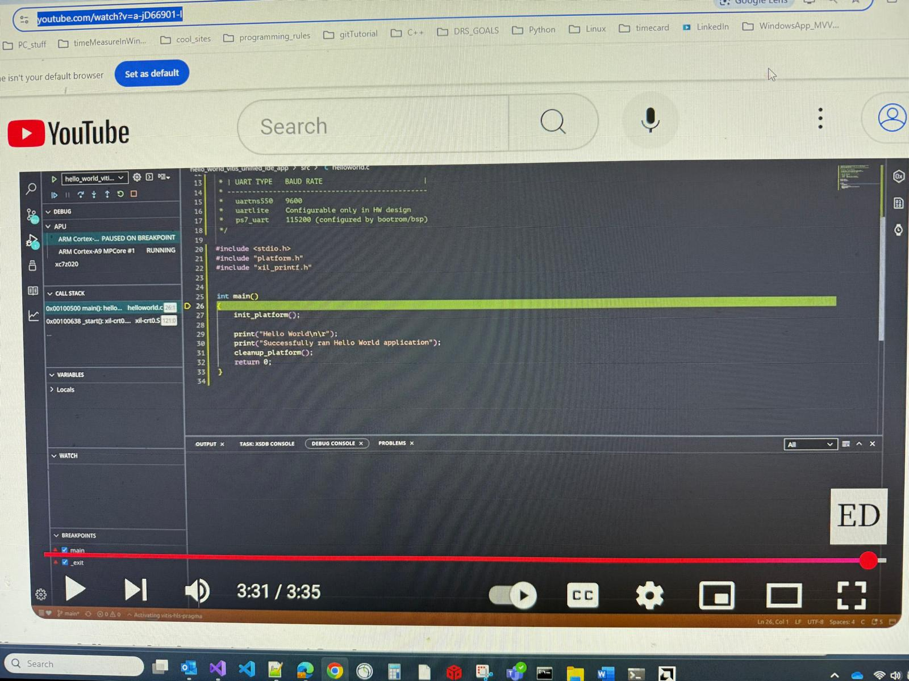

Nahid: My Vitis GUI:

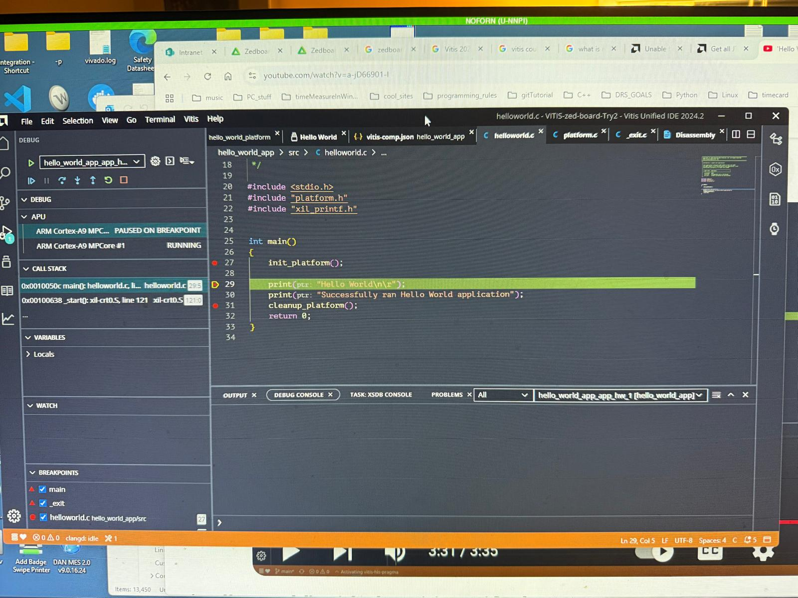

Nahid: Stepping...

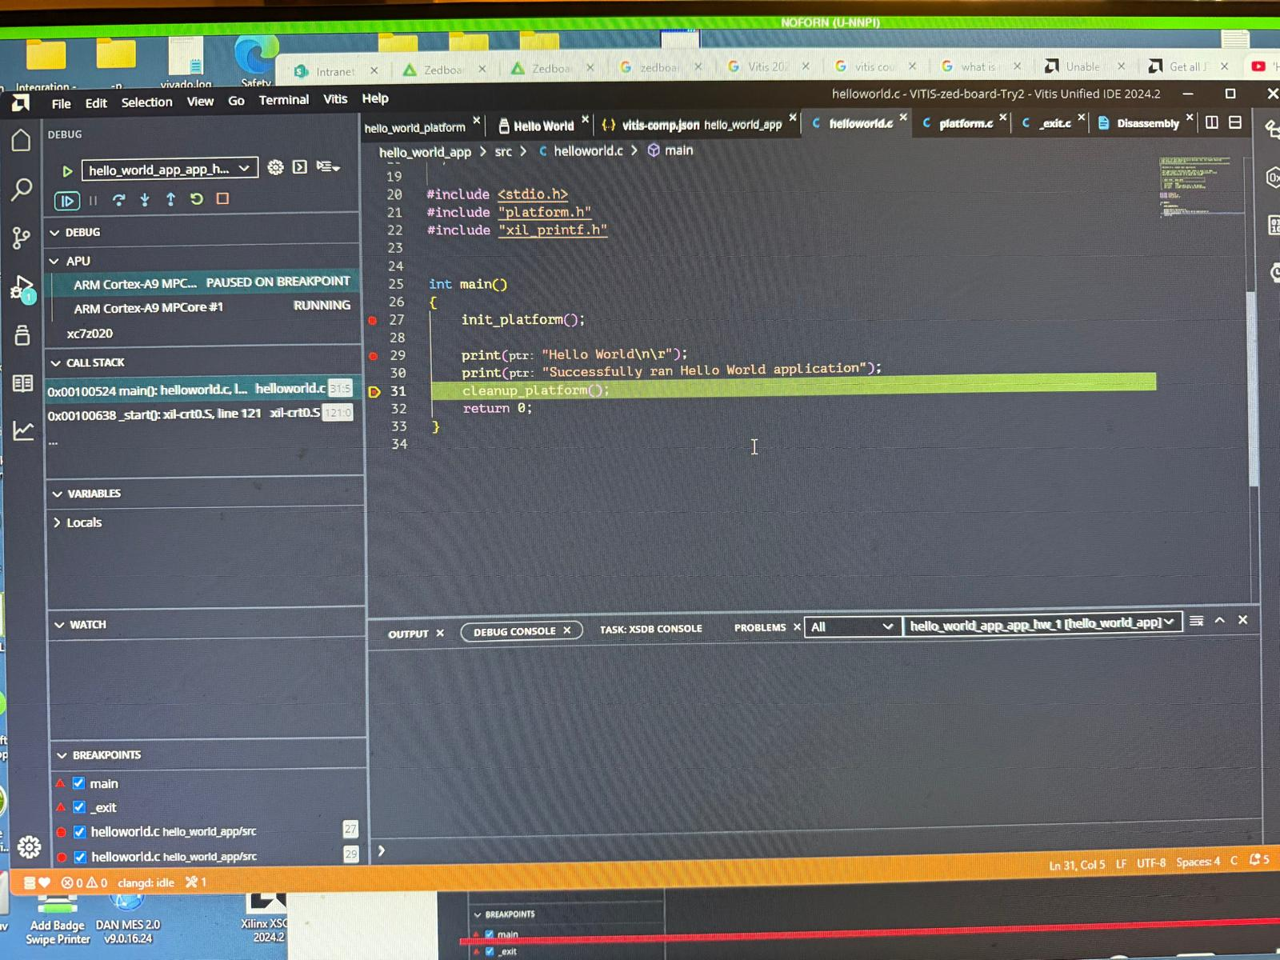

Nahid: I did not see output… the person in YouTube didn’t either. We both may need putty.

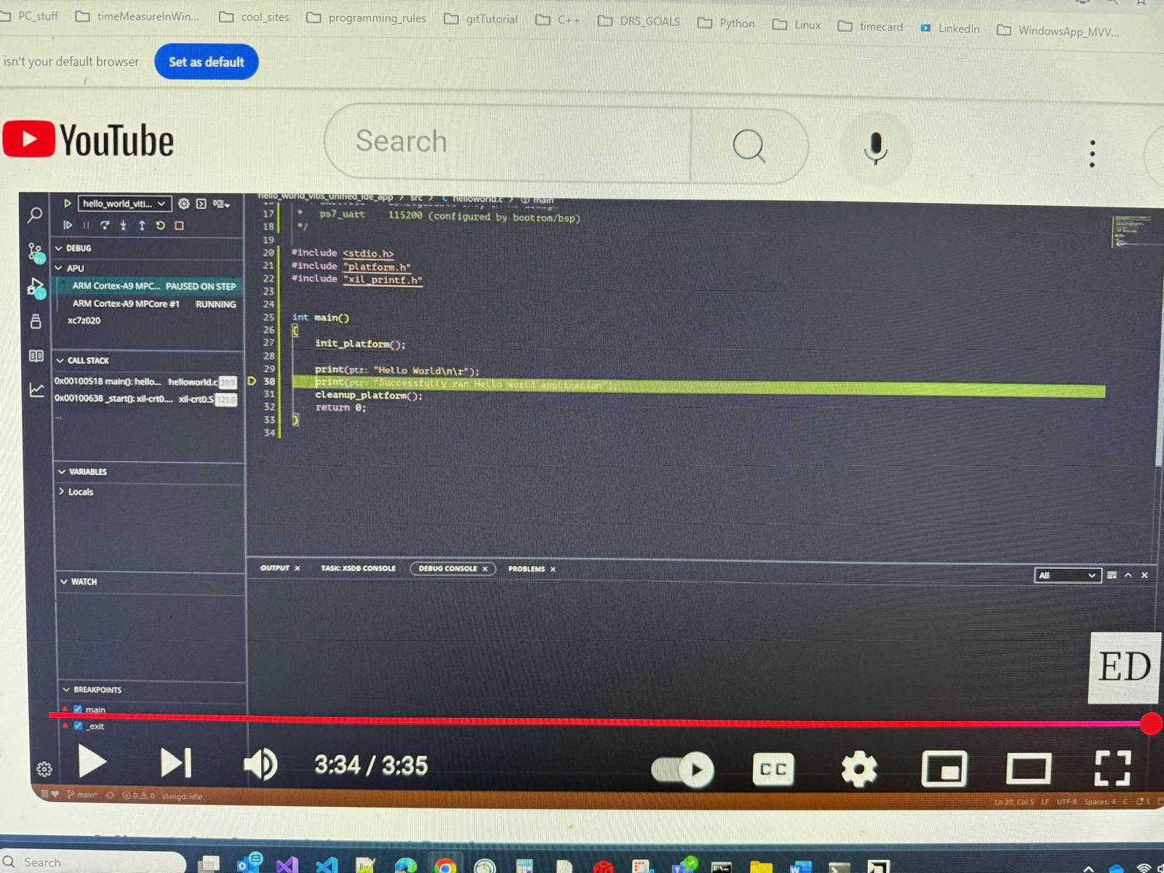

Nahid: So, here's the print...

