

AVS-4000 User Manual
Date: 02/10/20
Revision 0

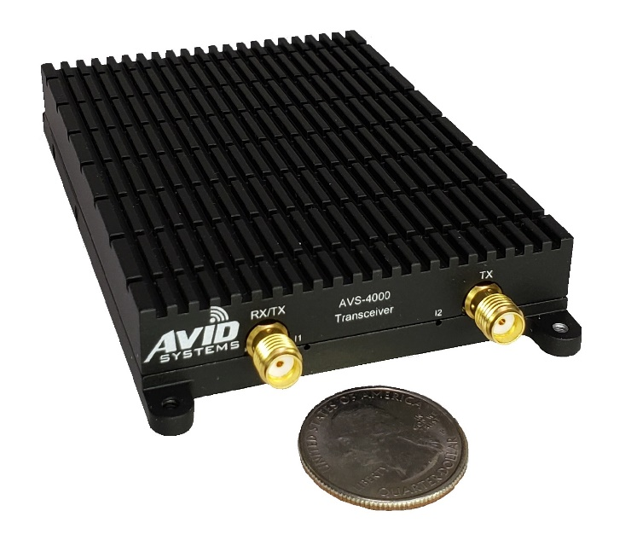

Revision History

Revision | Date | Author | Description
0.1 | 2/4/2020 | RAD | Initial Draft
0.3 | 2/10/2020 | WLC/RAD | Contains changes and descriptions of missing V49 fields.
0.4 | 5/14/2020 | DLW | Software Installation Instructions

Table of Contents
1.0 Introduction 4
2.0 Applicable Documents 5
3.0 System Specifications 5
4.0 System Overview 6
4.1 External Interfaces 9
4.1.1 Front Panel Interfaces 9
4.1.2 Rear Panel Interfaces 10
4.1.3 Side Panel GPIO/JTAG Connector 11
4.1.4 GPIO/JTAG Development Adapter (AVS-0019-001) 13
4.2 Reference and Time Base Description 15
4.3 RF Frontend Description 17
4.3.1 RF RX Details 17
4.3.2 RF TX Details 18
4.4 Digital Signal Path Description 19
4.4.1 RX DDC Description 19
4.4.2 TX DUC Description 20
4.4.3 Stream Control and Timestamping 21
4.4.4 Vita 49 Packet Format 21
4.5 Mechanical Information 23
5.0 AVS-4000 System Requirements 25
5.1 AVS-4000 Equipment Setup 25
5.2 Software Installation and Setup 25
5.2.2 Install QT 25
5.2.3 Install GNU Radio 25
5.2.1 Update the system 26
5.2.4 AVS-4000 Software Installation 26
5.2.6 AVS-4000 Software Installation without APT Repository 27
5.3 Initial System Test 28
6.0 Support Contact Information 31

1.0 Introduction
The AVS-4000 is a small USB Type C single channel transceiver that provides continuous frequency coverage from 2 MHz to 6 GHz. A USB 3.1 Gen1 interface with a USB Type C connector is utilized for both control and streaming of IQ samples via Vita 49 packets. The AVS-4000 has multiple reference inputs including a 10 MHz reference, 1PPS input, and an onboard GPS receiver. The radio is intended to provide low SWAP signal reception and transmission in a very small package with precision timing.

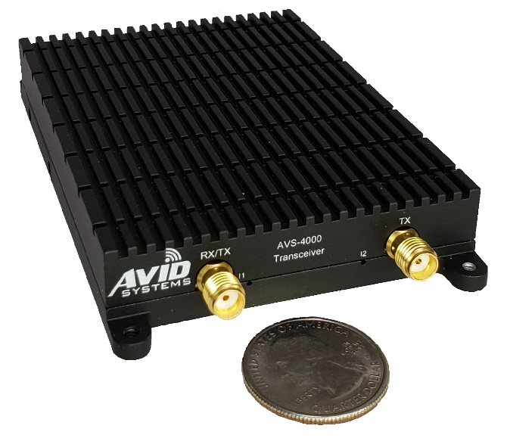
Figure 1: Front of AVS-4000

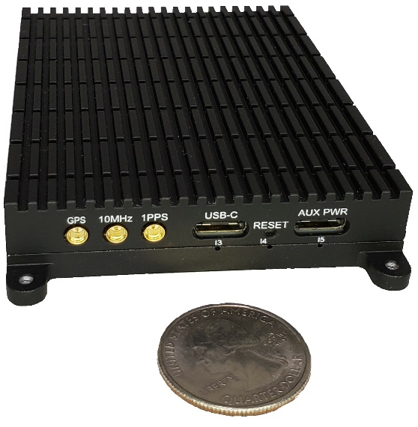
Figure 2: Rear of AVS-4000

2.0 Applicable Documents
- AVS-4000 Control API Document (AVS4000-API.pdf)

3.0 System Specifications
System Specification Table
RF Input and Output Impedance | 50Ω
Frequency Range | 2 MHz to 6GHz
RF Tuning Resolution | 1 Hz
Bandwidth | Up to 56 MHz  Selectable 50 MHz and 10 MHz SAW filtering in Low Band Conversion
RF RX Pre-Select Filtering | 5 Bands + Low Band Conversion Selectivity
RF TX Band Filtering | 5 Bands + Low Band Conversion
Typical RX Noise Figure | <6 dB
Typical RX IIP3 | -12dBm at Max RF Gain
Typical TX Output Power | +10dBM < 2GHz  +6dBm > 2GHz
RX Sample Rate Range | 1 Ksps to 61.44 Msps
TX Sample Rate Range | 1 Ksps to 61.44 Msps
A/D and D/A Converter Width | 12-bits
AVS-4000 Sample Width | 16-bits
FPGA Digital Tuning Resolution (DDC and DUC) | < 0.1 Hz
FPGA DDC Decimation Rates | [1, 2, 4, [8:2:2048], [2052:4:4096], [4104:8:8192]]
FPGA DUC Interpolation Rates | [1, 2, 4, [8:2:2048], [2052:4:4096], [4104:8:8192]]
Timestamp Resolution | 1/2 of the Master Sample Rate Period (AD9364 Sample Rate) typically 12.5 ns
Reference | 10MHz Reference Input: (AC Coupled) +2dBm to +15dBm  1PPS Input: 0VDC to 5VDC Max with VIH = 1.8VDC  GPS Antenna Input: +3.3VDC Output @30mA
Weight | 4.5 ounces
Dimensions | 4.20” x 2.64” x 0.62”

Table #1 – Systems Specifications

4.0 System Overview
The AVS-4000 is a small single channel USB Type C radio transceiver that is capable of providing frequency coverage from 1MHz to 6 GHz. The radio is designed around the AD9364 RF to bits transceiver and offers extremely fine RF frequency and sample rate steps due to fractional-N synthesizers in the system. A Xilinx Artix 100T FPGA performs RX down-conversion and filtering using a digital down converter (DDC) and TX up-conversion and filtering using a digital up converter (DUC). Backend circuitry performs timestamp application, packetizes the RX samples, and de-packetizes the TX samples. The FPGA also contains a high-resolution time base that can be loaded using one of the timing references in the system. The reference section of the radio has an external 10MHz input, a one pulse-per-second input, and an integrated GPS receiver that provides a 1-PPS output to the FPGA. The transceiver has provisions for synchronization of the radio and local time base. The software and firmware support tightly controlled RX stream and TX stream start-up. The combination of these features and many reference options provide for deterministic delays from start-up to start-up. The AVS-4000 also applies a high-resolution timestamp that compensates for filter delays and processing of the received samples. These features allow the AVS-4000 to be used in multi-radio distributed receiver systems as well as beamforming, TDOA, FDOA, and co-operative mesh networking scenarios. These scenarios are situations where other radios in this class would not be applicable.

The following figure is a high-level block diagram of the AVS-4000. This diagram depicts the data flow in the RX and TX paths and highlights the major sections of the transceiver. The following sections of the manual provide additional details of the design and are applicable to the use of the radio.

Figure 3: Block Diagram of AVS-4000

In the RF receive path, there are two major paths that can be utilized. The typical path contains a bank of 5 pre-select filters for operation from 70 Mhz to 6 GHz and are directly input to the AD9364. The second path is the low band extension path that extends the RF frequency of the radio down to 2 MHz. The frequency extension path mixes the RF signal up to a higher IF frequency that is within the operational range of the AD9364. The low band frequency extension path contains two selectable SAW filters that have band widths of 50 MHz and 10 MHz; these filters provide a wideband option as well as a higher selectivity option when the 10 MHz filter is selected. Both paths feed RX inputs of the AD9364. A series of switches allow the RX/TX connector to be used as a single RX input or function as both RX and TX. This functionality is used when the AVS-4000 is operating in a TDD scenario.

In the RF transmit path there are two paths out of the AD9364. The first path bypasses the TX low band frequency extension and outputs signals directly out of the AD9364 in the frequency range of 70 MHz to 6 GHz. For low frequency operation down to 1 MHz, the TX low band frequency extension can be utilized. In this mode, the AD9364 outputs the signal at a higher frequency IF. The signal is then mixed down to achieve output frequencies as low as 1MHz. Both paths have the option to select the use of an RF transmit amplifier when additional output power is required. All TX signals traverse the TX filter bank to filter harmonics.

For its size, the AVS-4000 has a robust reference section. The radio has three inputs that can be used as frequency and/or timing references. The radio is capable of disciplining the local TCXO to either an external PPS or the PPS generated by the integrated GPS receiver. The radio also has a traditional external 10MHz reference input and PLL that can lock the transceivers local oscillator to a user provided reference. In all reference modes, the user can use the external PPS, GPS PPS, or an internal PPS generated in the FPGA as the timing reference for the system.

The AD9364 is a complete RF to bits transceiver. In the receive path, the transceiver down-converts the RF input to baseband, digitizes the down-converted signal, performs various corrections to the samples, and then applies a series of filters to reduce the sample rate and limit the bandwidth of the samples provided to the FPGA. An automatic gain control algorithm adjusts the gain throughout the receive chain to ensure optimal performance and output power.

In the transmit direction, to reciprocal operations are performed. The AD9364 receives samples from the FPGA. These samples are interpolated and filtered in a series of filters; quadrature compensation is applied to the samples output from the filter chain. The corrected samples are then converted to an analog signal by the D/A converter in the AD9364. The analog symbols are then upconverted onto the RF carrier and attenuation is applied as specified by the user.

In both cases, the transmit samples from the FPGA to the AD9364 and the receive samples from the AD9364 to the FPGA are transferred at the Master.SampleRate (AD9364 Rate) as defined in the AVS-4000 API. The FPGA is responsible for receiving RX samples, providing them to the DDC and packetizing the samples into Vita 49 packets with timestamps applied. The Vita 49 packets are then transferred from the FPGA to the memory of the FX3 USB 3.1 Gen1 controller which in turn transfers the Vita 49 packets to the host computer via the USB connection. The RX Vita 49 packets that are transferred to the host are known as the Egress data. The IQ samples in the Vita 49 packets are at the DDC decimated rate, this is called the Rx.SampleRate as defined in the AVS-4000 API. The DDC in the FPGA is capable of both tuning and decimating the input samples. Available decimations rates range from 2 to 8192. Not all rates in this range are supported (see table 1 in section 3 FPGA DDC Decimation Rates). The DDC decimation is equal to the ratio of Master.SampleRate over Rx.SampleRate. The DDC is also capable of applying gain at a couple of points in the down conversion process.

In the Ingress (TX) direction, the USB controller receives packets from the host. The FPGA pulls these packets out of memory buffers in the USB controller and de-packetizes the Vita 49 packets. The packet timestamps and IQ samples are buffered and then sent to the DUC, digital upconverter. The digital up converter (DUC) applies a series of interpolating filters, gain adjustment, and is capable of tuning the upconverted sample within the baseband bandwidth at the Master.SampleRate. The FPGA then transfers the output samples of the DUC to the AD9364.

The previous section provided a brief overview of the dataflow in the AVS-4000. Details of applicable sections will be discussed in further detail later in this document.

4.1 External Interfaces
The interfaces of the AVS-4000 reside on the front panel, rear panel, and behind a door along the bottom left edge. The front edge contains the RF connectors and LED indicators. The rear edge contains the USB 3.1 Gen1 Type-C connector, USB Type-C Aux Power Connector, LED Indicators, and all reference related inputs. Along the bottom left edge there is a removable door that exposes a connector that contains GPIO and JTAG signals.

4.1.1 Front Panel Interfaces
The front panel or edge of the AVS-4000 contains the two RF connectors and two LED indicators.
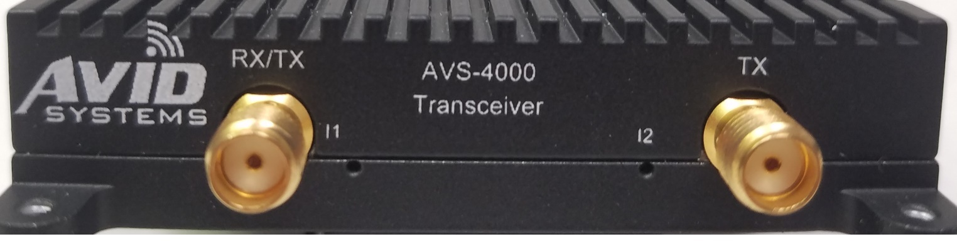
Figure 4: AVS-4000 Front Panel

Front Panel RF I/O
Label | Connector Type | Connector Polarity | Frequency Range | Direction | Description
RX/TX | Female SMA  50Ω | Standard | 5MHz-6GHz | Input and IO | RX Connector and can also be used for the TX output is TDD mode.
TX | Female SMA  50Ω | Standard | 5MHz-6GHz | Output | TX Connector
Table 1: Front Panel RF I/O Connectors
Front Panel LED Indicators
Label | LED Color | Description
I1 | GREEN | Software controlled indication that the RX Path is enabled and actively sending packets of samples.
I2 | YELLOW | Software controlled indication that the TX Path is enabled and actively receiving packets of samples.
Table 2: Front Panel LED Indicators

4.1.2 Rear Panel Interfaces
The rear panel or edge of the AVS-4000 contains the USB Type-C connector, USB Type-C AUX Power Connector, Reference Connectors, Reset button, and LED Indicators.
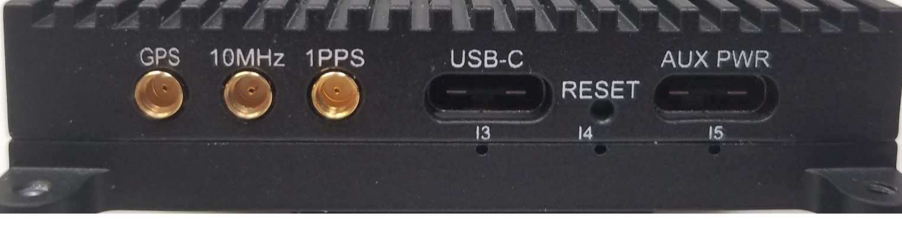
Figure 5: AVS-4000 Rear Panel

Rear Panel Reference Inputs
Label | Connector Type | Impedance | Input Range | Direction | Description
GPS | MMCX Female JACK | 50Ω | +3.3V Active Antenna @35mA | Input | The GPS input requires an active GPS antenna compatible with the 3.3V output of the AVS-4000. The AVS-4000 is capable of sourcing 35mA to the antenna.
10MHZ | MMCX Female JACK | 50Ω | 15dBm Max | Input | 10MHz reference input
1PPS | MMCX Female JACK | 3KΩ | 5V Max | Input | External reference. This input can be used to discipline the onboard TCXO to an external reference. It can also be used as an external timing reference only when the system in using an internal reference or external 10MHz reference.
Table 3: Rear Panel Reference Coaxial Connectors

Rear Panel USB Type-C Connectors
Label | Connector Type | VBUS Voltage | Description
USB-C | USB Type-C Receptacle | 5V | USB 3.1 Gen1 Interface connector. This connector shall be connected to the host and provides the only USB connection between the AVS-4000 and the host.
AUX PWR | USB Type-C Receptacle | 6V to 17V | This USB Type-C connector is for auxiliary power in the circumstance where a small single board computer is not capable of supplying the current required by the AVS-4000. This connector must be connected to a power adapter that sources between +6V and +17V on the VBUS pins in the standard USB Type C connector. When utilized, the power from this connector will provide the majority of power to the AVS-4000. Only a small amount of power will be drawn off of the connector with the USB-C label to power small portions of the USB interface. This input is capable of sourcing up to 3A of current to the AVS-4000. An optional USB Type C power adapter is available from Avid Systems. It is imperative that this adapter never be used with any other USB device due to the voltage on the connector.
Table 4: Rear USB Type-C Connectors

Rear Panel LED Indicators and Buttons
Label | LED Color | Description
I3 | Yellow | Indicates the selected PPS is active when blinking.
I4 | Blue | Indicates Power has been supplied to the board either from the USB-C connector or AUX PWR connector.
I5 | Green | Indicates the selected reference mode is locked when illuminated.
RESET | Button | This button can carefully be depressed to reset the AVS-4000 USB controller and all major circuitry.
Table 5: Rear LED Indicators and Button

4.1.3 Side Panel GPIO/JTAG Connector
When looking at the front of the AVS-4000 in an upright position, the unit has a hatch that is located on the left side along the bottom of the unit. Two 82° Flat Head size 0.060-80UNF black screws that are 0.125” long secure the hatch to the main housing of the unit. The location of this hatch is shown in the figure below.
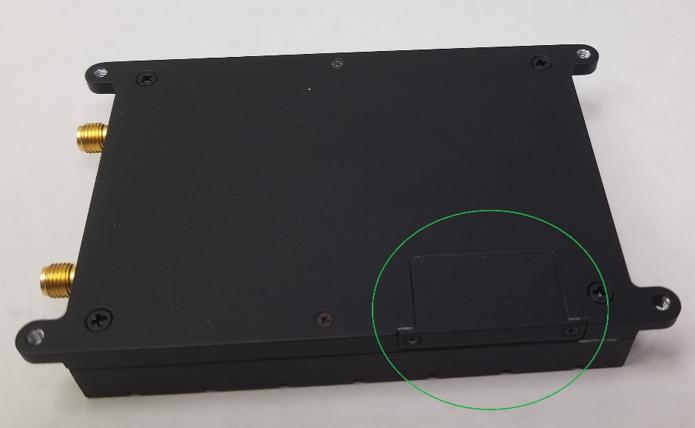
Figure 6: GPIO/JTAG Hatch and Screws
The screws can be carefully removed exposing the combined GPIO and JTAG connector of the unit.

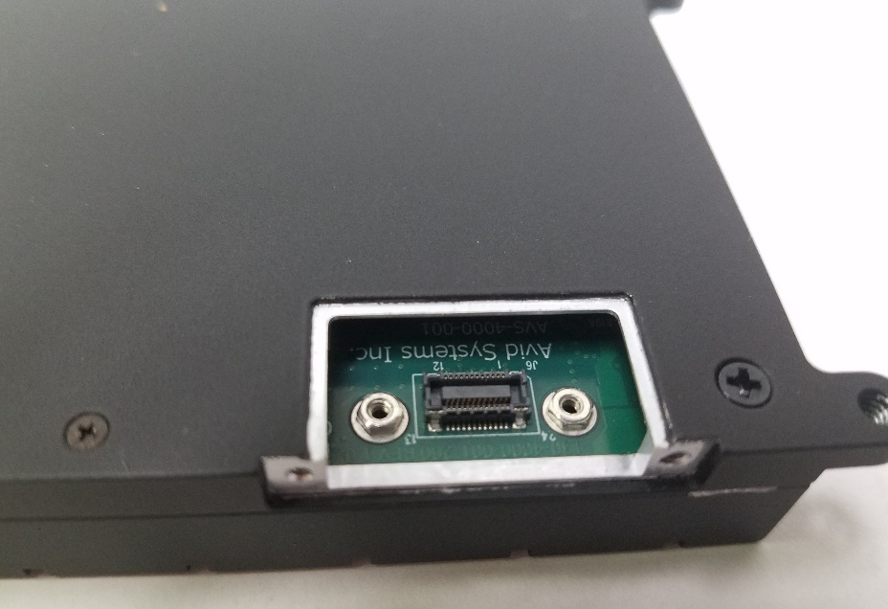
Figure 7: GPIO/JTAG Connector (J6)
The image shows connector J6 of the AVS-4000 exposed with the hatch removed. Attached to the PCB of the AVS-4000 and located next to J6 are two Penn Engineering SMTSO-M1.6-1-ET surface mount standoffs. These standoffs can be used to secure an adapter, flex cable, rugged connector adapter and housing, or custom solution to the AVS-4000. J6 is a 24-Pin Molex connector, part number 5009130242. The mating connector for this connector is 0559092474. The pinout of J6 is detailed in the table below. Care must be taken when using this connector because it houses two different voltages and IO at two different voltages. All JTAG related signals operate on a +2.5V rail. All GPIO operate on a +3.3V rail. The USB Controller JTAG and Debugger interface is not currently supported for customer use. The FPGA JTAG interface is a standard Xilinx JTAG interface. The GPIO interface within the connector can be used to control, monitor, and communicate with external devices in a system. These GPIO are controlled via software and have the ability to operate as an input, output, open-drain output, or be tri-stated. This provides the capability to utilize the GPIO in a multitude of different user applications within a system.

JTAG/GPIO Connector (J6) Pinout
Pin | Signal Name | DIR/ PWR | Voltage | Definition
1 | +2p5V_USB | PWR | +2.5V | +2.5V Power Rail (FX3 and FPGA JTAG)
2 | USB_TRST_N | I | +2.5V | Active Low TRSTn within FX3 JTAG/DBG Interface
3 | USB_TMS | I | +2.5V | Active High TMS within FX3 JTAG/DBG Interface
4 | USB_TDO | O | +2.5V | Active High TDO within FX3 JTAG/DBG Interface
5 | GND | PWR | 0V | Ground
6 | FPGA_TMS | I | +2.5V | Active High TMS within the FPGA JTAG Interface
7 | FPGA_TDO | O | +2.5V | Active High TDO within the FPGA JTAG Interface
8 | +3p3V | PWR | +3.3V | +3.3V Power Rail (GPIO). Capable of sourcing up to 150mA of current.
9 | GPIO0 | IO | +3.3V | GPIO[0], this pin can be used as an input, output, or open-drain output through software.
10 | GPIO1 | IO | +3.3V | GPIO[1], this pin can be used as an input, output, or open-drain output through software.
11 | GPIO2 | IO | +3.3V | GPIO[2], this pin can be used as an input, output, or open-drain output through software.
12 | GPIO3 | IO | +3.3V | GPIO[3], this pin can be used as an input, output, or open-drain output through software.
13 | GPIO7 | IO | +3.3V | GPIO[4], this pin can be used as an input, output, or open-drain output through software.
14 | GPIO6 | IO | +3.3V | GPIO[5], this pin can be used as an input, output, or open-drain output through software.
15 | GPIO5 | IO | +3.3V | GPIO[6], this pin can be used as an input, output, or open-drain output through software.
16 | GPIO4 | IO | +3.3V | GPIO[7], this pin can be used as an input, output, or open-drain output through software.
17 | GND | PWR | 0V | Ground
18 | FPGA_TDI | I | +2.5V | Active High TDI within the FPGA JTAG Interface
19 | FPGA_TCK | I | +2.5V | Active High TCK within the FPGA JTAG Interface
20 | GND | PWR | 0V | Ground
21 | USB_N_SRST | I | +2.5V | Active Low Reset within FX3 DBG Interface
22 | USB_TCK | I | +2.5V | Active High TCK within FX3 JTAG/DBG Interface
23 | USB_TDI | I | +2.5V | Active High TDI within FX3 JTAG/DBG Interface
24 | +2p5V_USB | PWR | +2.5V | +2.5V Power Rail (FX3 and FPGA JTAG)
Table 6: AVS-4000 JTAG/GPIO Connector (J6) Pinout

4.1.4 GPIO/JTAG Development Adapter (AVS-0019-001)
Avid Systems has developed an optional development adapter, the AVS-0019-001 that provides access to the interfaces within the GPIO/JTAG connector for development on the AVS-4000. In addition to this adapter, Avid Systems can provide other rugged connector and cable options.

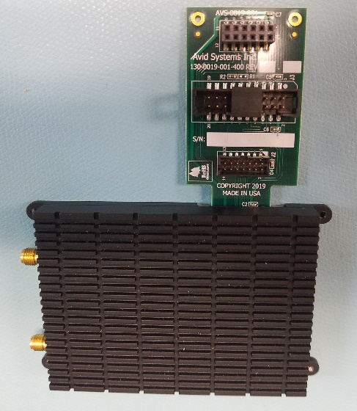
Figure 8: AVS-0019 JTAG/GPIO Adapter Connected to a AVS-4000

The tables below provide the pinout for each connector on the AVS-0019 adapter board. J1 on the adapter board mates with J6 of the AVS-4000. Connector J2 on the adapter provides a standard Xilinx JTAG connector in the standard pinout, Molex 878321420. Connector J3 on the adapter provides a J-link JTAG and debug interface to the Cypress FX3 USB Controller on the AVS-4000. This interface is not expected to be required by Users and is for factory use only. Connector J4 provides access to the GPIO of the AVS-4000. The +3.3V pin on J4 is capable of sourcing up to 150mA of current from the AVS-4000.

AVS-0019 Xilinx JTAG Connector (J2) Pinout
Pin | Signal Name | DIR/ PWR | Voltage | Definition
1 | GND | PWR | 0V | Ground
2 | +2p5V_USB | PWR | +2.5V | +2.5V Voltage Reference for Xilinx JTAG Cable.
3 | GND | PWR | 0V | Ground
4 | FPGA_TMS | I | +2.5V | JTAG TMS Input
5 | GND | PWR | 0V | Ground
6 | FPGA_TCK | I | +2.5V | JTAG TCK Input
7 | GND | PWR | 0V | Ground
8 | FPGA_TDO | O | +2.5V | JTAG TDO Output
9 | GND | PWR | 0V | Ground
10 | FPGA_TDI | I | +2.5V | JTAG TDI Input
11 | GND | PWR | 0V | Ground
12 | NC |  |  | No-Connect
13 | GND | PWR | 0V | Ground
14 | NC |  |  | No-Connect
Figure 9: AVS-0019 Xilinx JTAG Connector (J2) Pinout

AVS-0019 FX3 Debug Connector (J3) Pinout
Pin | Signal Name | DIR/ PWR | Voltage | Definition
1 | +2p5V_USB | PWR | +2.5V | +2.5V reference voltage
2 | +2p5V_USB | PWR | +2.5V | +2.5V reference voltage
3 | USB_TRST_N | I | +2.5V | Active Low JTAG Test Reset Input
4 | GND | PWR | 0V | Ground
5 | USB_TDI | I | +2.5V | JTAG TDI Input
6 | GND | PWR | 0V | Ground
7 | USB_TMS | I | +2.5V | JTAG TMS Input.
8 | GND | PWR | 0V | Ground
9 | USB_TCK | I | +2.5V | JTAG TCK Clock Input.
10 | GND | PWR | 0V | Ground
11 | USB_RTCK | O | +2.5V | Return Clock Output. Currently tied to GND.
12 | GND | PWR | 0V | Ground
13 | USB_TDO | O | +2.5V | JTAG TDO Output
14 | GND | PWR | 0V | Ground
15 | USB_N_SRST | I | +2.5V | Active Low Debug Reset Input
16 | GND | PWR | 0V | Ground
17 | NC | No Connect |  | Not Connected
18 | GND | PWR | 0V | Ground
19 | NC | No Connect |  | Not Connected
20 | GND | PWR | 0V | Ground
Figure 10: AVS-0019 FX3 Debug Connector (J3) Pinout

AVS-0019 GPIO Connector (J4) Pinout
Pin | Signal Name | DIR/ PWR | Voltage | Definition
1 | +3p3V | PWR | +3.3V | +3.3V power output
2 | NC | No Connect |  | Not Connected
3 | GPIO0 | IO | +3.3V | GPIO Signal Index0 (Output, Input, Tri-State)
4 | GPIO4 | IO | +3.3V | GPIO Signal Index4 (Output, Input, Tri-State)
5 | GPIO1 | IO | +3.3V | GPIO Signal Index1 (Output, Input, Tri-State)
6 | GPIO5 | IO | +3.3V | GPIO Signal Index5 (Output, Input, Tri-State)
7 | GPIO2 | IO | +3.3V | GPIO Signal Index2 (Output, Input, Tri-State)
8 | GPIO6 | IO | +3.3V | GPIO Signal Index6 (Output, Input, Tri-State)
9 | GPIO3 | IO | +3.3V | GPIO Signal Index3 (Output, Input, Tri-State)
10 | GPIO7 | IO | +3.3V | GPIO Signal Index7 (Output, Input, Tri-State)
11 | GND | PWR | 0V | Ground
12 | NC | No Connect |  | Not Connected
Figure 11: AVS-0019 FX3 Debug Connector (J3) Pinout

4.2 Reference and Time Base Description
The AVS-4000 reference circuit provides three inputs that can be used as external references for the transceiver. The diagram below is a simplified representation of the reference circuit on the AVS-4000.
Figure 12: AVS-4000 Reference Circuit
The AVS-4000 has five main reference modes that can be selected via the API. These include Internal, Internal Static, External, GPSDO, and PPS (PPSDO). They are described in the table below. Each mode has a default timing (PPS) selection that determines the source of the PPS that is used internally in the FPGA as a timing reference and marker.

Reference Mode Overview
REF MODE | Description
Internal | This mode fixes the control voltage of the TCXO to the center of the tuning range. The default timing reference PPS selection for this mode is the internally generated PPS. Generally used when no external reference is present.
Internal Static (Static Frequency Control) | This mode initially fixes the control voltage of the TCXO to a default factory setting. This mode allows the user or controlling application to tune the frequency of the TCXO using the PWMInc API command. The default timing reference PPS selection for this mode is the internally generated PPS.
External | This mode allows the PLL to control the control voltage of the TCXO and locks the TCXO to the external 10 MHz reference from the MMCX connector labeled 10MHz. The default timing reference for this mode is the internal PPS. For optimal timing and close synchronization of multiple boards, it is expected that the timing reference (PPS selection) for this mode will be changed to the external PPS after a PPS has been connected.
GPSDO | This mode locks the transceiver in phase a frequency to the PPS provided by the integrated GPS receiver. In this mode, the default timing reference is the internally generated PPS that is trained to be aligned with the PPS from the GPS module. It isn’t recommended that the timing reference would be changed in this mode. For this mode a compatible antenna must be connected to the MMCX input connector labeled GPS.
PPS (PPSDO) | This mode locks the transceiver in phase a frequency to the External PPS from the MMCX input connector labeled 1PPS. A valid PPS must be connected and active prior to enabling this mode. In this mode, the default timing reference is the internally generated PPS that is trained to be aligned with the External PPS input. It isn’t recommended that the timing reference would be changed in this mode.

As mentioned, the API provides the ability to select the timing reference. This selects the PPS that is used by internal circuitry. The API provides the user the ability to select the timing reference. This is envisioned to be used primarily in Internal, Internal Static, and External reference modes when a user has connected an active 1-PPS signal to the 1PPS MMCX input. The selection of External 10MHz reference with a phase aligned 1-PPS External Input will provide users the most reliable method of synchronizing multiple transceivers in a system.

Using the REF group of the API, the user is able to synchronize and set the local time base of the AVS-4000. This allows the user to specify the UTC and load the time base with the specified integer second portion of the correct UTC on the internal PPS timing reference, the user has selected. This time base operates at a 2-times the frequency of the Master.SampleRate set in the system. This is equivalent to 2-times the AD9364 RX and TX sample rate. This provides a high-resolution time base that is used to control transceiver operations. The resolution of this time base also provides the ability to provide high resolution timestamping.

4.3 RF Frontend Description
This section contains two sub-sections that provide some details regarding the receive and transmit portions of the RF frontend. The RF frontend has two external connectors. In TDD mode both receive and transmit can use one connector, the RX/TX SMA is used for this purpose. In RX only mode or FDD mode, the input RF signal is connected to the SMA connector labeled RX/TX. The TX SMA connector is used as the output for the transmit signal. The AVS-4000 API provides the control to select these modes. The AVS-4000 API also provides transmit and receive control in TDD operations. For extremely tight timing requirements, contact Avid Systems for T/R switch control embedded in the control data stream.

4.3.1 RF RX Details
The RF receive block performs the pre-selection filtering and contains the RX low band frequency extension. The RF RX path can receive signals from 6GHz down to 2 MHz. The low band frequency extension contains a low pass filter to limit the spectral content into the up-converting mixer. The output of the mixer contains a selectable SAW IF filter bank. The filters in the bank have 50MHz and 10MHz bandwidths. The AD9364 performs the IF to baseband conversion of the up-converted signal. The low band LO is generated using a fractional-N synthesizer for very fine frequency steps when tuning the LO.
The high band RF path is directly connected to the AD9364 through a switched filter bank that contains 5 bands.
Figure 13: RX RF Frontend Block
The API RX group provides the user the ability to control and manage this portion of the transceiver. By default, the API will automatically configure the radio in a manner that provides optimum performance at the desired frequency. The API also provides users the ability to manually select parameters in frequency ranges where there are multiple options so they can use the radio in a configuration that provides the best performance for their application.

4.3.2 RF TX Details
The transmit portion of the RF frontend extends the transmit frequency down to 2MHz. The path also contains an optional amplifier path that provides 15dB of additional gain. The TX path also contains a 5-band filter bank to filter undesired out of band spurious content.

Figure 14: RF TX Path Block Diagram
The API TX group provides the user the ability to control and manage the transmit portion of the transceiver. By default, the API will automatically configure the radio in a manner that provides optimum performance at the desired frequency. The API also provides users the ability to manually select parameters so they can use the radio in a configuration that provides the best performance for their application. This includes the ability to switch in the gain block amplifier for additional output signal power.

4.4 Digital Signal Path Description
The AVS-4000 control software manages the configuration of the AD9364 and FPGA. The AD9364 houses the A/D and D/A converters. The API exposes control of the AD9364 to the user. However, the most flexible portion of the RX and TX baseband paths are in the FPGA. On the receive side, the FPGA contains a DDC, digital down-converter, that is capable of tuning the baseband signal and then filtering and decimating the received signal with a series of CIC, FIR, and Half-band filters. The DDC also provides fine gain control to allow the signal to be scaled optimally in the DDC for any peak-to-average power ratio signal that is received. The output of the DDCs is packetized in Vita 49 packets that contain VRT and VRL headers for resilient reception by the host.

In the transmit path, packets with the same Vita 49 structure are de-packetized and the quadrature IQ samples in each packet are buffered along with the corresponding timestamps. When a stream is started, these samples are feed into the DUC, digital up-converter. The DUC contains interpolating filters that are made up of a series of CIC, FIR, and Half-Band filters. After the filter chain, the DUC has a tuner that allows the signal to be tuned to any frequency within the currently programmed bandwidth of the AD9364. The DUC also has distributed fine gain control to support any type of signal the user might wish to transmit. Combined with the fractional-N baseband synthesizer of the AD9364, the integer decimation and interpolation in the DDC and DUC chains of the FPGA provide the user the ability to target a nearly infinite set of sample rates.

The next several sections will detail the structure of the DDC, DUC, and the Vita 49 packets used to transport samples so the user can easily and optimally use the radio and integrate it into the system they are developing.

4.4.1 RX DDC Description
The DDC, digital down converter, processes samples from the AD9364 receive chain. The sample rate at the input of the DDC is the AD9364 RX sample rate, API Master.SampleRate. The DDC outputs samples destined for the Vita 49 packetizer are at the API rx.SampleRate. The DDC is capable of tuning the signal within this bandwidth. Care should to be taken to ensure the signal of interest is not tuned outside the bandwidth of the decimated output sample rate. The tuner also provides the capability to invert the spectrum of the signal. One of the filters in the DDC chain is the CIC. The CIC filter has a decimation range of 4 to 1024. A FIR filter called the CFIR accompanies the CIC anytime the CIC is enabled and compensates for the rolloff caused by the CIC across the output band. The CFIR has a fixed decimation of 2. The combination of the CIC and CFIR provide an overall decimation range of 8 to 2048. There are two half-band decimation filters that may be optionally used in the DDC processing chain. The half band filters can be used to provide an additional decimation of 2 and 4 when enabled. There are two points in the DDC chain where the user can adjust the gain for optimal performance. The user can adjust the DDC CICGAIN at the output of the CIC and the user can also control the DDC OGAIN at the output of the DDC. There are three points in the chain where the average quadrature magnitude and overflows are monitored. The average magnitude is measured at the input of the DDC, the output of the CIC after the gain has been adjusted, and at the output of the DDC. These measurements provide the user with bus loading information to ensure the proper gains are selected and monitors for overflows at all points in the DDC where overflow could possibly occur. Samples in the DDC are never allowed to overflow all overflows are caught and saturated through the entire chain.

Figure 15: DDC Block Diagram
From the diagram above, the user can determine all of the possible rates that the DDC can support. These rates are [1, 2, 4, [8:2:2048], [2052:4:4096], [4104:8:8192]]. The notation [x:INC:y] represents the set from x to y in steps of INC.

4.4.2 TX DUC Description
The function of the DUC, digital up converter, is very similar to that of the DDC with the exception that this chain interpolates instead of decimating. The Vita 49 de-packetizer presents quadrature samples to the DUC input and the output samples of the DUC are sent to the AD9364 TX chain. The CFIR and CIC are the first filters in the chain. The DUC CFIR interpolates by 2 and the CIC is capable of interpolating by 4 to 1024. This represents a total combined interpolation of 8 to 2048. The two interpolating half-band filters each interpolate by two. Just like the DDC, the average quadrature magnitude and overflow status is monitored and reported for three points in the chain, the input, the output of the CIC gain module, and at the output of the DUC prior to samples begin transferred to the AD9364. These points allow the user to monitor the input of the DUC and other placed in the DUC chain that samples can overflow due to user selected gain.
Figure 16: DUC Block Diagram
In reality, samples in the DUC are never permitted to overflow. Just like in the DDC, samples are saturated where overflows would have occurred. The overall interpolation rates supported by the DUC are [1, 2, 4, [8:2:2048], [2052:4:4096], [4104:8:8192]]. The notation [x:INC:y] represents the set from x to y in steps of INC.

4.4.3 Stream Control and Timestamping
RX and TX streams in the system can be started in several ways using the API. Using parameters in the RX and TX groups of the API, the user is able to start the data stream immediately, on the next PPS rising-edge, on the rollover of the fractional second (Integer Second increment) of the AVS-4000 time base, or at a specific time in the future. In the TX direction, the system is able to use the Vita 49 Timestamp in the first packet from the host to start the stream to give the application inline control of the transmit start time.

As mentioned in the reference section, the system has the ability to align the local time base to the internal timing reference, PPS, selected in the system. The time base has a resolution equivalent to the period of a clock that is running at 2 times the Master.SampleRate. For example, if the Master.SampleRate is set to 50 Msps, the time base will have a resolution of 10ns. This time base is used to apply timestamps to RX samples in the system. The firmware and software of the AVS-4000 compensate for delays in the RX path to provide accurate timestamping that compensate for implementation latencies and filter group delays to a Master.SampleRate cycle. When the radio is properly synchronized and started using the timing reference or synchronized time base, the timestamps remain accurate and repeatable from power cycle to power cycle.

4.4.4 Vita 49 Packet Format
Vita 49 Packets are employed as the transport mechanism between the AVS-4000 and the host. The AVS4000D daemon controls the radio and serves as a driver. The AVS4000d software provides the user with the option to receive raw I and Q samples that have been extracted from the Vita 49 packets or transmit raw IQ samples that will be placed into a Vita 49 packet before the samples are sent to the radio. As a second option, when timestamping is required, the user can select to transfer complete Vita 49 packets and extract both samples and timestamps as required. The diagram below depicts the fields of the Vita 49 framing and packet.
Figure 17: AVS-4000 Vita Packet Structure

The next couple of tables will briefly describe the fields within the VRL frame header/trailer and the VRT packet header.

V49.1 VRL Field | Length (Bits) | Description
Vita 49.1 Frame Alignment Word (FAW) | 32 | This field is defined as the ASCII representation of “VLRP” (“56 4C 52 50”). The main advantage of the VRL is that this field allows Vita packets of the AVS-4000 to be transferred in a system without additional framing.
Vita 49.1 Frame Count | 12 | This 12-bit field contains a running frame count. That allows the receiving system to determine if the transporting medium dropped any frames.
Vita 49.1 Frame Size | 20 | This 20-bit frame size field reports the length of the entire VRL frame in terms of 32-bit words. Currently, this field is always 0x800.
Vita 49.1 Frame End Word (Trailer) | 30 | This word is the last word in each frame can be used during parsing of the stream to determine the end of the frame. This field always contains the ASCII representation of “VEND” (“56 45 4E 44 0A”).
Figure 18: Vita 49.1 VRL Header and Trailer Fields

V49.0 VRT Field | Length (Bits) | Description
Pkt Type (Header Word) | 4 | The packet type is always “0001” indicating IF Data Packet with Stream Identifier.
C (Header Word) | 1 | The C field is “0” since Class Identifiers are not used or supported
T (Header Word) | 1 | The T field is “0” since a VRT (packet) trailer is not used or supported
RR (Header Word) | 2 | These bits are reserved and set to “00”.
TSI (Header Word) | 2 | This value is always “01” to indicate that packets to and from the AVS-4000 contain and expect the integer portion of UTC time.
TSF (Header Word) | 2 | This value is always “01” to indicate that the timestamp contained in the packets to and from the AVS-4000 contain and expect as sample count timestamp based on 2*Master.SampleRate. Over the period of a second the count will contain values of 0 to 2*Master.SampleRate – 1.
Pkt Count (Header Word) |  | This field contains the packet count that constantly increments.
Pkt Size (Header Word) |  | This field contains the packet sizer in terms of 32-bit words. This value is always 0x7FD or 2045 words.
Class Identifier | 64 | This optional field is not currently supported by the AVS-4000.
Stream Identifier | 32 | The stream identifier for the RX stream is fixed at 0 and the stream identifier for the TX stream can be set to any value specified by the user application.
Integer-Seconds Timestamp | 32 | In the AVS-4000 this is always the integer second portion of UTC time.
Fractional-Seconds Timestamp (MSW) | 32 | This word of the fractional timestamp is always a value of 0 since there is not a timestamp in the system that increments beyond 32-bits.
Fractional-Seconds Timestamp (LSW) | 32 | In the AVS-4000 this fractional timestamp is a count from 0 to (2*Master.SampleRate – 1)
Payload | 32 | Each packet contains 2040 quadrature samples each represented by a 16-bit I value in the upper half of the word and a 16-bit Q value in the lower half of the word.
V49.0 VRT Trailer | 32 | As indicated in the description of the T field of the header word, this field is not supported by the AVS-4000.
Table 7: VRT Packet Fields

Because this radio is USB and expected to be directly controlled by the application consuming packets, the radio does not provide Vita 49 context packets over the wire. However, upon request the ability to provide context packets can be provided.

4.5 Mechanical Information
The AVS-4000 is 4.20” L x 2.64” W x 0.62” H. The unit has mounting holes at each corner to allow for mechanical integration. The four mounting holes are labeled A are threaded holes that accept a #4-40 screw. The dimension drawing below contains the information required to mount the unit into a customer system. Additional drawings are available to customers upon request.
Table 8: AVS-4000 Dimensioned Mounting Drawing
The following drawings provide the mechanical centers of the connectors along the front and rear panels.
Table 9: Front Panel Connector Locations
Table 10: Rear Panel Connector Locations

5.0 AVS-4000 System Requirements
- OS – Ubuntu 18.04 LTS (64-bit)
- QT 5.9.5

5.1 AVS-4000 Equipment Setup
This section describes the initial setup of the system. The base AVS-4000 Kit provides a USB 3.1 Type A to USB Type-C cable and an RF cable for loop back testing. Connect the USB Type-C end of the cable provided to the AVS-4000. Connect the USB 3.1 Type A end of the cable to the host. For the initial system test, connect the Male SMA to Male SMA cable between the RX/TX and TX SMA connectors of the AVS-4000. Proceed to the software installation.

5.2 Software Installation and Setup

5.2.1 Update System
Prior to installing the software the system should be updated using the following commands.

$ sudo apt-get update;sudo apt-get upgrade -y

5.2.2 AVS-4000 Software Installation

The AVS-4000 software can be installed from the Avid Systems APT Repository. This allows the software to be installed and updated using the Ubuntu APT package manager. This is the preferred method of software installation.
Add repository:
$ wget -O - http://repo.avid-systems.com/site.gpg.key | sudo apt-key add -
$ sudo -s eval 'echo "deb [arch=amd64] http://repo.avid-systems.com/ bionic main" >> /etc/apt/sources.list'

Install AVS-4000 Packages:
$ sudo apt-get update
$ sudo apt-get install avs4000 gr-avs4000
Reading package lists... Done
Building dependency tree
Reading state information... Done
The following additional packages will be installed:
libavs4000 libavsapi libavscommon libboost-filesystem1.65.1
libboost-program-options1.65.1 libdouble-conversion1 libgnuradio-pmt3.7.11
libgnuradio-runtime3.7.11 liblog4cpp5v5 libpython-stdlib libqt5core5a
libqt5dbus5 libqt5network5 libqt5qml5 libvolk1-bin libvolk1.3 python
python-minimal python2.7 python2.7-minimal qttranslations5-l10n
Suggested packages:
qt5-qmltooling-plugins libvolk1-dev python-doc python-tk python2.7-doc
binutils binfmt-support
The following NEW packages will be installed:
avs4000 gr-avs4000 libavs4000 libavsapi libavscommon
libboost-filesystem1.65.1 libboost-program-options1.65.1
libdouble-conversion1 libgnuradio-pmt3.7.11 libgnuradio-runtime3.7.11
liblog4cpp5v5 libpython-stdlib libqt5core5a libqt5dbus5 libqt5network5
libqt5qml5 libvolk1-bin libvolk1.3 python python-minimal python2.7
python2.7-minimal qttranslations5-l10n
0 upgraded, 23 newly installed, 0 to remove and 18 not upgraded.
Need to get 5,277 kB/11.1 MB of archives.
After this operation, 48.8 MB of additional disk space will be used.
Do you want to continue? [Y/n]
Answer Y to the above question to allow the packages to be installed.
Once the installation is complete, the AVS-4000 software, GNU Radio and all dependencies should be installed.

After the packages have been install, the following should be done before attempting to connect to an AVS-4000.
$ sudo cp /usr/share/doc/avs4000/90-usb-avs4000.rules /etc/udev/rules.d
$ sudo udevadm control --reload-rules && udevadm trigger

5.2.3 AVS-4000 Software Installation without APT Repository
In the event that installation from the APT repository is not possible, then the AVS-4000 software could be installed from local copies of the debian packages. The debian package could be distributed via installation media (CD-ROM, Flash Drive, etc...) or via email.
The following commands would be used to install the AVS-4000 debian packages:
#
# Install dependencies
#
$ sudo apt-get update
$ sudo apt-get install libboost-filesystem1.65.1 libboost-program-options1.65.1 \
libgnuradio-pmt3.7.11 libgnuradio-runtime3.7.11 \
liblog4cpp5v5 \
libpython-stdlib libvolk1-bin libvolk1.3 \
python python-minimal python2.7 python2.7-minimal

#
# Install AVS4000 Packages
#
$ sudo dpkg -i dist/*amd64.deb

#
# If no dependency errors occur, then installation is complete.
# if dependencies errors occur then run the following
#
$ sudo apt-get -f install
... answer yes to installing the additional packages ...

# re-install packages now that dependencies have been satisfied
$ sudo dpkg -i dist/*amd64.deb

5.2.3 Starting AVS-4000 Daemon
After the software is installed, the AVS-4000 Daemon just be launched prior to using the AVS-4000. This can be done by doing:
$ avs4000d
Starting avs4000d daemon...

Once the daemon is started, it will be launch processes in the background.
The daemon should not be run as root.
The following command can be used to stop the daemon:
$ avs4000d -k

5.2.4 Example Python Scripts
As part of the software installation, example python scripts are installed on the system. These scripts can be found in the directory: /usr/share/doc/avs4000/examples
There are examples of accessing the API (Application Programming Interace) via python.
The following command can be used to list the AVS-4000 devices connected to the system:
$ /usr/share/doc/avs4000/examples/list.py
DN=1: AVS4000 [SN000008] READY

5.2.5 GNU Radio
In order to use GNU Radio, it needs to be installed on the system with the following command:
$ sudo apt install gnuradio

An example GNU Radio flow graph is included in the AVS-4000 software installation. To load the example, do following command to copy the flow graph to your home directory:
$ cd
$ zcat /usr/share/doc/gr-avs4000/examples/avs4000LoopbackEx.grc.gz > \
avs4000LoopbackEx.grc

Next, launch GNU Radio Companion.
From GNU Radio Companion, go to the menu, FILE->OPEN, navigate to your home directory and select avs4000LoopbackEx.grc.

Below is an image of the example loopback flowgraph. A signal source block generates a signal that is transmitted by the AVS4000TX block. An AVS4000RX block has its output connected to a Time Sink and Frequency Sink. If the AVS-4000 has a physical loopback connecting the TX to RX SMAs then the GNU Radio signal source will be displayed via the Time & Frequency Sink.

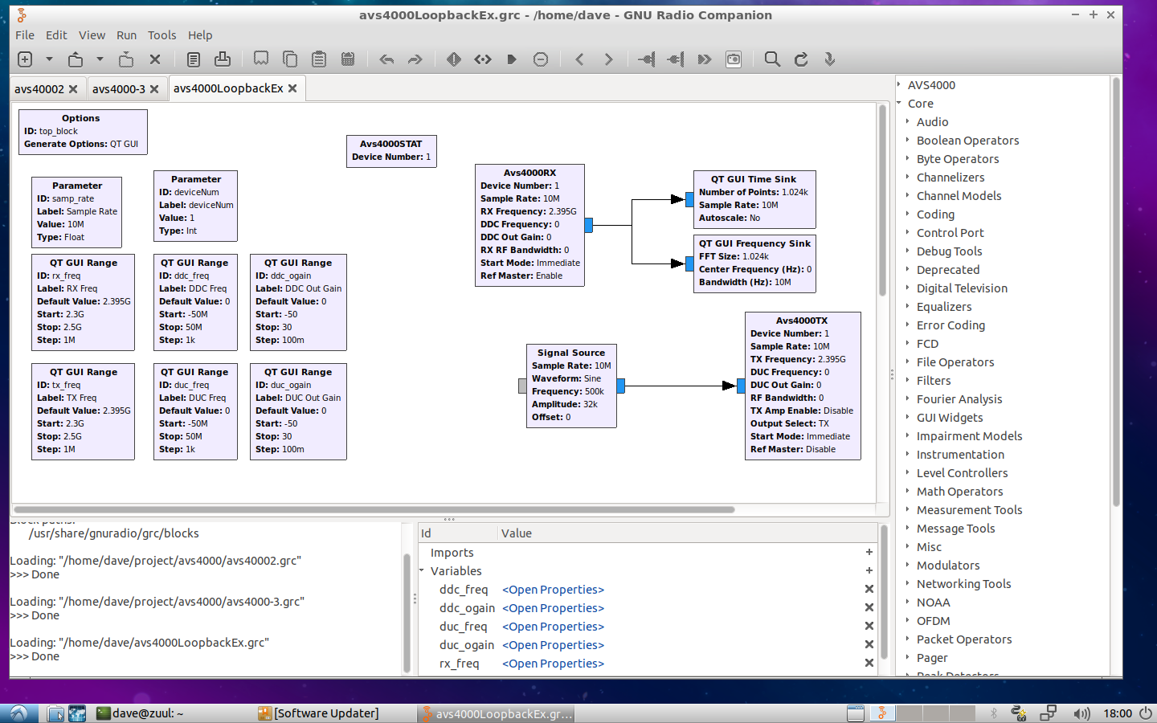
When the flowgraph is executed, two windows will be displayed. The first is a window labeled Top Block. This window will display the Time & Frequency of the RX signal. The second window labeled, AVS4000, displays status information about the AVS-4000.
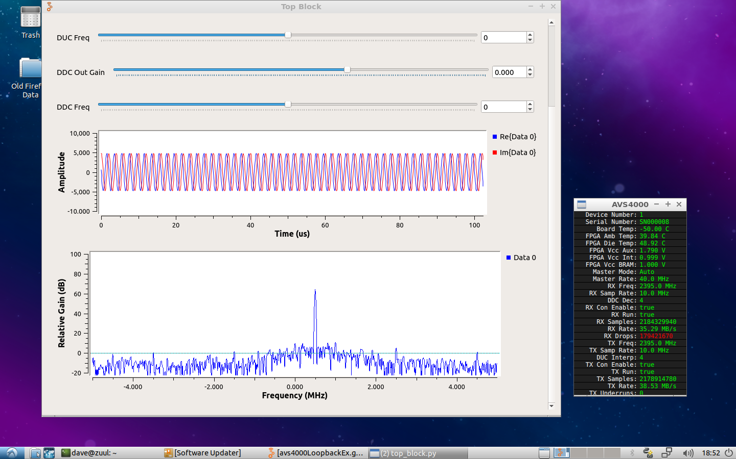

Table 11: GNU Radio Companion Start Flowgraph Icon

6.0 Support Contact Information
For technical assistance please contact:
info@avid-systems.com
301-703-8195
Avid Systems Inc.
2904 Back Acre Circle
Suite 101
Mount Airy, MD 21771

