**Tree Phenology and Climate - Shifting Phenology**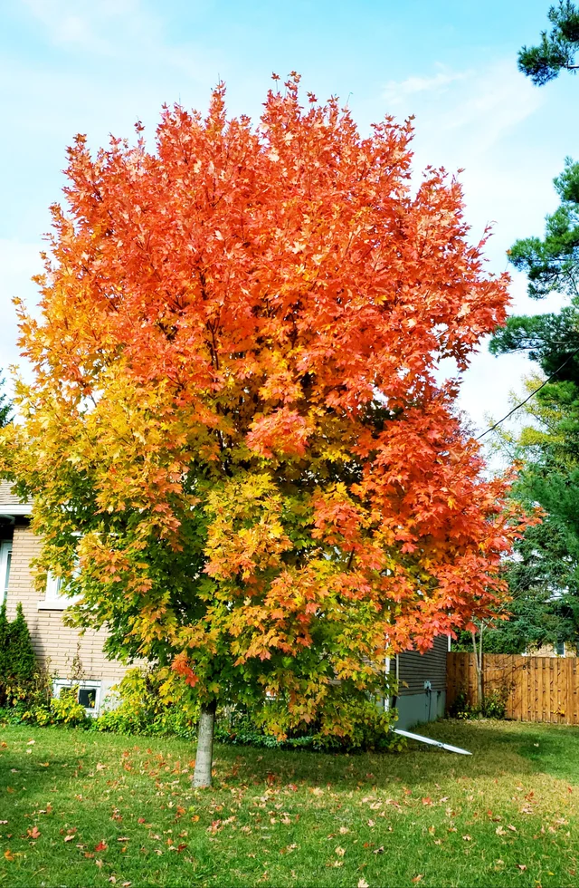

**What to do:**

1. Read lesson information
2. Answer the questions using the Shiny

**Introduction:**

Phenology is the timing of periodic life cycle events for organisms, sometimes referred to as “nature’s calendar”. Some examples of phenology are the timing of flowering for plants, or the timing of insect emergence. Phenology is important to study because the timing of these events are crucial for organismal survival, food web interactions, and species distributions and abundances. For example, insect emergence and plant flower phenology must be in sync for proper pollination. One of the main drivers of phenology is temperature. With the changing climate, changes in temperature may change the timing of phenology for many organisms.

For trees, one of the more noticeable phenological events is the timing of leaf senescence (i.e., leaf aging) in the fall. As trees prepare for the winter dormant season, they will pull nutrients out of leaves, most notably nitrogen. Most foliar nitrogen is in the chloroplasts and involved in photosynthesis. As chlorophyll is broken down and nitrogen is extracted, the leaves are exposed to harmful sunlight, and are not able to convert it into energy. Fall leaf color, red especially, is due to the production of anthocyanins which act as sunscreen to the leaves, protecting the plant from excess oxidative damage. Interestingly, the hue of leaves are often associated with how much sunlight they are exposed to: dark red is at places of maximum sunlight and light yellow is found in the understory, where less protection is needed from the sun.

**Task:**

Navigate to the phenology Shiny app ([link here](https://github.com/wleuenberger/PhenologyShiny)). This site is an interactive graphing application that allows you to select which variables are plotted on a graph. The Shiny app has the 4 years of tree phenology data (leaf color change and leaf fall) taken by students in this class from 2017-2019 and 2021. These phenological events measured by the students include: leaf color and leaf fall, which measure the percentage of leaf or change and percentage of leaves fallen on a given date. There are also several species of trees within this dataset that you can select and compare. Go through the species and response variables and compare the outcomes. You will manipulate the Shiny app to answer the questions below.

**Answer the following questions:**

Directions: For each of these questions, refer to the tab on the RShiny that corresponds to the section name in **BOLD**.

**General Questions/Before you begin (Pre-Shiny):**

* What is a question you think could be addressed by analyzing leaf color and fall?
* What environmental factors do you think could affect the autumn tree phenology under study?
* What is the difference between temperature and climate?

**Shiny Tab 1 Questions: Yearly Variation: 1 Species**

* What could cause the peak color change to happen in early November (around Week 45)? Please assume this is not due to human error.
* What abiotic factors could have contributed to variation in color change and leaf fall across years? Why do you think these could have contributed?
* Why is it important to look at annual variation in each species?
* Is the absence of 2020 data significant when analyzing the annual variation of a species? Why?
* Why might different species have different color change and leaf fall timelines within a given year?

**Shiny Tab 2 Questions: Yearly Variation: Within-species individuals**

* What abiotic factors could cause similar species to show different phenotypes in different years?
* Which of these factors seems most likely to you? Why?
* Would the phenology be considered shifting or constant? How does having this type of phenology benefit the tree?

**Shiny Tab 3 Questions: Phenology and Fall Weather**

* Plants adjust to their environment morphologically. So as climate shifts, these trees will have to adapt. What weather variables are most highly correlated to color change and leaf fall (positive and negative correlation)?
* What weather variables seem to have little effect on color change and leaf fall?
* Based on the trends of the data (2017-2019, 2021), can you hypothesize tree phenology data for 2022? What about 2050?
* Do you think you have enough data to explore this hypothesis? If not, how much data would be enough to hypothesize tree phenology in 2050? Based on what you learned, what is a testable hypothesis on the connection between the temperature/climate and phenology?
* Is there a pattern between fall precipitation and leaf color/fall? If so, please describe the pattern. If not, hypothesize why there might not be a pattern.
* What weather variable(s) do you find to be the most interesting? What makes this interesting?

**Shiny Tab 4 Questions: Phenology and Spring Precipitation**

* Is there an obvious pattern between spring precipitation and leaf color/fall? If so, please describe the pattern. If not, hypothesize why there might not be a pattern.
* Do any species not follow the conclusion from the above question? Please describe the differences in the pattern between spring precipitation and rainfall in this(these) species.

**Post-Exploration Reflection (Post-Shiny):**

* After looking at the Shiny, what correlations (or lack thereof) did you find surprising?
* How could you present this information differently to compare trends and interactions?
* What data would you collect to further investigate tree phenology changes?

Weather data definitions:

Daylight length (hours) - Total number of hours in a day between sunrise and sunset

Growing degree days - A measure of heat accumulation; more info available [here](https://www.canr.msu.edu/news/understanding_growing_degree_days)

Mean temperature (°C) - Average temperature per week

Precipitation (mm) - Average amount of rainfall per week

Temperature differential - Weekly average of daily maximum temperature - daily minimum temperature

Spring precipitation (mm) - Total amount of rainfall in the spring season prior to that year’s fall phenology measurements