Kofiko

User Manual

3 Feb 2010

Overview

Kofiko is a flexible platform that enables easy programming of behavioral paradigms. It is mostly MATLAB© based. Stimulus presentation is generated using Psychophysics toolbox which allows highly accurate stimulus presentation times. The system is using two computers, one for delivering stimulus (Stimulus Server), and another that collects various signals (eye position, motion, spikes, electrode position, etc) and deliver various output signals (juice, stimulus, strobe words, etc).

Kofiko has support for multiple paradigms and can display in real time various statistics about the current performance of the subject and of neural activity.

**Requirements**

**Hardware requirements**

**Kofiko Machine:**

At least a 2.5 GHz CPU

nVIDIA card. Tested with 9800 GT, but should work with newer model as well

Measurement Computing PCI-DAS 1002 (* note, support for NI cards may be added in the future)

Monitor that has a larger resolution of the stimulus server. i.e., if you are displaying stimuli at 1024x768, you should have a monitor with a resolution of at least 1650x 1024 pixels.

**Stimulus Server Machine**

At least a 2.5 GHz CPU

nVIDIA card. Tested with 9800 GT, but should work with newer model as well.

**Additional Hardware:**

Kofiko box (i.e., SCB-50 and C100FF-5, from MCC)

BNC Break-out box (i.e., BNC-16B from Plexon)

Photodiode and photodiode amplifier (optional, accurate screen timing can be obtained in software)

ISCAN or any equivalent system that can output eye position as an analog input (support for serial port may be added in the future)

Plexon (or any equivalent system that can record strobe events and can be triggered to start/stop recording)

Gigabit Ethernet hub.

**Software Requirements:**

Operating system on Kofiko and Stimulus Server: Windows 7 32 bit or XP wt. service pack 3.

Matlab: Tested with R2007b 32 bit. Should work with newer 32-bit versions as well

PTB: Tested with PTB 3. Should work with newer version as well.

Measurement computing Insta-CAL drivers for the Kofiko Machine.

Latest nVIDIA drivers for both computers.

**Wiring Diagram for Kofiko box**

[Currently missing]

**Hardware installation instructions**

[Currently missing]

**Software installation**

Kofiko Machine:

1. Copy the Kofiko installation zip file to any folder on the local drive and extract it.
2. Copy/Install PTB
3. Configure the following XML files (see section on XML config files below)
   1. Default.XML
   2. SessionBrowser.XML
   3. Register.XML
   4. StimulusServer.XML
   5. PlexonServer.XML (optional)
4. Make sure Insta-CAL configuration for the PCI-DAS 1002 is set on 16 differential inputs
5. Set up the following system environment variable
   1. Name = “MATLAB32BIN”
   2. Value = “C:\Program Files\Matlab\bin\win32\matlab32.exe”
6. Change the sharing permissions of the kofiko folder and make it available over the local network.

Stimulus Server

1. Map the shared network drive, typically, “Z:\”
2. Add the same environment variable (MATLAB32BIN, see above)

**XML configuration files**

[Currently missing]

**Running Kofiko**

**Step 1 – Boot up machines**

1. Turn on the stimulus server machine and login
2. Turn on the Kofiko machine and login
3. On the stimulus server, goto “Z: \” and execute “Run_StimulusServer.bat”
4. Wait until matlab loads up and you see a message saying that the stimulus server is running and listening on port XXX
5. On the Kofiko machine, go to the kofiko folder and execute “Run_KOFIKO.bat”

**Step 2 – Register your monkey**

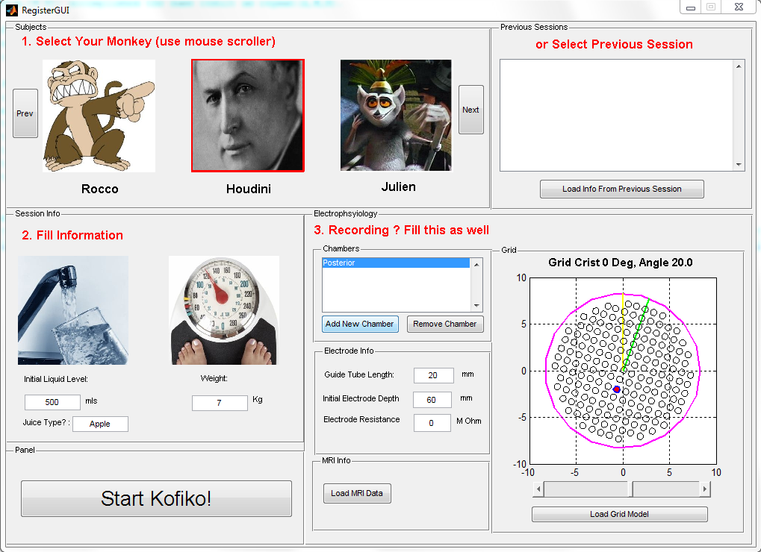

1. Select your monkey subject from the list of available monkeys
2. [Optional] Fill in additional information, such as weight, initial juice level and type
3. If you are recording, fill the information about chamber, grid and electrode. If this is the first time, do the following:
   1. Add a chamber by clicking “Add New Chamber”
   2. Add a grid by clicking “Load Grid Model” and select the correct type.
   3. Rotate your grid to the desired angle
   4. By clicking on the LEFT mouse button on any of the grid holes you can ADD/REMOVE an electrode. By clicking on the RIGHT button, you select an electrode.
   5. Select your electrode and fill in the details (guide tube length, initial electrode depth beyond the guide tube and electrode resistance)
   6. Load MRI Data if you want to observe in real time the position of your electrode relative to the anatomical scan.
4. Click on “Start Kofiko!”
5. If you have entered electrophysiology information, you will be asked to start a recording file on plexon. Goto to the plexon computer, run Sort Client, and select “Data->Start Recording”. Make sure to set the “Start recording upon RSTART event”.

**Step 3 – Using Kofiko**

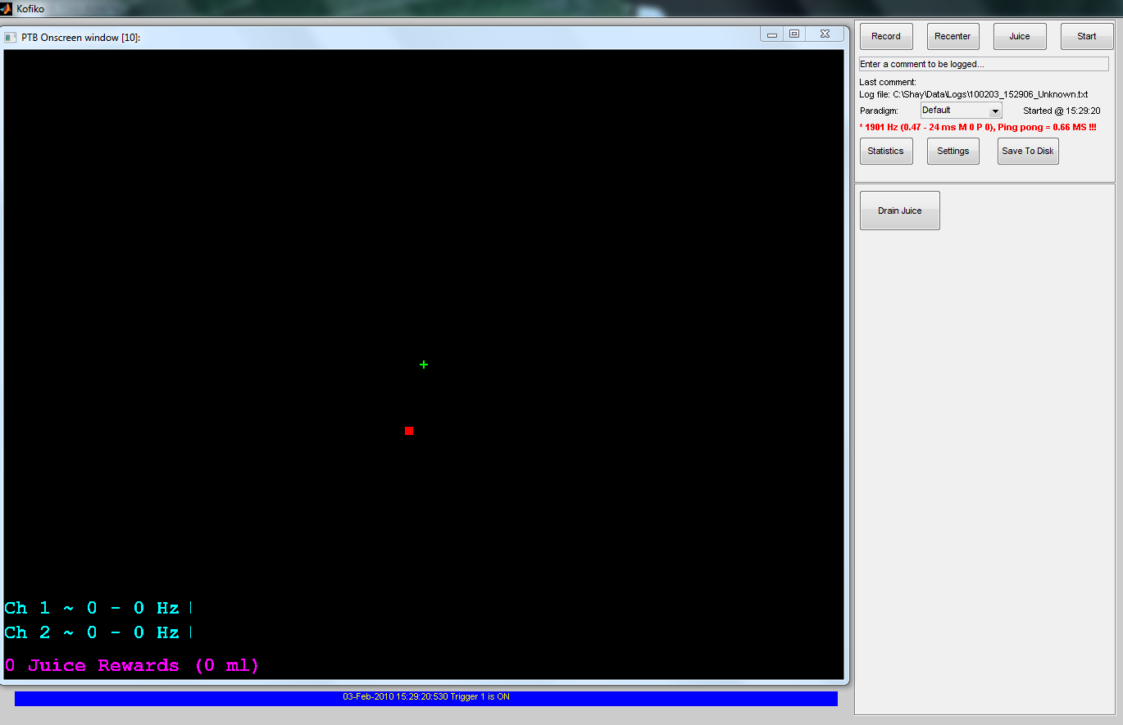

Kofiko has two main screens. The left screen correspond to the PTB window and displays a “sub-sampled” temporal version of what the monkey is seeing. The right window is split into an upper panel and a lower panel. The upper panel is paradigm-independent. The lower panel is paradigm dependent and will have different buttons depending on the paradigm you select.

The upper panel has the following buttons on the first row:

1. Record – sends a command to plexon to start recording.
2. Recenter – adjust the eye position signal. It assumes that there is a fixation spot SOMEWHERE on the screen (it doesn’t have to be on the center) and that the monkey is looking at it.
3. Juice – give a manual juice reward
4. Start – Start the currently selected paradigm

Below this set of buttons there is a place to enter comments and a text showing the current file name that was given to the log file.

Below that, there is a list-box where you can select the current paradigm (initially, set on the “Default” paradigm, which does not do anything.

The PTB Screen will always show the monkeys gaze as a small red rectangle. In addition, it displays the number of juice rewards the monkey has received so far, and an estimate to how much it corresponds to in ml.

At the moment, the following four paradigms have been implemented:

1. Five Dot Eye Calibration
2. Passive Fixation
3. fMRI Block Design
4. Classification Image

Detailed description of each paradigm is given in the following sections.

**Five Dot Eye Calibration Paradigm**

The purpose of this paradigm is to calibrate a simple model that converts analog eye signal (in voltage) to pixel coordinates. The model is linear and has four free parameters:



The Gains can be setup by manually adjusting the controls, while the offsets are set by clicking the “Recenter” button.

Additional buttons that the user can control include:

1. Gaze Time: the amount of time the monkey need to fixate to get a juice reward
2. Fixation Size: the radius (in pixels) of the fixation spot
3. Spread: determines the radius of the five dots that appear on the screen:

spread

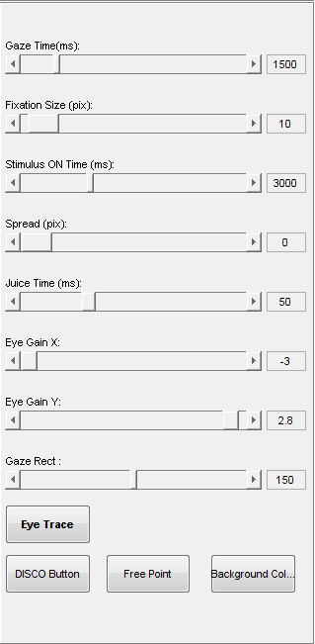

1. Stimulus ON : the time between position changes (if spread > 0)
2. Juice Time: The time (in ms) to open the valve after the monkey has fixated for “GazeTime”
3. Gaze rect: a rectangular region around each of the fixation spot. The monkey is allowed to fixate anywhere in that region to get a reward. The value represents half width of the box.
4. Eye Trace: Display previous eye traces
5. DISCO button: shows a growing disc which is suppose to draw the monkey’s attention back to the task
6. Free point: if turned on, allows the operator to move the fixation spot anywhere on the screen (using the mouse)
7. Background color: controls the color of the background.

**Passive Fixation Paradigm**

This paradigm displays a list of images on the screen. Each image is displayed for a fixed amount of time. After the display of each image, the image disappears and the screen is painted with the background for a different amount of time.

Available controllers:

1. Gaze Time: same as in five dot
2. Fixation size: same as in five dot
3. Stimulus ON : the amount of time an image will be displayed (given in ms). Note, this number should be a multiple of the stimulus server refresh rate (!!!)
4. Stimulus OFF: The off interval, given in ms. Can be zero.
5. Gaze Area: same as in five dot
6. Stimulus size: determines the size of the image in pixels. The actual width will be 2*X+ 1, where X represents the stimulus size.
7. Juice Time: same as in five dot
8. Rotation angle: This parameter will determine the angle at which each image is displayed.

Additional display information:

1. PSTH. Displayed as pink dots. Each dot is a spike. Spikes are aligned to stimulus onset which is represented as a green vertical line. Firing rate is computed by averaging the number of spikes between the two yellow vertical lines. These parameters can be changed under the “Settings” button.
2. Stimulus firing rate. This is the vertical bar chart which shows the firing rate per stimulus. Every time a stimulus is repeated, the average is updated only if the monkey actually fixated at the image.
3. Category average firing rate. Will average all the stimuli which correspond to the same category.

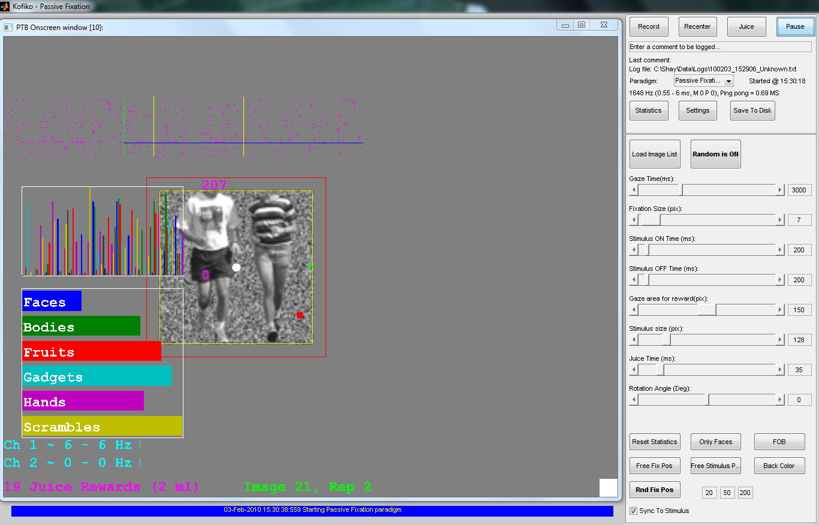

Additional parameters:

1. Reset Statistics – this will reset the stimulus and category statistics
2. Only faces – will load an image list containing only faces
3. FOB – will load the default Face Object Body Localizer
4. Free Fix Pos – will allow the operator to determine where to put the fixation spot on the screen (default is center)
5. Free Stimulus position – will allow the operator to select where the image will be displayed on the screen (default is center)
6. Rand Fix Pos – will automatically select a random fixation position every couple of images to keep the task more challenging. This is controlled by the three numeric parameters [A,B,C].Kofiko will select a random number between A..B and will display this number of images before randomly picking a new fixation spot. The fixation spot will change with a radius of C.
7. “Sync to Stimulus” option, will sync the image position and fixation position, such that whenever the fixation spot changes, the image will appear in the same position.

Additional notes:

At the moment, a maximum of 10 categories can be displayed. If more are available, the 10 that are displayed can be selected under the “Statistics” panel

**fMRI Block Design Paradigm**

This paradigm is designed to run at the scanner. It is still under development. It will display a list of images. The images are grouped into “blocks”. Blocks are grouped into a “Run”.

So far, the following controls have been implemented:

1. Gaze Time : Same as in five dot
2. Fixation Size: Same as in five dot
3. Gaze Area : Same as in five dot
4. Stimulus size : Same as in five dot
5. Juice Time: Same as in five dot
6. Rotation Angle: Same as in Passive fixation
7. TR: This parameter should be copied from the scanner workstation so Kofiko will know how long each TR is.
8. # TRs per block. This will determine how many TR pulses should be in each block. For example, 8 TRs with TR=2sec means each block will take 16 sec.
9. 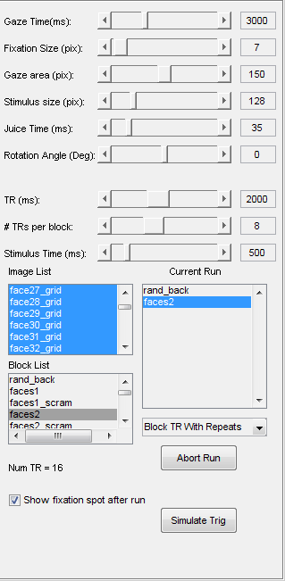Stimulus time: The time each image is going to be displayed in each block. Notice, if the number of images is smaller than the length of the block, then they will be repeated (no shuffling). Make sure the list is not longer than the length of a block, otherwise an error message will appear.
10. Image list: Displays the list of currently available images. Right click->Load to load a new image list
11. Block list: Displays the available blocks. Clicking on a block will highlight which images are in that block. Right click->Add to run will add the selected block to the current run
12. Run list: displays the list of blocks that will be displayed. Right click->load will load a different run of blocks.

Display modes:

Block TR with repeats: this is the default and “standard” way that displays each block for a fixed amount of time, as determined by TR value and #TRs.

Stimulus Time: This will ignore the # TRs per block and will display each image on the list once for the given amount of time specified by “Stimulus Time”

After selecting the display mode and run the number of TRs for the complete run will be displayed.

Additional Options:

“Show Fixation spot after run” – will display a fixation spot and will reward the monkey for fixating, while the operator is preparing for the next run.

Runs will start AUTOMATICALLY upon detecting a TR.

**Classification Image Paradigm**

[Currently missing]

**Kofiko Hot Keys (default. These can be configured in the XML)**

“A” – Draw monkey’s attention

“E” – Show/Hide eye traces

“R” – Reset Statistics

“P”- Hide PTB screen

“J” – Give Juice reward

“C” – Recenter

ALT+1 – show PSTH and firing rate for channel 1

ALT+2 - show PSTH and firing rate for channel 2

**Kofiko Output**

Two files are generated by kofiko. Both are stored under the “Log” Folder. One is a simple text file which contains various log messages. The other is matlab file that contains EVERYTHING that happened in kofiko. Every change will be time stamped. The following events are monitored and can be saved (XML configured):

* Switch to a new paradigm
* Change of paradigm value
* Start/Stop Recording
* Image display
* Eye position values
* Spike timing
* Motion values
* …

To fully analyze a session the corresponding plexon file should also be available. It should have the same file name as the kofiko generated file, but with the extension .PLX.

**Analysis scripts**

Several simple analysis scripts are available.

For example, the “standard” analysis for the “Passive Fixation” paradigm which includes PSTH, firing rates, significance compared to baseline, etc.

.

**Session Browser**

The session browser is an easy-to-use GUI that can load recorded session and display unit statistics.

It has four windows. The right one displays the various statistics. The left one is divided to three panels. The upper one has a list of all the available sessions. A session refers to a “day of experiments”, which corresponds to a kofiko MAT file and a plexon PLX file (or, multiple plexon files, if off-line sorting has been used). The middle window shows a list of all the units for which statistics has been computed. The bottom window is a “work space”. You can copy units down and then apply population analysis on the selected units.

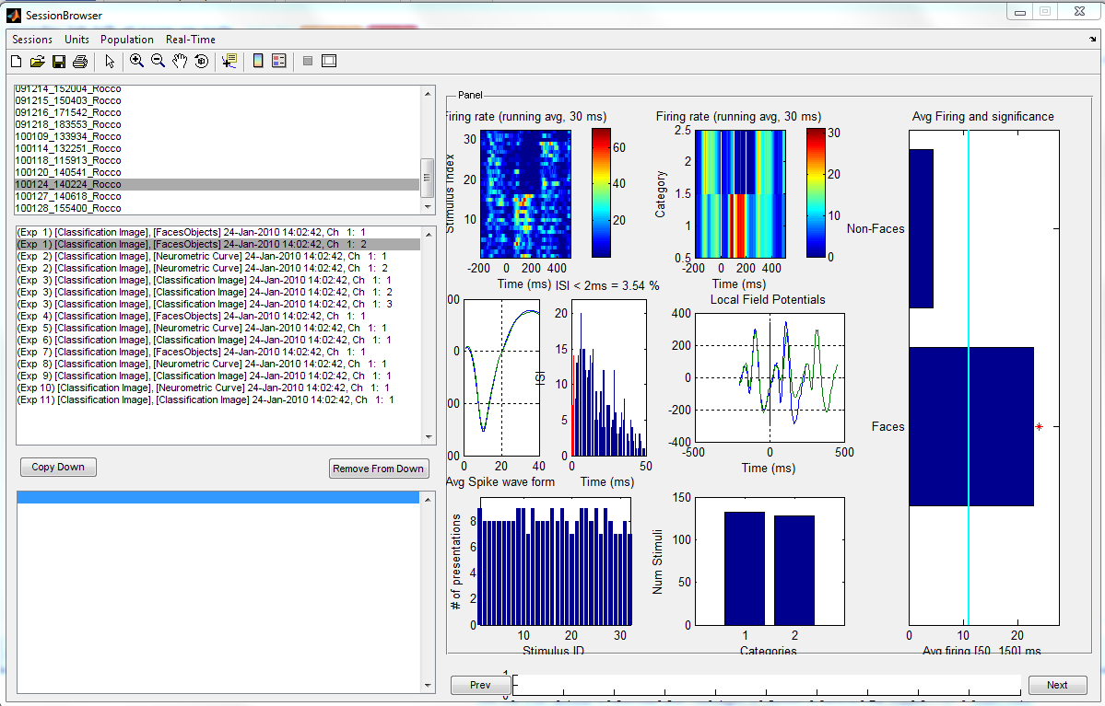

**Detailed information how to use Session Browser**

[Currently Missing]**Under the hood**

For detailed description how the system is implemented and how to program a new paradigm, please refer to the “New Paradigm Protocol” document.