Contents

Introduction 2

Current business activities 2

Business rules 3

Entities & their relevant attributes 5

Entity list 5

Entity structures with relevant attributes: 5

Primary Keys & Foreign Keys 9

Data Definition Language implementations: 10

Relationship between all entities 15

Cardinality 16

Final ER Diagram 18

References 19

# Introduction

Founded in 1996, Buddha Air is the largest airlines company of Nepal with greater than 100,000 hours of **flights**, 3 million satisfied passengers from 9 different domestic destinations. It has the highest capacity **aircraft**, all equipped with modern technology stuffs ensuring quality & safe flying.

Buddha Air has several **branches** in different **countries**. Most branches are in Nepal on many **states**. Its dedicated **employees** are keen to prove the quality service often recommended by its customers. Buddha Air is well known for low **airfare** for both way **routes** services across domestic customers.

Highly dedicated in customer services, Buddha Air offers several **discount** schemes for children and people with disabilities. Buddha Air has won multiple awards for its safety & reliability records of flying from national and international organizations.

Due to its high reliability, safety records and highly gained trusts from customers, Buddha Air is having more **transactions**, causing day to day expanding business activities hard to manage its operations. To ensure more flexible service for customers, it’s highly recommended to implement and Airlines Reservation System, a computerized system that will help manage all information related to flight, **passengers**, their **contact details**, reservation, transactions, schedule publishing, air fare payments etc.

# Current business activities

Buddha Air is operating on spot airline reservation, flight booking services with help of several travel agencies. It’s not only causing inconvenience for customers but also raises the actual tariff that customer has to pay. Though having branches in multiple cities targeting high range of customers, employee something fails to satisfy customers in remote areas when they have to travel for reservation also when they need to travel for cancellation or flight day extension. Followings are the key operations of Buddha Air’s day to day business:

1. Sales Transactions

All sales transactions are related to flight ticket sales; advance reservations, reservation cancellations etc.

* 1. Reservation

Buddha Air provides flight pre-reservation to its customers. All customers are open to reserve flights to travel in future. Reservations are taken before 11 hour of flight. Pre-reservation insuring future sales forecast.

* 1. Cancellation

No hard rules, as far as company does not have to lose anything. A customer is always can cancel their flights. Cancelled seats are released for re-sell instantly.

Company denies canceling a sold ticket, if cancellation request is made within 6 hour of flight.

1. Flight scheduling

Day to day flight scheduling, new flight arrangements according to sales potentiality, flight departure delay decisions all takes rooms in its daily flight scheduling activities etc.

1. Ticketing

On spot ticket sales, online reservation sales, urgent sales, VVIP ticketing is done in its several branches, authorized agents from different travel agencies.

# Business rules

Quality services to customers aren’t possible with defined business principles. Buddha Air has several business rules that apply from its own staffs to third party sales agents and potential customers. For each, business rules are as per listed below:

1. Customers

* They are welcome to those from different flight schedules those are available throughout a day depending upon their comfort, willingness and flexibility and of course upon flight availability.
* All customers are required to submit valid contact details.
* All customers must reserve a flight to travel. No on the gate sales are available. Also customers can’t buy tickets at airports, instead they need to visit online store or a sales counter to get a ticket or reserve for future plans.
* Full payments are necessary in-order to confirm a booking. Yes, there can be several discounts schemes which can be claimed by customers & is given upon proper alignment with discount descriptions.
* Customers must be penalized for cancellation. How much **charges** they have to pay, depends when they are canceling the flights. If it’s before 11 hour of flight they need to pay 10% of sales and if it’s within 11 hour of flight – 33.33% will be deducted from actual sales amount.
* Customers can demand the cancellation & 100% refund of flight is cancelled due to technical reason, bad weather.
* All customers are allowed up to 5 KG cargo free with each ticket. Exceeding 5 KG causes the additional fees.
* Each customer is eligible for $20,000 life insurance.
* Wheel chairs & oxygen is available for special passengers.

1. Employees (including sales agents)

* All employees must be dressed according to company dress code with an ID card, easily visible to guests.
* Employees are expected to be presence on their seat within duty hours.
* All employees are assigned to serve client based on first come first services. Yes- there is a provision for special cure for urgent & national security matters.
* Employees are hereby responsible for serving customers first, second their own jobs.
* Employees are not allowed to take flight reservations within 11 hour of flight.

**Database Design for Airline Reservation**

# Entities & their relevant attributes

## Entity list

1. AirCrafts
2. Route
3. AirFare
4. Flight_Schedule
5. Discounts
6. Charges
7. Countries
8. State
9. Contact_Details
10. Passengers
11. Branches
12. Employee
13. Transactions

## Entity structures with relevant attributes:

AirCrafts

|  |  |  |  |
| --- | --- | --- | --- |
| **Field** | **DataType** | **Description** | **Constraints** |
| AcID | INT | Field will store unique row number. | Primary Key |
| AcNumber | Varchar(32) | Aircraft number that identifies the plane. | NOT ULL |
| Capacity | INT | No. of seats available. | NOT NULL |
| MfdBy | Varchar(128) | Manufacturing company. | NOT NULL |
| MfdOn | DATETIME | Manufactured date of aircraft. | NOT NULL |

Route

|  |  |  |  |
| --- | --- | --- | --- |
| **Field** | **Data Type** | **Description** | **Constraints** |
| RtID | INT | Stores unique row id. | Primary Key |
| Airport | Varchar(32) | From where the flight will take off. | NOT NULL |
| Destination | Varchar (32) | Flight destinations. | NOT NULL |
| RouteCode | Varchar(16) | A unique Route code generated using Source & Destination of flight. | NOT NULL  UNIQUE |

AirFare

|  |  |  |  |
| --- | --- | --- | --- |
| **Field** | **Data Type** | **Description** | **Constraints** |
| AfID | INT | Stores unique row id. | Primary Key |
| Route | INT | Route id from Route table. | Foreign Key |
| Fare | Currency | Stores service charge amount. | NOT NULL |
| FSC | Currency | Stores fuel surcharge amount. | NOT NULL |

Flight_Schedule

|  |  |  |  |
| --- | --- | --- | --- |
| **Field** | **Data Type** | **Description** | **Constraints** |
| FlID | INT | Unique number to identify the flight. | Primary Key |
| FlightDate | DATETIME | Date of flight. | NOT NULL |
| Departure | DATETIME | Stores the departure time of flight. |  |
| Arrival | DATETIME | Stores the arrival time of flight on destination. |  |
| AirCraft | INT | Aircraft number that will fly, a number from Aircraft table. | Foreign Key |
| NetFare | INT | To determine total fare of flight, an ID from Air_Fare table. | Foreign Key |

Discounts

|  |  |  |  |
| --- | --- | --- | --- |
| **Field** | **Data Type** | **Description** | **Constraints** |
| DiID | INT | Unique row id. | Primary Key |
| Title | Varchar(32) | Label to know discount. | NOT NULL |
| Amount | INT | Discount amount in % | NOT NULL |
| Description | Varchar(255) | Discount remarks & details. |  |

Charges

|  |  |  |  |
| --- | --- | --- | --- |
| **Field** | **Data Type** | **Description** | **Constraints** |
| ChID | INT | Unique row id. | Primary Key |
| Title | Varchar(32) | Label for charge. | NOT NULL |
| Amount | INT | Amount of charge in %. | NOT NULL |
| Description | Varchar(255) | Describe cause of charge. |  |

Countries

|  |  |  |  |
| --- | --- | --- | --- |
| **Field** | **Data Type** | **Description** | **Constraints** |
| CtID | INT | Unique row id. | Primary Key |
| CountryName | Varchar(32) | Room to store country name | NOT NULL |

State

|  |  |  |  |
| --- | --- | --- | --- |
| **Field** | **Data Type** | **Description** | **Constraints** |
| StID | INT | Unique row id. | Primary Key |
| StateName | Varchar(32) | State name will take place here. |  |
| Country | INT | PK from Country table. | Foreign Key |

Contact_Details

|  |  |  |  |
| --- | --- | --- | --- |
| **Field** | **Data Type** | **Description** | **Constraints** |
| CnID | INT | Unique row id. | Primary Key |
| Email | Varchar(16) | Passenger’s contact email for transaction about flights. | NOT NULL |
| Cell | Varchar(16) | Passenger’s contact cell no for transaction about flights. | NOT NULL |
| Tel | Varchar(16) | Passenger’s contact telephone no. for transaction about flights. |  |
| Street | Varchar(64) | Street address of the passengers. | NOT NULL |
| State | INT | PK from State table. | Foreign Key |

Passengers

|  |  |  |  |
| --- | --- | --- | --- |
| **Field** | **Data Type** | **Description** | **Constraints** |
| PsID | INT | Unique row id. | Primary Key |
| Name | Varchar(32) | Passenger’s name | NOT NULL |
| Address | Varchar (64) | Passenger’s address | NOT NULL |
| Age | INT | Passenger’s age | NOT NULL |
| Nationalities | Varchar (16) | Nationality of the passenger. | NOT NULL |
| Contacts | INT | ContactID from Contact_Details table. | Foreign Key |

Branches

|  |  |  |  |
| --- | --- | --- | --- |
| **Field** | **Data Type** | **Description** | **Constraints** |
| BrID | INT | Unique id for each branches | Primary Key |
| Center | Varchar(16) | Branch Title | NOT NULL |
| Address | Varchar(32) | Address of the branch | NOT NULL |
| State | INT | State ID from state table | Foreign Key |

Employees

|  |  |  |  |
| --- | --- | --- | --- |
| **Field** | **Data Type** | **Description** | **Constraints** |
| EmpID | INT | Unique number to identity employee, unique on entire system. | Primary Key |
| Name | Varchar(32) | Employee name | NOT NULL |
| Address | Varchar(32) | Employee address | NOT NULL |
| Branch | INT | Associated branch id from Branch Table | Foreign Key |
| Designation | Varchar(32) | Working duty position. | NOT NULL |
| Email | Varchar(32) | Contact email of the employee | NOT NULL |
| Tel | Varchar(16) | Contact telephone number. |  |
| Ext | INT | Ext number of employee cabinet, if applicable. |  |

Transactions

|  |  |  |  |
| --- | --- | --- | --- |
| **Field** | **Data Type** | **Description** | **Constraints** |
| TsID | INT | Unique row id | Primary Key |
| BookingDate | Date/Time | Keeps the booking date. | NOT NULL |
| DepartureDate | Date/Time | Keeps the departure date. | NOT NULL |
| Passenger | INT | Transaction creator passengers row id to associate booking/cancellation, payments etc. | Foreign Key |
| Flight | INT | Flight no, a PK of Flight_Schedule to determine flying details & costs. | Foreign Key |
| Type | BIT | Reservation/Cancellation | NOT NULL |
| Employee | INT | Reservation agent, a row id of employee who helps the passenger to make transaction. | Foreign Key |
| Charges | INT | If transaction is cancellation, charges may apply as per business rules. | Foreign Key |
| Discount | INT | Discount offers may apply based on scheme criteria. | Foreign Key |
| Total | INT | Calculated value of actual payable cost by customer to make a transaction. | NOT NULL |

# Primary Keys & Foreign Keys

|  |  |  |  |  |
| --- | --- | --- | --- | --- |
| **SN** | **Table** | **Primary Key** | **Foreign Keys** | |
| **Column** | **References** |
| 1 | AirCraft | AcID | - | - |
| 2 | Flight_Schedule | FlID | AirCraft | AirCraft.AcID |
| Route | Route.RtID |
| AirFare | AirFare.AfID |
| 3 | Route | RtID | - | - |
| 4 | AirFare | AfID | Route | Route.RtID |
| 5 | Discounts | DiID | - | - |
| 6 | Charges | ChID | - | - |
| 7 | Passengers | PsID | Contacts | Contact_Details.CnID |
| 8 | Contact_Details | CnID | State | State.StID |
| 9 | State | StID | Country | Country.CtID |
| 10 | Country | CtID | - | - |
| 11 | Transaction | TsID | Passenger | Passengers.PsID |
| Flight | Flight_Schedule.FlID |
| Employee | Employee.EmpID |
| Charge | Charges.ChID |
| Discount | Discounts.DiID |
| 12 | Employee | EmpID | Branch | Branch.BrID |
| 13 | Branch | BrID |  |  |

# Data Definition Language implementations:

**/* 0. Create Database & use it */**

CREATE DATABASE BuddhAirBase;

USE BuddhaAirBase;

**/* 1. Create AirCrafts table*/**

CREATE TABLE AirCrafts(

AcID INT Primary Key,

AcNumber Varchar(32) NOT NULL,

Capacity INT NOT NULL,

MfdBy Varchar(128) NOT NULL,

MfdOn Datetime NOT NULL

);

**/* 1.1 Insert data into AirCrafts table*/**

INSERT INTO AirCrafts

(AcID, AcNumber, Capacity, MfdBy, MfdOn)

VALUES

(1, "ATR 72-500", 75, "Alenia Aeronotica", "23 April 1998");

**/* 2. Create Route table*/**

CREATE TABLE Route(

RtID INT,

Airport Varchar(32) NOT NULL,

Destination Varchar(32) NOT NULL,

RouteCode Varchar(16) NOT NULL UNIQUE,

PRIMARY KEY (RtID)

);

**/* 2.1 Insert data into Route table*/**

INSERT INTO Route

Values (1, "Kathmandu", "Pokhara", "KTM-PKR");

**/* 3. Create AirFare table*/**

CREATE TABLE AirFare(

AfID INT,

Route INT,

Fare Currency,

FSC Currency,

PRIMARY KEY (AfID),

CONSTRAINT fk_Route FOREIGN KEY (Route) REFERENCES Route(RtID)

);

**/* 3.1. Insert DATA into AirFare table*/**

INSERT INTO AirFare

VALUES

(1, 1, 86, 12);

**/* 4. Create Flight_Schedule table */**

CREATE TABLE Flight_Schedule(

FlID INT,

FlightDate DATETIME,

Departure DATETIME,

Arrival DATETIME,

AirCraft INT,

NetFare INT,

PRIMARY KEY (FlID),

CONSTRAINT fk_AirCraft FOREIGN KEY (AirCraft) REFERENCES AirCrafts(AcID),

CONSTRAINT fk_NetFare FOREIGN KEY (NetFare) REFERENCES AirFare(AfID)

);

**/* 4.1 Insert DATA into Flight_Schedule */**

INSERT INTO Flight_Schedule

VALUES

(1, 'January 23, 2012', '23:20', '1:20', 1, 1);

**/* 5. Create Discounts table */**

CREATE TABLE Discounts(

DiID INT PRIMARY KEY,

Title Varchar(32),

Amount INT,

Description Varchar (255)

)

**/* 5.1 Insert data into Discounts table */**

INSERT INTO Discounts

VALUES

(1,'Childrens', 10, 'Discount is provide all childrens under age of 10.');

**/* 6. Create Charges table */**

CREATE TABLE Charges(

ChID INT PRIMARY KEY,

Title Varchar(32),

Amount INT,

Description Varchar (255)

)

**/* 6.1 Insert data into Charges table */**

INSERT INTO Charges

VALUES

(2,'Urgent Cancellation', 33.33, '33.3% will be charged for cancellation for booking within 11 hrs from flight time');

**/* 7. Crate Country table*/**

CREATE TABLE Countries (

CtID INT PRIMARY KEY,

CountryName Varchar (32) NOT NULL

);

**/* 7.1 Insert data into Country table */**

INSERT INTO Countries

VALUES

(1, 'Nepal');

**/* 8. Create State table*/**

CREATE TABLE State(

StID INT,

StateName Varchar (32),

Country INT,

PRIMARY KEY (StID),

CONSTRAINT fk_Country FOREIGN KEY (Country) REFERENCES Countries(CtID)

);

**/* 8.1. Insert data into State table*/**

INSERT INTO State

VALUES

(1, 'Bagmati', 1);

**/* 9. Create Contact_Details table*/**

CREATE TABLE Contact_Details(

CnID INT PRIMARY KEY,

Email Varchar (16) NOT NULL,

Cell Varchar (16) NOT NULL,

Tel Varchar (16),

Street Varchar (64),

State INT NOT NULL,

CONSTRAINT fk_State FOREIGN KEY (State) REFERENCES State(StID)

);

**/* 9.1 Insert data into Contact_Details */**

INSERT INTO Contact_Details

VALUES

(1,'hello@shekhardesigner.com', '9851121824', '01-4215384', 'Gandaki Marga', 1);

**/* 10. Create Passengers table */**

CREATE TABLE Passengers(

PsID INT PRIMARY KEY,

Name Varchar (32) NOT NULL,

Address Varchar (64) NOT NULL,

Age INT NOT NULL,

Nationality Varchar(16) NOT NULL,

Contacts INT NOT NULL,

CONSTRAINT fk_Contacts FOREIGN KEY (Contacts) REFERENCES Contact_Details(CnID)

);

**/* 10.1 Insert data into Passengers table */**

INSERT INTO Passengers

VALUES

(1,'Shekhar Kumar Sharma', 'Sinamanga-39, KTM', 23, 'Nepalese', 1);

**/* 11. Create Branch table */**

CREATE TABLE Branches(

BrID INT PRIMARY KEY,

Center Varchar(16) NOT NULL,

Address Varchar(32) NOT NULL,

State INT,

CONSTRAINT fk_StateOfEmployee FOREIGN KEY (State) REFERENCES State(StID)

);

**/* 11.1 Insert data into branches table */**

INSERT INTO Branches

VALUES

(1, 'Kathmandu', 'New Road, Kathmandu', 1);

**/* 12. Create Employee table */**

CREATE TABLE Employee

(

EmpID INT PRIMARY KEY,

Name Varchar (32) NOT NULL,

Address Varchar (32) NOT NULL,

Branch INT NOT NULL,

Designation Varchar(32) NOT NULL,

Email Varchar (16) NOT NULL,

Tel Varchar (16) NOT NULL,

Ext INT,

CONSTRAINT fk_Branch FOREIGN KEY (Branch) REFERENCES Branches(BrID)

);

**/* 12.1 Insert data into Employee table */**

INSERT INTO Employee

VALUES

(1, 'Diwan Adhikari', 'Bagbazaar - 11, KTM', 1, 'Sales Executive', 'the.one@yahoo.com', '01-4215254', 12);

**/* 13. Create table Transactions */**

CREATE TABLE Transactions(

TsID INT PRIMARY KEY,

BookingDate DATETIME,

DepartureDate DATETIME,

Passenger INT,

Flight INT,

Type BIT,

Employee INT,

Charges INT,

Discount INT,

CONSTRAINT fk_Passenger FOREIGN KEY (Passenger) REFERENCES Passengers(PsID),

CONSTRAINT fk_Flight FOREIGN KEY (Flight) REFERENCES Flight_Schedule(FlID),

CONSTRAINT fk_Employee FOREIGN KEY (Employee) REFERENCES Employee(EmpID),

CONSTRAINT fk_Charges FOREIGN KEY (Charges) REFERENCES Charges(ChID),

CONSTRAINT fk_Discount FOREIGN KEY (Discount) REFERENCES Discounts(DiID)

);

**/* 13.1 Insert data into Transactions */**

INSERT INTO Transactions

VALUES

(1,'12 November 2011', '21 December 2011', 1, 1, 0, 1, NULL, NULL);

# Relationship between all entities

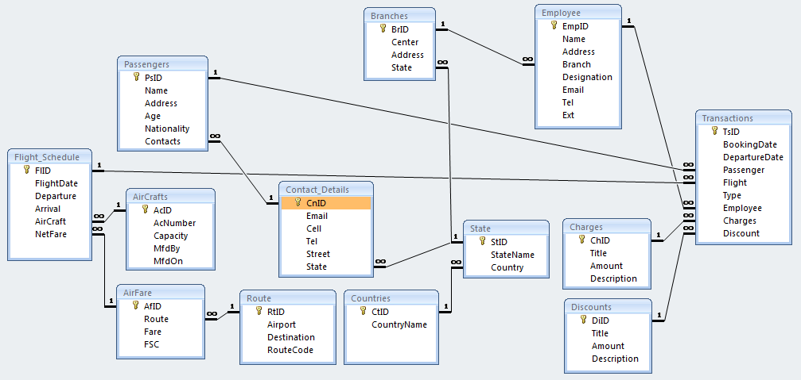

# Cardinality

Cardinality notations, using *Chen style*.

M = many, N = 0, 1, 2 …

|  |  |  |
| --- | --- | --- |
| **SN** | **Entities** | **Cardinality** |
| 1. | AirCrafts & Flight_Schedule | 1 : M |
| 2. | Route & AirFare | 1 : 1 |
| 3. | AirFare & Flight_Schedule | 1 ; M |
| 4. | Discounts & Transactions | N : 1 |
| 5. | Charges & Transactions | N : 1 |
| 6. | Countries & State | 1 : M |
| 7. | State & Branches | 1 : M |
| 8. | Contact_Details & State | M : 1 |
| 9. | Passengers & Contact_Details | 1 : 1 |
| 10 | Passengers & Transactions | 1 : 1 |
| 11. | Branches & Employee | 1 : M |
| 12. | Employees & Transactions | 1 : M |
| 13. | Transactions & Flight_Schedule | M : 1 |

Cardinality diagram (*Information engineering style notations*)

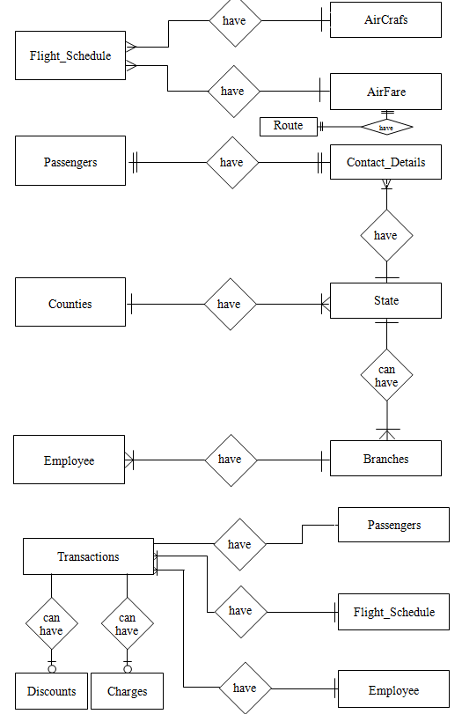

# Final ER Diagram

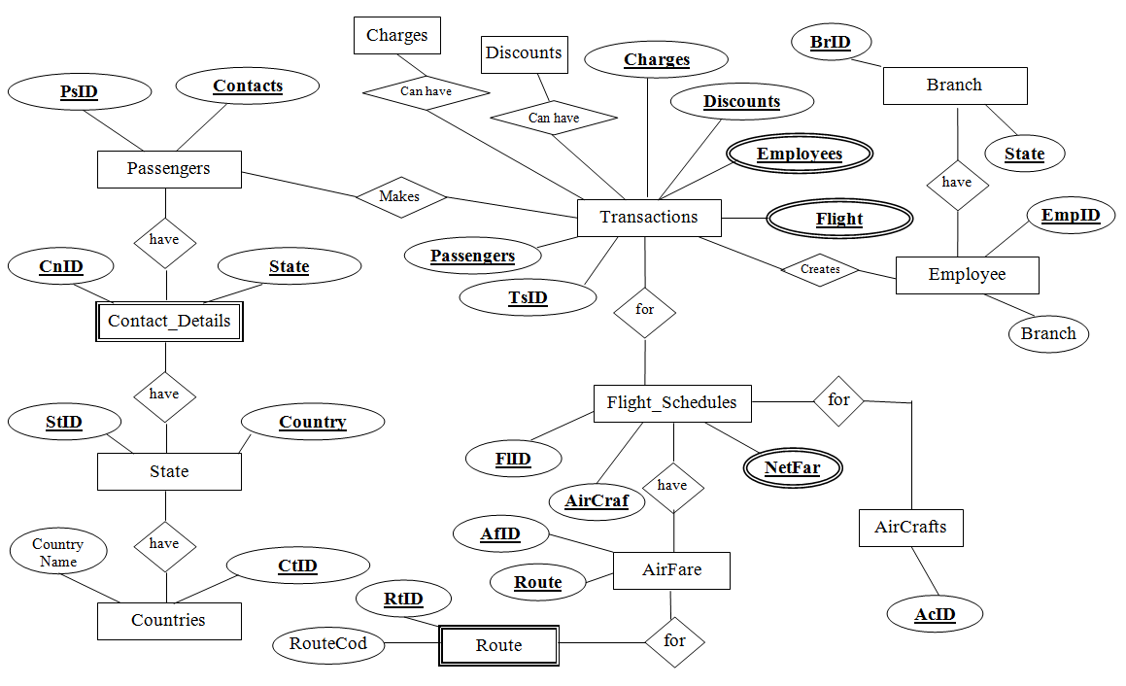

# References

1. Ramez Elmasri and Shamkant B. Navathe , *‘Fundamentals of Database Systems’* Addison Wesley Publishing Company
2. Allan Leake, (2000), *Definition of Database*

<http://searchsqlserver.techtarget.com/definition/database>

1. SmartDraw (2011), *Resources – Tutorials* <http://www.smartdraw.com/resources/tutorials>
2. BuddhaAir, Nepal (2011) – *Company History* <http://www.buddhaair.com/company/history.php>