1.1功率注水算法--信道状况好的时刻，多分配功率，像桶子一样，高就多注水。
注水算法是根据某种准则，并根据信道状况对发送功率进行自适应分配，通常是信道状况好的时刻，多分配功率，信道差的时候，少分配功率，从而最大化传输速率。实现功率的“注水”分配，发送端必须知道CSI。
当接收端完全知道信道而发送端不知道信号时，发送天线阵列中的功率平均分配是合理的。当发送端知道信道，可以增加信道容量。
考虑一个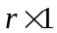维的零均值循环对称复高斯信号向量，r为发送信道的秩。向量在传送之前被乘以矩阵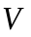(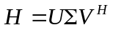)。在接收端，接受到的信号向量y被乘以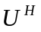。这个系统的有效输入输出关系式由下式给出：
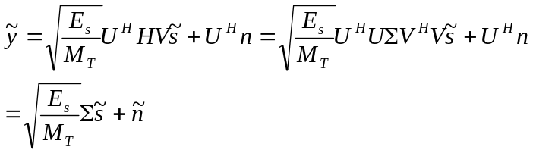
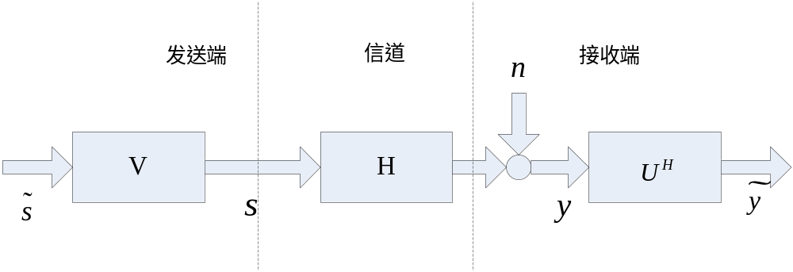
其中是维的变换的接受信号向量，是协方差矩阵为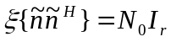的零均值循环对称复高斯变换噪声向量。向量必须满足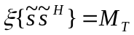已限制总的发送能量。
可以看出
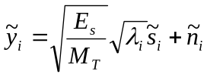，i=1,2,…,r
MIMO信道的容量是单个平行SISO信道容量之和，由下式给出
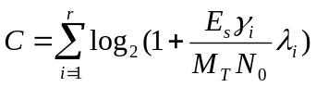
其中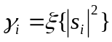(i=1,2,…,r)反映了第i个子信道的发送能量，且满足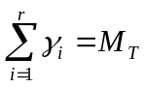。
可以在子信道中分配可变的能量来最大化互信息。现在互信息最大化问题就变成了：
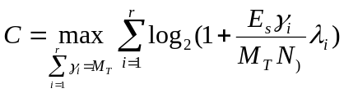
最大化目标在变量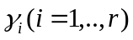中是凹的，用拉格朗日法最大化。最佳能量分配政策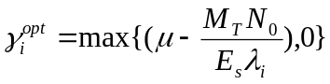
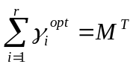
注水算法：
Step1:迭代计数p=1,计算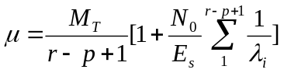
Step2:用μ计算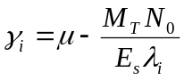，i=1,2,…,r-p+1
Step3:若分配到最小增益的信道能量为负值,即设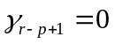，p=p+1，转至Step1.
若任意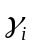非负，即得到最佳注水功率分配策略。

1.2 发送端知道信道时的信道容量
% in this programe a highly scattered enviroment is considered. The
% Capacity of a MIMO channel with nt transmit antenna and nr recieve
% antenna is analyzed. The power in parallel channel (after
% decomposition) is distributed as water-filling algorithm
clear all
close all
clc
nt_V = [1 2 3 2 4];
nr_V = [1 2 2 3 4];
N0 = 1e-4;
B = 1;
Iteration = 1e2; % must be grater than 1e2
SNR_V_db = [-10:3:20];
SNR_V = 10.^(SNR_V_db/10);
color = ['b';'r';'g';'k';'m'];
notation = ['-o';'->';'<-';'-^';'-s'];
for(k = 1 : 5)
nt = nt_V(k);
nr = nr_V(k);
for(i = 1 : length(SNR_V))
Pt = N0 * SNR_V(i);
for(j = 1 : Iteration)
H = random('rayleigh',1,nr,nt);
[S V D] = svd(H);
landas(:,j) = diag(V);
[Capacity(i,j) PowerAllo] = WaterFilling_alg(Pt,landas(:,j),B,N0);
end
end
f1 = figure(1);
hold on
plot(SNR_V_db,mean(Capacity'),notation(k,:),'color',color(k,:))
clear landas
end
f1 = figure(1)
legend_str = [];
for( i = 1 : length(nt_V))
legend_str =[ legend_str ;...
{['nt = ',num2str(nt_V(i)),' , nr = ',num2str(nr_V(i))]}];
end
legend(legend_str)
grid on
set(f1,'color',[1 1 1])
xlabel('SNR in dB')
ylabel('Capacity bits/s/Hz')

注水算法子函数
function [Capacity PowerAllo] = WaterFilling_alg(PtotA,ChA,B,N0);
%
% WaterFilling in Optimising the Capacity
%===============
% Initialization
%===============
ChA = ChA + eps;
NA = length(ChA); % the number of subchannels allocated to

H = ChA.^2/(B*N0); % the parameter relate to SNR in subchannels
% assign the power to subchannel
PowerAllo = (PtotA + sum(1./H))/NA - 1./H;
while(length(find(PowerAllo < 0 ))>0)
IndexN = find(PowerAllo <= 0 );
IndexP = find(PowerAllo > 0);
MP = length(IndexP);
PowerAllo(IndexN) = 0;
ChAT = ChA(IndexP);
HT = ChAT.^2/(B*N0);
PowerAlloT = (PtotA + sum(1./HT))/MP - 1./HT;
PowerAllo(IndexP) = PowerAlloT;
end
PowerAllo = PowerAllo.';
Capacity = sum(log2(1+ PowerAllo.' .* H));
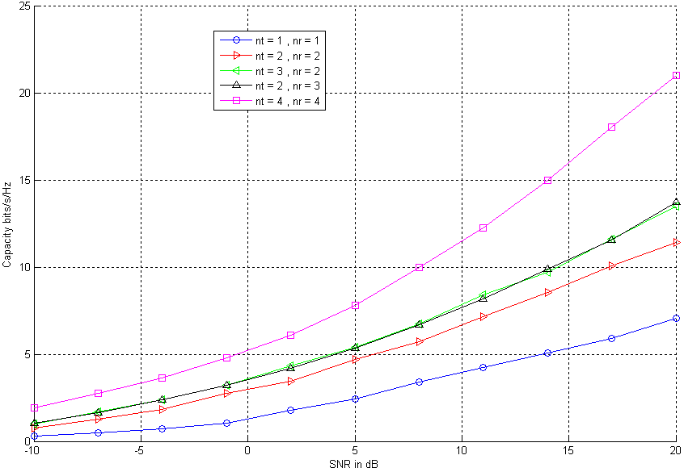
注意：是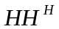的奇异值，所以对H奇异值分解后要平方ChA.^2

1.3 发送端不知道信道时的信道容量
功率均等发送，信道容量的表达式为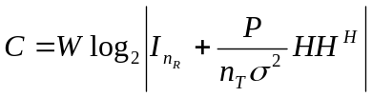
clear all
clc
nt_V = [1 2 3 2 4];
nr_V = [1 2 2 3 4];
N0 = 1e-4;
B = 1;
Iteration = 1e2; % must be grater than 1e2
SNR_V_db = [-10:3:20];
SNR_V = 10.^(SNR_V_db/10);
color = ['b';'r';'g';'k';'m'];
notation = [':o';':>';'<:';':^';':s'];
for(k = 1 : length(nt_V))
nt = nt_V(k);
nr = nr_V(k);
for(i = 1 : length(SNR_V))
Pt = N0 * SNR_V(i);
for(j = 1 : Iteration)
H = random('rayleigh',1,nr,nt);
Capacity(i,j)=log2(det(eye(nr)+Pt/(nt*B*N0)* H*H'));
end
end
f2= figure(2);
hold on
plot(SNR_V_db,mean(Capacity'),notation(k,:),'color',color(k,:))
clear landas
end
f2= figure(2)
legend_str = [];
for( i = 1 : length(nt_V))
legend_str =[ legend_str ;...
{['nt = ',num2str(nt_V(i)),' , nr = ',num2str(nr_V(i))]}];
end
legend(legend_str)
grid on
set(f2,'color',[1 1 1])
xlabel('SNR in dB')
ylabel('Capacity bits/s/Hz')
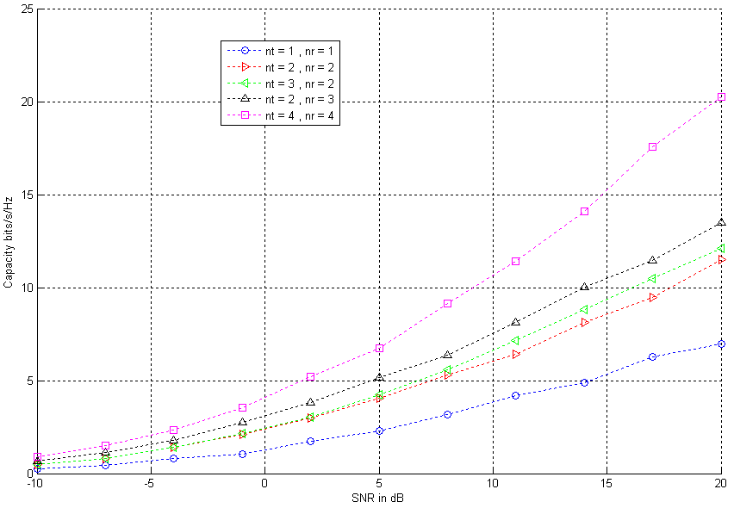

1.4 已知信道和未知信道容量比较
clear all
close all
clc
nt_V = [1 2 3 2 4];
nr_V = [1 2 2 3 4];
N0 = 1e-4;
B = 1;
Iteration = 1e2; % must be greater than 1e2
SNR_V_db = [-10:3:20];
SNR_V = 10.^(SNR_V_db/10);
color = ['b';'r';'g';'k';'m'];
notation = ['-o';'->';'<-';'-^';'-s'];
notation_uninf= [':o';':>';'<:';':^';':s'];
for(k = 1 : length(nt_V))
nt = nt_V(k);
nr = nr_V(k);
for(i = 1 : length(SNR_V))
Pt = N0 * SNR_V(i);
for(j = 1 : Iteration)
H = random('rayleigh',1,nr,nt);
[S V D] = svd(H);
landas(:,j) = diag(V);
Capacity_uninf(i,j)=log2(det(eye(nr)+Pt/(nt*B*N0)* H*H'));
[Capacity(i,j) PowerAllo] = WaterFilling_alg(Pt,landas(:,j),B,N0);
end
end
f1 = figure(1);
hold on
plot(SNR_V_db,mean(Capacity'),notation(k,:),'color',color(k,:))
hold on
plot(SNR_V_db,mean(Capacity_uninf'),notation_uninf (k,:),'color',color(k,:))
clear landas
end
grid on
set(f1,'color',[1 1 1])
xlabel('SNR in dB')
ylabel('Capacity bits/s/Hz')
f1 = figure(1)
legend_str = [];
for( i = 1 : length(nt_V))
legend_str =[ legend_str ;...
{['nt = ',num2str(nt_V(i)),' , nr = ',num2str(nr_V(i))]}];
end
legend(legend_str)
grid on
set(f1,'color',[1 1 1])
xlabel('SNR in dB')
ylabel('Capacity bits/s/Hz')
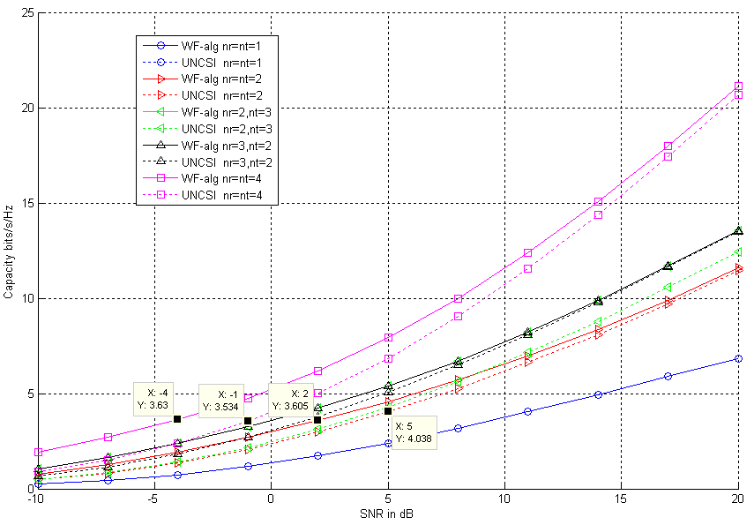
由图形中可以看出：
- 在小信噪比时，相同信噪比下利用CSI的功率注水算法获得容量优于未知CSI的平均功率分配算法；相同容量下已知CSI信噪比比未知CSI时的信噪比小3dB.
- 当信噪比增大到一定程度时，功率注水算法所获得的信道容量将收敛到平均功率分配的信道容量。

