SYNCHRONIZED DESTRUCTION: A REAL-TIME MULTIPLAYER JAVA GAME

by
William Locklier and Parker Cole

Table of Contents

SYNCHRONIZED DESTRUCTION: A REAL-TIME MULTIPLAYER JAVA GAME i
ABSTRACT iii
CHAPTER I 1
INTRODUCTION: RESOURCES AND DEVELOPMENT 1
1.1 Development Part 1 4
1.2 Development Part 2 5
CHAPTER II 6
FUNCTIONALITY AND GAMEPLAY 6
3.1 How To Run 6
3.2 Gameplay 10
3.3 Potential Future Additions and Directions 13
CHAPTER III 14
CONCLUSION 14
REFERENCES AND RESOURCES 15

ABSTRACT

William Locklier, Parker Cole M. S., University of South Alabama. Synchronized Destruction: A Real-Time Multiplayer Java Game.
Utilizing varying Java tools and programming strategies, this project was centered around designing and implementing a real-time multiplayer, player vs player (PvP) tank game over a network connection. This game allows two players to play simultaneously in a battle of skill – featuring real-time movement, firing mechanics and an integrated chat window for back-and-forth communication. This program model employs a client-server architecture, with one player as the host and other as the joined client.

CHAPTER I

INTRODUCTION: RESOURCES AND DEVELOPMENT

In beginning this project, we had to first pick a development environment. Both of us were familiarized with game development in Java and its corresponding libraries, so we decided on using IntelliJ IDEA. IntelliJ is an integrated development environment (IDE). This software provides a myriad of features that enabled us to code, troubleshoot, debug and share Java related programs using only one application.
For libraries and application programming interfaces (APIs) needed for this game to work, we imported Java Swing – which was used to create the graphical user interface (GUI), including both the game and chat panels. It was also used for key press and mouse input.
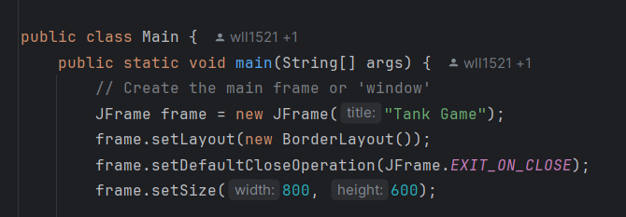
Figure 1:JFrame Panel created for game application
Java Network was imported to allow for socket to socket TCP/IP communication, which of course was crucial in designing the code that allows for any client to act as the host and listen for incoming client connections on a specified port. When the client sends a connection request, the host accepts the requests and solidifies end-to-end socket connections between the host and client’s IP / port.
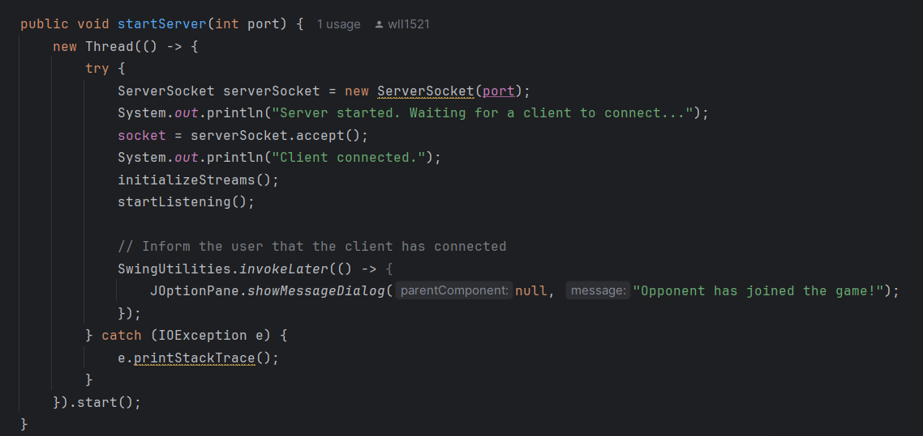
Figure 2: Server Socket Host
On the other side, the client uses the connect option to enter in the host’s IP address to send the request. The TCP request goes through and the connection is again established, providing both the client and server input and output streams.
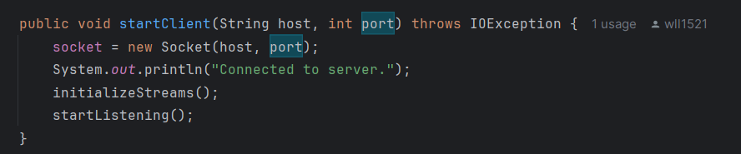
Figure 3: Client connection to server
A TCP synchronous connection was used because it is reliable and ordered. Guaranteeing real-time accuracy in a game where it is most crucial. Networking operations are handled in separate threads to allow for different operations to happen concurrently - from firing and movement to chat messaging. UDP was decided against because creating a reliable UDP connection would involve creating another protocol over that layer.
Java serialization was imported for sending complex objects over the network via input and output streams. This allowed for the conversion of objects into byte streams to be sent from one end-user to the other. Chat messages, bullets, tank destroyed events and all other game state updates like position and angle are serializable and able to be sent through the output stream. Bytes then come in through the input stream and are deserialized / reconstructed.
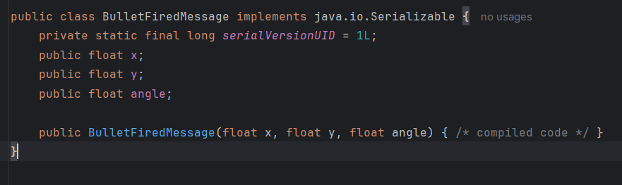
Figure 4: Bullet message for synchronous action
Several other Java utilities are imported for varying niche uses for things like array lists (used for entities like bullets and tanks), hashsets (used to track key presses) and network communication threads (used to handle in and out (I/O) traffic separately with less potential for bottlenecking and deadlocks within our own critical section that is accessed by these multiple threads, handling GUI rendering and longer running tasks separately).
All these tools allow for seamless and efficient management of resource allocation. Given the simplicity of these tools – we were allowed more flexibility in continued development on this project and any other that might be in consideration in the future.

1.1 Development Part 1
Once the tools and plan were established, we were able to begin coding starting with the initial game engine logic. The first and hardest task of course was going to be creating the engine that would render the graphics, physics and assets used within the game world, such as tank movements and spawning bullets. This would be the foundation for everything else to be built upon.
For ease of debugging and coding efficiency we decided to separate the code in segments:
- Game panel – renders real-time gameplay.
- Chat panel – renders real-time chat messages.
- Network manager – manages client-server message communication using object serialization and listeners.
- Main – program start.
- Several utility classes for miscellaneous things like object entities and world state messaging.

Once the engine was built, we made the game panel and chat panel for their respective features. Then we designed the network manager that would be used by these panels for their objects / elements to be transferred back and forth between the acting server and client, with unique ID’s for each player’s tank. We had not yet, at this point, been able to create a system of ID generation for individual bullet objects for better synchronized trajectory.

1.2 Development Part 2
The problems we encountered were naturally going to be physics and networking issues for such a new game. We had bugs with tank hitboxes, bullets flying in wrong directions, bullets staying on the map, different bullet velocities for the server and client. We also had plenty of networking issues with firewalls, and routing. Blocking some messages for some allotment of time, meaning some bullets wouldn’t register on the other client. Some chat messages not showing up while others would.
We resolved most of the networking issues by moving away from the blocking queue for message transfer and instead opting for listeners. Listeners are functions, or objects in this case, that wait to receive event messages and then consequently perform some action. In our case, it was updating the game state. So rather than process all messages unilaterally through some queue, we had an array of listeners wait for their respective messages from the different messages corresponding to the different objects in our game.

CHAPTER II

FUNCTIONALITY AND GAMEPLAY

3.1 How To Run
First, install JetBrains IntelliJ IDEA. This can be found at https://www.jetbrains.com/idea/. Once this software is installed, you can import all the required files from github at https://github.com/wll1521/Java-Multiplayer-Tank-Game.git. Set the main as the file to run and you should be able to play once you configure the main to be the file that is ran (shown later).

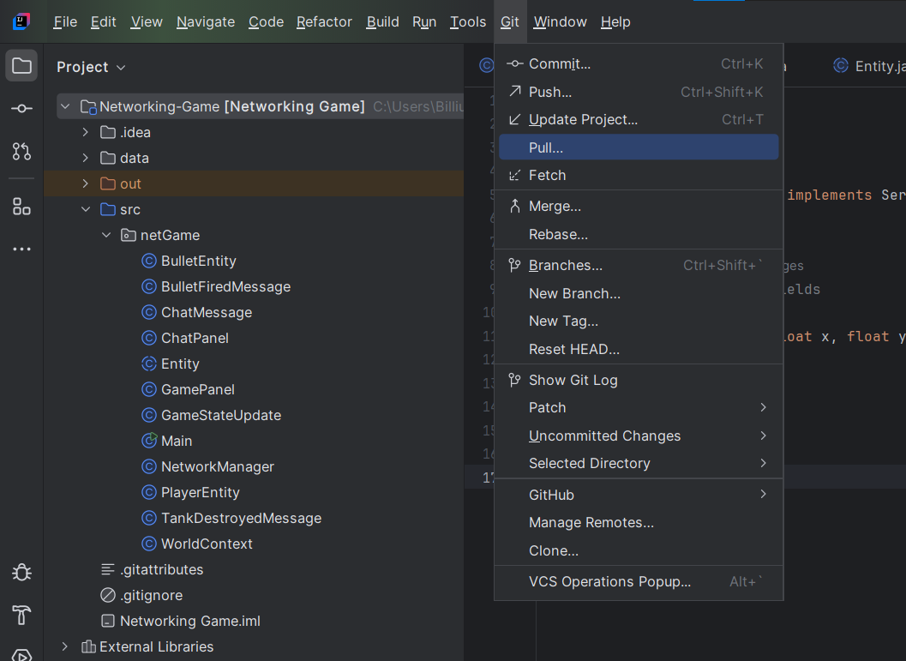
Figure 5: Git commands for IntelliJ IDEA application

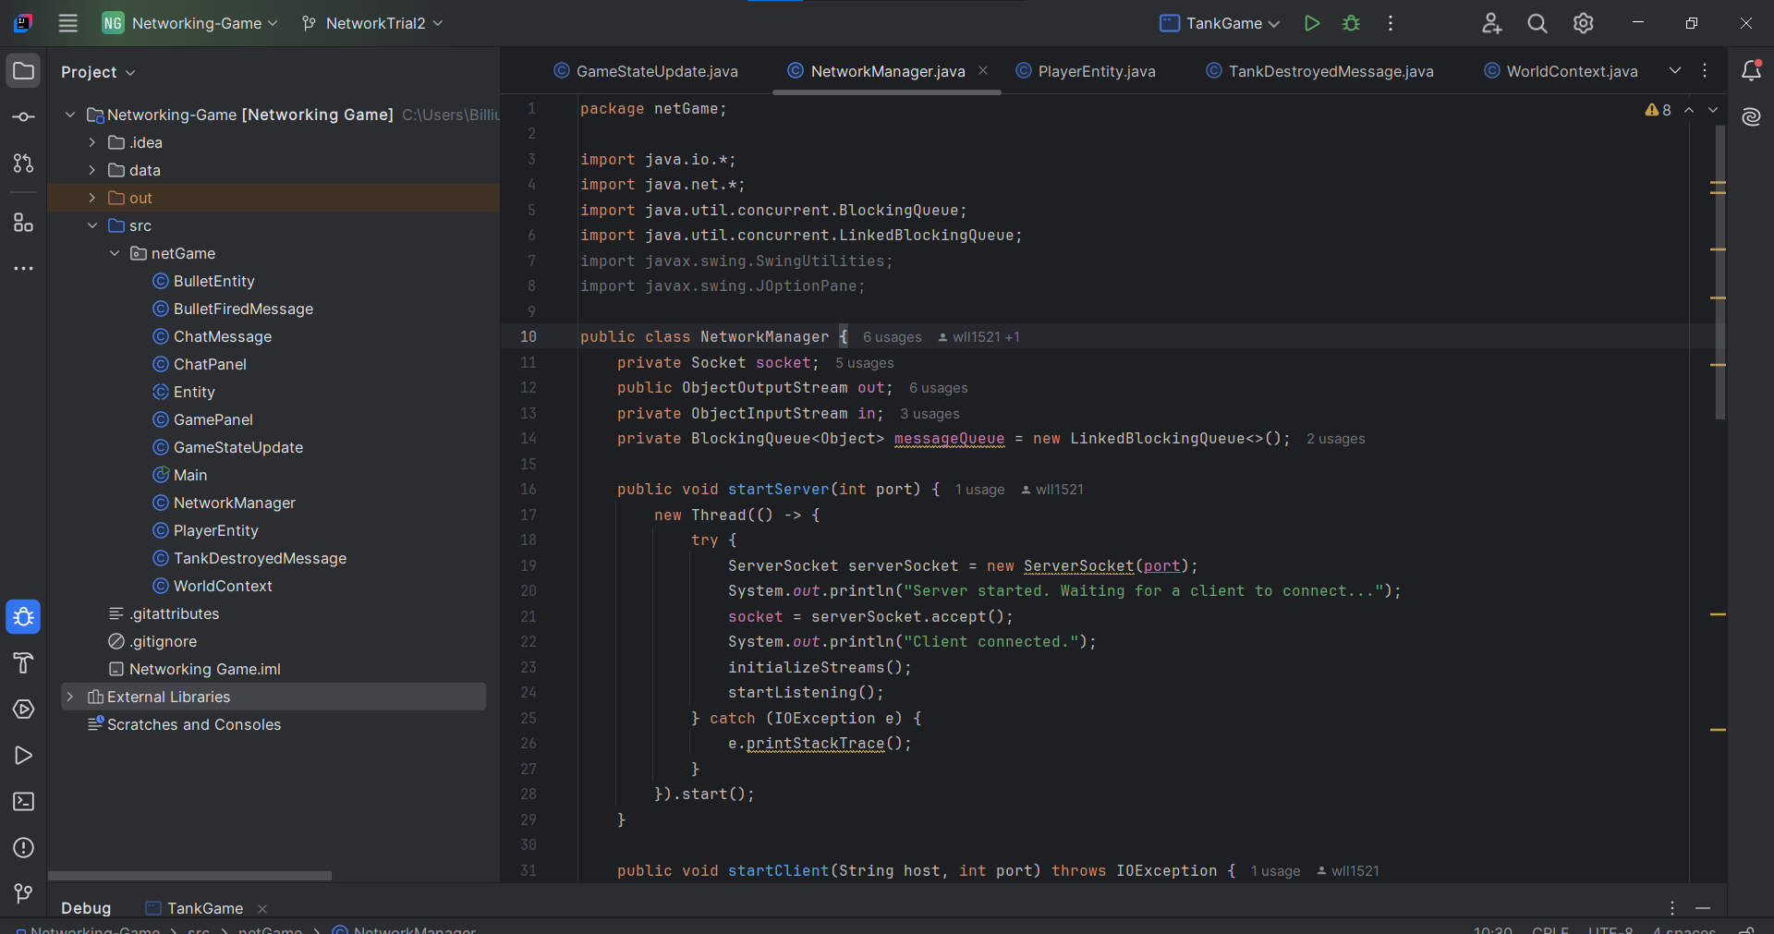
Figure 6: JetBrains IntelliJ IDEA application

If you want to be able to play two applications at once to test the functionality as we did, you can enable multiple instances. This, and other general IDEA settings can be changed in the configuration menu. To get there, you can click on the 3 dots next to the ladybug symbol and click edit.
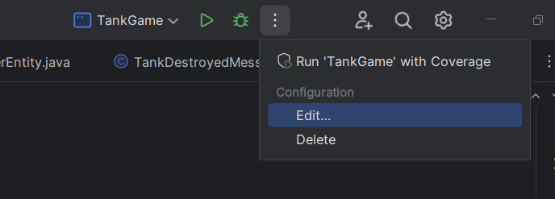
Figure 7: Edit Configurations

Ensure that the following settings are selected as shown in figure 8.
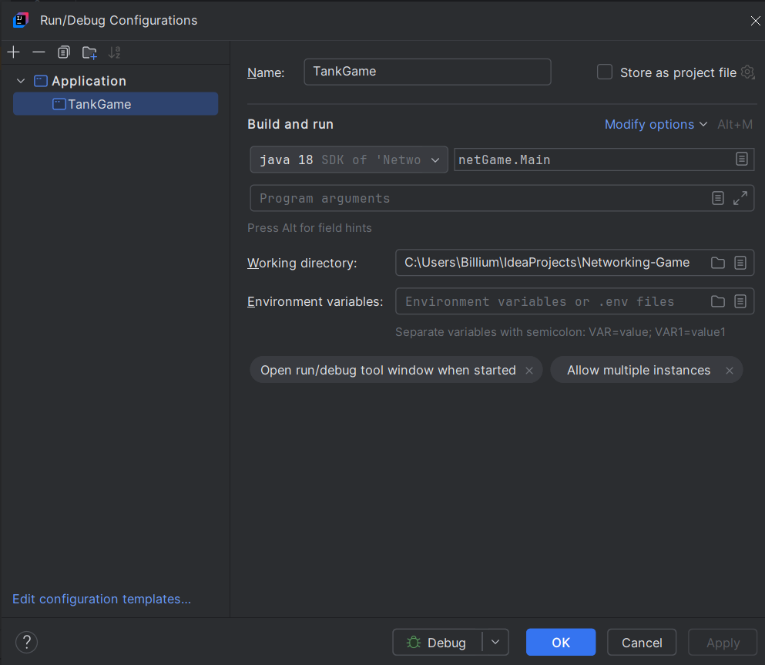
Figure 8: Configurations Menu

Now you should be able to play. To switch between versions, you can use the checkout option.

3.2 Gameplay
The motivation behind in the game is simple. Takeout your enemy before your opponent can do the same. Afterwards you can chat about how things went right and where they went wrong. Then perhaps discuss a more feature rich game alternative to play.
To begin, you must hit the run button in the IDE application.
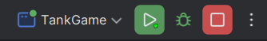
Figure 9: Run button

Afterwards, you should see a pop-up asking whether you intend to be the host or join a hosted game.
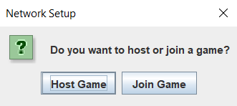
Figure 10: Host / Join Selection Screen

Upon hosting, the acting server will begin listening on its designated port for another player to join. You must leave the screen alone shown in figure 12, until you see the second screen in figure 15, otherwise you will not connect.
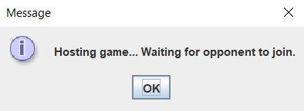
Figure 12: Hosting game pop-up. Should leave until the client joins

On the joining client side, while the host is waiting, you click the “Join Game” option instead and enter the host’s IP address. Alternatively, if you are using the same machine for observation and debugging in our case, you can just use localhost.
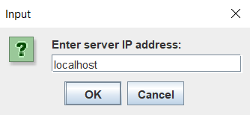
Figure 12: Joining client server IP input. We use localhost to simulate and debug on the same machine

If the connection is successful, you will see another pop-up shown in figure 14 and the host will receive one shown in figure 15.
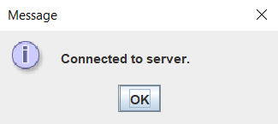
Figure 13: Pop-up notification acknowledging a successful connection to host. Should click OK before host does

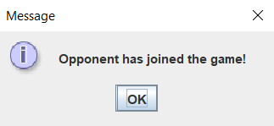
Figure 15: Pop-up host notification acknowledging a successful connection to client. Can click OK to this and then the original pop-up to begin the game

At this point the joining client should select OK and then the host should as well, starting up separate applications for each player sharing world states as they generate inputs and play the game. Note: Version NT2 currently doesn’t use this notification. Only NT3. The host has to know some other way that a client connected.
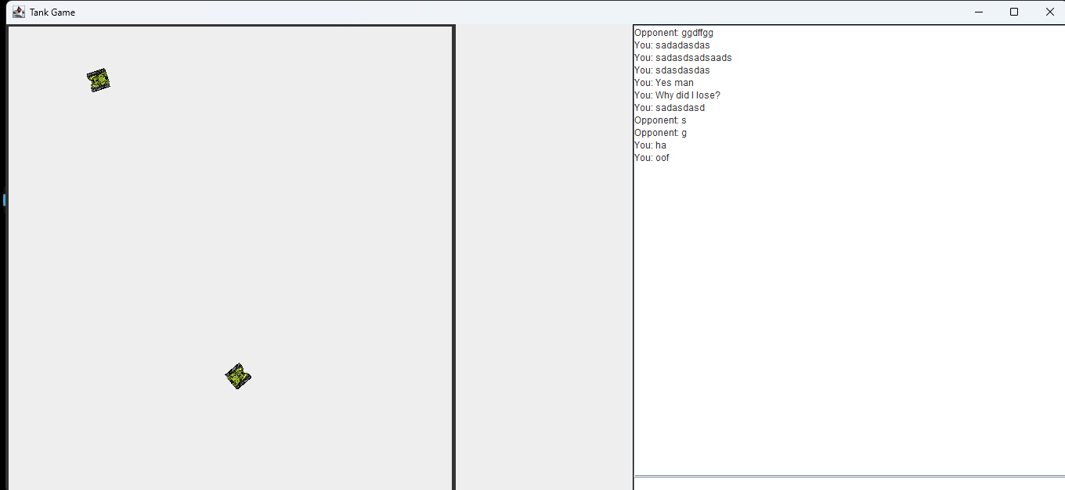
Figure 16: Application window

To move your tank you use the up, down, left and right arrow keys. To fire, you press spacebar. For chatting, you must click into the chat panel and click on the bottom text input area. Once you’ve written your message, hit enter and the focus will be sent back to the game panel automatically where you can begin moving and shooting once again.

3.3 Potential Future Additions and Directions
While this game is fully functional, there are several features that we would have liked to add for a better user experience. Extending the networking model to support more than two players in a session, better graphics and sound options. Other features such as terrain and interactable or destructible buildings, different game modes, etc.

CHAPTER III

CONCLUSION

This project game development provides insight into the complexities of distributed systems and how hosts communicate, passing messages in order to allow a seemingly infinite number of possibilities. Including this simple application that allows for the user to observe how a real-time game is programmed with implemented networking features in Java. Despite the many challenges in getting this interactive application to function, this project successfully demonstrates how to utilize an established infrastructure in order to create an engaging multiplayer experience within the Java framework. A language still used by many game developers around the world.

REFERENCES AND RESOURCES

• Community Forums:
- StackOverflow - https://stackoverflow.com/
- JetBrains - https://www.jetbrains.com/help/idea/getting-started.html
- YouTube (Math Kimchi) - https://www.youtube.com/watch?v=QDPW4oaNGHE
- YouTube Playlist (RyiSnow) - https://www.youtube.com/watch?v=om59cwR7psI&list=PL_QPQmz5C6WUF-pOQDsbsKbaBZqXj4qSq
• Graphics Assets Websites:
- Alucard. (2016). 2D Tanks Top Down. Opengameart. https://opengameart.org/content/2d-tanks-top-down
• Development Tools:
- IntelliJ IDEA - used for code development and debugging.

