# Sailing

There are three cases.

### case 1. equal_length cloth sail

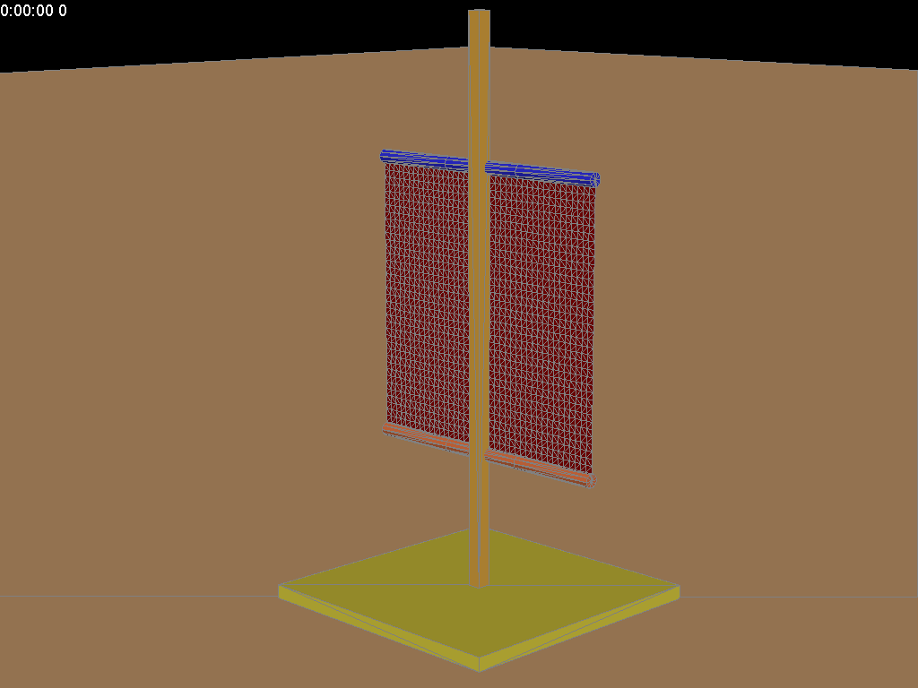 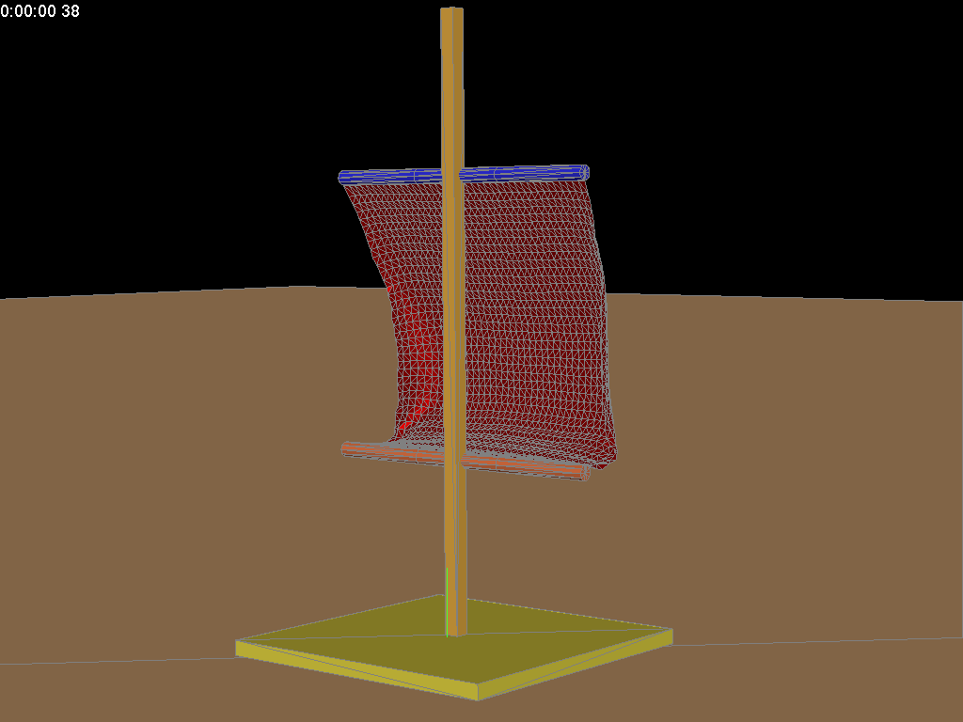

### case 2. small_top cloth sail

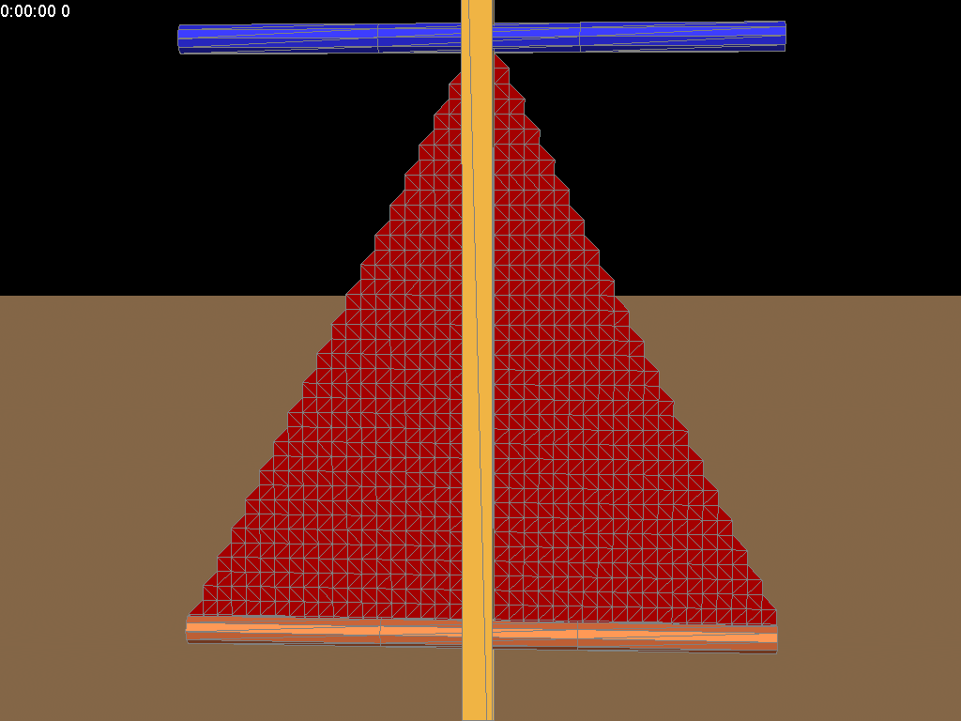

### case 3. small_bottom cloth sail

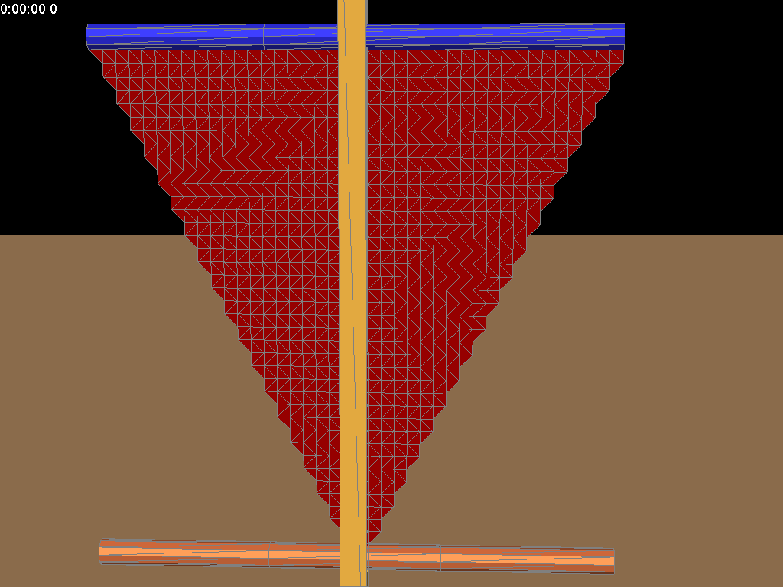

The corresponding animation showed in the folder, as well as triangular mesh for the latter two case.