Turn of Phrase

Turn of Phrase is an online Brain Game that challenges a user to find the expression, demonstrated in an illustration. Our website is an online guide to this game that provides the user with the game’s rules, a demo to the game, information about the game’s creators and a feedback form.

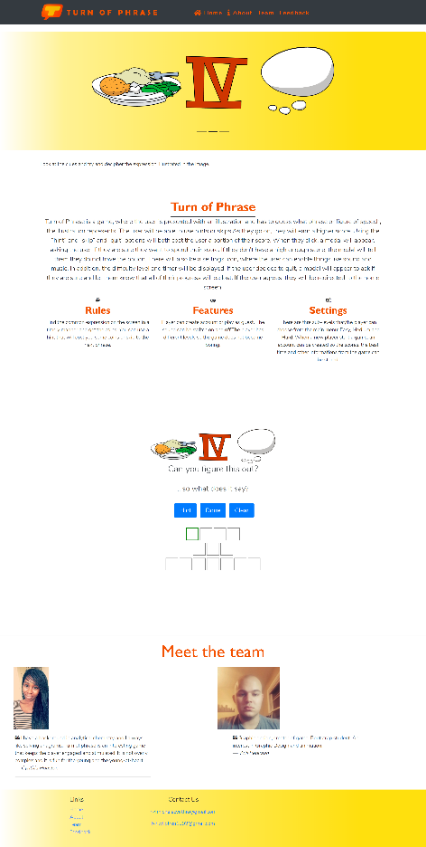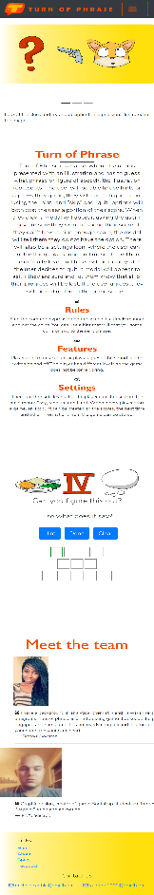 We have created a website that takes place in two pages. One page is scrolls down and the navbar links to three different sections within the page. The other page is a feedback form. We used several features we have learned from this course in the implementation of this design. We used a jumbotron that cycles through different examples of images, included in this game. We used the tooltip feature to give a hint to the example, used in the demo. We made use of the fontawesome feature, to use some icons, within the navbar and about section. We used modal features, within the demo to tell the user if they got the example right or wrong. We also used responsive web design, primarily in the about and team sections, to reorganize the page elements, for different browser width.

I learned a lot about Bootstrap, throughout this project and throughout the duration of this class in general. I learned about styling modals, which was useful to me, because up until now, I have only been aware of the alert method, which can not be stylized. I also enjoyed learning about styling different bootstrap classes with external style sheets, such as the jumbotron. That way, you can use the positive features of bootstrap, but still have a site that is unique. One problem that we came across, was that when you use the sticky header and navigate to elements on a page, the header will cover up the top of that element. The solution I came across, was to add a margin to the top of the element. I’m not sure if that is the best way to do that or not. I do intend to keep working on the project, after the duration of this class. I did not add as much style or functionality to the website as I wanted, and did not finish the game itself. We used the feedback form to demonstrate our knowledge of form elements, but it does not actually have functionality. As I learn more backend languages, I want to improve the website.