- 准备xls_deploy_tool.py工具环境。xls_deploy_tool.py是一个python脚本，运行在python环境，并且python要安装了proto组件和xlrd组件
  - 安装python运行时
    - 在python官网下载并安装python2.7（不能装最新的python3，因为python3不向下兼容，而protobuff是用python2的）。
    - 把你刚刚选择安装python的路径添加到本地环境变量的path中。如下图
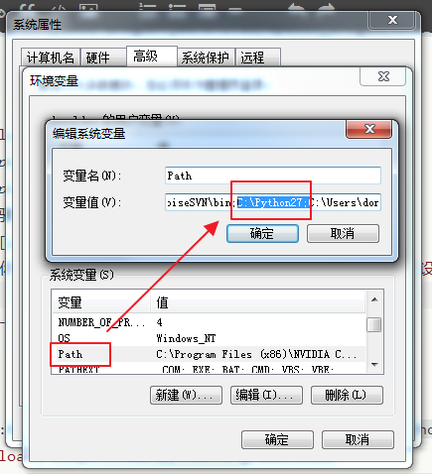
环境变量path
  - 安装setuptool
    - python安装protobuff之前，需要先安装setuptool。setuptool类似于python的一个组件安装管理器
    - 在setuptool官网的最下面点击下载安装文件，这里我们可以安装setuptools-5.1.zip。解压它。
    - 用命令行进入刚解压的setuptool目录，执行命令python setup.py install
  - 安装protobuff
    - 我们目前使用2.5.0的protobuff版本
    - 在protobuff官网下载protobuff的“全文件压缩包”（protobuf-2.5.0.tar.bz2）和“编译器压缩包”（protoc-2.5.0-win32.zip）
    - 将“全文件压缩包”解压
    - 在里面创建compiler文件夹，即protobuf-2.5.0\python\google\protobuf\compiler
    - 将“编译器压缩包”里的protoc.exe拷到protobuf-2.5.0\src
    - 用命令行进入刚解压的protobuf\python目录，执行命令python setup.py install
  - 安装xlrd（xls reader）
    - 在xlrd官网下载并解压
    - 用命令行进入刚解压的xlrd目录，执行命令python setup.py install
- xls_deploy_tool.py
  - xls_deploy_tool.py是腾讯魔方工作室jameyli同学的作品
  - 使用方法是在命令行键入如下命令
    - python xls_deploy_tool.py <表格名> <xls文件名>
  - 它将“符合格式”的xls文件生成data文件和proto文件
  - “符合格式”指的是要求xls的每一列的前4行用于定义数据格式。例子如图：
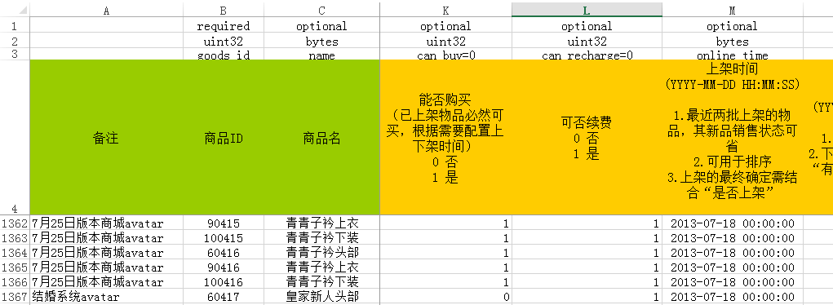
    - 详细格式文档可参考xls_deploy_tool.py 的文件注释。
- xls_deploy_tool.py生成的文件
  - 生成的data文件是最终在游戏内进行读取的数据文件，以protobuff定义的格式进行压缩存储（或者明文存储，但xls_deploy_tool.py暂时只实现了压缩存储）
  - 生成的proto文件是用于解释上面这个data文件的解释类。
    - 但由于我们需要在我们游戏内对其进行读取，而游戏往往只能运行其他高级语言，所以需要将proto翻译成对应的语言
    - 这里以C#为例
- 将proto语言翻译成C#语言
  - 需要分两步走：
    - 使用“编译器压缩包”（比如protoc-2.5.0-win32.zip）的protoc.exe将proto解释成“FileDescriptorSet ”中间格式
    - 使用protobuf-net的protogen.exe将“FileDescriptorSet ”翻译成cs文件
  - protoc.exe
    - 使用先前“编译器压缩包”（protoc-2.5.0-win32.zip）里的protoc.exe，命令行命令大概是
  - protogen.exe
    - 下载、解压protobuf-net
    - ProtoGen目录都需要用到，其中的protogen.exe负责将proto文件翻译成cs代码。
- 在Unity读取data文件，并且用cs代码解释
  - 到protobuf-net的github网站，下载工程的zip包，解压，把里面的protobuf-net文件夹放置在Unity工程的Assets\Plugins目录下
注：不能使用protobuf-net\Full\unity\下的protobuf-net.dll拷到Unity工程的Assets\Plugins目录下的方法。
因为部署到iOS设备，会发生JIT错误（ExecutionEngineException: Attempting to JIT compile method）。原因是因为iOS不允许JIT（Just In Time），只允许AOT（Ahead Of Time）。
解决这个问题的方法之一是使用protobuf-net的precompile工具，但研究发现，过程会比较麻烦。具体可参阅precompile的help命令，或者谷歌“precompile protobuf net”。
解决这个问题的方法之二，也是比较简单、证明过可行的，就是直接把源代码代替protobuf-net.dll，拷到Unity工程的Assets\Plugins目录下。
  - 引用导出的cs类，using ProtoBuf的命名空间，使用Serailizer.Deserialize<T>()全局函数，进行数据的解释，关键代码如下
    - private T ReadOneDataConfig<T>(string FileName)
    - {
    - FileStream fileStream;
    - fileStream = GetDataFileStream(FileName);
    - if (null != fileStream)
    - {
    - T t = Serializer.Deserialize<T>(fileStream);
    - fileStream.Close();
    - return t;
    - }

    - return default(T);
    - }
    - private FileStream GetDataFileStream(string fileName)
    - {
    - string filePath = GetDataConfigPath(fileName);
    - if (File.Exists(filePath))
    - {
    - FileStream fileStream = new FileStream(filePath, FileMode.Open);
    - return fileStream;
    - }

    - return null;
    - }
    - private string GetDataConfigPath(string fileName)
    - {
    - return Application.streamingAssetsPath + "/DataConfig/" + fileName + ".data";
    - }
附Killer的bat文件
- @echo off

- set XLS_NAME=%1
- set SHEET_NAME=%2
- set DATA_DEST=%3

- echo.
- echo =========Compilation of %XLS_NAME%.xls=========

- ::---------------------------------------------------
- ::第一步，将xls经过xls_deploy_tool转成data和proto
- ::---------------------------------------------------
- set STEP1_XLS2PROTO_PATH=step1_xls2proto

- @echo on
- cd %STEP1_XLS2PROTO_PATH%

- @echo off
- echo TRY TO DELETE TEMP FILES:
- del *_pb2.py
- del *_pb2.pyc
- del *.proto
- del *.data
- del *.log
- del *.txt

- @echo on
- python xls_deploy_tool.py %SHEET_NAME% ..\DataConfig\%XLS_NAME%.xls

- ::---------------------------------------------------
- ::第二步：把proto翻译成cs
- ::---------------------------------------------------
- cd ..

- set STEP2_PROTO2CS_PATH=.\step2_proto2cs
- set PROTO_DESC=proto.protodesc
- set SRC_OUT=..\src

- cd %STEP2_PROTO2CS_PATH%

- @echo off
- echo TRY TO DELETE TEMP FILES:
- del *.cs
- del *.protodesc
- del *.txt

- @echo on
- dir ..\%STEP1_XLS2PROTO_PATH%\*.proto /b > protolist.txt

- @echo on
- for /f "delims=." %%i in (protolist.txt) do protoc --descriptor_set_out=%PROTO_DESC% --proto_path=..\%STEP1_XLS2PROTO_PATH% ..\%STEP1_XLS2PROTO_PATH%\*.proto
- for /f "delims=." %%i in (protolist.txt) do ProtoGen\protogen -i:%PROTO_DESC% -o:%%i.cs

- cd ..

- ::---------------------------------------------------
- ::第三步：将data和cs拷到Assets里
- ::---------------------------------------------------

- @echo off
- set OUT_PATH=..\Assets
- set DATA_DEST=StreamingAssets\DataConfig
- set CS_DEST=Scripts\Killer\DataConfig\ProtoGen

- @echo on
- copy %STEP1_XLS2PROTO_PATH%\*.data %OUT_PATH%\%DATA_DEST%
- copy %STEP2_PROTO2CS_PATH%\*.cs %OUT_PATH%\%CS_DEST%

- ::---------------------------------------------------
- ::第四步：清除中间文件
- ::---------------------------------------------------
- @echo off
- echo TRY TO DELETE TEMP FILES:
- cd %STEP1_XLS2PROTO_PATH%
- del *_pb2.py
- del *_pb2.pyc
- del *.proto
- del *.data
- del *.log
- del *.txt
- cd ..
- cd %STEP2_PROTO2CS_PATH%
- del *.cs
- del *.protodesc
- del *.txt
- cd ..

- ::---------------------------------------------------
- ::第五步：结束
- ::---------------------------------------------------
- cd ..

- @echo on
附protoc.exe的参数文档：
- E:\Project\ied_kl_rep\client_proj\trunk\KillerProject\DataConfigBuild\step2_prot
- o2cs>protoc --help
- Usage: protoc [OPTION] PROTO_FILES
- Parse PROTO_FILES and generate output based on the options given:
- -IPATH, --proto_path=PATH Specify the directory in which to search for
- imports. May be specified multiple times;
- directories will be searched in order. If not
- given, the current working directory is used.
- --version Show version info and exit.
- -h, --help Show this text and exit.
- --encode=MESSAGE_TYPE Read a text-format message of the given type
- from standard input and write it in binary
- to standard output. The message type must
- be defined in PROTO_FILES or their imports.
- --decode=MESSAGE_TYPE Read a binary message of the given type from
- standard input and write it in text format
- to standard output. The message type must
- be defined in PROTO_FILES or their imports.
- --decode_raw Read an arbitrary protocol message from
- standard input and write the raw tag/value
- pairs in text format to standard output. No
- PROTO_FILES should be given when using this
- flag.
- -oFILE, Writes a FileDescriptorSet (a protocol buffer,
- --descriptor_set_out=FILE defined in descriptor.proto) containing all of
- the input files to FILE.
- --include_imports When using --descriptor_set_out, also include
- all dependencies of the input files in the
- set, so that the set is self-contained.
- --include_source_info When using --descriptor_set_out, do not strip
- SourceCodeInfo from the FileDescriptorProto.
- This results in vastly larger descriptors that
- include information about the original
- location of each decl in the source file as
- well as surrounding comments.
- --error_format=FORMAT Set the format in which to print errors.
- FORMAT may be 'gcc' (the default) or 'msvs'
- (Microsoft Visual Studio format).
- --plugin=EXECUTABLE Specifies a plugin executable to use.
- Normally, protoc searches the PATH for
- plugins, but you may specify additional
- executables not in the path using this flag.
- Additionally, EXECUTABLE may be of the form
- NAME=PATH, in which case the given plugin name
- is mapped to the given executable even if
- the executable's own name differs.
- --cpp_out=OUT_DIR Generate C++ header and source.
- --java_out=OUT_DIR Generate Java source file.
- --python_out=OUT_DIR Generate Python source file.
附protogen.exe参数列表
- E:\Project\ied_kl_rep\client_proj\trunk\KillerProject\DataConfigBuild\step2_prot
- o2cs\ProtoGen>protogen.exe --help
- protobuf-net:protogen - code generator for .proto
- usage: protogen -i:{infile2} [-i:{infile2}] [-o:{outfile}] [-t:{template}] [-p:{
- prop}[=value]] [-q] [-d]

- -i: Input file(s); proto definitions, either as text or pre-compiled binary (via
- protoc)
- -o: Output file; if none specified, writes to stdout
- -t: Template to use; defaults to csharp
- -p: Property for the template; value defaults to true; use -p:help to view avail
- able options
- -q: Quiet; suppresses header
- -d: Include all dependencies of the input files in the set so the set is self-co
- ntained.
- -ns: Default namespace; used in code generation when no package is specified

- Examples:

- protogen -i:input.proto -o:output.cs
- protogen -i:input.proto -o:output.xml -t:xml
- protogen -i:input.proto -o:output.cs -p:datacontract -q
- protogen -i:input.proto -o:output.cs -p:observable=true

