递归方式学习方法

Problem 5

1.Circuit switching（电路交换技术）is used in public telephone

networks 公用电话网络 and is the basis for private networks built on leased lines（租用线路：电话公司租用的电话线路） and using on-site circuit switches.

Circuit switching was developed to handle voice

traffic but can also handle digital data, although this latter use is often inefficient.

2.With circuit switching, a a dedicated path （专有线路 专线？） is established between two stations for communication. Switching and transmission resources（交换和传输线路） within the network are reserved for the exclusive use（独占） of the circuit for the duration of the connection. The connection is transparent : Once it is established, it appears to attached devices（附加设备） as if there were a direct connection.

3.

**知识点：数据报交换和虚电路交换技术**

Packet switching（数据包交换）was designed to provide a more efficient facility（设备） than circuit switching for bursty data traffic （暴冲流量：数据突增） .With packet switching, a station transmits data（传输数据） in small blocks,called packets. . Each packet contains some portion（一部分） of the user data plus control information（用户数据和信息控制） needed for proper functioning of the network. A key distinguishing element（区分元素） of packet-switching networks is whether the internal operation（内部操作） is datagram or virtual circuit （数据报或者虚电路） .

4.station（站）和node（节点）的区别

The devices attached to the network are referred to as station *.* The switching devices whose purpose is to provide communication are referred to as nodes *.*

5.For switched networks,some nodes connect only to other nodes. Their sole task（唯一的） is the Internal (to the network) switching of data . Other nodes have one or more stations attached as well; in addition to their switching functions, such nodes accept data from and deliver（传递） data to the attached stations. **.**

6.Communication via circuit switching（通过电路交换的通信） implies that there is a dedicated(专用的)communication path between two stations. That path is a connected sequence of links between network nodes （一条连接网络节点之间已连接序列） .

On each physical link, a logical channel （一条逻辑信道）  is dedicated to the connection（连接专用）.

Communication via circuit switching（电路交换技术） involves three phases（包括三个阶段）, which can be explained with a simple network system **.**

7.A public telecommunications network（电信网络）can be described using four generic architectural components: Subscribers（用户）,Subscriberline（用户线路）,Exchanges（交换）,Trunks（躯干） .

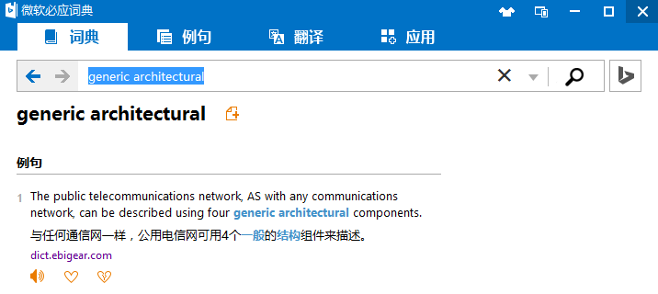

8.Three elements of Circuit switch node are controlunit,digitalswitch,networkinterface

9. In softswitch terminology（软交换技术的术语：将传统的交换设备部件化，分为[呼叫控制](http://baike.baidu.com/view/8244363.htm)与媒体处理，二者之间采用标准协议（[MGCP](http://baike.baidu.com/subview/757434/757434.htm)、[H248](http://baike.baidu.com/subview/3320396/3320396.htm)）且主要使用纯软件进行处理）, the physical switching function is performed by media gateway （媒体网关：一个连接不同类型网络的单元，执行全异网络例如PSTN（PSTN ( Public Switched Telephone Network )定义：公共交换电话网络，一种常用旧式电话系统。即我们日常生活中常用的电话网。）之间的转换；基于IP或ATM的数据网络；2.5G和3G无线电接入网络或 PBX（Private Branch Exchange，用户级交换机）） .

10. Packet switching features delivery of variable bit rate data streams (sequences of packets) over a computer network which allocates transmission resources（[分配](http://cn.bing.com/dict/clientsearch?mkt=zh-CN&setLang=zh&form=BDVEHC&ClientVer=BDDTV3.5.0.4311&q=allocates%20transmission%20resources" \t "_blank)[传输](http://cn.bing.com/dict/clientsearch?mkt=zh-CN&setLang=zh&form=BDVEHC&ClientVer=BDDTV3.5.0.4311&q=allocates%20transmission%20resources" \t "_blank)[资源](http://cn.bing.com/dict/clientsearch?mkt=zh-CN&setLang=zh&form=BDVEHC&ClientVer=BDDTV3.5.0.4311&q=allocates%20transmission%20resources" \t "_blank)） as needed using nodes . When traversing network adapters（经过网络适配器）, switches, routers, and other network nodes, packets are buffered and queued （缓冲和排队） , resulting in variable delay and throughput（吞吐量） depending on the network's capacity and the traffic load on the network.

11. Packet switching has four advantages over circuit switching: 1.Line efficiency is greater 2.A packet-switching network can perform data-rate conversion. 3.When traffic becomes heavy on a circuit-switching network,some calls are Blocked 4.Priorities can be used .

12. Switching concerned with three types of delay: Propagation delay（传播延迟）,transmission time（传播时间）,No dedelay

13.ATM（**异步传输模式**（**ATM** Asynchronous Transfer Mode），就是建立在电路交换和分组交换的基础上的一种新的交换技术） is designed to unify（统一化） telecommunication and computer networks . ATM uses asynchronous time-division multiplexing （异步时分复用） , and encodes data into cells （信元） . This differs from approaches such as the Internet Protocol or Ethernet that use variable sized packets and frames（包和帧）. ATM uses

a connection-oriented（面向连接的） model in which a virtual circuit must be established between two endpoints before the actual data exchange begins.