1. 通訊網路安全 (無線安全)

AP

I.攻擊

2. 系統|DB|Web OWASP TOP10 WAP

程式 SQLi WEP

WEP2

II 3.企業安全

III. 4. IOT

Cloud 🡺中級 aircrade-ng

App

7.app http、dns、網頁攻擊

3.IP ICMP ping 🡨-Synflood

Kali linux的httrack上面打

apt-get install httrack

然後輸入httrack

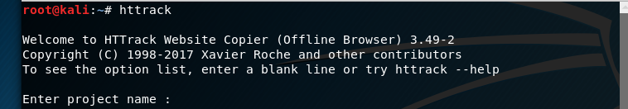

輸入名稱

放的位置(我放桌面)

然後打網址(你打GOOGLE電腦會爆掉 東西太多)

<https://www.youtube.com/watch?v=EygeNcS0RRU>

影片完整教學在這裡

今天教的

1.

<https://github.com/MyDearGreatTeacher/IPAS/blob/master/%E8%B3%87%E8%A8%8A%E5%AE%89%E5%85%A8%E6%8A%80%E8%A1%93/%E7%B6%B2%E7%AB%99%E5%AE%89%E5%85%A8.md>

3. 這個翻中文(作業) <https://github.com/MyDearGreatTeacher/IPAS/blob/master/%E8%B3%87%E8%A8%8A%E5%AE%89%E5%85%A8%E6%8A%80%E8%A1%93/%E9%9B%B2%E7%AB%AF%E5%AE%89%E5%85%A8.md>

2. <https://github.com/MyDearGreatTeacher/IPAS/blob/master/%E8%B3%87%E8%A8%8A%E5%AE%89%E5%85%A8%E6%8A%80%E8%A1%93/3_%E5%AE%89%E5%85%A8%E9%98%B2%E8%AD%B7%E8%88%87%E5%AE%89%E5%85%A8%E7%87%9F%E9%81%8B.md>