CARD k-mers: Advancing Metagenomic Surveillance for Antimicrobial Resistance with Rapid Pathogen-of-Origin Prediction

Mateusz A. Wlodarski^{a,b}, Tammy T. Y. Lau^{a,b,%}, Brian P. Alcock^{a,b}, Amogelang R. Raphenya^{a,b}, Finlay Maguire^{c,d,e}, Robert G. Beiko^{c,d} , Tiffany E. Ta^{a,b} , & Andrew G. McArthur^{a,b,#}

ª M.G. DeGroote Institute for Infectious Disease Research, McMaster University, Hamilton, Ontario, Canada
^{b} Department of Biochemistry and Biomedical Sciences, McMaster University, Hamilton, Ontario, Canada
^{c} Faculty of Computer Science, Dalhousie University, Halifax, Nova Scotia, Canada
^{d} Institute for Comparative Genomics, Dalhousie University, Halifax, Nova Scotia, Canada
^{e} Department of Community Health & Epidemiology, Dalhousie University, Halifax, Nova Scotia, Canada

KEYWORDS: metagenomics, taxonomic classification, antimicrobial resistance, k-mers, AMR surveillance

ABSTRACT
Antimicrobial resistance (AMR) is a global health crisis that demands urgent, inter-disciplinary surveillance and prevention across human, agricultural, and environmental networks. One challenge during antibiotic-resistant outbreaks is quickly identifying the pathogen-of-origin responsible for the onset of symptoms. This diagnosis is crucial for doctors to prescribe appropriate antibiotics and begin treatment. Traditional culture-based methods designed for this task remain the gold standard, however there is a need for faster results and the capability to sequence the entire microbial environment (i.e., metagenome). Taxonomic k-mer classifiers like Kraken2 and CLARK circumvent these shortcomings by using exact word matching between a reference set of pre-computed, pathogen-specific k-mers and a query sequence, but are often designed for general use and perform poorly on niche sequence spaces. Here we present CARD k-mers, a novel classification tool and the first to combine species-level taxonomic predictions and mobility analysis specifically for antibiotic resistance genes (ARGs) encoded in short metagenomic reads. By synergizing with the Comprehensive Antibiotic Resistance Database (CARD), CARD k-mers predicts the pathogen-of-origin and genomic context of input sequence data. We benchmarked CARD k-mers against Kraken2 and CLARK using 103,456 in silico pathogen-specific AMR alleles, where it outperformed its competitors by 10.85% and 15.2% respectively, while correctly predicting the genomic data-type of 176 plasmid-specific and 4,590 chromosome-specific AMR alleles, at speeds upwards of 675,675 reads per minute. This delivery of accurate, species-level taxonomic predictions to ARGs in just minutes significantly advances the speed and scope of untargeted AMR pathogen surveillance over current targeted qPCR methods and other metagenomic classifiers, and the tool is suitable for researchers with basic command-line skills. CARD k-mers is available at: https://github.com/arpcard/rgi#using-rgi-kmer-query-k-mer-taxonomic-classification.
ABBREVIATIONS:
CARD: The Comprehensive Antibiotic Resistance Database
CARD-R: CARD Resistomes & Variants
LGT: lateral gene transfer
RGI: Resistance Gene Identifier
AMR: antimicrobial resistance
ARG: antibiotic resistance gene
qPCR: quantitative Polymerase Chain Reaction
SNP: single nucleotide polymorphism
CRE: cumulative relative entropy
UMAP: Uniform Manifold Approximation and Projection
DATA SUMMARY:
CARD k-mers is written in Python and can be used once the Resistance Gene Identifier software has been installed, along with CARD Resistomes & Variants sequence collection to build the k-mer reference library. Full software documentation is available at from https://github.com/arpcard and all validation datasets and results from https://github.com/wlodarsm/card_k-mers/tree/main
IMPACT STATEMENT
Antimicrobial resistance is a global health crisis that is motivating the need for fast and accurate pathogen-of-origin identification of clinical and environmental samples via the classification of short metagenomic sequencing reads. We compare the novel computational tool CARD k-mers with leading k-mer classifiers, Kraken2 and CLARK in a head-to-head classification test involving antibiotic resistance genes and give evidence-based recommendations for the best k-mer sizes for antimicrobial resistant gene sequences. This marks the pioneering adaptation of a k-mer classifier tailored for sequences containing antibiotic resistance genes. Overall, our work illustrates that better pathogen-of-origin classification using k-mer classifiers can be improved by defining a narrowed sequence space.
INTRODUCTION Antimicrobial resistance (AMR) is a pressing global health challenge exacerbated by the overuse of antibiotics and a stagnation in the development of novel drugs^{1,2}.Without decisive mitigation efforts, AMR is projected to cause approximately 39 million cumulative deaths by 2050¹. Antibiotic-resistant bacterial pathogens harboring ARGs evade treatment through well-characterized resistance mechanisms³, with particular concern for plasmid-borne elements due to their high potential mobility between organisms via lateral gene transfer (LGT)⁴. These events facilitate the rapid dissemination of resistance traits, leading to multidrug- and ultimately, to pandrug-resistant organisms ⁵. The genomic complexity introduced by LGT amplifies the challenges of AMR surveillance and containment.
Recent advances in sequencing technologies now enable comprehensive genomic surveillance of microbial environments, from wastewater and agricultural runoff to clinical samples^{6,7}. These methods facilitate the detection and tracking of ARGs and priority AMR pathogens across diverse contexts. Resources such as CARD have become indispensable in this effort, offering tools like the Resistance Gene Identifier (RGI, CARD’s main software) for in silico identification of known ARGs and putative novel variant discovery⁸. While these advancements have improved global public health outcomes, a critical gap remains: identifying the pathogen-of-origin in complex metagenomic samples. This step is essential in clinical settings, where timely and accurate diagnoses are necessary to guide effective antibiotic treatment⁶.
Historically, pathogen and plasmid identification relied on cultured isolates, where growth media and molecular diagnostics inherently provided taxonomic information and genomic context⁹. These traditional phenotypic methods are limited by their reliance on culturable bacteria and inability to detect novel or diverse pathogens and plasmids, while being labor-intensive¹⁰. Consequently, culture-independent, genotypic methods are increasingly replacing traditional approaches due to their ability to sequence entire microbial communities (metagenomes) with high-throughput and speed². These metagenomic datasets, often containing millions of sequencing reads, present unique analytical challenges for determining the pathogen-of-origin.
For decades, alignment-based tools such as BLAST, Burrows-Wheeler Transform, and Hidden Markov Model searches have been the dominant approaches for sequence classification¹¹. These methods rely on aligning DNA reads to a reference genome to assign taxonomic labels. However, they are computationally intensive, rely on subjective scoring matrices, and assume homology between sequences, making them ill-suited for analyzing large, diverse metagenomes^{6,11}. LGT events, rapid mutation rates, and genomic variability in microbial populations often violate the core assumptions of alignment-based approaches, further limiting their utility¹¹. Additionally, alignment scoring can be subject to bias; for example, older BLOSUM matrices, such as BLOSUM62, have been shown to yield inflated scores compared to updated versions¹².
To address these challenges, bioinformatics has shifted toward alignment-free sequence classification methods, particularly k-mer-based approaches, which are also used in metagenomic assembly and a genome-wide association studies^{13–15}. These methods rely on exact word matching between pre-computed pathogen-specific k-mers and query sequences, bypassing the computational bottlenecks of alignment tools. Kraken2 and CLARK have emerged as leading k-mer-based classifiers, capable of processing millions of reads per minute, making them highly suitable for large-scale sequence analysis^{16,17}. Kraken2 classifies sequences using the last common ancestor approach, assigning reads to the lowest common taxonomic rank shared by all organisms containing a given k-mer. This conservative strategy reduces overclassification by accounting for k-mer sharing across taxa. Conversely, CLARK relies on discriminatory k-mers, which are uniquely associated with specific taxa, enabling more precise classifications at finer taxonomic levels. However, recent evaluations have demonstrated that standard metagenomic classification tools including Kraken2 and CLARK, rely heavily on general-purpose reference databases that are not optimized for domain-specific analyses^{18–20}. This dependency can severely limit their accuracy and precision when applied to AMR-focused datasets, where the taxonomic and functional complexity often surpasses what broad-spectrum reference libraries can effectively capture. As a result, there is a clear need for specialized, context-aware approaches that better reflect the unique composition and genomic diversity of AMR-related microbial communities. Additionally, current targeted qPCR metagenomic surveillance methods struggle at capturing emerging pathogens and ARGs^{21,22}. This highlights the need for a specialized classifier optimized for ARGs and their associated pathogens, enabling untargeted AMR surveillance of metagenomic samples.
Introducing CARD k-mers
CARD now supports a pilot k-mer classification algorithm, CARD k-mers, specifically tailored for untargeted metagenomic AMR surveillance. CARD k-mers integrates seamlessly with CARD’s Resistomes & Variants sequence data (CARD-R), enabling accurate species-level taxonomic predictions and mobility analysis for short metagenomic reads encoding ARGs. By leveraging CARD-R ARG alleles matching the RGI-Strict criteria –representing ARG variants closely related to known alleles but not yet described in the literature—CARD k-mers is uniquely positioned to detect pathogens with both known and novel functional variant ARGs. An example metagenomic AMR surveillance workflow with CARD k-mers is available in Figure 1.
The CARD k-mers algorithm
CARD k-mers operates by constructing a reference k-mer set derived from the alleles stored in the CARD-R database. For CARD-R version 4.0.0, this dataset includes approximately 40 million k-mers of length 61 (61-mers). These k-mers are divided into two primary categories: taxonomic and genomic k-mers, each serving a specific role in classification and analysis. Taxonomic k-mers are designed to predict the pathogen-of-origin and consist of single-species k-mers, which are unique to individual species, and genus-specific k-mers, which are unique to a specific genus. These classifications allow for both species-level identification and broader taxonomic resolution when species-specific information is unavailable. Genomic k-mers, on the other hand, focus on the genomic context of ARGs and their potential mobility. They are further categorized into k-mers unique to chromosomal sequences, k-mers unique to plasmid sequences, and k-mers shared between chromosomes and plasmids. This dual classification strategy enables CARD k-mers not only to identify the pathogen-of-origin but also to evaluate the mobility risks of associated ARGs. The inclusion of mobility assessment, in addition to taxonomic classification, distinguishes CARD k-mers from other k-mer-based classifiers and provides valuable insights into the potential dissemination of resistance traits.
To assign taxonomic predictions, input sequences encoding ARGs such as FASTA files, RGI-predicted open reading frames, or metagenomic reads must meet a minimum coverage threshold defined by the minimum coverage parameter, which is set to a default value of 10 k-mers. This threshold requires at least 10 k-mers from a single category (taxonomic or genomic) to match the input sequence for a classification to be assigned. Classification decisions follow a structured rules-based logic tree detailed in Figure 2.
The CARD k-mers algorithm is implemented as a command-line tool within the RGI software under the command RGI kmer_query. The tool accepts input files in multiple formats, including FASTA, RGI JSON, and RGI BAM, and produces output files in both text and JSON formats (Figure 3, 4). These outputs provide a summary of the pathogen-of-origin predictions and k-mer counts for chromosomal and plasmid sequences associated with the input data. Currently, CARD k-mers supports the classification of 377 pathogens and two genomic origin types: chromosome and plasmid. As regular updates continue to occur in CARD, improved accuracy and utility of CARD k-mers will follow. Comprehensive documentation, including installation guidelines and usage instructions, is available at https://github.com/arpcard/rgi#using-rgi-kmer-query-k-mer-taxonomic-classification.
METHODS
Classification validation datasets
Two datasets were constructed to perform separate validation tests for CARD k-mers: pathogen and genomic classification. The first dataset to validate pathogen classification accuracy began with 320,614 in silico predicted ARG alleles, sourced from CARD-R version 4.0.0 (Figure 5). As an initial filter, 9,722 alleles were excluded because of probable LGT occurence, since they were observed in multiple species, making them non-pathogen-specific. For example, prevalence sequence "A" was excluded as it appeared in 48 different pathogens, whereas prevalence sequence "B," unique to Salmonella enterica, was retained. Two-thirds of the alleles (rounded down) for each pathogen were allocated to a "reference set" to build the pathogen-specific k-mer library for a custom version of CARD k-mers. The remaining one-third was assigned to a "testing set" for validation. To ensure inclusion, each pathogen required at least three unique alleles in CARD-R, the minimum necessary for the one-third holdout validation strategy. As a result, 62 pathogens were excluded due to insufficient data, leaving a total of 315 pathogens in the dataset. Stratifying the data by pathogen preserved the relative allele distribution rates of the original CARD-R dataset. Altogether, the training set contained 207,589 alleles from 315 pathogens, while the testing set included 103,456 alleles to validate pathogen classification accuracy. CARD k-mers (RGI version 6.0.2) was compared against two Kraken2 and one CLARK classifier. Kraken2 default (version 2.0.8) utilized the standard 70 GB library, and Kraken2 (CARD), used the same custom reference set alleles as CARD k-mers. CLARK (version 1.3.0) used its standard library. The second validation dataset included a subset of the 8,207 genomic-specific alleles (alleles found exclusively in chromosomes or plasmids) from the testing set and were used to evaluate the genomic classification accuracy of CARD k-mers (Figure 6).
Classification rules
Following the classification of the 103,456 test set alleles, output files containing pathogen-of-origin prediction data were generated from each of the four classifiers: CARD k-mers, Kraken2, CLARK, and Kraken2 (CARD). Kraken2 classifiers assigned highly specific taxonomy labels, often down to the exact strain level. To standardize comparisons, an intermediate taxonomy mapping was created using ENTREZ and NCBI’s taxonomy database to scrape taxonomy identifiers and corresponding scientific names for Kraken2 and CLARK. This step was unnecessary for CARD k-mers, as its output inherently includes the scientific names of predicted pathogens.
Classification accuracy was assessed by comparing the predicted pathogen-of-origin to the labelled pathogen in CARD-R for each allele. For Kraken2 classifiers, a species-level prediction was considered correct if there was an exact scientific name match. Since alleles in CARD-R are mapped to a base species, Kraken2 predictions specifying a strain name were also accepted as correct if the base species matched. For example, if Kraken2 predicted the PO of prevalence sequence “93,594” as Escherichia coli s8 0145:H28 str. RM12581, this was considered a correct pathogen prediction because the CARD-R label for this allele was Escherichia coli. Genus-level classification accuracy was recorded using similar criteria, requiring an exact genus match between the predicted pathogen and the CARD-R label genus. False species predictions were labelled as erroneous calls if an incorrect species name was produced, unclassified if the call was ambiguous, and rejected (CARD k-mers only) if the query sequence failed to meet the minimum coverage threshold value.
For the CARD k-mers genomic classification accuracy test, accuracy was evaluated based on the ability of CARD k-mers to correctly classify the genomic data-type of each allele as either plasmid or chromosome. Predictions of “chromosome & plasmid” indicated that the algorithm found genomic k-mers within input sequences belonging both to plasmids and chromosomes, whereas “no genomic info” predictions were deemed as uninformative.
Performance benchmarking of CARD k-mers library construction and query processing
Reference k-mer libraries for CARD k-mers (RGI version 6.0.2) were constructed using 61-mers and 15-mers to benchmark speed and peak memory usage during library construction. Additionally, one million 250 base pair reads were classified to benchmark speed and peak memory usage during query processing. All benchmarking analyses were performed on a Cisco Blade server (Intel(R) Xeon(R) Gold 6238 CPU @ 2.10GHz, 88 cores, 1.5 TB RAM, running Ubuntu), provided by Cisco Systems Canada. Metagenomic data are available at Zenodo: https://zenodo.org/records/6543357²³.
Theoretical k-mer size datasets
To determine the lower bound for k-mer size for pathogen-specific AMR alleles, cumulative relative entropy (CRE) was calculated using KITSUNE v1.3.5²⁴. The pathogen classification validation testing dataset, which included 103,456 AMR alleles, was randomly sampled with replacement 100 times, resulting in a total of 10,338,900 AMR pathogen-specific alleles analyzed. The alleles were then stratified into quartiles based on genomic size, and CRE was recalculated for each quartile to assess the effects of genomic size on recommended k-mer size. To validate k-mer size specifically for plasmid-associated alleles, the same approach was applied to the 893 plasmid-specific alleles from the testing dataset: alleles were randomly sampled with replacement 100 times, yielding a total of 89,300 plasmid-specific AMR alleles for CRE analysis. Quartile stratification based on genomic size was repeated to evaluate variations in recommended k-mer size across different plasmid genomic sizes. The KITSUNE-recommended CRE cutoff value of 0.1 was applied to determine the optimal minimum k-mer size for pathogen- and plasmid-specific AMR alleles. We didn’t evaluate chromosome specific k-mer size since plasmids are primarily responsible for AMR mobility.
Experimental k-mer size validation
To experimentally determine optimal k-mer size, pathogen and genomic classification validations were repeated with k values ranging from 5 to 100.
RESULTS
Pathogen classification accuracy
For pathogen classification, we evaluated five metrics: correct species accuracy, erroneous predictions, correct genus accuracy (alleles with a correct genus, but false species prediction), the number of unclassified alleles, and the number of alleles that were rejected (failed to meet the minimum k-mer coverage value) for CARD k-mers. Kraken2 and CLARK do not reject sequences. CARD k-mers classified 75.69% of tested alleles to the correct species level, with an additional 3.0% classified correctly at the genus level. Kraken2 achieved a species-level accuracy of 64.84% (1.80% genus-level), and CLARK reached 60.5% (3.4% genus-level). Kraken2 (CARD) produced the highest species accuracy of 78.85%.
The proportion of unclassified alleles varied across tools. Kraken2 and Kraken2 (CARD) returned comparatively few unclassified alleles (1.60% and 0.11%, respectively), whereas CARD k-mers and CLARK had higher unclassified rates (19.88% and 34.1%, respectively). Error rates showed the opposite pattern: while Kraken2 (default and CARD) had higher erroneous prediction rates (31.75% and 18.72%), CLARK and CARD k-mers had substantially lower rates (2.0% and 1.3%, respectively) (Figure 7).
Genomic classification accuracy
For the CARD k-mers genomic classification test, five metrics were considered: correct data-type predictions, chromosome & plasmid predictions (k-mers that are non-specific to one genomic type) erroneous predictions, unclassified sequences, and rejected sequences. For the genomic origin prediction test, CARD k-mers correctly predicted the genomic origin of 63.18% of chromosome and 20.02% of plasmid ARGs. 35.61% of the chromosome alleles and 77.47% of the plasmid alleles mapped to k-mers from both chromosome plasmids. Erroneous rates were 1.03% for chromosome alleles and 2.5% for plasmid alleles. 4 of the chromosome alleles were labelled as unclassified, and 8 were rejected. No plasmid alleles were unclassified or rejected (Figure 8).
Theoretical and experimental minimum and optimal k-mer sizes
Average CRE reached the cutoff value of 0.1 (minimum suggested k-mer size) at k=15 for pathogen-specific alleles (CRE=0.08) and k=13 for plasmid-specific alleles (CRE=0.05). Quartile CRE plots for pathogen-specific alleles remained stable across quartiles, whereas smaller Q1 plasmid alleles reached the cutoff value and exhibited slightly faster CRE decay compared to larger Q4 plasmid alleles (Q1: k=11, Q4=13, Figure 10).
Pathogen classification accuracy plateaued at approximately 80% beyond k=15, with an inverse relationship being observed between the percentage of unclassified alleles and increasing k-mer size. Predictions for correct genus, erroneous, and rejected categories remained consistent across larger k-mer sizes. Similarly, genomic classification accuracy for chromosome-specific and plasmid-specific alleles formed asymptotes at ~70% and ~20%, respectively. However, unlike pathogen predictions, genomic predictions showed an inverse relationship between the percentage of correct data-type predictions and the proportion of sequences containing both chromosome and plasmid k-mers, rather than unclassified predictions, which remain stable with increasing k-mer size (Figure 11).
UMAP Visualization of Unclassifiable AMR Alleles
In the pathogen classification test, 20,456 AMR alleles (19.88% of calls) were labeled as unclassified by CARD k-mers. These unclassifiable alleles were vectorized based on their associations with pathogens recorded in CARD-R. The vectorization process involved converting allele-pathogen relationships into a binary matrix, where each allele was represented by a vector indicating its presence or absence across various pathogens. This representation enabled the grouping of AMR alleles by their shared associations and provided a structured input for dimensionality reduction analysis.
To better understand patterns within this unclassified data, a three-dimensional UMAP (Uniform Manifold Approximation and Projection) reduction was applied. The UMAP visualization revealed two primary clusters corresponding to AMR alleles predominantly associated with Escherichia coli and Klebsiella pneumoniae. These clusters highlight the phylogenetic proximity and shared resistance traits of these pathogens.
The grouping and counting process further identified the five most common unclassified alleles: Ecol_EFTU_PLV, evgS, sul1, tet(A), and tet(M) (Figure 12, Table 2). Notably, Ecol_EFTU_PLV, a conserved bacterial housekeeping gene encoding elongation factor Tu, was found in both primary clusters due to its ubiquitous presence across bacterial species.
DISCUSSION
Reliable pathogen-of-origin predictions with CARD k-mers
CARD k-mers outperformed Kraken2 by 10.9% and CLARK by 15.2% in species accuracy for pathogen-specific AMR alleles, supporting its utility as a viable alignment-free tool for pathogen-of-origin prediction in sequences encoding ARGs. Although Kraken2 (CARD) achieved 3.1% higher species accuracy than CARD k-mers, it produced 17.4% more erroneous calls. In the context of AMR surveillance, erroneous calls may pose significant public health risks, as the misidentification of resistant pathogens-of-origin can lead to inappropriate interventions²⁵. CARD k-mers adopts a conservative approach by tolerating a higher percentage of unclassified calls to minimize false positives, ensuring a lower error rate than Kraken2, which aims to assign the maximum number of reads to species, resulting in a lower F1 score due to reduced assignment fidelity²⁶. The conservative paradigm of CARD k-mers is particularly valuable for AMR surveillance, where precision is paramount. If desired, CARD k-mers allows users to adjust parameters to balance sensitivity and specificity according to their surveillance needs, enhancing its versatility and applicability.
Additionally, CARD k-mers yielded the highest genus level accuracy at 3.0%. Genus-level AMR surveillance can play a useful role in guiding treatment and mitigation strategies, even when species-level identification is unavailable. Many bacterial genera exhibit characteristic resistance mechanisms that can inform clinical decision-making. For instance, Pseudomonas species possess intrinsic resistance to amoxicillin due to efflux pumps and porin modifications, which render the antibiotic ineffective²⁷. Early genus-level identification of Pseudomonas in clinical specimens allows clinicians to rule out the use of amoxicillin and other ineffective treatments, opting instead for targeted therapies such as piperacillin-tazobactam or ceftazidime while awaiting species-level data. Genus-level identification also allows researchers and public health officials to track the spread of resistant genera across regions and ecosystems, identifying hotspots of resistance.
Further developments should focus on the validation of clinical/environmental metagenomic datasets, and subsequent analysis, such as the synergy implemented between Kraken2 and Bracken to estimate microbial abudance²⁸. This addition will enrich classifications performed by CARD k-mers, adding a critical quantitative dimension that deepens users’ understanding of the ARG landscape, its potential impact on host health, and informs actionable strategies to mitigate AMR-related risks in evolving conditions.
Genomic classification contextualizes AMR mobility risks
Once again, the conservative paradigm of CARD k-mers proved effective in reducing error rates during genomic classification. Genomic classification results in a high number of alleles assigned to the "plasmid & chromosome k-mers" category, a class we recommend retaining rather than binning them into the unclassified category. These k-mers, while not unique to one genomic data-type, still provide valuable genomic context and help prevent incorrect conclusions. For instance, even in the absence of direct plasmid k-mers, the presence of plasmid & chromosome k-mers precludes ruling out plasmid-borne AMR in each metagenomic dataset. Future updates to CARD k-mers could incorporate genomic islands, another type of mobile genetic element that harbors AMR genes²⁹. Furthermore, analyzing which plasmids and ARGs consistently classified as plasmid & chromosome k-mers will enhance classification accuracy and deliver actionable insights for downstream AMR surveillance and intervention strategies.
Specializing the k-mer reference library improves classification
Kraken2 (CARD) significantly outperformed the standard Kraken2 library in pathogen classification. Providing CARD-R AMR alleles as reference data to Kraken2 improved species accuracy by 14%, reduced the number of erroneous calls by 13.1%, and reduced the number of unclassified calls by 1.5%, despite the standard Kraken2 database being over 70GB larger than CARD-R. This finding suggests that k-mer classifier accuracy can be significantly improved by defining a precise sequence space to build the required reference k-mer sets, and extends previous work done on Kraken2 general database optimization to the AMR sequence space^{18,19}.
Recommended k-mer size
K-mer size is an arbitrary yet important parameter for k-mer classifiers³⁰. As a default, CARD k-mers uses 61-mers, Kraken2 35-mers, CLARK 31-mers, but there is weak empirical evidence to support these choices. One theoretical approach remains CRE, which represents the relative information content of an individual genome over different k-mer lengths. K-mer sizes with lower CRE are favourable because there are more distinct k-mers at that given size, allowing more precise sequence classification³¹. For pathogen and genomic classification, based on our CRE curves, experimental data and performance monitoring, we recommend either 15-mers for faster library building and query processing, or 61-mers for a slightly higher accuracy setting, albeit at worse performance (Figure 9). These findings align with recent works investigating k-mer based ARG detection, which suggest smaller sized 13-mers³². We do not recommend using sizes smaller than 15-mers, and sizes that are too large risk being larger than the ARGs themselves, resulting in those sequences being rejected. Furthermore, the effects of smaller k-mers on variant AMR sequences and their subsequent classification are largely unknown and require further investigation; its plausible that smaller k-mers offset the effects of single nucleotide polymorphisms (SNPs) since k-mer coverage can instead occur over conserved regions of the AMR alleles.
CARD k-mers performance
Overall, CARD k-mers sacrifices speed for improved classification accuracy compared to Kraken2 and CLARK in terms of reads per minute, but due to its highly specialized library, achieves k-mer library construction much faster than Kraken2 and CLARK, which can take several days to build. To avoid longer wait times during library construction, CARD k-mers users can download the pre-compiled k-mer database available on the CARD website. Additionally, users can pre-process their input data to contain only ARGs by using RGI before classifying them with CARD k-mers, and take advantage of multi-threading if possible. The eventual implementation of faster k-mer counting algorithms such as Squeakr into CARD k-mers will improve speed and reduce memory usage³³. CARD website: https://card.mcmaster.ca
Mobility and evolution of AMR alleles
The LGT of ARGs among bacteria complicates the accurate taxonomic classification of short metagenomic reads. Gene mobility enables diverse bacterial species to acquire and share ARGs, leading to discrepancies between phylogenetic relationships and the distribution of resistance traits. Consequently, metagenomic analyses may misattribute ARGs to incorrect taxa, posing challenges in identifying the true reservoirs and vectors of AMR. Understanding the extent and mechanisms of LGT is crucial for improving the precision of metagenomic AMR surveillance and developing effective strategies to combat the spread of resistance³⁴.
CARD k-mers addresses some of the challenges introduced by LGT by leveraging its pathogen-centric AMR allele database, CARD-R. This approach facilitates the construction of pathogen-specific k-mers, which inherently include SNPs for AMR alleles associated with distinct pathogens. These embedded pathogen-specific SNPs act as genetic markers, enabling the differentiation of native AMR alleles from those acquired via LGT, partially mitigating concerns about gene mobility^{35,36}. Additionally, 310,891 (97%) of the AMR alleles in CARD-R are unique to a single host pathogen, enabling precise taxonomic predictions for most alleles (Figure 5). For the remaining 3% of mobile AMR alleles, users can deduce a probabilistic pathogen prediction with CARD k-mers based on exact k-mer counts, while simultaneously assessing genomic context through the presence or absence of genomic k-mers (plasmid and/or chromosome). This dual-layer approach allows for an additional mobility risk evaluation, offering valuable insights into the dissemination potential of ARGs in metagenomic samples.
SNPs also present significant challenges in the classification of emerging AMR alleles. The presence of SNPs can lead to variations that are difficult to interpret, complicating the determination of an allele's functional impact. This complexity is further exacerbated by the limitations of current classification methods, which may not adequately account for the diverse effects of SNPs on gene function³⁷. However, CARD k-mers demonstrates greater tolerance to SNPs over other classifiers via the construction and storage of ARG variant-specific k-mers. This capability is enabled by the inclusion of "strict" hits in CARD-R, which represent ARG variants not yet been described in the literature. As a result, CARD k-mers is uniquely positioned to detect both known and emerging AMR pathogens, making it a powerful tool for comprehensive AMR surveillance.
Future iterations of CARD k-mers have the potential to provide rich phenotypic insights by integrating the extensive annotations of ARGs available in CARD. This will enable deeper k-mer analyses, such as predicting affected drug classes and resistance mechanisms. These enhancements could improve the genotype-to-phenotype predictive power of CARD k-mers for short metagenomic reads.
Challenges in classifying unclassifiable AMR alleles
Despite the strategies CARD k-mers implements to mitigate LGT, not all AMR alleles receive classification. As observed in the UMAP visualization, EFTu, a conserved bacterial housekeeping gene encoding elongation factor Tu, is difficult to classify due to shared k-mers across bacterial species³⁸. Similarly, sul1, a highly mobile antibiotic resistance gene that has propagated globally since the 1940s, reflects the selective pressures exerted by the widespread use of early synthetic antimicrobials, such as sulfonamides. Its extensive mobility and wide distribution complicate efforts to predict its pathogen-of-origin, thereby challenging the tracing of its evolutionary and epidemiological history³⁹.
These findings underscore the inherent difficulty in classifying conserved genes and mobile ARGs with redundant k-mers. They highlight the limitations of current classification strategies and emphasize the need for additional contextual data, such as genomic location and phylogenetic analysis, to enhance classification accuracy. Future efforts should integrate complementary epidemiological methods to refine the identification of AMR alleles, particularly for those that remain ambiguous due to their high mobility or shared genetic traits.
Summary
Overall, CARD k-mers represents a much-needed advancement over current methods in AMR surveillance by addressing key challenges in pathogen-of-origin identification and ARG mobility assessment from short metagenomic reads. Leveraging the pathogen-specific CARD-R database, it achieves high taxonomic specificity and detects both known and novel ARG variants through the inclusion of “strict” hits in CARD-R, offsetting the effects of LGT and SNPs on classification. Additionally, its genomic context analysis via plasmid- and chromosome-specific k-mers provides valuable insights into the dissemination potential of ARGs. Further refinements to the algorithm and additions of the phenotypic annotations in CARD should be further investigated to improve classification accuracy and expand genotype-to-phenotype predictions. Additionally, the implementation of streamlined workflows and microbial abundance estimations have the potential to better inform antibiotic stewardship, accelerate outbreak response, and guide environmental monitoring efforts, ultimately strengthening untargeted AMR surveillance and improving clinical outcomes.

CONFLICTS OF INTERESTS
All authors have no competing financial or non-financial interests to report.
FUNDING INFORMATION
ETHICAL APPROVAL
Not required as all sequences were generated in-silico.
AUTHOR CONTRIBUTIONS
Conceptualization: M.A.W., T.T.Y.L. and A.G.M. Methodology: M.A.W., T.T.Y.L., B.P.A., A.R.R., F.M., R.G.B. and A.G.M. Formal analysis: M.A.W. and A.G.M. Visualization: M.A.W., T.T.Y.L., T.E.T. and A.G.M. Funding acquisition: A.G.M. Supervision: M.A.W. and A.G.M. Writing – original draft: M.A.W. Writing – review and editing: M.A.W., B.P.A., A.R.R., and A.G.M.

ACKNOWLEDGEMENTS
Thank you to Samantha L. Wilson and Jonathan M. Stokes for their guidance and mentorship for this work.

REFERENCES
1. Naghavi, M. et al. Global burden of bacterial antimicrobial resistance 1990–2021: a systematic analysis with forecasts to 2050. The Lancet 0, (2024).
2. Pazda, M., Kumirska, J., Stepnowski, P. & Mulkiewicz, E. Antibiotic resistance genes identified in wastewater treatment plant systems - A review. Sci Total Environ 697, (2019).
3. Peterson, E. & Kaur, P. Antibiotic resistance mechanisms in bacteria: Relationships between resistance determinants of antibiotic producers, environmental bacteria, and clinical pathogens. Front Microbiol 9, 426686 (2018).
4. Zhang, T., Zhang, X. X. & Ye, L. Plasmid metagenome reveals high levels of antibiotic resistance genes and mobile genetic elements in activated sludge. PLoS One 6, (2011).
5. Mencía-Ares, O. et al. Antimicrobial use and production system shape the fecal, environmental, and slurry resistomes of pig farms. Microbiome 8, (2020).
6. Ko, K. K. K., Chng, K. R. & Nagarajan, N. Metagenomics-enabled microbial surveillance. Nature Microbiology 2022 7:4 7, 486–496 (2022).
7. Larsson, D. G. J. & Flach, C. F. Antibiotic resistance in the environment. Nat Rev Microbiol 20, 257–269 (2022).
8. Alcock, B. P. et al. CARD 2023: expanded curation, support for machine learning, and resistome prediction at the Comprehensive Antibiotic Resistance Database. Nucleic Acids Res (2022) doi:10.1093/nar/gkac920.
9. Abayasekara, L. M. et al. Detection of bacterial pathogens from clinical specimens using conventional microbial culture and 16S metagenomics: A comparative study. BMC Infect Dis 17, 1–11 (2017).
10. Smalla, K., Jechalke, S. & Top, E. M. Plasmid detection, characterization and ecology. Microbiol Spectr 3, (2015).
11. Zielezinski, A., Vinga, S., Almeida, J. & Karlowski, W. M. Alignment-free sequence comparison: benefits, applications, and tools. Genome Biology 2017 18:1 18, 1–17 (2017).
12. Styczynski, M. P., Jensen, K. L., Rigoutsos, I. & Stephanopoulos, G. BLOSUM62 miscalculations improve search performance. Nat Biotechnol 26, 274–275 (2008).
13. Chen, J. et al. Genome-based model for differentiating between infection and carriage Staphylococcus aureus. Microbiol Spectr (2024) doi:10.1128/SPECTRUM.00493-24.
14. Blaisdell, B. E. A measure of the similarity of sets of sequences not requiring sequence alignment. Proc Natl Acad Sci U S A 83, 5155–5159 (1986).
15. Vinga, S. Editorial: Alignment-free methods in computational biology. Brief Bioinform 15, 341–342 (2014).
16. Wood, D. E., Lu, J. & Langmead, B. Improved metagenomic analysis with Kraken 2. Genome Biol 20, (2019).
17. Ounit, R., Wanamaker, S., Close, T. J. & Lonardi, S. CLARK: fast and accurate classification of metagenomic and genomic sequences using discriminative k-mers. BMC Genomics 16, 1–13 (2015).
18. Smith, R. H., Glendinning, L., Walker, A. W. & Watson, M. Investigating the impact of database choice on the accuracy of metagenomic read classification for the rumen microbiome. Anim Microbiome 4, (2022).
19. Liu, Y., Ghaffari, M. H., Ma, T. & Tu, Y. Impact of database choice and confidence score on the performance of taxonomic classification using Kraken2. aBIOTECH 5, 465–475 (2024).
20. Nasko, D. J., Koren, S., Phillippy, A. M. & Treangen, T. J. RefSeq database growth influences the accuracy of k-mer-based lowest common ancestor species identification. Genome Biol 19, 1–10 (2018).
21. Li, B. & Yan, T. Next generation sequencing reveals limitation of qPCR methods in quantifying emerging antibiotic resistance genes (ARGs) in the environment. Appl Microbiol Biotechnol 105, 2925–2936 (2021).
22. Elbait, G. D. et al. Comparison of qPCR and metagenomic sequencing methods for quantifying antibiotic resistance genes in wastewater. PLoS One 19, e0298325 (2024).
23. Raphenya, R. et al. Datasets for benchmarking antimicrobial resistance genes in bacterial metagenomic and whole genome sequencing. doi:10.1038/s41597-022-01463-7.
24. Pornputtapong, N. et al. KITSUNE: A Tool for Identifying Empirically Optimal K-mer Length for Alignment-Free Phylogenomic Analysis. Front Bioeng Biotechnol 8, 1080 (2020).
25. World Health Organization. Antimicrobial Resistance: Global Report on Surveillance. (World Health Organization, 2014).
26. Portik, D. M., Brown, C. T. & Pierce-Ward, N. T. Evaluation of taxonomic classification and profiling methods for long-read shotgun metagenomic sequencing datasets. BMC Bioinformatics 23, 1–39 (2022).
27. Appendix 5 - Antibiotic sensitivity overview. https://drug.wellingtonicu.com/appendices/appendix5/?utm_source=chatgpt.com.
28. Lu, J., Breitwieser, F. P., Thielen, P. & Salzberg, S. L. Bracken: Estimating species abundance in metagenomics data. PeerJ Comput Sci 2017, e104 (2017).
29. Bertelli, C. et al. Enabling genomic island prediction and comparison in multiple genomes to investigate bacterial evolution and outbreaks. Microb Genom 8, mgen000818 (2022).
30. Bernard, G. et al. Alignment-free inference of hierarchical and reticulate phylogenomic relationships. Brief Bioinform 20, 426–435 (2019).
31. Wu, G. A., Jun, S. R., Sims, G. E. & Kim, S. H. Whole-proteome phylogeny of large dsDNA virus families by an alignment-free method. Proc Natl Acad Sci U S A 106, 12826 (2009).
32. Prosperi, M. & Marini, S. KARGA: Multi-platform Toolkit for k-mer-based Antibiotic Resistance Gene Analysis of High-throughput Sequencing Data. IEEE EMBS Int Conf Biomed Health Inform 2021, (2021).
33. Pandey, P., Bender, M. A., Johnson, R. & Patro, R. Squeakr: an exact and approximate k-mer counting system. Bioinformatics 34, 568–575 (2018).
34. de Abreu, V. A. C., Perdigão, J. & Almeida, S. Metagenomic Approaches to Analyze Antimicrobial Resistance: An Overview. Front Genet 11, 575592 (2021).
35. Ren, Y. et al. Prediction of antimicrobial resistance based on whole-genome sequencing and machine learning. Bioinformatics 38, 325–334 (2022).
36. Hendriksen, R. S. et al. Using Genomics to Track Global Antimicrobial Resistance. Front Public Health 7, 478239 (2019).
37. Shi, J. et al. Antimicrobial resistance genetic factor identification from whole-genome sequence data using deep feature selection. BMC Bioinformatics 20, 1–14 (2019).
38. Weijland, A., Harmark, K., Cool, R. H., Anborgh, P. H. & Parmeggiani, A. Elongation factor Tu: a molecular switch in protein biosynthesis. Mol Microbiol 6, 683–688 (1992).
39. Landecker, H. Antimicrobials before antibiotics: war, peace, and disinfectants. Palgrave Communications 2019 5:1 5, 1–11 (2019).

FIGURES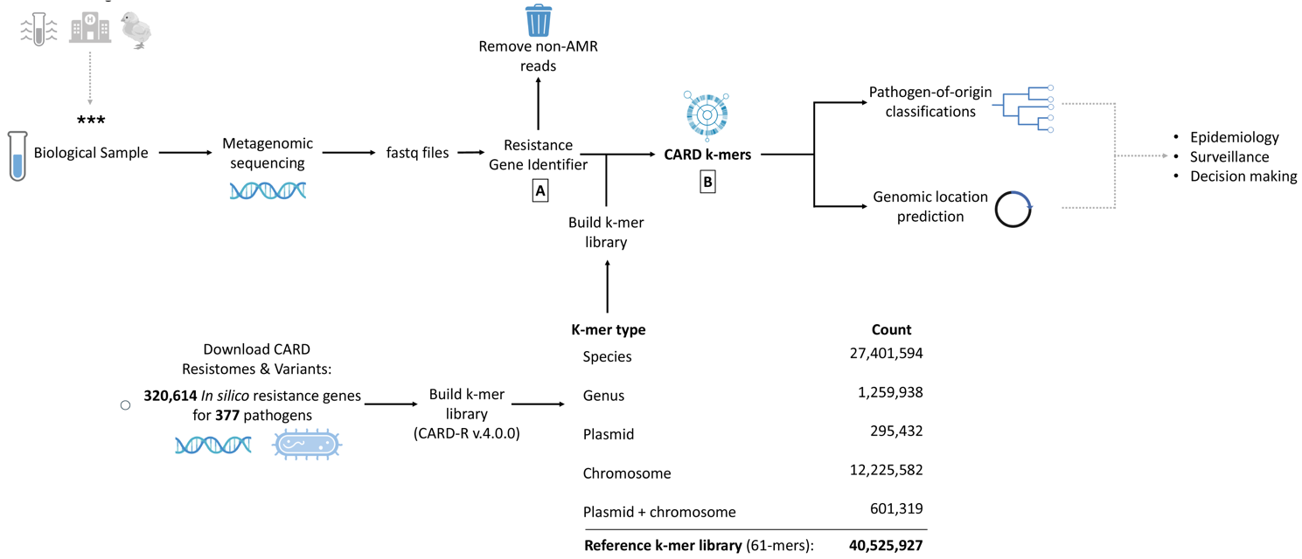
Figure 1: Top-level overview of a possible metagenomic AMR surveillance workflow utilizing CARD k-mers for pathogen-of-origin prediction. First, a biological sample containing a suspected resistant pathogen is collected and culture-independent metagenomic sequencing is performed. (A) Trimmed fastq files are filtered with the Resistance Gene Identifier (CARD’s accompanying software tool) to remove all non-AMR reads. (B) The remaining resistance gene reads are classified using CARD k-mers, enabling predictions of both the pathogen-of-origin and the genomic source (plasmid and/or chromosome). Prior to classification, users must construct the reference k-mer library by downloading the CARD Resistomes & Variants module.
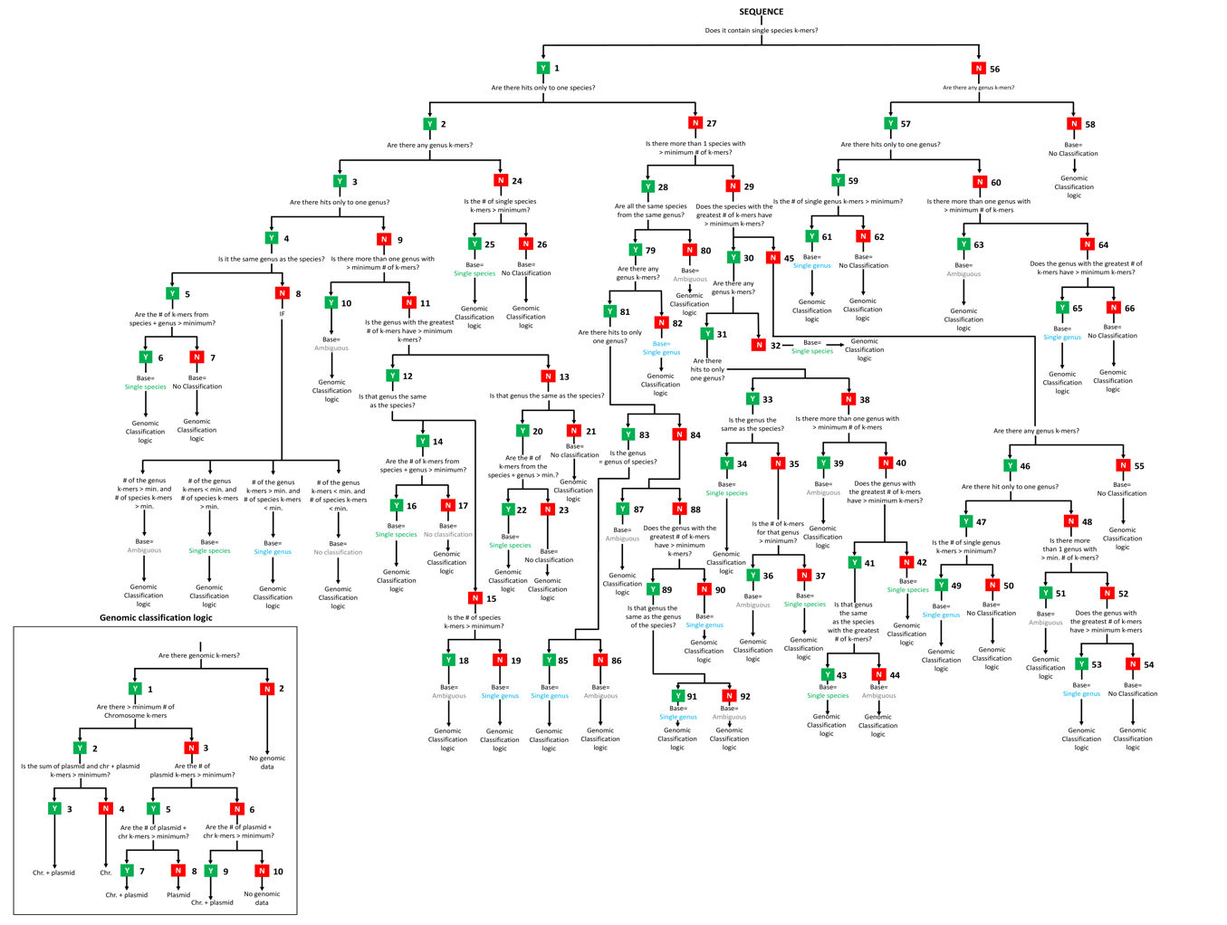
Figure 2: CARD k-mers’ classification logic tree. To receive pathogen and genomic classification, input sequences are passed through this rules-based decision tree. The first goal is to provide the query sequence with a “base” value. Four possible base values exist: single species, single genus, ambiguous and no classification. Once a base value has been assigned, CARD k-mers predicts the ARG’s genomic location. Four possible genomic predictions exist: chromosome, plasmid, chromosome and plasmid, or no genomic data. A more high-definition version can be visualized at https://github.com/arpcard
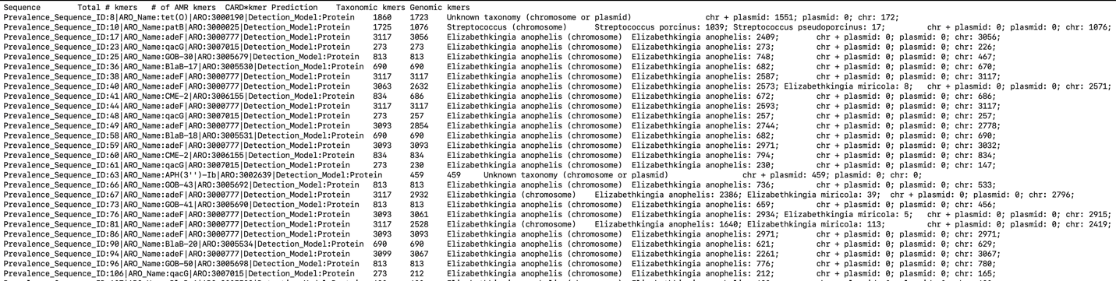
Figure 3: Example text format output for CARD k-mers. The table includes sequence identifiers, total k-mer counts, the number of AMR k-mers, CARD-based predictions, taxonomic assignments, and genomic context (chromosomal vs. plasmid-derived sequences). Taxonomic and genomic k-mers provide insights into the origin and distribution of resistance determinants across diverse bacterial taxa.
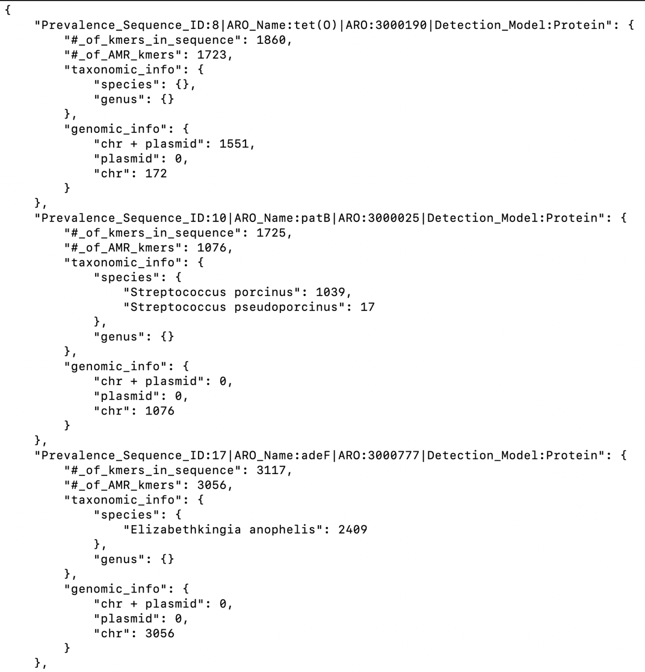
Figure 4: Example json format output for CARD k-mers. Each sequence entry includes details on total k-mer counts, AMR-specific k-mers, taxonomic classifications (species and genus levels, where available), and genomic origins (chromosomal, plasmid, or combined). Unlike the text output, the JSON format does not provide explicit taxonomic or genomic predictions. Instead, it displays the exact k-mer counts for each species or genus identified, as well as the k-mer counts corresponding to each data-type presence. This makes it a useful complementary reference to the text output, providing a more granular view of the k-mer distribution and its associations. Example observations include sequences linked to Elizabethkingia anophelis and Streptococcus porcinus, highlighting their potential contributions to AMR profiles.

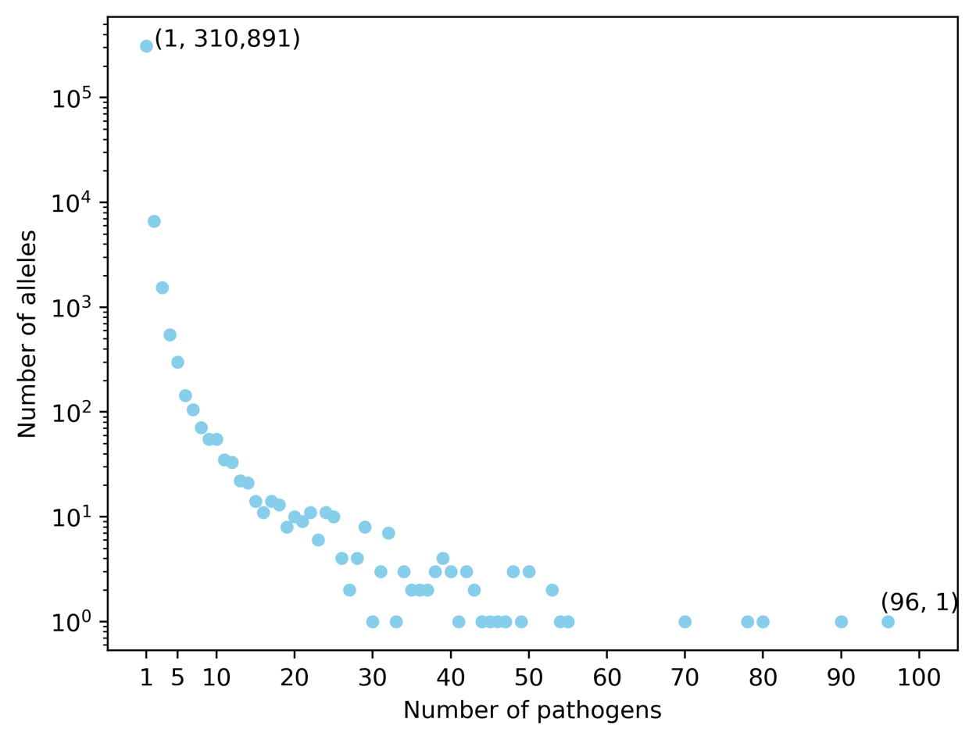
Figure 5: Distribution of CARD-R v4.0.0 alleles. The graph illustrates the number of distinct pathogens encoding each unique allele. The x-axis (logarithmic scale) represents the number of unique alleles, and the y-axis denotes the number of pathogens encoding each allele count. Of the total alleles in CARD-R, 310,891 were found in only one species, while 9,722 were identified in more than one species. One notable allele, adeF, was found in 96 distinct pathogens, potentially indicating high mobility. Mobile AMR alleles are better suited for genomic classification with CARD k-mers, as opposed to pathogen classification.
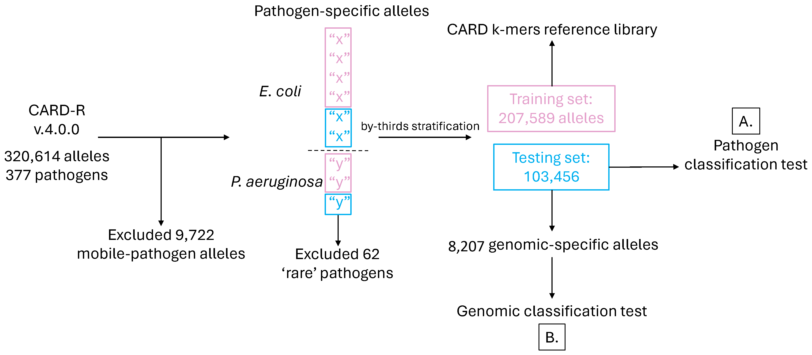
Figure 6: Validation dataset construction. Following exclusion of 9,722 multi-pathogen alleles from CARD-r v.4.0.0, ARG alleles were stratified by pathogen via a ‘by thirds’ holdout validation strategy to maintain the original allele distribution for each pathogen (i.e., 2/3 of alleles were randomly assigned to the training set and 1/3 randomly assigned to the testing set). 315 pathogens were included in the stratification (E. coli and P. aeruginosa shown as examples), but 63 pathogens were excluded due to insufficient data (<3 ARG alleles). The result produced a custom training set and two testing sets to validate CARD k-mers. The larger assessed pathogen classification accuracy (A) and the 8,207 genomic alleles (only found in plasmids or chromosomes, but not both) were sourced from the testing set to validate CARD k-mers’ genomic origin prediction accuracy (B).
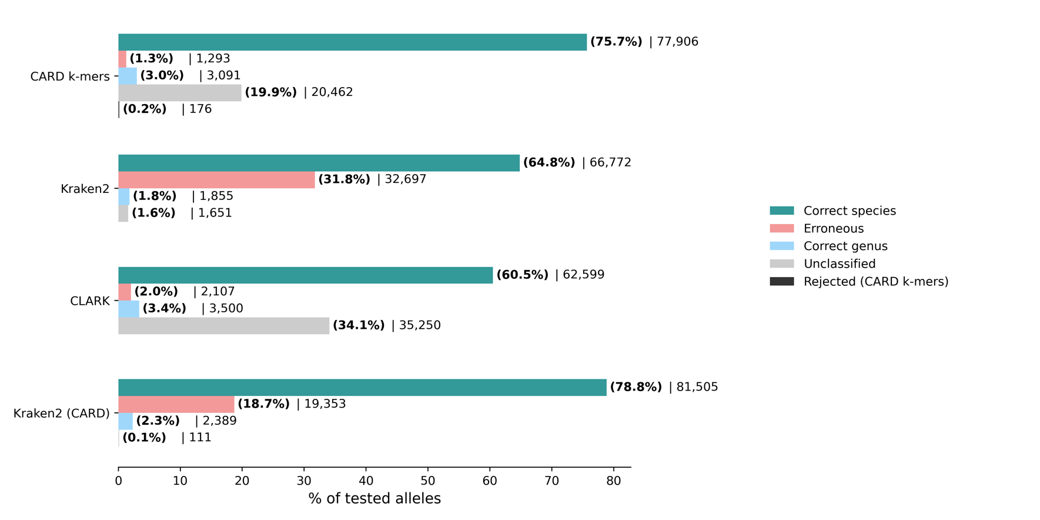
Figure 7: Classification accuracy comparison between CARD k-mers (61-mers), Kraken2 (using default reference or CARD training set (both 35-mers), and CLARK (31-mers) for pathogen-specific alleles. Alleles in the testing set were either rejected (CARD k-mers only: did not meet the minimum threshold number of k-mers) unclassified, classified erroneously (incorrect species and genus), classified as the level of genus (but incorrect species), or classified as the correct species. Beside each bar is the % of tested alleles of that category followed by the total number of tested alleles.

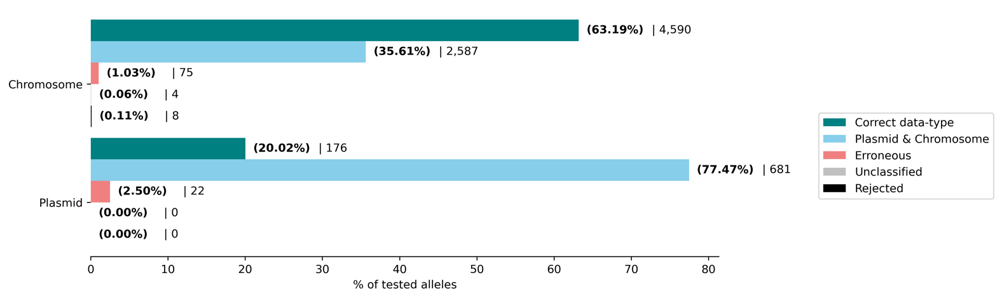
Figure 8: CARD k-mers (61-mers) genomic context prediction accuracy. Alleles in the testing set were either rejected (did not meet the minimum threshold number of k-mers), unclassified, erroneously classified (incorrect genomic context), contained both chromosome & plasmid k-mers, or correctly classified to a unique genomic context (chromosome or plasmid). Beside each bar is the % of tested alleles of that category followed by the total number of tested alleles.

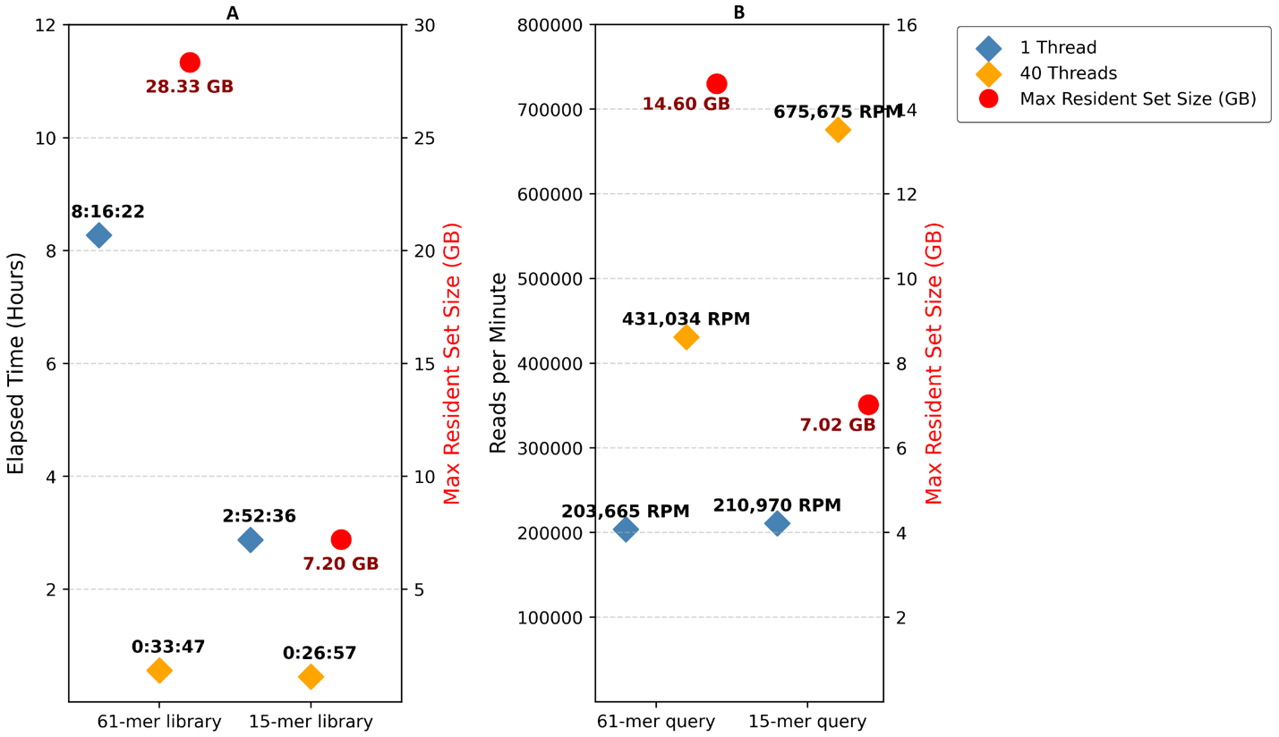
Figure 9: Performance benchmarks for CARD k-mers library construction and query classification. (A) Wall-clock time and peak memory usage (Max Resident Set Size) were measured for standard 61-mer and 15-mer CARD k-mers reference library construction using 1-thread and 40-thread configurations. Elapsed time is presented in hours:minutes:seconds, while peak memory usage, recorded in gigabytes, is shown as an average (red) since memory usage was consistent across thread counts. (B) Classification performance is represented in reads classified per minute (RPM) for 61-mer and 15-mer CARD k-mers queries. RPM values were calculated for 1-thread and 40-thread configurations. Average max resident set size for query operations is also shown in red.
Figure 10: Cumulative relative entropy (CRE) analysis of CARD-R AMR alleles: 103,456 AMR alleles from the CARD-R testing set (Figure 6) were stratified into size quartiles (Q1: smallest – Q4: largest) and bootstrapped into 100 sub-datasets, totaling 10,338,900 in silico alleles. Using KITSUNE v1.3.1, the average CRE for pathogen-specific alleles was calculated in (A), and the CRE for each quartile was plotted in (B). The same analysis was performed for 89,300 plasmid-specific AMR alleles, with results shown in (C) and (D). A CRE cutoff value of 0.1 was used to determine the optimal minimum k-mer size.
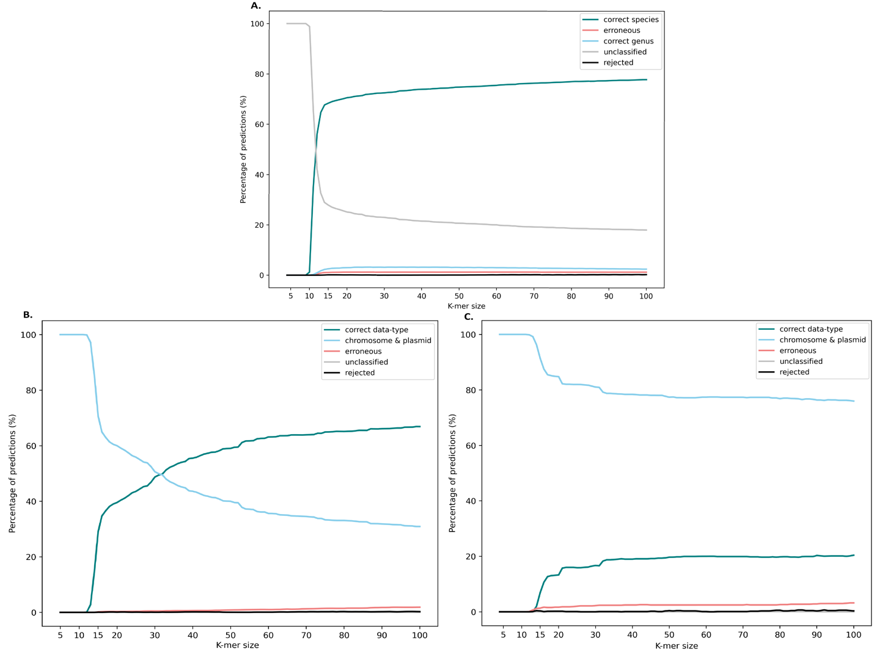
Figure 11. Effects of k-mer size on pathogen and genomic classification accuracy with CARD k-mers. (A) Pathogen classification accuracy plateaus at ~80% beyond k=15, with decreasing unclassified predictions as k-mer size increases. Predictions for correct genus, erroneous, and rejected categories remain stable. Genomic classification accuracy shows (B) chromosome-specific predictions stabilizing at ~70% and (C) plasmid-specific predictions at ~20%. Unlike pathogen classification, genomic predictions show an inverse relationship between correct data-type predictions and sequences containing both chromosome and plasmid k-mers.
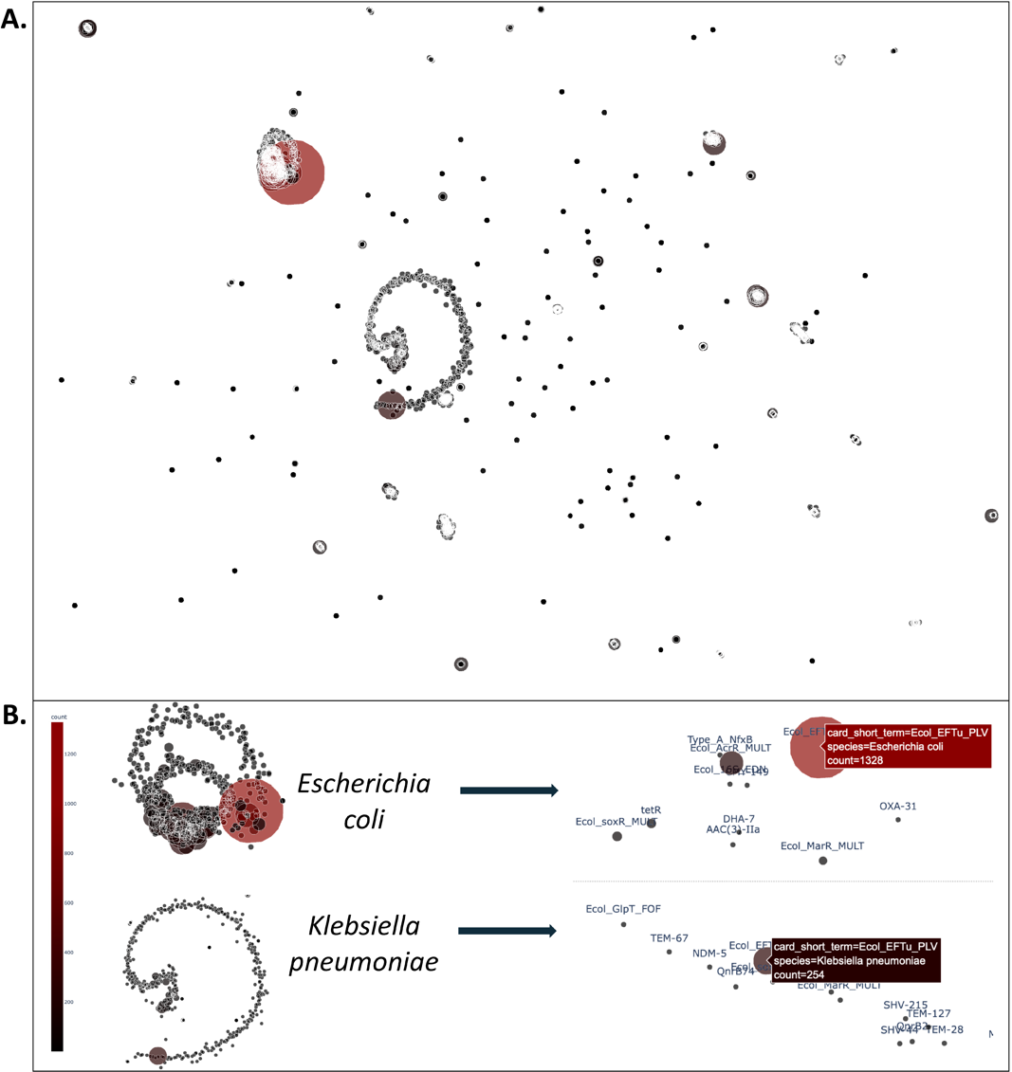
Figure 12. UMAP visualization of unclassified AMR alleles of CARD k-mers during classification validation. (A) UMAP dimension reduction was performed on 20,462 unclassified AMR alleles following pathogen classification testing by CARD k-mers. (B) Two primary clusters were observed, corresponding to AMR alleles associated with Escherichia coli and Klebsiella pneumoniae. The most abundant allele in both clusters was Ecol_EFTU_PLV, a conserved housekeeping gene encoding elongation factor Tu (EFTu), with counts of 1,328 in E. coli and 254 in K. pneumoniae. Full interactive UMAP visualization is available atfile:///Users/mateuszwlodarski/Desktop/manuscript_figs/umap_unclassified_amr_alleles.html
Table 1: CARD k-mers reference library k-mer counts. Over 40 million 61-mers are built and stored for taxonomic and genomic predictions. P, C, B class k-mers are used to predict the genomic location of in input ARG sequence data, while S and G class k-mers are used to predict the pathogen-of-origin.

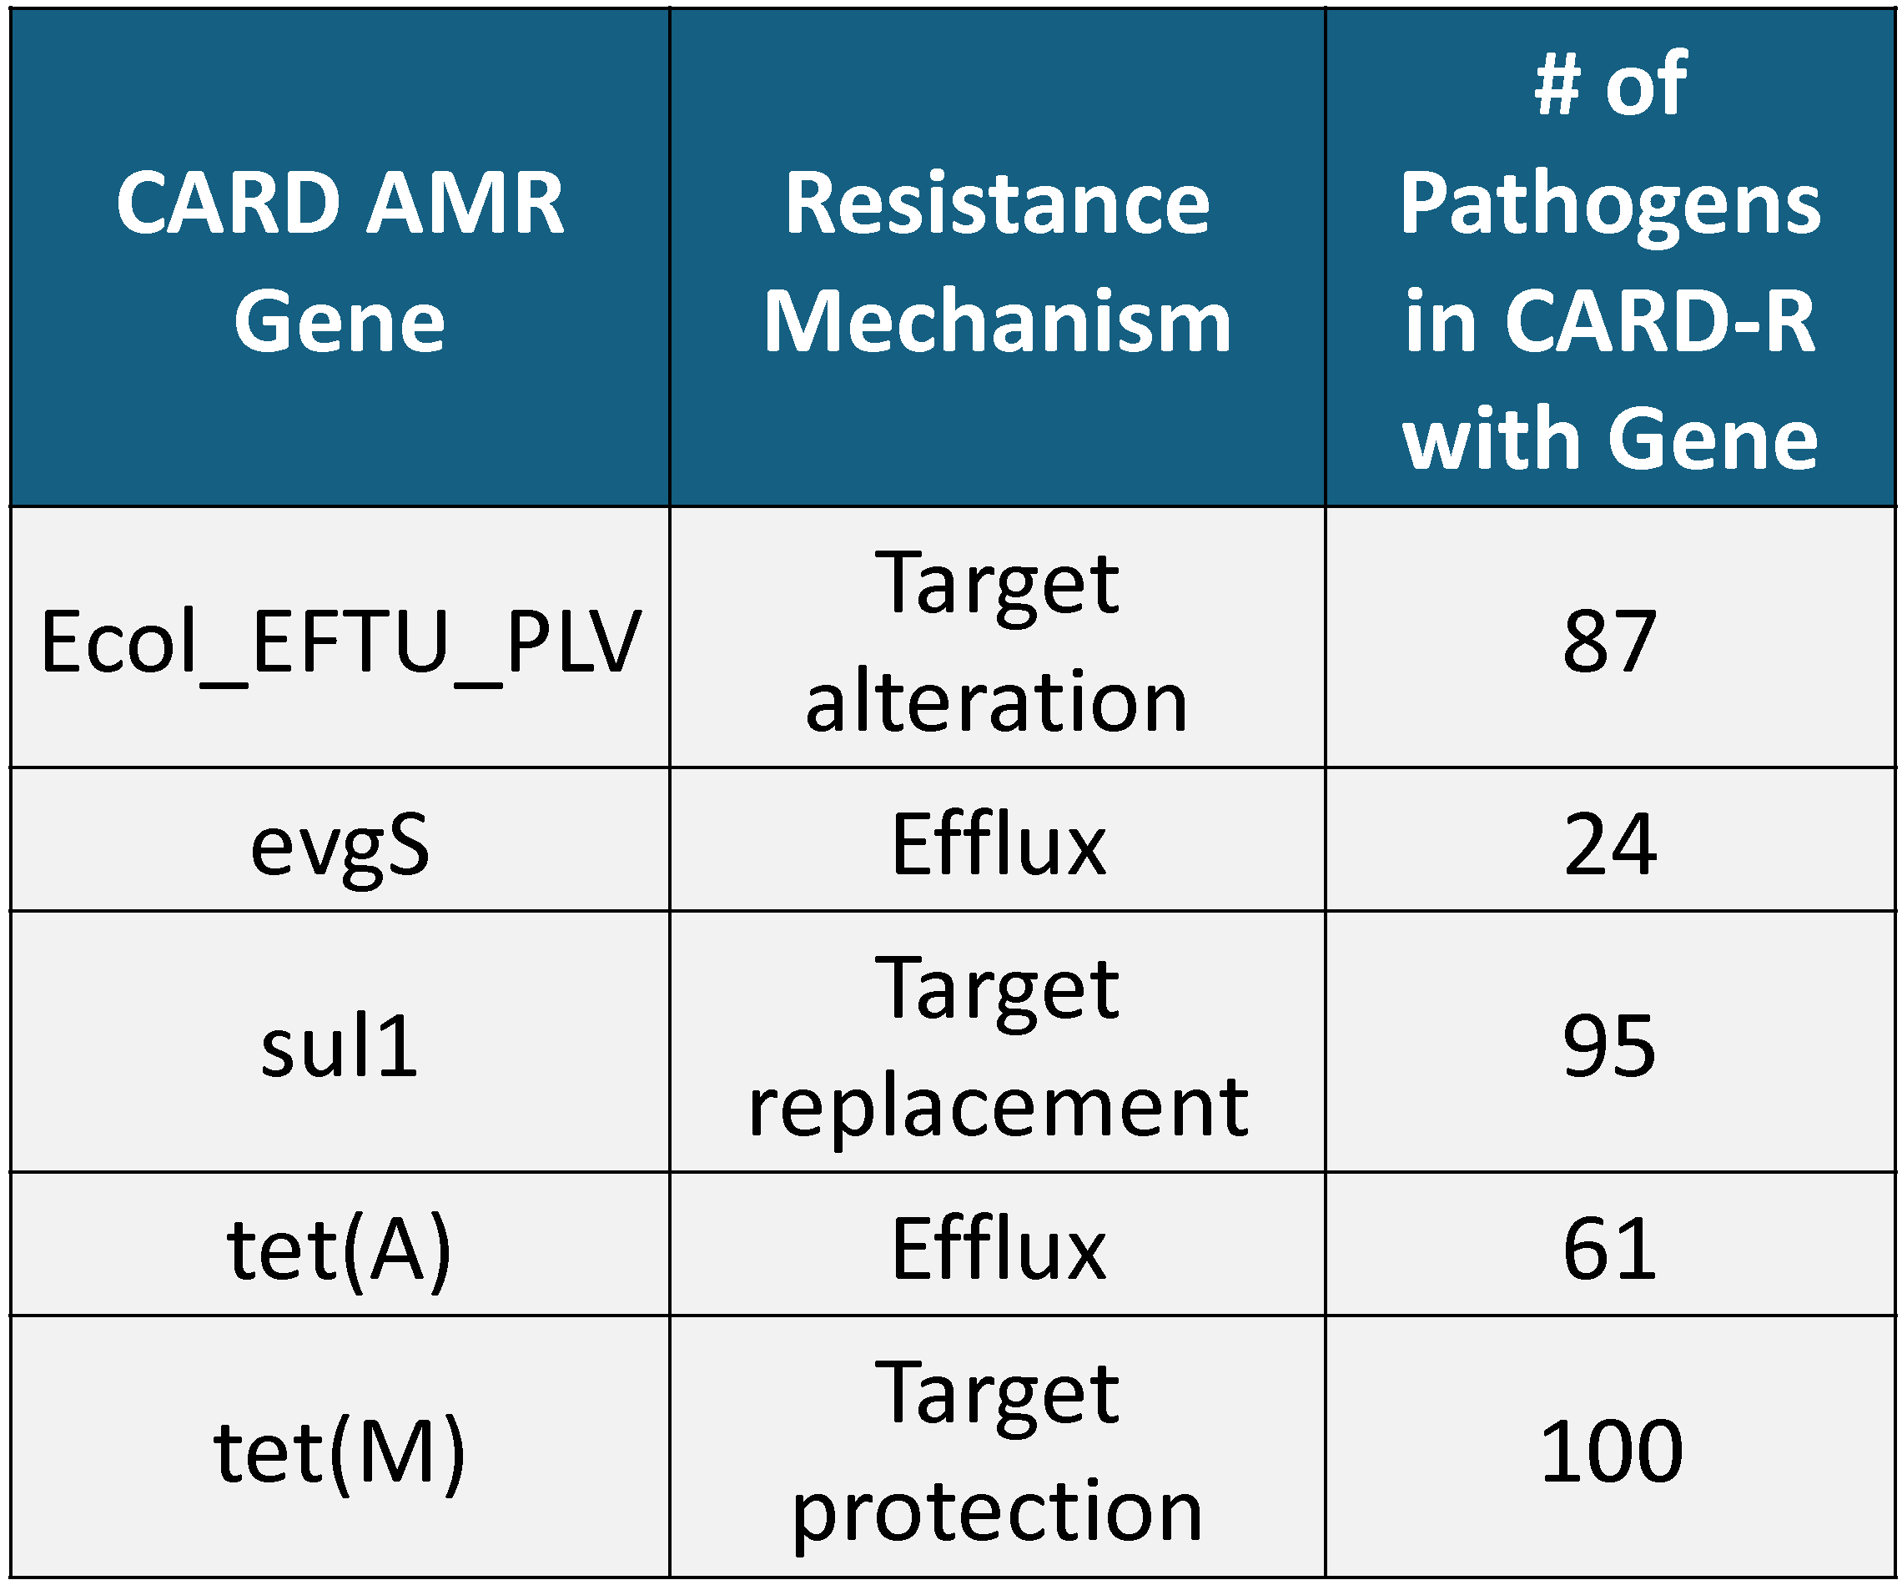
Table 2: List of the 5 most abundant unclassified AMR alleles by CARD k-mers. Both mobile resistance genes (e.g., sul1, tet(A), tet(M)) and conserved housekeeping genes (e.g., EFTu) pose classification challenges due to their widespread distribution and sequence similarity across bacterial species.

