# wlopera-shop:

Aplicación tienda en línea (Ecommerce) creada en NextJs (ReactJS), Tailwind, Go, React Icons y Zustang (gestor de estados)

# Crear el proyecto

loper@wlopera MINGW64 /c/A_CURSOS/2024/React/next-project

$ npx create-next-app@latest wlopera-shop

npm WARN exec The following package was not found and will be installed: create-next-app@15.1.0

? Would you like to use TypeScript? » No / Yes

√ Would you like to use TypeScript? ... No / Yes

? Would you like to use ESLint? » No / Yes

√ Would you like to use ESLint? ... No / Yes

? Would you like to use Tailwind CSS? » No / Yes

√ Would you like to use Tailwind CSS? ... No / Yes

? Would you like your code inside a `src/` directory? » No / Yes

√ Would you like your code inside a `src/` directory? ... No / Yes

? Would you like to use App Router? (recommended) » No / Yes

√ Would you like to use App Router? (recommended) ... No / Yes

? Would you like to use Turbopack for `next dev`? » No / Yen N

? Would you like to use Turbopack for `next dev`? » No / Yes

√ Would you like to use Turbopack for `next dev`? ... No / Yes

? Would you like to customize the import alias (`@/*` by default)? » No / Yes

√ Would you like to customize the import alias (`@/*` by default)? ... No / Yes

Creating a new Next.js app in C:\A_CURSOS\2024\React\next-project\wlopera-shop.

Using npm.

Initializing project with template: app-tw

Installing dependencies:

- react

- react-dom

- next

Installing devDependencies:

- typescript

- @types/node

- @types/react

- @types/react-dom

- postcss

- tailwindcss

- eslint

- eslint-config-next

- @eslint/eslintrc

# Utilizar fuentes del curso

**<https://www.youtube.com/watch?v=oHRScyU-ffg&list=PLCKuOXG0bPi3y7tz8Hq6itoi1vhPf6eVG&index=1>**

# Configurar proyecto

Copiar Imágenes requeridas. Reemplazar valores por defecto (copiar todos los datos de carpeta public)

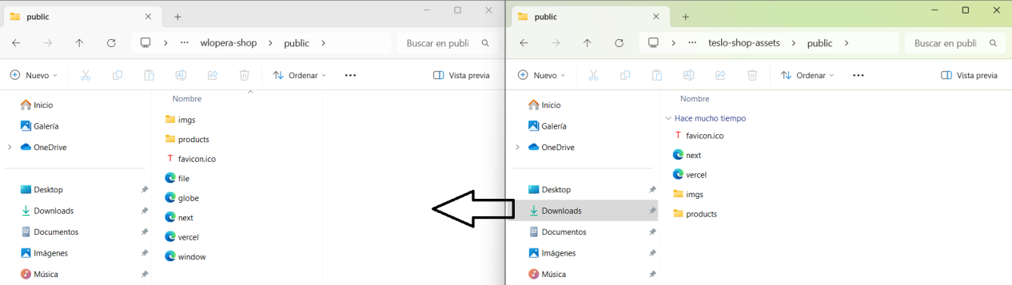

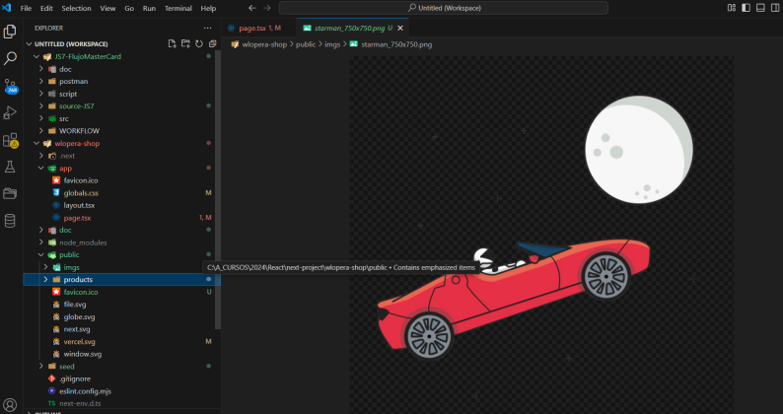

Copiar datos requeridos (seed)

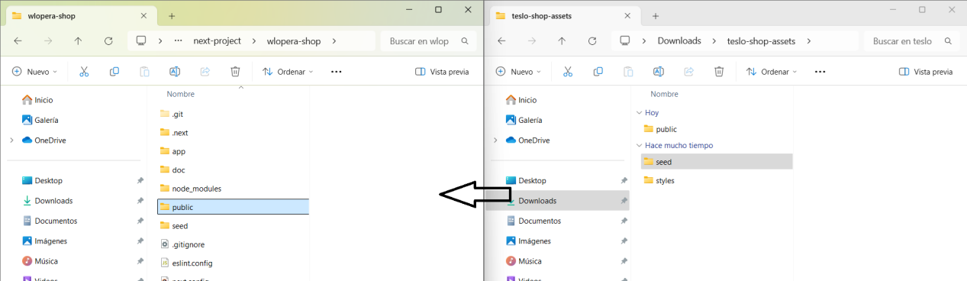

Sustituir los estilos globales

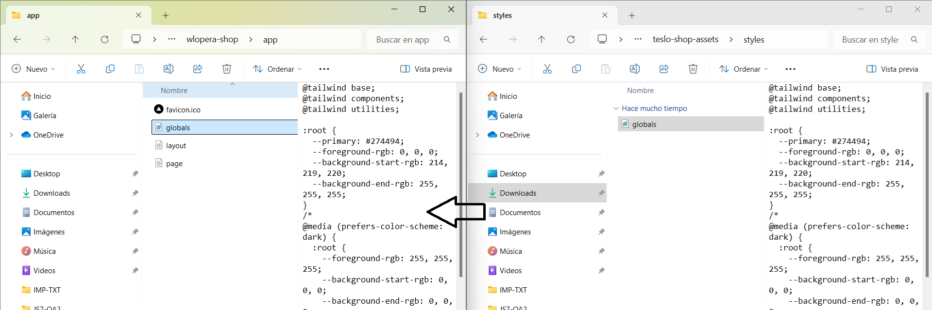

# Levantar y probar APP

_> npm run dev

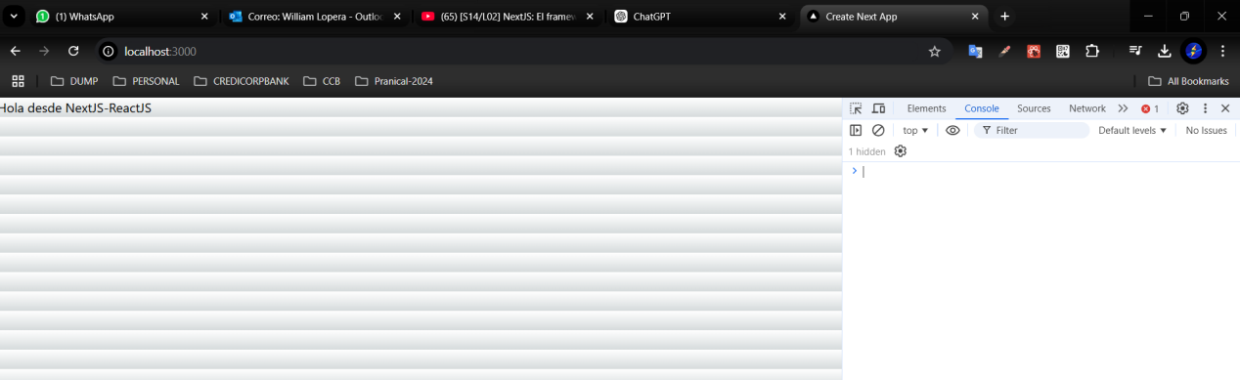

# Carpetas del APP

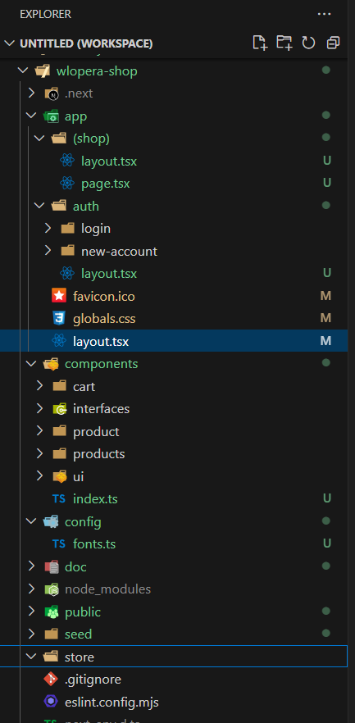

# Configuración y layout iniciales del APP

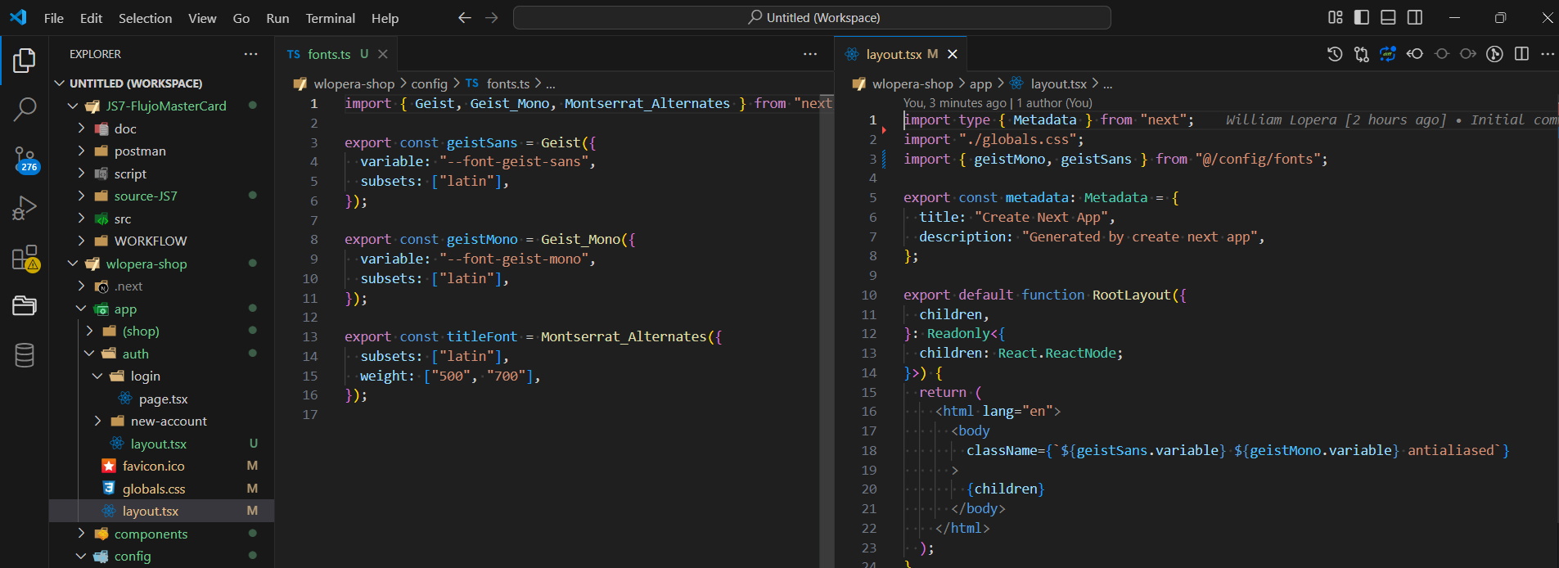

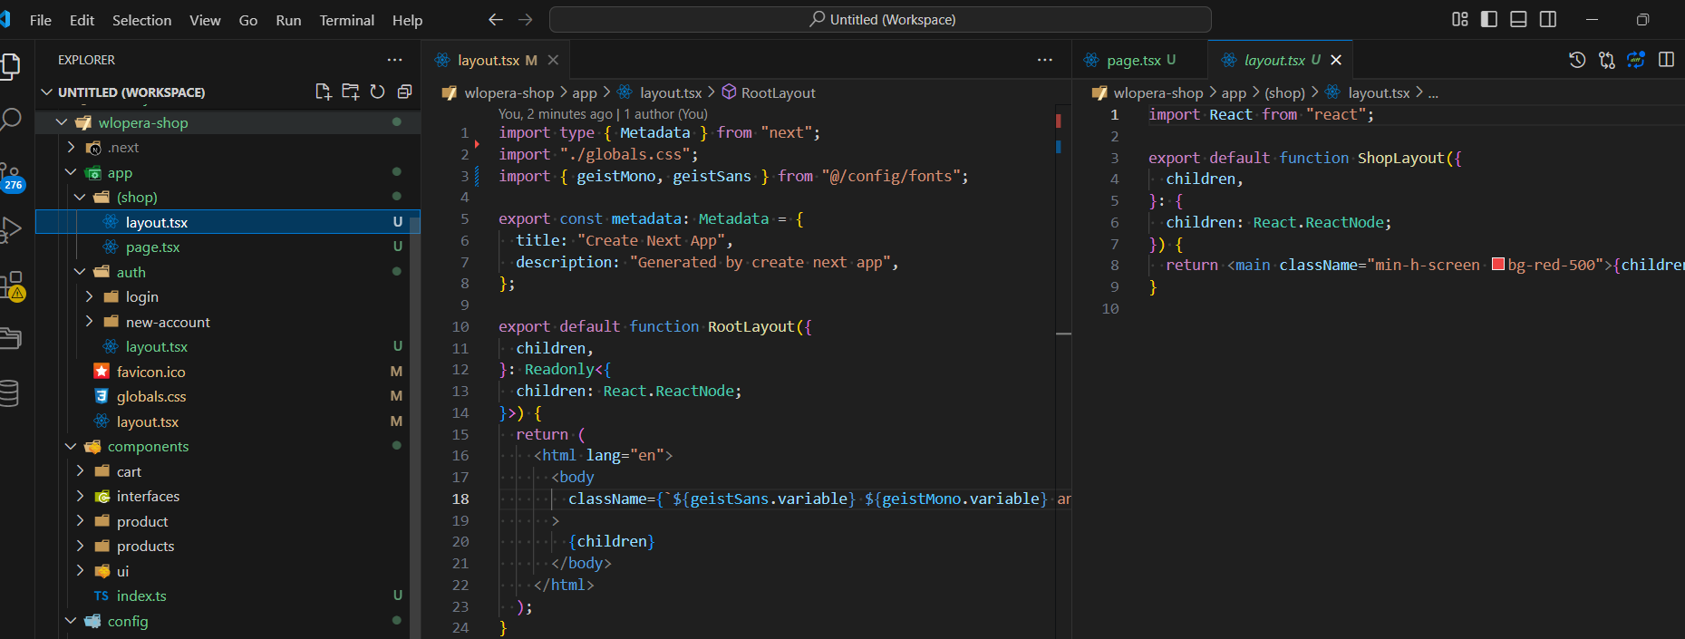

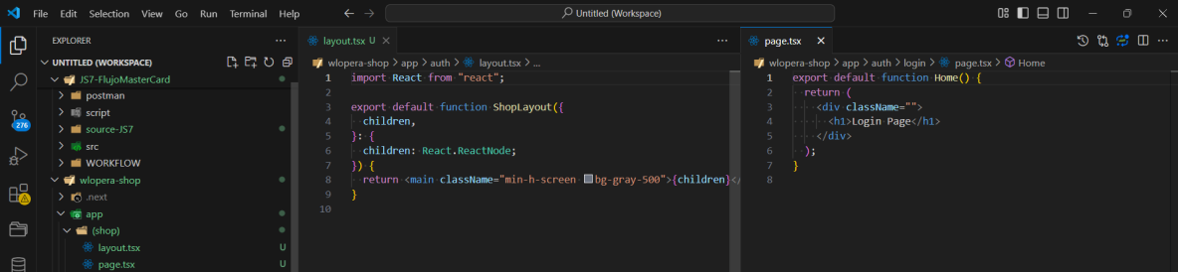

# Manejo de paginas de la tienda

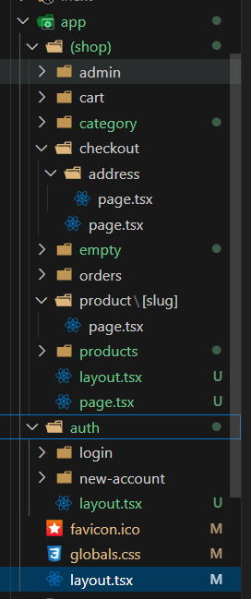

# Zustang - manejador de estados

<https://zustand-demo.pmnd.rs/>

<https://zustand.docs.pmnd.rs/getting-started/introduction>

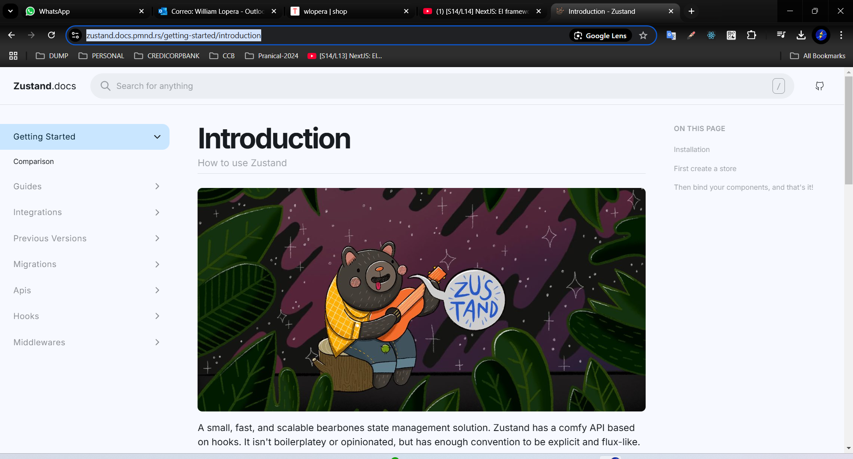

npm install zustand

# CLSX - Apoyo uso de Tailwind

Una pequeña utilidad (239B) para construir cadenas de nombres de clase de manera condicional. También sirve como un reemplazo más rápido y más pequeño para el módulo de nombres de clase.

https://www.npmjs.com/package/clsx

$ npm i clsx

added 1 package, and audited 374 packages in 1s

140 packages are looking for funding

run `npm fund` for details

found 0 vulnerabilities