**ECE/CS 4434/6434  
Homework 3  
Due Date: Friday, September 27, 4:59 PM**

**Reading: Lectures 5-7 + Chapter 2 of Koren + Dugan’s Chapter on Reliability Models**

**Note: Show your work for each part to get partial credit.**

**Problem 1 (25 pts) –** Consider the following non-series-parallel system of six independent identical components. The system is functioning properly if all components along at least one path from input to output are functioning properly.

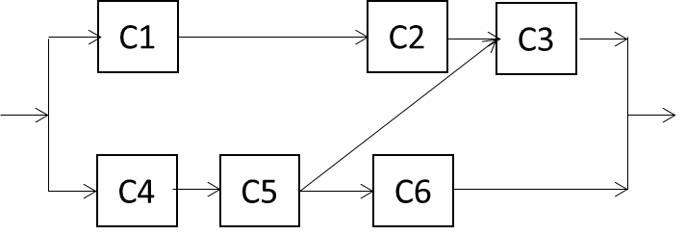

**Part A (15 pts)** Determine an ***exact*** expression for the system reliability (not upper bound or lower bounds) as a function of component reliabilities (*R*). **(Hint:** Note that there is a connection from C5 to C3, and C1-C2-C6 is not a valid path).

P(System Works | C3 Works) P(C3 Works) + P(System Works|C3 Fails)P(C3 Fails)

P(System Works | C3 Works) = P(System Works |C3 Works and C6 Works)(P(C6 Works) + P(System Works | C3 Works and C6 Fails)P(C6 Fails)

P(System Works | C3 Works and C6 Works)P(C6 Works) = (1-(1-(RC1RC2)(1-RC4RC5)))RC6

P(System Works | C3 Works and C6 Fails)(P(C6 Fails) = (1-(1-(RC1RC2)(1-RC4RC5)))(1-RC6)

P(System Works | C3 Fails)(P(C3 Fails) = (RC4RC5RC6)(1-RC3)

P(System Works) = P(System Works | C3 Fails)P(C3 Fails) + (P(System Works | C3 Works and C6 Works)P(C6 Works) + P(System Works | C3 Works and C6 Fails)(P(C6 Fails))P(C3 Works)

P(System Works) = R3(1-R) + ((1-(1-R2)2)(R) + (1-(1-R2)2)(1-R))R

P(System Works ) = R3-R4 + ((2R3-R5) + (2R2-R4)(1-R))R

P(System Works) = R3-R4 + ((2R3-R5) +(2R2-R4 – 2R3 + R5))R

P(System Works) = R3-R4 + (2R3 – R5 + 2R2 -R4 – 2R3 + R5)R

P(System Works) = R3-R4 + 2R4 – R6 + 2R3 -R5 – 2R4 + R6

P(System Works) = 3R3 – R4 - R5

**Part B (10 pts)** Write the ***upper bound expression*** for the system reliability and use it to derive the exact system reliability expression. Compare your results to Part A.(**Hint:** Refer to **Lecture 6, Slide 30** for an example).

P(System Works)Upper = 1-(1-R3)3

**Remember Class Activity 2.**

**Problem 2 (25 pts) –** Data storage can be implemented in several different ways, including direct attach storage, clusters, and storage area networks. Direct attach storage (DAS) is essentially a storage device (such as a hard disk, RAID array, or tape) directly connected to a server by a cable. A cluster is a group of two or more servers joined together to minimize the possibility of system failures. When one server in a cluster fails, another server automatically takes over the activities and applications of the failed server. Clustering leads to high performance and high availability. The following figure shows i) a basic DAS, ii) a redundant DAS with two host bus adapters (HBA), and iii) a high-availability cluster, consisting of two servers that can fail over to each other, two host bus adapters (HBA) per server, and a storage array with two switches.

|  |  |
| --- | --- |
| **i) Basic DAS** |  |
| **ii) Redundant DAS** | **iii) High-availability Cluster** |

Suppose you are a development engineer on a Reliability Engineering team and would like to compare the reliability and availability of different storage configurations, by conducting a reliability analysis of model systems. The quality group have provided you with the following estimates for the failure rate of each subsystem:

|  |  |  |  |
| --- | --- | --- | --- |
|  | Failure rate λi (failures/hour) | Reliability (1 year) | MTTR (hours) |
| Storage Array | 1.4501E-5 | **RSA = ?** | 3.99 |
| Switch | 3.91E-6 | RSW = 0.97 | 7.66 |
| HBA | 3.95E-6 | RHB = 0.97 | 8.00 |
| Server | 2.18E-5 | RSE = 0.83 | 4.75 |

**Source:** S. Shetty, Dell Power Solutions, 2002.

**Part A (5 pts)** Assuming the time to failure of the storage array follows an exponential distribution, calculate its reliability RSA for **mission time of 1 year**.

R(t) = e-λt

T = 365 * 24 = 8760

λ = 1.4501E-5

R(t) = e-1.4501E-5 * 8760

R(t) = 0.8807

**Part B (10 pts)** Draw the reliability block diagram of the **redundant DAS** and write its reliability function based on the reliability of its components (**same as Part A of Class Activity 2**).

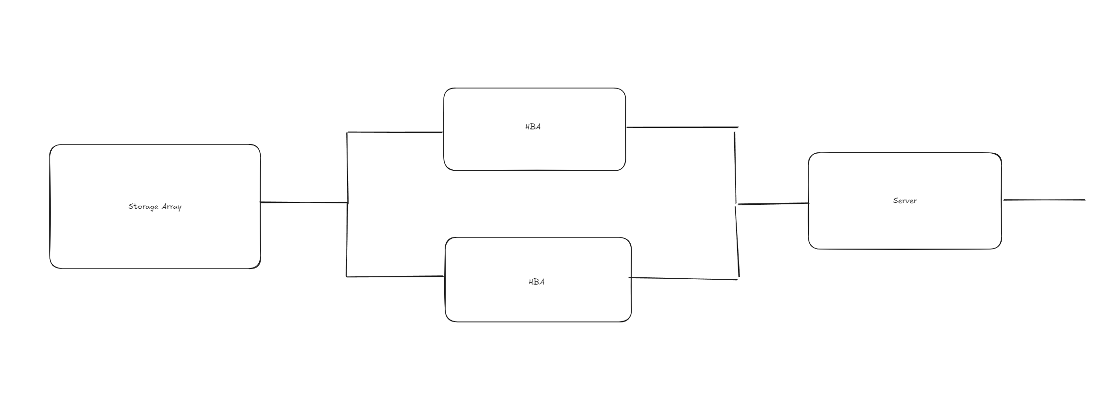

Reliability = Rsys = RSA * (1-(1-RHB)2) * RSE

**Part C (10 pts)** Draw the reliability block diagram of the **high-availability cluster** and calculate an ***upper bound*** for its reliability function based on the reliability of its components. **Hint:** Find the set of paths in the system that any or all of them should be functional for the system to function properly. (**same as Part B of Class Activity 2**).

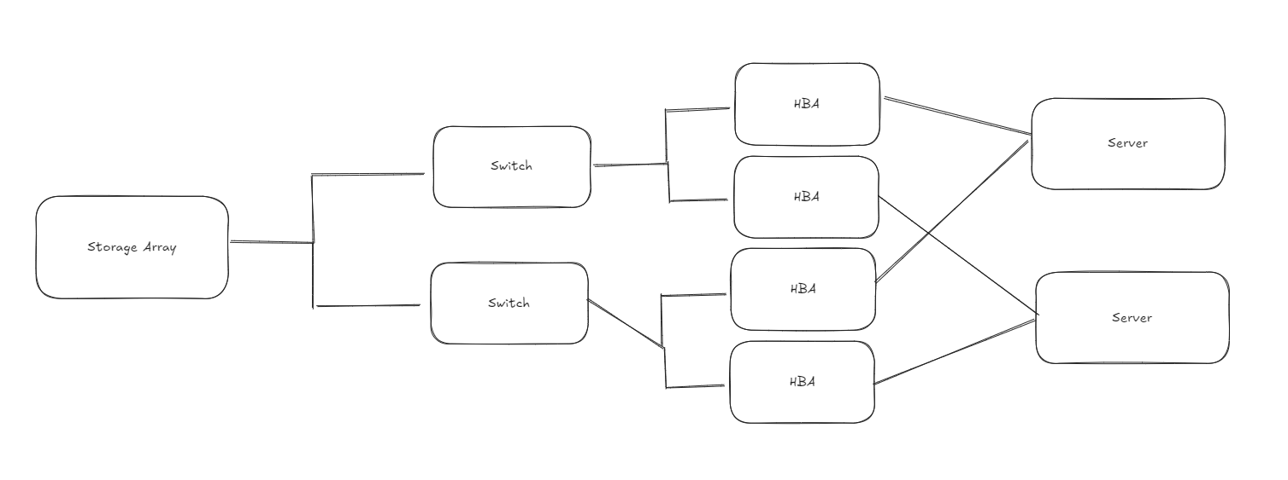

Reliability = Rsys = 1 – (1 – RSARSWRHBRSE)4

**Problem 3** (20 pts) **–** The system shown in the figure below is a processing system for a helicopter:



* The system has dual-redundant processors (PU) and dual-redundant remote terminals (RT).
* The interesting part of the system is the navigation equipment. The aircraft can be completely navigated using the Inertial Navigation System (INS). If the INS fails, the aircraft can be navigated using the combination of the Doppler and the attitude heading and reference system (AHRS). This is an example of functional redundancy where the data from the **AHRS and the Doppler can be used to replace the INS**, if the INS fails.
* The system contains three AHRS units, of which **only one is needed** to work.
* There are two buses A and B in the system, and **each bus is also dual-redundant**. Because of the other sensors and instrumentation, ***both* buses are required** for the system to function properly regardless of which navigation mode is being employed.

**Part A)** (10 pts) Identify the components that are in series and those that are in parallel and draw the reliability block diagram of the system.

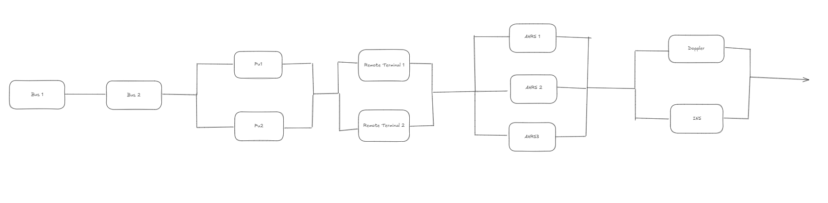

**Part B)** (10 pts)Calculate the reliability of the system using the information in the table below:

|  |  |
| --- | --- |
| **Component Reliability** | |
| Processing Unit (RPU ) | 0.92 |
| Remote Terminal (RRT) | 0.95 |
| AHRS (RAHRS) | 0.88 |
| INS (RINS) | 0.85 |
| Doppler (RDOP) | 0.90 |
| Bus (RBUS) | 0.88 |

**Hints:** (0.85)2 ≈ 0.72, (0.85)3 ≈ 0.61, (1 - 0.85)2 ≈ 0.023

(0.88)2 ≈ 0.77, (0.88)3 ≈ 0.68, (1 - 0.88)2 ≈ 0.014

(0.90)2 = 0.81, (0.90)3 ≈ 0.73, (1 - 0.90)2 = 0.01

(0.92)2 ≈ 0.85, (0.92)3 ≈ 0.78, (1 - 0.92)2 ≈ 0.006

(0.95)2 ≈ 0.90, (0.95)3 ≈ 0.86, (1 - 0.95)2 ≈ 0.003

Reliability = Rsys = RBUS2 * (1-(1-RPU)2) * (1-(1-RRT)2) * (1-(1-RAHRS)3 * (1-(1-RDOP)(1- RINS))

RSYS = 0.77 * (1 – 0.006) * (1-0.003) * (1 – 0.0017) * (1-(0.1)(0.15))

RSYS = 0.7503

**Problem 4 (30 pts) –** A detector-redundant (DR) system is composed of a number of parallel unit-detector pairs that operate simultaneously using identical inputs. Each unit-detector pair (shown in the figure below) is a series combination of a simplex unit and its associated detector. The outputs from unit-detector pairs are fed into a checking circuit. The checking circuit will check the outputs from the pairs and identifies the correct output. If there are multiple pairs with correct output, one will be selected randomly. Assume that each of the detectors and the checking circuit may themselves fail. The system is said to have failed when all unit-detector pairs or the checking circuit have failed.

**etectorUnitrom the site of accidentects in highly-safe industries such as commercial aircraft the recalls.iod of 2000-2012**

A unit-detector pair (DR1)

**Part A (5 pts)** Draw the reliability block diagram for a three-unit detector-redundant (DR3) system.

**Part B (10 pts)** Derive the reliability formula for the three-unit detector-redundant system (DR3) and the TMR system (with a voter, without online detectors). Assume the reliability of a simplex unit is *r*, the reliability of a detector is *d,* the reliability of the checking circuit is *c*, and the reliability of a voter is *v*.

**RDR3 = (1-(1-r*d)3) * c**

RTMR = ((3 Choose 2) * r^2 (1-r) + (3 Choose 3) (r^3)) * v

RTMR = (3r^2(1-r) + r^3) * v

**RTMR = 3r2 – 2r3 * v**

**Part C (15 pts)** If the detectors are perfect (*d = 1*), draw the reliability graphs of the following systems vs. the component reliability (*r*), and compare them:

- The Simplex system (Rsimplex = r),

- The TMR system with voter reliability of *v* = 1,

- The TMR system with voter reliability of *v* = 0.97,

- The DR3 system with checking circuit reliability of *c* = 1, and

- The DR3 system with checking circuit reliability of *c* = 0.97.

Use MATLAB, Mathematica, or any other tools to generate these 5 graphs. Highlight the graph for each system by generating legends. **Explain your observations.**

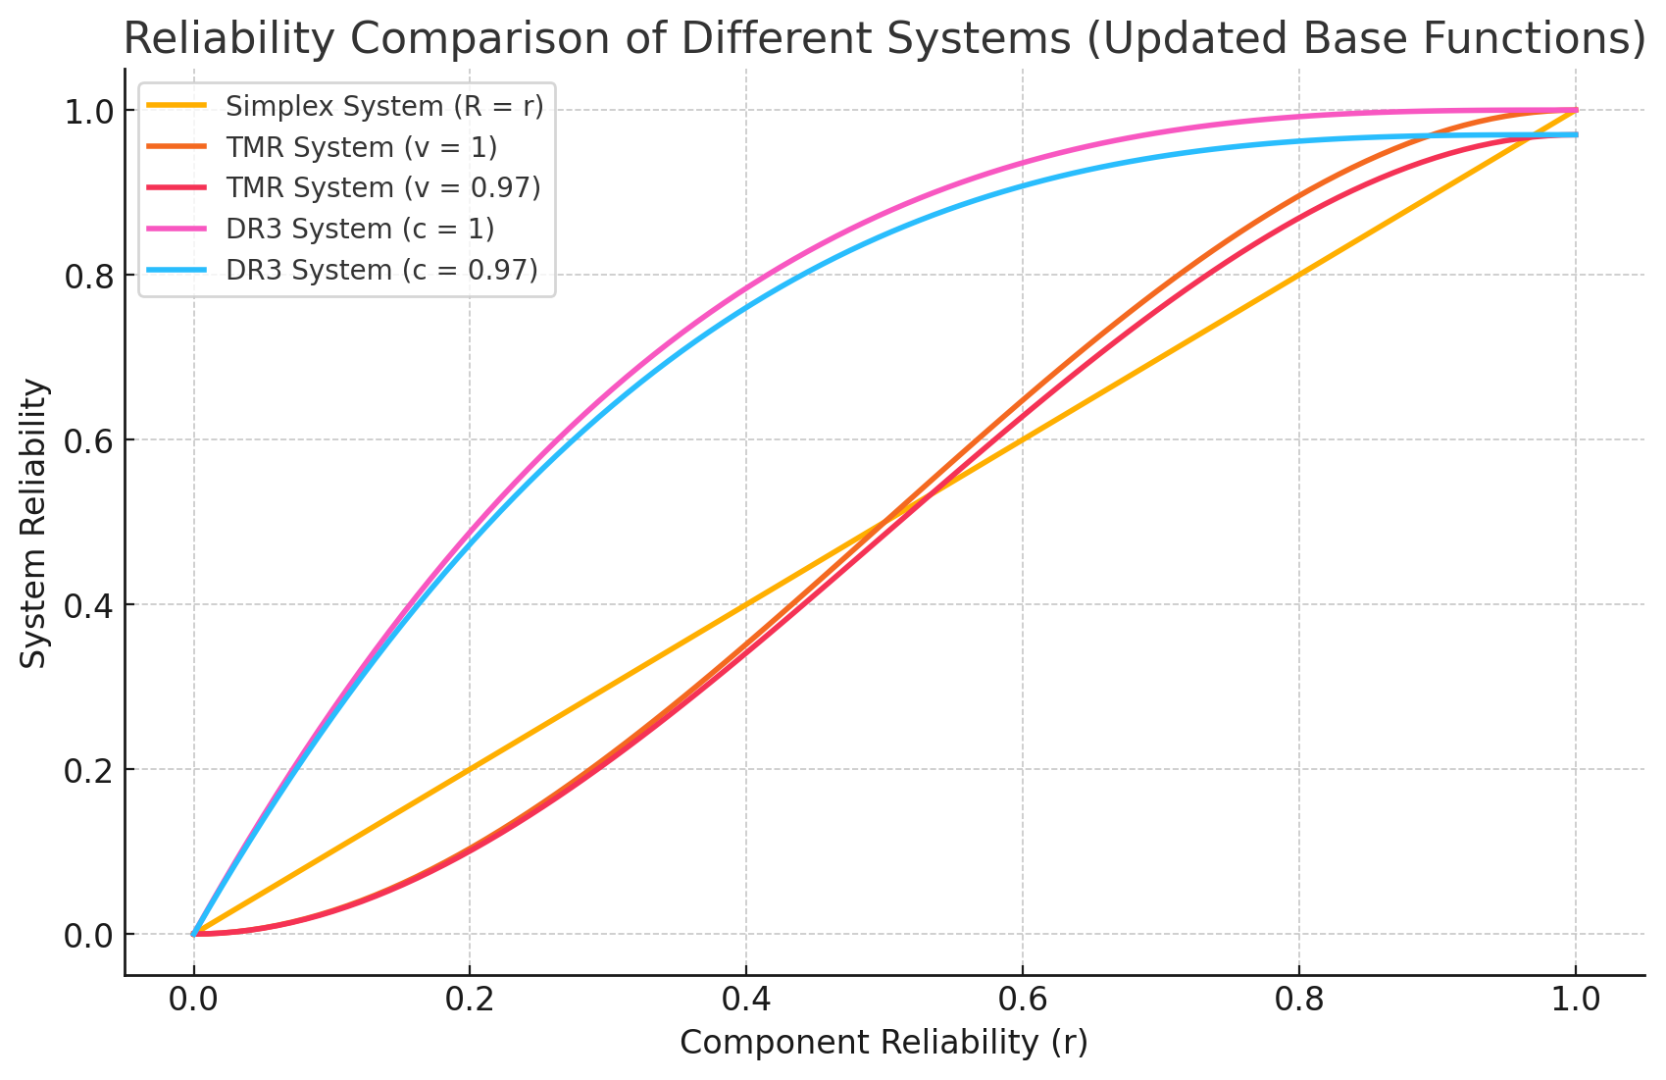

As expected, system reliability increases linearly with the Simplex System. We see TMR decrease slighly when the voter is not perfect which is also expected. The same can be said for the DR3 system where when the checker is imperfect the performance drops slightly. Because DR3 only requires 1 of 3 systems to remain operational and simply samples randomly from them, it follows that its system reliability would be significantly higher than a TMR voter that requires at least two to be operational. DR3 is also made signficantly more reliable by the reliability of the detectors being 1.

(**Hint:** Refer to **Lecture 7 Slide 11**, to see a similar diagram that shows TMR (with perfect voter, v = 1) vs. Simplex reliability.)