**ECE/CS 4434/6434  
Homework 4  
Due Date: Friday, October 4, 4:59 PM**

**Reading: Lectures 7-9 + Chapter 2 of Koren + Dugan’s Chapter on Reliability Models**

**Remember Class Activity 3.**

**Problem 1 (45 pts) –** Consider the following storage system composed of two subsystems S1 and S2. S1 is a dual system composed of two disks A and B, where the failure of any of them will cause the failure of the subsystem S1. S2 is composed of a disk C which acts as a backup **(cold standby)** of the subsystem S1 and will be powered on only after dual subsystem fails.

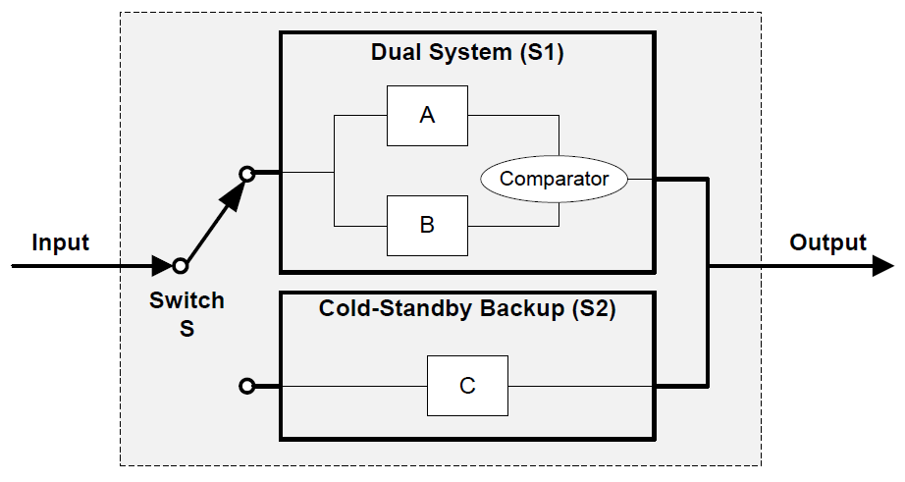

Assume that A and B are identical disks and the **comparator in the subsystem S1 is perfect**. We model the lifetime of the disks A, B, C, and switch S with independent random variables X1, X2, X3,X4. Assume X1 and X2 are exponentially distributed with parameter and X3 is exponentially distributed with parameter 3

**Part A (4 pts) –** Write the reliability function of the subsystem S2 and use it to calculate its mean time to failure (MTTF).

**Part B (5 pts) –** Draw the reliability block diagram of the subsystem S1 and find its reliability function and failure rate () in terms of

**Part C (5 pts) – Assuming that switch S is perfect**, identify the states of the storage system based on the reliability of subsystems S1 and S2. Draw the diagram for the Markov chain representing the system. (**Hint:** Cold standby sparing means that S2 is only powered up when S1 has failed).

S1 (State 1) = System 1 Works

S2 (State 2) = System 1 Fails, System 2 Works

F (Fail State) System 1 and System 2 Both Fail

**Part D** **(14 pts) –** Use the Markov model in Part C to derive the reliability function of the system in terms of (**Note:** Write and solve the differential equations to derive the reliability function).

**Hint:** In order to calculate the inverse Laplace transform of , you can use the method of partial fraction expansion as explained in **Lecture 9, Slide 13.** Read more about this method here: <https://ocw.mit.edu/courses/18-03sc-differential-equations-fall-2011/pages/unit-iii-fourier-series-and-laplace-transform/partial-fractions-and-inverse-laplace-transform/>

Partial Fraction Expansion:

Inverse Laplace Transform:

Inverse Laplace of

Final State and Overall Reliability:

Integrate over t:

Final Reliability:

**Part E (7 pts) –** Now **assume switch S is not perfect** and its lifetime (X4) is exponentially distributed with failure rate of . Identify the states of the storage system based on the reliability of subsystems S1 and S2 and the switch S. Draw the diagram for the Markov chain representing the system.

**Part F** **(5 pts) –** Write the equation for the first state in the Markov model in Part E where “both subsystems S1 and S2 and the switch are working” and solve this equation to derive the probability of being in that state (P1(t)) in terms of (**Note:** You do not need to show all the steps for solving the differential equations in this part. Use the steps shown in **Lecture 9, Slide 6,** to simplify your answer as much as you can).

**Part G (5 pts) –** Compare the probability functions P1(t) that you derived for being in the first state of the Markov Model in the parts D and F. Explain your observations. Which system has a higher chance of being in this state in a short mission time? Why? (**Note:** Provide one sentence justifying the difference between the systems).

Because the imperfect switch has the additional term it increases the rate of decay of the system resulting in the perfect switch probability scenario being higher for short mission times.

**Problem 2 (55 pts) –** In this problem we compare the **TMR** and **TMR-Simplex** systems using dynamic reliability models.

**TMR**

Consider a basic TMR system consisting of three identical components. The lifetime of each component is exponentially distributed with parameter and the **majority voter is perfect**.

**Part A (8 pts) –** Draw the state diagram of the basic TMR system showing all possible states S, state transitions, and transition probabilities in terms of component failure probabilities or We define the state of system as S = (S1, S2, S3), where Si = 1 if component *i* is fault-free and Si = 0 if component *i* is faulty. Each state represents a unique combination of faulty and fault-free components within the system. (**Hint**: This will be a Markov model with eight distinct states).

**Part B (5 pts) –** Partition the state diagram in part A and reduce the Markov model to only three states, including: perfect, one-failed, system-failed (two or three components failed). (**Hint:** The probability of transitioning from perfect state to one-failed depends on the probability of failure of any of the three components).

**TMR-Simplex**

Now consider a **TMR-Simplex** configuration which combines the benefits of both TMR and Simplex systems. It is a TMR system that after the first component failure reconfigures to a single component by discarding one of the two remaining components. (**See Lecture 7, Slide 38)**.

**Part C (5 pts) –** Identify the states of the TMR-Simplex system and draw the Markov chain representing the system. Assume the TMR-Simplex system like the basic TMR is composed of three identical components with failure rates of and the **majority voter is perfect**.

**Part D (10 pts) –** Write the equations for the Markov model in Part C and solve them to derive the reliability function of the TMR-Simplex (RTMR-Simplex) in terms of . (**Hint:** Use the steps shown in **Lecture 9, Slide 6,** to simplify your answer as much as you can.)

**Part E (15 pts) –** Use the reliability function in Part D to calculate the MTTF of the TMR-Simplex system and compare it to the MTTF of the basic TMR and the Simplex systems. (**Note**: For calculating MTTF of the basic TMR and Simplex systems, you may start by writing their reliability functions RTMR and RSimplex based on the definitions provided in the lectures.)

TMR-Simplex MTTF is higher than both Simplex and TMR as it somewhat combines the effects of both and as a result gets the best of both worlds. The reliability is heightened by having 3 redundant components and is maintained by simply switching to one upon any component failures.

**Part F (12 pts) –** Plot the time-dependent reliability of the three systems: RTMR-Simplex, RTMR, and RSimplex in one graph ( vs. ) and use the graph to reason about the reliability of each system. Which configuration/system is appropriate for what kind of applications?

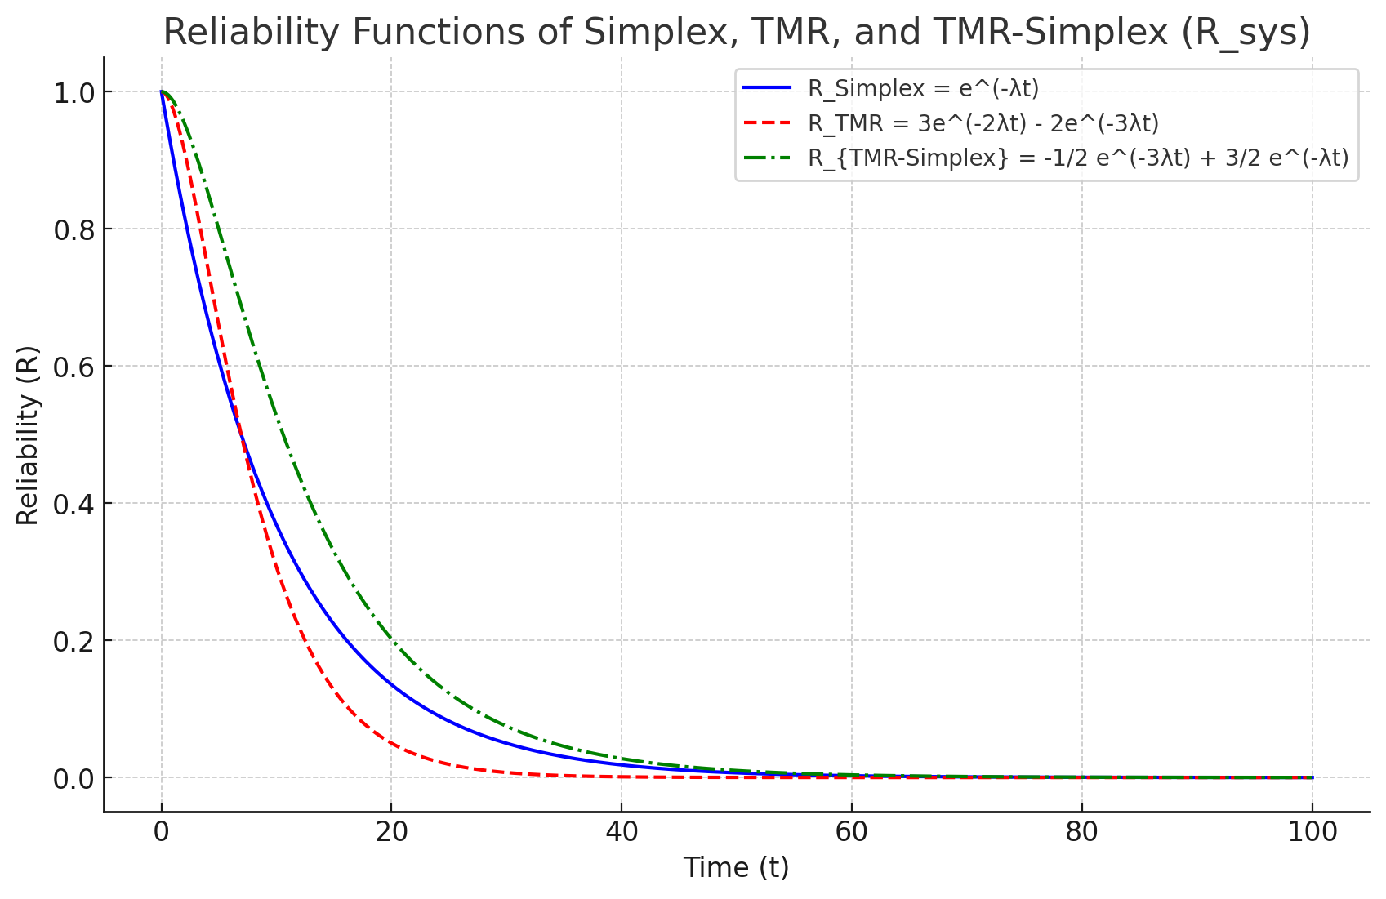

**Hint:** Use Matlab, Excel, or any other tool to generate the graph. See **Lecture 7, Slides 13-14, 38** to see similar graphs plotted for comparing these systems.