Project Eddie Temperature and CO2 Project

biobill

2019-06-10

setwd("~/Documents/R Projects/Project_Eddie")  
# setwd(gsub(pattern = '/scripts', replacement = '', x = getwd()))  
  
# install packages ----  
# install.packages("readxl")  
# install.packages("tidyverse")  
# install.packages("lubridate")  
# install.packages("scales")  
  
# load libraries ----  
library(tidyverse)

## Registered S3 methods overwritten by 'ggplot2':  
## method from   
## [.quosures rlang  
## c.quosures rlang  
## print.quosures rlang

## ── Attaching packages ───────────────────────────────────────────────── tidyverse 1.2.1 ──

## ✔ ggplot2 3.1.1 ✔ purrr 0.3.2  
## ✔ tibble 2.1.3 ✔ dplyr 0.8.1  
## ✔ tidyr 0.8.3 ✔ stringr 1.4.0  
## ✔ readr 1.3.1 ✔ forcats 0.4.0

## ── Conflicts ──────────────────────────────────────────────────── tidyverse_conflicts() ──  
## ✖ dplyr::filter() masks stats::filter()  
## ✖ dplyr::lag() masks stats::lag()

library(readxl)  
library(lubridate)

##   
## Attaching package: 'lubridate'

## The following object is masked from 'package:base':  
##   
## date

library(scales)

##   
## Attaching package: 'scales'

## The following object is masked from 'package:purrr':  
##   
## discard

## The following object is masked from 'package:readr':  
##   
## col_factor

library(janitor)

##   
## Attaching package: 'janitor'

## The following objects are masked from 'package:stats':  
##   
## chisq.test, fisher.test

library(plotly)

##   
## Attaching package: 'plotly'

## The following object is masked from 'package:ggplot2':  
##   
## last_plot

## The following object is masked from 'package:stats':  
##   
## filter

## The following object is masked from 'package:graphics':  
##   
## layout

# read in file and make year numeric ----  
modern_temp.df <- read_excel("./data/book_tgt_climate_9.xlsx",   
 skip = 3,  
 sheet="Temp (C)")   
  
modern_temp.df <- modern_temp.df %>%  
 clean_names() %>%  
 rename(temp_c = temperature)   
  
write_csv(modern_temp.df, "finalized_data/modern_temp.csv")  
  
# read excel file from link - harder -----  
# url <- "http://www.earth-policy.org/datacenter/xls/book_tgt_climate_9.xlsx"  
# destfile <- "book_tgt_climate_9.xlsx"  
# curl::curl_download(url, destfile)  
# avg_temp.df <- read_excel(destfile, skip = 2)  
  
  
# plot the new temp data -----  
modern_temp.plot <- modern_temp.df %>%  
 ggplot(aes(year, temp_c)) +   
 geom_point() +  
 geom_line()  
modern_temp.plot

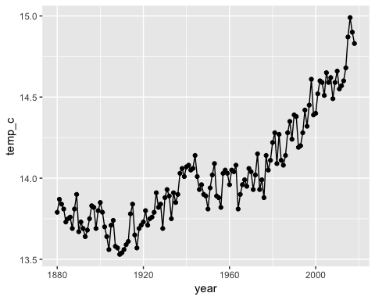

ggplotly(modern_temp.plot)

## PhantomJS not found. You can install it with webshot::install_phantomjs(). If it is installed, please make sure the phantomjs executable can be found via the PATH variable.

# filter out new data that isolates the max -----  
max_modern_temp.df <- modern_temp.df %>%  
 filter(year > 1964)  
  
# current temp max linear plot -----  
max_modern_temp.plot <- max_modern_temp.df %>%  
 ggplot(aes(year, temp_c)) +   
 geom_point() +  
 geom_line() +   
 geom_smooth(method = "lm")  
max_modern_temp.plot

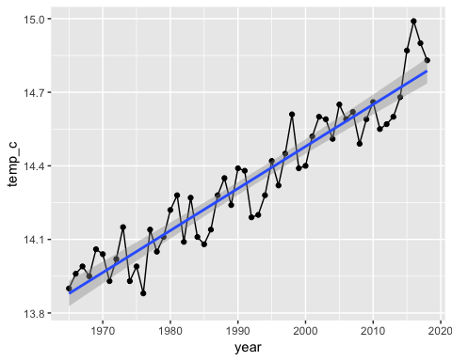

ggplotly(max_modern_temp.plot)

# linear model current temp ----  
modern_temp_inc.model <- lm(temp_c ~ year, data = max_modern_temp.df)  
summary(modern_temp_inc.model)

##   
## Call:  
## lm(formula = temp_c ~ year, data = max_modern_temp.df)  
##   
## Residuals:  
## Min 1Q Median 3Q Max   
## -0.18781 -0.08018 0.01993 0.07602 0.23697   
##   
## Coefficients:  
## Estimate Std. Error t value Pr(>|t|)   
## (Intercept) -1.978e+01 1.663e+00 -11.90 <2e-16 ***  
## year 1.713e-02 8.348e-04 20.52 <2e-16 ***  
## ---  
## Signif. codes: 0 '***' 0.001 '**' 0.01 '*' 0.05 '.' 0.1 ' ' 1  
##   
## Residual standard error: 0.09561 on 52 degrees of freedom  
## Multiple R-squared: 0.8901, Adjusted R-squared: 0.888   
## F-statistic: 421.1 on 1 and 52 DF, p-value: < 2.2e-16

# read in current co2---  
modern_co2.df <- read_delim("data/co2_annmean_mlo.txt", delim = " ",  
 skip_empty_rows = TRUE,   
 comment = "#",  
 col_names = FALSE) %>%  
 rename(year= X1, co2 = X2, uncertainty = X3 ) %>%  
 mutate(year = as.numeric(year), co2 = as.numeric(co2))

## Parsed with column specification:  
## cols(  
## X1 = col_character(),  
## X2 = col_character(),  
## X3 = col_character()  
## )

# plot current co2-----  
modern_co2.plot <- modern_co2.df %>% ggplot(aes(x=year, y = co2)) +   
 geom_point() +   
 geom_smooth(method="lm")  
modern_co2.plot

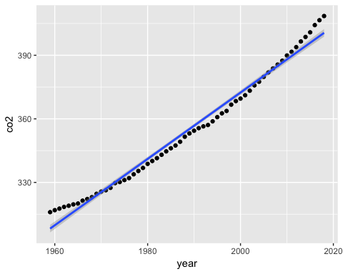

ggplotly(modern_co2.plot)

# current co2 linear model ----   
modern_co2.model = lm(co2~year, data=modern_co2.df)  
summary(modern_co2.model)

##   
## Call:  
## lm(formula = co2 ~ year, data = modern_co2.df)  
##   
## Residuals:  
## Min 1Q Median 3Q Max   
## -4.344 -2.703 -1.224 2.070 7.934   
##   
## Coefficients:  
## Estimate Std. Error t value Pr(>|t|)   
## (Intercept) -2.759e+03 5.199e+01 -53.07 <2e-16 ***  
## year 1.566e+00 2.614e-02 59.89 <2e-16 ***  
## ---  
## Signif. codes: 0 '***' 0.001 '**' 0.01 '*' 0.05 '.' 0.1 ' ' 1  
##   
## Residual standard error: 3.507 on 58 degrees of freedom  
## Multiple R-squared: 0.9841, Adjusted R-squared: 0.9838   
## F-statistic: 3587 on 1 and 58 DF, p-value: < 2.2e-16

# save cleaned modern co2 data   
write_csv(modern_co2.df, "finalized_data/modern_co2.csv")  
  
# ice core data ----  
ancient_temp_co2.df <- read_excel("data/Vostok Ice Core Data 2018.xls")   
  
# clean data  
ancient_temp_co2.df <-ancient_temp_co2.df %>%  
 rename(years_1000 = age)  
  
# plot ice core temp ----  
anc_temp.plot <- ancient_temp_co2.df %>% ggplot(aes(years_1000, temp_c)) +  
 geom_point() +   
 geom_line() +   
 scale_x_reverse()  
ggplotly(anc_temp.plot)

anc_temp.plot

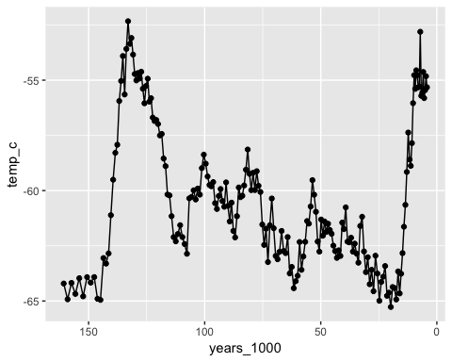

# isolate max rate temp ----  
anc_max_temp.df <- ancient_temp_co2.df %>%  
 filter(years_1000 > 9.7 & years_1000 < 16.02)  
  
  
# model max temp linear ----  
anc_max_temp.model <- lm(temp_c ~ years_1000, data=anc_max_temp.df)  
summary(anc_max_temp.model)

##   
## Call:  
## lm(formula = temp_c ~ years_1000, data = anc_max_temp.df)  
##   
## Residuals:  
## Min 1Q Median 3Q Max   
## -1.34682 -0.30001 -0.08291 0.30803 1.70972   
##   
## Coefficients:  
## Estimate Std. Error t value Pr(>|t|)   
## (Intercept) -41.420 1.599 -25.90 1.69e-10 ***  
## years_1000 -1.433 0.124 -11.56 4.16e-07 ***  
## ---  
## Signif. codes: 0 '***' 0.001 '**' 0.01 '*' 0.05 '.' 0.1 ' ' 1  
##   
## Residual standard error: 0.8519 on 10 degrees of freedom  
## Multiple R-squared: 0.9304, Adjusted R-squared: 0.9234   
## F-statistic: 133.6 on 1 and 10 DF, p-value: 4.156e-07

# co2 plot ----  
anc_co2.plot <- ancient_temp_co2.df %>%   
 ggplot(aes(years_1000, co2_ppm)) +  
 geom_point() +   
 geom_line() +   
 scale_x_reverse()  
ggplotly(anc_co2.plot)

anc_co2.plot

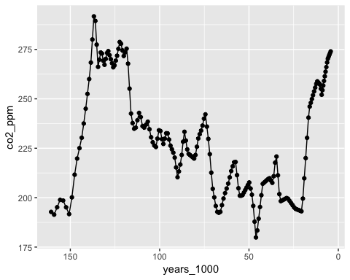

# extract max co2 data ----  
anc_co2_max.df <- ancient_temp_co2.df %>%  
 filter(years_1000 > 11.7 & years_1000 < 20.65)  
  
# co2 anc max plot ----  
anc_co2_max.plot <- anc_co2_max.df %>%   
 ggplot(aes(years_1000, co2_ppm)) +  
 geom_point() +   
 geom_line() +   
 scale_x_reverse()  
ggplotly(anc_co2_max.plot)

anc_co2_max.plot

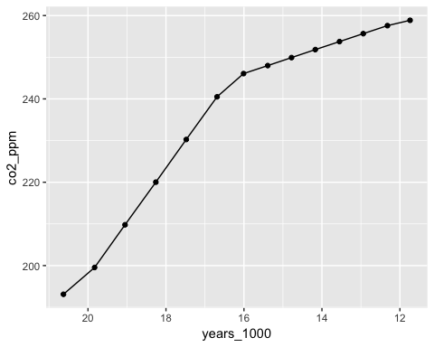

# old co2 model  
anc_co2_max.model <- lm(co2_ppm ~ years_1000, data=anc_co2_max.df)  
summary(anc_co2_max.model)

##   
## Call:  
## lm(formula = co2_ppm ~ years_1000, data = anc_co2_max.df)  
##   
## Residuals:  
## Min 1Q Median 3Q Max   
## -9.3324 -5.5647 0.0165 5.0727 9.9912   
##   
## Coefficients:  
## Estimate Std. Error t value Pr(>|t|)   
## (Intercept) 356.4861 10.8970 32.71 4.21e-13 ***  
## years_1000 -7.5208 0.6747 -11.15 1.09e-07 ***  
## ---  
## Signif. codes: 0 '***' 0.001 '**' 0.01 '*' 0.05 '.' 0.1 ' ' 1  
##   
## Residual standard error: 6.925 on 12 degrees of freedom  
## Multiple R-squared: 0.9119, Adjusted R-squared: 0.9046   
## F-statistic: 124.3 on 1 and 12 DF, p-value: 1.094e-07

# save cleaned ancient data   
write_csv(ancient_temp_co2.df, "finalized_data/ancient_temp_co2.csv")  
   
# test.df <- read_csv("https://raw.githubusercontent.com/wlperry/Project_Eddie/master/finalized_data/avg_temp.csv")