Lecture: Two-Way ANOVA Redux
  - The same machinery on data that fights back
Bill Perry

Where We Left Off
Last session — factorial ANOVA, on penguin body mass:
- Two crossed factors, three null hypotheses
- Main effects and the interaction; read the interaction first
- Estimated marginal means, and why they are not group means
- Type I / II / III sums of squares
- Effect sizes with effectsize
Today is the same analysis again, on a dataset that does not cooperate.
 Important
Why do it twice?
The penguin design is nearly proportional — 73/73, 34/34, 58/61. So raw means ≈ EMMs, and Type I / II / III barely move.
Everything you were told mattered, did not visibly matter. Today it does.

 Tip
🖐 Nothing new is being taught
No new test, no new function. The same five commands, on data where each one earns its keep.

Part 1 · What Penguins Could Not Show You

Three Things This Dataset Does Differently
 | penguins | crayfish
Cell sizes | 34–73, nearly proportional | 5–20
Type I vs. Type III | barely move; interaction identical | lake F 121 → 90
Interaction | F = 8.8, statistical | F = 12.7, biological
Assumptions | pass | both fail
Confounds | none worth saying | one you must disclose
Same model. Same five functions. Four conclusions you could not have reached last time.
 Note
📖 What you are practising
- Reading Anova(type = 3) completely, not just the p column
- Reading summary() line by line, and finding the missing rows
- Choosing an SS type when the choice changes the answer
- Using emmeans four different ways on one model
- Deciding whether a failed assumption actually matters

Part 2 · The Crayfish Common Garden

The Study
Sargent & Lodge (2014), Evolutionary Applications.
Young-of-year rusty crayfish (Faxonius rusticus) were taken from
- their native range (Ohio), and
- an invaded range (Wisconsin),
and grown in enclosures in three northern Wisconsin lakes — Big, High and Papoose — in summer 2011.
The question. Have invasive-range populations evolved faster growth? A common-garden design answers it: put both origins in the same environment and the difference that remains is not environmental.
Variable | What it is
range | Native / Invasive — factor A, 2 levels
lake | Big / High / Papoose — factor B, 3 levels
growth_per_day | mm per day — the response
initial_length | starting length, mm
days | length of the deployment
avg_temp | mean water temperature, °C
A 2 × 3 factorial: six cells, 84 crayfish.

How Unbalanced Is It?
#| warning: false
#| collapse: true
cray_df %>%
count(range, lake) %>%
pivot_wider(names_from = lake,
values_from = n)
## # A tibble: 2 × 4
## range Big High Papoose
## <fct> <int> <int> <int>
## 1 Native 5 14 11
## 2 Invasive 17 17 20
Every cell is filled, so every effect is estimable. But the smallest cell is 5 and the largest is 20 — a four-fold range.
Important
This is not “a bit” unbalanced
Balance is not just equal n. A design is proportional when the cell counts follow the row and column totals. Check Native: 5 / 14 / 11 against Invasive 17 / 17 / 20. Big is 23% of the Native crayfish and 31% of the Invasive ones.
Non-proportional imbalance is exactly the condition under which the three SS types stop agreeing, and under which a raw marginal mean stops estimating what you think.

Tip
🖐 Why it happened
Field enclosures. Animals escape, enclosures fail, crayfish die. This is what real data looks like — the penguin balance was the unusual thing.

The Cell Means — the Result Is Already Visible
## range lake n mean sd
## 1 Native Big 5 0.2472 0.0102
## 2 Native High 14 0.2518 0.0300
## 3 Native Papoose 11 0.1882 0.0079
## 4 Invasive Big 17 0.3172 0.0347
## 5 Invasive High 17 0.3242 0.0463
## 6 Invasive Papoose 20 0.1850 0.0221
Read down the pairs:
- Big — Native 0.247, Invasive 0.317 → a gap of +0.070
- High — Native 0.252, Invasive 0.324 → +0.072
- Papoose — Native 0.188, Invasive 0.185 → −0.003
Important
That is an interaction, in words
The invasive growth advantage is large and almost identical in two lakes, and gone in the third.
“Invasive crayfish grow faster” is true in Big and High and false in Papoose. A main effect alone would have averaged those into a single misleading number.

Look at It Before You Model It
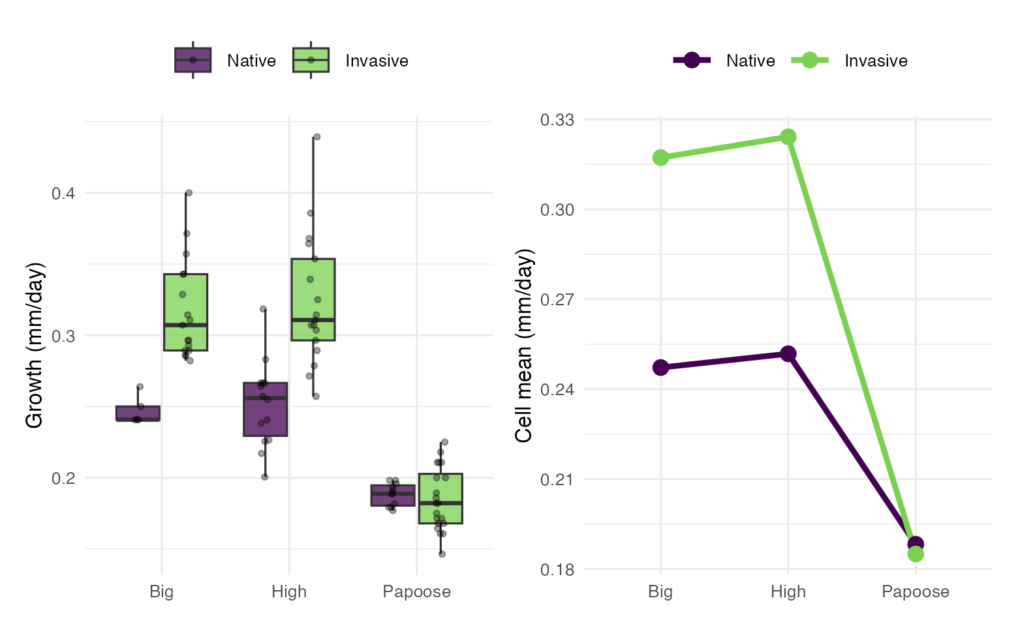
Note
📖 The two lines converge
Parallel lines = no interaction. These are parallel from Big to High and then collapse onto each other at Papoose.
The interaction is not a sign flip — nobody overtakes anybody. It is the disappearance of a difference. That is the most common shape an ecological interaction takes, and the easiest one to miss if you only read p-values.

Tip
🖐 Also notice the spread
The Invasive/High box is tall; the Native/Papoose box is tiny. Hold that thought until Part 7.

⚠️ Before Any of That — Read the Methods
## range days mean_temp n
## 1 Native 106, 108 22.03 30
## 2 Invasive 70 23.85 54
days is perfectly confounded with range: every Native crayfish was in the water 106–108 days, every Invasive one exactly 70. And the two groups therefore experienced water ~1.8 °C apart.
Important
⚠️ What this does and does not break
The response is growth per day, which removes the duration itself. It does not remove the fact that the two origins were grown in different parts of the summer, at different temperatures, at different sizes-for-age.
So range is not a clean contrast of genotype. It is a contrast of genotype-plus-deployment-window.

Tip
🖐 Say it, do not hide it
We still fit the model — it is the right model for the design we have. But this belongs in the methods and the discussion, not in a footnote.
The lake effect and the interaction are unaffected: both origins were in all three lakes.

Part 3 · Reading Anova(type = 3) Line by Line

Fit, and Then the Table
options(contrasts = c("contr.sum",
"contr.poly"))
cray_model <- lm(
growth_per_day ~ range * lake,
data = cray_df)
Anova(cray_model, type = 3)
## Anova Table (Type III tests)
##
## Response: growth_per_day
## Sum Sq Df F value Pr(>F)
## (Intercept) 4.3228 1 4460.871 < 0.00000000000000022 ***
## range 0.0365 1 37.695 0.00000003234 ***
## lake 0.1741 2 89.835 < 0.00000000000000022 ***
## range:lake 0.0246 2 12.704 0.00001674553 ***
## Residuals 0.0756 78
## ---
## Signif. codes: 0 '***' 0.001 '**' 0.01 '*' 0.05 '.' 0.1 ' ' 1
range * lake expands to range + lake + range:lake — both main effects and the interaction.
Important
⚠️ The options() line is not decoration
Type III main effects mean what you think they mean only when the factors are coded with sum-to-zero contrasts. Leave R’s default contr.treatment in place and the row still says “range” — but it is testing a different hypothesis. Part 5 shows exactly which one.
Contrasts are baked in when lm() runs, so the order is always set → fit → test. Changing the option afterwards does nothing.

Every Row, Explained
Row | Df | What the F is a ratio of | What it tests | Verdict
(Intercept) | 1 | $MS_{intercept}/MS_{resid}$​ | is the grand mean of the six cell means zero? | F = 4461 — true and useless; obviously not zero
range | 1 | $MS_{range}/MS_{resid}$​ | averaged over lakes, do Native and Invasive differ? | F_{1,78} = 37.70,  p < 0.0001
lake | 2 | $MS_{lake}/MS_{resid}$​ | averaged over ranges, do the three lakes differ? | F_{2,78} = 89.84,  p < 0.0001
range:lake | 2 | $MS_{range:lake}/MS_{resid}$​ | is the range effect the same in every lake? | F_{2,78} = 12.70,  p = 0.000017
Residuals | 78 | — | 84 crayfish − 6 cell means = 78 | $SS$ = 0.0756,  $MS$ = 0.000969
Note
✅ Where the df come from
range has 2 levels → 1 df. lake has 3 → 2 df. The interaction is their product, 1 × 2 = 2 df. Model df 1 + 2 + 2 = 5, plus the intercept = 6 = the number of cells. Residual df = 84 − 6 = 78. The df are a check on whether R fit the design you think it did.

Read the Interaction Row First
Important
The reading order is not top-to-bottom
- range:lake first. p = 0.000017 → significant.
- Because it is significant, the two main-effect rows are answers to questions you no longer want to ask.
- Go to simple effects instead (Part 6).
“Invasive crayfish grow 0.046 mm/day faster” is the range row. It is a true statement about an average that describes no lake: the real numbers are +0.070, +0.072 and −0.003.

 Warning
⚠️ But do not delete the main effects
- Report them. They are part of the model, they consume df, and a reader needs them to see the decomposition.
- Report them and say that the interaction makes them conditional. What you must not do is report the range row alone as the finding.

Tip
🖐 If the interaction had been n.s.
Then the main effects are the story, and you read the table top-to-bottom like a one-way ANOVA done twice. Many factorial papers are that case. This one is not.

Part 4 · Reading summary(model) Line by Line

The Coefficient Table
summary(cray_model)
##
## Call:
## lm(formula = growth_per_day ~ range * lake, data = cray_df)
##
## Residuals:
## Min 1Q Median 3Q Max
## -0.067059 -0.020593 -0.004712 0.014782 0.115141
##
## Coefficients:
## Estimate Std. Error t value Pr(>|t|)
## (Intercept) 0.252269 0.003777 66.790 < 0.0000000000000002 ***
## range1 -0.023190 0.003777 -6.140 0.00000003234 ***
## lake1 0.029942 0.005930 5.049 0.00000284101 ***
## lake2 0.035707 0.004978 7.172 0.00000000037 ***
## range1:lake1 -0.011822 0.005930 -1.994 0.0497 *
## range1:lake2 -0.012993 0.004978 -2.610 0.0109 *
## ---
## Signif. codes: 0 '***' 0.001 '**' 0.01 '*' 0.05 '.' 0.1 ' ' 1
##
## Residual standard error: 0.03113 on 78 degrees of freedom
## Multiple R-squared: 0.7958, Adjusted R-squared: 0.7827
## F-statistic: 60.8 on 5 and 78 DF, p-value: < 0.00000000000000022

Six Cells, Six Numbers — So What Is Missing?
The design has six cells. The table has six rows. Count the names you would have expected:
Expected | Present?
(Intercept) | ✅
range1 (Native) | ✅
range2 (Invasive) | ❌ missing
lake1 (Big), lake2 (High) | ✅
lake3 (Papoose) | ❌ missing
range1:lake1, range1:lake2 | ✅
range1:lake3, range2:lake* | ❌ missing
Four cells’ worth of names are gone. Nothing was dropped and nothing failed.
Important
They are not missing — they are implied
contr.sum imposes one rule: every set of effects sums to zero.
$$α_{Native}+α_{Invasive}=0$$

$$β_{Big}+β_{High}+β_{Papoose}=0$$
So once R has told you range1 = −0.0232, the Invasive effect is forced to be +0.0232. Printing it would be printing the same number twice.
Six cells can only support six free numbers. A 2-level factor spends 1, a 3-level factor spends 2, the interaction spends 1 × 2 = 2, the intercept spends 1. Total: 6. The design is exactly used up.

Recovering the Four Missing Numbers
b <- coef(cray_model)
c(range_Native = b[["range1"]],
range_Invasive = -b[["range1"]],
lake_Big = b[["lake1"]],
lake_High = b[["lake2"]],
lake_Papoose = -(b[["lake1"]] +
b[["lake2"]])) %>%
round(5)
## range_Native range_Invasive lake_Big lake_High lake_Papoose
## -0.02319 0.02319 0.02994 0.03571 -0.06565
Papoose is −0.0656 — by far the biggest lake effect, and R never printed it.
Warning
⚠️ The trap this sets
A reader skimming summary() sees lake1 and lake2 both positive and significant and concludes “lakes raise growth.”
The unprinted level is the one doing the work. Under contr.sum the omitted level is always the one you most need to compute, because it carries the negative of everything else.

Tip
🖐 The same logic for the interaction
range1:lake3 = −(range1:lake1 + range1:lake2) = +0.0248, and every range2: term is the negative of its range1: partner.

The Intercept Is Not the Grand Mean
c(intercept = coef(cray_model)[[1]],
cell_means = mean(cray_cells$mean),
raw_grand = mean(cray_df$growth_per_day)
) %>% round(6)
## intercept cell_means raw_grand
## 0.252269 0.252269 0.255181
Important
0.252269, not 0.255181
- Under contr.sum intercept is unweighted mean of the six cell means — every cell counts once, whatever its n.
- Raw grand mean weights each cell by its n, pulled toward the big Invasive cells.
- Same idea as an estimated marginal mean, sitting in intercept row. On a balanced design the two are identical, which is why you never noticed it with the penguins.

Reconstructing a Cell Mean by Hand
Invasive crayfish in Papoose Lake — every term is a negative, because Invasive is level 2 and Papoose is level 3:
$$\hat{y}=μ+α_{Inv}+β_{Pap}+(αβ)_{Inv,Pap}$$
by_hand <-
b[["(Intercept)"]] -
b[["range1"]] -
b[["lake1"]] - b[["lake2"]] +
b[["range1:lake1"]] +
b[["range1:lake2"]]
emm_cell <- as.data.frame(
emmeans(cray_model, ~ range * lake)) %>%
filter(range == "Invasive",
lake == "Papoose")
round(c(by_hand = by_hand,
emmeans = emm_cell$emmean,
observed = cray_cells$mean[6]), 6)
## by_hand emmeans observed
## 0.184995 0.184995 0.184995
Important
All three are 0.184995
The hand calculation, emmeans, and the observed cell mean agree exactly.
That is the payoff of the whole part: summary() is not a wall of numbers, it is a complete and exact recipe for all six cell means — once you know that the missing levels are the negative sums.

Note
📖 Why they agree exactly here
A model with both main effects and the interaction has one parameter per cell. It is saturated: it reproduces the cell means perfectly. Drop the interaction and it would not.

Anova() or summary()? Both, for Different Jobs
 | summary(model) | Anova(model, type = 3)
Unit of output | one row per parameter | one row per term
lake appears as | 2 rows, 2 t-tests | 1 row, 1 F-test on 2 df
Answers | “how big is particular effect?” | “does this factor matter?”
Multi-level factors | ✅ gives you the sizes | ❌ hides them
Overall test of a factor | ❌ — two t-tests not test of lake | ✅
Interaction | 2 separate rows | 1 honest 2-df test
$R^{2}$, residual SE | ✅ | ❌
Important
✅ The rule
Never report a multi-level factor’s significance from summary(). Two significant t-tests out of two is not a 2-df F-test, and it is not corrected for anything.
Anova() to decide whether a term matters. summary() to see how big the pieces are. emmeans() to say anything a biologist can read.

Part 5 · Type I, II, III — Where It Finally Matters

All Three, on This Design
t1 <- anova(cray_model) # Type I
t2 <- Anova(cray_model, type = 2) # Type II
t3 <- Anova(cray_model, type = 3) # Type III
tibble(
term = c("range", "lake", "range:lake"),
`Type I` = round(t1[1:3, "F value"], 2),
`Type II` = round(t2[1:3, "F value"], 2),
`Type III` = round(t3[2:4, "F value"], 2)
) %>% as.data.frame()
## term Type I Type II Type III
## 1 range 36.30 35.71 37.70
## 2 lake 121.15 121.15 89.83
## 3 range:lake 12.70 12.70 12.70
Note the row offset: Anova() puts (Intercept) in row 1 and anova() does not.
Important
Finally, numbers that move
lake’s F drops from 121 to 90 — a quarter of it was never lake’s to claim. On penguins the same comparison moved from 758 to 747 and interaction did not budge.
The interaction is identical in all three. That is always true: the highest-order term is entered last whatever the scheme, so there is nothing left to adjust for.

Tip
🖐 Why Type II = Type I for lake here
Type I entered range then lake, so lake was already adjusted for range. Type II adjusts each main effect for the other. Same thing — for the second term entered.

Type I Depends on the Order You Typed
# range first
anova(lm(growth_per_day ~ range * lake,
data = cray_df))["range", "Sum Sq"]
## [1] 0.03517443
# lake first
anova(lm(growth_per_day ~ lake * range,
data = cray_df))["range", "Sum Sq"]
## [1] 0.03460209
Same model, two different sums of squares for range — because anova() credits each term only with what the terms above it left behind.
Important
What each type adjusts for
- Type I — adjusted for terms above it only. Order-dependent; sums to $SS_{total}$.
- Type II — adjusted for every term that does not contain it. Order-free.
- Type III — adjusted for all others, interaction included. Order-free; needs sum-to-zero contrasts.

Warning
⚠️ anova() is Type I
anova() is base R and sequential; car::Anova(type = 3) is a different function. Typing anova() on an unbalanced design and calling it Type III reports the wrong table.

Two Codings, Two Meanings for One Coefficient
A contrast coding does not change the model. It changes what the parameters are asked to be. Refit the identical model under R’s default:
options(contrasts = c("contr.treatment",
"contr.poly"))
cray_trt <- lm(growth_per_day ~ range * lake,
data = cray_df)
options(contrasts = c("contr.sum", # put
"contr.poly")) # it back
round(coef(cray_trt), 5)
## (Intercept) rangeInvasive lakeHigh
## 0.24720 0.07002 0.00459
## lakePapoose rangeInvasive:lakeHigh rangeInvasive:lakePapoose
## -0.05895 0.00234 -0.07327
 | contr.sum | contr.treatment
Baseline | unweighted grand mean | first level of everything (Native, Big)
The range term is | Native’s deviation from grand mean | Native → Invasive gap in Big Lake only
Effects sum to | 0 | nothing
Important
Look at rangeInvasive = 0.07002
Not an average of anything. Exactly the Native–Invasive gap in Big Lake — the number Part 6’s simple effects will report.
Under contr.treatment the “range” coefficient is a simple effect.

So the “Type III” Row Changes Its Question
Type III asks one thing: “are this term’s coefficients all zero?” Change what the coefficients mean and you have changed the hypothesis — while the row label stays the same.
## term contr.sum contr.treatment
## 1 range 37.70 19.55
## 2 lake 89.83 14.01
## 3 range:lake 12.70 12.70
The range row reads F = 37.70 one way and F = 19.55 the other. Same data, same model, same label.
Important
Where did 19.55 and 14.01 come from?
They are not corruptions. They are real tests of the wrong thing — and you have already seen both numbers:
- 19.55 is simple effect of range within Big Lake
- 14.01 is simple effect of lake within Native
contr.treatment turned both “main effect” rows into tests at reference level, that is what its coefficients mean.

Note
📖 What is untouched
The interaction row — 12.70 both ways. It is the highest-order term, so there is no reference level left to condition on. And Type I and Type II are completely coding-invariant: identical SS either way.

The Main Effect Flips When You Rename a Lake
If the range row is really “the range effect at the reference lake”, then changing the reference must change it. R picks the reference alphabetically, so:
options(contrasts = c("contr.treatment", "contr.poly"))
cray_pap <- lm(growth_per_day ~ range * lake,
data = mutate(cray_df, lake = relevel(lake, "Papoose")))
options(contrasts = c("contr.sum", "contr.poly"))
round(Anova(cray_pap, type = 3)["range", ], 4)
## Anova Table (Type III tests)
##
## Response: growth_per_day
## Sum Sq Df F value Pr(>F)
## range 0.0001 1 0.0774 0.7816
Reference lake | range F | p
Big (R’s default) | 19.55 | 0.00003
Papoose | 0.08 | 0.78
none — contr.sum | 37.70 | 0.00000003
Warning
⚠️ Read that table again
A headline result and a flat nothing, from the same model on the same 84 crayfish, decided by the alphabetical order of three lake names. Rename Papoose to “Apoose” and your main effect evaporates.
A quantity that depends on a naming choice is not a main effect.

🖐 The exception worth knowing. Drop the interaction and the problem disappears: in an additive model the Type III main-effect Fs are identical under both codings (27.62, 93.73). Nothing is conditional, so there is no reference level to condition on. The hazard is interactions, specifically.

Which One Do You Report?
Important
Report Type III here, and say so.
Reasons, in order:
- Cells are non-proportionally unbalanced, so types genuinely disagree and choice is a real one.
- Neither factor is prior to the other. Range did not cause lake; lake did not cause range. There is no defensible order, so an order-dependent table is indefensible.
- It is what the field expects from an unbalanced factorial, and what emmeans is consistent with.
With contr.sum set before the fit — otherwise, per last three slides, you are reporting simple effects at whichever level sorts first.

And the honest caveat. Type III main effects in the presence of a real interaction are tests of averaged-over effects that may describe no actual group. We report them, then go to simple effects.
Note
📖 When Type II is the better answer
If the interaction is not significant and you are willing to say the effects are additive, Type II is more powerful — it does not waste adjustment on a term you have decided is noise.
Some statisticians argue for always dropping a non-significant interaction and refitting. That is defensible. Deciding after seeing the p-value is less so.

Tip
🖐 On a balanced design
All three are identical, and the whole argument evaporates. That is the real reason to balance a design when you can.

Part 6 · emmeans, Four Ways

Way 1 — Marginal Means
emmeans(cray_model, ~ range)
## range emmean SE df lower.CL upper.CL
## Native 0.229 0.00625 78 0.217 0.242
## Invasive 0.275 0.00425 78 0.267 0.284
##
## Results are averaged over the levels of: lake
## Confidence level used: 0.95
## range raw_mean
## 1 Native 0.2277
## 2 Invasive 0.2704
- EMM 0.2287 and 0.2751 → difference 0.0464
- Raw 0.2284 and 0.2697 → difference 0.0413
Note
📖 The raw mean understates it by 12%
The raw Invasive mean is pulled down because 20 of the 54 Invasive crayfish were in Papoose, the worst lake. The EMM averages the three lakes equally, so it is not contaminated by where the animals happened to survive.
Milder than the penguin toy — but in the same direction, for the same reason.

Warning
⚠️ Read the NOTE R prints
“Results may be misleading due to involvement in interactions.” That is not boilerplate. It is emmeans telling you this number describes no lake.

Way 2 — Simple Effects, range Within Each Lake
pairs(emmeans(cray_model, ~ range | lake))
## lake = Big:
## contrast estimate SE df t.ratio p.value
## Native - Invasive -0.07002 0.0158 78 -4.421 <0.0001
##
## lake = High:
## contrast estimate SE df t.ratio p.value
## Native - Invasive -0.07237 0.0112 78 -6.441 <0.0001
##
## lake = Papoose:
## contrast estimate SE df t.ratio p.value
## Native - Invasive 0.00325 0.0117 78 0.278 0.7816
The | means “separately within each level of”. This is the analysis the significant interaction sent you to.
Important
This is the actual result of the study
- Big — Invasive faster by 0.070, p < 0.0001
- High — faster by 0.072, p < 0.0001
- Papoose — 0.003, p = 0.78
Two lakes show a large invasive advantage; the third shows nothing.
Write this, not the main effect.

Tip
🖐 No multiplicity adjustment appears
Each lake has only one comparison (2 levels → 1 pair), so there is nothing to adjust within a lake. Across the three families, emmeans leaves it to you.

Way 3 — Turn It Around: lake Within Each Range
pairs(emmeans(cray_model, ~ lake | range))
## range = Native:
## contrast estimate SE df t.ratio p.value
## Big - High -0.00459 0.0162 78 -0.283 0.9568
## Big - Papoose 0.05895 0.0168 78 3.511 0.0021
## High - Papoose 0.06355 0.0125 78 5.067 <0.0001
##
## range = Invasive:
## contrast estimate SE df t.ratio p.value
## Big - High -0.00694 0.0107 78 -0.650 0.7932
## Big - Papoose 0.13223 0.0103 78 12.876 <0.0001
## High - Papoose 0.13916 0.0103 78 13.552 <0.0001
##
## P value adjustment: tukey method for comparing a family of 3 estimates
Important
A difference of magnitude, not of sign
Papoose is worse than Big and High in both ranges — lake did not stop mattering. The Papoose deficit is 0.059 / 0.064 for Native and 0.132 / 0.139 for Invasive: more than twice as costly. Big vs. High is n.s. in both (p = 0.96, 0.79).

Note
📖 Same 2 df, two readings
Way 2: “the invasive advantage disappears in Papoose.” Way 3: “Papoose penalises invasive crayfish twice as hard.”
Both correct. Pick the one that answers your question. Tukey does appear here — 3 levels give 3 pairs.

Way 4 — The Interaction Contrast
contrast(emmeans(cray_model, ~ range * lake),
interaction = c("pairwise", "pairwise"))
## range_pairwise lake_pairwise estimate SE df t.ratio p.value
## Native - Invasive Big - High 0.00234 0.0194 78 0.121 0.9043
## Native - Invasive Big - Papoose -0.07327 0.0197 78 -3.723 0.0004
## Native - Invasive High - Papoose -0.07562 0.0162 78 -4.665 <0.0001
A difference of differences: is the range gap in lake X different from the range gap in lake Y?
Important
This localises the interaction
Big vs. High 0.0023, p = 0.90; Big vs. Papoose −0.073, p = 0.0004; High vs. Papoose −0.076, p < 0.0001.
The 2-df interaction is entirely Papoose. Anova() said an interaction exists; this says which cells it lives in — the only one of the four ways that does.

Tip
🖐 The sentence to report
“The interaction was driven by Papoose Lake, where the invasive advantage was 0.073–0.076 mm/day smaller than in the other two lakes (both p < 0.001), which did not differ (p = 0.90).”

And the Picture: emmip()
emmip(cray_model, range ~ lake, CIs = TRUE) +
theme_minimal(base_size = 9)
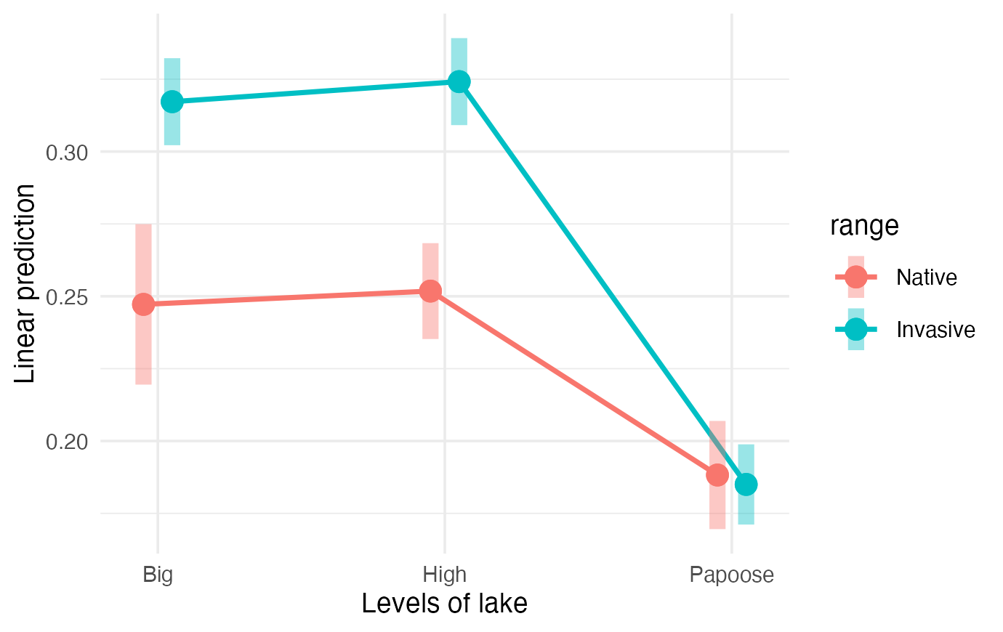
Note
📖 Why emmip and not your own ggplot
It plots the model’s means with intervals from the model’s standard errors. A ggplot of raw cell means plots something slightly different — on an unbalanced design those are not the same numbers.
For the final figure in a paper, build it yourself from as.data.frame(emmeans(...)) so you control every element — but check it against emmip() first.

Tip
🖐 Read the overlap, not the lines
At Papoose the two intervals sit on top of each other. At Big and High they do not come close. That is the interaction, drawn.

Why There Are No Planned Comparisons Today
A planned comparison is a specific contrast you commit to before seeing the data, because theory demands it. It costs no multiplicity penalty, because you did not go looking.
This design cannot support one:
- range has 2 levels. There is only one possible comparison, so “planned” and “post-hoc” are the same test.
- lake has 3 levels but they are unordered nuisance environments. There is no a priori reason to pit Big against High rather than against Papoose.
Note
📖 Where they will fit
You need a factor whose levels have structure — a dose gradient, a control-vs-all-treatments comparison, an ordered sequence.
The urchin density gradient (0 / 33 / 66 / 100%) is the natural case: a linear trend contrast is a single df that asks the real biological question, instead of six pairwise tests that do not.

Tip
🖐 Preview of the syntax
contrast(emm, list(linear = c(-3, -1, 1, 3))), with the weights summing to zero. We will build these properly later.

Part 7 · Effect Size, Assumptions, Reporting

How Big, Not Just Whether
eta_squared(Anova(cray_model, type = 3))
## # Effect Size for ANOVA (Type III)
##
## Parameter | Eta2 (partial) | 95% CI
## ------------------------------------------
## range | 0.33 | [0.19, 1.00]
## lake | 0.70 | [0.60, 1.00]
## range:lake | 0.25 | [0.11, 1.00]
##
## - One-sided CIs: upper bound fixed at [1.00].
Term | partial η² | label
range | 0.33 | large
lake | 0.70 | large
range:lake | 0.25 | large
Important
lake is the biggest effect in the study
Partial η² = 0.70 for a factor nobody was interested in. The experimental factor, range, gets 0.33.
Model $R^{2}$ = 0.80. For field ecology that is extraordinary — and most of it is “which lake did this animal happen to live in.”

Tip
🖐 This is the number for the next study
If lake carries 0.70 of the explainable variation, a design with more lakes beats one with more crayfish per lake. The p-values could not have told you that.

Diagnostics — One Call
check_model(cray_model,
check = c("qq", "homogeneity", "outliers"))
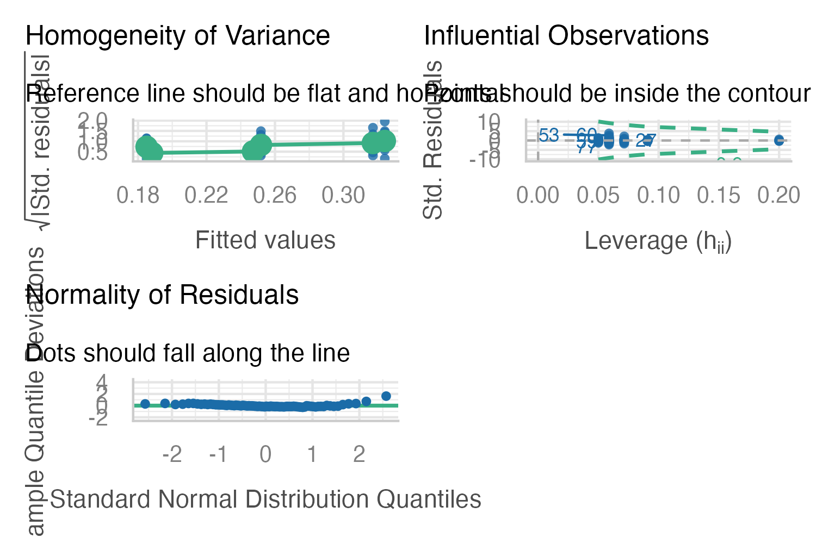
Warning
⚠️ Two panels are telling you off
The Q-Q tail bends away hard — one crayfish grew 9.25 → 40 mm in 70 days, a standardised residual of 3.8.
The homogeneity panel rises instead of staying flat. Cell SDs run 0.008 (Native/Papoose) to 0.046 (Invasive/High): a six-fold spread, biggest in the fastest-growing cells.

Tip
🖐 Positive mean–variance relationship
Spread rising with the mean is the signature of a response that wants a log scale. Two slides on.

The Formal Tests, the Same Way
check_normality(cray_model)
## Warning: Non-normality of residuals detected (p = 0.004).
check_heteroscedasticity(cray_model)
## Warning: Heteroscedasticity (non-constant error variance) detected (p < .001).
Same two assumptions, as tests rather than pictures — and performance writes the verdict in words instead of leaving you to remember which way a p-value points.
Note
📖 Why not shapiro.test() and leveneTest() by hand?
You can, and week 8 did it that way first so you would know what is under the hood. check_normality() is shapiro.test() on the residuals — the same p = 0.0043.
check_heteroscedasticity() is a Breusch–Pagan test, which asks whether the residual variance trends with the fitted values. That is the right question for a mean–variance relationship; Levene asks only whether the six cells differ.

Warning
⚠️ Neither test is the boss
At n = 84 both are sensitive enough to flag things that may not matter. The panels and the next slide decide.

Does the Violation Change the Answer?
Three independent ways to ask. The interaction F, each way:
## approach interaction_F
## 1 as fitted 12.70
## 2 log(growth) 13.24
## 3 outlier dropped 13.45
## 4 HC3 robust SEs 27.58
And the log model’s assumptions, asked the same way:
check_normality(m_log)
## OK: residuals appear as normally distributed (p = 0.358).
check_heteroscedasticity(m_log)
## OK: Error variance appears to be homoscedastic (p = 0.241).
Important
✅ Every route gives the same conclusion
Three main effects and an interaction, all strongly significant, with the interaction F between 12.7 and 27.6.
The log transform turns both warnings into OK: — p = 0.36 and p = 0.24 — and changes nothing about what you conclude.

Note
📖 What to actually report
Report the log-scale model — it is the one whose assumptions hold — and state that the untransformed analysis gave the same conclusions.
That sentence is worth more than a passed Shapiro test. “The assumption failed, here are three checks, the answer is stable” is what robustness means.

Reporting It
Note
How to report this result
“Daily growth rate differed between native and invasive crayfish (two-way ANOVA on log-transformed growth, Type III SS; F_{1,78} = 34.2, p < 0.001) and among lakes (F_{2,78} = 124.7, p < 0.001), and the two factors interacted (F_{2,78} = 13.2, p < 0.001; partial η² = 0.25).
Invasive crayfish grew faster than native crayfish in Big (+0.070 mm d⁻¹, p < 0.001) and High (+0.072, p < 0.001) lakes but not in Papoose (+0.003, p = 0.78); the interaction contrast confirmed Papoose differed from both other lakes (p ≤ 0.0004) while Big and High did not differ (p = 0.90).
Native and invasive animals were deployed in different windows (106–108 vs. 70 days, mean temperature 22.0 vs. 23.8 °C), so the range effect is not a clean genotypic contrast.”

Important
✅ Four things that must be in it
- Which SS type — otherwise the reader cannot reproduce you
- The interaction before the main effects, and the simple effects that unpack it
- An effect size, not just p
- The confound, in the methods, unprompted

Warning
⚠️ What a weaker version would say
“Invasive crayfish grew significantly faster than native crayfish (p < 0.001).” True, and it hides that this is false in one of the three lakes studied.

Part 8 · Wrap-Up

What You Did Today
- Ran the same factorial ANOVA as last session on data that is genuinely unbalanced, and watched the choices start to matter
- Read Anova(type = 3) row by row — every df accounted for, and the interaction row read first
- Read summary() line by line and found the four missing coefficients, then reconstructed a cell mean by hand to 6 decimals
- Saw the intercept is the mean of cell means, not of the data
- Watched lake’s F fall from 121 (Type I) to 90 (Type III), and Type I change when you reorder the formula
- Used emmeans four ways — marginal, simple effects both directions, and the interaction contrast that localised the effect to Papoose
- Failed two assumption tests and then showed the answer was stable
Important
✅ The one idea to keep
A significant interaction demotes every main effect to a conditional statement. The table tells you an interaction exists; only the simple effects and the interaction contrast tell you what it is.
Here: the invasive crayfish growth advantage is real, large, and absent in one of the three lakes tested. No single p-value in the ANOVA table says that.

Note
📖 Up next
What happens when the thing on the right-hand side is continuous — and when lake would be better as a random effect than a fixed one.

Readings
- Whitlock & Schluter, Ch. 18 — factorial designs and interactions.
- Gotelli & Ellison, Ch. 10 — two-factor ANOVA and the interpretation of interaction terms.
- Quinn & Keough (2002), Experimental Design and Data Analysis for Biologists, Ch. 9 — unbalanced factorial designs and the sums-of-squares types. §9.2 is the reference for the Type I/II/III argument in Part 5.
- Sargent, L. W., & Lodge, D. M. (2014). Evolution of invasive traits in nonindigenous species: increased survival and faster growth in invasive populations of rusty crayfish (Faxonius rusticus). Evolutionary Applications, 7(8), 949–961.
Note
📖 On the dataset
A real common-garden experiment, not a textbook example — so there is no chapter to look up and no clean answer in the back. The textbook PDFs are on Canvas; the crayfish paper is worth reading for the methods section alone.

Tip
🖐 Worth your time
Hector, A., von Felten, S., & Schmid, B. (2010). Analysis of variance with unbalanced data: an update for ecology & evolution. Journal of Animal Ecology, 79, 308–316. Twelve pages, and it is about exactly Part 5.

