Generalized Linear Models
  - Generalized linear models
Bill Perry

THE SETUP
# Load required packages
# install.packages("ResourceSelection")
# install.packages("pscl")
library(janitor)
library(pscl)
library(tinytable)
library(skimr)
library(performance)
library(ResourceSelection)
library(car)
library(emmeans)
library(DHARMa)
library(MASS)
library(broom)
library(flextable)
library(parameters)
library(patchwork) # For combining plots
library(faraway) # For gala dataset
library(tidyverse)
# Set options
options(scipen = 999)

Lecture 14: Generalized Linear Models Activity

Generalized Linear Models (GLMs) extend linear models to handle different types of response variables:
- Normal distribution: Continuous data (like regular ANOVA/regression)
- Poisson distribution: Count data
- Binomial distribution: Binary data (presence/absence, success/failure)
- Gamma distribution: Positive continuous data
- Negative binomial: Overdispersed count data

The Three Components of GLMs
- Random component: The response variable and its probability distribution
- Systematic component: The predictor variables (continuous or categorical)
- Link function: Connects expected value of Y to predictor variables

How to approach the problem
- What is the question?
  - unclear data mining can lead to lost time
- Data Variable type: what does the data look like - types of variable read in
- Data Completeness: Is there a lot of sparcity
- Data Structure: what does the data look like graphically
- Model Choice: what is the right model to analyze the data to answer your question
- Model Run: run model - summary
- Model Assumptions: test early before you get excited and bend the rules
- Model Statistics : run the final stats
- Model Followup tests: post F pairwise comparisons or others
- Graphical display of results: highlighting the data and statistics

Part 1: Gaussian GLM
The simplest form of GLM uses a normal (Gaussian) distribution with an identity link function. This is equivalent to standard ANOVA
Let’s compare a standard linear model and a Gaussian GLM

Island Biogeography Data
The gala dataframe from the faraway package contains data on 30 Galapagos islands, testing MacArthur-Wilson’s theory of island biogeography.
- Variables in the dataframe:
  - sppNumber of plant species (count data)
  - endemicsNumber of endemic species (count data)
  - areaIsland area (km²)
  - elevation -Maximum elevation (m)
  - Nearest - Distance to nearest island (km)
  - scruz - Distance to Santa Cruz island (km)
  - adjacent - area of adjacent island (km²)

The data - variable types
# Create a categorical variable for demonstration
g_df <- gala %>% clean_names() %>%
rename(spp = species) %>%
mutate(size_cat = case_when(
area < 1 ~ "small",
area >= 1 & area < 100 ~ "medium",
area >= 100 ~ "large"
),
size_cat = factor(size_cat, levels = c("small", "medium", "large")))
g_df <- g_df %>% filter(area < 3000)
head(g_df %>% dplyr::select(-scruz, -adjacent), 10)
spp endemics area elevation nearest size_cat
Baltra 58 23 25.09 346 0.6 medium
Bartolome 31 21 1.24 109 0.6 medium
Caldwell 3 3 0.21 114 2.8 small
Champion 25 9 0.10 46 1.9 small
Coamano 2 1 0.05 77 1.9 small
Daphne.Major 18 11 0.34 119 8.0 small
Daphne.Minor 24 0 0.08 93 6.0 small
Darwin 10 7 2.33 168 34.1 medium
Eden 8 4 0.03 71 0.4 small
Enderby 2 2 0.18 112 2.6 small

Data completeness

The Formula for Geometric Mean (GM)
- The geometric mean is the n-th root of the product of n numbers.²
- For a set of numbers $x_{1},x_{2},...,x_{n}$, the formula is:
- $GM=\sqrt[n]{x_{1}⋅x_{2}⋅…⋅x_{n}}$
g_df %>% skim()
Data summary
Name | Piped data
Number of rows | 29
Number of columns | 8
_______________________
Column type frequency:
factor | 1
numeric | 7
________________________
Group variables | None
Variable type: factor
skim_variable | n_missing | complete_rate | ordered | n_unique | top_counts
size_cat | 0 | 1 | FALSE | 3 | med: 12, sma: 11, lar: 6
Variable type: numeric
skim_variable | n_missing | complete_rate | mean | sd | p0 | p25 | p50 | p75 | p100 | hist
spp | 0 | 1 | 76.21 | 105.25 | 2.00 | 12.00 | 40.00 | 93.00 | 444.00 | ▇▂▁▁▁
endemics | 0 | 1 | 23.93 | 25.05 | 0.00 | 7.00 | 17.00 | 30.00 | 95.00 | ▇▅▁▁▁
area | 0 | 1 | 109.72 | 235.81 | 0.01 | 0.23 | 2.33 | 58.27 | 903.82 | ▇▁▁▁▁
elevation | 0 | 1 | 321.86 | 343.31 | 25.00 | 94.00 | 186.00 | 367.00 | 1494.00 | ▇▂▂▁▁
nearest | 0 | 1 | 10.38 | 14.42 | 0.20 | 1.10 | 3.30 | 10.70 | 47.40 | ▇▁▁▂▁
scruz | 0 | 1 | 57.97 | 69.01 | 0.00 | 10.70 | 47.40 | 85.90 | 290.20 | ▇▃▁▁▁
adjacent | 0 | 1 | 248.22 | 876.89 | 0.03 | 0.52 | 2.33 | 58.27 | 4669.32 | ▇▁▁▁▁

Data graphically
#| message: false
#| warning: false
#| paged-print: false
ggplot(g_df, aes(x = spp)) +
geom_histogram(binwidth = 25, fill = "darkblue", color = "black") +
labs(title = "Distribution of species Richness",
subtitle = "Galapagos Islands",
x = "Number of Plant species",
y = "Number of Islands") +
theme_minimal()
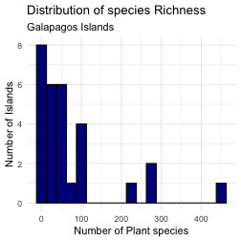

Data graphically as size categories
ggplot(g_df, aes(x = size_cat, y = spp, fill = size_cat)) +
geom_boxplot(color = "darkblue") +
labs(title = "Distribution of species Richness",
subtitle = "Galapagos Islands",
x = "Number of Plant species",
y = "Number of Islands") +
theme_minimal()
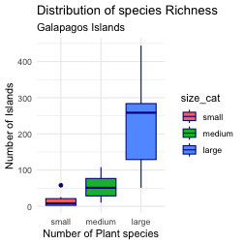

GLM with Gaussian (Normal) Distribution: Setup
The simplest form of GLM uses a normal (Gaussian) distribution with an identity link function. This is equivalent to standard linear model
Let’s compare a standard linear model and a Gaussian GLM using the Galapagos dataset, modeling endemic species richness by island size category.

Linear model the old way
# Fit a standard linear model
lm_model <- lm(endemics ~ size_cat, data = g_df)
summary(lm_model)
Call:
lm(formula = endemics ~ size_cat, data = g_df)
Residuals:
Min 1Q Median 3Q Max
-39.000 -4.636 -0.667 6.333 33.000
Coefficients:
Estimate Std. Error t value Pr(>|t|)
(Intercept) 5.636 4.236 1.331 0.1948
size_catmedium 16.030 5.864 2.734 0.0111 *
size_catlarge 56.364 7.130 7.905 0.0000000221 ***
---
Signif. codes: 0 '***' 0.001 '**' 0.01 '*' 0.05 '.' 0.1 ' ' 1
Residual standard error: 14.05 on 26 degrees of freedom
Multiple R-squared: 0.708, Adjusted R-squared: 0.6855
F-statistic: 31.51 on 2 and 26 DF, p-value: 0.0000001124

The ANOVA model
Anova(lm_model, type = 3 )
Anova Table (Type III tests)
Response: endemics
Sum Sq Df F value Pr(>F)
(Intercept) 349.5 1 1.7707 0.1948
size_cat 12438.6 2 31.5135 0.0000001124 ***
Residuals 5131.2 26
---
Signif. codes: 0 '***' 0.001 '**' 0.01 '*' 0.05 '.' 0.1 ' ' 1

The Gaussian GLM model
# Fit a Gaussian GLM
gauss_model <- glm(endemics ~ size_cat, data = g_df,
family = gaussian(link = "identity"))
summary(gauss_model)
Call:
glm(formula = endemics ~ size_cat, family = gaussian(link = "identity"),
data = g_df)
Coefficients:
Estimate Std. Error t value Pr(>|t|)
(Intercept) 5.636 4.236 1.331 0.1948
size_catmedium 16.030 5.864 2.734 0.0111 *
size_catlarge 56.364 7.130 7.905 0.0000000221 ***
---
Signif. codes: 0 '***' 0.001 '**' 0.01 '*' 0.05 '.' 0.1 ' ' 1
(Dispersion parameter for gaussian family taken to be 197.3543)
Null deviance: 17569.9 on 28 degrees of freedom
Residual deviance: 5131.2 on 26 degrees of freedom
AIC: 240.4
Number of Fisher Scoring iterations: 2

GLM ANOVA
Anova(gauss_model, type = "III", test = "F")
Analysis of Deviance Table (Type III tests)
Response: endemics
Error estimate based on Pearson residuals
Sum Sq Df F values Pr(>F)
size_cat 12438.6 2 31.514 0.0000001124 ***
Residuals 5131.2 26
---
Signif. codes: 0 '***' 0.001 '**' 0.01 '*' 0.05 '.' 0.1 ' ' 1

Assumption Tests of Both Models

Linear model assumptions
# Create diagnostic plots
par(mfrow = c(1, 1))
plot(lm_model)
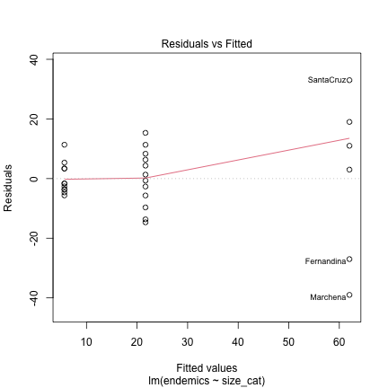
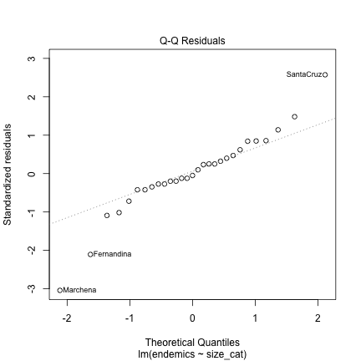
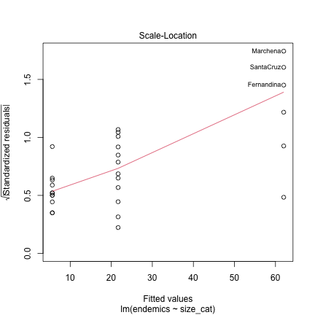
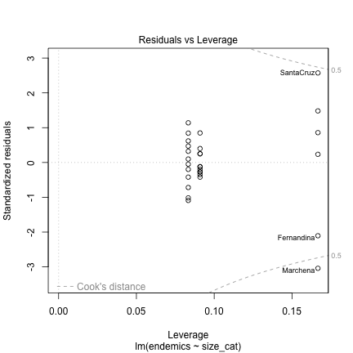
par(mfrow = c(1, 1))

GLM ASSUMPTIONS
# Create diagnostic plots
# par(mfrow = c(2, 2))
plot(gauss_model)
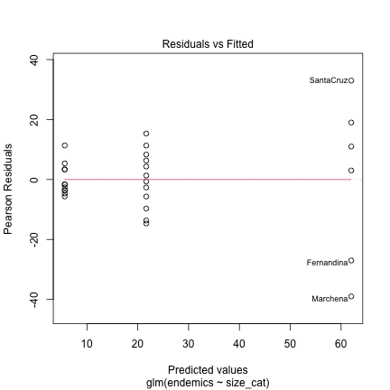
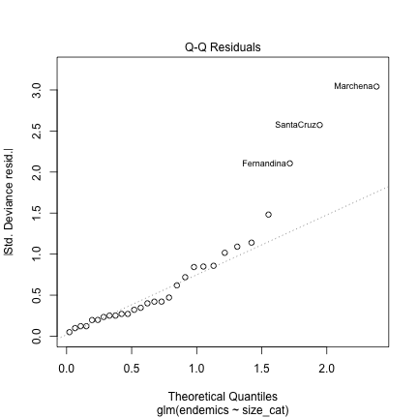
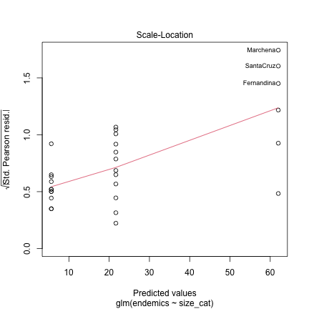
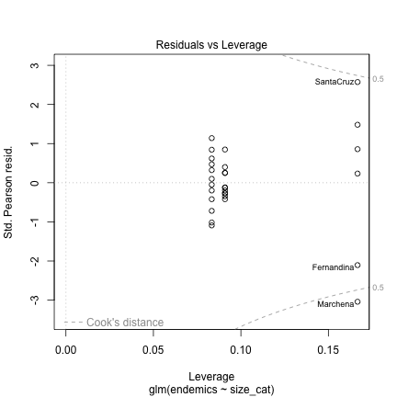
# par(mfrow = c(1, 1))

Shapiro Wilk Test Linear Model
shapiro.test(residuals(lm_model))
Shapiro-Wilk normality test
data: residuals(lm_model)
W = 0.94396, p-value = 0.1273

Shapiro Test Gaussian Model
shapiro.test(residuals(gauss_model))
Shapiro-Wilk normality test
data: residuals(gauss_model)
W = 0.94396, p-value = 0.1273

Levenes Test - this is why a Poisson Model fits
leveneTest(endemics ~ size_cat, data = g_df)
Levene's Test for Homogeneity of Variance (center = median)
Df F value Pr(>F)
group 2 7.9881 0.001975 **
26
---
Signif. codes: 0 '***' 0.001 '**' 0.01 '*' 0.05 '.' 0.1 ' ' 1

Dharma Assumption Test
# 1. Simulate residuals
# (This is the standard first step for all DHARMa diagnostics)
sim_gauss_res <- simulateResiduals(fittedModel = gauss_model, n = 1000)
# 2. Test for dispersion
# This will provide a p-value and the ratio
testDispersion(sim_gauss_res)
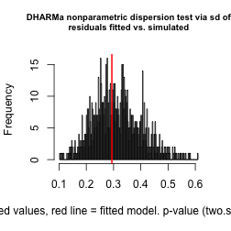
DHARMa nonparametric dispersion test via sd of residuals fitted vs.
simulated
data: simulationOutput
dispersion = 0.93779, p-value = 0.882
alternative hypothesis: two.sided
# Plot diagnostic plots
plot(sim_gauss_res)
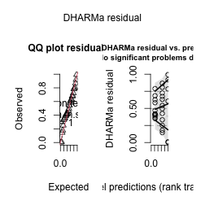

Emmeans Linear Model
# Calculate estimated marginal means
lm_emmeans <- emmeans(lm_model, ~ size_cat)
lm_emmeans
size_cat emmean SE df lower.CL upper.CL
small 5.64 4.24 26 -3.07 14.3
medium 21.67 4.06 26 13.33 30.0
large 62.00 5.74 26 50.21 73.8
Confidence level used: 0.95

Emmeans GLM Mode
# Calculate estimated marginal means
gauss_emmeans <- emmeans(gauss_model, ~ size_cat)
gauss_emmeans
size_cat emmean SE df lower.CL upper.CL
small 5.64 4.24 26 -3.07 14.3
medium 21.67 4.06 26 13.33 30.0
large 62.00 5.74 26 50.21 73.8
Confidence level used: 0.95

Pairs LM
# # Pairwise comparisons with Sidak correction
lm_pairs <- pairs(lm_emmeans, adjust = "sidak")
lm_pairs
contrast estimate SE df t.ratio p.value
small - medium -16.0 5.86 26 -2.734 0.0330
small - large -56.4 7.13 26 -7.905 <0.0001
medium - large -40.3 7.02 26 -5.742 <0.0001
P value adjustment: sidak method for 3 tests

Pairs GLM
# # Pairwise comparisons with Sidak correction
gauss_pairs <- pairs(gauss_emmeans, adjust = "sidak")
gauss_pairs
contrast estimate SE df t.ratio p.value
small - medium -16.0 5.86 26 -2.734 0.0330
small - large -56.4 7.13 26 -7.905 <0.0001
medium - large -40.3 7.02 26 -5.742 <0.0001
P value adjustment: sidak method for 3 tests

Plot of GLM
plot(gauss_emmeans, comparisons = TRUE)
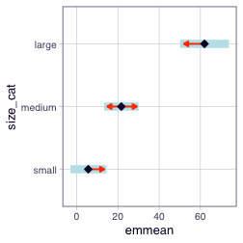

GLM ANOVA with Poisson Distribution
- Poisson GLMs Poisson model used when response variable is count data:
  - Number of species on an island
  - Number of parasites in a host
  - Number of bird nests in a plot
  - Number of seeds produced by a plant
- The Poisson distribution assumes:
  - Counts are non-negative integers (0, 1, 2, 3, …)
  - The mean equals the variance
  - Events occur independently
- Key consideration: If variance > mean (overdispersion), consider negative binomial regression instead.
- Now let’s fit a Poisson GLM to model the relationship between the rounded quarter-mile time and the number of cylinders:

Fit Poisson GLM with size_cat as predictor
poiss_model <- glm(spp ~ size_cat,
data = g_df,
family = poisson(link = "log"))
summary(poiss_model)
Call:
glm(formula = spp ~ size_cat, family = poisson(link = "log"),
data = g_df)
Coefficients:
Estimate Std. Error z value Pr(>|z|)
(Intercept) 2.67101 0.07930 33.68 <0.0000000000000002 ***
size_catmedium 1.33784 0.08833 15.15 <0.0000000000000002 ***
size_catlarge 2.77429 0.08372 33.14 <0.0000000000000002 ***
---
Signif. codes: 0 '***' 0.001 '**' 0.01 '*' 0.05 '.' 0.1 ' ' 1
(Dispersion parameter for poisson family taken to be 1)
Null deviance: 3031.18 on 28 degrees of freedom
Residual deviance: 898.03 on 26 degrees of freedom
AIC: 1057.2
Number of Fisher Scoring iterations: 5

GLM with Poisson Distribution: Setup
Does island size category, as a whole, have a statistically significant effect on the number of plant species?
- test = "LR": important part!
  - normal ANOVA (with a Gaussian/normal distribution) test is an F-test.
  - GLM (like Poisson) can’t use F-test in the same way
    - use a Likelihood Ratio (LR) test
    - LR test statistically compares fit of full model (the one with size_cat) to simpler null model (one without size_cat)
    - LR test tells us if it is significant
Anova(poiss_model, type = "III", test = "LR")
Analysis of Deviance Table (Type III tests)
Response: spp
LR Chisq Df Pr(>Chisq)
size_cat 2133.2 2 < 0.00000000000000022 ***
---
Signif. codes: 0 '***' 0.001 '**' 0.01 '*' 0.05 '.' 0.1 ' ' 1

Let’s check for overdispersion, which is common in count data:
- Should be close to 1 for a well-fitting Poisson model
- If > 1.5, may indicate overdispersion
  - What is Underdispersion?
    - In a Poisson model, we expect the variance to equal the mean. The dispersion parameter measures the ratio of observed variance to expected variance:
      - Dispersion ≈ 1: Good fit (variance = mean, as Poisson assumes)
      - Dispersion > 1: Overdispersion (variance > mean)
      - Dispersion < 1: Underdispersion (variance < mean)
  - a dispersion parameter this large is a warning
  - our data more variable than a Poisson model expects
  - use a Negative Binomial model
# Pass your model to the function
performance::check_overdispersion(poiss_model)
# Overdispersion test
dispersion ratio = 33.525
Pearson's Chi-Squared = 871.642
p-value = < 0.001

DHARMA assumption plots
# 1. Simulate residuals
# (This is the standard first step for all DHARMa diagnostics)
sim_res <- simulateResiduals(fittedModel = poiss_model, n = 1000)
# 2. Test for dispersion
# This will provide a p-value and the ratio
testDispersion(sim_res)
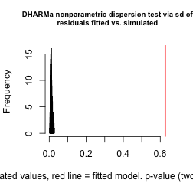
DHARMa nonparametric dispersion test via sd of residuals fitted vs.
simulated
data: simulationOutput
dispersion = 55.559, p-value < 0.00000000000000022
alternative hypothesis: two.sided
# Plot diagnostic plots
plot(sim_res)
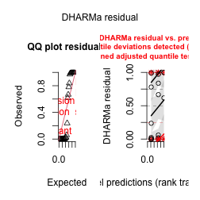

WHY DOES THE SHAPIRO TEST NOT WORK???
this you should consider - well it shouldn’t but it does this time . dang it…
shapiro.test(residuals(poiss_model))
Shapiro-Wilk normality test
data: residuals(poiss_model)
W = 0.98973, p-value = 0.9909

Poisson GLM Emmeans
# 1. Calculate Estimated Marginal Means (EMMs)
# type = "response" converts the log-means back to the "species count" scale
pois_emm <- emmeans(poiss_model,
specs = ~ size_cat,
type = "response")
print(pois_emm)
size_cat rate SE df asymp.LCL asymp.UCL
small 14.5 1.15 Inf 12.4 16.9
medium 55.1 2.14 Inf 51.0 59.4
large 231.7 6.21 Inf 219.8 244.2
Confidence level used: 0.95
Intervals are back-transformed from the log scale

POISSON GLM Pairs Plots
# 2. Pairwise Comparisons
# Compares all pairs: Small-Medium, Small-Large, Medium-Large
pois_pairs <- pairs(pois_emm, adjust = "tukey")
print(pois_pairs)
contrast ratio SE df null z.ratio p.value
small / medium 0.2624 0.02320 Inf 1 -15.146 <0.0001
small / large 0.0624 0.00522 Inf 1 -33.139 <0.0001
medium / large 0.2378 0.01120 Inf 1 -30.403 <0.0001
P value adjustment: tukey method for comparing a family of 3 estimates
Tests are performed on the log scale
# 3. Compact Letter Display (CLD)
# The easiest way to see the groupings
pois_cld <- multcomp::cld(pois_emm,
Letters = letters,
alpha = 0.05)
print(pois_cld)
size_cat rate SE df asymp.LCL asymp.UCL .group
small 14.5 1.15 Inf 12.4 16.9 a
medium 55.1 2.14 Inf 51.0 59.4 b
large 231.7 6.21 Inf 219.8 244.2 c
Confidence level used: 0.95
Intervals are back-transformed from the log scale
P value adjustment: tukey method for comparing a family of 3 estimates
Tests are performed on the log scale
significance level used: alpha = 0.05
NOTE: If two or more means share the same grouping symbol,
then we cannot show them to be different.
But we also did not show them to be the same.
Poisson GLM Plot
# 1. Get the estimated means and CIs into a dataframe
emm_poiss_df <- as.data.frame(pois_emm)
# 2. Create visualization
ggplot() +
# Plot raw data (jittered so we can see the points)
geom_jitter(data = g_df,
aes(x = size_cat, y = spp),
width = 0.2, # Spreads points horizontally
alpha = 0.5) +
# Add estimated means (points)
geom_point(data = emm_poiss_df,
aes(x = size_cat, y = rate), # 'rate' is the mean
size = 4, color = "blue") +
# Add confidence intervals (error bars)
geom_errorbar(data = emm_poiss_df,
aes(x = size_cat,
ymin = asymp.LCL, # Lower Confidence Limit
ymax = asymp.UCL), # Upper Confidence Limit
width = 0.2, color = "blue", linewidth = 1) +
labs(title = "species Richness by Island Size Category",
subtitle = "Poisson GLM predictions (on the response scale)",
x = "Island Size Category",
y = "Number of Plant species") +
theme_minimal()
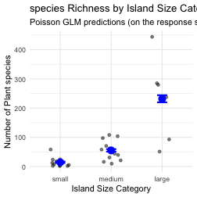

Negative Binomial GLM ANOVA
- Dealing with Overdispersion in Count Data
  - count data shows more variability than expected under a Poisson distribution (variance > mean
  - need to use negative binomial model
  - model_nb <- glm.nb(qsec_round ~ cyl, data = mtcars_count)
- negative binomial model includes a dispersion parameter (theta)
- allows the variance to be larger than the mean
- standard errors bigger because NB model accounts for high variability (overdispersion)
- estimates dispersion parameter ‘Theta’ (or 1/theta)
- how it models the overdispersion.
Call:
glm.nb(formula = spp ~ size_cat, data = g_df, init.theta = 1.660219232,
link = log)
Coefficients:
Estimate Std. Error z value Pr(>|z|)
(Intercept) 2.6710 0.2471 10.810 < 0.0000000000000002 ***
size_catmedium 1.3378 0.3358 3.984 0.0000677150798 ***
size_catlarge 2.7743 0.4027 6.889 0.0000000000056 ***
---
Signif. codes: 0 '***' 0.001 '**' 0.01 '*' 0.05 '.' 0.1 ' ' 1
(Dispersion parameter for Negative Binomial(1.6602) family taken to be 1)
Null deviance: 81.681 on 28 degrees of freedom
Residual deviance: 31.824 on 26 degrees of freedom
AIC: 283.97
Number of Fisher Scoring iterations: 1
Theta: 1.660
Std. Err.: 0.442
2 x log-likelihood: -275.972

Assumptions
# 1. Simulate residuals
nb_sim_res <- simulateResiduals(fittedModel = nb_model)
# 2. Plot the diagnostics
plot(nb_sim_res)
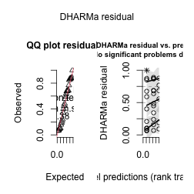

Note Shapiro test does not work
shapiro.test(residuals(nb_model))
Shapiro-Wilk normality test
data: residuals(nb_model)
W = 0.94501, p-value = 0.1357

Overdispersion
# This will test if there is *still* significant overdispersion
check_overdispersion(nb_model)
# Overdispersion test (using simulated residuals)
dispersion ratio = 0.586
p-value = 0.632

ANOVA GLM Negative Binmial
# Get the overall Anova (Type III Likelihood Ratio test)
nb_anova <- Anova(nb_model, type = "III", test = "LR")
print(nb_anova)
Analysis of Deviance Table (Type III tests)
Response: spp
LR Chisq Df Pr(>Chisq)
size_cat 49.858 2 0.00000000001491 ***
---
Signif. codes: 0 '***' 0.001 '**' 0.01 '*' 0.05 '.' 0.1 ' ' 1
# 1. Calculate the Estimated Marginal Means on the "response" scale
nb_emmeans <- emmeans(nb_model, spec = ~ size_cat, type = "response")
print(nb_emmeans)
size_cat response SE df asymp.LCL asymp.UCL
small 14.5 3.57 Inf 8.91 23.5
medium 55.1 12.50 Inf 35.27 86.0
large 231.7 73.70 Inf 124.22 432.0
Confidence level used: 0.95
Intervals are back-transformed from the log scale

Pairwise
# 2. Run pairwise comparisons on those means
nb_pairs <- pairs(nb_emmeans)
print(nb_pairs)
contrast ratio SE df null z.ratio p.value
small / medium 0.2624 0.0881 Inf 1 -3.984 0.0002
small / large 0.0624 0.0251 Inf 1 -6.889 <0.0001
medium / large 0.2378 0.0929 Inf 1 -3.675 0.0007
P value adjustment: tukey method for comparing a family of 3 estimates
Tests are performed on the log scale
# 3. Get the Compact Letter Display (CLD)
nb_cld <- multcomp::cld(nb_emmeans, Letters = letters)
print(nb_cld)
size_cat response SE df asymp.LCL asymp.UCL .group
small 14.5 3.57 Inf 8.91 23.5 a
medium 55.1 12.50 Inf 35.27 86.0 b
large 231.7 73.70 Inf 124.22 432.0 c
Confidence level used: 0.95
Intervals are back-transformed from the log scale
P value adjustment: tukey method for comparing a family of 3 estimates
Tests are performed on the log scale
significance level used: alpha = 0.05
NOTE: If two or more means share the same grouping symbol,
then we cannot show them to be different.
But we also did not show them to be the same.

REGRESSIONS——

Generalized Linear Models (GLMs) extend linear models to handle different types of response variables:
- Normal distribution: Continuous data (like regular ANOVA/regression)
- Poisson distribution: Count data
- Binomial distribution: Binary data (presence/absence, success/failure)
- Gamma distribution: Positive continuous data
- Negative binomial: Overdispersed count data

Gaussian GLM (equivalent to simple linear regression)
The simplest form of GLM uses a normal (Gaussian) distribution with an identity link function. This is equivalent to a standard linear regression.
Let’s compare a standard linear model and a Gaussian GLM.
# 1. Distribution of Endemic Species
p1 <- ggplot(g_df, aes(x = endemics)) +
geom_histogram(binwidth = 10, fill = "darkblue", color = "black") +
labs(title = "Distribution of Endemic Species",
x = "Number of Endemic Species",
y = "Number of Islands") +
theme_minimal()
# 2. Distribution of All Species
p2 <- ggplot(g_df, aes(x = spp)) +
geom_histogram(binwidth = 25, fill = "darkgreen", color = "black") +
labs(title = "Distribution of All Species",
x = "Number of Plant Species",
y = "Number of Islands") +
theme_minimal()
# 3. Endemics vs Area (for Gaussian model)
p3 <- ggplot(g_df, aes(x = area, y = endemics)) +
geom_point() +
geom_smooth(method = "lm", se = FALSE, color = "blue") +
labs(title = "Endemic Species vs. Island Area",
x = "Area (km²)",
y = "Number of Endemic Species") +
theme_minimal()
# 4. Species vs Area (for Poisson/NB models)
p4 <- ggplot(g_df, aes(x = area, y = spp)) +
geom_point() +
labs(title = "All Species vs. Island Area",
x = "Area (km²)",
y = "Number of Plant Species") +
theme_minimal()
# Combine plots
(p1 + p2) / (p3 + p4)
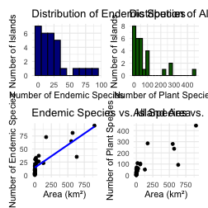

GLM with Gaussian (Normal) Distribution: Setup
We will model the continuous endemics variable as a function of the continuous area variable. This is a simple linear regression. We compare the lm() function with the glm() function using family = gaussian.

The linear model summary
# Fit a standard linear model
lm_reg_model <- lm(endemics ~ area, data = g_df)
summary(lm_reg_model)
Call:
lm(formula = endemics ~ area, data = g_df)
Residuals:
Min 1Q Median 3Q Max
-34.690 -10.366 -2.612 6.528 43.733
Coefficients:
Estimate Std. Error t value Pr(>|t|)
(Intercept) 14.36338 2.99342 4.798 0.0000523735 ***
area 0.08720 0.01168 7.468 0.0000000493 ***
---
Signif. codes: 0 '***' 0.001 '**' 0.01 '*' 0.05 '.' 0.1 ' ' 1
Residual standard error: 14.57 on 27 degrees of freedom
Multiple R-squared: 0.6738, Adjusted R-squared: 0.6617
F-statistic: 55.77 on 1 and 27 DF, p-value: 0.00000004929

The ANOVA model
This table gives the F-statistic for the overall model, which in a simple linear regression, tests the same hypothesis as the t-test for the area slope.
Anova(lm_reg_model, type = 3 )
Anova Table (Type III tests)
Response: endemics
Sum Sq Df F value Pr(>F)
(Intercept) 4887.1 1 23.024 0.00005237345 ***
area 11838.8 1 55.775 0.00000004929 ***
Residuals 5731.0 27
---
Signif. codes: 0 '***' 0.001 '**' 0.01 '*' 0.05 '.' 0.1 ' ' 1

The Gaussian GLM model
Note the estimates and p-values are identical to the lm() output.
# Fit a Gaussian GLM
gauss_reg_model <- glm(endemics ~ area, data = g_df,
family = gaussian(link = "identity"))
summary(gauss_reg_model)
Call:
glm(formula = endemics ~ area, family = gaussian(link = "identity"),
data = g_df)
Coefficients:
Estimate Std. Error t value Pr(>|t|)
(Intercept) 14.36338 2.99342 4.798 0.0000523735 ***
area 0.08720 0.01168 7.468 0.0000000493 ***
---
Signif. codes: 0 '***' 0.001 '**' 0.01 '*' 0.05 '.' 0.1 ' ' 1
(Dispersion parameter for gaussian family taken to be 212.261)
Null deviance: 17570 on 28 degrees of freedom
Residual deviance: 5731 on 27 degrees of freedom
AIC: 241.6
Number of Fisher Scoring iterations: 2

GLM ANOVA
Again, this F-test is identical to the one from the lm() model.
Anova(gauss_reg_model, type = "III", test = "F")
Analysis of Deviance Table (Type III tests)
Response: endemics
Error estimate based on Pearson residuals
Sum Sq Df F values Pr(>F)
area 11839 1 55.775 0.00000004929 ***
Residuals 5731 27
---
Signif. codes: 0 '***' 0.001 '**' 0.01 '*' 0.05 '.' 0.1 ' ' 1

Assumption Tests of Both Models
The diagnostic plots for lm_model and gauss_model will be identical.
# Create diagnostic plots for lm()
par(mfrow = c(1, 1))
plot(lm_reg_model)
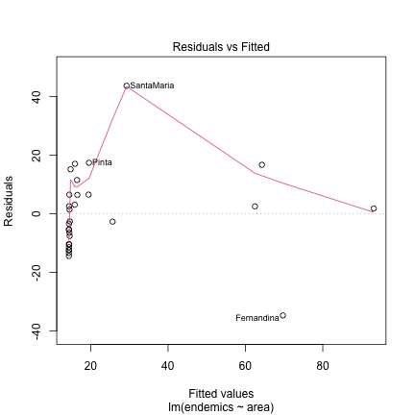
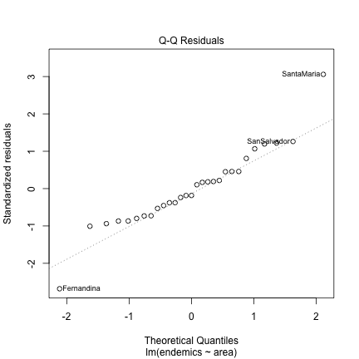
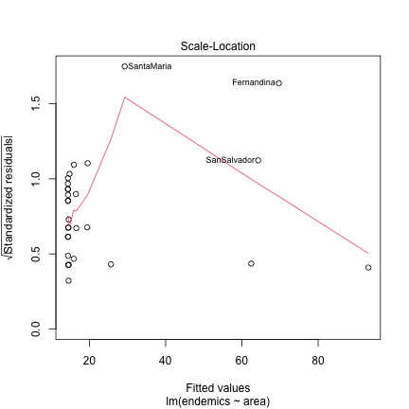
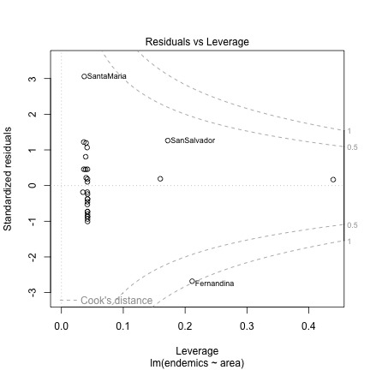
par(mfrow = c(1, 1))

Shapiro-Wilk Test (Normality of Residuals)
shapiro.test(residuals(lm_reg_model))
Shapiro-Wilk normality test
data: residuals(lm_reg_model)
W = 0.93735, p-value = 0.08547
shapiro.test(residuals(gauss_reg_model))
Shapiro-Wilk normality test
data: residuals(gauss_reg_model)
W = 0.93735, p-value = 0.08547

GLM Regression with Poisson Distribution
- Poisson GLMs are used when the response variable is count data.
- We will now model the total number of species (spp) as a function of island area.
- The Poisson distribution assumes the mean equals the variance.
- Key consideration: If variance > mean (overdispersion), we should use a negative binomial model instead.
- Fit Poisson GLM with area as predictor
poiss_reg_model <- glm(spp ~ area,
data = g_df,
family = poisson(link = "log"))
summary(poiss_reg_model)
Call:
glm(formula = spp ~ area, family = poisson(link = "log"), data = g_df)
Coefficients:
Estimate Std. Error z value Pr(>|z|)
(Intercept) 3.73721483 0.03022162 123.66 <0.0000000000000002 ***
area 0.00269318 0.00005759 46.76 <0.0000000000000002 ***
---
Signif. codes: 0 '***' 0.001 '**' 0.01 '*' 0.05 '.' 0.1 ' ' 1
(Dispersion parameter for poisson family taken to be 1)
Null deviance: 3031.2 on 28 degrees of freedom
Residual deviance: 1229.5 on 27 degrees of freedom
AIC: 1386.6
Number of Fisher Scoring iterations: 5

GLM with Poisson Distribution: ANOVA
Does island area, as a whole, have a statistically significant effect on the number of plant species? We use a Likelihood Ratio (LR) test.
Anova(poiss_reg_model, type = "III", test = "LR")
Analysis of Deviance Table (Type III tests)
Response: spp
LR Chisq Df Pr(>Chisq)
area 1801.7 1 < 0.00000000000000022 ***
---
Signif. codes: 0 '***' 0.001 '**' 0.01 '*' 0.05 '.' 0.1 ' ' 1
# Calculate the dispersion parameter
# A simpler check
performance::check_overdispersion(poiss_reg_model)
# Overdispersion test
dispersion ratio = 52.256
Pearson's Chi-Squared = 1410.899
p-value = < 0.001

DHARMa Residual Diagnostics
We can use the DHARMa package to check model assumptions. The Q-Q plot clearly shows the model fits poorly.
# 1. Simulate residuals
sim_pois_res <- simulateResiduals(fittedModel = poiss_reg_model, n = 1000)
# 2. Test for dispersion
testDispersion(sim_pois_res)
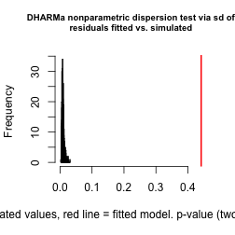
DHARMa nonparametric dispersion test via sd of residuals fitted vs.
simulated
data: simulationOutput
dispersion = 48.199, p-value < 0.00000000000000022
alternative hypothesis: two.sided
# Plot diagnostic plots
plot(sim_pois_res)
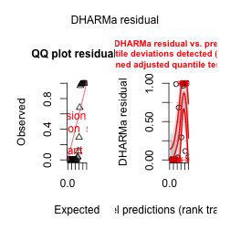

Plotting the Poisson Regression
Even though the model is a poor fit, we can visualize its prediction.
ggplot(g_df, aes(x = area, y = spp)) +
geom_point(alpha = 0.6) +
geom_smooth(method = "glm",
method.args = list(family = "poisson"),
se = TRUE,
color = "blue") +
labs(title = "Species Richness by Island Area",
subtitle = "Poisson GLM regression line",
x = "Island Area (km²)",
y = "Number of Plant Species") +
theme_minimal()
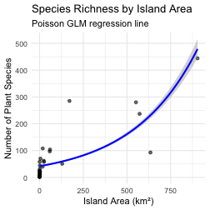

Negative Binomial GLM Regression
Used to handle overdispersed count data.
The negative binomial model includes a dispersion parameter (theta) to account for the variance being larger than the mean.
nb_reg_model <- glm.nb(spp ~ area, data = g_df)
summary(nb_reg_model)
Call:
glm.nb(formula = spp ~ area, data = g_df, init.theta = 1.098629663,
link = log)
Coefficients:
Estimate Std. Error z value Pr(>|z|)
(Intercept) 3.6082304 0.1987610 18.15 < 0.0000000000000002 ***
area 0.0033531 0.0007672 4.37 0.0000124 ***
---
Signif. codes: 0 '***' 0.001 '**' 0.01 '*' 0.05 '.' 0.1 ' ' 1
(Dispersion parameter for Negative Binomial(1.0986) family taken to be 1)
Null deviance: 55.178 on 28 degrees of freedom
Residual deviance: 32.695 on 27 degrees of freedom
AIC: 295.08
Number of Fisher Scoring iterations: 1
Theta: 1.099
Std. Err.: 0.271
2 x log-likelihood: -289.083

NB Assumption Diagnostics (DHARMa)
The DHARMa residual plot looks much better. The Q-Q plot is nearly on the line, and the residual vs. predicted plot shows no strong pattern.
# 1. Simulate residuals
nb_sim_reg_res <- simulateResiduals(fittedModel = nb_reg_model)
# 2. Plot the diagnostics
plot(nb_sim_reg_res)
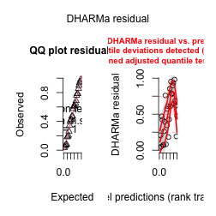

Overdispersion Check
The check_overdispersion test on the DHARMa residuals shows no remaining overdispersion (p = 0.816). This model successfully handled the issue.
testDispersion(nb_sim_reg_res)
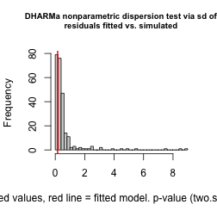
DHARMa nonparametric dispersion test via sd of residuals fitted vs.
simulated
data: simulationOutput
dispersion = 0.27162, p-value = 0.488
alternative hypothesis: two.sided

ANOVA GLM Negative Binomial
We again use a Likelihood Ratio (LR) test to get the overall p-value for the area predictor.
# Get the overall Anova (Type III Likelihood Ratio test)
nb_reg_anova <- Anova(nb_reg_model, type = "III", test = "LR")
print(nb_anova)
Analysis of Deviance Table (Type III tests)
Response: spp
LR Chisq Df Pr(>Chisq)
size_cat 49.858 2 0.00000000001491 ***
---
Signif. codes: 0 '***' 0.001 '**' 0.01 '*' 0.05 '.' 0.1 ' ' 1

Plotting the Negative Binomial Regression
This plot shows the fitted line from our final, best-fitting model.
ggplot(g_df, aes(x = area, y = spp)) +
geom_point(alpha = 0.6) +
geom_smooth(method = "glm.nb",
se = FALSE,
color = "purple") +
labs(title = "Species Richness by Island Area",
subtitle = "Negative Binomial GLM regression line",
x = "Island Area (km²)",
y = "Number of Plant Species") +
theme_minimal()
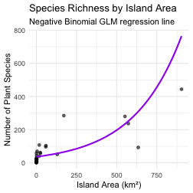

Logistic Regression
Logistic regression is a GLM used when the response variable is binary (e.g., dead/alive, present/absent). It models the probability of the response being “1” (success) given predictor values.
Let’s examine the simple logistic regression model:
$$π(x)=\frac{e^{β_{0}+β_{1}x}}{1+e^{β_{0}+β_{1}x}}$$
- Where:
  - $π(x)$ is the probability that Y = 1 given X = x
  - $β_{0}$ is the intercept
  - $β_{1}$ is the slope (rate of change in $π(x)$ for a unit change in X)
To linearize this relationship, we use the logit link function:
$$g(x)=log\left(\frac{π(x)}{1−π(x)}\right)=β_{0}+β_{1}x$$
This transforms the probability (which is bounded between 0 and 1) to a linear function that can range from -∞ to +∞.

Example: Lizard Presence on Islands
Based on the example from Polis et al. (1998), we’ll model the presence/absence of lizards (Uta) on islands in the Gulf of California based on perimeter/area ratio.
set.seed(123)
island_data <- data.frame(
island_id = 1:30,
pa_ratio = seq(5, 70, length.out = 30),
uta_present = c(rep(1, 10),
rbinom(10, 1, prob = 0.5), # Mixed outcomes in middle
rep(0, 10)))%>%
mutate(uta_present_factor = factor(uta_present, levels = c(0, 1),
labels = c("Absent", "Present")))
ggplot() +
# Add jittered points for observed data
geom_point(data = island_data,
aes(x = pa_ratio, y = uta_present),
position = position_dodge2(width=.1), alpha = 0.7) +
labs(title = "Probability of Uta Presence vs. Perimeter/area Ratio",
x = "Perimeter/area Ratio",
y = "Probability of Presence") +
scale_y_continuous(limits = c(0, 1)) +
theme_minimal()
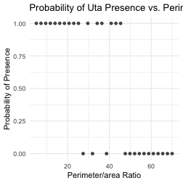

Example: Lizard Presence on Islands
Based on the example from Polis et al. (1998), we’ll model the presence/absence of lizards (Uta) on islands in the Gulf of California based on perimeter/area ratio.
# Fit the logistic regression model
lizard_model <- glm(uta_present ~ pa_ratio,
data = island_data,
family = binomial(link = "logit"))
# Model summary
summary(lizard_model)
Call:
glm(formula = uta_present ~ pa_ratio, family = binomial(link = "logit"),
data = island_data)
Coefficients:
Estimate Std. Error z value Pr(>|z|)
(Intercept) 5.9374 2.1297 2.788 0.00530 **
pa_ratio -0.1493 0.0517 -2.887 0.00388 **
---
Signif. codes: 0 '***' 0.001 '**' 0.01 '*' 0.05 '.' 0.1 ' ' 1
(Dispersion parameter for binomial family taken to be 1)
Null deviance: 41.455 on 29 degrees of freedom
Residual deviance: 19.090 on 28 degrees of freedom
AIC: 23.09
Number of Fisher Scoring iterations: 6

Lizard Example: Visualization and Testing
Let’s visualize the data and the fitted model:
#| paged-print: false
# Create a dataframe for predictions
pred_data <- data.frame(
pa_ratio = seq(min(island_data$pa_ratio),
max(island_data$pa_ratio),
length.out = 100)
)
# Get predicted probabilities
pred_data$prob <- predict(lizard_model,
newdata = pred_data,
type = "response")
# Plot
ggplot() +
# Add jittered points for observed data
geom_point(data = island_data,
aes(x = pa_ratio, y = uta_present),
position = position_dodge2(width=.1), alpha = 0.7) +
# Add predicted probability curve
geom_line(data = pred_data,
aes(x = pa_ratio, y = prob),
color = "blue", size = 1) +
# Add confidence intervals (optional)
labs(title = "Probability of Uta Presence vs. Perimeter/area Ratio",
x = "Perimeter/area Ratio",
y = "Probability of Presence") +
scale_y_continuous(limits = c(0, 1)) +
theme_minimal()
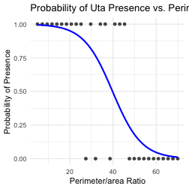
We want to test the null hypothesis that β₁ = 0, meaning there’s no relationship between P/A ratio and lizard presence.
There are two common ways to test this hypothesis:
- Wald test: Tests if the parameter estimate divided by its standard error differs significantly from zero
- Likelihood ratio test: Compares the fit of the full model to a reduced model without the predictor variable
reduced_model <- glm(uta_present ~ 1,
data = island_data,
family = binomial(link = "logit"))
anova(reduced_model, lizard_model, test = "Chisq")
Analysis of Deviance Table
Model 1: uta_present ~ 1
Model 2: uta_present ~ pa_ratio
Resid. Df Resid. Dev Df Deviance Pr(>Chi)
1 29 41.455
2 28 19.090 1 22.365 0.000002254 ***
---
Signif. codes: 0 '***' 0.001 '**' 0.01 '*' 0.05 '.' 0.1 ' ' 1

Interpreting the Odds Ratio

Working with Odds Ratios
The odds ratio represents how the odds of the event (e.g., lizard presence) change with a unit increase in the predictor.
- Odds ratio = exp(β₁)
- If odds ratio > 1: Increasing the predictor increases the odds of event
- If odds ratio < 1: Increasing the predictor decreases the odds of event
- If odds ratio = 1: No effect of predictor on odds of event
- For every one-unit increase in island’s Perimeter/area Ratio - odds of finding a lizard present multiplied by 0.898
- the odds decrease by 10.2% (which is 1 - 0.898) for every one-unit increase in the P/A ratio
- entire interval is below 1.0, you can be confident the relationship is negative: more P/A ratio means lower odds of lizards
coef_lizard <- coef(lizard_model)[2] # Extract slope coefficient
odds_ratio <- exp(coef_lizard)
ci <- exp(confint(lizard_model, "pa_ratio"))
cat("Odds Ratio:", round(odds_ratio, 3), "\n\n",
"95% CI:", round(ci[1], 3), "to", round(ci[2], 3), "\n")
Odds Ratio: 0.861
95% CI: 0.753 to 0.932
# This function is specifically for model parameters
model_parameters(lizard_model, exponentiate = TRUE)
Parameter | Odds Ratio | SE | 95% CI | z | p
---------------------------------------------------------------------
(Intercept) | 378.94 | 807.02 | [14.47, 94371.40] | 2.79 | 0.005
pa ratio | 0.86 | 0.04 | [ 0.75, 0.93] | -2.89 | 0.004
This gives you the odds ratio (in the estimate column) and the exponentiated CIs (conf.low, conf.high) for all terms in your model, all in one clean table.
library(broom)
# This one function does everything
tidy(lizard_model, exponentiate = TRUE, conf.int = TRUE)
# A tibble: 2 × 7
term estimate std.error statistic p.value conf.low conf.high
<chr> <dbl> <dbl> <dbl> <dbl> <dbl> <dbl>
1 (Intercept) 379. 2.13 2.79 0.00530 14.5 94371.
2 pa_ratio 0.861 0.0517 -2.89 0.00388 0.753 0.932

Assessing Model Fit
There are several ways to assess the goodness-of-fit for logistic regression models:
# This one function gives McFadden's and other popular R² values
performance::r2(lizard_model)
# R2 for Logistic Regression
Tjur's R2: 0.588
pscl::pR2(lizard_model)
fitting null model for pseudo-r2
llh llhNull G2 McFadden r2ML r2CU
-9.5450726 -20.7276993 22.3652534 0.5395016 0.5255070 0.7017187
# 'g' is the number of groups to test (e.g., 10 for deciles)
# Note: You need to provide the observed 'y' values
hoslem.test(lizard_model$y, fitted(lizard_model), g = 10)
Hosmer and Lemeshow goodness of fit (GOF) test
data: lizard_model$y, fitted(lizard_model)
X-squared = 2.4032, df = 8, p-value = 0.9661
Logistic regression has different and generally fewer assumptions to test than standard linear regression.
- The main “assumptions” for logistic regression are:
  - Binary Outcome: The dependent variable must be binary (0/1) or proportional (e.g., number of successes / number of trials). Your uta_present is 0/1, so this is met.
  - Independence of Observations: Each observation (each island) must be independent. This is a study design assumption.
  - Linearity of the Logit: This is the most important one to test. It assumes a linear relationship between any continuous predictors and the log-odds (logit) of the outcome.
  - No (or little) Multicollinearity: If you have multiple predictors, they shouldn’t be highly correlated with each other.
- Linearity of the Logit (The Most Important Check) continuous predictor (pa_ratio) has a linear relationship with the log-odds of the outcome looking for a flat, non-curved line.
# This runs multiple checks, but the "Linearity" one is key
check_model(lizard_model, residual_type = "normal")
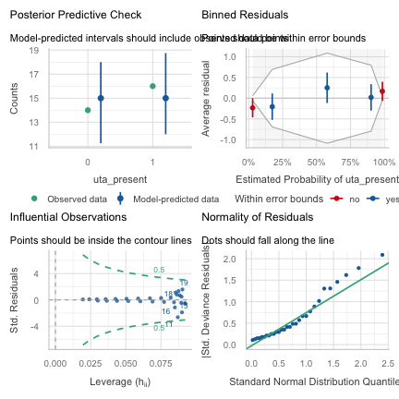
DHARMa is excellent for GLMs. It simulates residuals and plots them against predictors. This is a very robust way to check for all kinds of model misfit, including non-linearity. plotResiduals function will show three quantile regression lines. You want all three (the solid red one and two dashed ones) to be flat and near 0.5. If they are sloped or curved, it indicates a pattern that your model missed (i.e., non-linearity).
# 1. Simulate the residuals
sim_res <- simulateResiduals(fittedModel = lizard_model)
# 2. Plot residuals against the predictor
# DHARMa has a specific function for this
plotResiduals(sim_res, lizard_model$model$pa_ratio,
xlab = "Perimeter/area Ratio",
main = "DHARMa Residuals vs. Predictor")
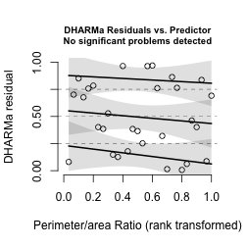
- Multicollinearity only with 2 or more predictors
if you did have more predictors (e.g., pa_ratio and island_area), you would test it like this:
- Overall Model Fit (Goodness-of-Fit) This isn’t an “assumption” so much as a check that the model as a whole is adequate. You already have the two main tests in your file!
Hosmer-Lemeshow Test (from your code) Interpretation: For this test, a GOOD model has a non-significant p-value (p > 0.05). This means your model’s predicted probabilities are not significantly different from the observed probabilities in the data, which is what you want.
# You need the pscl library
# library(pscl)
# Note: g = 10 (deciles) is a common choice
hoslem.test(lizard_model$y, fitted(lizard_model), g = 10)
Hosmer and Lemeshow goodness of fit (GOF) test
data: lizard_model$y, fitted(lizard_model)
X-squared = 2.4032, df = 8, p-value = 0.9661

