Introduction — Start with R
  - Getting started in R
Bill Perry

Lecture 1: Syllabus
- Please look over the syllabus as it has all the details of the class and how it will run.

Lecture 1: Who am I?
- Bill Perry
- Office is in SSB 13
- Phone 218-726-8145
- Email is wlperry_at_d.umn.edu


Lecture 1: My goals
- How do we make observations and hypotheses?
- How do we design an experiment
- How do we collect data?
- How do we organize, clean, summarize, and view the data?
- How do we use statistics to test our hypotheses
  - what tests to use
  - what are the assumptions
  - what are the interpretations

Lecture 1: My expectations
- Communication
- Practice
- Failure
- Learn to correct and troubleshoot

Lecture 1: Science
- Way to acquire knowledge, organize it and apply it back to the real world
- Make predictions and testing these predictions using a falsifiable approach - statistics
- Explanations that cannot be falsified are not science

What is Statistics?
Zar (1999) - “analysis and interpretation of data with view towards objective evaluation of conclusions based on the data”
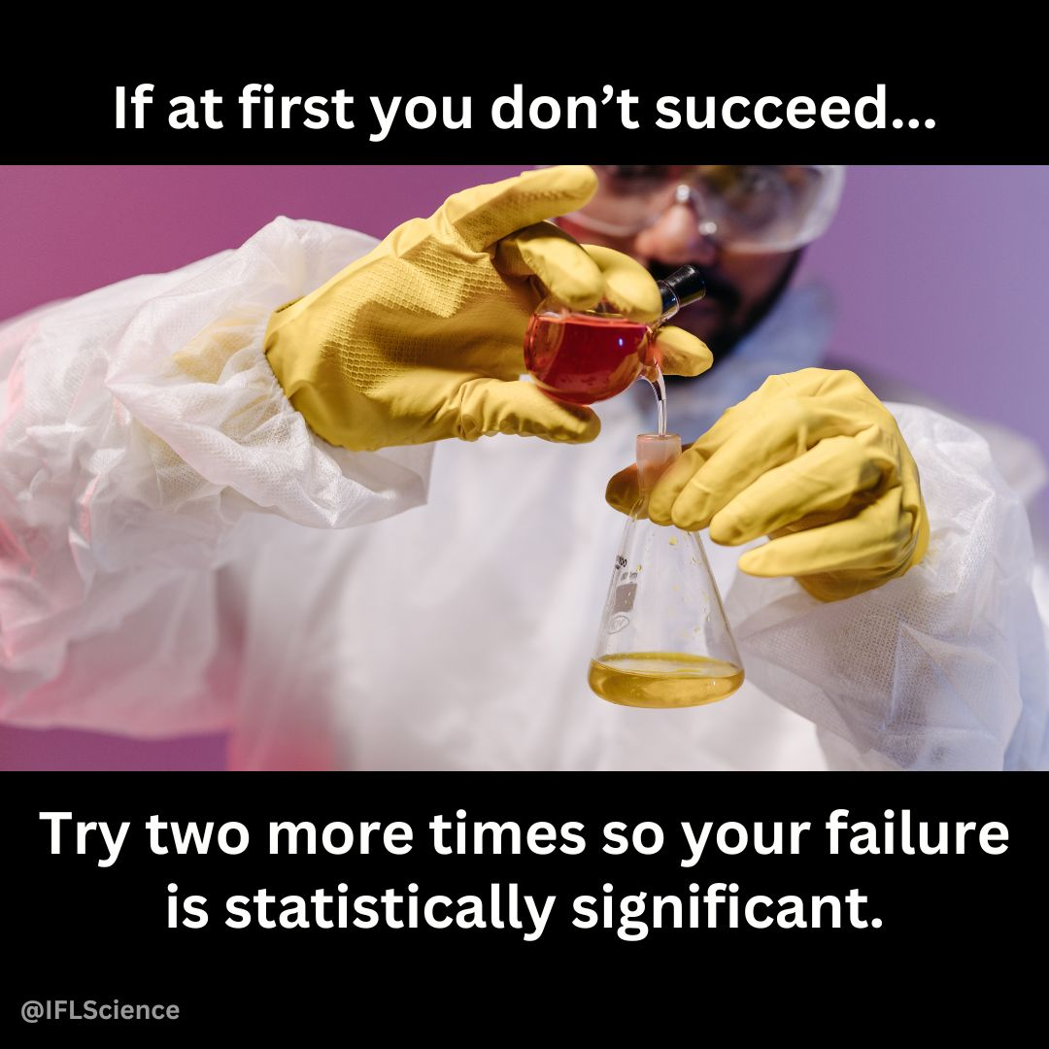

Lecture 1: Inductive reasoning (Specific → General)

Inductive Reasoning (Specific → General)
Inductive reasoning involves observing specific cases and using them to form a general conclusion.
Example:
- Measure 10 pine needles from a tree - average length is 75 mm.
- Measure 10 more needles from the same tree and gets similar results.
- Measures needles from second tree - average length is 120 mm .
- You generalize pine needles from different trees vary in length, but each tree tends to have a characteristic range.
Conclusion (Induction): “Pine needle length varies by tree, but each tree seems to have a typical range of lengths.
Potential Issue: Conclusion is not guaranteed to be true - based on patterns observed in a sample, and there could be exceptions.
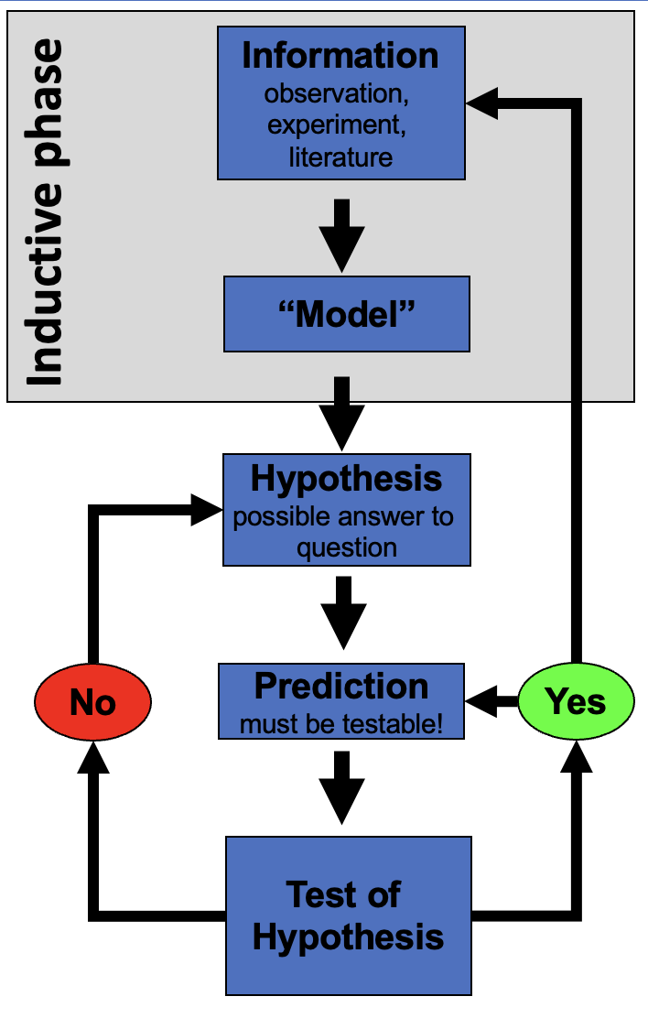

Lecture 1: Deductive reasoning (General → Specific)

Deductive Reasoning (General → Specific)
Deductive reasoning starts with a general principle and applies it to a specific case.
Example:
- General Principle: Pine needles from a species of pine tree have a predictable length range (e.g., 70–80 mm).
- Specific Case: Collect sample of pine needles and measure them.
- Prediction: Since its the species the needle lengths should fall within 70–80 mm.
- Measurement: Check the data and confirm needles fall within this expected range.
Conclusion (Deduction): “This tree belongs the species with a needle length range of 70–80 mm, we expect its needle lengths to fall in this range.”
Stronger than induction because it’s based on a general rule—but if the assumption (length range) is incorrect, conclusion could still be wrong.
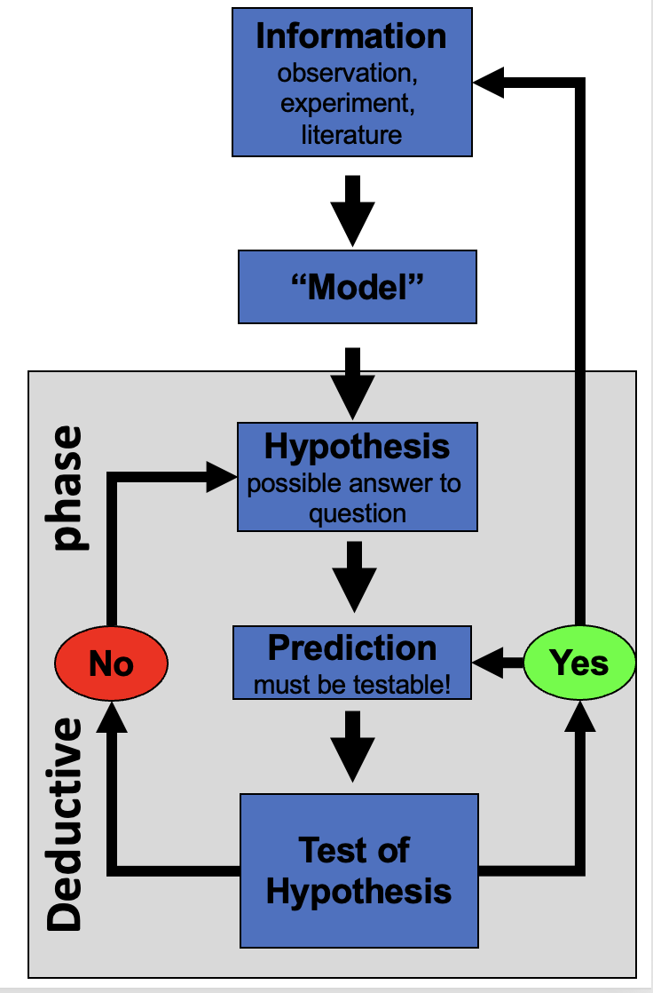

Lecture 1: Reality of reasoning

In reality we are doing both of these processes


How do we test hypotheses

Statistics
- Design good experiments
- Design good tests
- Summarize patterns/data
- Use to make probabilistic determinations to see if differences are “real”
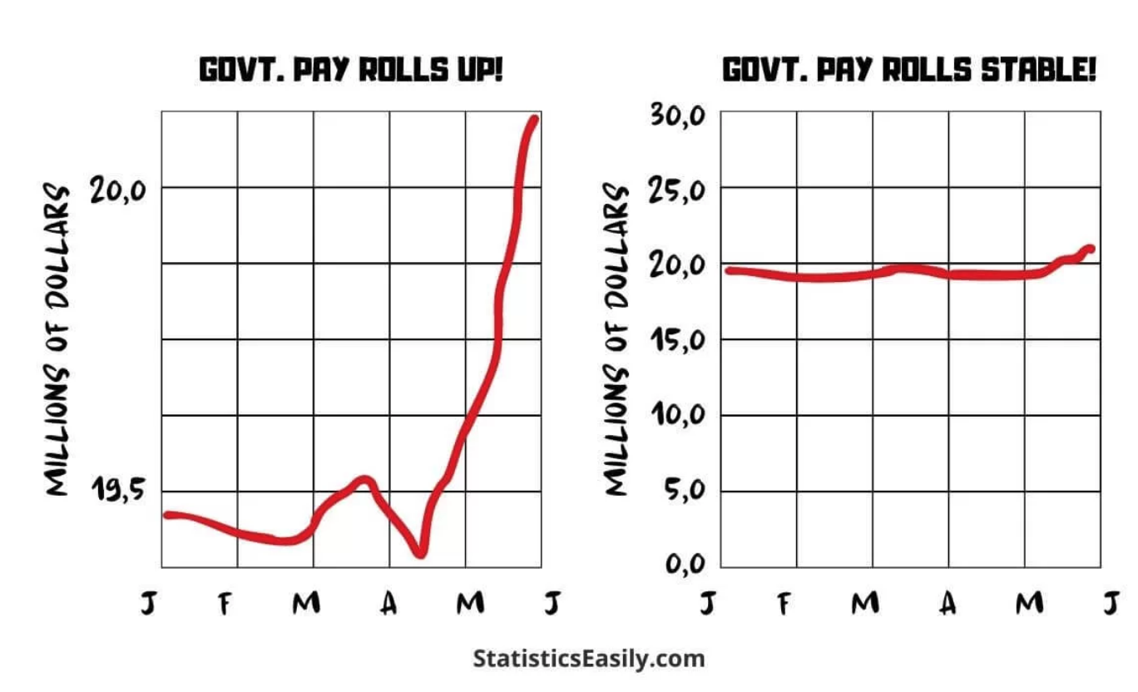

Data Types
- Continuous
  - numeric
- Discrete
  - integer or numerical
- Categorical
  - nominal – up, down, right, left…
  - ordinal – order - a, b, c, d or morning, afternoon, evening
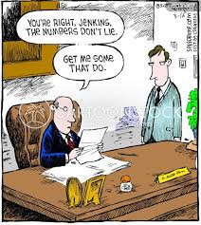

Measurements
Data is obtained through measurement
The world is a messy place and how you measure matters
Our measures depend on
- accuracy - how close we are to the real value
- precision - how close all our measurements are but may not be precise
