Probability & Inference
  - Probability and inference
Bill Perry

In class activity 4:

What did we do last time in activity 3?
- Setting up a project and variable names and code names
- How to use the pipe command %>%
- How to create descriptive statistics of a sample
p_df %>%
summarize(
mean_length = mean(length_mm, na.rm = TRUE),
sd_length = sd(length_mm, na.rm = TRUE),
n_length = sum(!is.na(length_mm)))
- More graphs…
- ggplot(data = p_df, aes(x=length_mm, fill = wind)) +
geom_histogram( binwidth = 2,
# sets the width in units of the bins - try different nubmers
position = position_dodge2(width = 0.5))
- 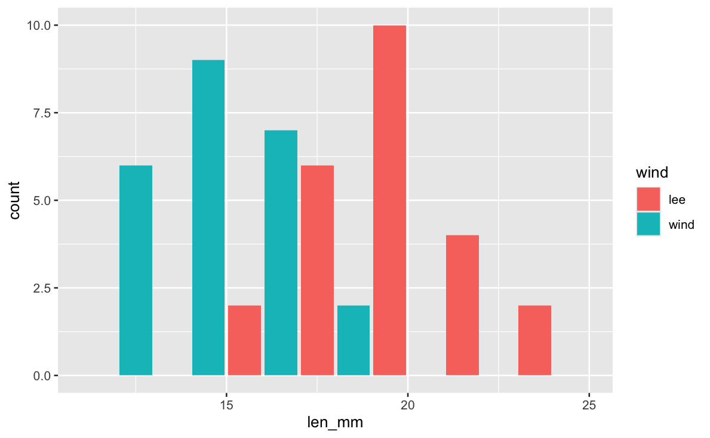
- What questions do you have and what is unclear - what did not work so far when you started the homework?

Introduction
In this active learning module, we’ll explore real data from fish populations in Alaska. We’ll focus on understanding:
- How to create and interpret frequency distributions
- How sample size affects our view of a population
- How distributions differ among lakes
We’ll use the tidyverse package for data manipulation and visualization.

Setup
First, let’s load the packages we need and the dataset:
# # Install the patchwork package if needed
# install.packages("patchwork")
library(patchwork)
library(skimr)
library(tidyverse)
# Read in the data file
g_df <- read_csv("data/gray_I3_I8.csv")
i3_df <- g_df %>% filter(lake =="I3")
# Look at the first few rows
head(g_df)
# A tibble: 6 × 5
site lake species length_mm mass_g
<dbl> <chr> <chr> <dbl> <dbl>
1 113 I3 arctic grayling 266 135
2 113 I3 arctic grayling 290 185
3 113 I3 arctic grayling 262 145
4 113 I3 arctic grayling 275 160
5 113 I3 arctic grayling 240 105
6 113 I3 arctic grayling 265 145

Part 1: Summary Statistics - descriptive statistics
# Calculate mean, standard deviation, and sample size by lake
stats_df <- g_df %>%
group_by(lake) %>%
summarize(
mean_length = mean(length_mm, na.rm = TRUE),
sd_length = sd(length_mm, na.rm = TRUE),
se_length = sd(length_mm, na.rm = TRUE)/ sum(!is.na(length_mm))^.5,
count = sum(!is.na(length_mm)),
.groups = "drop"
) %>%
arrange(desc(count))
stats_df
# A tibble: 2 × 5
lake mean_length sd_length se_length count
<chr> <dbl> <dbl> <dbl> <int>
1 I8 363. 52.3 5.18 102
2 I3 266. 28.3 3.48 66

Part 2: Creating Frequency Distributions

Basic Histograms
A histogram shows how many observations fall into certain ranges (or “bins”).
Let’s create a simple histogram of fish lengths from I3 :
# Filter for I3 and create a histogram
i3_df %>%
ggplot(aes(x = length_mm)) +
geom_histogram(binwidth = 10)
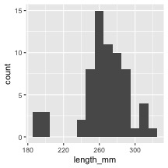
 Activity 1
Try changing the binwidth parameter to 5 and then to 1. How does the appearance of the histogram change?
# Try it here or above...

Comparing Lakes
Now let’s compare two lakes
# Compare histograms from I3 I8 lakes
g_df %>%
ggplot(aes(x = length_mm, fill = lake)) +
geom_histogram(binwidth = 10, position = position_dodge2(width = 0.9))
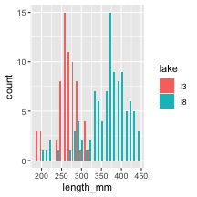
Now let’s compare two lakes side by side:
# Compare histograms from lake I3 I8
g_df %>%
ggplot(aes(x = length_mm, fill = lake)) +
geom_histogram(binwidth = 10) +
facet_wrap("lake")
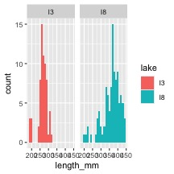

Part 2: From Histograms to Density Plots
Density plots give us a smoothed version of the histogram It has the proportion of the data under each part of the curve This sums to 1
# Create a density plot
i3_df %>%
ggplot(aes(x = length_mm)) +
geom_density(fill = "blue", alpha = 0.5)
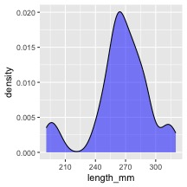
We can overlay the density plot on the histogram :
# Combine histogram and density plot
i3_df %>%
ggplot(aes(x = length_mm)) +
geom_histogram(aes(y = after_stat(density)), binwidth = 2,
fill = "lightblue", alpha = 0.7) +
geom_density(color = "blue", linewidth = 1)
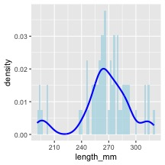

Part 3 - area under the density curve
We could show this if we really wanted…
# Function to calculate area under density curve
calculate_density_area <- function(data_vector) {
# Remove NA values
data_vector <- data_vector[!is.na(data_vector)]
# Calculate density
dens <- density(data_vector)
# Calculate area using numeric integration (trapezoidal rule)
# Area should be approximately 1
dx <- diff(dens$x)
y_avg <- (dens$y[-1] + dens$y[-length(dens$y)]) / 2
area <- sum(dx * y_avg)
return(area)
}
# Apply to i3 lake data
i3_data <- i3_df %>%
pull(length_mm)
area_value <- calculate_density_area(i3_data)
# Create plot with calculated area
i3_df %>%
ggplot(aes(x = length_mm)) +
geom_density(fill = "blue", alpha = 0.4) +
geom_area(stat = "density", fill = "red", alpha = 0.3) +
labs(title = "Area Under Probability Density Function = 1",
subtitle = paste("Calculated area =", round(area_value, 4)),
x = "Length (mm)",
y = "Density")
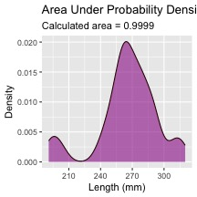

looking at particular areas…
This can be adapted to calculate the area of a subset of the plot
I don’t expect you to know or be able to do all of this but is here to play with the code
# ------- PART 3: SET INPUT VALUES -------
# change these values to calculate different probabilities
# For this example, let's calculate the probability of fish between 40mm and 60mm
lower_bound <- 320 # change this value
upper_bound <- 350 # change this value
# ------- PART 1: PREPARE THE DATA -------
# Filter data for just one lake to keep it simple for students
i3_fish <- i3_df %>%
filter(!is.na(length_mm)) # Remove any missing values
# ------- PART 2: CREATE A FUNCTION TO CALCULATE PROBABILITY -------
# This function calculates the probability of finding a fish with length between
# lower_bound and upper_bound using the empirical distribution of our data
calculate_probability <- function(data_vector, lower_bound, upper_bound) {
# First, we create a density object from our data
dens <- density(data_vector)
# Find indices of x-values that fall within our bounds
indices <- which(dens$x >= lower_bound & dens$x <= upper_bound)
# If we have no points in the range, return 0
if(length(indices) <= 1) {
return(0)
}
# Get x and y values within our bounds
x_values <- dens$x[indices]
y_values <- dens$y[indices]
# Calculate the area using the trapezoidal rule
# (average height × width) for each segment, then sum all segments
widths <- diff(x_values)
avg_heights <- (y_values[-1] + y_values[-length(y_values)]) / 2
area_in_range <- sum(widths * avg_heights)
# Return the calculated probability
return(area_in_range)
}
# ------- PART 4: CALCULATE THE PROBABILITY -------
# Calculate the probability for the specified range
probability <- calculate_probability(i3_fish$length_mm, lower_bound, upper_bound)
# Calculate the total area to show that the complete distribution sums to approximately 1
total_area <- calculate_probability(i3_fish$length_mm,
min(i3_fish$length_mm),
max(i3_fish$length_mm))
# ------- PART 5: CREATE THE VISUALIZATION -------
# Create density data for the highlighting
density_data <- density(i3_fish$length_mm)
density_df <- data.frame(x = density_data$x, y = density_data$y)
# Create a subset for the area of interest
highlight_df <- density_df %>%
filter(x >= lower_bound & x <= upper_bound)
# Create the plot
ggplot(i3_fish, aes(x = length_mm)) +
# First, plot the overall density curve in light blue
geom_density(fill = "lightblue", alpha = 0.5) +
# Then highlight our region of interest in dark red
geom_area(data = highlight_df, aes(x = x, y = y),
fill = "darkred", alpha = 0.7) +
# Add vertical lines to clearly mark the boundaries
geom_vline(xintercept = lower_bound, linetype = "dashed", color = "red") +
geom_vline(xintercept = upper_bound, linetype = "dashed", color = "red") +
# Add informative labels
labs(
title = "Probability Distribution of Fish Lengths",
subtitle = paste0("Probability of fish between ", lower_bound,
" and ", upper_bound, " mm = ",
round(probability * 100, 1), "%"),
caption = paste("Total area under the curve =", round(total_area, 3)),
x = "Fish Length (mm)",
y = "Density"
) +
# Add text annotations to explain the areas
annotate("text", x = (lower_bound + upper_bound)/2,
y = max(density(i3_fish$length_mm)$y) * 0.7,
label = paste0("Area = ", round(probability, 3)),
color = "white", size = 4) +
# Make the plot look nicer
theme_minimal() +
theme(
plot.title = element_text(face = "bold"),
plot.subtitle = element_text(color = "darkred")
)
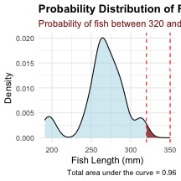

Part 4: this is great but integrating area each time is a pain
Converting data to Z scores
# Calculate the mean and standard deviation of fish lengths
mean_length <- mean(i3_df$length_mm, na.rm = TRUE)
sd_length <- sd(i3_df$length_mm, na.rm = TRUE)
# Calculate Z-scores for fish lengths
i3_df <- i3_df %>%
mutate(z_score = (length_mm - mean_length) / sd_length)
# View the first few rows with Z-scores
head(i3_df)
# A tibble: 6 × 6
site lake species length_mm mass_g z_score
<dbl> <chr> <chr> <dbl> <dbl> <dbl>
1 113 I3 arctic grayling 266 135 0.0139
2 113 I3 arctic grayling 290 185 0.862
3 113 I3 arctic grayling 262 145 -0.127
4 113 I3 arctic grayling 275 160 0.332
5 113 I3 arctic grayling 240 105 -0.905
6 113 I3 arctic grayling 265 145 -0.0214

Now plot the Z Scores as a histogram
z_fish_plot <- i3_df %>%
ggplot(aes(x=z_score)) +
geom_histogram()
z_fish_plot
`stat_bin()` using `bins = 30`. Pick better value `binwidth`.
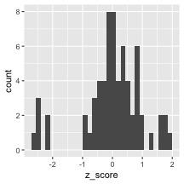

we can use this now to get the area the same way as above but easier…
Proportion within 1 standard deviation = sum of absolute values of Z Scores that are less than or equal to 1 divided by the number in the sample…
Remember in a true normal distribution it is 68% within 1 std dev.
should be approximately (varies if distribution is not normal):
- 68% of data within ±1σ of the mean
- 95% of data within ±2σ of the mean - really 1.96σ
- 99.7% of data within ±3σ of the mean
# What proportion of fish are within 1 standard deviation of the mean?
within_1sd <- sum(abs(i3_df$z_score) <= 1, na.rm = TRUE) / sum(!is.na(i3_df$z_score))
cat("Proportion within 1 SD:", round(within_1sd * 100, 1), "%\n")
Proportion within 1 SD: 81.8 %

Z-score example calculation in r
We can use R to get these values easier…
# For standard normal distribution (mean=0, sd=1):
- pnorm(z) # gives cumulative probability (area to the left)
- qnorm(p) # gives z-value for a given probability
- dnorm(z) # gives probability density
# Examples:
z_value <- 1.22
prob_left <- pnorm(z_value) # 0.975 (97.5% to the left)
prob_right <- 1 - pnorm(z_value) # 0.025 (2.5% to the right)
prob_between <- pnorm(2) - pnorm(-2) # 0.95 (95% between ±1.96)
# To find z-value for a given probability:
z_for_95_percent <- qnorm(0.888) # 1.96
print(prob_left)
[1] 0.8887676
print(prob_right)
[1] 0.1112324
print(prob_between)
[1] 0.9544997
print(z_for_95_percent)
[1] 1.21596

We can now use this for fun in the fish
Lets say we are interested in knowing at what point from I3 it is not likely to catch a larger fish?
Maybe we expect 95% of the time to catch a fish that is “common” but the 5% is the unlikely portion….
# Examples:
# What fish length corresponds to the top 5% (unlikely)?
top_5_percent_z <- qnorm(0.95) # z-score for 95th percentile
unlikely_length <- mean_length + (top_5_percent_z * sd_length)
cat("Only 5% of fish are longer than:", round(unlikely_length, 1), "mm\n")
Only 5% of fish are longer than: 312.2 mm
cat("This corresponds to z-score:", round(top_5_percent_z, 3), "\n")
This corresponds to z-score: 1.645

Part 5: Comparing a sampe mean to an expected mean….
Did the smaple come from that lake?
Lets practice a One-Sample t-Test
Let’s perform a one-sample t-test to determine if the mean fish length in Lake I3 differs from 260 mm:
# get only lake I3
i3_df <- g_df %>% filter(lake=="I3")
# what is the mean
i3_mean <- mean(i3_df$length_mm, na.rm=TRUE)
cat("Mean:", round(i3_mean, 1), "mm\n")
Mean: 265.6 mm
# Perform a one-sample t-test
t_test_result <- t.test(i3_df$length_mm, mu = 260)
# View the test results
t_test_result
One Sample t-test
data: i3_df$length_mm
t = 1.6091, df = 65, p-value = 0.1124
alternative hypothesis: true mean is not equal to 260
95 percent confidence interval:
258.6481 272.5640
sample estimates:
mean of x
265.6061

Part 6: Comparing two means
Formulating Hypotheses
For the following research questions about Arctic grayling, write the null and alternative hypotheses:
- Are fish in Lake I8 longer than fish in Lake I3?
# Let's test one of these hypotheses: Are fish in Lake I8 longer than fish in Lake I3?
# Perform an independent t-test
t_test_result <- t.test(length_mm ~ lake, data = g_df,
alternative = "less") # H₀: μ_I3 ≥ μ_I8, H₁: μ_I3 < μ_I8
# Display the results
t_test_result
Welch Two Sample t-test
data: length_mm by lake
t = -15.532, df = 161.63, p-value < 2.2e-16
alternative hypothesis: true difference in means between group I3 and group I8 is less than 0
95 percent confidence interval:
-Inf -86.66138
sample estimates:
mean in group I3 mean in group I8
265.6061 362.5980

