Module 4 — Graphing Effectively
  - Boxplots, group comparisons, and saving a publication-ready figure
Bill Perry

Where We Left Off
Last time you:
- Computed mean, median, SD, and SE — by hand and with summarize()
- Fixed the length() trap with sum(!is.na())
- Got tidy per-group tables with group_by() + summarize()
 Note
✅ Key idea from Module 3
You now have real numbers describing lee vs. windward needles. Today we make those numbers visible — and save the result properly.

 Note
Today’s roadmap
- The ggplot grammar, recapped
- Boxplots done right — with raw points
- Plotting mean ± SE directly
- Faceting and a quick theme tour
- ggsave(), for real this time

Part 1 · The ggplot Grammar, Recapped
Every ggplot is three pieces joined with +:
- data — which data frame
- aes() — which columns map to x, y, color, fill…
- geom — how to draw it
library(tidyverse)
pine_df <- read_csv("data/pine_needles.csv")
 Note
✅ Key idea
Everything today is the same three pieces — we’re just adding more layers and more polish on top of them.

 Tip
🖐 Recap from Module 1
ggplot(pine_df, aes(x = n_s, y = length_mm)) +
geom_point()
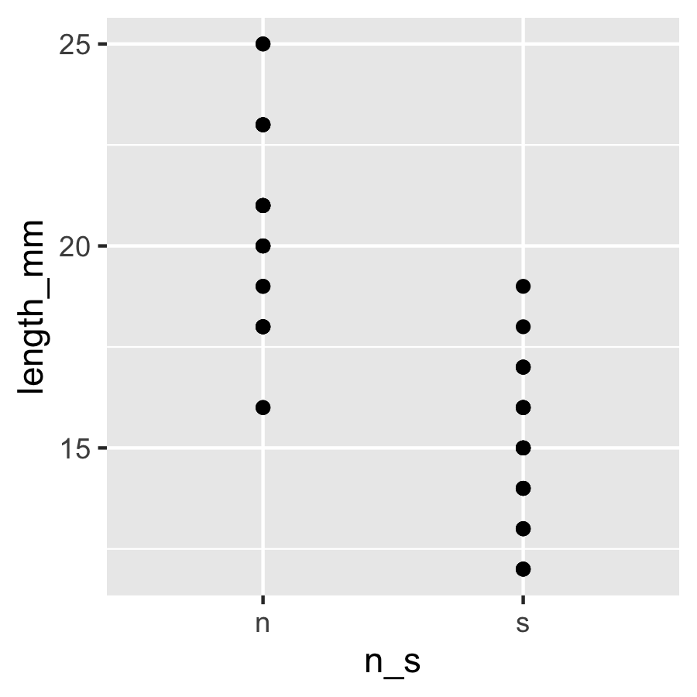

Part 2 · Boxplot Anatomy
pine_box_plot <- ggplot(pine_df, aes(x = n_s, y = length_mm, fill = n_s)) +
geom_boxplot(alpha = 0.6, outlier.shape = NA) +
labs(
title = "Needle Length by Side of Tree",
x = "Side (n = lee, s = windward)",
y = "Needle length (mm)",
fill = "Side"
) +
theme_minimal() +
theme(legend.position = "none")
pine_box_plot
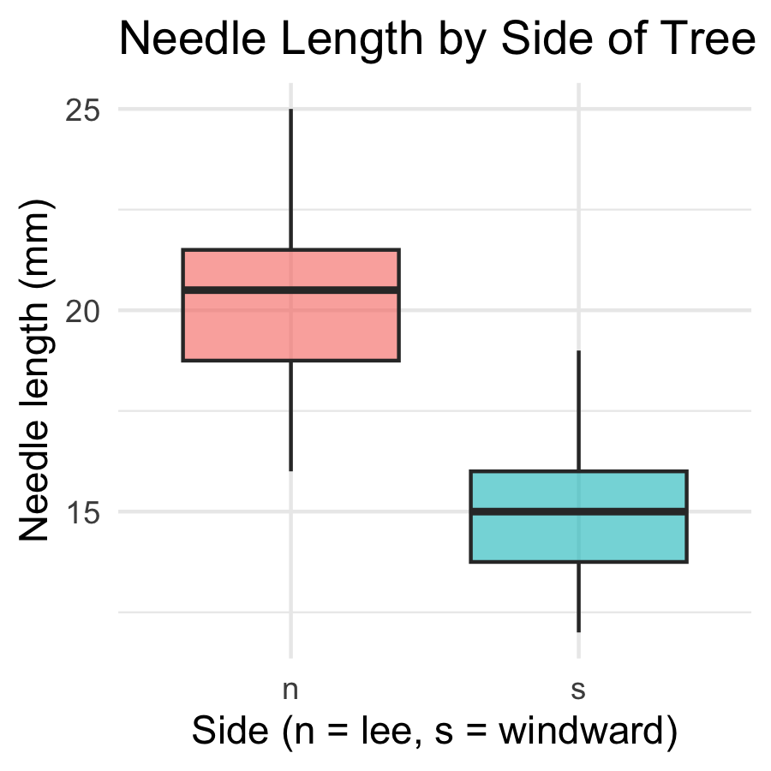
Boxplot anatomy:
- Middle line = median
- Box edges = 25th and 75th percentile (IQR)
- Whiskers = 1.5 × IQR
- Dots beyond whiskers = outliers
📖 R4DS §9 — Layers

Boxplot + Raw Points
 Note
🔮 Predict first: With only 6 needles per side per tree, does a boxplot alone show you everything? What might it hide?

pine_jitter_plot <- ggplot(pine_df, aes(x = n_s, y = length_mm, fill = n_s)) +
geom_boxplot(alpha = 0.5, outlier.shape = NA) +
geom_point(
position = position_jitter(width = 0.15, seed = 42),
alpha = 0.6,
size = 2
) +
labs(
title = "Needle Length by Side of Tree",
x = "Side of tree", y = "Needle length (mm)", fill = "Side"
) +
theme_minimal() +
theme(legend.position = "none")
pine_jitter_plot
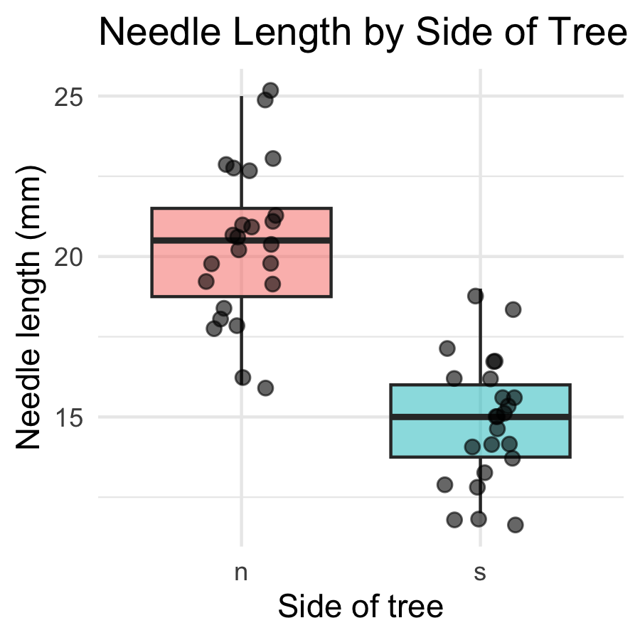
- position_jitter(width = 0.15) spreads points sideways so they don’t overlap
- seed = 42 — same jitter layout every time you render
- alpha = 0.6 — semi-transparent, so overlapping points are still visible
 Tip
Always show the raw points alongside a boxplot when n is small — every point matters, and a box alone can hide a bimodal or lopsided pattern.

Part 3 · Mapping Color by Group
pine_team_plot <- ggplot(pine_df, aes(x = n_s, y = length_mm, color = group)) +
geom_point(
position = position_jitter(width = 0.15, seed = 42),
size = 2.5, alpha = 0.8
) +
labs(
title = "Needle Length by Side, Colored by Team",
x = "Side of tree", y = "Needle length (mm)", color = "Field team"
) +
theme_minimal()
pine_team_plot
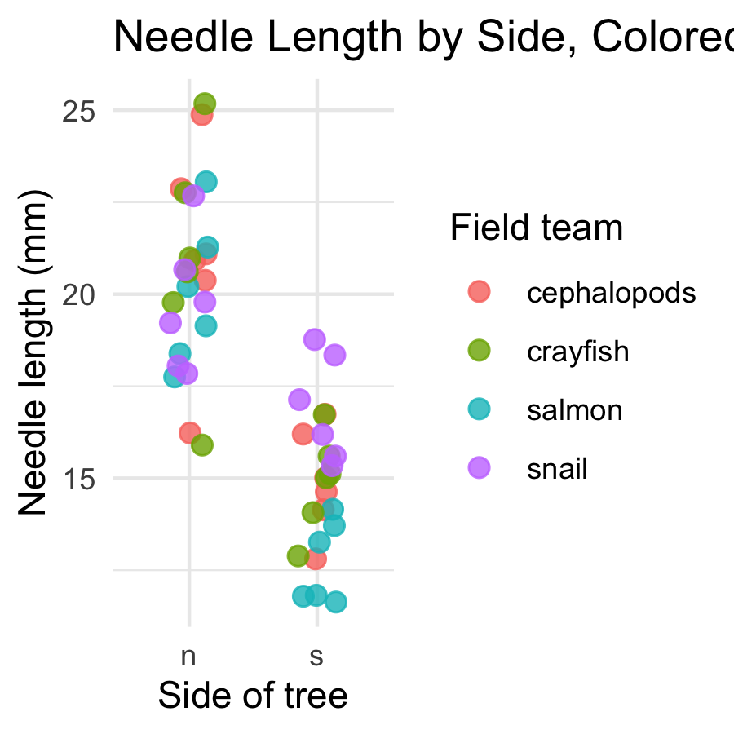
- color = group maps a third variable onto the plot — no new geom needed
- ggplot auto-builds the legend and picks colors for you
- Mapping inside aes() always means “vary this by data” — not “make everything this color”
 Warning
⚠️ Watch out!
color = "steelblue" outside aes() sets one fixed color. color = group inside aes() maps colors to a variable. Mixing these up is one of the most common ggplot mistakes.

Part 4 · Mean ± SE — Plotted Directly
pine_mean_se_plot <- ggplot(pine_df, aes(x = n_s, y = length_mm, color = n_s)) +
geom_point(
position = position_jitter(width = 0.15, seed = 42),
alpha = 0.3, size = 2
) +
stat_summary(fun = mean, geom = "point", size = 4) +
stat_summary(
fun.data = mean_se,
geom = "errorbar",
width = 0.15, linewidth = 0.9
) +
labs(
title = "Mean ± SE Needle Length by Side",
x = "Side of tree", y = "Needle length (mm)"
) +
theme_minimal() +
theme(legend.position = "none")
pine_mean_se_plot
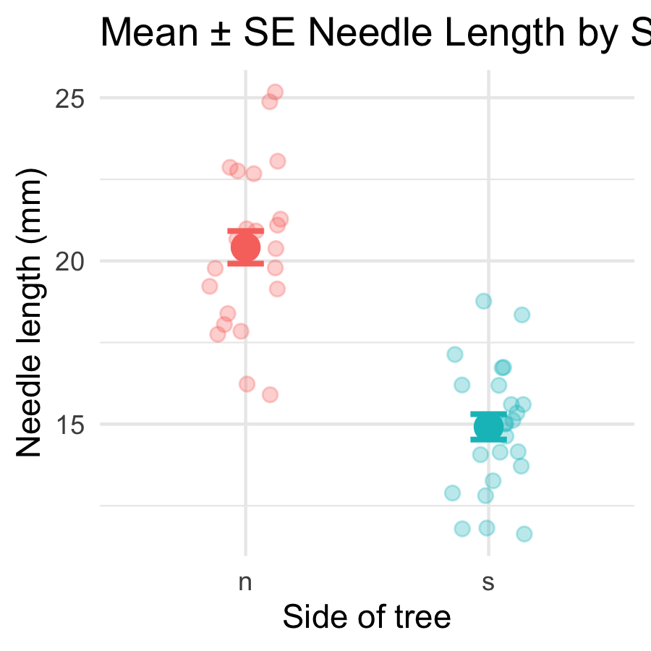
Two stat_summary() layers:
call | draws
fun = mean | one large point at the mean
fun.data = mean_se | error bars for ± 1 SE
stat_summary() computes the mean and SE for you, straight from the raw data — no summarize() step required first.
 Note
✅ Key idea
This is the exact same mean and SE you calculated by hand in Module 3 — now you can see them.

Part 5 · Faceting — One Panel Per Group
pine_facet_plot <- ggplot(pine_df, aes(x = n_s, y = length_mm, fill = n_s)) +
geom_boxplot(alpha = 0.6, outlier.shape = NA) +
facet_wrap(~group) +
labs(
title = "Needle Length by Side, Faceted by Team",
x = "Side of tree", y = "Needle length (mm)"
) +
theme_minimal() +
theme(legend.position = "none")
pine_facet_plot
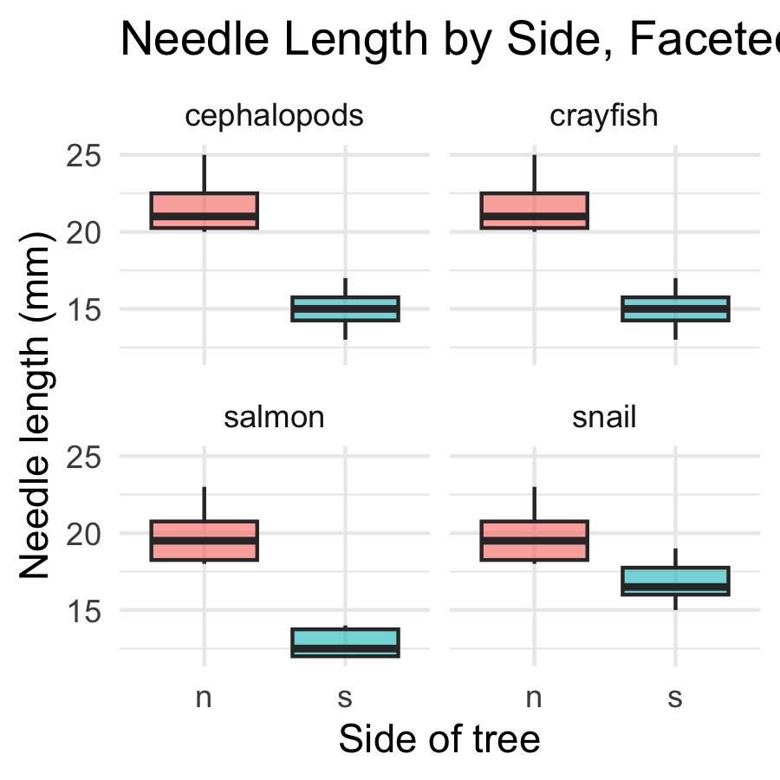
- facet_wrap(~group) gives each field team its own small panel
- Same x/y scale across panels — easy to compare
- Useful the moment “does every group show the same pattern?” is the real question
 Tip
🖐 Notice
A faceted plot answers a different question than a single colored plot: not just “is there an overall pattern,” but “does the pattern hold for everyone?”

Part 6 · A Quick Theme Tour
pine_jitter_plot + theme_bw()
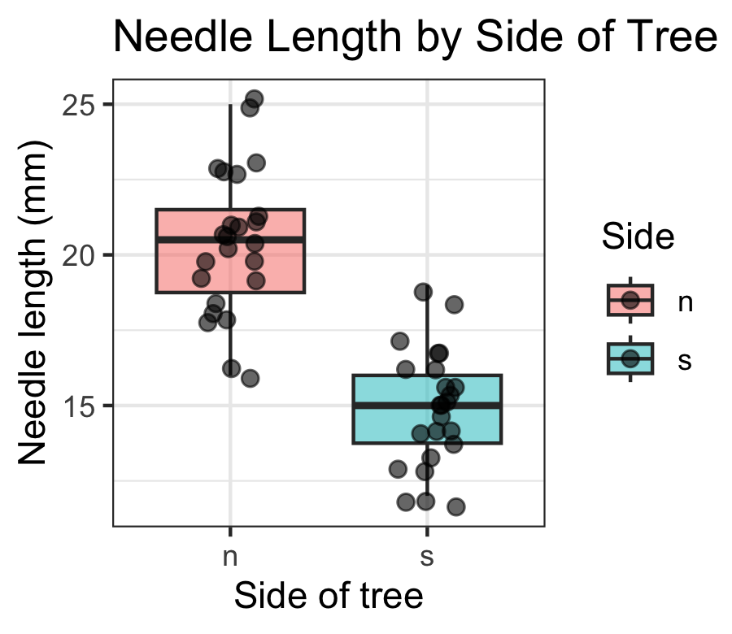
pine_jitter_plot + theme_classic()
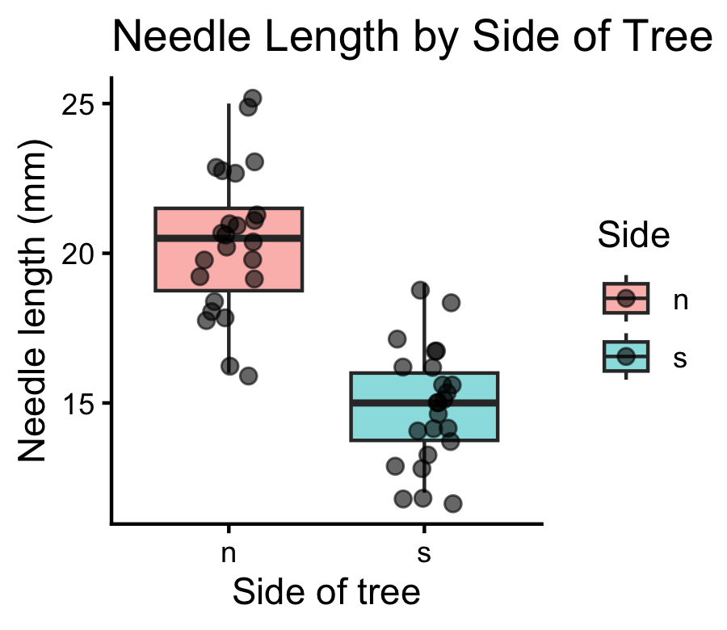
- theme_minimal() — light, few gridlines (what we’ve used so far)
- theme_bw() — white background, black-and-white frame
- theme_classic() — just x/y axis lines, no gridlines at all
 Note
✅ Key idea
A theme changes appearance only — never the data or the statistics underneath. Pick one and use it consistently across a report.

Part 7 · Saving a Real Figure
ggsave(
"figures/pine_needle_boxplot.png",
plot = pine_jitter_plot,
width = 3,
height = 3,
units = "in",
dpi = 300
)
 Warning
⚠️ Watch out!
ggsave() wants the filename first, then plot =. If you skip plot =, it saves whatever plot was drawn last — not necessarily the one you meant.

 Note
✅ Key idea
Always set width, height, units, and dpi explicitly. Letting ggsave() guess gives you a plot sized for your screen, not for a report or a poster.

Wrap-up
Today you:
- Built boxplots with raw points overlaid, not hidden
- Mapped a third variable with color = / fill = inside aes()
- Plotted mean ± SE directly with stat_summary() — no separate summary table needed
- Faceted a plot with facet_wrap() to check every group at once
- Compared themes, and saved a real, correctly-sized figure with ggsave()
 Tip
🖐 Before next class
Finish the worksheet: build a mean ± SE plot faceted by group, pick a theme, and save it to figures/ at 3×3in, 300 dpi.

 Note
Where this leads
You can now import, wrangle, describe, and visualize a dataset end to end. That full pipeline — raw data → clean → summarize → visualize — is the foundation every later statistical test builds on.

Getting unstuck
When code breaks — and it will, that is normal:
- Read the error message out loud; it usually names the line
- Check the usual suspects: library(tidyverse) loaded? Is color/fill inside aes() when it should be?
- ?function_name opens the help page
- Bring the exact error (copy-paste it) to class or office hours
 Note
✅ Key idea
Every working scientist googles error messages daily. Getting stuck is not failing — it is the job.

