Lecture: Analysis of Variance (ANOVA)
  - Single-factor ANOVA
Bill Perry

Where We Left Off
Covered last time — Multiple Regression:
- The MLR model, regression parameters
- Analysis of variance for regression
- Null hypotheses, explained variance
- Assumptions and diagnostics
- Collinearity, interactions, dummy variables
- Model selection, importance of predictors
 Note
✅ Key idea from last lecture
You already built an ANOVA table for a regression — you just called it “analysis of variance for regression.” Today we apply the exact same machinery to categorical predictors.

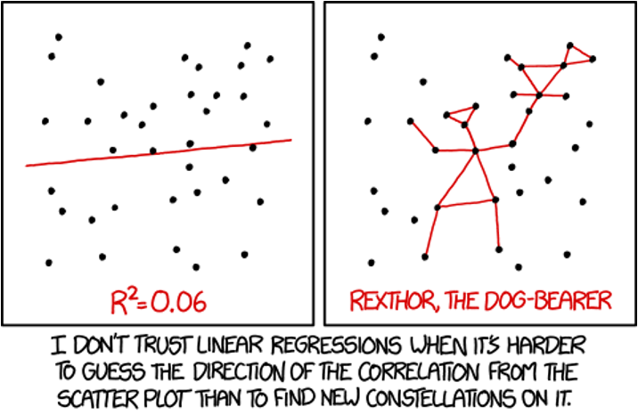
XKCD comic ‘Linear Regression’: a scatterplot of scattered points with a nearly flat fitted regression line labeled R-squared = 0.06 next to the same points connected into a constellation-like stick figure labeled ‘Rexthor, the Dog-Bearer’, captioned ‘I don’t trust linear regressions when it’s harder to guess the direction of the correlation from the scatter plot than to find new constellations on it.’

Part 1 · ANOVA Overview

Today’s Objectives
ANOVA: analysis of variance, single-factor today, multi-factor to come.
- Predictor variables: fixed
- The ANOVA model
- Analysis and partitioning of variance
- Null hypothesis
- Assumptions and diagnostics
- Post-hoc tests — Tukey and others
- Reporting the results
- Mixed-model ANOVA — random effects
Note
📖 Reference
Gotelli & Ellison, A Primer of Ecological Statistics, Ch. 10 — The Analysis of Variance, is the core reference for this lecture.

What if the response is continuous and the predictor(s) categorical?
 | Continuous X | Categorical X
Continuous Y | Regression | ANOVA
Categorical Y | Logistic regression

Part 2 · ANOVA and Regression Connection

ANOVA and Regression Connection
Both regression and ANOVA:
- Partition the total variation in Y
- Use F-tests for significance, where one MS is divided by another
Regression:
- Form: $Y=β_{0}+β_{1}X+ε$ — Y is the response, β₀ the intercept, β₁ the slope, X the predictor, ε the error
- Test: $H_{0}:β_{1}=0$ — rejecting means X significantly predicts Y
ANOVA:
- Form: $Y_{ij}=μ+A_{i}+ε_{ij}$ — $Y_{ij}$ is observation j in group i, μ the grand mean, $A_{i}$ the effect of group i, ε the error
- Test: $H_{0}:μ_{1}=μ_{2}=...=μ_{k}$ — rejecting means at least one group differs

The Same Partitioning, Two Kinds of Predictor
General method for partitioning variation in a continuous dependent variable:
- One or more continuous (and categorical) predictors → regression
- One or more categorical predictors → ANOVA
- Categorical predictor variables represent groups or experimental treatments
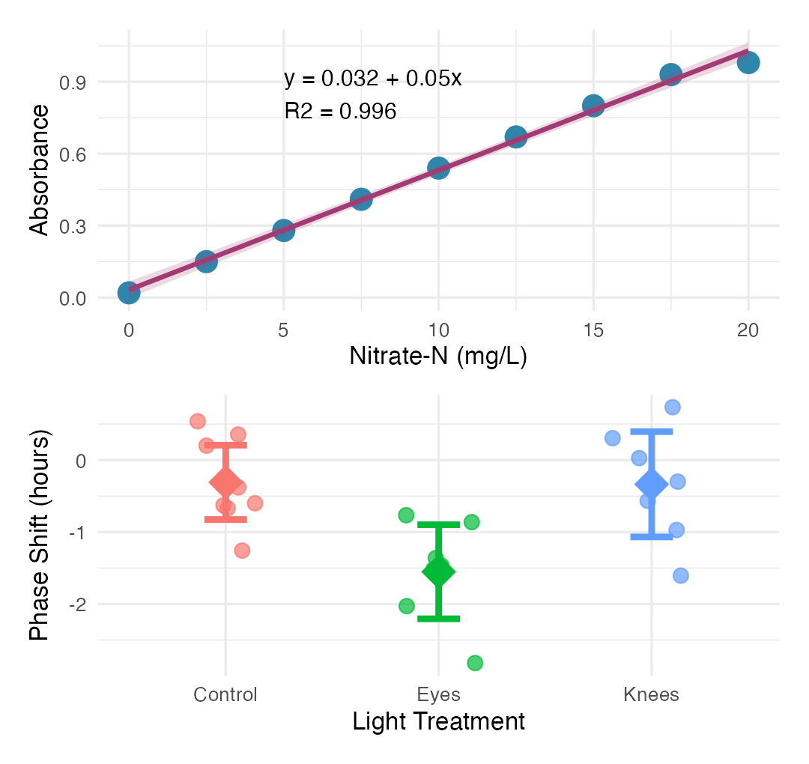

ANOVA as Regression
 Tip
ANOVA as regression
With one categorical variable, ANOVA is equivalent to regression with dummy variables. In fact, when we run ANOVAs we use the same code as for regression!
regression: model <- lm(response ~ predictor, data = df) anova: model <- lm(response ~ factor, data = df)
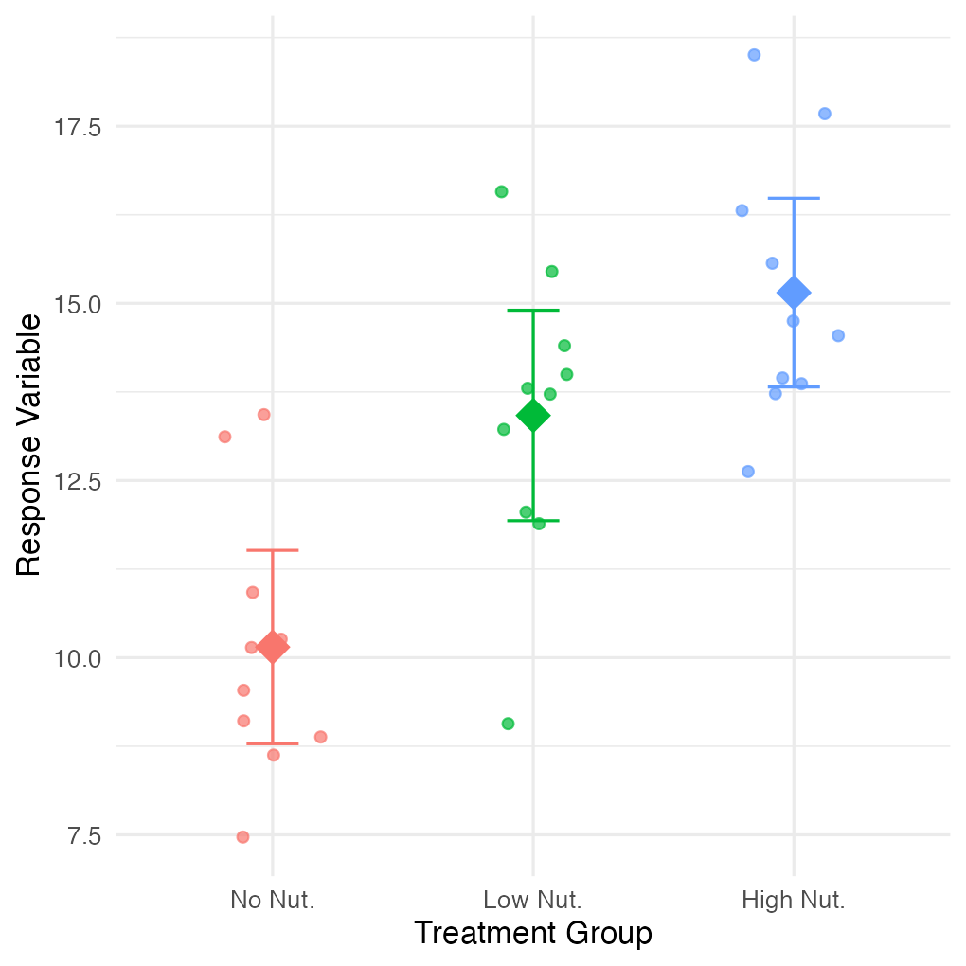

Part 3 · ANOVA Goals and Logic

ANOVA Goals
ANOVA aims to compare means of groups:
- Attributes contribution of predictors + “error” to variability
- Tests H₀ that population (random effects) or group (fixed effects) means are equal
- Single factor (1-way) and multifactor (2-, 3-way designs)
  - Single factor: one factor with more than two levels
- Multifactor: two or three factors with two or more levels each — examines variation due to factors AND their interaction
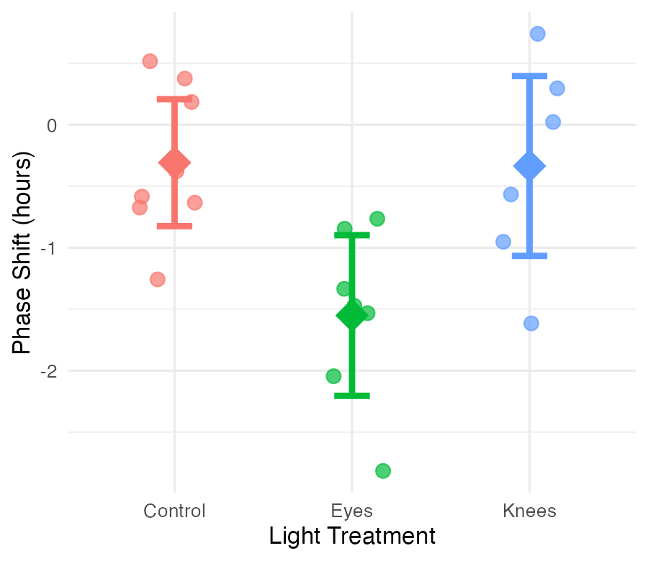

Analysis of Variance
Analysis of variance is the most powerful approach known for simultaneously testing if the means of k groups are equal — it works by assessing whether individuals chosen from different groups are, on average, more different than individuals chosen from the same group.
The null hypothesis of ANOVA is that the population means μᵢ are the same for all treatments.
- H₀: μ₁ = μ₂ = … = μₖ
- H₁: at least one μᵢ is different from the others
Rejecting H₀ in ANOVA is evidence that the mean of at least one group is different from the others — it does not indicate which means differ.
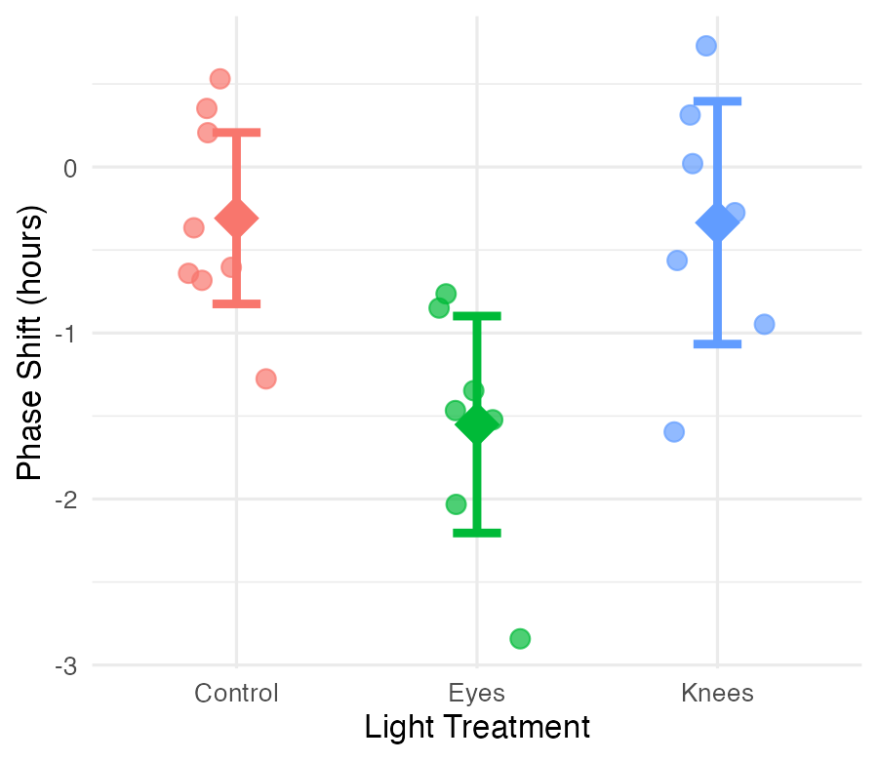

ANOVA Logic
Even if all groups had the same true mean, the data would likely show different sample means for each group due to sampling error.
The key insight of ANOVA: we can estimate how much variation among group means ought to be present from sampling error alone if H₀ is true. ANOVA lets us determine whether there is more variance among the sample means than expected by chance alone. If so, we infer real differences among the population means.
Two key measures of variation are calculated and compared:
- Group mean square ($MS_{groups}$) — variation among subjects from different groups
- Error mean square ($MS_{error}$) — variation among subjects within the same group
$$F=\frac{MS_{groups}}{MS_{error}}$$
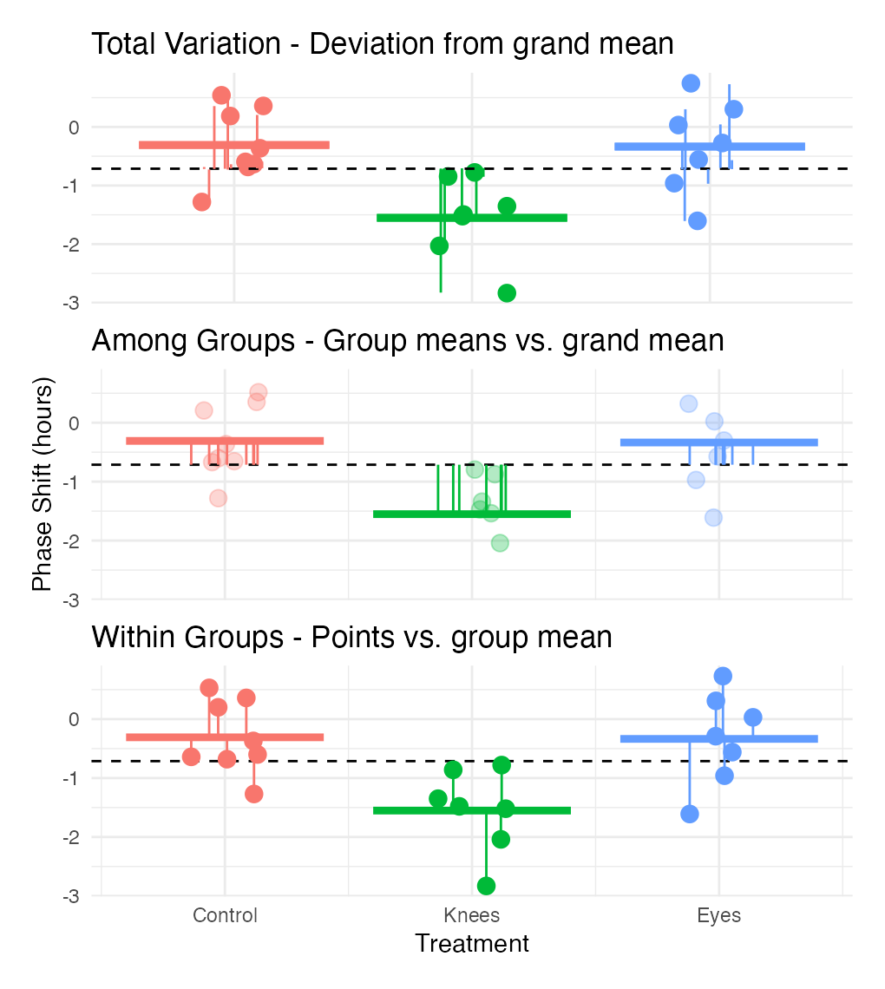

Part 4 · Partitioning the Sum of Squares

Partitioning the Sum of Squares
The total variation in Y can be expressed as a sum of squares:
$$SS_{total}=\sum_{i=1}^{a}{\sum_{j=1}^{n}{(}}Y_{ij}−\overset{‾}{Y})^{2}$$
This can be partitioned into two components:
- Among Groups (Treatment): $SS_{among}=n\sum_{i=1}^{a}{(}{\overset{‾}{Y}}_{i}−\overset{‾}{Y})^{2}$
- Within Groups (Error): $SS_{within}=\sum_{i=1}^{a}{\sum_{j=1}^{n}{(}}Y_{ij}−{\overset{‾}{Y}}_{i})^{2}$
These components are additive: $SS_{total}=SS_{among}+SS_{within}$
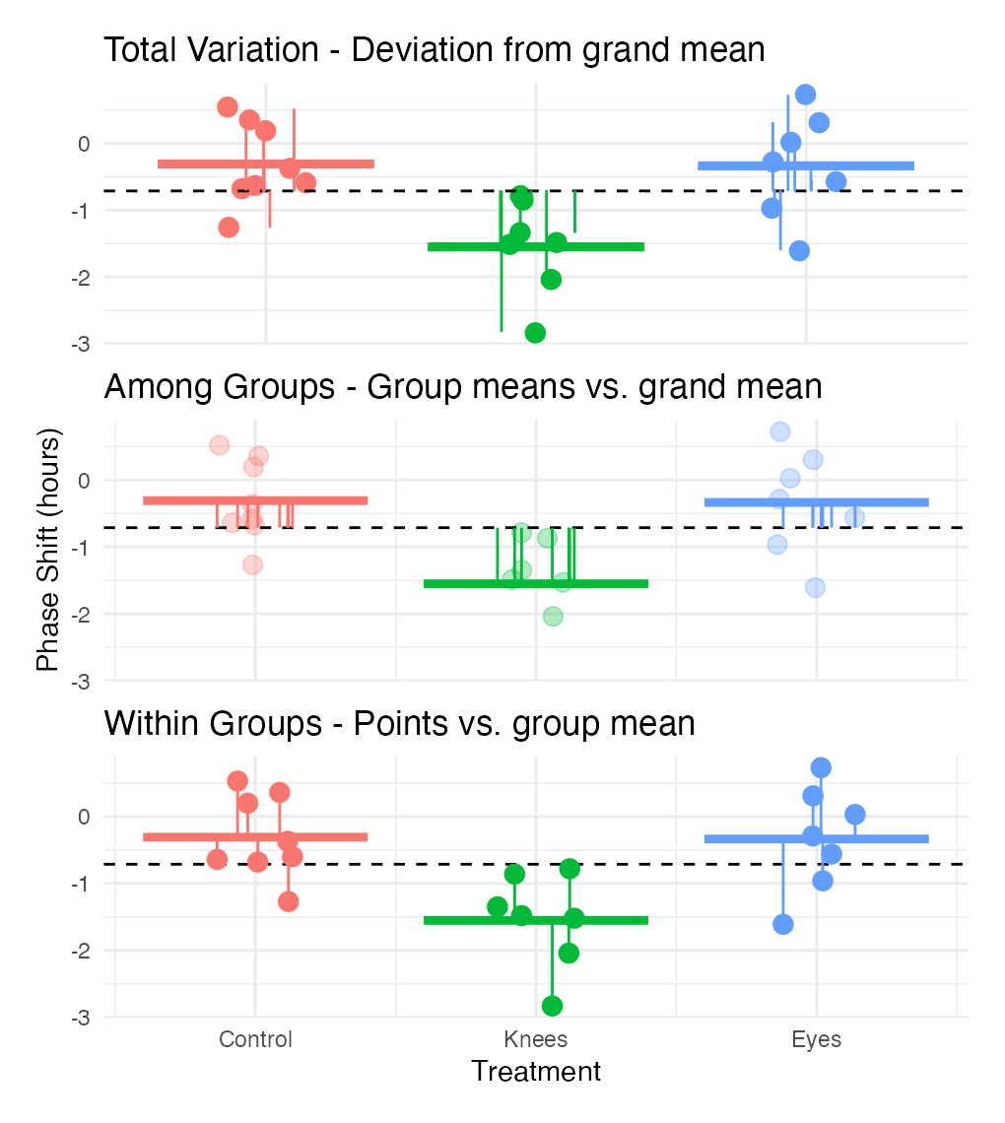

A Worked Sum-of-Squares Example
Call:
lm(formula = phase_shift ~ treatment, data = circ_data)
Residuals:
Min 1Q Median 3Q Max
-1.27857 -0.36125 0.03857 0.61147 1.06571
Coefficients:
Estimate Std. Error t value Pr(>|t|)
(Intercept) -0.30875 0.24888 -1.241 0.22988
treatmentEyes -1.24268 0.36433 -3.411 0.00293 **
treatmentKnees -0.02696 0.36433 -0.074 0.94178
---
Signif. codes: 0 '***' 0.001 '**' 0.01 '*' 0.05 '.' 0.1 ' ' 1
Residual standard error: 0.7039 on 19 degrees of freedom
Multiple R-squared: 0.4342, Adjusted R-squared: 0.3746
F-statistic: 7.289 on 2 and 19 DF, p-value: 0.004472
Analysis of Variance Table
Response: phase_shift
Df Sum Sq Mean Sq F value Pr(>F)
treatment 2 7.2245 3.6122 7.2894 0.004472 **
Residuals 19 9.4153 0.4955
---
Signif. codes: 0 '***' 0.001 '**' 0.01 '*' 0.05 '.' 0.1 ' ' 1
 Important
Key connection to regression
This is the same partitioning we saw in regression analysis:
$$SS_{total}=SS_{regression}+SS_{residual}$$
- $SS_{among}$ in ANOVA = $SS_{regression}$ in regression
- $SS_{within}$ in ANOVA = $SS_{residual}$ in regression
Both measure how much variation is explained by our model vs. unexplained (error).

The ANOVA Table
The ANOVA table organizes all computations leading to a test of the null hypothesis of no differences among population means.
- Source of variation — what is being tested
- Sum of squares — total variation for each source
- df — degrees of freedom for each source
- Mean squares — sum of squares divided by df
- F-ratio — ratio of mean squares, used to test significance
- P-value — probability of observing our results if H₀ is true
Example: for a one-way ANOVA with 3 groups and 4 replicates per group: df(treatments) = a − 1 = 2, df(error) = a(n − 1) = 3(4 − 1) = 9, df(total) = an − 1 = 11
Call:
lm(formula = phase_shift ~ treatment, data = circ_data)
Residuals:
Min 1Q Median 3Q Max
-1.27857 -0.36125 0.03857 0.61147 1.06571
Coefficients:
Estimate Std. Error t value Pr(>|t|)
(Intercept) -0.30875 0.24888 -1.241 0.22988
treatmentEyes -1.24268 0.36433 -3.411 0.00293 **
treatmentKnees -0.02696 0.36433 -0.074 0.94178
---
Signif. codes: 0 '***' 0.001 '**' 0.01 '*' 0.05 '.' 0.1 ' ' 1
Residual standard error: 0.7039 on 19 degrees of freedom
Multiple R-squared: 0.4342, Adjusted R-squared: 0.3746
F-statistic: 7.289 on 2 and 19 DF, p-value: 0.004472
Analysis of Variance Table
Response: phase_shift
Df Sum Sq Mean Sq F value Pr(>F)
treatment 2 7.2245 3.6122 7.2894 0.004472 **
Residuals 19 9.4153 0.4955
---
Signif. codes: 0 '***' 0.001 '**' 0.01 '*' 0.05 '.' 0.1 ' ' 1
# A tibble: 3 × 4
treatment Mean SD N
<fct> <dbl> <dbl> <int>
1 Control -0.309 0.618 8
2 Eyes -1.55 0.706 7
3 Knees -0.336 0.791 7

Comparing ANOVA and Regression Tables
Important
ANOVA table:
Source | df | SS | MS | F | p
Treatment | a-1 | SS_treatment | MS_treatment | F | p
Error | a(n-1) | SS_error | MS_error
Total | a*n-1 | SS_total
Is equivalent to an ANOVA table from a regression model:
Source | df | SS | MS | F | p
Regression | k | SS_regression | MS_regression | F | p
Error | n-k-1 | SS_residual | MS_residual
Total | n-1 | SS_total
Where k = number of predictor/dummy variables = a − 1, and a = treatment groups/levels of factors.

Part 5 · The F-Ratio

The F-Ratio
$$F=\frac{MS_{among}}{MS_{error}}$$
- Under H₀ (all means equal): the F-ratio should be approximately 1
- Larger F-ratios suggest among-group variance exceeds what’s expected by chance
- With the circadian rhythm data: F = 7.29, p = 0.004 — we reject H₀
- The F-ratio follows an F-distribution with (a − 1) and a(n − 1) df
# A tibble: 2 × 2
Metric Value
<chr> <dbl>
1 F-observed 7.29
2 F-critical (alpha = 0.05) 3.52
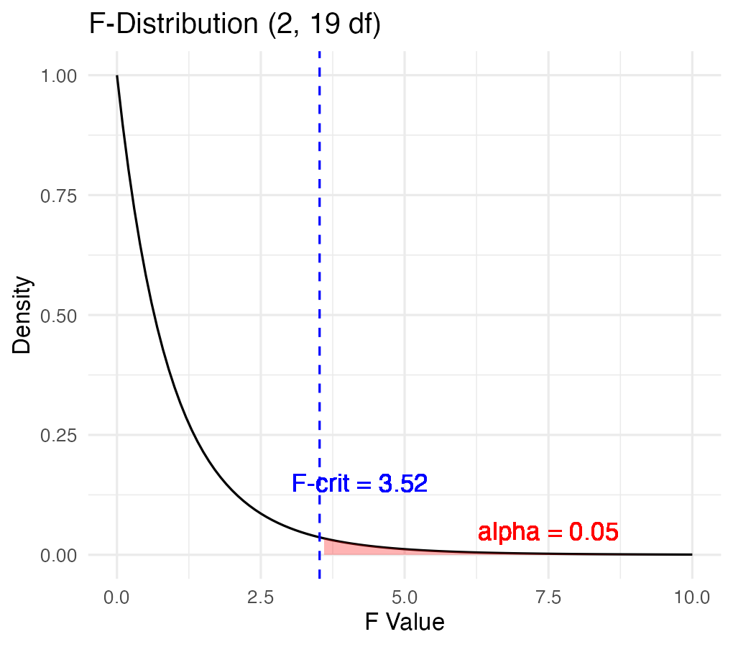

Connection of an F-Test to a T-Test
An ANOVA with two groups (a = 2) is equivalent to a t-test — why F = t²? Both test the same hypothesis: are the means of two groups different?
- The t-statistic: $t=\frac{{\overset{‾}{X}}_{1}−{\overset{‾}{X}}_{2}}{SE_{difference}}$ — measures how many standard errors apart the two means are, and can be + or −
- The F-statistic: $F=\frac{MS_{B}}{MS_{W}}$ — the ratio of variance between groups to variance within groups
- Unlike t, F is always non-negative (it’s a ratio of squared quantities)
The mathematical connection:
- Both measure the same signal-to-noise ratio — numerators capture the difference between groups (signal), denominators capture variability within groups (noise)
- With two groups: $MS_{B}$ relates directly to $({\overset{‾}{X}}_{1}−{\overset{‾}{X}}_{2})^{2}$, and $MS_{W}$ relates to the pooled variance
- Degrees of freedom match up too: t-test df = n₁ + n₂ − 2; F-test df₁ = 1 (numerator), df₂ = n₁ + n₂ − 2 (denominator)
- An F-distribution with df₁ = 1 is the square of a t-distribution with df₂

Why This Matters — ANOVA Generalizes the T-Test
- Shows ANOVA is actually a generalization of the t-test
- When a = 2, you get the same result either way
- But ANOVA extends naturally to comparing three or more groups — you can’t do that directly with a t-test without running into multiple-comparison problems
Using circ_data (Control vs Knees groups):
t-statistic: 0.0741
t^2: 0.0055
F-statistic: 0.0055
Difference (should be ~0): 0

F-Ratio, Confirmed on the Full Model
$$F=\frac{MS_{among}}{MS_{error}}$$
- Under H₀ (all means equal), the F-ratio should be ≈ 1
- Larger F-ratios suggest among-group variance exceeds chance
- With the circadian rhythm data: F₂,₁₉ = 7.29, p = 0.004 — we reject H₀
- The F-ratio follows an F-distribution with (a − 1) and a(n − 1) df
Call:
lm(formula = phase_shift ~ treatment, data = circ_data)
Residuals:
Min 1Q Median 3Q Max
-1.27857 -0.36125 0.03857 0.61147 1.06571
Coefficients:
Estimate Std. Error t value Pr(>|t|)
(Intercept) -0.30875 0.24888 -1.241 0.22988
treatmentEyes -1.24268 0.36433 -3.411 0.00293 **
treatmentKnees -0.02696 0.36433 -0.074 0.94178
---
Signif. codes: 0 '***' 0.001 '**' 0.01 '*' 0.05 '.' 0.1 ' ' 1
Residual standard error: 0.7039 on 19 degrees of freedom
Multiple R-squared: 0.4342, Adjusted R-squared: 0.3746
F-statistic: 7.289 on 2 and 19 DF, p-value: 0.004472
Anova Table (Type II tests)
Response: phase_shift
Sum Sq Df F value Pr(>F)
treatment 7.2245 2 7.2894 0.004472 **
Residuals 9.4153 19
---
Signif. codes: 0 '***' 0.001 '**' 0.01 '*' 0.05 '.' 0.1 ' ' 1
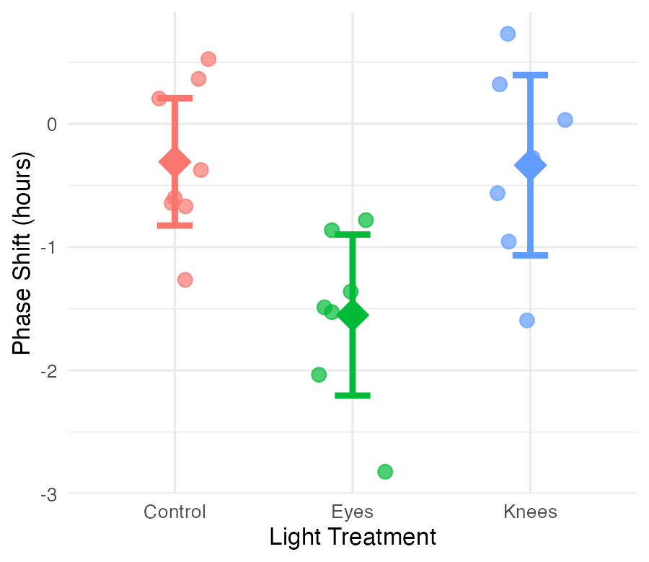

Part 6 · Variance Explained — R²

Variance Explained: R²
R² summarizes the contribution of group differences to total variation:
$$R^{2}=\frac{SS_{among}}{SS_{total}}$$
This is interpreted as the “fraction of the variation in Y that is explained by groups.” For the circadian rhythm data:
$$R^{2}=\frac{7.224}{16.639}=0.43$$
43% of the total variation in phase shift is explained by differences in light treatment, with the remaining 57% unexplained.
Connection to regression: this is exactly the same calculation as R² in regression, $R^{2}=SS_{regression}/SS_{total}$.
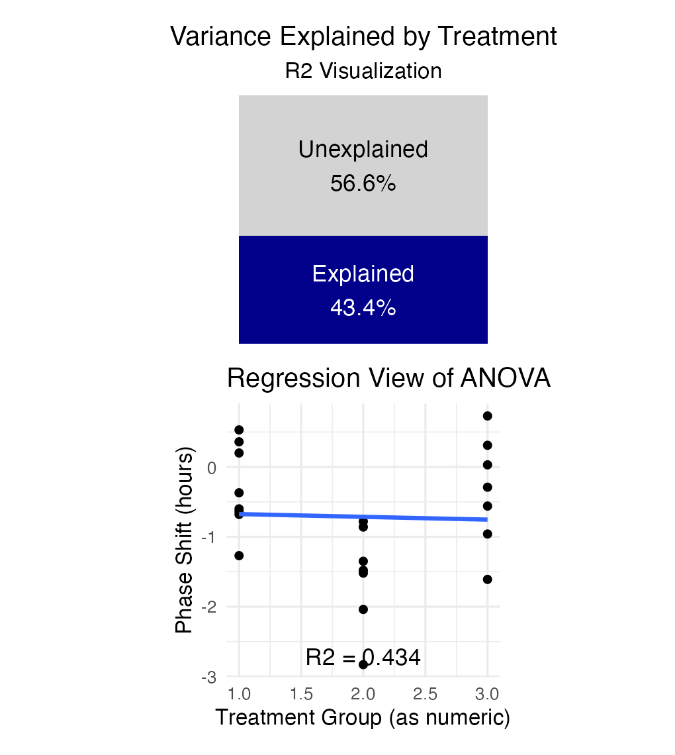

Part 7 · Assumptions and Diagnostics

ANOVA Assumptions
ANOVA has the same assumptions as the two-sample t-test, but applied to all k groups:
- Random samples from corresponding populations
- Normality — Y values are normally distributed in each population
- Homogeneity of variance — variance is the same in all populations
- Independence — observations are independent
Checking assumptions:
- Normality: QQ plots, histogram of residuals, Shapiro-Wilk test
- Homogeneity: plot residuals vs. predicted values or x-values
- Independence: examine the experimental design
If assumptions are violated: transform Y (e.g., log, square root), use robust or non-parametric alternatives, or use generalized linear models (GLMs).

The Four Standard Diagnostic Plots
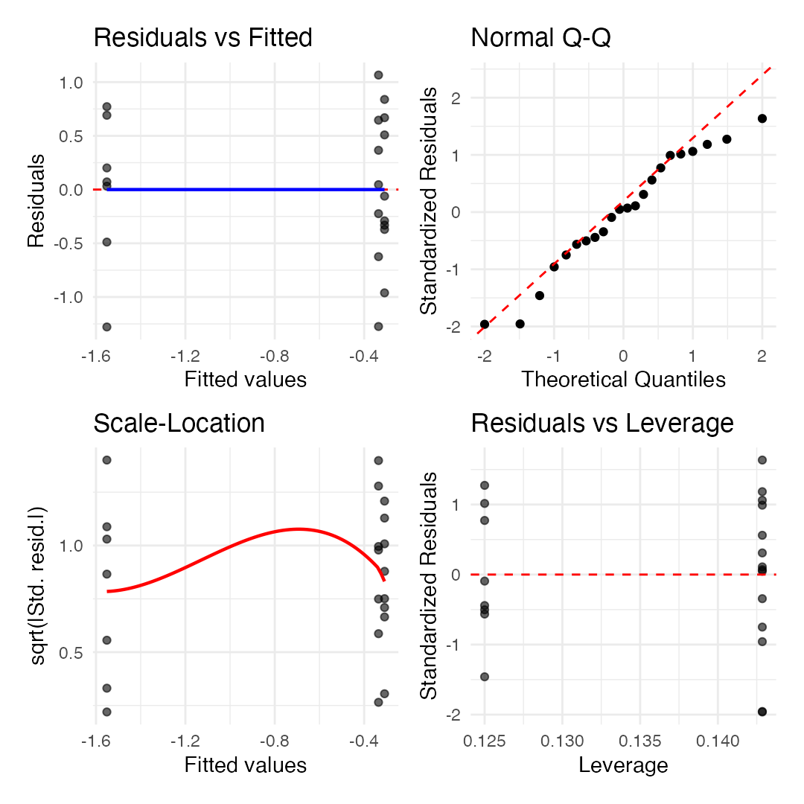
Tip
🖐 Notice
These are the same four diagnostic views R gives you automatically from plot(model) — here built by hand with ggplot2 + broom::fortify() so we can style them consistently.

A Newer Way to Check — the performance Package
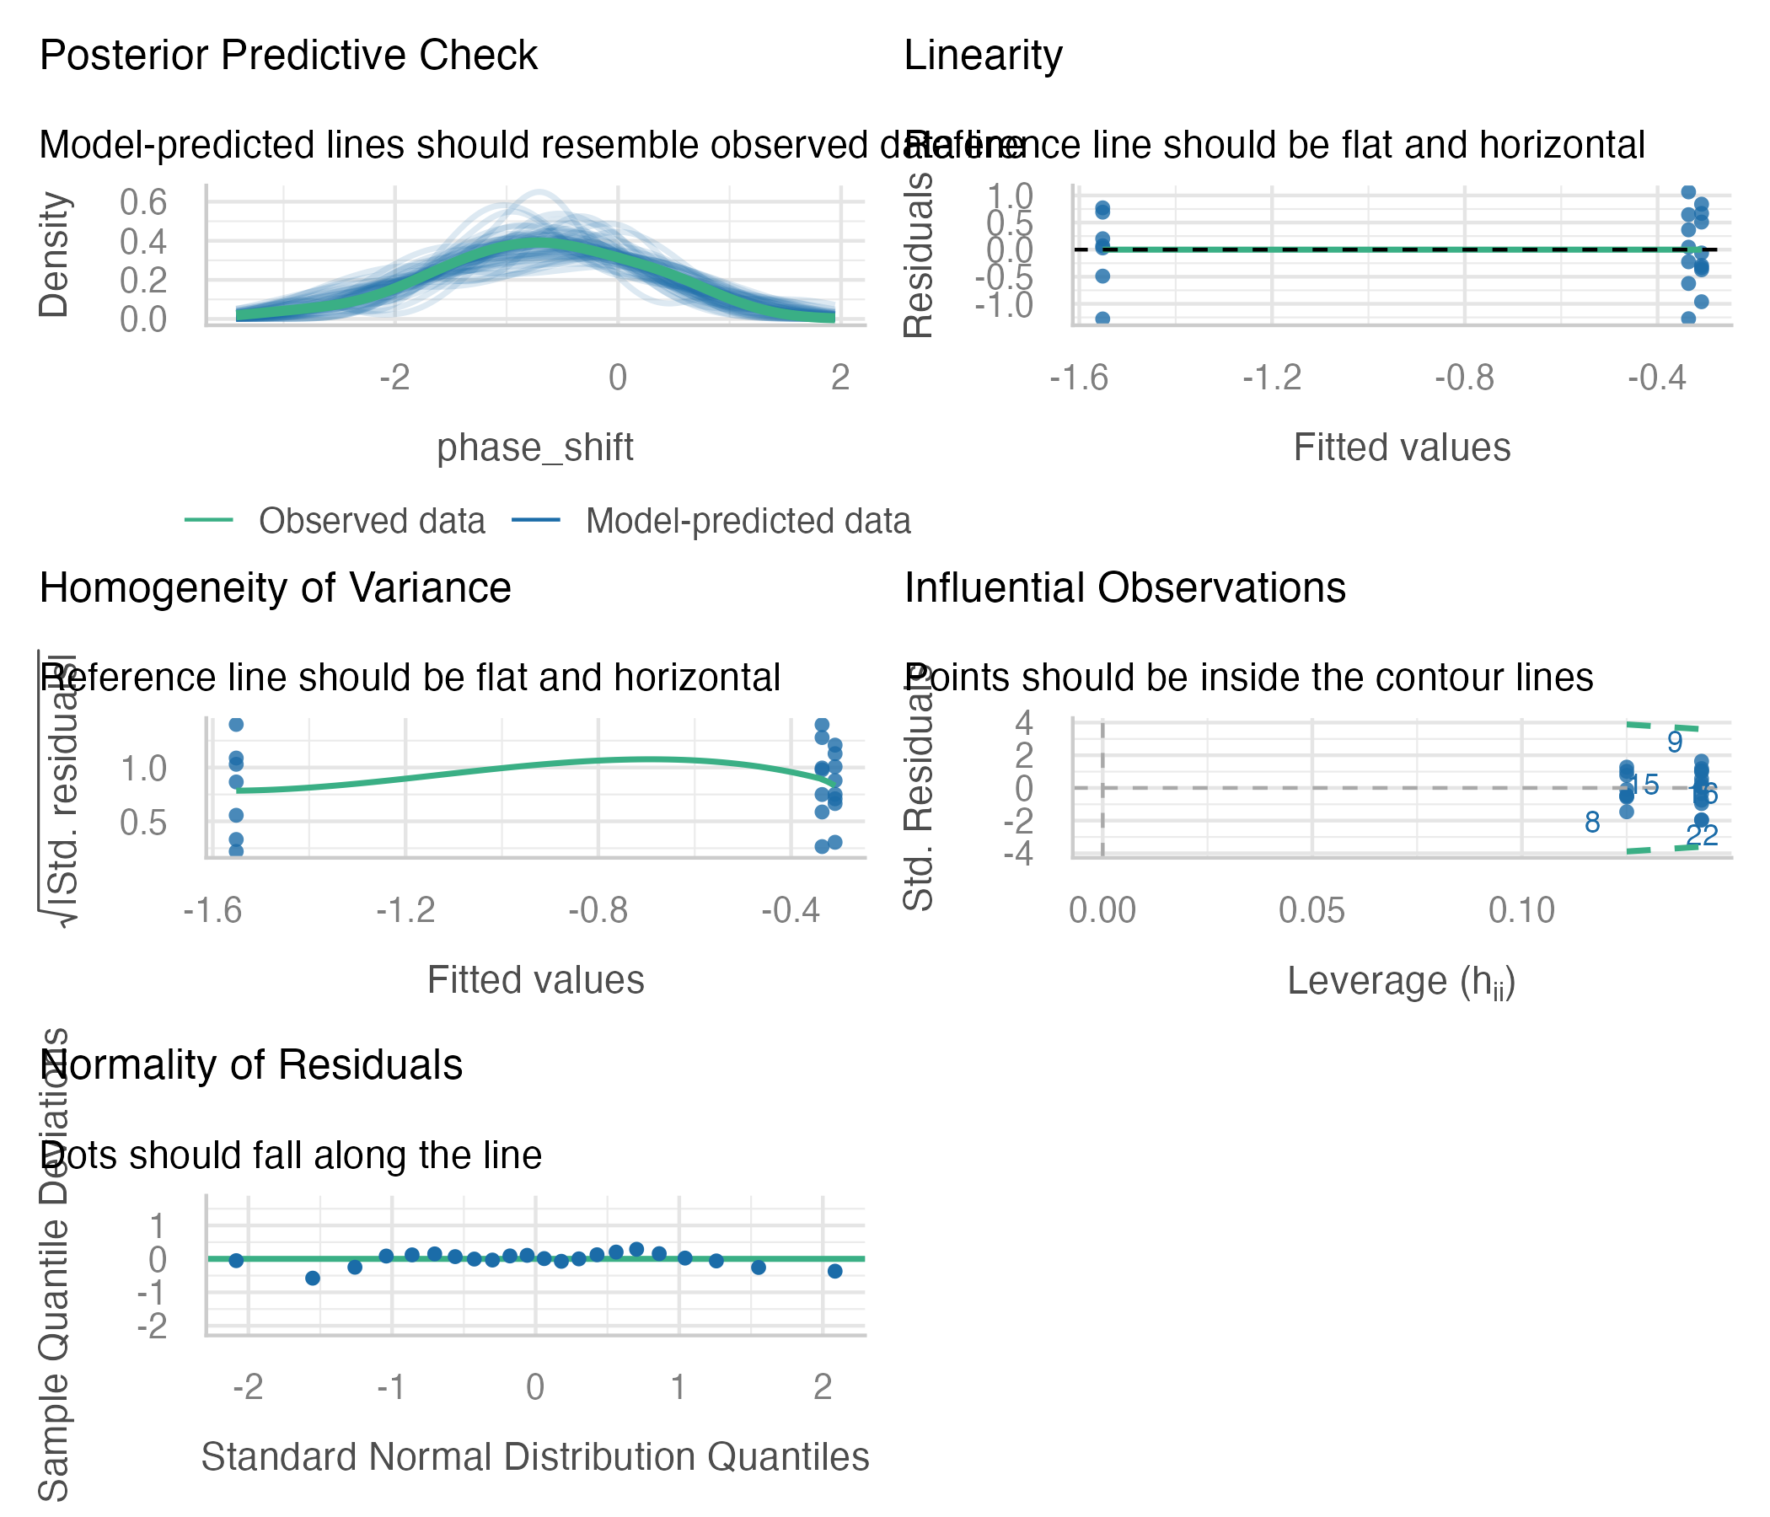
Multi-panel model diagnostic figure generated by performance::check_model(), including residual, normality, homogeneity of variance, and collinearity panels with built-in reference bands.
Note
✅ Key idea
check_model() from the performance package builds all the standard diagnostic panels — plus a few extra (e.g., collinearity) — in one call, with built-in guidance on what “good” looks like for each panel.

Levene’s Test
Levene’s test of homogeneity of variance.
- Null hypothesis: variances are homogeneous
- So you want a non-significant result here
Levene's Test for Homogeneity of Variance (center = median)
Df F value Pr(>F)
group 2 0.1586 0.8545
19

Shapiro-Wilk Test
Shapiro-Wilk normality test.
- Null hypothesis: the data are normally distributed
- So you want a non-significant result here
Shapiro-Wilk normality test
data: residuals(circ_model)
W = 0.95893, p-value = 0.468

Shared Assumptions with Regression
Note
ANOVA and regression share virtually identical assumptions, because they are both linear models:
Assumption | ANOVA | Regression
Linearity | Each group has its own mean; effects are additive (no interaction in one-way ANOVA) | Relationship between X and Y is linear
Normality | Residuals are normal | Residuals are normal
Equal variance | Variance is the same across all groups | Variance is the same across all X values
Independence | Observations are independent | Observations are independent

Part 8 · Post-Hoc Testing

ANOVA Post-Hoc Testing — Overview
When ANOVA rejects H₀, we need to determine which groups differ.
- Unplanned (post hoc) comparisons: used when no specific comparisons were planned; must adjust for multiple testing. Common methods: Tukey-Kramer, Bonferroni, Scheffé, Sidak
- Planned comparisons: have strong prior justification, use pooled variance from all groups, have higher precision than separate t-tests
- Example: Tukey’s HSD to compare all pairs of treatments in the circadian rhythm data
contrast estimate SE df t.ratio p.value
Control - Eyes 1.243 0.364 19 3.411 0.0079
Control - Knees 0.027 0.364 19 0.074 0.9970
Eyes - Knees -1.216 0.376 19 -3.231 0.0117
P value adjustment: tukey method for comparing a family of 3 estimates
treatment emmean SE df lower.CL upper.CL .group
Eyes -1.551 0.266 19 -2.25 -0.855 a
Knees -0.336 0.266 19 -1.03 0.361 b
Control -0.309 0.249 19 -0.96 0.343 b
Confidence level used: 0.95
Conf-level adjustment: sidak method for 3 estimates
P value adjustment: tukey method for comparing a family of 3 estimates
significance level used: alpha = 0.05
NOTE: If two or more means share the same grouping symbol,
then we cannot show them to be different.
But we also did not show them to be the same.

Post-Hoc Testing — Planned Comparisons
When ANOVA rejects H₀, we need to determine which groups differ.
- Unplanned (post hoc) comparisons: used when no specific comparisons were planned; must adjust for multiple testing. Common methods: Tukey-Kramer, Bonferroni, Scheffé
- Planned comparisons: have strong prior justification, use pooled variance from all groups, have higher precision than separate t-tests
- Example: using Tukey’s HSD to compare all pairs of treatments
[1] "Control" "Eyes" "Knees"
contrast estimate SE df t.ratio p.value
control vs eyes 1.243 0.364 19 3.411 0.0029
control vs knees 0.027 0.364 19 0.074 0.9418

Comparison of Post-Hoc Tests
The main post-hoc tests:
- Tukey-Kramer (HSD): compares all possible pairs of group means, controls family-wise error rate, most powerful when comparing ALL pairwise combinations
- Bonferroni: adjusts α by dividing by the number of comparisons (α/k); very conservative; best for a small number of planned comparisons
- Sidak: similar to Bonferroni but slightly less conservative: 1−(1−α)^(1/k); gives slightly more power
- Dunnett’s Test: specifically for comparing treatment groups to a control; more powerful than the others for that specific job
The key tradeoff is between power (detecting real differences) and Type I error control (avoiding false positives). More conservative tests give better error control but less power.
tukey_result <- emmeans(circ_model, "treatment") |>
pairs(adjust = "tukey")
bonferroni_result <- emmeans(circ_model, "treatment") |>
pairs(adjust = "bonferroni")
sidak_result <- emmeans(circ_model, "treatment") |>
pairs(adjust = "sidak")
dunnett_result <- emmeans(circ_model, "treatment") |>
contrast(method = "trt.vs.ctrl", ref = 1, adjust = "dunnett")
all_methods <- bind_rows(
summary(tukey_result) |>
as_tibble() |>
select(contrast, estimate, SE, p.value) |>
mutate(Method = "Tukey"),
summary(bonferroni_result) |>
as_tibble() |>
select(contrast, estimate, SE, p.value) |>
mutate(Method = "Bonferroni"),
summary(sidak_result) |>
as_tibble() |>
select(contrast, estimate, SE, p.value) |>
mutate(Method = "Sidak")
)
all_methods |>
select(contrast, Method, p.value) |>
pivot_wider(names_from = Method, values_from = p.value) |>
arrange(Tukey)
# A tibble: 3 × 4
contrast Tukey Bonferroni Sidak
<chr> <dbl> <dbl> <dbl>
1 Control - Eyes 0.00787 0.00879 0.00877
2 Eyes - Knees 0.0117 0.0132 0.0131
3 Control - Knees 0.997 1 1.000

Post-Hoc Visualization
When ANOVA rejects H₀, we need to determine which groups differ.
- Unplanned comparisons: used when no specific comparisons were planned; must adjust for multiple testing. Common methods: Tukey-Kramer, Bonferroni, Scheffé
- Planned comparisons: have strong prior justification, use pooled variance, higher precision than separate t-tests
- Example: Tukey’s HSD to compare all pairs of treatments
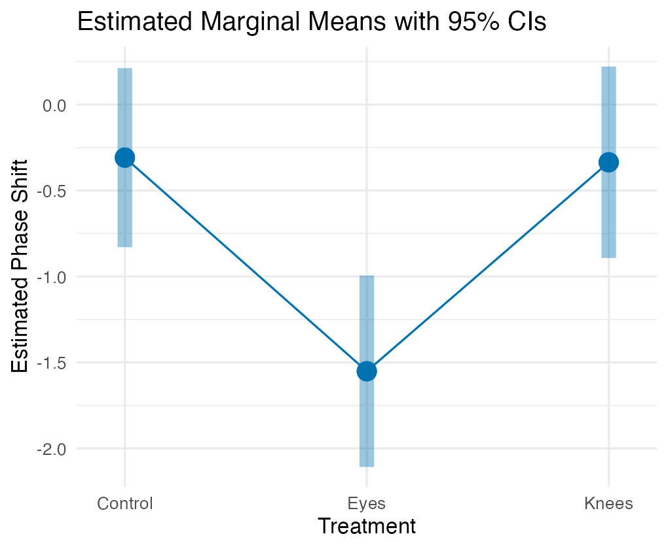

Significance Groups Plot
When ANOVA rejects H₀, we need to determine which groups differ.
- Unplanned comparisons: used when no specific comparisons were planned; must adjust for multiple testing. Common methods: Tukey-Kramer, Bonferroni, Scheffé
- Planned comparisons: have strong prior justification, use pooled variance, higher precision than separate t-tests
- Example: Tukey’s HSD to compare all pairs of treatments
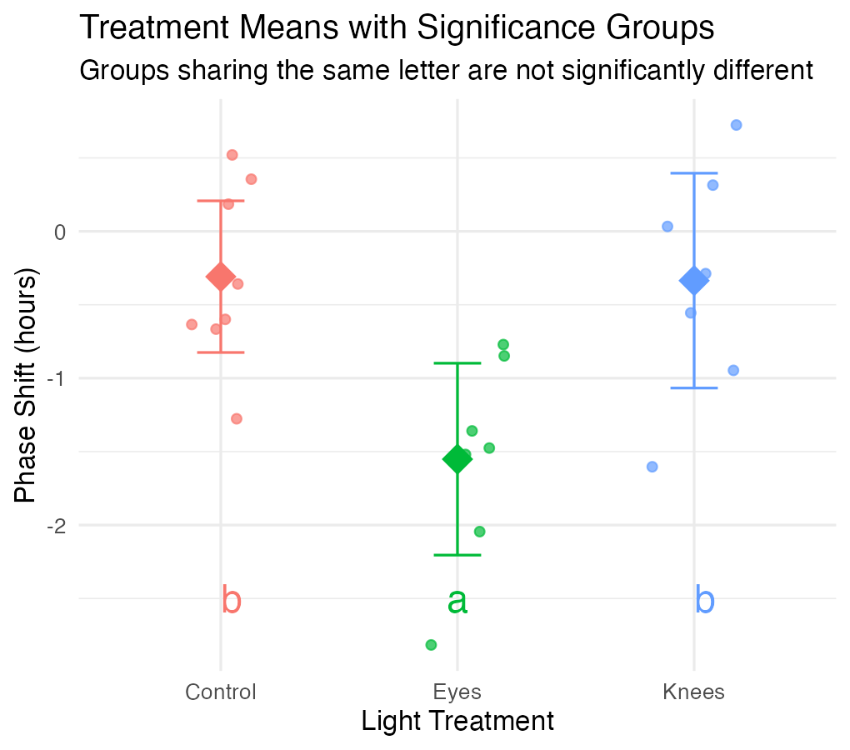

Part 9 · Reporting Results

Reporting ANOVA Results
Formal scientific writing example:
“The effect of light treatment on circadian rhythm phase shift was analyzed using a one-way ANOVA. There was a significant effect of treatment on phase shift (F(2, 19) = 7.29, p = 0.004, η² = 0.43). Post-hoc comparisons using Tukey’s HSD test indicated that the mean phase shift for the Eyes treatment (M = −1.55 h, SD = 0.71) was significantly different from both the Control treatment (M = −0.31 h, SD = 0.62) and the Knees treatment (M = −0.34 h, SD = 0.79). However, the Control and Knees treatments did not significantly differ from each other. These results suggest that light exposure to the eyes, but not to the knees, impacts circadian rhythm phase shifts.”
Note
Key ANOVA principles
- Compares means across multiple groups simultaneously
- Both ANOVA and regression are special cases of the General Linear Model — ANOVA with categorical predictors = regression with dummy variables
- Both partition variance into explained and unexplained components: $SS_{Total}=SS_{Between}+SS_{Within}$
- Fixed effects target specific groups of interest (most common); random effects sample from a larger population

Part 10 · Non-Parametric Alternatives

Overview of Non-Parametric Tests
Common non-parametric alternatives to ANOVA — these make fewer assumptions about the data distribution.
- Kruskal-Wallis test — non-parametric alternative to one-way ANOVA; tests for differences in median ranks; works with ordinal or continuous data. Assumptions: independent observations, similar distribution shapes
- Mood’s median test (not covered here) — tests whether medians differ across groups; more robust but less powerful than Kruskal-Wallis; good for highly skewed data
When to use non-parametric tests:
- Small sample sizes
- Heavily skewed data
- Legitimate outliers present
- Very unequal variances
- Ordinal (ranked) data
- Assumption checks clearly fail
Trade-offs: fewer assumptions and more robust to outliers, but less statistical power and testing medians/ranks rather than means.

The Kruskal-Wallis H Test
The most common non-parametric alternative to one-way ANOVA.
What it does: ranks all observations from smallest to largest, compares the sum of ranks between groups, tests if groups come from the same distribution.
Hypotheses: H₀ — all groups have the same distribution (same median); H₁ — at least one group differs.
Test statistic:
$$H=\frac{12}{N(N+1)}\sum_{i=1}^{k}{n_{i}}({\overset{‾}{R}}_{i}−\overset{‾}{R})^{2}−3(N+1)$$
Where N = total sample size, k = number of groups, ${\overset{‾}{R}}_{i}$ = mean rank for group i, $\overset{‾}{R}$ = overall mean rank = (N+1)/2, nᵢ = sample size for group i. Distribution approximated by χ² with (k−1) df.
Assumptions of Kruskal-Wallis — much more relaxed than parametric ANOVA:
- Independence — same as parametric ANOVA, still critical
- Similar distribution shapes — groups should have similar spread/variance; if violated, interpret as differences in distributions generally, not just medians
- Ordinal or continuous data
What’s NOT assumed: normal distribution, equal variances (though it helps interpretation), a specific distribution shape.

Demonstrating Assumption Violations
Creating a modified dataset with clear violations:
set.seed(42)
violated_circ_df <- circ_data %>%
mutate(
phase_shift_violated = case_when(
treatment == "Control" ~ phase_shift,
treatment == "Knees" ~ phase_shift * 3.25,
treatment == "Eyes" ~ {
n <- length(phase_shift)
c(phase_shift[1:(n-2)], phase_shift[(n-1):n] - 7)
}
)
)
violated_model <- lm(phase_shift_violated ~ treatment,
data = violated_circ_df)
What we changed: increased variance in the Knees group, added extreme outliers to the Eyes group, creating unequal variances and non-normality.
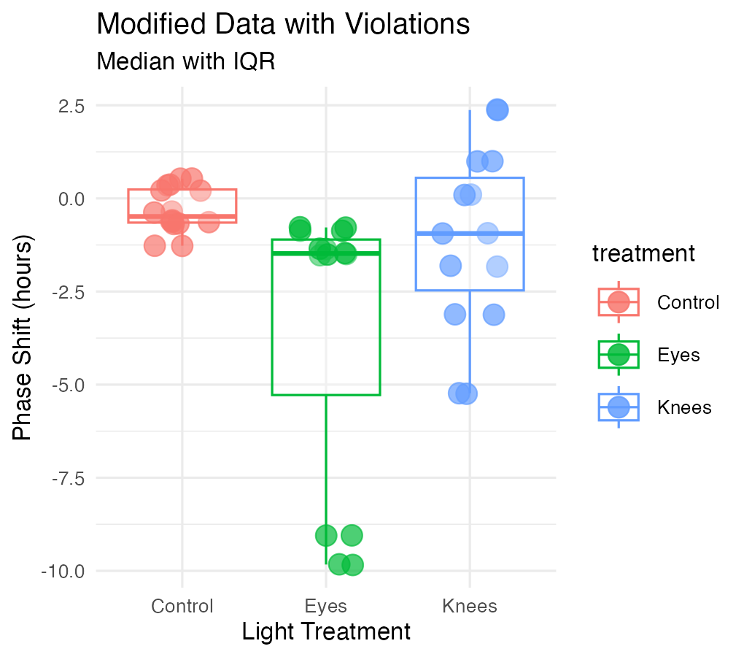

Checking Violated-Data Assumptions — Normality
Clear violation: p < 0.05, points deviate from the line.
Shapiro-Wilk normality test
data: resid(violated_model)
W = 0.89473, p-value = 0.02335
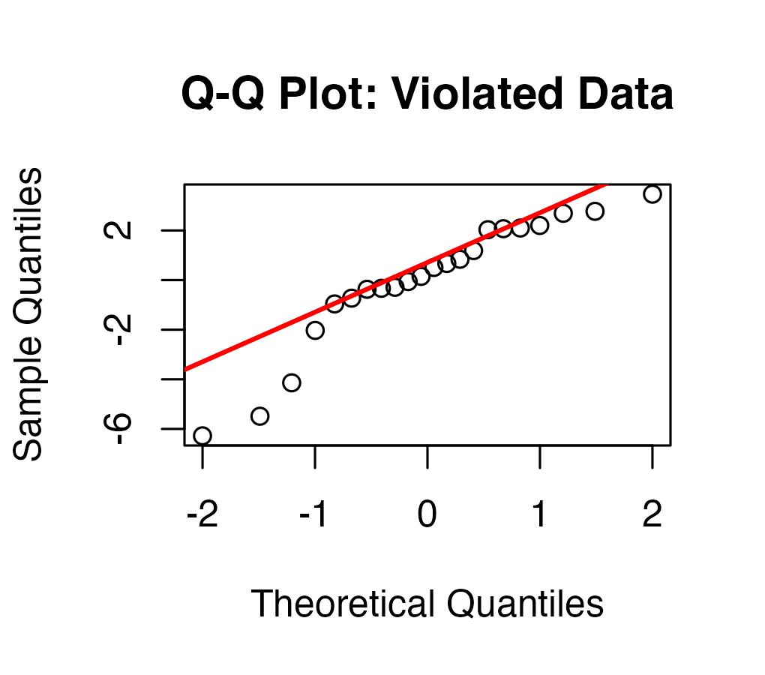

Checking Violated-Data Assumptions — Variance
Clear violation: p < 0.05, unequal variances evident.
Levene's Test for Homogeneity of Variance (center = median)
Df F value Pr(>F)
group 2 1.5618 0.2355
19
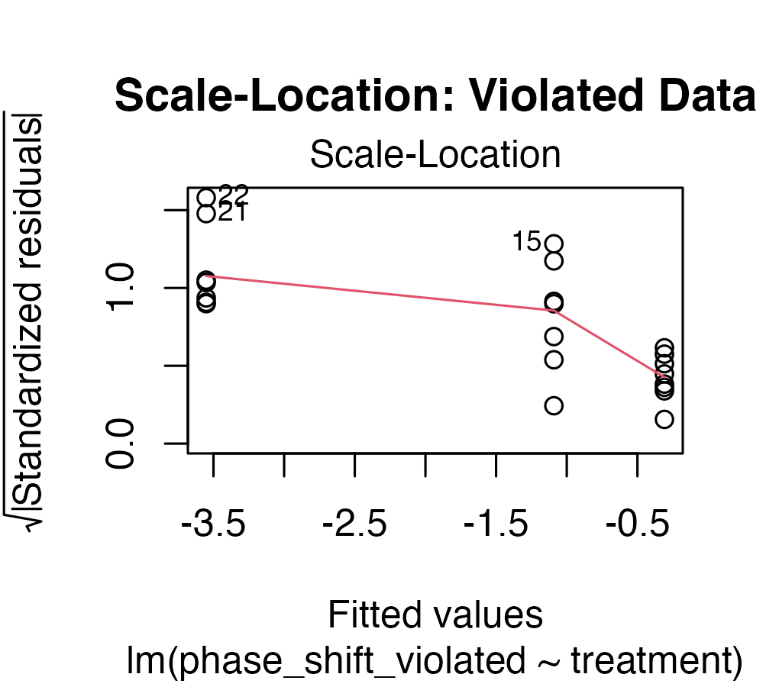

Performing the Kruskal-Wallis Test — Original Data
Even though assumptions are met, let’s compare results:
kruskal_original_result <- kruskal.test(
phase_shift ~ treatment,
data = circ_data)
kruskal_original_result
Kruskal-Wallis rank sum test
data: phase_shift by treatment
Kruskal-Wallis chi-squared = 9.4231, df = 2, p-value = 0.008991
Interpretation: H = test statistic (χ² approximation); df = k − 1 = 2; p = 0.009 (significant at α = 0.05); conclusion: at least one group differs.
Compare to parametric ANOVA:
Analysis of Variance Table
Response: phase_shift
Df Sum Sq Mean Sq F value Pr(>F)
treatment 2 7.2245 3.6122 7.2894 0.004472 **
Residuals 19 9.4153 0.4955
---
Signif. codes: 0 '***' 0.001 '**' 0.01 '*' 0.05 '.' 0.1 ' ' 1
How Kruskal-Wallis works:
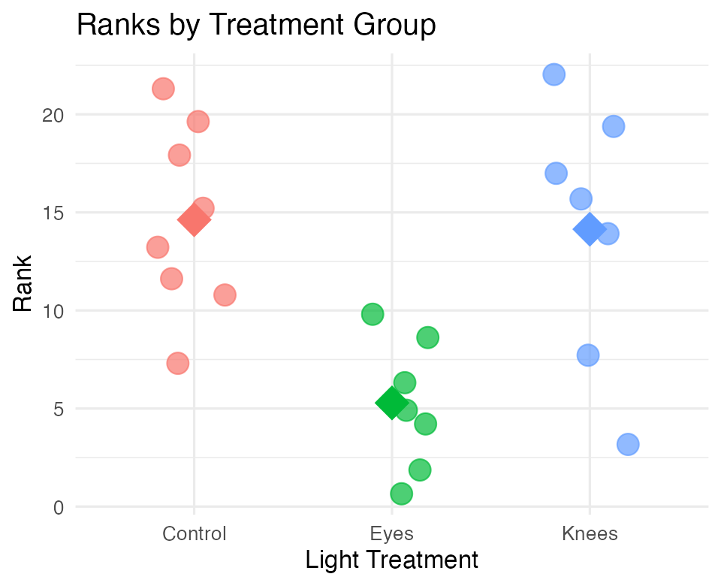
# A tibble: 3 × 4
treatment mean_rank sum_rank n
<fct> <dbl> <dbl> <int>
1 Control 14.6 117 8
2 Eyes 5.29 37 7
3 Knees 14.1 99 7

Kruskal-Wallis on Violated Data
Non-parametric test handles violations:
kruskal_violated_result <- kruskal.test(
phase_shift_violated ~ treatment,
data = violated_circ_df)
kruskal_violated_result
Kruskal-Wallis rank sum test
data: phase_shift_violated by treatment
Kruskal-Wallis chi-squared = 6.8453, df = 2, p-value = 0.03263
Analysis of Variance Table
Response: phase_shift_violated
Df Sum Sq Mean Sq F value Pr(>F)
treatment 2 41.806 20.9029 2.8361 0.0836 .
Residuals 19 140.037 7.3704
---
Signif. codes: 0 '***' 0.001 '**' 0.01 '*' 0.05 '.' 0.1 ' ' 1
This is the whole argument, in four numbers:
Data | ANOVA (parametric) | Kruskal-Wallis
Original | F = 7.29, p = 0.004 ✅ | H = 9.42, p = 0.009 ✅
Violated | F = 2.84, p = 0.084 ❌ | H = 6.85, p = 0.033 ✅

Important
The parametric test lost the effect. The rank test kept it.
Nothing about the biology changed — we only inflated one group’s variance and pushed two points out into the tail. That was enough to drag the F-test’s p-value from 0.004 to 0.084, across the α = 0.05 line.
Kruskal-Wallis barely noticed, because ranks don’t care how far out an outlier is, only that it is out there.

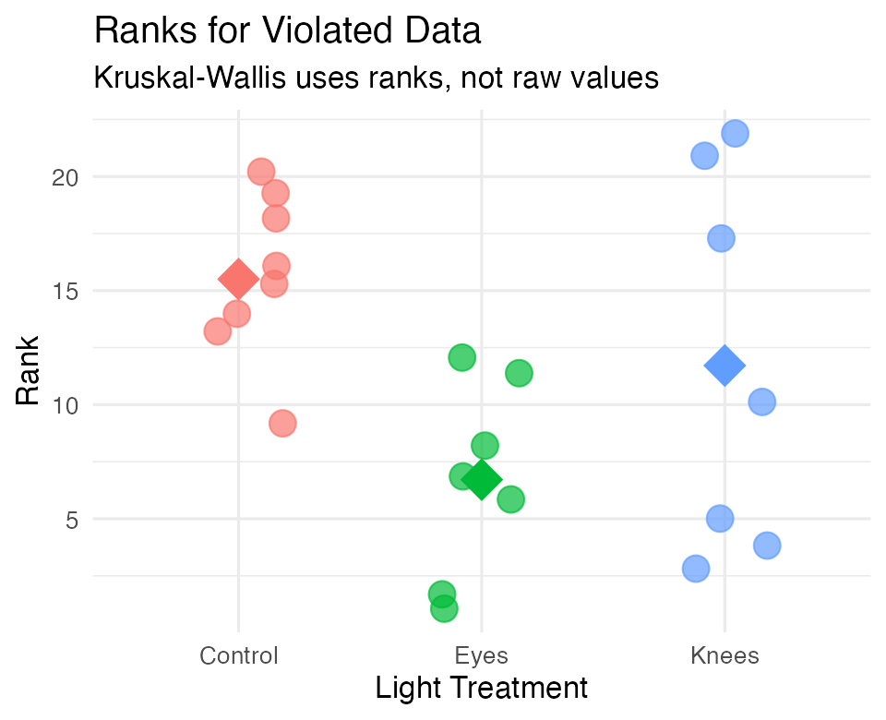
Why Kruskal-Wallis is robust: uses ranks instead of raw values, outliers affect ranks minimally, unequal variances are less problematic, no distribution assumptions are needed.

Post-Hoc Tests for Kruskal-Wallis — Pairwise Wilcoxon
Just like ANOVA, we need post-hoc tests to identify which groups differ:
Pairwise comparisons using Wilcoxon rank sum exact test
data: nonparam_circ_df$phase_shift and nonparam_circ_df$treatment
Control Eyes
Eyes 0.0037 -
Knees 1.0000 0.0787
P value adjustment method: bonferroni
Interpretation of p-values: Control vs Eyes: p = 0.004 (significant); Control vs Knees: p = 1.000 (not significant); Eyes vs Knees: p = 0.079 (not significant).
Common adjustment methods: "bonferroni" (most conservative), "holm" (less conservative), "BH" (Benjamini-Hochberg, controls false discovery rate), "none" (not recommended).
pairwise_violated_result <- pairwise.wilcox.test(
x = violated_circ_df$phase_shift_violated,
g = violated_circ_df$treatment,
p.adjust.method = "bonferroni"
)
pairwise_violated_result
Pairwise comparisons using Wilcoxon rank sum exact test
data: violated_circ_df$phase_shift_violated and violated_circ_df$treatment
Control Eyes
Eyes 0.0037 -
Knees 1.0000 1.0000
P value adjustment method: bonferroni
# A tibble: 3 × 3
comparison original_data violated_data
<chr> <dbl> <dbl>
1 Control vs Eyes 0.0037 0.0037
2 Control vs Knees 1 1
3 Eyes vs Knees 0.0787 1

Dunn’s Test — an Alternative Post-Hoc
Dunn’s test is specifically designed for Kruskal-Wallis post-hoc comparisons:
dunn_original_result <- dunnTest(
phase_shift ~ treatment,
data = circ_data,
method = "bonferroni")
dunn_original_result
Comparison Z P.unadj P.adj
1 Control - Eyes 2.7789287 0.005453849 0.01636155
2 Control - Knees 0.1434629 0.885924641 1.00000000
3 Eyes - Knees -2.5517789 0.010717452 0.03215236
Advantages: designed specifically for Kruskal-Wallis, provides Z-statistics in addition to p-values, multiple adjustment methods available, more appropriate than multiple Wilcoxon tests. A Z-statistic tells you how many standard deviations a difference is from the expected value (usually zero, “no difference”).
dunn_violated_result <- dunnTest(
phase_shift_violated ~ treatment,
data = violated_circ_df,
method = "bonferroni"
)
dunn_violated_result
Comparison Z P.unadj P.adj
1 Control - Eyes 2.614212 0.008943349 0.02683005
2 Control - Knees 1.126449 0.259975463 0.77992639
3 Eyes - Knees -1.440520 0.149720243 0.44916073
Interpreting Z-statistics: large |Z| values indicate bigger differences; Z > 1.96 is approximately equivalent to p < 0.05; the sign indicates the direction of the difference.

Which Post-Hoc Test Should You Use?
- Use Dunn’s test because it’s the proper follow-up to Kruskal-Wallis, maintains consistency with the overall K-W ranking, is more statistically appropriate for the omnibus test you ran, and is standard in published research
- Wilcoxon is fine for simple two-group comparisons, but once you’ve run Kruskal-Wallis (a 3+ group test), Dunn’s is the standard choice
Tip
🖐 Notice
Kruskal-Wallis ranks ALL your data once. Dunn’s test uses those same ranks. Pairwise Wilcoxon throws away that information and re-ranks separately for each pair.

Reporting Non-Parametric Results
Essential elements to include: test name and purpose, sample sizes per group, medians and IQRs (not means and SDs!), test statistic (H) and degrees of freedom, p-value, effect size, post-hoc test results, conclusion.
Example write-up: “A Kruskal-Wallis test was conducted to compare the effect of light treatment on circadian rhythm phase shift across three groups: Control (n = 8), Knees (n = 7), and Eyes (n = 7). Median phase shifts were −0.48 hours (IQR = 0.89) for Control, −0.29 hours (IQR = 0.93) for Knees, and −1.48 hours (IQR = 0.68) for Eyes. The test revealed a statistically significant difference in phase shift between the groups, H(2) = 9.42, p = 0.009, ε² = 0.45. Post-hoc pairwise comparisons using Dunn’s test with Bonferroni correction indicated that the Eyes treatment differed significantly from both Control (p = 0.016) and Knees (p = 0.032), while Control and Knees did not differ (p = 1.000).”
Note
📖 Where ε² comes from
$$ε^{2}=\frac{H}{(n^{2}−1)/(n+1)}$$
Here $9.42/21=0.45$ — the rank-based analogue of R². Watch out: some software reports $η_{H}^{2}=(H−k+1)/(n−k)$ instead, which gives 0.39 for these data. Say which one you used.

In-text citation format:
The Kruskal-Wallis test revealed significant differences between treatment groups, H(2) = 9.42, p = .009.
 Warning
⚠️ Common mistakes to avoid
- Reporting means instead of medians, using SD instead of IQR
- Not mentioning it’s a non-parametric test
- Not justifying why a non-parametric test was used

Reporting — the Table Format
Table 1. Descriptive Statistics for Phase Shift by Treatment
Note. IQR = interquartile range.
Kruskal-Wallis H(2) = 9.42, p = 0.009
# A tibble: 3 × 6
treatment n Median IQR Min Max
<fct> <int> <dbl> <dbl> <dbl> <dbl>
1 Control 8 -0.485 0.89 -1.27 0.53
2 Eyes 7 -1.48 0.675 -2.83 -0.78
3 Knees 7 -0.29 0.93 -1.61 0.73

Wrap-up
Today you:
- Saw that ANOVA is regression with a categorical predictor — same partitioning, same F-ratio, different-looking output
- Split $SS_{total}$ into $SS_{among}$ and $SS_{within}$, and turned them into mean squares
- Built the F-ratio as signal ÷ noise, and confirmed that with two groups F = t² exactly
- Checked the assumptions — Levene’s for equal variance, Shapiro-Wilk on the residuals, and the four diagnostic plots
- Used Tukey’s HSD to find which groups differ, after the omnibus test said some group does
- Reported the result the way a journal expects, with an effect size
- Switched to Kruskal-Wallis and Dunn’s test when assumptions fail
Important
⚠️ The order matters
A significant F says at least one group differs — it does not say which. Post-hoc tests answer that, and they only make sense after a significant omnibus test. Running all pairwise t-tests instead inflates your Type I error with every comparison.

Note
✅ The one idea to keep
We deliberately broke the assumptions and watched the parametric p-value slide from 0.004 to 0.084 while the rank-based one held at 0.033.
The data’s biology never changed. Only its shape did. That is what “assumption violation” costs you, in one number.

Note
Up next — Two-Way ANOVA
- Two categorical predictors at once
- Interaction: when the effect of one factor depends on the other

Getting unstuck
When code breaks — and it will, that is normal:
- Read the error message out loud; it usually names the line
- Check the usual suspects: is your grouping variable a factor (as.factor())? Did you pass the model to TukeyHSD() via aov(), not lm()? Is car loaded for leveneTest(), FSA for dunnTest()?
- ?function_name opens the help page
- Bring the exact error (copy-paste it) to class or office hours
Note
✅ Key idea
Every working scientist googles error messages daily. Getting stuck is not failing — it is the job.

