Lecture: ANCOVA — Analysis of Covariance
  - Covariates
Bill Perry

Part 1 · From GLMs to ANCOVA

Review
Review
- General Linear Models (GLM)
- Gaussian GLMs (normal distribution)
- Poisson GLMs (count data)
- Logistic GLMs (binary outcomes)
- Model assumptions and diagnostics
- Connection to ANOVA and linear models
# Placeholder for review image

ANCOVA Overview
Overview
- Analysis of covariance (ANCOVA):
  - Introduction to ANCOVA
  - The ANCOVA workflow in R
  - When to use ANCOVA
  - Building the ANCOVA model in R
  - Assumptions of ANCOVA
    - Homogeneity of slopes (The critical test!)
  - Interpreting results & “Adjusted Means”
  - Handling violations (heterogeneous slopes)

Introduction to ANCOVA
What is ANCOVA?
- ANCOVA = Analysis of COVAriance
  - It’s a combination of regression and ANOVA
  - It’s used when you have:
    - A continuous response variable (Y)
    - A categorical predictor (Factor A)
    - A continuous predictor (Covariate X)
  - Common use:
    - Compare means of factor levels (groups), after statistically adjusting for the effect of the continuous covariate.
  - Another use:
    - Determine whether two or more regression lines differ in slopes and/or intercepts.
 Note
Gotelli & Ellison, A Primer of Ecological Statistics, Ch. 9 (Regression) and Ch. 10 (The Analysis of Variance) — ANCOVA combines the two frameworks.

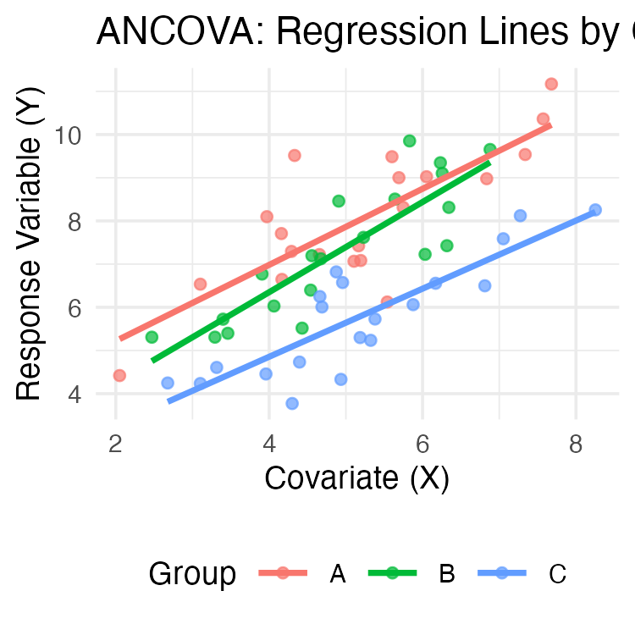

When to Use ANCOVA
- Common Applications of ANCOVA
  - Increasing statistical power
    - The covariate (e.g., body size, initial temperature) explains some of the “noise” (residual error) in the response variable.
    - By “removing” this variation, we reduce the residual error, making it easier to detect the true effect of our categorical factor.
    - This results in a more powerful test of treatment effects.
  - Adjusting for confounding variables
    - Imagine your treatment groups happen to differ in their average covariate value (e.g., Group A was tested in a warmer room than Group B).
    - ANCOVA allows you to separate the treatment effect from the covariate effect.
  - Testing equality of regression lines
    - Do treatments have the same relationship (slope) with a continuous variable?

ANCOVA Example: Cricket Chirping
Cricket Chirping Example
- Want to compare chirping rate of two cricket species:
  - Oecanthus exclamationis
  - Oecanthus niveus
- But…
  - Measured rates at different temperatures.
  - Range of temperatures differed between species.
  - There is an apparent relationship between pulse rate and temperature.
- Problem: Are the species different, or are they just at different temperatures?
- Solution: ANCOVA lets us adjust for the temperature effect to get a clearer, more powerful test of the species effect. .
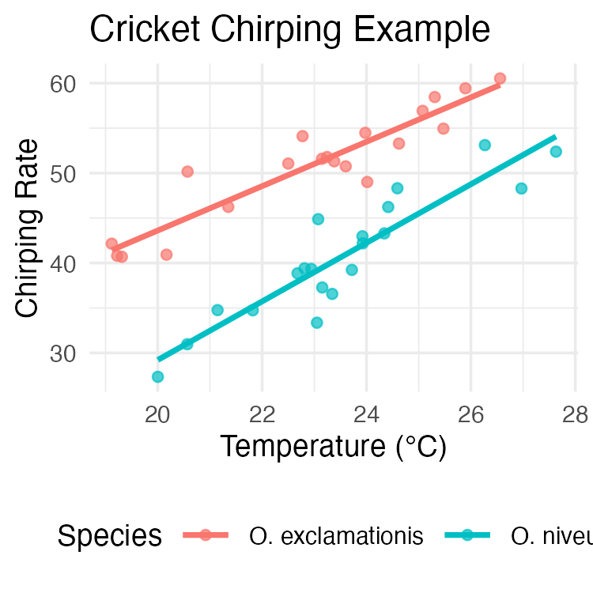

Part 2 · The ANCOVA Model

ANCOVA Linear Model: Conceptual Framework
- The ANCOVA Model
  - Key concept: Dfference between “unadjusted” group means and “adjusted” means
- In this visualization:
  - Group Means (asterisks): The raw average X and Y for each group.
  - Group A and Group B have different mean X values. Comparing directly misleading
  - Adjusted Means (triangles): ANCOVA statistically “moves” each group mean along regression line to single, common X value (the overall mean X).
  - ANCOVA compares heights (the Y values) of adjusted means.
  - Adjustment “levels the playing field,” estimating each group’s mean if all groups had same average covariate value

ANCOVA Model Visualization
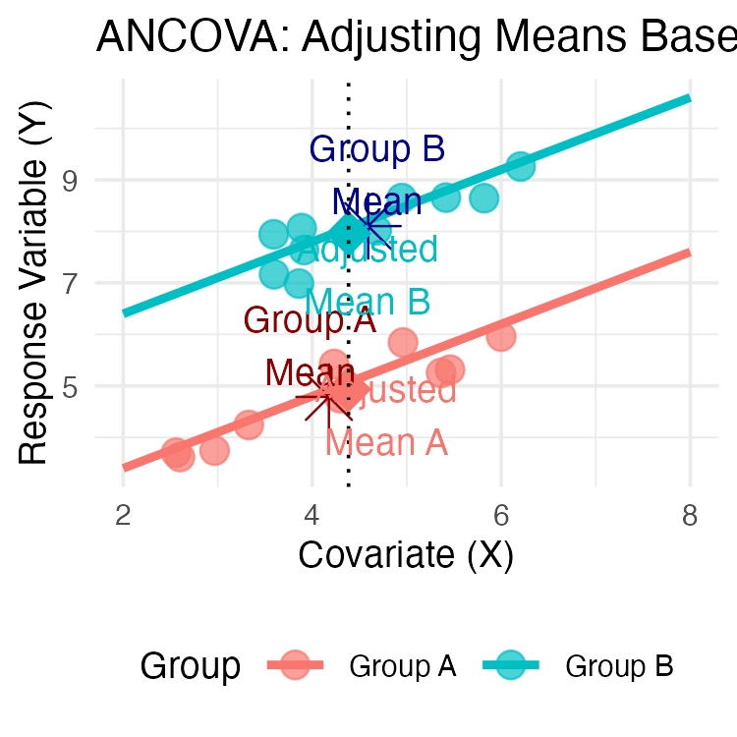

Mathematical Model for ANCOVA
- Single-factor ANCOVA with
  - factor A (p levels, i = 1 to p), a continuous covariate (x), and response variable (y): $Y_{ij}=μ+α_{i}+β(X_{ij}−\overset{‾}{X})+ε_{ij}$
- Where:
  - $Y_{ij}$ = response value for observation j in level i of factor A
  - $μ$ = overall mean
  - $α_{i}$ = effect of level i of factor A (what we test in ANOVA)
  - $β$ = common regression slope relating Y to X (what we test in Regression)
  - $X_{ij}$ = covariate value for observation j in level i of factor A
  - $\overset{‾}{X}$ = mean value of covariate
  - $ε_{ij}$ = error term

ANCOVA Parameters Interpretation
- Interpretation of Parameters
  - $μ$ = overall mean response
  - $α_{i}$ = effect of level i (difference between group’s adjusted mean and overall mean)
  - $β$ = pooled within-group regression coefficient (the slope)
  - $X_{ij}$ = covariate value for observation j in group i
  - $\overset{‾}{X}$ = overall mean of covariate
  - $ε_{ij}$ = unexplained error
- Model assumes homogeneous slopes (i.e., $β$ same for all groups) .
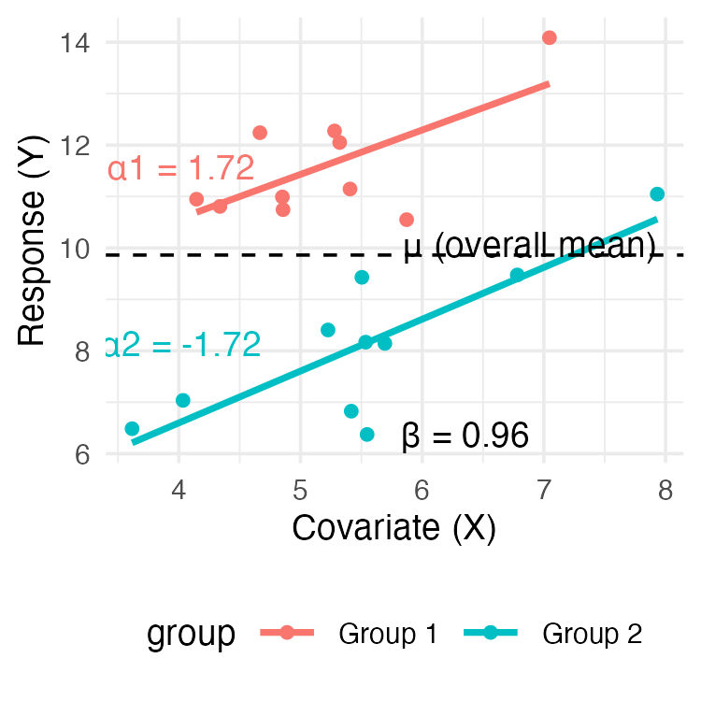

Building the ANCOVA Model in R
- Remember lm(y ~ predictor).
  - ANCOVA combines the predictors from ANOVA and regression.
- Simple Linear Regression:
  - Predict y using a continuous variable x.
    - model_reg <- lm(y ~ x, data = mydata)
- One-Way ANOVA:
  - We want to compare y among groups in a categorical factor A.
    - model_aov <- lm(y ~ A, data = mydata)
- ANCOVA (Additive Model):
  - Compare y among groups in A, after accounting for effect of x.
  - Add terms together
    - model_ancova <- lm(y ~ A + x, data = mydata)
  - Model assumes slope of y ~ x relationship is same for all groups in A.

Building the ANCOVA Model in R — The Two Formulas
- ANCOVA (Interaction Model):
  - What if the slopes are different for each group?
  - Test for interaction between factor and covariate.
    - model_int <- lm(y ~ A * x, data = mydata)
  - Shorthand for: lm(y ~ A + x + A:x, data = mydata)
  - The A:x term tests if the slopes are different.

ANCOVA in R: Workflow Steps 1 and 2
- Step 1: Test for Homogeneity of Slopes - Always Start Here
  - Fit interaction model first - tests key assumption that all groups share same slope.
- # The asterisk * tests for both main effects AND the interaction
model_int <- lm(y ~ A * x, data = mydata)
- Step 2: Examine the Interaction Term
  - ANOVA table for model_int and find the p-value for interaction term (A:x).
- Anova(model_int, type = "III")
  - If p > 0.05 (e.g., p = 0.4) - interaction IS NOT significant - slopes are homogeneous (parallel).
  - If p < 0.05 (e.g., p = 0.02): - interaction IS significant - slopes heterogeneous (NOT parallel).
  - ** standard ANCOVA model (y ~ A + x) inappropriate**
  - Analysis stops here and interpret interaction (often most interesting result!)

ANCOVA in R: Workflow Step 3
- Step 3: Run the ANCOVA (Additive Model)
  - If interaction not significant, run the simpler additive model the final ANCOVA model.
- # We use the + sign, which means "additive"
model_ancova <- lm(y ~ A + x, data = mydata)
# Get the final ANCOVA table
Anova(model_ancova, type = "III")
# Get the adjusted means
library(emmeans)
emmeans(model_ancova, "A")

Part 3 · Partitioning Variance & the ANOVA Table

Analysis of Variance for ANCOVA: Partitioning
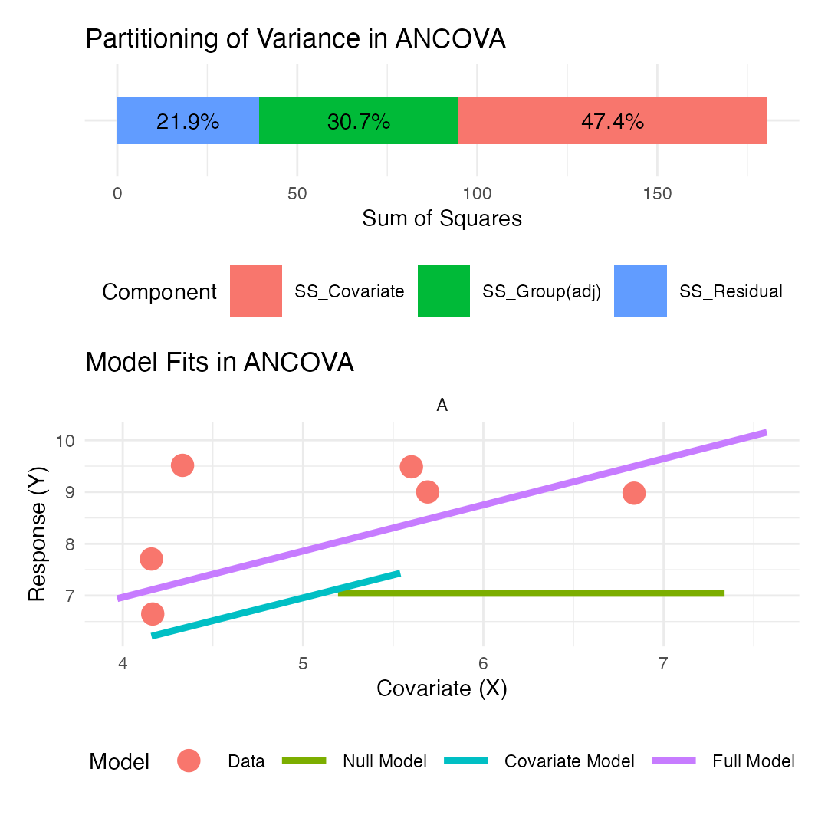

ANOVA Table for ANCOVA
The ANOVA table for a single-factor ANCOVA has these components:
# Create a tibble with ANOVA table information
anova_table <- tibble(
Source = c("Factor A (adjusted)", "Covariate", "Residual", "Total"),
df = c("(p-1)", "1", "n-p-1", "n-1"),
`Sum of Squares` = c("SS_A(adj)", "SS_Covariate", "SS_Residual", "SS_Total"),
`Mean Square` = c(
"MS_A(adj) = SS_A(adj)/(p-1)",
"MS_Covariate = SS_Covariate/1",
"MS_Residual = SS_Residual/(n-p-1)",
""
),
`F-ratio` = c("MS_A(adj)/MS_Residual", "MS_Covariate/MS_Residual", "", ""),
`Expected MS` = c("σ² + n∑α²/(p-1)", "σ² + β²∑(X-X̄)²", "σ²", "")
)
# Create
anova_table
## # A tibble: 4 × 6
## Source df `Sum of Squares` `Mean Square` `F-ratio` `Expected MS`
## <chr> <chr> <chr> <chr> <chr> <chr>
## 1 Factor A (adjust… (p-1) SS_A(adj) "MS_A(adj) =… "MS_A(ad… "σ² + n∑α²/(…
## 2 Covariate 1 SS_Covariate "MS_Covariat… "MS_Cova… "σ² + β²∑(X-…
## 3 Residual n-p-1 SS_Residual "MS_Residual… "" "σ²"
## 4 Total n-1 SS_Total "" "" ""

Null Hypotheses in ANCOVA

Homogeneity of Slopes (Test this first!)
$$H_{0}:β_{1}=β_{2}=...=β_{p}$$
Are the regression slopes the same for all groups?
Test with the A:x interaction term in lm(y ~ A * x).

Treatment Effect (adjusted for covariate)
$$H_{0}:α_{1}=α_{2}=...=α_{p}=0$$
Are the adjusted group means equal?
Test with F = MS_A(adj)/MS_Residual (the ‘A’ term in lm(y ~ A + x)).

Covariate Effect
$$H_{0}:β=0$$
Is there a relationship between the covariate and the response?
Test with F = MS_Covariate/MS_Residual (the ‘x’ term in lm(y ~ A + x)).

Visualization of Homogeneity of Slopes
Parallel vs. Non-Parallel Slopes
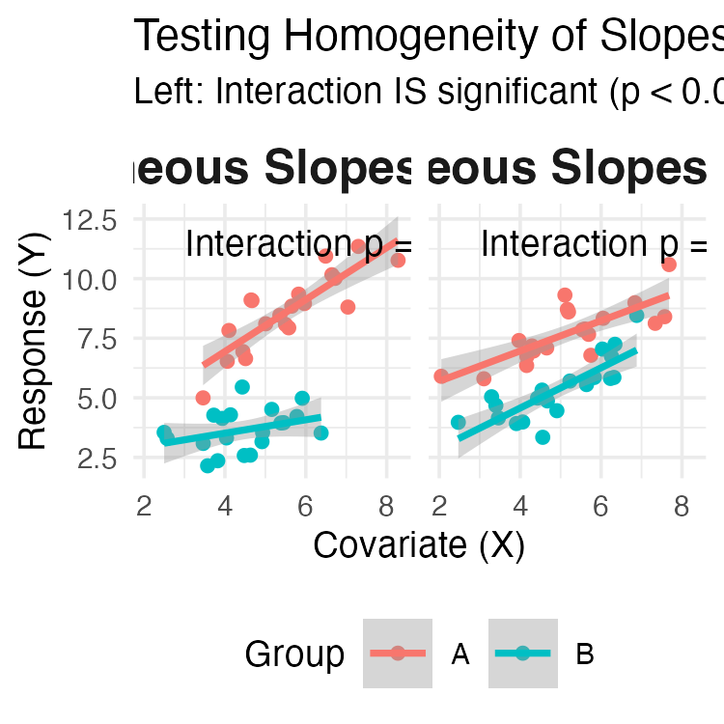

Part 4 · Worked Example — Fruitfly Longevity

Partridge Example: Data Overview
ANCOVA on Longevity of Male Fruitflies
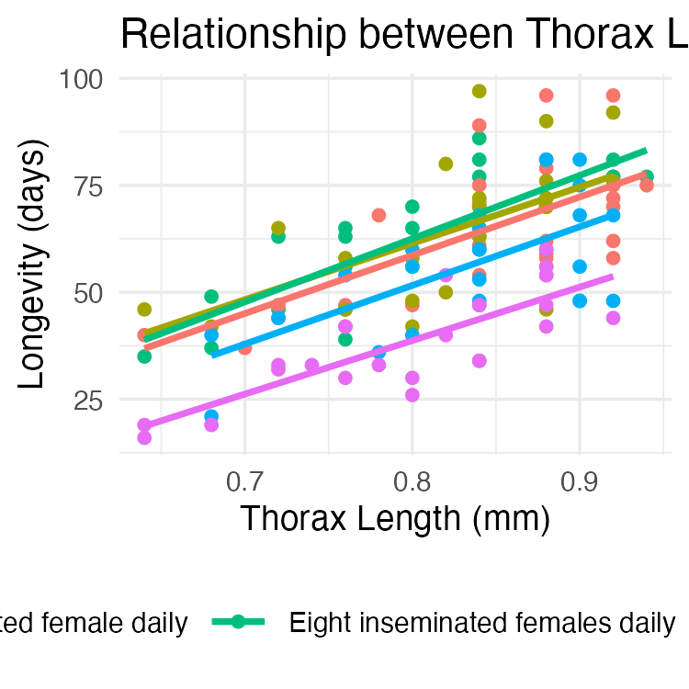

Partridge Example: Steps 1–2 — Test Homogeneity of Slopes
- Testing Homogeneity of Slopes
  - First, fit interaction model.
  - The p-value for the interaction term (THORAX:treatment) is 0.9844.
  - Since this is well > 0.05, we conclude the slopes are homogeneous — the five treatment groups share a common relationship between thorax length and longevity.
  - We can proceed to Step 3 and fit the simpler additive model.
# Step 1: Fit model with interaction term
homo_slopes_model <- lm(LONGEV ~ THORAX * treatment, data = partridge)
# Step 2: Test significance of interaction using Type III SS
Anova(homo_slopes_model, type = "III")
## Anova Table (Type III tests)
##
## Response: LONGEV
## Sum Sq Df F value Pr(>F)
## (Intercept) 2963.8 1 26.0142 1.349e-06 ***
## THORAX 12805.8 1 112.3988 < 2.2e-16 ***
## treatment 36.9 4 0.0810 0.9881
## THORAX:treatment 42.5 4 0.0933 0.9844
## Residuals 13102.1 115
## ---
## Signif. codes: 0 '***' 0.001 '**' 0.01 '*' 0.05 '.' 0.1 ' ' 1
# Extract the p-value for interaction
p_interaction <- Anova(homo_slopes_model, type = "III")[
"THORAX:treatment",
"Pr(>F)"
]

Partridge Example: Step 3 — Fit the Additive ANCOVA
- Since the interaction was not significant, we re-run the model without it.
  - Interpretation:
    - THORAX: covariate highly significant
    - thorax length explains significant amount of variance in longevity
    - treatment: treatment effect, after adjusting for thorax length, is highly significant
# Step 3: Fit the ANCOVA model (additive model)
ancova_model <- lm(LONGEV ~ THORAX + treatment, data = partridge)
# View the final ANCOVA table
Anova(ancova_model, type = "III")
## Anova Table (Type III tests)
##
## Response: LONGEV
## Sum Sq Df F value Pr(>F)
## (Intercept) 3069.7 1 27.791 6.123e-07 ***
## THORAX 13168.9 1 119.219 < 2.2e-16 ***
## treatment 9611.5 4 21.753 1.719e-13 ***
## Residuals 13144.7 119
## ---
## Signif. codes: 0 '***' 0.001 '**' 0.01 '*' 0.05 '.' 0.1 ' ' 1

Partridge Example: Getting Adjusted Means
- The ANOVA table tells us the treatments are different, but not which ones.
  - Use emmeans package to get the adjusted means / perform pairwise comparisons
  - The “estimated marginal mean” (or adjusted mean)
  - predicted longevity for each group, assuming an average thorax length
  - This is the “level playing field” comparison.
# Get adjusted means using emmeans
library(emmeans)
adjusted_means <- emmeans(ancova_model, "treatment")
adjusted_means
## treatment emmean SE df lower.CL upper.CL
## No females 61.5 2.11 119 57.3 65.7
## One inseminated female daily 64.2 2.10 119 60.0 68.3
## Eight inseminated females daily 65.4 2.11 119 61.3 69.6
## One virgin female daily 54.5 2.11 119 50.3 58.7
## Eight virgin females daily 41.6 2.12 119 37.4 45.8
##
## Confidence level used: 0.95

Partridge Example: Pairwise Comparisons
- Pairwise Comparisons of Adjusted Means to see which groups differ
  - Interpretation:
    - The pairs() output gives p-values for all combinations.
    - The plot shows these comparisons visually. Red arrows connect any groups that are NOT significantly different.
    - Here, “One virgin female” and “One inseminated female” are not different from each other, but all other comparisons are significant.
# Pairwise comparisons of adjusted means
pairs(adjusted_means, adjust = "tukey")
## contrast estimate SE
## No females - One inseminated female daily -2.65 2.98
## No females - Eight inseminated females daily -3.93 3.00
## No females - One virgin female daily 7.02 2.97
## No females - Eight virgin females daily 19.95 3.01
## One inseminated female daily - Eight inseminated females daily -1.28 2.98
## One inseminated female daily - One virgin female daily 9.67 2.98
## One inseminated female daily - Eight virgin females daily 22.60 2.99
## Eight inseminated females daily - One virgin female daily 10.95 3.00
## Eight inseminated females daily - Eight virgin females daily 23.88 2.97
## One virgin female daily - Eight virgin females daily 12.93 3.01
## df t.ratio p.value
## 119 -0.891 0.8996
## 119 -1.311 0.6849
## 119 2.361 0.1336
## 119 6.636 <0.0001
## 119 -0.428 0.9929
## 119 3.249 0.0129
## 119 7.560 <0.0001
## 119 3.650 0.0035
## 119 8.031 <0.0001
## 119 4.298 0.0003
##
## P value adjustment: tukey method for comparing a family of 5 estimates

Partridge Example: Pairwise Comparisons — Compact Letters
- Pairwise Comparisons of Adjusted Means to see which groups differ
  - Interpretation:
    - The pairs() output gives p-values for all combinations.
    - The plot shows these comparisons visually. Red arrows connect any groups that are NOT significantly different.
    - Here, “One virgin female” and “One inseminated female” are not different from each other, but all other comparisons are significant.
# Plot adjusted means with confidence intervals
plot(adjusted_means, comparisons = TRUE) +
labs(
title = "Adjusted Means by Treatment",
x = "Adjusted Longevity (days)",
y = "Treatment"
) +
theme_minimal(base_size = 9)
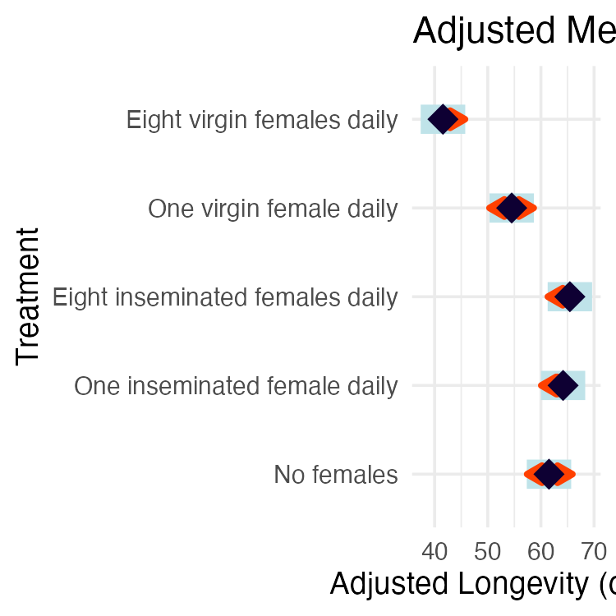

Visualizing ANCOVA Results
Visualization Options for ANCOVA
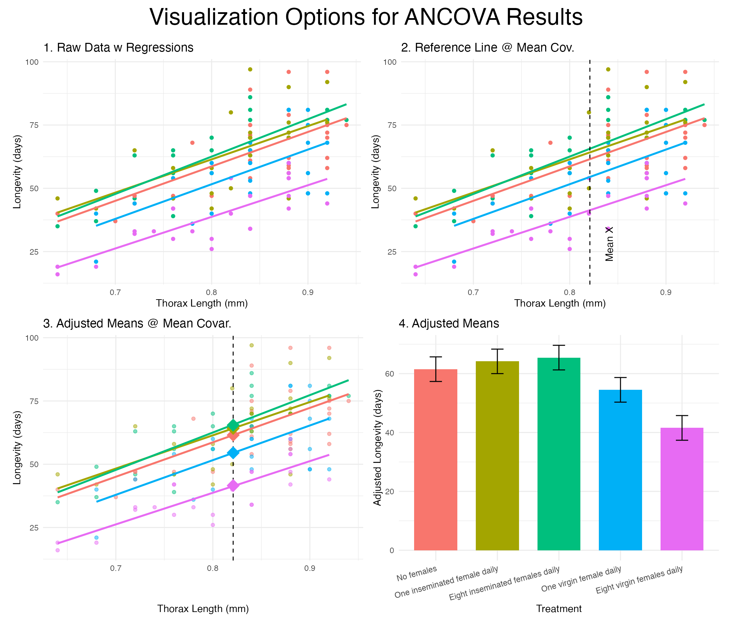
A 2x2 panel comparing four ways to visualize ANCOVA results for the fruitfly data: raw data with regression lines by treatment, the same plot with a reference line at the mean covariate, adjusted means plotted as diamonds at the mean covariate, and a bar chart of adjusted means with confidence-interval error bars.

Part 5 · Heterogeneous Slopes & Assumptions

What if Slopes are HETEROGENEOUS? (p < 0.05)
- Example: Sea Urchin Shrinking w/ Heterogeneous Slopes
- Constable (1993) studied sea urchin test shrinking:
  - Compared suture widths between treatments
  - Three groups: high food, low food, initial sample
  - Covariate: body volume (cube root transformed)
- The analysis showed:
  - Significant interaction between treatment and covariate
  - Heterogeneous slopes across treatments
- Relationship between body volume and suture width depends on treatment group
- Standard ANCOVA is invalid.
.
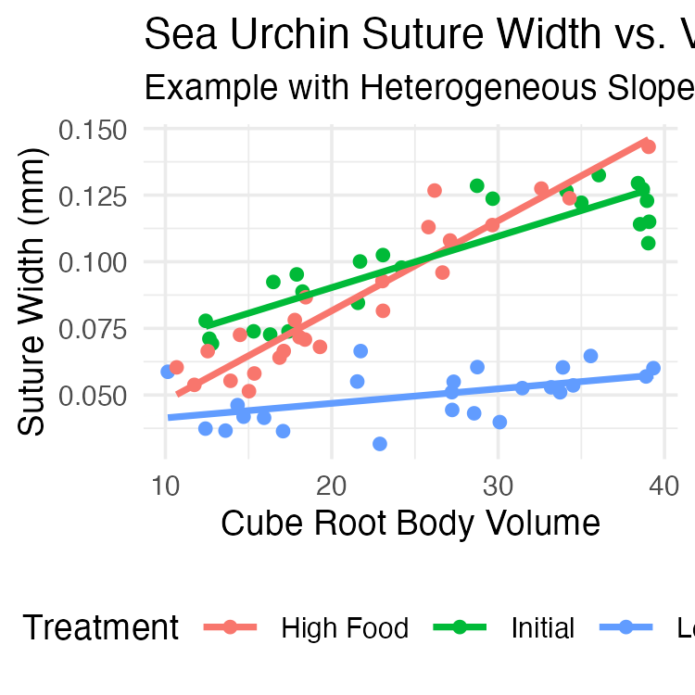

Handling Heterogeneous Slopes
If the interaction term is significant (p < 0.05):
- Report interaction! often more interesting biological result than simple mean differences
- Analyze slopes: Use emmeans to get slopes for each group.
- emtrends(model_int, "treatment", var = "x")
- Johnson-Neyman procedure: advanced method to identify regions of covariate (X-axis) where groups are (and are not) significantly different.
- Separate regressions: Analyze each group separately (less powerful).
## Anova Table (Type III tests)
##
## Response: suture_width
## Sum Sq Df F value Pr(>F)
## (Intercept) 0.0093295 1 104.97 2.828e-15 ***
## volume 0.0197876 1 222.63 < 2.2e-16 ***
## treatment 0.0020070 2 11.29 6.064e-05 ***
## volume:treatment 0.0062129 2 34.95 4.453e-11 ***
## Residuals 0.0058662 66
## ---
## Signif. codes: 0 '***' 0.001 '**' 0.01 '*' 0.05 '.' 0.1 ' ' 1

Interpretation of Heterogeneous Slopes
- With heterogeneous slopes, interpretation shifts from “adjusted means” to “regions of significance”:
  - Initial > Low Food when cube root body volume > 2.95
For large urchins, initial sample has wider sutures than low food urchins
  - High Food > Initial when cube root body volume > 1.81
For most urchins, high food treatment results in wider sutures than initial samples.
  - High Food > Low Food when cube root body volume > 2.07
For most medium to large urchins, high food results in wider sutures than low food.
- Biological interpretation is food regime affects suture width differently depending on urchin size

Assumptions of ANCOVA
- Key Assumptions
  - Independence of observations
Samples are random and independent.
  - Normal distribution of residuals
Check with QQ plots.
  - Homogeneity of variances (Homoscedasticity)
Equal variances across groups.
Check with residual vs. fitted plots.
  - Linearity
A linear relationship exists between Y and X within each group.
Check with scatterplots (we did this!).
  - Homogeneity of regression slopes (The critical one!)
Regression slopes are equal across all groups.
We tested this first! (the A:x interaction).
Note
Whitlock & Schluter, Analysis of Biological Data, Ch. 17 — Regression, on regression diagnostics and residual assumptions that carry over to ANCOVA.

Checking Assumptions in R
- For assumptions 2 and 3, we check the final model (the additive one, if appropriate).
- Interpretation:
  - Residuals vs. Fitted: The red line should be roughly flat at 0. Looks good.
  - Normal Q-Q: Points should fall along the dashed line. Looks good.
  - Scale-Location: Red line should be flat (tests homogeneity of variance). Looks good.
  - Residuals vs. Leverage: No points should be in the top/bottom right (high leverage/influence). Looks good.
- Conclusion: The assumptions are met.
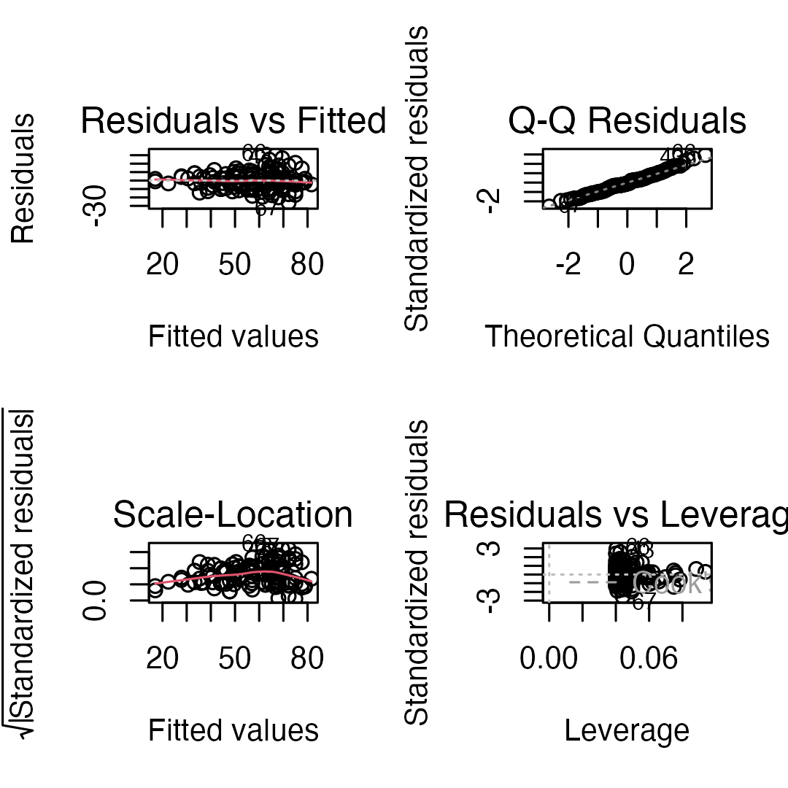

Robust ANCOVA Approaches
- Non-Parametric Alternatives
- When ANCOVA assumptions are badly violated (especially normality or homogeneity of variance), consider:
- Rank Transformation (Simplest)
  - Rank transform both Y and X variables.
  - Run standard ANCOVA on the ranked data.
  - lm(rank(y) ~ rank(x) + A)
- Bootstrapping
  - Use bootstrapping to estimate parameters without assuming normality.
- Quantile Regression
  - Models relationships at different quantiles (e.g., the median) instead of the mean.
- Permutation Tests
  - Randomization tests of treatment effects. .
# Example of rank-transformed ANCOVA
partridge$rank_LONGEV <- rank(partridge$LONGEV)
partridge$rank_THORAX <- rank(partridge$THORAX)
# Fit ANCOVA on ranked data
rank_ancova <- lm(
rank_LONGEV ~
rank_THORAX + treatment,
data = partridge
)
Anova(rank_ancova, type = "III")
## Anova Table (Type III tests)
##
## Response: rank_LONGEV
## Sum Sq Df F value Pr(>F)
## (Intercept) 18783 1 38.236 9.121e-09 ***
## rank_THORAX 54314 1 110.564 < 2.2e-16 ***
## treatment 40447 4 20.584 6.536e-13 ***
## Residuals 58458 119
## ---
## Signif. codes: 0 '***' 0.001 '**' 0.01 '*' 0.05 '.' 0.1 ' ' 1
# Compare p-values for treatment effect
cat(
"P-value (parametric):",
Anova(ancova_model, type = "III")["treatment", "Pr(>F)"],
"\n"
)
## P-value (parametric): 1.719359e-13
cat(
"P-value (rank-based):",
Anova(rank_ancova, type = "III")["treatment", "Pr(>F)"]
)
## P-value (rank-based): 6.536035e-13
Note: The results are very similar, which gives us more confidence in our original parametric test.

Part 6 · Reporting Results

Writing Up ANCOVA Results
Scientific Writing Example
Here’s how you might write up ANCOVA results for publication:
“We analyzed the effects of mating opportunity on male fruitfly longevity using analysis of covariance (ANCOVA), with thorax length as a covariate. Before conducting the main analysis, we tested the homogeneity-of-slopes assumption and found no significant treatment × thorax length interaction (F₄,₁₁₅ = 0.09, P = 0.98), indicating that the effect of body size on longevity was consistent across treatments.
The ANCOVA revealed significant effects of both treatment (F₄,₁₁₉ = 21.75, P < 0.001) and thorax length (F₁,₁₁₉ = 119.22, P < 0.001) on longevity. Thorax length was positively associated with longevity.
After adjusting for body size, longevity declined with the number of virgin females a male was housed with (adjusted mean ± SE: 54.5 ± 2.11 days for one virgin female and 41.6 ± 2.12 days for eight, versus 61.5 ± 2.11 days for males housed alone). Males housed with inseminated females — which do not mate — did not differ from males housed alone (64.2 ± 2.10 and 65.4 ± 2.11 days; Tukey P = 0.90 and P = 0.68). Six of the ten pairwise comparisons were significant at P < 0.05; the four that were not all involved comparisons among the no-female and inseminated-female groups.”
 Important
⚠️ Why the inseminated-female groups are the point of the design
Newly inseminated females will not mate. Males housed with them get the presence of females without the mating. Those groups are the control that isolates the cost of mating itself from the cost of simply having company — and they show no reduction in longevity at all.

Publication Quality Figure
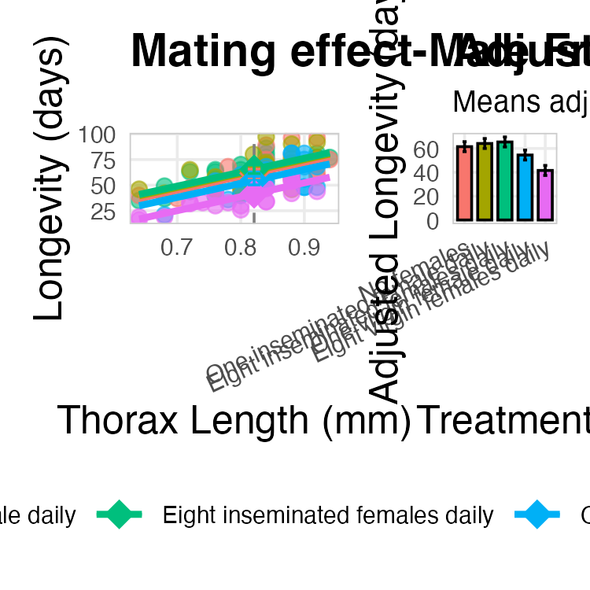

Summary
- Purpose:
  - ANCOVA combines regression and ANOVA.
  - It increases power by accounting for a continuous covariate.
  - It adjusts for confounds by comparing “adjusted means.”
- The Analysis Workflow
  - Step 1: Always test for homogeneity of slopes first (lm(y ~ A * x)).
  - Step 2: If slopes are homogeneous (p > 0.05), proceed to the additive model (lm(y ~ A + x)).
  - Step 3: If slopes are heterogeneous (p < 0.05), STOP and interpret the interaction.
- Interpretation
  - Use car::Anova(model, type = "III") to get the ANOVA table.
  - Use emmeans() to get adjusted means and pairwise comparisons.
- Assumptions
  - Independence of observations
  - Normal distribution of residuals
  - Homogeneity of variances
  - Linearity of relationships within groups
  - Homogeneity of regression slopes (The most important one!)

