Lecture: Graphing Effectively
  - Boxplots, axis limits, a reusable themes file, multi-panel figures, and saving publication-ready output
Bill Perry

Where We Left Off
Last time you:
- Computed mean, median, SD, and SE — by hand and with summarize()
- Fixed the length() trap with sum(!is.na())
- Got tidy per-group tables with group_by() + summarize()
 Note
✅ Key idea from Describing Your Data
You now have real numbers describing shady vs. sunny needles. Today we make those numbers visible — and save the result properly.

Note
Today’s roadmap
- The ggplot grammar, recapped
- Boxplots done right — with raw points
- Axis labels and titles with labs()
- Axis limits with coord_cartesian()
- Mapping color by group
- Mean ± SE with stat_summary()
- A themes file you source() once — publication-ready figures
- patchwork — many plots on one page
- ggsave(), for real this time
⏱ Histograms, density curves, faceting, and scale_color_manual() are in the notes as time allows — the worksheet has them either way.

Part 1 · The ggplot Grammar, Recapped

The ggplot Grammar, Recapped
Every ggplot is three pieces joined with +:
- data — which data frame
- aes() — which columns map to x, y, color, fill…
- geom — how to draw it
library(tidyverse)
library(readxl)
pine_df <- read_csv("data/pine_data.csv")
📥 Download the data
Note
✅ Key idea
Everything today is the same three pieces — we’re just adding more layers and more polish on top of them.

Note
📖 Reference
Whitlock & Schluter, The Analysis of Biological Data, Ch. 2 — Displaying Data, is the core reference for this whole lecture.
📖 R4DS §1 — Data visualization and §9 — Layers

 Tip
🖐 Recap from Getting Started
ggplot(pine_df, aes(x = side, y = needle_length_mm)) +
geom_point()
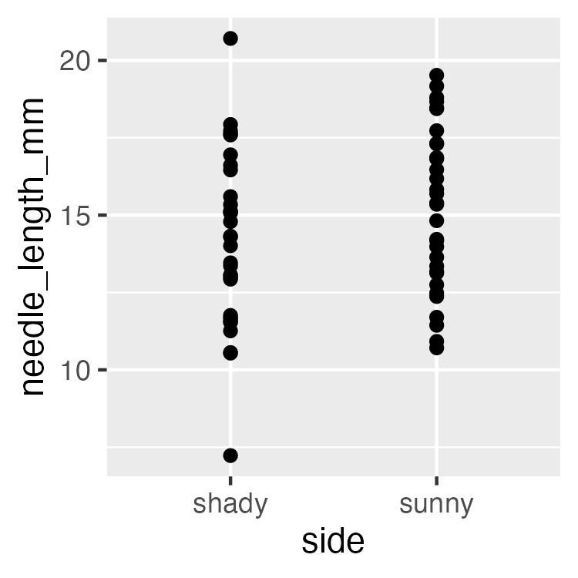

Part 2 · Boxplot Anatomy

Boxplot Anatomy
pine_box_plot <- ggplot(pine_df, aes(x = side, y = needle_length_mm, fill = side)) +
geom_boxplot(alpha = 0.6, outlier.shape = NA) +
labs(
title = "Needle Length by Side of Tree",
x = "Side of tree",
y = "Needle length (mm)",
fill = "Side"
) +
theme_minimal(base_size = 9) +
theme(legend.position = "none")
pine_box_plot
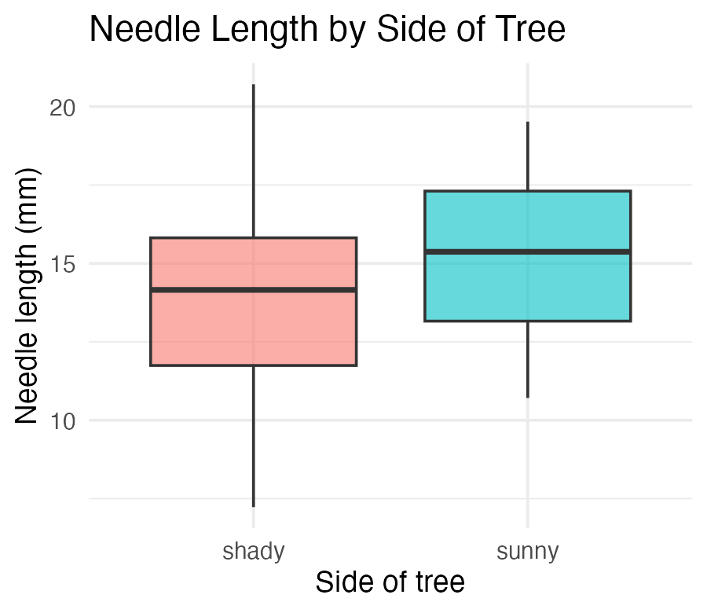
Boxplot anatomy:
- Middle line = median
- Box edges = 25th and 75th percentile (IQR)
- Whiskers = 1.5 × IQR
- Dots beyond whiskers = outliers
Whitlock & Schluter, Ch. 2 — Displaying Data, on the boxplot and the five-number summary it draws.
📖 R4DS §9 — Layers

Boxplot + Raw Points
Note
🔮 Predict first: With only 8 needles per side per tree, does a boxplot alone show you everything? What might it hide?

pine_jitter_plot <- ggplot(pine_df, aes(x = side, y = needle_length_mm, fill = side)) +
geom_boxplot(alpha = 0.5, outlier.shape = NA) +
geom_point(
position = position_jitter(width = 0.15),
alpha = 0.6,
size = 2
) +
labs(
title = "Needle Length by Side of Tree",
x = "Side of tree",
y = "Needle length (mm)",
fill = "Side"
) +
theme_minimal(base_size = 9) +
theme(legend.position = "none")
pine_jitter_plot
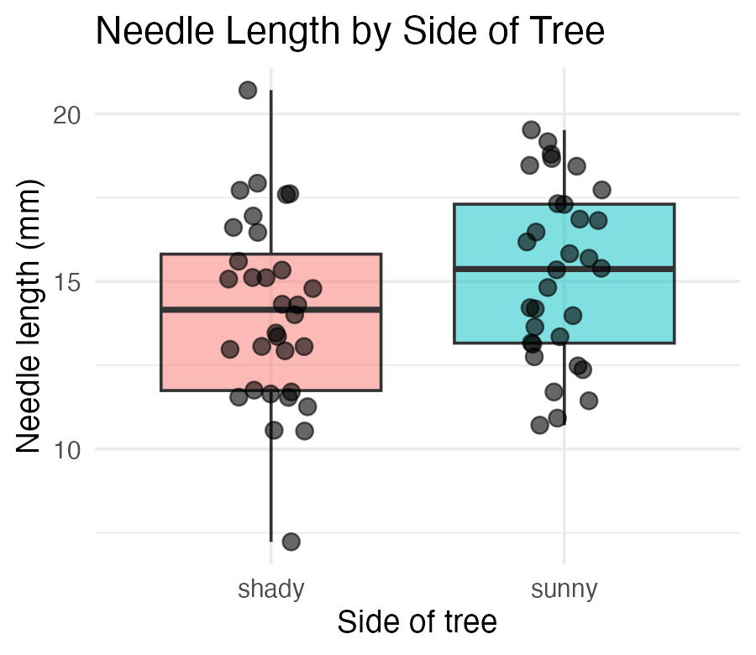
- position_jitter(width = 0.15) spreads points sideways so they don’t overlap
- alpha = 0.6 — semi-transparent, so overlapping points are still visible
Tip
Always show the raw points alongside a boxplot when n is small — every point matters, and a box alone can hide a bimodal or lopsided pattern.

Note
📖 Reference
Whitlock & Schluter, Ch. 2 — Displaying Data, “How to draw a good graph,” makes exactly this argument: show the data, not only the summary.

▶ Your Turn — Code It Now
 Important
Stop here and write code.
Worksheet Parts 1, 2 and 3 — load the data, build the boxplot, add the raw points.
Come back when it runs. If it does not run, that is the interesting part — bring the error.

Part 2b · Axis Labels and Titles, Done Right

Before labs() — Never Ship This
ggplot(pine_df, aes(x = side, y = needle_length_mm, fill = side)) +
geom_boxplot(alpha = 0.6, outlier.shape = NA) +
theme_minimal(base_size = 9) +
theme(legend.position = "none")
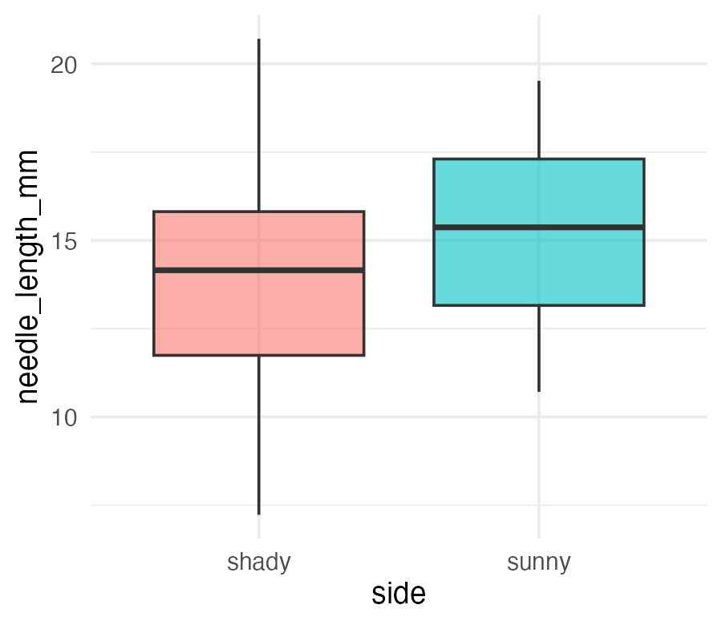
Important
The x-axis reads side and the y-axis reads needle_length_mm — the literal column names, not something a reader outside your lab would understand.

 Warning
⚠️ Watch out!
A plot with default column-name axes is a plot that only makes sense to you, today. Six months from now, even you may not remember what side meant.

labs() — Every Piece of Text on the Plot
ggplot(pine_df, aes(x = side, y = needle_length_mm, fill = side)) +
geom_boxplot(alpha = 0.6, outlier.shape = NA) +
labs(
title = "Needle Length by Side of Tree",
subtitle = "Four field teams, four trees",
x = "Side of tree",
y = "Needle length (mm)",
fill = "Side",
caption = "Data: pine_data.csv"
) +
theme_minimal(base_size = 9) +
theme(legend.position = "none")
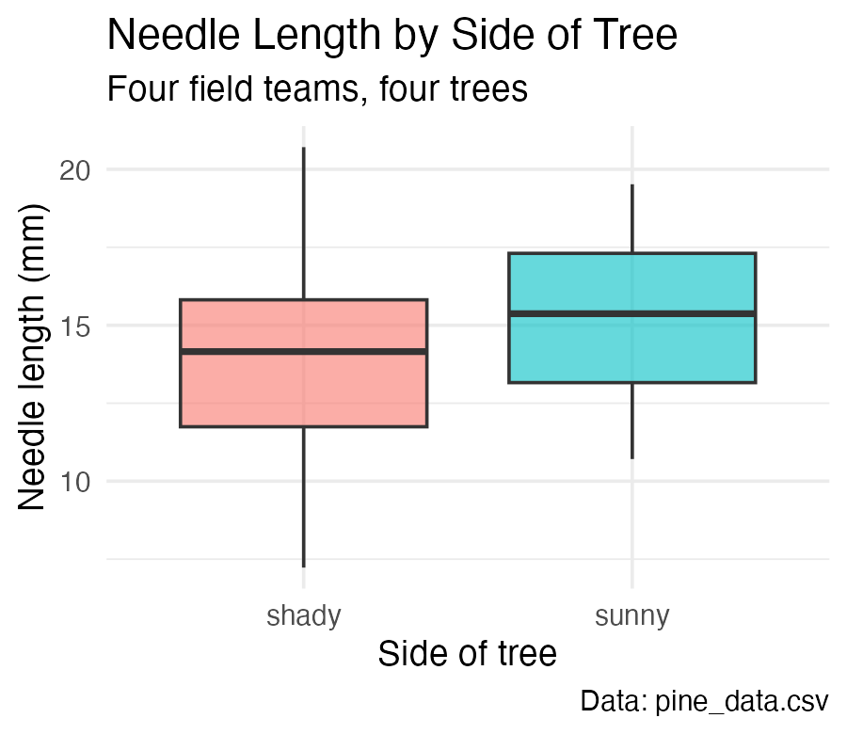
One function, five jobs:
Argument | Controls
title | main title
subtitle | smaller text under the title
x / y | axis labels
caption | small text, bottom-right
color/fill | legend title for that aesthetic

Note
✅ Key idea
labs() never touches the data or the statistics — only what a reader sees written on the plot. Change it freely.

Note
📖 Reference
📖 R4DS §11.1 — Labels

labs() — the Legend Title Trap
# Whichever aesthetic name you mapped, use that same name in labs()
ggplot(pine_df, aes(x = side, y = needle_length_mm, color = team)) +
geom_point(position = position_jitter(width = 0.15)) +
labs(color = "Field team") # matches aes(color = team)
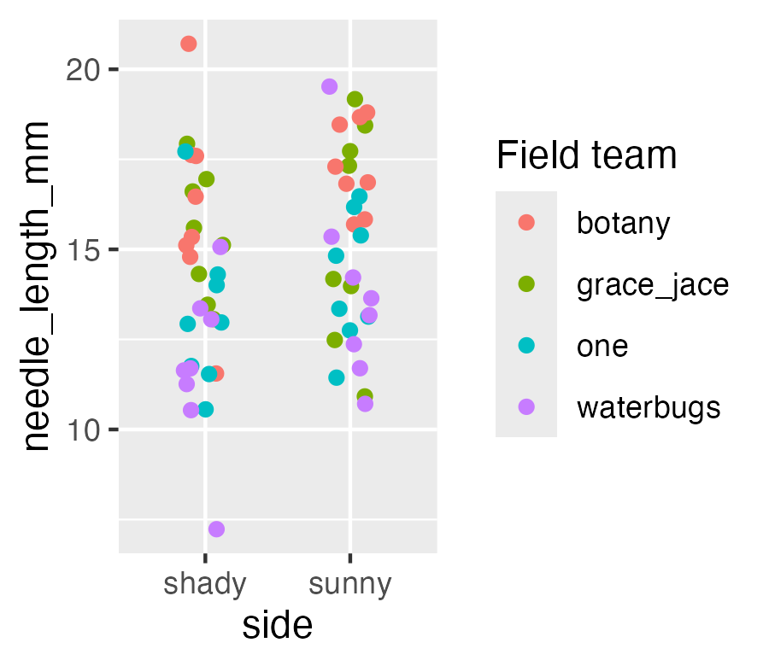
Warning
⚠️ Watch out!
The legend title comes from whatever you write for the aesthetic you mapped — color = "Field team" in labs() relabels a color = mapping. Write fill = "..." instead and it does nothing, because this plot never mapped fill.

▶ Your Turn — Code It Now
Important
Stop here and write code.
Worksheet Part 3b — write real titles, axis labels, and a legend title with labs().
Come back when it runs. If it does not run, that is the interesting part — bring the error.

Part 2c · Setting the Axis Limits — coord_cartesian()

coord_cartesian() — Choosing What the Reader Sees
ggplot(pine_df, aes(x = side, y = needle_length_mm, fill = side)) +
geom_boxplot(alpha = 0.6, outlier.shape = NA) +
labs(
title = "Needle Length by Side of Tree",
x = "Side of tree",
y = "Needle length (mm)"
) +
coord_cartesian(ylim = c(0, 25)) +
theme_minimal(base_size = 9) +
theme(legend.position = "none")
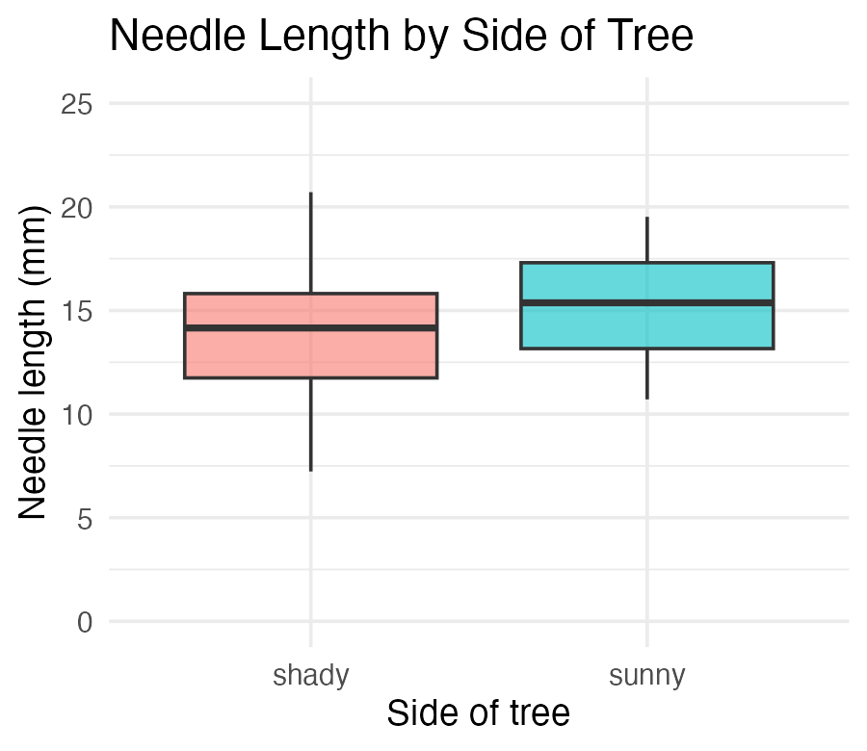
ggplot picks axis limits from your data. That is a fine default for exploring — and the wrong default the moment a reader has to judge how big a difference is.
- coord_cartesian(ylim = c(0, 25)) — set the y-axis range
- coord_cartesian(xlim = c(...)) — same for x
- Both at once: coord_cartesian(xlim = c(...), ylim = c(...))
Note
✅ Key idea
Starting a measurement axis at zero is what keeps a 1 mm difference from looking like a canyon. Decide the limits deliberately; don’t inherit them.

coord_cartesian() — Both Axes at Once
pine_scatter_plot <- ggplot(pine_df, aes(x = needle_length_mm, y = needle_width_mm,
color = side)) +
geom_point(alpha = 0.6, size = 2) +
labs(
title = "Needle Width vs. Length",
x = "Needle length (mm)",
y = "Needle width (mm)",
color = "Side"
) +
coord_cartesian(xlim = c(5, 25), ylim = c(0.4, 1.8)) +
theme_minimal(base_size = 9)
pine_scatter_plot
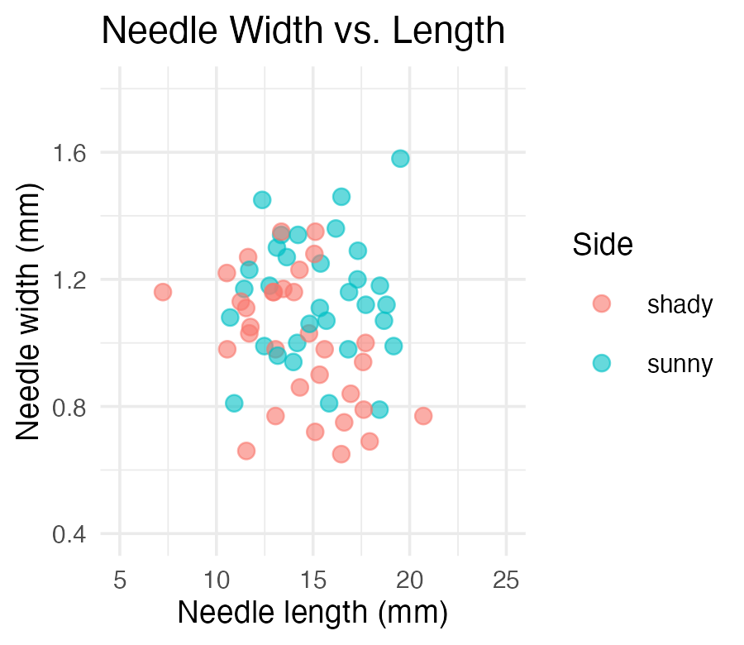
Tip
🖐 Notice
Two continuous axes, so both xlim = and ylim = are useful here. On the boxplot, x was a category — there is nothing to zoom.

Note
📖 Reference
📖 R4DS §11.4 — Scales

The Trap — ylim() Deletes Data, coord_cartesian() Does Not
Note
🔮 Predict first: Both plots below ask for a y-axis running 14 to 16 mm. One of them changes where the boxes are drawn. Which one, and why?

# ❌ ylim() THROWS AWAY every row outside the range first
ggplot(pine_df, aes(x = side, y = needle_length_mm, fill = side)) +
geom_boxplot(alpha = 0.6) +
ylim(14, 16) +
labs(title = "ylim() — boxes redrawn from survivors") +
theme_minimal(base_size = 8) +
theme(legend.position = "none")
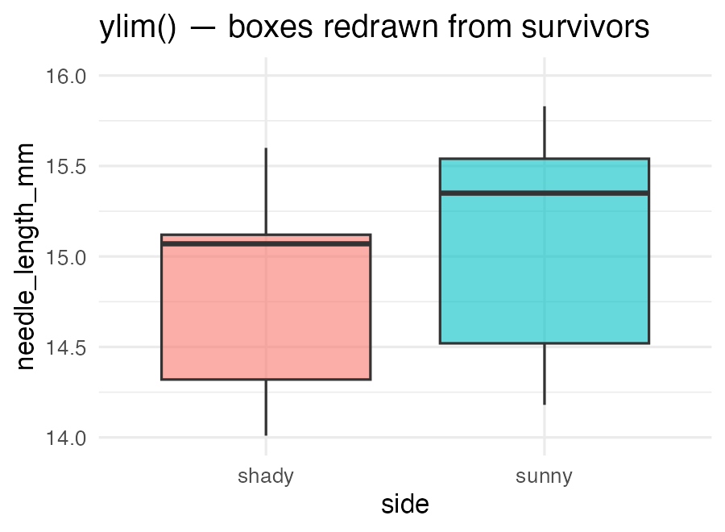
# ✅ coord_cartesian() keeps every row and just crops the view
ggplot(pine_df, aes(x = side, y = needle_length_mm, fill = side)) +
geom_boxplot(alpha = 0.6) +
coord_cartesian(ylim = c(14, 16)) +
labs(title = "coord_cartesian() — same boxes, zoomed") +
theme_minimal(base_size = 8) +
theme(legend.position = "none")
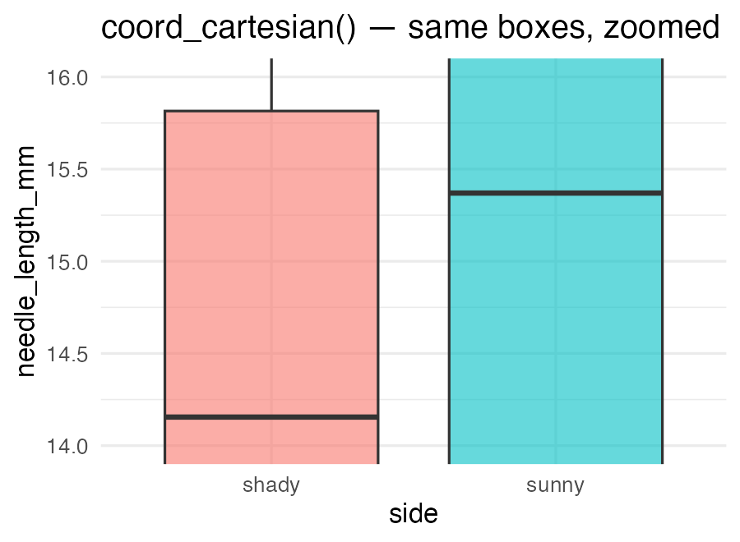
Warning
⚠️ Watch out!
ylim(14, 16) and scale_y_continuous(limits = c(14, 16)) filter the data before the geom draws it. Every needle outside 14–16 mm is silently dropped, and the median, the quartiles, and the whiskers are all recomputed from what is left. R warns about “removed rows” and students read past it every time.
coord_cartesian() computes the statistics on all the data and then zooms the camera. The boxes do not move.

Tip
🖐 The rule
Use coord_cartesian() to zoom. Use filter() when you actually mean to remove data — on purpose, in the data step, where you can see it.

Note
📖 Worth knowing — changing the axis scale, not just its limits
Right-skewed data (a few very large values squashing everything else into a corner) is usually better read on a log axis:
+ scale_x_log10() # the AXIS is logged; the data are untouched
That is different again from logging the data itself with mutate(log_length = log(needle_length_mm)), which changes the numbers every later calculation sees.
Nothing today needs it — our needles are not skewed. Try it on your scatterplot if you are curious, and we will come back to it when a distribution actually calls for it.

▶ Your Turn — Code It Now
Important
Stop here and write code.
Worksheet Part 3c — set your axis limits with coord_cartesian(). The ylim() trap stays on screen; you do not need to type it.
Come back when it runs. If it does not run, that is the interesting part — bring the error.

Part 3 · Mapping Color by Group

Mapping Color by Group
pine_team_plot <- ggplot(pine_df, aes(x = side, y = needle_length_mm, color = team)) +
geom_point(
position = position_jitter(width = 0.15),
size = 2.5,
alpha = 0.8
) +
labs(
title = "Needle Length by Side, Colored by Team",
x = "Side of tree",
y = "Needle length (mm)",
color = "Field team"
) +
theme_minimal(base_size = 9)
pine_team_plot
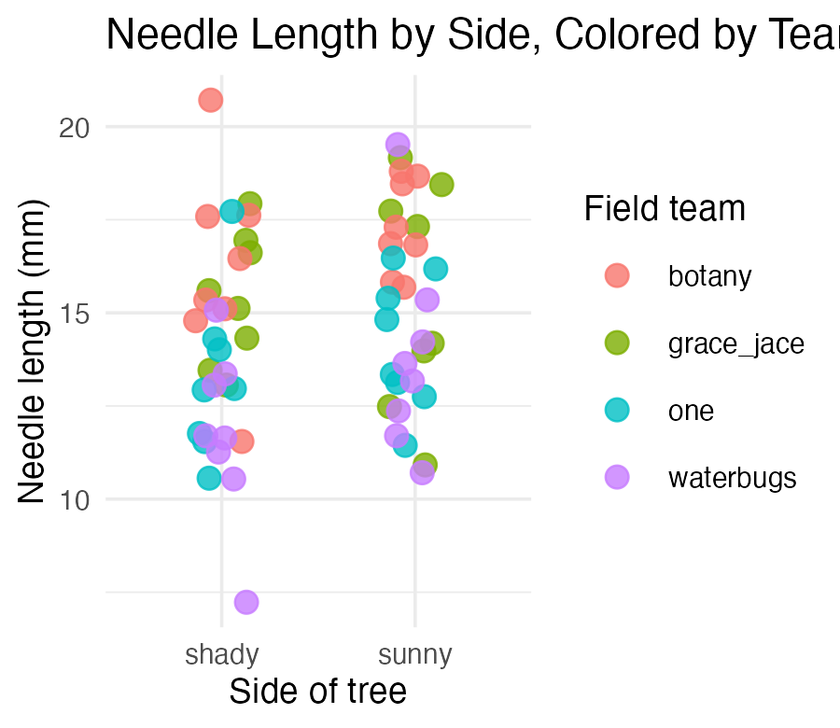
- color = team maps a third variable onto the plot — no new geom needed
- ggplot auto-builds the legend and picks colors for you
- Mapping inside aes() always means “vary this by data” — not “make everything this color”
Warning
⚠️ Watch out!
color = "darkblue" outside aes() sets one fixed color. color = team inside aes() maps colors to a variable. Mixing these up is one of the most common ggplot mistakes.

Note
📖 Worth knowing — where you put aes() matters too
An aes() inside ggplot() is global: every layer inherits it. An aes() inside a single geom applies to that layer only:
# global — both layers colored by side
ggplot(pine_df, aes(x = side, y = needle_length_mm, color = side)) +
geom_point() + stat_summary(fun = mean, geom = "point", size = 4)
# per-layer — points colored by team, the mean drawn in plain black
ggplot(pine_df, aes(x = side, y = needle_length_mm)) +
geom_point(aes(color = team)) +
stat_summary(fun = mean, geom = "point", size = 4)
Just know it exists for now — we will lean on it later, when a plot has to show raw data and a fitted model at the same time.

Note
📖 Reference
📖 R4DS §9.1 — Aesthetic mappings

▶ Your Turn — Code It Now
Important
Stop here and write code.
Worksheet Part 4 — map color = / fill = to a third variable.
Come back when it runs. If it does not run, that is the interesting part — bring the error.

Part 3b · Histograms and Density — Seeing the Whole Distribution
Note
⏱ If time allows — everything in this part is on the worksheet, so it is safe to work through on your own if we run short in class.

Histograms — the Shape Behind the Summary
Note
🔮 Predict first: In Describing Your Data we found the overall mean(needle_length_mm) ≈ 14.67 and the median ≈ 14.55 — nearly identical. What shape do you expect the full distribution to have — symmetric, or skewed?

ggplot(pine_df, aes(x = needle_length_mm)) +
geom_histogram(binwidth = 2, fill = "darkblue", color = "white") +
labs(
title = "Distribution of Needle Length",
x = "Needle length (mm)",
y = "Count"
) +
theme_minimal(base_size = 9)
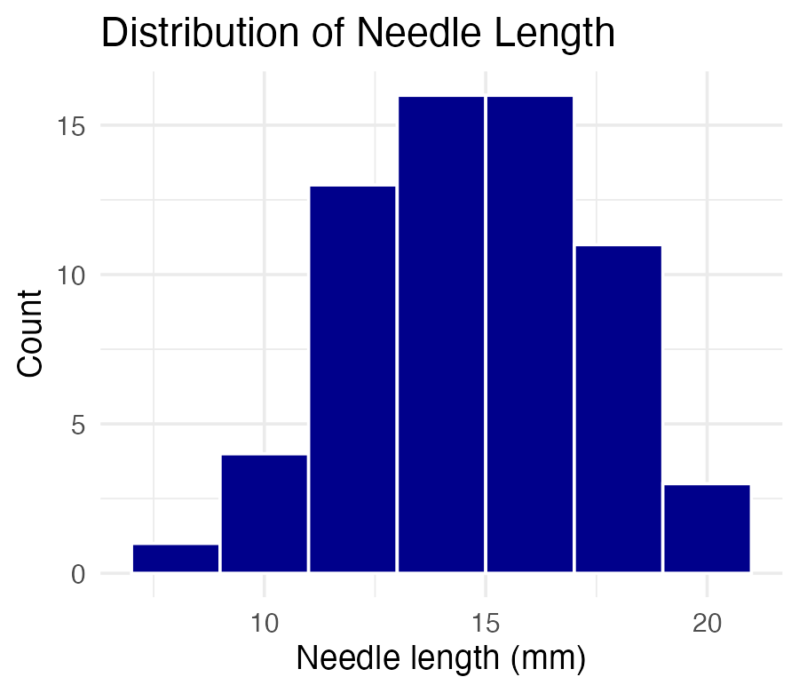
- binwidth sets the width of each bar in data units (here, 2mm)
- Too wide hides structure; too narrow shows noise — try a few values
Tip
🖐 Try it yourself
Change binwidth = 2 to binwidth = 0.5 and to binwidth = 5. Which tells the real story?

Note
📖 Reference
Whitlock & Schluter, Ch. 2 — Displaying Data, on frequency distributions and choosing bin width.
📖 R4DS §10.3 — Variation

Histograms by Group — fill and facet_wrap() Together
ggplot(pine_df, aes(x = needle_length_mm, fill = side)) +
geom_histogram(binwidth = 2, color = "white", alpha = 0.7) +
facet_wrap(~side, ncol = 1) +
labs(x = "Needle length (mm)", y = "Count", fill = "Side") +
theme_minimal(base_size = 8) +
theme(legend.position = "none")
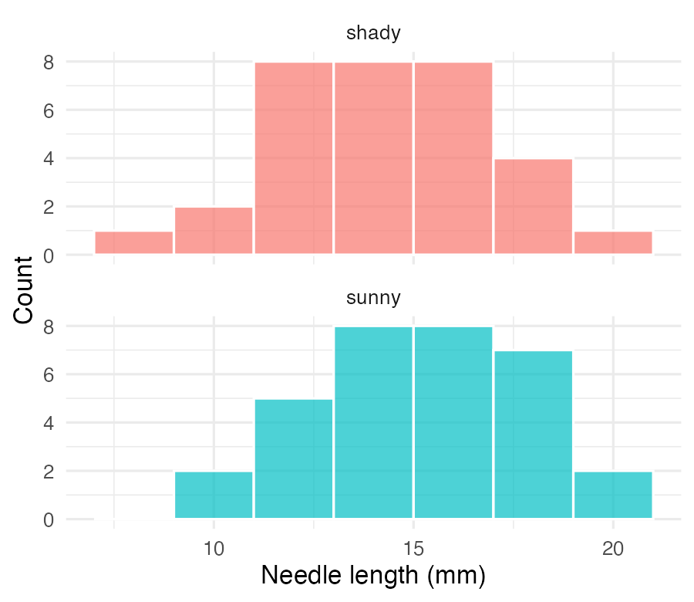
Note
✅ Key idea
Overlapping histograms on one panel are hard to read. Faceting stacks them into separate panels sharing an x-axis — same comparison, much clearer.

Note
📖 Reference
📖 R4DS §9.5 — Facets

Density Curves — a Smoothed Alternative
ggplot(pine_df, aes(x = needle_length_mm, fill = side)) +
geom_density(alpha = 0.5) +
labs(
title = "Needle Length Density by Side",
x = "Needle length (mm)",
y = "Density",
fill = "Side"
) +
theme_minimal(base_size = 9)
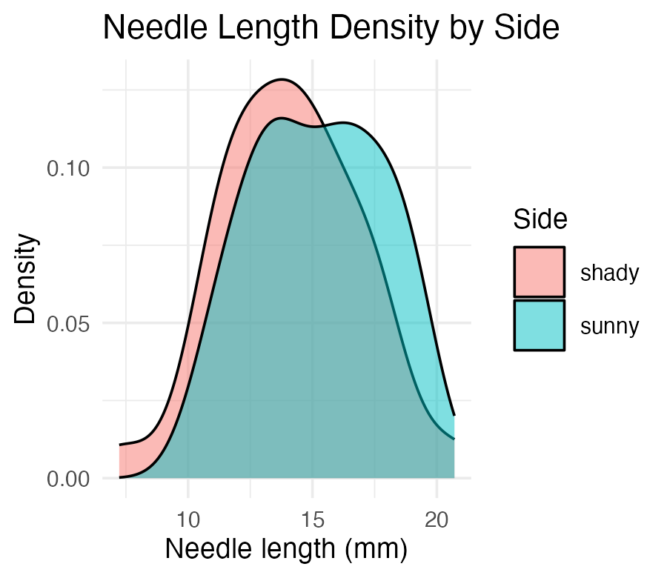
Tip
📖 Histogram vs. density
A density curve is a smoothed histogram, rescaled so the area under each curve sums to 1. It overlays cleanly for group comparisons — no faceting required, at the cost of hiding the raw bin counts.

Note
📖 Reference
Gotelli & Ellison, A Primer of Ecological Statistics, Ch. 3 — Summary Statistics, on the shape of a distribution behind any mean and SD you report.

▶ Your Turn — Code It Now
Important
Stop here and write code.
Worksheet Part 4b — histograms and density curves. ⏱ Skip it if we are short; nothing later depends on it.
Come back when it runs. If it does not run, that is the interesting part — bring the error.

Part 4 · Mean ± SE — Plotted Directly

Mean ± SE — Plotted Directly
pine_mean_se_plot <- ggplot(pine_df, aes(x = side, y = needle_length_mm, color = side)) +
geom_point(
position = position_jitter(width = 0.15),
alpha = 0.3,
size = 2
) +
stat_summary(fun = mean, geom = "point", size = 4) +
stat_summary(
fun.data = mean_se,
geom = "errorbar",
width = 0.15,
linewidth = 0.9
) +
labs(
title = "Mean ± SE Needle Length by Side",
x = "Side of tree",
y = "Needle length (mm)"
) +
theme_minimal(base_size = 9) +
theme(legend.position = "none")
pine_mean_se_plot
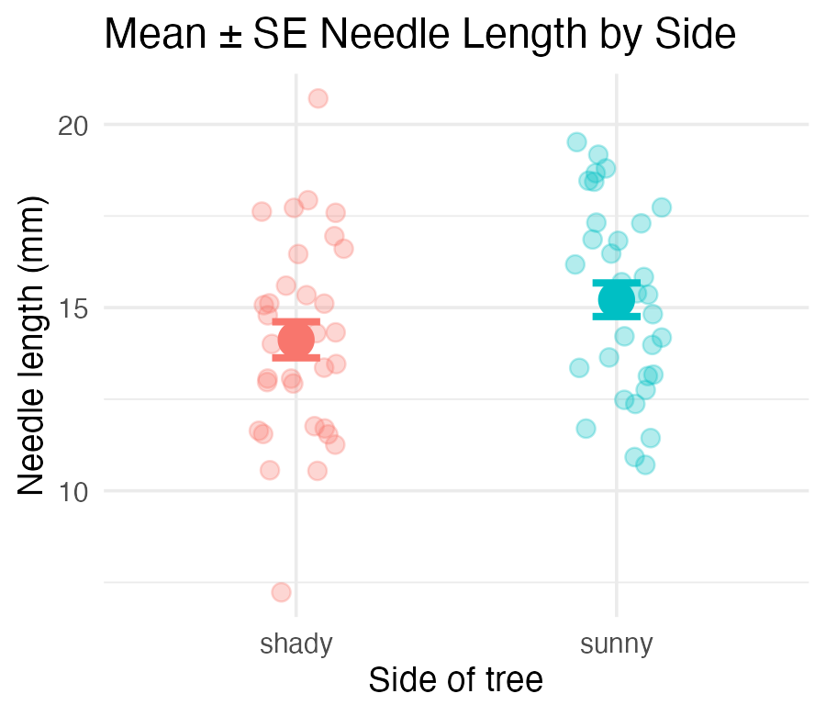
Two stat_summary() layers:
call | draws
fun = mean | one large point at the mean
fun.data = mean_se | error bars for ± 1 SE
stat_summary() computes the mean and SE for you, straight from the raw data — no summarize() step required first.
Warning
⚠️ Convenient, but read the fine print
“Straight from the raw data” means it used all 64 needles. Those are the naive error bars from Describing Your Data — the ones that treat 8 needles from one tree as 8 independent facts.

Note
📖 Reference
Whitlock & Schluter, Ch. 4 — Estimating with Uncertainty, on what an error bar is an estimate of.
Gotelli & Ellison, Ch. 6 — Designing Successful Field Studies, on why independence decides which rows you may average.

The error bar is a claim — make it an honest one
Note
🔮 Predict first: We are about to draw the same two means, but with error bars built from the 4 tree means instead of the 64 needles. Will the dots move? Will the bars?

team_means_df <- pine_df |>
group_by(team, side) |>
summarize(team_mean_mm = mean(needle_length_mm), .groups = "drop")
ggplot(team_means_df, aes(x = side, y = team_mean_mm, color = side)) +
geom_point(size = 2, alpha = 0.6,
position = position_jitter(width = 0.08)) +
stat_summary(fun = mean, geom = "point", size = 4) +
stat_summary(fun.data = mean_se, geom = "errorbar",
width = 0.15, linewidth = 0.9) +
labs(title = "Mean ± SE, computed from 4 trees",
x = "Side of tree", y = "Mean needle length (mm)") +
theme_minimal(base_size = 9) +
theme(legend.position = "none")
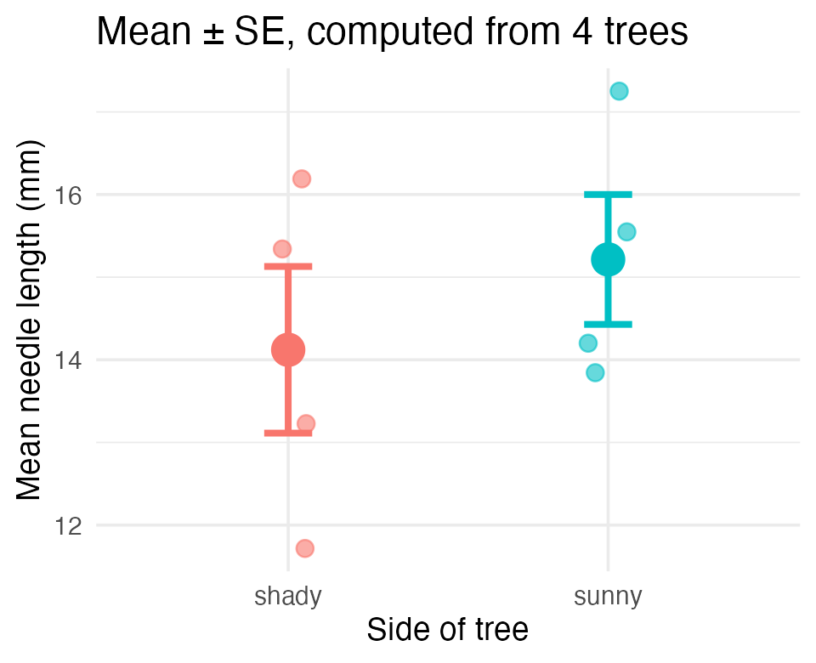
Important
Same dots. Longer bars.
The means are identical (14.12 and 15.21). The SEs went from 0.49/0.46 to 1.01/0.79 — roughly double.
Each small point here is one tree, not one needle. That is the plot our design actually supports.

Tip
🖐 The habit
Before you draw an error bar, ask what one point in it represents. stat_summary() will happily compute an SE over anything you hand it — including rows that aren’t independent.

▶ Your Turn — Code It Now
Important
Stop here and write code.
Worksheet Part 5 — mean ± SE with stat_summary().
Come back when it runs. If it does not run, that is the interesting part — bring the error.

Part 5 · Faceting — One Panel Per Group
Note
⏱ If time allows — the worksheet walks through this one too.

Faceting — One Panel Per Group
pine_facet_plot <- ggplot(pine_df, aes(x = side, y = needle_length_mm, fill = side)) +
geom_boxplot(alpha = 0.6, outlier.shape = NA) +
facet_wrap(~team) +
labs(
title = "Needle Length by Side, Faceted by Team",
x = "Side of tree",
y = "Needle length (mm)"
) +
theme_minimal(base_size = 7) +
theme(legend.position = "none")
pine_facet_plot
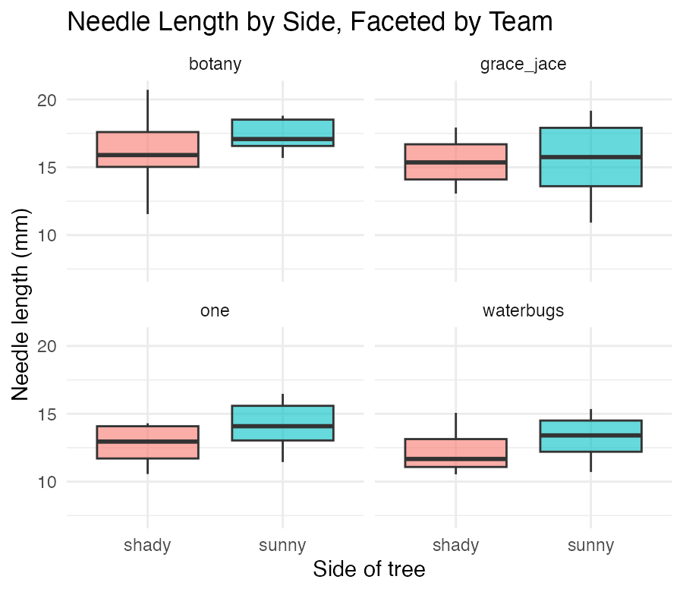
- facet_wrap(~team) gives each field team its own small panel
- Same x/y scale across panels — easy to compare
- Useful the moment “does every group show the same pattern?” is the real question
Tip
🖐 Notice
A faceted plot answers a different question than a single colored plot: not just “is there an overall pattern,” but “does the pattern hold for everyone?”
📖 R4DS §9.5 — Facets

▶ Your Turn — Code It Now
Important
Stop here and write code.
Worksheet Part 6 — facet by field team. ⏱ Skip it if we are short.
Come back when it runs. If it does not run, that is the interesting part — bring the error.

Part 6 · Themes — Write It Once, Use It Everywhere

The Built-in Themes
pine_jitter_plot + theme_bw(base_size = 9)
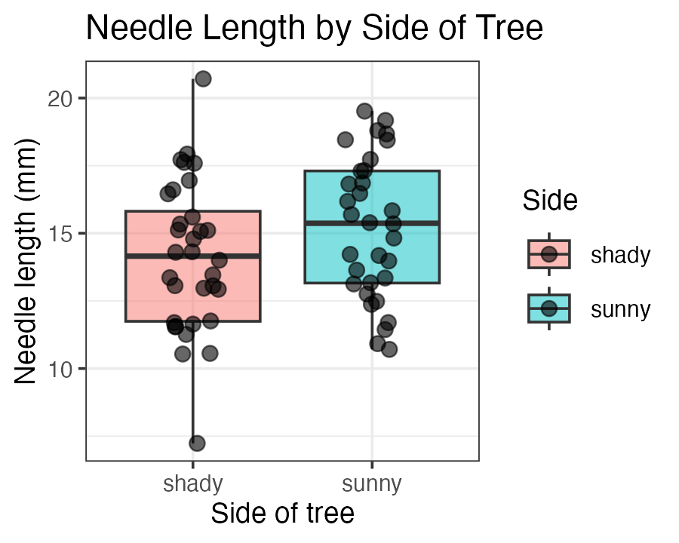
- theme_minimal() — light, few gridlines (what we have used so far)
- theme_bw() — white background, black-and-white frame
- theme_classic() — just x/y axis lines, no gridlines
A theme changes appearance only — never the data or the statistics underneath.
Warning
⚠️ The problem with the built-ins
None of them is quite publication-ready, so you end up appending ten lines of theme(axis.title = element_text(...), ...) to every single plot — and retyping them in every script, slightly differently each time.

The Themes File — Three Sizes, Written Once
Download r_themes_for_3_sizes.R from the activity page and save it in your project folder, next to your .Rproj file.
It defines three functions, each sized for a different final output:
Function | Built for | Base font
theme_small() | ~3 × 3 in — a journal panel | 9 pt
theme_regular() | ~7 × 7 in — a report figure | 16 pt
theme_large() | ~16 × 16 in — a poster | 36 pt
All three give you the same publication look: white background, a black panel border, black axis lines and ticks, bold axis titles, no gridlines.
Important
Two steps, once each
- Open the file and run it (Ctrl/Cmd + Shift + Enter, or Source). Look at your Environment pane — theme_small, theme_regular, and theme_large appear as functions. That is all “running it” does: it defines them.
- From then on, source() it at the top of any script that makes a figure. One line replaces the whole block of theme code you would otherwise paste into every script.

# At the top of your script,
# with library(tidyverse):
source("r_themes_for_3_sizes.R")
Note
✅ Why source() and not copy-paste
source() runs that file top to bottom, exactly as if you had typed it. Fix a margin in the themes file once and every figure in every script picks up the change the next time you run it.
Copy-pasted theme code gives you fifteen slightly different themes and no way to fix them all.

Warning
⚠️ Watch out!
source() needs the path to be right. With the file in your project root and an .Rproj open, "r_themes_for_3_sizes.R" is enough. Put it in a scripts/ folder and it becomes source("scripts/r_themes_for_3_sizes.R").

Using the Themes
pine_theme_plot <- ggplot(pine_df, aes(x = side, y = needle_length_mm, fill = side)) +
geom_boxplot(alpha = 0.6, outlier.shape = NA) +
labs(
title = "Needle Length by Side of Tree",
x = "Side of tree",
y = "Needle length (mm)"
) +
coord_cartesian(ylim = c(0, 25)) +
theme_small() +
theme(legend.position = "none")
pine_theme_plot
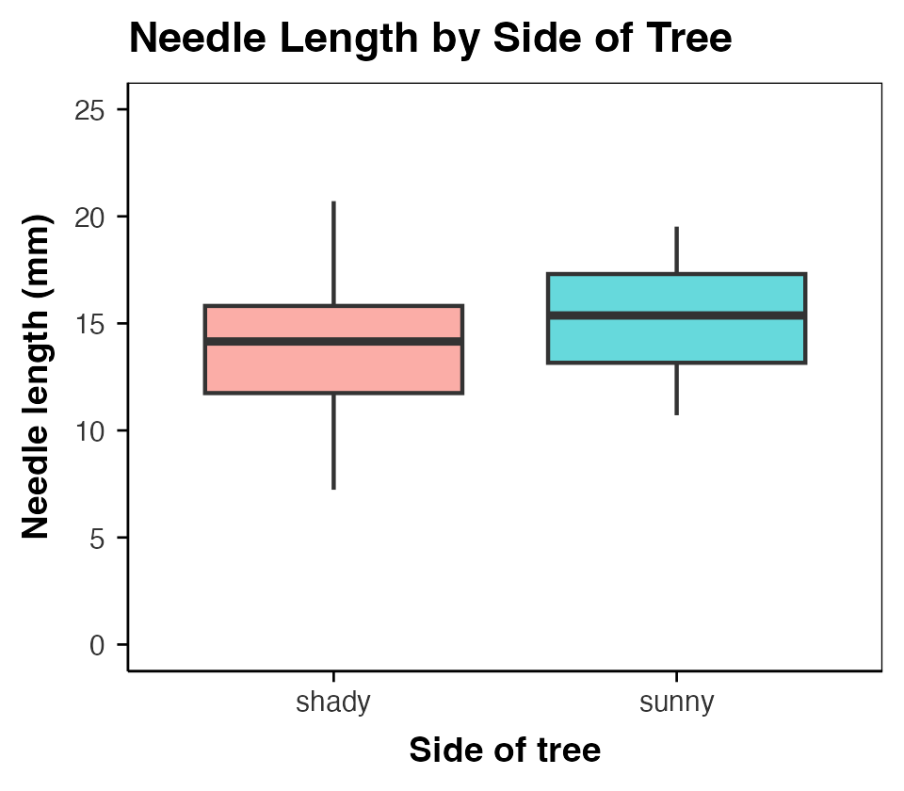
It is one more + layer, exactly like theme_minimal():
+ theme_small() # 3 × 3 in
+ theme_regular() # 7 × 7 in
+ theme_large() # poster
Tip
🖐 Match the theme to the size you will save
Pick the theme for the figure’s final printed size, then pass that same size to ggsave(). A theme_large() plot saved at 3 × 3 in is unreadable, and theme_small() on a poster disappears.

Note
Still your plot
Anything you add after the theme still wins — theme_small() + theme(legend.position = "none") keeps the theme and drops the legend.

▶ Your Turn — Code It Now
Important
Stop here and write code.
Worksheet Parts 7 and 7b — try the built-in themes, then download, run, and source() the themes file.
Come back when it runs. If it does not run, that is the interesting part — bring the error.

Part 7 · Many Plots on One Page — patchwork

patchwork — + for Whole Plots
install.packages("patchwork") # once per computer
library(patchwork)
Save each plot into an object, then combine them:
plot_a + plot_b # side by side
plot_a / plot_b # stacked
Note
✅ Key idea
patchwork reuses the operators you already know. + puts plots beside each other, / puts one over the other — and the result is still a plot object you can save.

pine_jitter_plot + pine_mean_se_plot
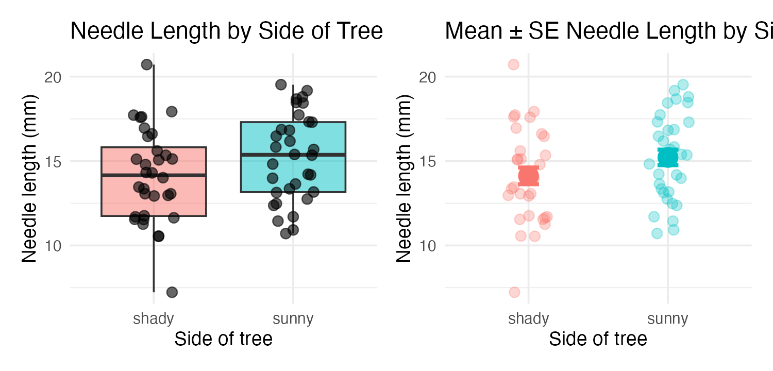

patchwork — Building a Real Figure
combined_plot <- (pine_jitter_plot + pine_mean_se_plot) / pine_scatter_plot +
plot_annotation(tag_levels = "A")
combined_plot
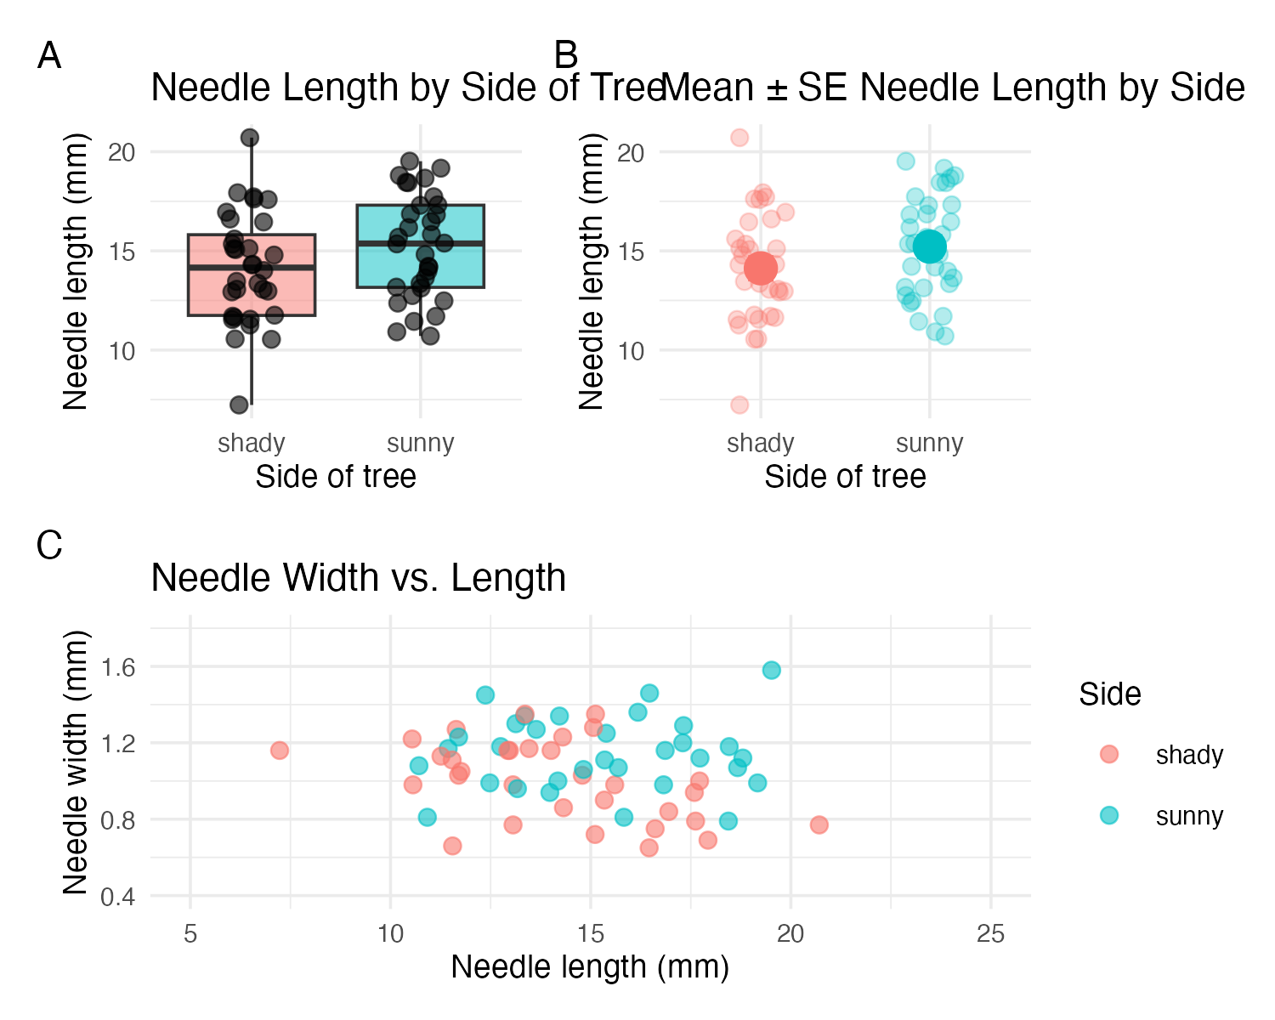
- Parentheses group plots, exactly like arithmetic: (a + b) / c is two on top, one across the bottom
- plot_annotation(tag_levels = "A") tags the panels A, B, C — what a figure caption refers to
- combined_plot is one object, so ggsave() saves the whole multi-panel figure in one call
Tip
🖐 Size it for the whole figure
A three-panel figure needs roughly three panels’ worth of space. Give ggsave() a width/height for the combined plot, not for one panel.

▶ Your Turn — Code It Now
Important
Stop here and write code.
Worksheet Part 7c — combine your plots with patchwork.
Come back when it runs. If it does not run, that is the interesting part — bring the error.

Part 8 · Saving a Real Figure

Saving a Real Figure
# One panel, built with theme_small() — save it at the size the theme was written for
ggsave(
"figures/pine_needle_boxplot.png",
plot = pine_theme_plot,
width = 3,
height = 3,
units = "in",
dpi = 300
)
# The three-panel patchwork figure — bigger canvas, one call
ggsave(
"figures/pine_needle_combined.png",
plot = combined_plot,
width = 7,
height = 6,
units = "in",
dpi = 300
)
Warning
⚠️ Watch out!
ggsave() wants the filename first, then plot =. If you skip plot =, it saves whatever plot was drawn last — not necessarily the one you meant.

Note
✅ Key idea
Always set width, height, units, and dpi explicitly. Letting ggsave() guess gives you a plot sized for your screen, not for a report or a poster.

Note
📖 Reference
Whitlock & Schluter, Ch. 2 — Displaying Data, on what a figure has to carry to stand on its own in a report.
📖 R4DS §11 — Communication

▶ Your Turn — Code It Now
Important
Stop here and write code.
Worksheet Part 8 — save both figures with ggsave().
Come back when it runs. If it does not run, that is the interesting part — bring the error.

Part 9 · Custom Colors and Legends — scale_color_manual()

scale_color_manual() — Choosing Your Own Colors
Tip
🚀 Advanced / extra work — ggplot’s default colors are fine for exploring data, but a real figure often needs specific colors (journal style, colorblind-safe palettes, matching a poster). This is how you take control.

ggplot(pine_df, aes(x = side, y = needle_length_mm, color = side)) +
geom_point(
position = position_jitter(width = 0.15),
size = 2.5
) +
stat_summary(fun = mean, geom = "point", size = 4, color = "black") +
scale_color_manual(
name = "Side of tree",
labels = c(shady = "Shady side", sunny = "Sunny side"),
values = c(shady = "#2c7fb8", sunny = "#d95f0e")
) +
labs(x = "Side of tree", y = "Needle length (mm)") +
theme_minimal(base_size = 9)
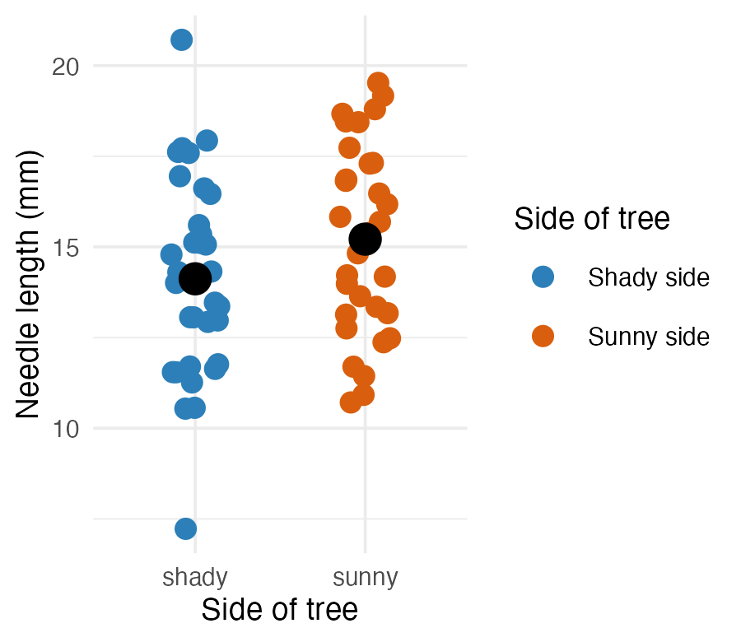
Three arguments, matched by name:
Argument | Does what
name | the legend title
labels | text shown for each level
values | the actual color for each level

Note
✅ Key idea
labels and values are both named vectors, keyed by the raw values in your data (shady, sunny) — not by the pretty text you want to display. ggplot looks up each raw value and substitutes the label/color you gave it.

Tip
📖 Why these two colors?
#2c7fb8 (blue) and #d95f0e (orange) are a blue–orange pair, the safest two-colour choice for colour-vision deficiency: red–green confusion, which affects roughly 8% of men, leaves the blue–orange axis intact.
Don’t take that on faith — check any pair you invent with a simulator (the colorblindr or dichromat packages), or start from a palette that was built for it: scale_color_viridis_d() or RColorBrewer::brewer.pal(n, "Dark2").
📖 R4DS §11.4 — Scales, including the ColorBrewer palettes.

scale_color_manual() — Getting the Names Wrong
# Typo: "sun" instead of the real value "sunny"
ggplot(pine_df, aes(x = side, y = needle_length_mm, color = side)) +
geom_point() +
scale_color_manual(
values = c(shady = "#2c7fb8", sun = "#d95f0e")
)
Warning
⚠️ Watch out!
- Every level that appears in your data must get an entry in values
  - (and in labels, if you supply it), spelled exactly as it appears in the column
  - check with unique(pine_df$side) first if you are not sure
  - A missing or misspelled level draws as grey with a warning.

scale_fill_manual() — the fill Twin
ggplot(pine_df, aes(x = side, y = needle_length_mm, fill = side)) +
geom_boxplot(alpha = 0.7, outlier.shape = NA) +
scale_fill_manual(
name = "Side of tree",
labels = c(shady = "Shady side", sunny = "Sunny side"),
values = c(shady = "#2c7fb8", sunny = "#d95f0e")
) +
labs(x = "Side of tree", y = "Needle length (mm)") +
theme_minimal(base_size = 9)
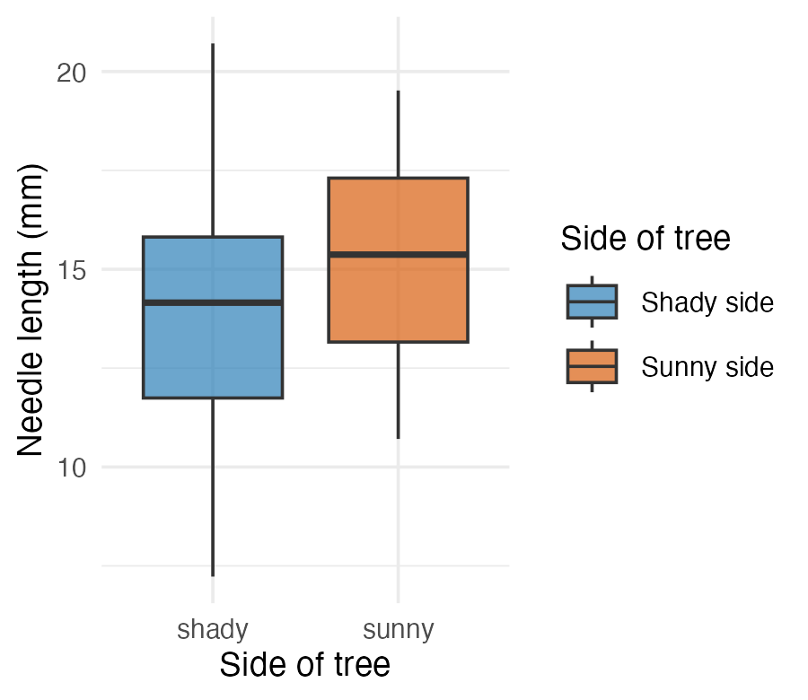
Tip
🖐 Notice
Same three arguments, same pattern — scale_fill_manual() is scale_color_manual() for the fill aesthetic instead of color. A boxplot’s box is fill; its jittered points (if you added geom_point(color = ...)) would be color. A plot can need both at once.

▶ Your Turn — Code It Now
Important
Stop here and write code.
Worksheet Part 8b — 🚀 optional bonus: pick your own colors with scale_color_manual(), and check them against a colorblind-safe palette.

Wrap-up
Today you:
- Built boxplots with raw points overlaid, not hidden
- Wrote real axis labels, titles, and legend titles with labs() — never shipped a default column name
- Mapped a third variable with color = / fill = inside aes()
- Set axis limits deliberately with coord_cartesian() — and learned that ylim() deletes rows while coord_cartesian() only zooms
- Plotted mean ± SE directly with stat_summary() — and saw that an error bar is only as honest as the rows you feed it
- source()d a themes file so theme_small() / theme_regular() / theme_large() are one + layer away in every script, forever
- Combined panels with patchwork — a + b, a / b, (a + b) / c, tagged A/B/C
- Saved a real, correctly-sized figure with ggsave()
- (As time allowed) Histograms, density curves, facet_wrap(), and custom colors with scale_color_manual()
Tip
🖐 Before next class
Finish the worksheet: source the themes file, build a two-panel patchwork figure with coord_cartesian() limits you chose on purpose, and save it to figures/ at 300 dpi.

Note
Where this leads
You can now import, wrangle, describe, and visualize a dataset end to end. That full pipeline — raw data → clean → summarize → visualize — is the foundation every later statistical test builds on.

Readings
Before next class — chapter PDFs are posted on Canvas:
- Whitlock & Schluter, The Analysis of Biological Data — Ch. 2, Displaying Data. Read “How to draw a good graph” closely: it is the standard every figure you hand in this term is held to
- Gotelli & Ellison, A Primer of Ecological Statistics — Ch. 3, Summary Statistics, for the distributions behind the boxplots and histograms
If you want more:
- Whitlock & Schluter, Ch. 4 — Estimating with Uncertainty, on what an error bar actually claims
Note
✅ Key idea
W&S tells you which graph is honest. R4DS tells you how to draw it. You need both.

Note
📖 R for Data Science (2e)
Free online at r4ds.hadley.nz:
- §1 — Data visualization
- §9 — Layers — geoms, aesthetics, positions, facets
- §10 — Exploratory data analysis — histograms and distribution shape
- §11 — Communication — labels, scales, themes, saving

Getting unstuck
When code breaks — and it will, that is normal:
- Read the error message out loud; it usually names the line
- Check the usual suspects: library(tidyverse) loaded? Is color/fill inside aes() when it should be?
- ?function_name opens the help page
- Bring the exact error (copy-paste it) to class or office hours
📖 R4DS §8 — Workflow: getting help
Note
✅ Key idea
Every working scientist googles error messages daily. Getting stuck is not failing — it is the job.

