Power and Type I & II Error
  - Errors and power
Bill Perry

Lecture 5: Review
Covered
- Statistical inference fundamentals
- Hypothesis testing principles
- T Distributions
- One sample T Tests
- Two sample T Tests
- Paired T Tests
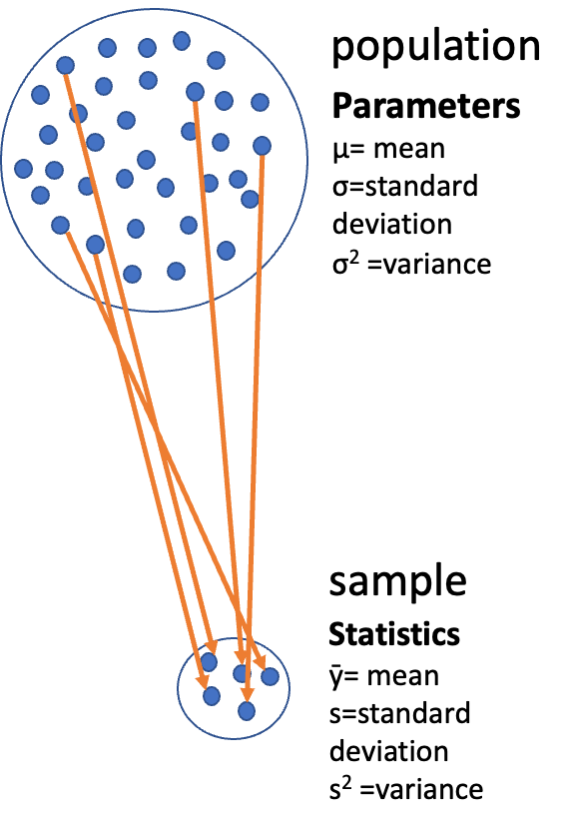

Lecture 6: Overview

The objectives:
- Brief review
- Hypothesis tests for two populations
- Assumptions of parametric tests
- Power of Parametric Tests
- Introduction to Non-Parametric Tests


Lecture 6: Statistical hypothesis testing
- Major goal of statistics:
  - inferences about populations from samples…
    - assign degree of confidence to inferences
  - Statistical hypothesis testing:
    - formalized approach to inference
  - Hypotheses ask whether samples come from populations with certain properties
  - Often interested in questions about population means
    - but other questions are of interest


Lecture 6: Hypothesis Components
Useful hypotheses:
- Rely on specifying
  - Ho is the hypothesis of “no effect”
    - two samples from population with same mean
    - sample is from population of mean = X
  - Ha (research or alternate hypothesis)
    - is the opposite of the Ho
    - or predicts that there is an effect of x on y
    - but does NOT suggest a direction which is a prediction


Lecture 6: Hypothesis Examples
Together Ho and Ha encompass all possible outcomes:
- Ho: µ=0, Ha: µ ≠ 0
  - mean equals 0 or mean does not equal 0
- Ho: µ = 35, Ha: µ ≠ 35
  - mean equals 35 or mean does not equal 35
- Ho: µ1 = µ2, Ha: µ1 ≠ µ2
  - mean of population 1 equals mean of population 2 or it does not
- Ho: µ > 0, Ha: µ ≤ 0
  - can be directional mean is greater than 0 or mean is not equal or less than 0
  - this becomes a one sided test as it predicts only one direction


Lecture 6: Statistical Testing Framework
Statistical tests assess likelihood of the null hypothesis being true
- If the Ho is likely false, then Ha assumed to be correct
- More precisely:
  - the long run probability of obtaining sample value (or more extreme one) if the null hypothesis is true
    - p(data|Ho) - the probability of observing the data given that the null hypothesis Ho is true


Lecture 6: Understanding P-values
Hypothesis tests
- Expressed as p-value (0-never to 1-always )
- Interpret p-value as:
  - probability of obtaining sample value of statistic (or more extreme one) if Ho is true
- High p-value:
  - high probability of obtaining sample statistic under Ho
    - if the null hypothesis (Ho) were true, you would frequently observe data similar to your sample statistic
    - your observed results are quite compatible with what the null hypothesis predicts
- Low p-value: low probability of obtaining sample statistic under Ho
  - if the null hypothesis (Ho) were true, you would rarely observe data similar to or more extreme than your sample statistic
  - Your results are unusual under the null hypothesis, suggesting that either you’ve witnessed a rare event or the null hypothesis may be incorrect


Lecture 6: P-value Interpretation
Statistical test results:
- p = 0.3 means that if I repeated the study 100 times, I would get this (or more extreme) result due to chance 30 times
- p = 0.03 means that if I repeated the study 100 times, I would get this (or more extreme) result due to chance 3 times
Which p-value suggests Ho likely false?
At what point reject Ho?
p < 0.05 conventional “significance threshold” (α = alpha or p value)
p < 0.05 means: if Ho is true and we repeated the study 100 times
- we would get this (or more extreme) result less than 5 times due to chance

Lecture 6: Significance Levels and Interpretation
Statistical test results:
- α is the rate at which we will reject a true null hypothesis (Type I error rate)
- Lowering α will lower likelihood of incorrectly rejecting a true null hypothesis (e.g., 0.01, 0.001)
- Both Hs and α are specified BEFORE collection of data and analysis
Traditionally α=0.05 is used as a cut off for rejecting null hypothesis
There is nothing magical about 0.05 - actual p-values need to be reported - also need to decide prior to study
p-value range | Interpretation
P > 0.10 | No evidence against Ho - data appear consistent with Ho
0.05 < P < 0.10 | Weak evidence against the Ho in favor of Ha
0.01 < P < 0.05 | Moderate evidence against Ho in favor of Ha
0.001 < P < 0.01 | Strong evidence against Ho in favor of Ha
P < 0.001 | Very strong evidence against Ho in favor of Ha

Lecture 6: Understanding P-values Visually
A p-value is the probability of observing the sample result (or something more extreme) if the null hypothesis is true.
- Common interpretations:
  - p < 0.05: Strong evidence against H₀
  - 0.05 ≤ p < 0.10: Moderate evidence against H₀
  - p ≥ 0.10: Insufficient evidence against H₀
- Common misinterpretations:
  - p-value is NOT the probability that H₀ is true
  - p-value is NOT the probability that results occurred by chance
  - Statistical significance ≠ practical significance
- Note that there is a difference in how to state the hypotheses
  - one sample T-TEST
  - two sample T-TEST
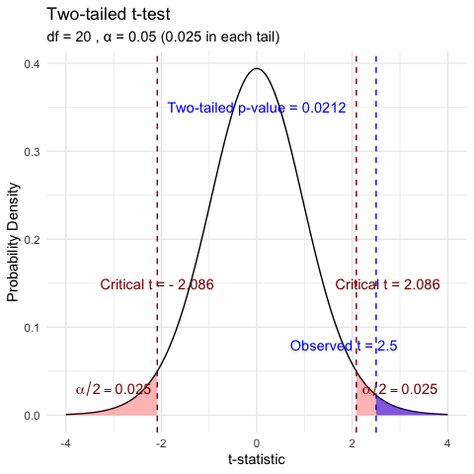

Lecture 6: Historical Context


Lecture 6: Fisher’s Perspective
Fisher:
p-value as informal measure of discrepancy between data and Ho
“If p is between 0.1 and 0.9 there is certainly no reason to suspect the hypothesis tested. If it is below 0.02 it is strongly indicated that the hypothesis fails to account for the whole of the facts. We shall not often be astray if we draw a conventional line at .05 …”


Decision errors
- Even good studies can reach incorrect conclusions
- “Decision errors”
- Two types of decision errors
- Want to know probability of making these errors
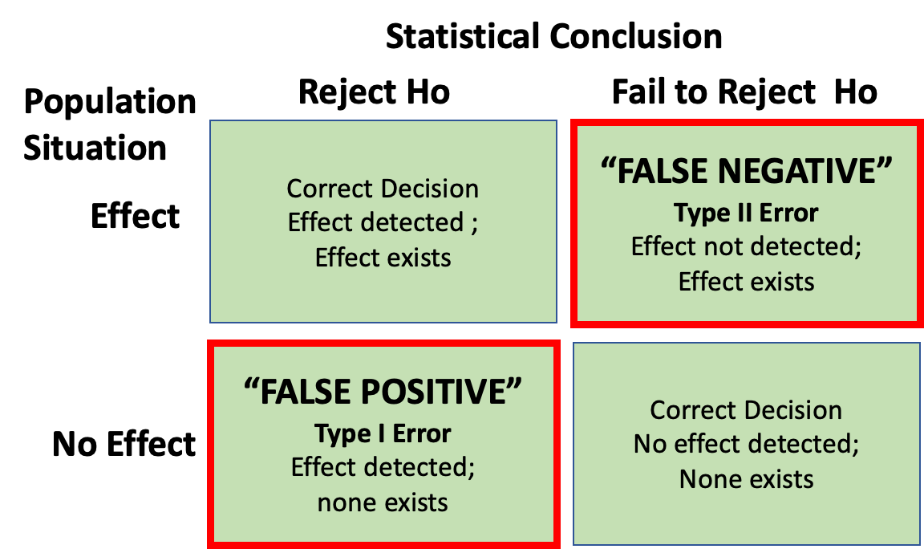

Type I and Type II Errors - Concept
- Type I error rate
  - α: wrongly reject H₀ when it’s true
  - α = 0.05 means a type I error rate of 5%
- Type II error rate, β
  - wrongly fail to reject H₀ when it’s false
- Power = 1-β: probability of correctly rejecting H₀ when H₁ is true
- Inverse relationship between type I and type II error - but not straightforward
- Result of chance - sample not representative of population
- Which type of error is more dangerous?
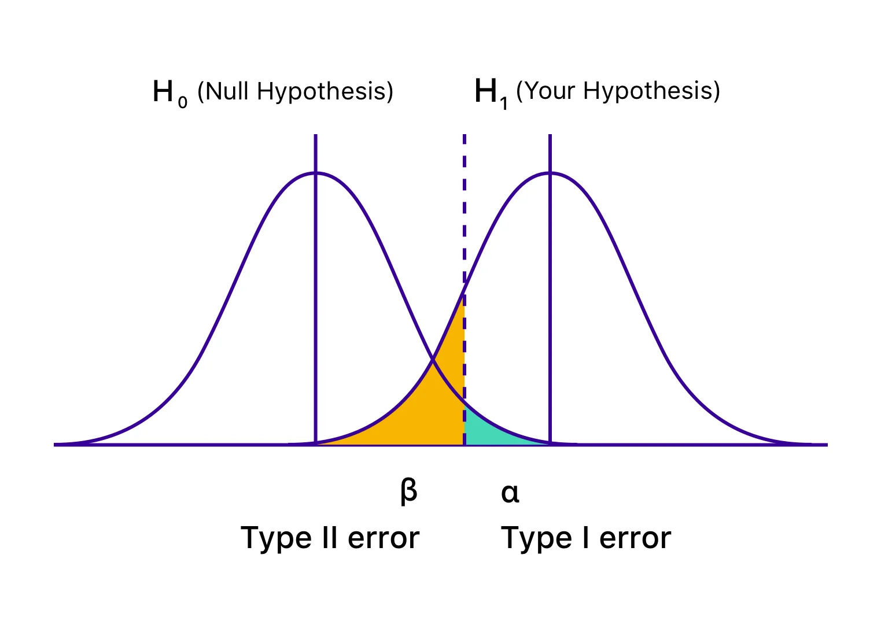
the dotted line is the alpha = 0.05

Lecture 6: Type I and Type II Errors - Details
When making decisions based on hypothesis tests, two types of errors can occur:
Type I Error (False Positive)
- Rejecting H₀ when it’s actually true
- Probability = α (significance level)
- “Finding an effect that isn’t real”
Type II Error (False Negative)
- Failing to reject H₀ when it’s actually false
- Probability = β - “Missing an effect that is real”
Statistical Power = 1 - β
- Probability of correctly rejecting a false H₀
- Increases with:
  - Larger sample size
  - Larger effect size
  - Lower variability
  - Higher α level
The farther apart the means or lower variance the lower the beta error is ~ have higher power. - CLICK TO NEXT AS SAME TEXT
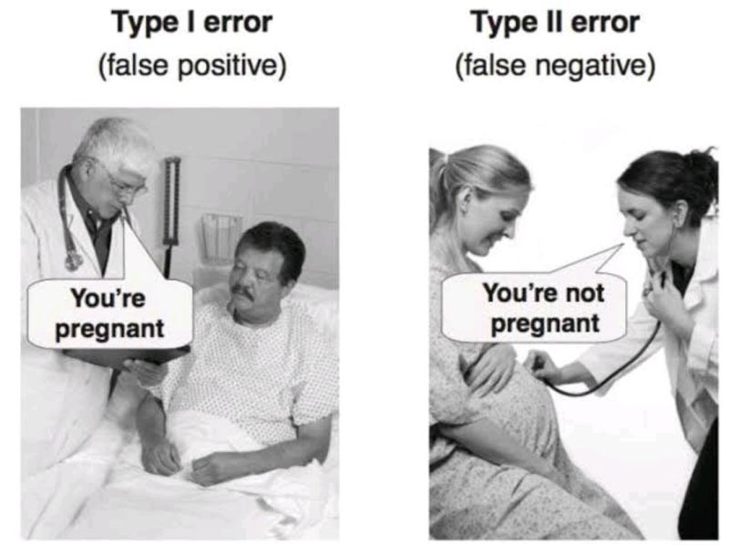

Lecture 6: Type I and Type II Errors - Visualization
When making decisions based on hypothesis tests, two types of errors can occur:
Type I Error (False Positive)
- Rejecting H₀ when it’s actually true
- Probability = α (significance level)
- “Finding an effect that isn’t real”
Type II Error (False Negative)
- Failing to reject H₀ when it’s actually false
- Probability = β - “Missing an effect that is real”
Statistical Power = 1 - β
- Probability of correctly rejecting a false H₀
- Increases with:
  - Larger sample size
  - Larger effect size
  - Lower variability
  - Higher α level
The farther apart the means or lower variance the lower the beta error is ~ have higher power.
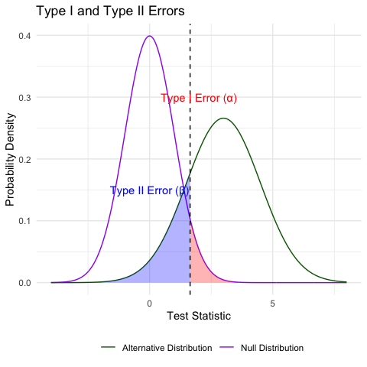

Practice Exercise: Interpreting Errors and Power
 Practice Exercise 6: Interpreting P-values and Errors
Given the following scenarios, identify whether a Type I or Type II error might have occurred:
- A researcher concludes that island mice size is larger, when in fact it is not.
- A study fails to detect a real difference in mouse size on islands when there is and concludes there is no effect.
- Let’s calculate the power of our t-test to detect a 5 mm difference in mass sampling_sites:
- pooled standard deviation
  - This is the combined standard deviation of both groups weighted by respective degrees of freedom.
- Cohen’s d
  - standardized difference between means - here assuming a difference of 1 units (g)
  - delta = 0.423: The standardized effect size (Cohen’s d)
library(car)
library(patchwork)
library(tidyverse)
library(readxl)
m_df <- read_csv("data/mice_weights.csv") %>%
filter(!is.na(mass_g))
sidney_df <- m_df %>% filter(sampling_site=="Sidney Island")
vancouver_df <- m_df %>% filter(sampling_site=="Vancouver")
# Calculate power for detecting a 30 mm difference
n1 <- nrow(sidney_df)
n2 <- nrow(vancouver_df)
sd_pooled <- sqrt((var(sidney_df$mass_g) * (n1-1) +
var(vancouver_df$mass_g) * (n2-1)) /
(n1 + n2 - 2))
# Calculate power
effect_size <- 1 / sd_pooled # Cohen's d
df <- n1 + n2 - 2
alpha <- 0.05
power <- power.t.test(n = min(n1, n2),
delta = effect_size,
sd = 1, # Using standardized effect size
sig.level = alpha,
type = "two.sample",
alternative = "two.sided")
# Display results
power
Two-sample t test power calculation
n = 28
delta = 0.4231154
sd = 1
sig.level = 0.05
power = 0.3427604
alternative = two.sided
NOTE: n is number in *each* group

What if we calculated power for the pine needles you measured?
pine_switch_df <- read_excel("data/class_pine needle length switched.xlsx")
ps_df <- pine_switch_df %>%
group_by(group, tree_no, tree_char, side) %>%
summarise(length_mm = mean(length_mm, na.rm=TRUE))
ps_shady_df <- ps_df %>%
filter(side == "shady")
ps_sunny_df <- ps_df %>%
filter(side == "sunny")
pine_alpha <- 0.05
# Calculate power for detecting a 30 mm difference
pine_n1 <- nrow(ps_shady_df) # FIX: was using sidney_df instead of ps_shady_df
pine_n2 <- nrow(ps_sunny_df) # FIX: was using vancouver_df instead of ps_sunny_df
pine_sd_pooled <- sqrt((var(ps_shady_df$length_mm) * (pine_n1-1) +
var(ps_sunny_df$length_mm) * (pine_n2-1)) /
(pine_n1 + pine_n2 - 2)) # FIX: was using n1, n2 instead of pine_n1, pine_n2
cat("Pooled SD:", round(pine_sd_pooled, 2), "mm\n\n")
Pooled SD: 2.58 mm
# More realistic effect sizes to test:
observed_diff <- abs(mean(ps_shady_df$length_mm) - mean(ps_sunny_df$length_mm))
pine_effect_size_observed <- observed_diff / pine_sd_pooled
cat("Effect size for observed", round(observed_diff, 2), "mm difference: Cohen's d =", round(pine_effect_size_observed, 2), "\n")
Effect size for observed 1.45 mm difference: Cohen's d = 0.56
# 2. Power for the observed difference
pine_power_observed <- power.t.test(n = min(pine_n1, pine_n2),
delta = pine_effect_size_observed,
sd = 1,
sig.level = pine_alpha,
type = "two.sample",
alternative = "two.sided")
cat("Power for observed", round(observed_diff, 2), "mm difference:", round(pine_power_observed$power, 3), "\n")
Power for observed 1.45 mm difference: 0.182

What is Power
Statistical power represents the probability of detecting a true effect (rejecting the null hypothesis when it is false). In this case, with a power of 97%, there’s a 97% chance of detecting a true difference of X units between the means of the two groups if such a difference actually exists.
A power analysis like this is typically done for one of these purposes:
- Before data collection to determine required sample size
- After a study to evaluate if the sample size was adequate
- To determine the minimum detectable effect size with the given sample
With 97% power, this test has excellent ability to detect the specified effect size. Generally, 80% power is considered acceptable, so 97% indicates a very well-powered study for detecting a difference of XXg between the groups.

Lecture 6: Error Bars and Their Interpretation
Error bars are graphical representations of the variability of data that show:
- The precision of a measurement
- The uncertainty around an estimate
- A confidence interval for a parameter
Common types of error bars:
- Standard Error (SE): Shows precision of the mean
- Standard Deviation (SD): Shows variability in the data
- Confidence Interval (CI): Shows plausible range for parameter
When interpreting graphs:
- Always check what the error bars represent
- Non-overlapping 95% CI bars suggest statistically significant differences
- Error bars help assess both statistical and practical significance
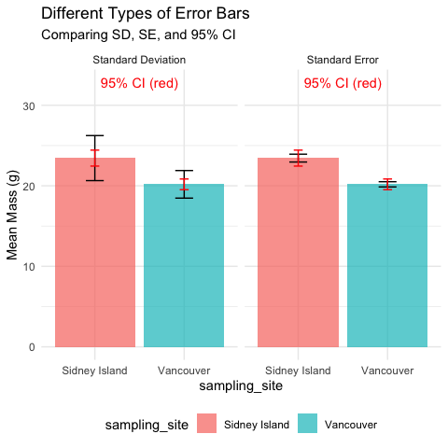

Lecture 6: Sampling and Pseudoreplication
Pseudoreplication occurs when measurements that are not independent are analyzed as if they were independent.
- A critical consideration in experimental design
- Results in underestimated standard errors and confidence intervals
- Leads to inflated Type I error rates (false positives)
Examples of pseudoreplication:
- Measuring the same individual multiple times
- Treating multiple fish from the same tank as independent
- Using multiple data points from a single site
How to avoid pseudoreplication:
- Identify the true experimental unit
- Use appropriate statistical techniques (e.g., mixed models)
- Be clear about the level of replication
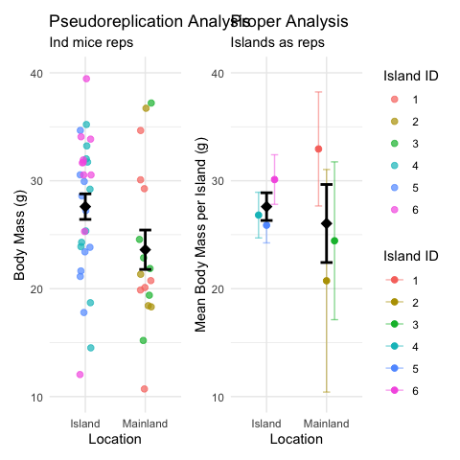

Lecture 6: Summary and Key Takeaways
Key concepts covered:
- P-values measure evidence against the null hypothesis
  - Not the probability that H₀ is true
  - Should be interpreted in context with effect size
- Hypothesis testing provides a framework for making decisions
  - Null and alternative hypotheses must be specified beforehand
  - α level determines Type I error rate
- Type I and Type II errors represent different kinds of mistakes
  - Type I (α): False positive - rejecting true H₀
  - Type II (β): False negative - failing to reject false H₀
  - Statistical power = 1 - β
- Error bars communicate uncertainty in different ways
  - Always check what type of error bar is shown
  - CI bars help assess statistical significance
- Pseudoreplication inflates significance
  - Identify true experimental units
  - Account for non-independence in analysis

