Lecture 02
Bill Perry

Review of Lecture 1
Covered
- Inductive vs deductive reasoning
- Formulating research questions
- Accuracy vs precision
- Data types and classifications
- Setting up R projects
- Installing and loading libraries
- Reading files into R
- Creating basic graphs

Lecture 2: Project Design & Data Visualization

The objectives:
- Design a well-organized project
- Implement good naming conventions
  - Controlled vocabulary
  - Including units in names
- Create and use metadata effectively
- Build tidy, well-structured spreadsheets
- Understand data repositories
- Create effective visualizations with ggplot2
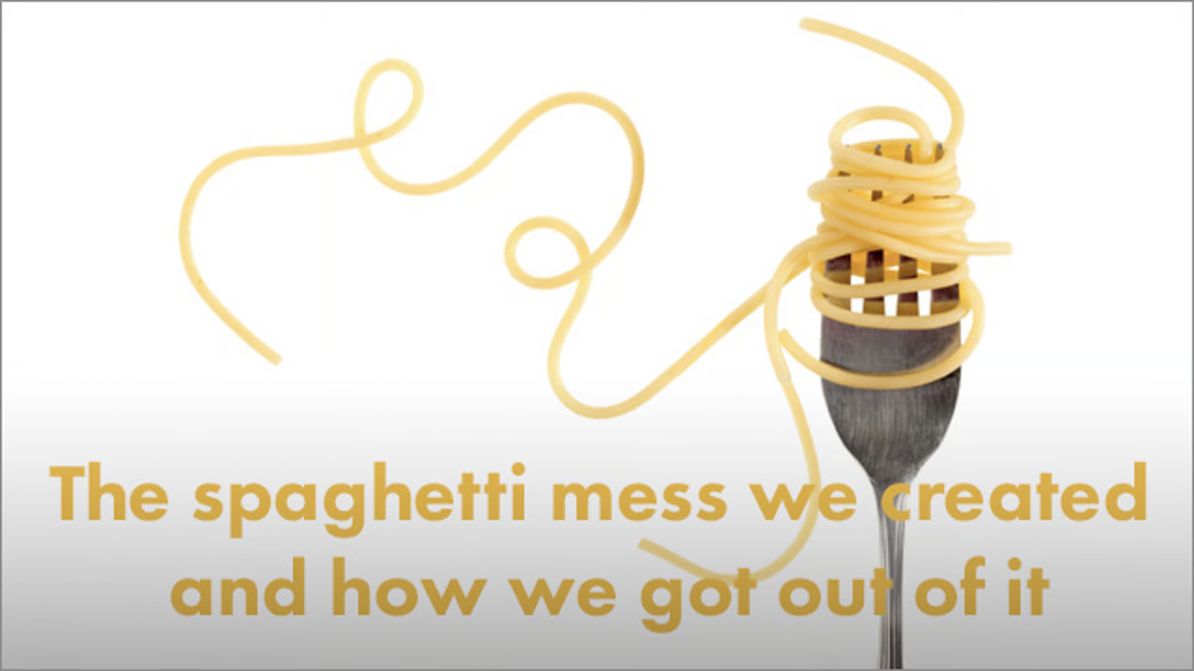

Project Design: Step 1
- Data: the raw material of science
- Wide variety of formats, sizes, complexity
- Data management and curation often under emphasized
- Good data management: owe it to our funding agencies, colleagues, supervisors, and study systems
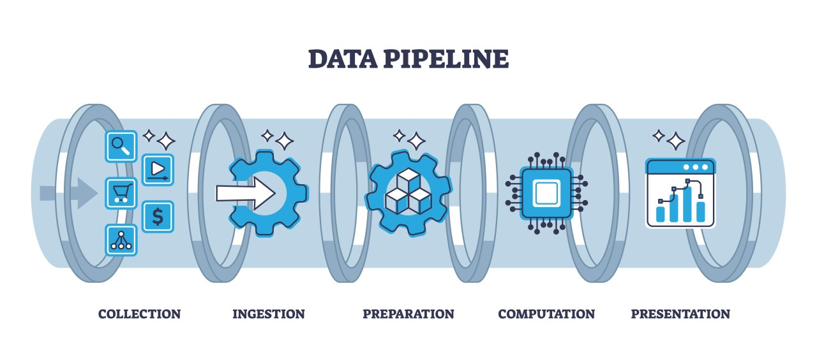

Lecture 2: Project Design: Step 1
- Determine data types you’ll collect
- Establish controlled vocabulary
  - Example: do_mgl for dissolved oxygen in mg/L
  - Example: drp_ugl for dissolved reactive phosphorus in μg/L
- Plan your data flow from collection to analysis
- Organize your project structure (folders, files)
- Enter data promptly after collection
- Save in multiple formats (Excel and CSV)
- Ensure tidy data principles from the start
 Note
See Hadley Wickham’s Tidy Data principles for best practices

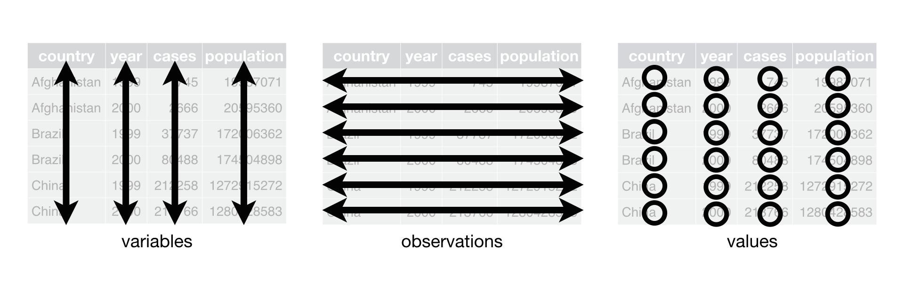

Project Design: Step 2
Create a Metadata Sheet that includes:
- Variable descriptions
- Units of measurement
- Collection methods
- Instrument details
- Dates and locations
- Any other relevant contextual information


Practice Exercise 1: Pine Data Organization
 Practice Exercise 1: Pine Data Organization
Let’s examine our pine needle data:
- - What naming conventions did you choose?
- - How did you organize the data?
- - How can you verify data formats (numeric vs categorical)?
- - What’s your plan for organizing outputs and figures?
# Code to read and examine data
library(tidyverse)
library(patchwork)
library(flextable)
pine_df <- read_csv("data/pine_needles.csv")
pine_df
# A tibble: 48 × 6
date group n_s wind tree_no length_mm
<chr> <chr> <chr> <chr> <dbl> <dbl>
1 3/20/25 cephalopods n lee 1 20
2 3/20/25 cephalopods n lee 1 21
3 3/20/25 cephalopods n lee 1 23
4 3/20/25 cephalopods n lee 1 25
5 3/20/25 cephalopods n lee 1 21
6 3/20/25 cephalopods n lee 1 16
7 3/20/25 cephalopods s wind 1 15
8 3/20/25 cephalopods s wind 1 16
9 3/20/25 cephalopods s wind 1 14
10 3/20/25 cephalopods s wind 1 17
# ℹ 38 more rows

Lecture 2: Data Management: Step 3
Storage and Backup Strategy:
- Store raw data and metadata securely
  - Save in both Excel and CSV formats
  - Consider write-protecting raw data files
- Implement the 3-2-1 backup rule:
  - 3 total copies of data
  - 2 different storage media
  - 1 offsite location (cloud storage)
- Establish a regular backup schedule


Lecture 2: Data Management: Step 4
Initial Data Inspection:
- Examine data in the Environment tab
- Run summary() and glimpse() functions
- Create exploratory visualizations
- Check for outliers, errors, and missing data
# Specify how to handle missing values during import
pine_df <- read_csv("data/pine_needles.csv",
na = c("", "NA", "N/A", "missing", "null"))
# Get a quick summary
summary(pine_df)
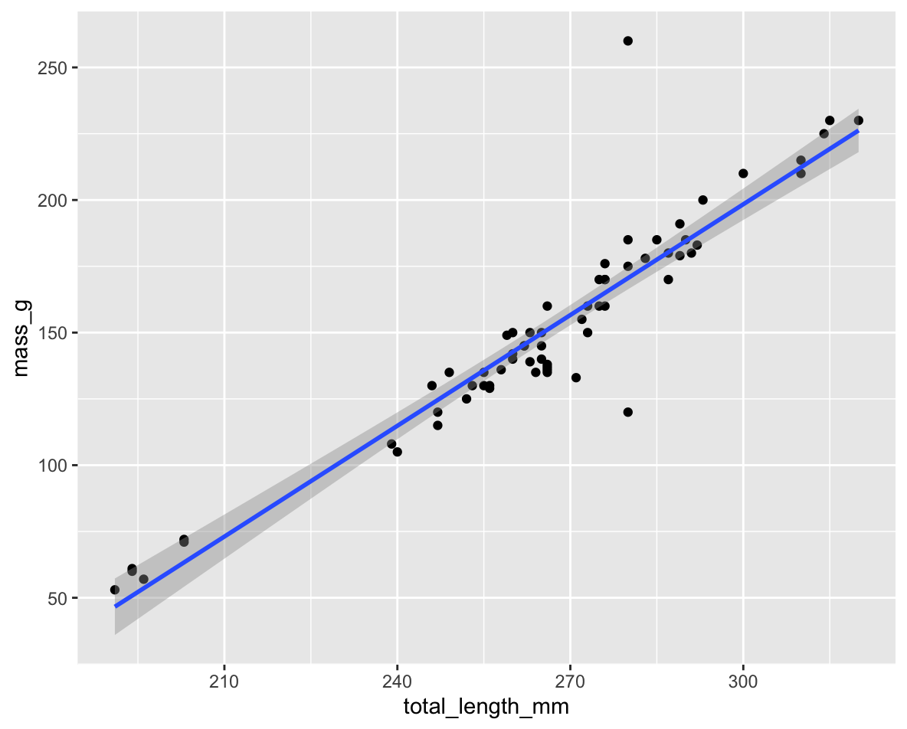

Practice Exercise 2: Try plotting a histogram
 Practice Exercise 2: Try plotting a histogram of your data
Create a histogram of pine needle lengths to check the distribution:
# Write your code here to make a plot
# How do you examine the data - what are the ways you think and lets try it!

Lecture 2: Data Management: Step 5
Data Cleaning:
- Correct errors and inconsistencies
- Replace missing values with proper NA codes
- Document all changes made to raw data
- Save a clean, master version (consider making read-only)
- Keep notes on data cleaning procedures
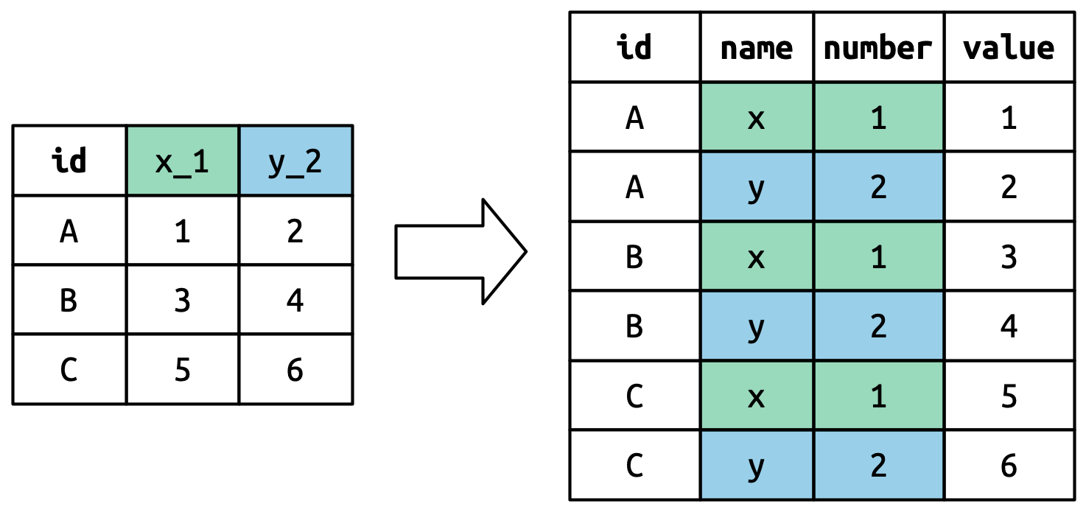

Lecture 2: Data Management: Step 6
Analysis and Visualization Workflow:
- Create exploratory visualizations
- Summarize and transform data as needed
- Document all analysis steps
- Save outputs systematically
A useful way to organize script files is number them in the order they get run.
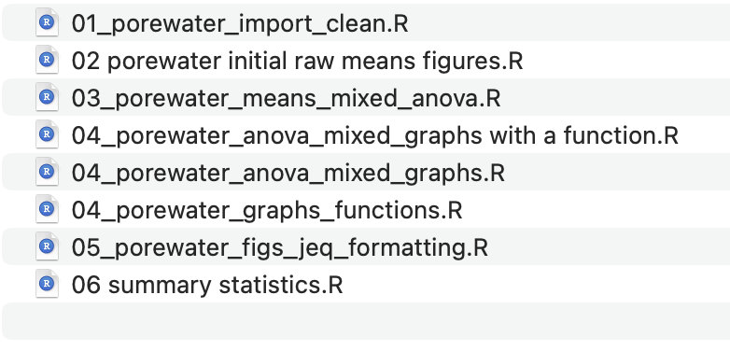

Lecture 2: Effective Data Visualization

Why make plots?

Get in a group and discuss
- What is the purpose of a data visualization?
- What elements are essential in an effective plot?
- What characteristics define a “good” plot?
- What common mistakes make plots ineffective?
Napoleon’s Disastrous Invasion of Russia Detailed in an 1869 Data Visualization: It’s Been Called “the Best Statistical Graphic Ever Drawn”
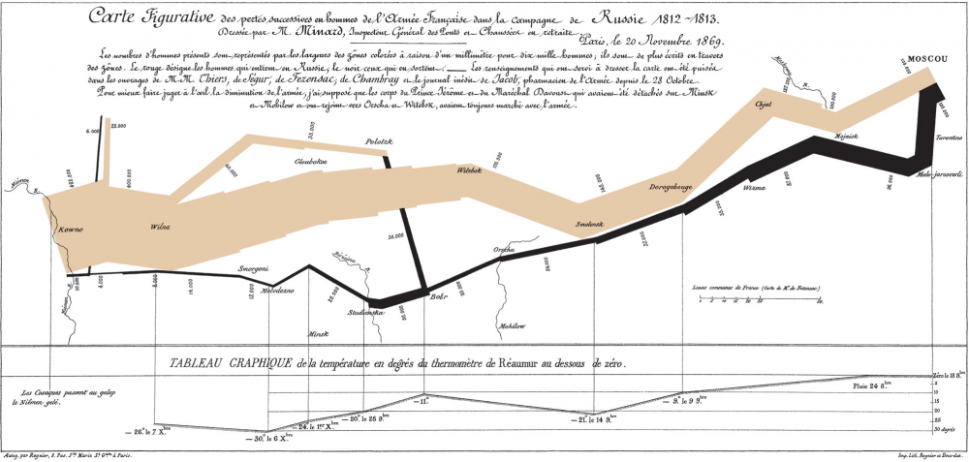

Lecture 2: Tables vs. Visualizations
How readable are tables?
We will get to what these number mean and how to make them in the next lecture.
- Tables
  - are they useful in a presentation?
wind | n | mean_mm | sd_mm | min_mms | max_mm
lee | 24 | 20 | 2.45 | 16 | 25
wind | 24 | 15 | 1.91 | 12 | 19

Lecture 2: Displaying data
- how does a table compare to a plot?
- Does this help?
- What is this plot?
  - if you don’t explain does the audience know?
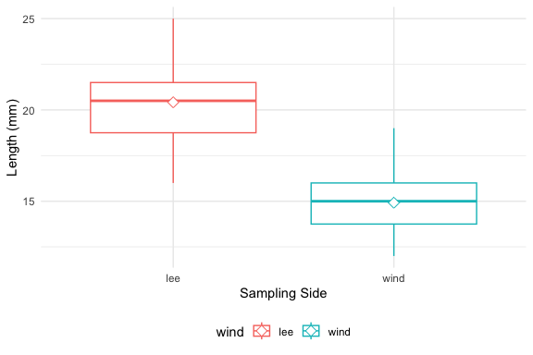

Lecture 2: Principles of Effective Graphics
According to Tufte (2001), good scientific graphics:
- Show the data without distortion
- Maximize data-ink ratio (minimize non-data elements)
- Make large datasets coherent and understandable
- Encourage comparison between elements
- Reveal multiple layers of information
- Serve a clear purpose in telling your story
- Integrate with statistical methods appropriately
# A tibble: 4 × 7
group mean_mm sd_mm n se_mm conf_low conf_high
<chr> <dbl> <dbl> <int> <dbl> <dbl> <dbl>
1 cephalopods 18 3.86 12 1.11 15.5 20.5
2 crayfish 18 3.86 12 1.11 15.5 20.5
3 salmon 16.3 3.94 12 1.14 13.8 18.8
4 snail 18.3 2.27 12 0.655 16.9 19.8

Lecture 2: Creating Effective Graphics
According to Tufte (2001), good scientific graphics:
- To implement these principles:
  - Focus on the data, not decorative elements
  - Ensure proportional representation of numbers
  - Provide clear and informative labels
  - Remove unnecessary elements (“chart junk”)
  - Revise and refine visualizations iteratively

Lecture 2: Displaying data - Good Graphics
To make good graphics:
- Above all, focus on data
- Do not distort data
- Graphical representation of numbers → directly proportional to numbers
- Strive for clarity through labeling
- Maximize data-ink ratio
  - Remove non-data ink
  - Reduce redundant data ink
- Revise and redraw
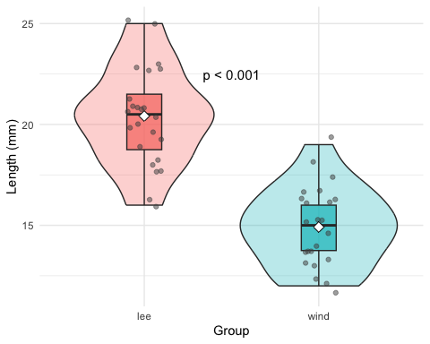

Lecture 2: Displaying data - Poor Example
What do you think?
Does this -
- Focus on data
- Distort data
- Is it directly proportional to numbers
- Is labeling clear
- Maximize data-ink ratio
  - Remove non-data ink
  - Reduce redundant data ink
- Revise and redraw
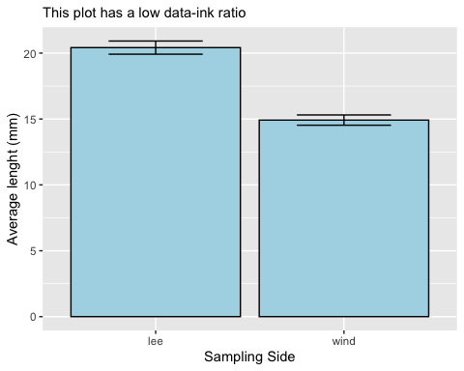

Lecture 2: Displaying data - Better Example
What do you think?
Does this -
- Focus on data
- Distort data
- Is it directly proportional to numbers
- Is labeling clear
- Maximize data-ink ratio
  - Remove non-data ink
  - Reduce redundant data ink
- Revise and redraw
What is one of the most common plots you make all the time?
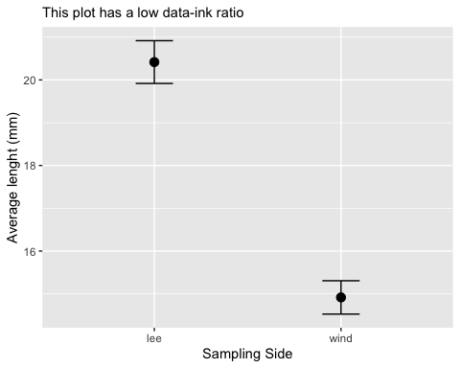

Lecture 2: Displaying data - Common Problems

Common Visualization Problems
- Data distortion:
  - Non-zero baselines on bar charts
  - 3D effects that skew perspective
  - Inappropriate scales
- Excessive “chart junk”:
  - Too many grid lines
  - Unnecessary decorative elements
  - Redundant information
- Poor color choices:
  - Too many colors
  - Non-colorblind-friendly palettes
  - Colors that don’t print well in grayscale
- Misleading representations:
  - Pie charts with too many categories
  - Dual y-axes with different scales
  - Truncated axes without clear indication
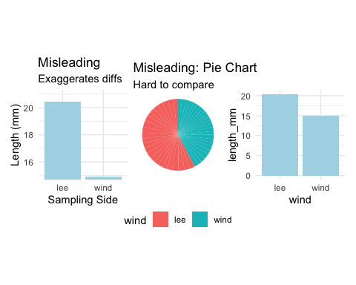

Practice Exercise 3: Basic Plots with Pine Data
 Practice Exercise 3: Lets try some plots with pine data first
Lets try to make some basic plots
# Write your code here to make a dot plot or X y plot
# How do you examine the data - what are the ways you think and lets try it!
# what is missing - hwo do you tell the effect of wind?

Practice Exercise 4: Colors, Shapes, and Fills
 Practice Exercise 4: OK we are closer but what about colors or shape or fills
Lets try to make some more basic plots
This is free time - we will free code this….
Below are some examples of code you will need for the future
# Write your code here to make a dot plot or X y plot
# How do you examine the data - what are the ways you think and lets try it!
# what is missing - hwo do you tell the effect of wind?

Lecture 2: Introduction to the Grammar of Graphics - ggPLOT
We will learn the anatomy of a GGplot is layers
- ggplot2 uses a layered grammar of graphics approach:
  - Data: The dataset you’re visualizing
  - Aesthetics: Mapping variables to visual properties
  - Geometries: The visual elements representing data
  - Facets: Splitting visualization into subplots
  - Statistics: Statistical transformations of the data
  - Coordinates: The space in which data is plotted
  - Themes: Overall visual style of the plotWe have aesthetics

Lecture 2: Building a ggplot Visualization

Key Components:
- Aesthetics (aes) map variables to visual properties:
  - x and y positions
  - color, fill, shape, size, alpha
  - group, linetype
- **Geometries (geom_*)** determine how data is displayed:
  - geom_point(): Scatter plots
  - geom_line(): Line graphs
  - geom_boxplot(): Box-and-whisker plots
  - geom_violin(): Violin plots
  - geom_histogram(): Histograms
  - geom_bar(): Bar charts
- Position adjustments control how elements are arranged:
  - position_dodge(): Side-by-side elements
  - position_jitter(): Add random noise to points
  - position_stack(): Stack elements on top of each other
- Labels and annotations provide context:
  - labs(): Title, subtitle, caption, axis labels
  - annotate(): Add text, shapes, etc.

Lecture 2: Fine-tuning your visualizations
- Colors, fills, and shapes:
- scale_color_manual(
values = c("wind" = "darkblue", "lee" = "darkred"),
labels = c("wind" = "Windward", "lee" = "Leeward")
)
- Coordinate systems:
- coord_cartesian(ylim = c(10, 30)) # Zoom in without dropping data
- Themes:
- theme_minimal() +
theme(
axis.title = element_text(size = 14),
legend.position = "bottom"
)
- Combining plots with patchwork:
- plot1 + plot2 + plot_layout(ncol = 2)

Practice Exercise 5: Publication-Quality Plot
 Practice Exercise 4: Creating a Publication-Quality Plot
Create a fully customized plot that would be suitable for publication:
# Create a publication-quality plot
pine_df %>%
ggplot(aes(x = wind, y = length_mm, fill = wind)) +
geom_violin(alpha = 0.4) +
geom_boxplot(width = 0.2, alpha = 0.7, outlier.shape = NA) +
geom_jitter(width = 0.1, alpha = 0.5, color = "gray30", size = 2) +
stat_summary(fun = mean, geom = "point", shape = 23, size = 3, fill = "white") +
labs(
title = "Pine Needle Length Varies with Wind Exposure",
subtitle = "Needles on the leeward side tend to be longer",
x = "Tree Side",
y = "Needle Length (mm)",
caption = "Data collected Spring 2023") +
scale_fill_manual(
values = c("wind" = "#1b9e77", "lee" = "#d95f02"),
labels = c("wind" = "Windward", "lee" = "Leeward")) +
theme_minimal() +
theme(
plot.title = element_text(face = "bold", size = 16),
plot.subtitle = element_text(size = 12, color = "gray30"),
axis.title = element_text(face = "bold"),
legend.title = element_blank(),
legend.position = "bottom")

Key Takeaways
- Plan your data management from the beginning
  - Consistent naming conventions
  - Good organization
  - Regular backups
- Make your data tidy from the start
  - One observation per row
  - One variable per column
  - One value per cell
- Create effective visualizations by:
  - Focusing on data, not decoration
  - Using appropriate plot types
  - Following good design principles
  - Customizing for clear communication
- Master the grammar of graphics to:
  - Build plots layer by layer
  - Communicate patterns clearly
  - Tell compelling stories with data

Next Steps
- Practice creating different types of plots
- Learn to combine multiple plots effectively
- Explore statistical transformations in ggplot2
- Develop a consistent visualization style

